
$22.22/30ml – 30mg | 50mg

Grape Drink
Tart grape, fruit juice, and mixed berries.

Juicy Apple
Sweet and sour; red and green apple mix.

Mango Tango
Pineapple and mango mix with a touch of blackcurrant.

Cool Melon
Cantaloupe and melon with a soft touch of cucumber and menthol.

Fizzy Lemonade
Lemonade and lime with a cool, carbonated, menthol finish.

Banana Cream Pie
Caramelized banana, pie crust, and vanilla custard.

Blue Magic
Blueberry vanilla muffin.

Crunch Berry
Strawberry, mixed berries, milk and cereal.

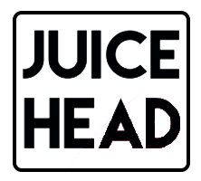
$22.22/30ml – 25mg | 50mg

Strawberry Kiwi
Sweet strawberry and tart kiwi with a creamy touch to round out the trifecta of flavors.

Peach Pear
Rich peach mixed with sweet pear for a perfectly balanced concoction.

Pineapple Grapefruit
An infusion of sweet pineapple and tart grapefruit.

Watermelon Lime
A mix of watermelon and sour lime for an explosion of flavor.


$22.22/30ml – 24mg | 48mg

Golden Ticket
Rich, creamy, chocolate milk, as accurate as they come. Some lucky boxes may contain a golden ticket.

Strawberry Milk
Sweet strawberry with a touch of creamy milk.

Fairgrounds Deep Fried Cream Cake
A tasty reiteration of a fluffy yellow sponge cake topped with a dollop of light whipped cream deep fried to a golden finish

$22.22/30ml – 35 | 50mg

Hawaiian P.O.G.
Passion Fruit | Orange | Guava

Lava Flow
Strawberry | Pineapple | Coconut

Really Berry
Blueberry | Blackberry | Lemon

Strawberry Pom
Formerly Brain Freeze
Strawberry | Kiwi | Pomegranate | Menthol

Melon
Formerly Polar Breeze
Honeydew | Pineapple | Cantaloupe | Menthol
Berry
Formerly Very Cool, thank you.
Blackberry | Blueberry | Raspberry | Menthol

American Patriot
Classic-Cut Rich Tobacco with a hint of honey


$22.22/30ml – 30mg | 50mg

Original
Classic red McIntosh apples, also available in menthol.

Watermelon
Sweet red apple juice with a watermelon finish, also available in menthol.

Mango
Tropical mangoes mixed with a splash of reds apple, also available in menthol.

Grape
A seriously sweet and tart, grape apple mixture; also available in menthol.

Berries
blueberry, raspberry, and pomegranate paired with the iconic apple juice.

Guava
Sweet apple incorporating notes of ripened guavas; also available in menthol.



$22.22/30ml – 35mg | 50mg

Blue Razz
Gushing Blue Raspberry taffy that you just can't get enough of.

Mystery
A Mysterious blend of fruity taffy that will keep you guessing.

Mint
This Limited Edition Flavor delivers a cool blast of arctic mint!

Apple Crisp
Sweet and Crisp Apples blasted with menthol.

Melon Lush
Watermelons and honeydew’s are blended perfectly with stretchy taffy


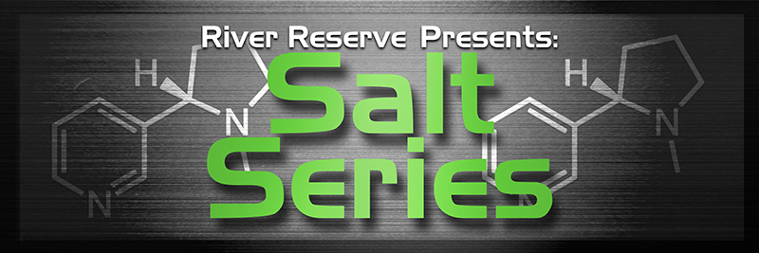

$22.22/30ml – 25mg | 40mg

Blue Island Punch
A medley of tropical fruits blended to perfection.

Lemon Drifter
delicious blend of fresh lemon and our signature creamy yogurt

Royal Tobacco
A robust full bodied tobacco.

Summer Berry
Fresh strawberries and juicy watermelon expertly blended.

Tangie
Sweet and juicy tangerines with a hint of cool menthol.

Vanilla Waffle Cone
Fresh baked waffle cone with Vanilla ice cream.

Winter Berry
Fresh strawberries and juicy watermelon expertly blended with a blast of refreshing menthol.


$22.22/30ml – 24mg | 48mg

Raspberry Dragon Fruit Iced Tea
A sweet and satisfying raspberry dragon fruit iced tea.

Papaya Mango Cantaloupe
A refreshing blend of papaya, mango and cantaloupe.

Coconut + Cream
A balanced blend of coconut and creams.

