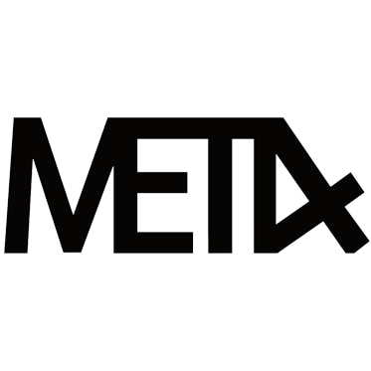
$22.22/30ml – 24mg | 48mg

Golden Ticket
Rich, creamy, chocolate milk, as accurate as they come. Some lucky boxes may contain a golden ticket.

Strawberry Milk
Sweet strawberry with a touch of creamy milk.

Fairgrounds Deep Fried Cream Cake
A tasty reiteration of a fluffy yellow sponge cake topped with a dollop of light whipped cream deep fried to a golden finish

