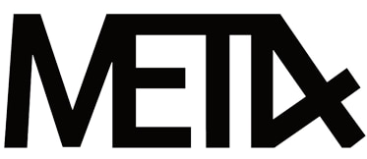
$22.22/30ml – 24mg | 48mg

Golden Ticket
Rich, creamy, chocolate milk, as accurate as they come. Some lucky boxes may contain a golden ticket.

Strawberry Milk
Sweet strawberry with
a touch of creamy milk.

Fairgrounds Deep Fried Cream Cake
A tasty reiteration of
a fluffy yellow sponge cake
topped with a dollop of
light whipped cream
deep fried to a golden finish

