
COMP1028 Programming and Algorithm
Session: Autumn 2025
Group Coursework (25%)
Group Name | We C your C
Group Members
Name 1 | Hue Wei Feng |  | ID 1 | 20711677
Name 2 | Ian Yap Yu Sheng |  | ID 2 | 20723833
Name 3 | Valiant Tai Zi Pin |  | ID 3 | 20705238
Name 4 |  |  | ID 4
Name 5 |  |  | ID 5
Marks  Total (100) | Program Functionalities (65) | Bonus (5) | Code Quality (10) | Presentation / Demo (10) | Report / Documentation (10)
Submission Date | 5/12/2025

1. Introduction

This project aims to implements a Toxic Text Analyzer in C programming language to perform toxicity analysis and general statistics analysis on text files.

The core aim is to process a given text file or a csv file, compute essential word and character statistics, identify and quantify the frequency of toxic words, and provide various reporting and comparison functionalities.

The functionalities the current project achieved are:

- File Loading and Preprocessing: Allows loading of a .txt or .csv file and preparing its content for analysis.

- Text Analysis: Calculates general statistics such as total words, unique words, character counts (letters, digits, punctuation, whitespace), and average sentence length.

- Toxic Word Detection: Identifies and tracks the frequency of toxic words based on a toxic word dictionary text file.

- Reporting: Displays toxicity analysis, word frequencies, and an ASCII-based bar chart for the top 10 toxic words.

- Persistent Storage: Saves the detailed analysis results to a CSV file.

- Comparison: Compares the toxicity percentage of two previously saved analysis CSV files and find out which file is more toxic.

- Adding new words to dictionaries: Allows users to add new words to the toxic words dictionary dynamically.

- Menu-driven Interface: Provides an interactive menu for easy program navigation.

- Large file handling: The current program is capable of running analysis on large files, though execution time increases proportionally.

2. Key Design Choices

2.1 Data structures used (arrays and structs)

- Structs used: Structs such as WordEntry and ToxicWordEntry are used for storing and tracking word frequencies. WordEntry holds the word and its frequency. ToxicWordEntry is similar, tracking toxic words specifically. Furthermore, Analysis struct is used to store all the generated statistics from the current user inputted file.

- Dynamic Arrays of Struct are implemented: Dynamically allocated arrays of structs for unique words and unique toxic words allows the program to process text files without being constrained by fixed buffer sizes.

- Usage of Realloc: Realloc is used when initial capacity that is originally set is reached, then the uniqueCapacity or uniqueToxicCapacity is reallocated to doubled the size of the current memory to store more data. Doubling helps reduce the number of times needed to call the function realloc. For example, if we did realloc everytime we have reached the capacity and we still have 100 words left not yet processed that means we need to use realloc 100 times.

2.2 File handling strategy

- Temporary File to hold contents: Contents of the user's chosen file are written to a temporary file named read.txt. This allows us to read from read.txt file line-by-line using fgets. So that whether it’s a csv file or a text file we will only have a single function to read the file contents without having two different function (one for reading .csv file and one for reading .txt file).

- Normalization during Load: The words from both toxic words and stop words dictionaries are converted to lowercase using tolower() during the loading process. This ensures that comparison during the main analysis are case-insensitive.

- Dynamic Output Naming: User can save the analysis results to a CSV file. The function then will generate the output filename based on the input file name. For example, document.txt becomes document_analysis.csv and document1.txt becomes document1_analysis.csv. This allows multiple files to each have a different analysis output file.

- Toxicity Analysis File Comparison: The compareFileToxicity function implements a file reading strategy to compare the toxicity of two previously generated analysis files. Instead of analysing two files and compare their data, the function reads previously generated _analysis files to compare the data of the two files. This helps negate the process of repeated analysing of files if user just wants to compare toxicity between two files.

2.3 File Modularization

- Use of header files and .c files : The Toxiclib.h serves as the public interface of the library. It contains all essential definitions required by the main program, including: constants, data structs and global variables. While .c file(function.c) contains the actual logic, function bodies, and global variable definitions. Through the use of .c and .h files we are able to improve readability of the code without needing to add all the functions and functions logic in one large .c file.

2.4 Tokenization approach (punctuation removal, case folding, splitting etc.)

- Case Folding: All characters in the text are converted to lowercase using tolower() during the file processing loop in generalStats. This ensures that "Word," "word," and "WORD" are treated as the same token. Furthermore, this is also to allow the comparison of words with toxicwords and stopwords which were also converted to lowercases.

- Punctuation Removal: All punctuation marks are identified using ispunct(). Once counted, each punctuation character is immediately replaced with a space (' ') in the buffer. This guarantees that words attached to punctuation (e.g., "word!" or (word)) are correctly separated from the punctuation mark before the splitting phase begins.

- Word Splitting: Once the text is normalized, function strtok() is used to split the modified buffer into word tokens. The delimiter string " \t\n\r" ensures that words are correctly separated by spaces, tabs, newline characters, and carriage returns.

- Post-Tokenization Cleanup: After strtok returns a token, additional logic is used to remove any leading or trailing non-alphabetic characters (which might include numbers or remaining special characters), ensuring only the core alphabetical word is processed.

2.5 Stopword handling

- Normalization Stopwords: The words are normalized to lowercase using the tolower() function during the loading process before storage. This pre-processing step guarantees case-insensitive matching when analyzing the input text.

- Linear Search Exclusion: The isStopword function uses a direct linear search (strcmp) to check if any tokenized word is same as the words in the pre-loaded dictionary. If a match is found, the word is immediately discarded, meaning it is excluded from both the totalWords count and the uniqueWords tracking list. This ensures that common words like 'the' or 'and' do not skew the unique words to total words ratio(lexical diversity).

Sorting Algorithm used and justification

- Sorting Algorithm Used Is Bubble Sort: While Bubble Sort is known to be an inefficient sorting algorithm for comparison, and is not the most efficient choice for large-scale data analysis (where Merge Sort would be preferred). However, it was selected for this project due to ease of implementation as its straightforward logic minimizes the complexity of managing nested loops and struct swapping.

2.7 Toxic word detection strategy

- Normalization Toxic Word: Just like stopwords these dictionary words are normalized to lowercase using tolower() during loading to ensure accurate, case-insensitive matching against the text tokens. The add_words feature allows users to permanently append new words to this dictionary file, enhancing the system's ongoing relevance.

- Linear Search Comparison: Also same as Stopwords it uses a direct linear search (strcmp) to check if any tokenized word is same as the words in the pre-loaded dictionary. If a match is found, the global variable toxicword count is incremented. The word frequency is tracked using trackToxicWord, which manages the dynamic array uniqueToxicWords.

2.8 Menu-driven user interface design

- Ascii Design: The program uses a ascii character interrface, constructed using standard ASCII characters such as hypens - to create visual separation, headers (like "TOXIC TEXT ANALYSER"), and structure. Furthermore, the bar chart created to visualizing top 10 toxic words also uses ASCII characters.

3. Challenges Faced and Lessons Learned

3.1 Challenges Faced
3.1.1 Memory Management and Freeing Pointers

A significant early challenge was the correct management of dynamic memory, particularly preventing memory leaks and ensuring capacity for large inputs. Initially, we faced limitations because we had not allocated sufficient memory space for the dynamically sized word lists (unique words and unique toxic words) to handle large text files.

Thus, we decided to use dynamic allocation strategy. We used malloc() for the initial allocation and implemented realloc() with a capacity doubling technique to dynamically expand storage for the unique word lists as needed. Furthermore, we decided to always look out when to use free() especially after any allocated buffer was no longer needed such as the buffer used in GeneralStats, ensuring that every call to malloc or realloc was matched by a corresponding call to free to prevent memory leaks.

3.1.2 File handling

Reading the user's input file presented a hurdle, as the program needed to handle potentially different file types (e.g., .txt, .csv) without knowing the format in advance.

Therefore, in order to ensure the analysis function (generalStats) could rely on a single, normalized stream of raw text, we implemented the strategy of writing the input file's contents to a temporary working file(read.txt). This decision unified the input format, allowing the tokenization logic to remain simple and consistent regardless of the original file extension without needing to create separate functions to analyze different file formats.

3.1.3 Time management

Due to the large amount of coursework during development, we had to carefully manage the project scope. This meant prioritizing core functionality and essential robustness features over implementing highly advanced, high-complexity features.

Thus, we made a decision to focus our efforts on core functions first rather than pursuing secondary features like using a faster sorting algorithm (Merge Sort). This strategy ensured the deliverable was stable and functional.

3.1.4 Header files and variables standardisation

Working collaboratively (three people contributing to the code) became challenging when our development process initially lacked standardization. Different members used different variable names for the same purpose, leading to integration issues and redundant code. Some members used global variables while some uses struct. When we decided to combine all of our codes it showed errors for variables having multiple initialisation. It took a few days to standardized and remove the redundant variables.

Therefore, we decided to try implement separate .c and .h files to make the code more modular and readable. The header file (Toxiclib.h) provided a single place to define and extern all global variables, constants ,structs and function prototypes. This standardization helps to make sure the variables we are using are standardised and we can easily view what variables have been used without needing to check each files separately.

3.2 Lesson Learned

3.2.1 Time Management and standardisation of code

First and foremost, the early struggles with conflicting variable names across teammates highlighted the importance of a standardizing variables and communication during development. Furthermore, the time constraints of this semester taught us the importance of better project and time management as we did not allocate enough time for this project causing us to leave some advanced features out. Last but not least, in future we will try to implement a more efficient way to sort the words by frequency rather than using bubble sort.

3.2.2 Algorithms and C programming

We learned to properly malloc, realloc, and free memory blocks after the buffer used was not needed for writing stable code and preventing leaks. Moreover, we learned the benefit of using structs over scattered global variables which helped improve code readability and allows us to standardized the variables. In addition, we now understand of the differences between reading and writing file types as different files types require different reading methods. Last but not least, we understand now that different sorting algorithms plays a huge role in sorting through large files and in future we will use more efficient sorting algorithm.

Appendices

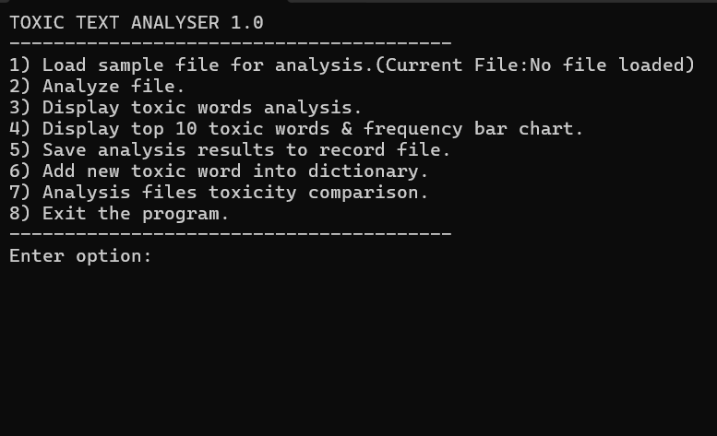
Figure 1 Menu Interface for users

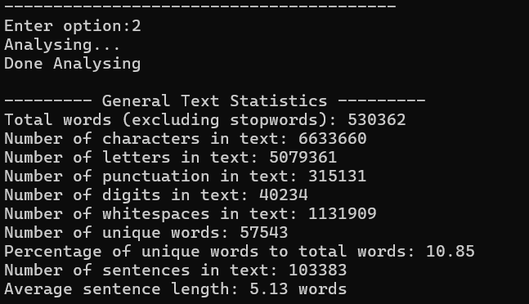
Figure 2 Large File Handling

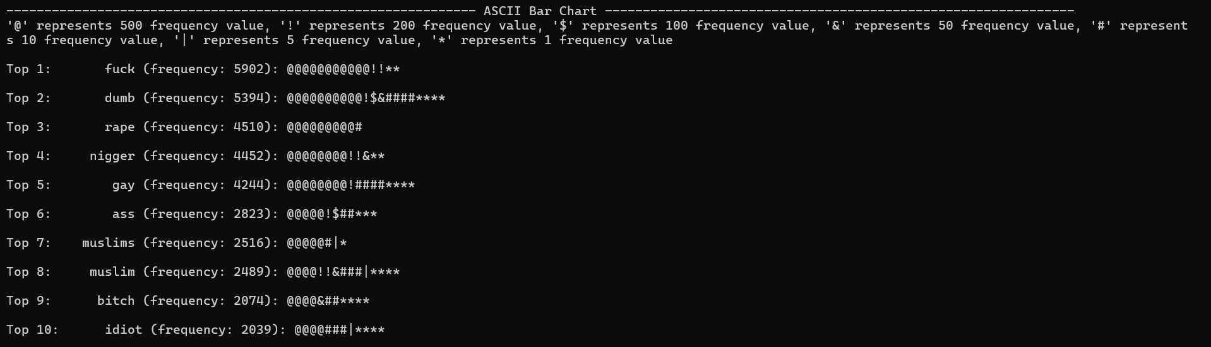
Figure 3 Ascii Bar Chart

Figure 4 File Analysis Output

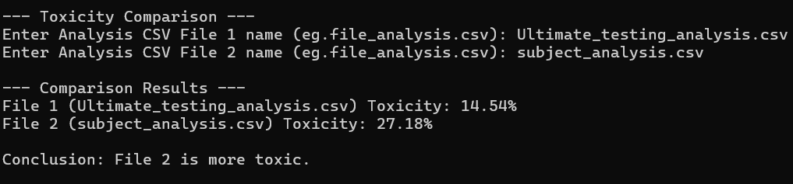
Figure 5 File Toxicity Comparison

Appendix A: ReadMe

Task to do in order to run on:

Visual Studio Code:
1.Change your task json file
2.Change the args from "${file}", to "${fileDirname}\main.c", "${fileDirname}\functions.c",
3.Press run and debug

Visual Studio Community:
1.Add all the necessary files into one folder
2.Press run and debug

All files that must be included:
1.Stopwords.txt
2.ToxicWords.txt
3.main.c
4.functions.c
5.Toxiclib.h

Sample Files for testing
1.Ultimate_testing.csv
2.subject.txt
3.industry.csv

Vs Code changing Task Json file
1.Open your task json file
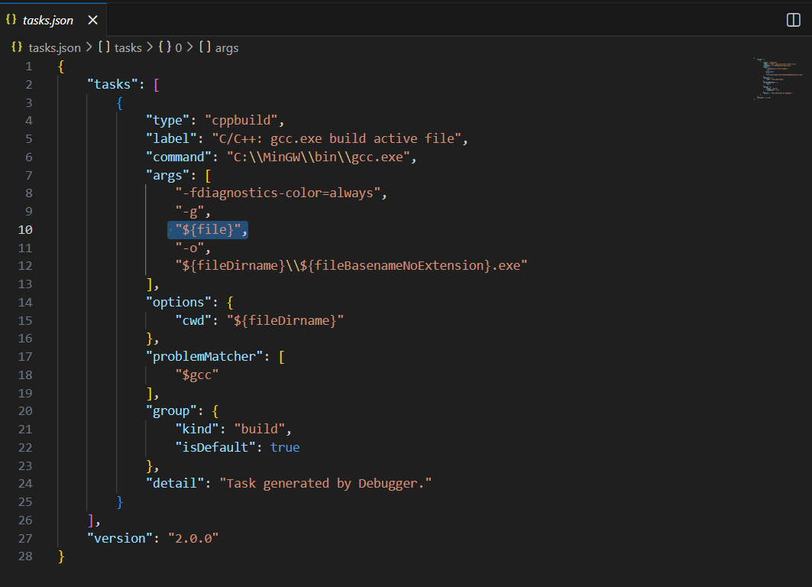

2.Change the highlighted part into
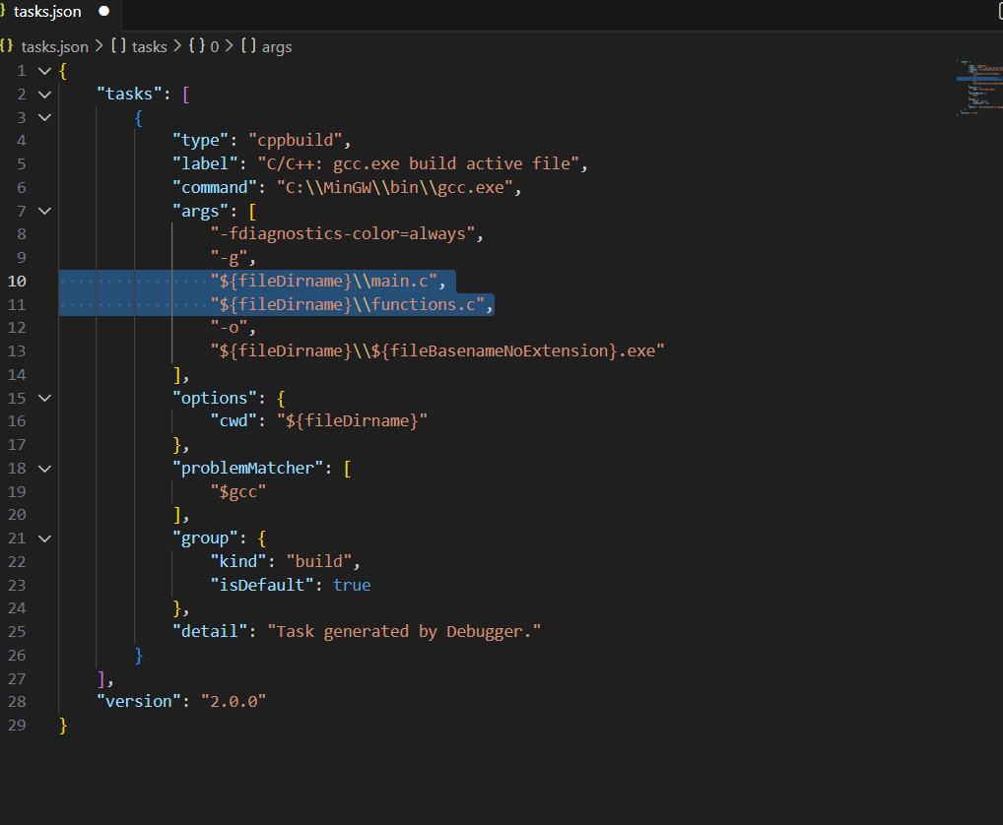

GitHub Link & Video Link
GitHub Repository: https://github.com/Johnwicktheman/AssingmentProgrammingGroupWeCyourC/tree/main

(Note: Please also zip all project files and submit a copy to Moodle as well)
Video Presentation Link: ______________________

Appendix B: Marking Scheme Summary
Criteria | Description / Notes
Text Input & File Processing | It can handle large files and support different input files
Tokenization & Word Analysis | It can show average sentence length, lexical diversity and other statistics
Toxic Word Detection | Allows the expansion of toxic word dictionary
Sorting & Reporting | Used bubble sort and displays Top 10 toxic words and Top 10 most frequent words
Persistent Storage | Allows user to output the current results as a _analysis csv file
User Interface | Allows user to see the current Top Toxic Word ASCII Bar chart
Error Handling & Robustness | Handle wrong filenames and provided friendly user error recovery
Code Quality & Modularity | Seperated functions into .c and .h files to improve readability and standardize variables. Use of structs to store results
Bonus Features | Allows comparison between two _analysis csv files
Presentation / Demo | Explain the overall program
Report / Documentation | Explain the overall program

