I Can Sleep When I’m Dead Site Plan

Ethan Cotter

WDD 130

Overview

Purpose
To create an entertaining and informative website that tells readers the effects of lack of sleep and what it does to a person.

Audience
Everyone, especially people with poor sleep habits.

Branding

Website Logo

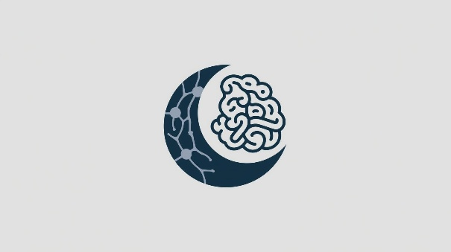

Style Guide

Color Palette
Primary | Secondary | Accent 1 | Accent 2
#143045 | #C8D3DA | #8B2635 | #D5AC4E

Typography

Heading Font: Pacifico

Paragraph Font: Baloo 2

Navigation
Home Life Health

Content

[put all content for the pages here, including written text and images]

MAIN PAGE CONTENT:

I Can Sleep When I’m Dead

“I Can Sleep When I’m Dead” is a fun simple website that is meant to teach the reader about the effect of sleep deprivation and the negative effects it can have on people. Enjoy the interesting facts and relax as you learn more about sleep deprivation at your own pace. On this main page you will learn about some causes of sleep deprivation with the Life and Health page each discussing some the effects of sleep deprivation.

How does it start? Well sleep deprivation is when a person does not get enough sleep at night and comes from a variety of factors. Many people are willing to sacrifice some sleep to stay up for some fun, or to try and catch up on some work or homework but skipping good sleep can compound onto the next day and make that person less productive creating a cycle. According to “Effects of Sleep Deprivation” written by Rob Newsom “Nearly half of people in the U.S. have trouble sleeping, and around one-third of adults sleep less than seven hours each night.”

All this skipping on sleep isn’t very good for people, and it also causes humans to accrue “sleep debt.” In “How Sleep Deprivation Affects the Human Body” by Brandon Peters he explains that “Sleep debt is the amount of sleep lost from insufficient sleep, regardless of the cause. For example, if you need eight hours of sleep to feel fully rested but only clock six hours, you have a two-hour sleep deficit for that night. This may have important health consequences as the debt builds.” As “sleep debt” as Brandon Peters puts it can add up much more quickly than people think and simply can’t be wiped away with one good night of sleep. It’s important to have a consistent sleep schedule or else human beings will start to degrade their bodies and minds. Please check the Health and Life sections to learn about how the lack of sleep can affect you.

Life Page:

Cognitive function and decision-making abilities are significantly impaired by lack of sleep. Sleep-deprived students often exhibit decreased reaction times, impaired judgment, and reduced creativity. This can lead to poor academic choices, such as procrastination or ineffective study strategies, as well as risky behaviors in their personal lives.

Social and relationship problems can also stem from chronic sleep deprivation. Irritability, mood swings, and decreased empathy are common side effects of insufficient sleep, which can strain friendships, romantic relationships, and interactions with peers and professors.

Health Page:

Mental health consequences of sleep deprivation are equally concerning. Lack of sleep has been linked to increased rates of anxiety, depression, and mood disorders among college students. The relationship between sleep and mental health is bidirectional, with poor sleep exacerbating mental health issues and mental health problems often leading to disrupted sleep patterns.

Physical health issues also arise from chronic sleep deprivation. Students who consistently skimp on sleep are more susceptible to illnesses due to a weakened immune system. They may also experience weight gain, as lack of sleep disrupts hormones that regulate appetite and metabolism. In extreme cases, prolonged sleep deprivation can even lead to more severe health consequences.

Statistics of how sleep deprivation can affect health taken from Johns Hopkins Medicine’s “The Effects of Sleep Deprivation.”
- A 36% greater risk for colorectal cancer
- A 33% greater dementia risk
- A 48% greater risk of developing heart disease
- Nearly a 3X greater risk of developing type 2 diabetes
- A 50% higher risk of developing obesity
- A 3X greater likelihood of catching a cold

This is a diagram showing the effect of sleep deprivation
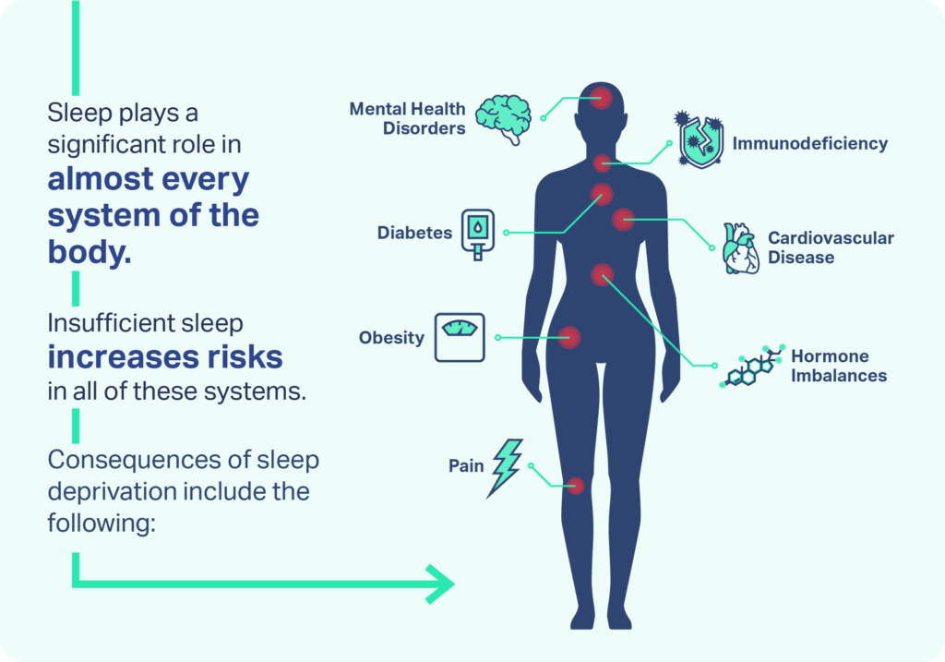

This picture is for fading in slightly or flashing on screen
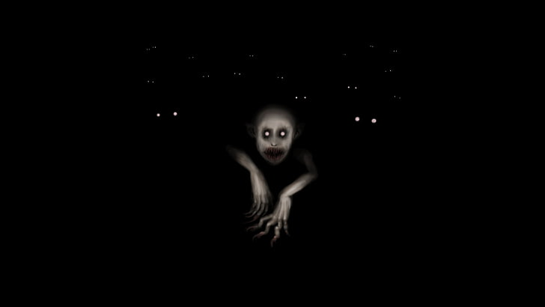

Sources:
https://www.verywellhealth.com/what-are-the-physical-effects-of-sleep-deprivation-3015079
https://pmc.ncbi.nlm.nih.gov/articles/PMC6473877/
https://neurolaunch.com/sleep-deprivation-in-college-students/
https://www.sleepfoundation.org/sleep-deprivation/effects-of-sleep-deprivation

Wireframes

Home
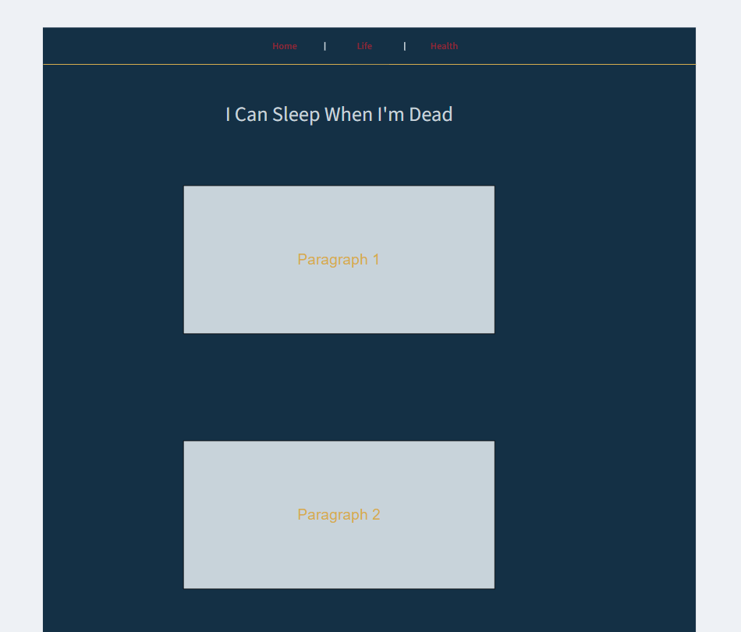
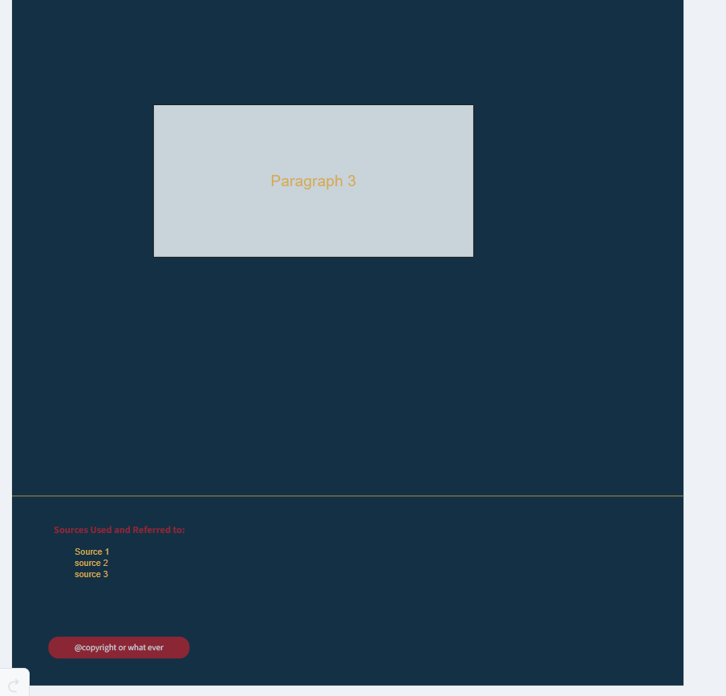

Other Pages (relatively similar however the health page has a diagram)
