[The World’s Table] Site Plan

[Johny Suy]

WDD 130

Overview

Purpose
[The purpose of this website is to gather all the recipes all around the world and put them in one place.
Which makes it easy for people just by clicking on the image of the meat, fruits or vegetables, it will show
to them What kind of dish they can make with many different countries around the world.]

Audience
[Target audiences: Chefs, housewife, business owners, restaurant owners]

Branding

Website Logo


Style Guide

Color Palette
Primary | Secondary | Accent 1 | Accent 2
#495867 | #ce796b | #E19451 | #f2e8cf

Typography

Heading Font: [Kaushan Script]

Paragraph Font: [Questa]

Navigation
Home Recipes About me

Content

Home Page:
- Introduction to The World’s Table
- A hero image showing dishes from different countries
- Brief mission statement about connecting cultures through food
- You can find more images as you think it fit for the page
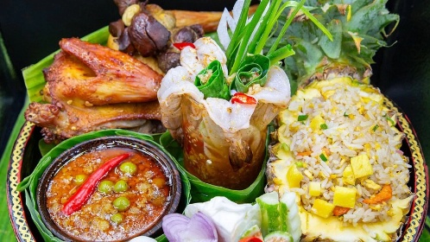

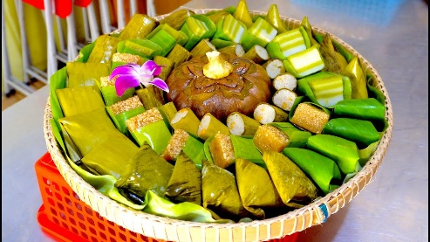

Recipes Page:
- Categorized by ingredients (meats, vegetables, fruits, desserts)
- Each category shows clickable images that lead to global recipes
- Example: Clicking on “Chicken” shows dishes like Teriyaki Chicken (Japan), Butter Chicken (India), Chicken Adobo (Philippines), etc.

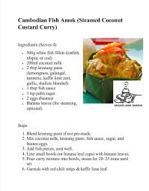

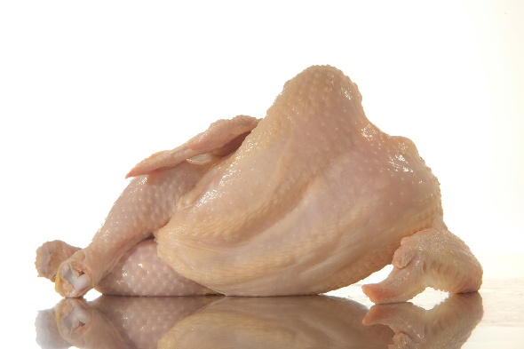

About Me Page:
- Name: Johny Suy
- Create a form for premium subscriptions(Include the cost too. Etc 20$/year)

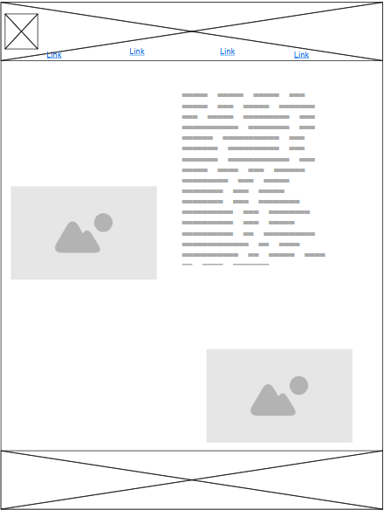
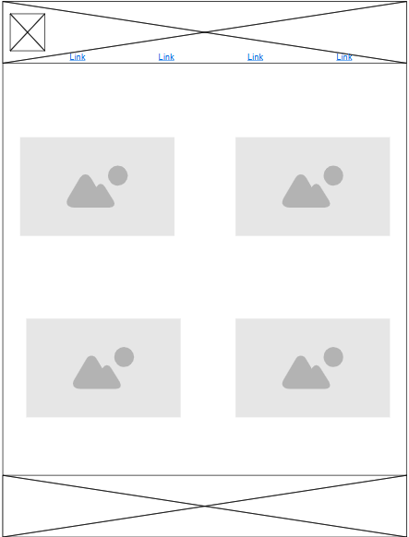
Wireframes

Home

