Analysis of Backtest

Strategy: long with entire portfolio when 2 days rolling average is over 185 days moving average, short entire portfolio otherwise

### AAPL Moving Average 2-185 Crossover Strategy from 2002-10-17 to 2018-01-01 (in sample):

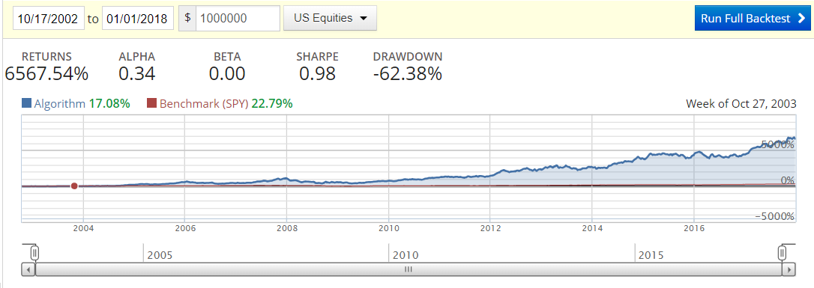

* As we can see from the backtest, performance of our strategy within the research timeframe (2002-10-17 to 2018-01-01, in sample backtest) is outstanding, which is the direct result of the exhaustive research exploring the best performance scenario over all combinations of time windows within 300
* Pretty significant alpha, and no beta, decent Sharpe Ratio, meaning though the strategy captures good alpha, there’s also a good amount of risk
* This is to confirm that the research did yield a strategy that is optimal for the specific time frame
* We next explore the out of sample scenario and try to see if the strategy still works on same asset out of sample and cross asset

### AAPL Moving Average 2-185 Crossover Strategy from 2018-01-01 to 2018-09-17 (out of sample):

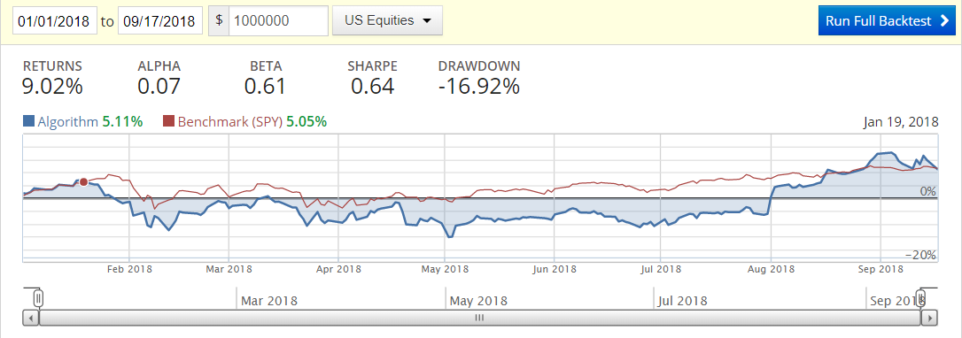

* Significantly worst return than the in-sample backtest, but eventually still positive, however draw down and risk is too much for an actual investment strategy
* Alpha in this backtest is much lower and is more correlated with the market, Sharple ratio is also much lower, meaning the characteristics from the in-sample backtest performance did not get transferred to this out of sample backtest
* In conclusion, this strategy does not work well in the out of sample scenario of the same asset

### MSFT Moving Average 2-185 Crossover Strategy from 2002-10-17 to 2018-09-17 (out of sample):

* Cross asset(MSFT) out of sample backtest performs much worst and the strategy is virtually unusable
* None of the statistics get transferred in this backtest, a complete failure

### Conclusion:

* This particular strategy only works in sample for AAPL stock only and performs poorly out of sample in any case
* When looking for a strategy, we much need to be able to generalize it and avoid overfitting and allow the strategy to work out of sample, otherwise it’ll be meaning less even if it has high yield in-sample