
HYT GLOBAL INSTITUTE
Learning Management System
HYTech Learning Management System
User Manual
Super Admin · Trainer · Trainee
A step-by-step guide to every screen, field, and permission in the system
Version 1.0 | October 2026 | Document code HGI-LMS-UM-001

Prepared for | HYT Global Institute — Training Operations
Prepared by | Documentation Team
Applies to | HYTech LMS, build of 21 October 2026
Status | Released for review

Document Information
Item | Details
Document title | HYTech Learning Management System — User Manual
Document code | HGI-LMS-UM-001
Version | 1.0
Status | Released for review
Date issued | 21 October 2026
System name | HYTech Learning Management System (HYTech LMS)
Institution | HYT Global Institute
Intended readers | Super Admins, Trainers, Trainees, onboarding staff, IT support
Basis of content | Direct review of the application source code (routes, navigation, screens, and validation rules) as of the date of issue
Screenshots | Placeholders only — see the note in Section 3

Version History
Version | Date | Author | Summary of changes
0.1 | 21 October 2026 | Documentation Team | Initial outline and role inventory
1.0 | 21 October 2026 | Documentation Team | First complete release: all three role manuals, permissions matrix, troubleshooting, glossary

Review and Approval
Role | Name | Signature | Date
Prepared by | Documentation Team
Reviewed by | System Administrator
Approved by | Institution Head

Table of Contents
Right-click the field below and choose "Update Field" if the entries are not shown.
Document Information 2
Version History 2
Review and Approval 2
Table of Contents 3
1. Introduction 8
Document conventions 8
2. Purpose and Scope 9
2.1 Purpose 9
2.2 Scope — what this manual covers 9
2.3 Out of scope — what this manual does not cover 9
2.4 Assumptions 9
3. System Requirements 10
3.1 Device and browser 10
3.2 Accounts and credentials 10
3.3 Network and email 10
3.4 Supported file types for learning materials 10
4. How to Access the System 11
4.1 Web address 11
4.2 First-time access (trainers and trainees) 11
4.3 Self-registration (trainees only) 11
5. General Login and Logout Instructions 12
5.1 Signing in 12
5.2 Signing in with two-factor authentication (Super Admin) 12
5.3 Forgot password 12
5.4 Signing out 13
5.5 Changing your password (while signed in) 13
5.6 Reading the dashboard layout 13
6. Super Admin User Manual 15
6.1 Understanding the Super Admin workspace 15
6.2 The Dashboard 15
6.3 Managing trainee accounts 16
6.3.1 Creating a trainee account 16
6.3.2 Viewing a trainee's record 17
6.3.3 Editing a trainee 17
6.3.4 Deleting a trainee 17
6.3.5 Searching the directory 17
6.4 Managing trainer accounts 17
6.4.1 Creating a trainer account 18
6.4.2 Handling "Awaiting activation" 18
6.4.3 Viewing, editing, and deleting a trainer 18
6.4.4 Assigning a trainer to a program 18
6.5 Managing courses (training programs) 19
6.5.1 Creating a course 19
6.5.2 Opening and editing a course 19
6.5.3 Deleting a course 19
6.6 Reviewing competencies 20
6.7 Reviewing lessons, quizzes, and exams 20
6.8 Processing enrollment applications 20
6.8.1 Approving an application 21
6.8.2 Rejecting or cancelling 21
6.8.3 Marking a program complete 21
6.8.4 Recording a full payment from the enrollment record 21
6.8.5 Changing status with the status chips 21
6.9 Managing class schedules 22
6.9.1 Creating a schedule 22
6.9.2 Editing, copying the link, and deleting 22
6.10 Monitoring attendance 22
6.11 Recording payments (Accounting) 23
6.11.1 Recording a payment 23
6.12 Reports and analytics 23
6.13 Trainer feedback (read, correct, export) 24
6.13.1 Reading one submission 24
6.13.2 Correcting a submission 25
6.13.3 Exporting feedback to CSV 25
6.14 Announcements 25
6.14.1 Creating an announcement 25
6.14.2 Editing, pinning, and deleting 26
6.15 System settings 26
6.15.1 Institution Information 26
6.15.2 Assessment Thresholds 26
6.15.3 System Preferences 26
6.15.4 System Information 27
6.15.5 Data Management 27
6.16 Account security and two-factor authentication (MFA) 27
6.16.1 Turning MFA on for the first time 27
6.16.2 Turning MFA off 27
6.17 Changing your own password 27
6.18 Troubleshooting for Super Admins 28
7. Trainer User Manual 29
7.1 Understanding the Trainer workspace 29
7.2 The Dashboard 29
7.3 Viewing assigned courses 30
7.4 Viewing enrolled trainees 30
7.5 Creating and managing lessons 30
7.5.1 Creating a lesson 30
7.5.2 Adding learning materials 31
7.5.3 Editing and deleting a lesson 31
7.6 Creating and managing quizzes 31
7.6.1 Creating a quiz 31
7.6.2 Editing and deleting a quiz 32
7.7 Creating and managing exams 32
7.8 Handling quiz access requests 33
7.9 Managing class schedules 33
7.9.1 Creating a session 33
7.9.2 Session actions 33
7.10 Recording attendance 34
7.11 Evaluating trainee performance 34
7.12 Reviewing typing test results 35
7.13 Monitoring trainee progress 35
7.14 Posting announcements 36
7.15 Updating your profile and password 36
7.16 Troubleshooting for Trainers 36
8. Trainee User Manual 37
8.1 Understanding the Trainee workspace 37
8.2 The Dashboard 37
8.3 Viewing your courses 38
8.4 Enrolling in a program 38
8.5 Studying a lesson and downloading materials 39
8.6 Taking a quiz 40
8.7 Taking an exam 40
8.8 Requesting late access or a retake 41
8.9 Viewing class schedules 41
8.10 Viewing your attendance 41
8.11 Viewing grades and results 42
8.12 Taking the typing test 42
8.13 Submitting trainer feedback 42
8.14 Making a payment 43
8.15 Reading announcements 44
8.16 Updating your profile and password 44
8.17 Troubleshooting for Trainees 44
9. Role-Based Permissions and Access Comparison 45
9.1 Master permissions table 45
9.2 Features available to all roles 46
9.3 Features exclusive to the Super Admin 46
9.4 Features exclusive to the Trainer 46
9.5 Features exclusive to the Trainee 47
9.6 Features that depend on assignment or status 47
10. Common Errors and Troubleshooting 48
10.1 How to troubleshoot in general 48
10.2 Message index 48
10.3 Symptom-based troubleshooting 49
10.4 When an expected option is unavailable 49
11. Security Guidelines and Best Practices 50
11.1 Passwords 50
11.2 Two-factor authentication 50
11.3 Shared and public computers 50
11.4 Phishing and impersonation 50
11.5 Handling trainee and trainer data 50
11.6 Account lifecycle 50
11.7 Device hygiene 51
12. Frequently Asked Questions 52
13. Glossary of Terms 54
14. Support and Contact Information 55
14.1 Who to contact 55
14.2 What to include in a support request 55
14.3 Service expectations 55
15. Appendix A — Screenshot Checklist 56
16. Appendix B — Items To Be Confirmed 58
16.1 Features intentionally absent from this manual 58

1. Introduction
The HYTech Learning Management System (LMS) is the web portal of HYT Global Institute for planning, delivering, and tracking training programs. It replaces paper class records and scattered spreadsheets with one shared workspace.
The system has three roles, and each role sees a different menu:
Role | Who they are | Main responsibility
Super Admin | The institution's system owner or administrator | Creates accounts, sets up programs, approves enrollments, monitors the whole institution, and is the only role that can read trainee feedback
Trainer | The person who teaches a program | Builds lessons and assessments, schedules classes, records attendance, evaluates trainees, and monitors progress
Trainee | The learner | Enrolls, studies lessons, takes quizzes and exams, checks grades and attendance, pays fees, and submits trainer feedback

Everything a user can see is controlled by their role and, for trainers, by which programs are assigned to them. A trainer cannot open a program they are not assigned to, and a trainee cannot open a program they are not enrolled in.
Note The system uses the words program and course for the same thing. The menu calls the module Courses, while records inside it are called training programs. This manual uses both terms interchangeably and always means the same record.

Document conventions
Style | Meaning
Bold | A menu item, button, tab, field label, or page name exactly as it appears on screen
Monospace | Text you type, a value, or a file name
1. 2. 3. | Steps that must be done in order
> Note | Extra information that helps you understand the step
> Tip | A faster or safer way to do something
> Warning | Something that cannot be undone, or that affects other users
To Be Confirmed (TBC) | The system does not currently define this, or the answer depends on your institution's setup

2. Purpose and Scope

2.1 Purpose
This manual helps a first-time user operate the system without constant help from an administrator. It explains:
• what each role can and cannot do;
• where each feature is located in the menu;
• which fields must be filled in, and in what format;
• what confirmation appears when an action succeeds;
• what to do when an action fails.

2.2 Scope — what this manual covers
• Signing in, signing out, first-time account setup, password reset, and two-factor authentication.
• All Super Admin screens: dashboard, trainees, trainers, courses, competencies, lessons, quizzes, exams, enrollment, schedules, attendance, accounting, reports, trainer feedback, announcements, and system settings.
• All Trainer screens: dashboard, courses, trainees, lessons, quizzes, exams, schedules, attendance, evaluations, typing tests, progress monitoring, and announcements.
• All Trainee screens: dashboard, courses, lessons, quizzes, exams, schedules, attendance, grades, typing test, trainer feedback, enrollment, payments, announcements, and profile.

2.3 Out of scope — what this manual does not cover
• Server installation, database migration, and deployment. These are covered in the technical documentation docs/BACKEND.md and docs/FEEDBACK_AND_TIMERS.md.
• Institutional policy on grading, fees, or scholarship eligibility.
• Email server configuration.
• Payroll, HR, or accounting systems outside this portal.

2.4 Assumptions
This manual assumes that:
1. Your institution has a working deployment of the system and a valid web address.
2. Your account has already been created by the Super Admin (trainers and trainees) or provisioned during system setup (Super Admin).
3. You have a stable internet connection and a modern web browser.
4. Your institution uses the default assessment thresholds unless your Super Admin has changed them: passing score 75%, typing test passing rate 40%, attendance requirement 80%.
If any of these is not true, contact your Super Admin before following the steps in this manual.

3. System Requirements

3.1 Device and browser
Item | Minimum | Recommended
Device | Desktop or laptop | Desktop or laptop (mobile works but tables are easier on a wide screen)
Screen width | 1024 px | 1366 px or wider
Browser | Current version of Chrome, Edge, Firefox, or Safari | Latest Chrome or Edge
JavaScript | Must be enabled | Enabled
Internet | Required at all times | Wired or stable Wi-Fi
PDF reader | Required to open downloadable materials | Any built-in viewer

Note There is nothing to install. The system runs in the browser.

3.2 Accounts and credentials
Requirement | Who needs it
Institutional email address | All roles — this is your login name
Password rated Good or higher | All roles
Access to the email inbox | Trainers and trainees (to open the activation link), anyone resetting a password
Authenticator app (Google Authenticator, Microsoft Authenticator, Authy, etc.) | Super Admin, when two-factor authentication is switched on

3.3 Network and email
• The portal must be reachable from your network. If the page does not load at all, ask your IT contact whether the site is blocked.
• Activation and password-reset emails are sent by the system. If they do not arrive, check the Spam or Junk folder first.

3.4 Supported file types for learning materials
Trainers can attach materials to a lesson in two ways: by uploading a file or by pasting a link. Uploaded files are stored with the lesson record, so keep them small (a few megabytes at most). Large files should be placed in your institution's shared drive and added as a link instead.

4. How to Access the System

4.1 Web address
1. Open your browser.
2. Type the portal address provided by your institution.
3. Press Enter.
Note — To Be Confirmed The production web address is deployment-specific and is not stored inside the application. Ask your Super Admin or IT contact for the exact URL, then write it here for your records: Institution portal URL: https://hytech-learning-management-portal-qt64.vercel.app/
The first screen you see is the Sign in page.
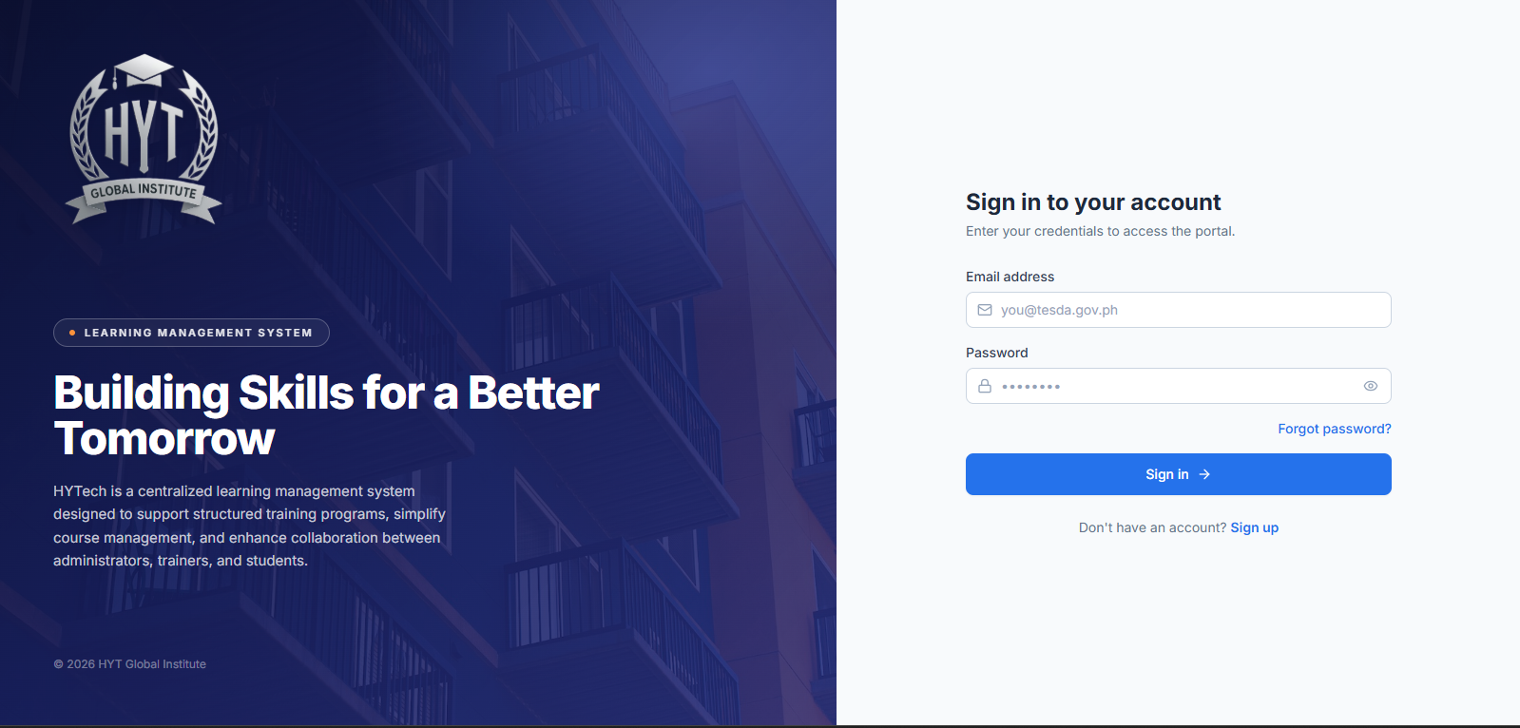
Caption: Sign-in page of the HYTech LMS.
What to look for: (1) the institution logo and the tagline panel on the left; (2) the Email address field; (3) the Password field with the eye icon that shows or hides what you typed; (4) the Forgot password? link; (5) the Sign in button; (6) the Sign up link at the bottom, which is for trainees who do not yet have an account.

4.2 First-time access (trainers and trainees)
New trainer and trainee accounts are created by the Super Admin. The system does not issue a temporary password. Instead:
1. The Super Admin creates your account and enters your email address.
2. The system sends you an activation email containing a secure link.
3. You open the link and land on the Account setup page.
4. You create your own password (rated Good or higher) and confirm it.
5. You are taken straight to your dashboard — no second sign-in needed.
Warning The activation link can only be used once and expires. If it has expired, the page shows "This link is invalid or has expired." Ask your Super Admin to resend the invitation, then open the newest email. Older links will not work.

4.3 Self-registration (trainees only)
If your institution allows public registration, a person can create a trainee account from the Sign up page.
1. On the Sign in page, click Sign up.
2. Complete First Name, Last Name, Email, Contact Number, Password, Confirm Password, Date of Birth, Profile Picture (optional), and Address.
3. Tick the agreement box for the Terms and Conditions and Privacy Policy.
4. Click Create Account.
5. The message "Account created successfully! You can now sign in." appears and you are returned to the Sign in page.
Note Self-registration creates a trainee account only. Trainer and Super Admin accounts are always created by the administrator.

5. General Login and Logout Instructions
These steps are the same for all three roles. After signing in, the system opens the dashboard that belongs to your role.

5.1 Signing in
1. Open the portal address in your browser.
2. In Email address, type the email address registered to your account.
3. In Password, type your password. Click the eye icon to check what you typed if needed.
4. Click Sign in.
5. Wait for the page to load. A green message "Welcome back, [First name]!" confirms success.
6. You land on:
– Super Admin → Dashboard at /admin
– Trainer → Dashboard at /trainer
– Trainee → Dashboard at /trainee
If sign-in fails: a red message appears under the Password field. Check for a mistyped email, a stuck Caps Lock, or an extra space copied with the password. If the message says the credentials are invalid, use Forgot password?.
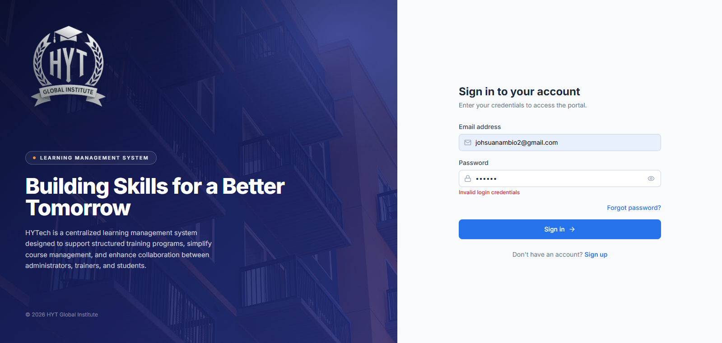Caption: A failed sign-in.
What to look for: the red error text directly below the Password field. The form does not clear your email address, so you only need to retype the password.

5.2 Signing in with two-factor authentication (Super Admin)
If your Super Admin account has two-factor authentication switched on, a second step appears after the password.
1. Complete Email address and Password, then click Sign in.
2. The page changes to Two-factor authentication.
3. Open your authenticator app and read the current 6-digit code.
4. Type the code in Verification code. The field accepts digits only and stops at six.
5. Click Verify & sign in.
6. You land on the Super Admin dashboard.
Tip The code changes every 30 seconds. If it is rejected, wait for the next code and try again.
Note Clicking Use a different account returns you to the email and password step without closing the browser.

5.3 Forgot password
1. On the Sign in page, click Forgot password?.
2. In the Reset your password dialog, type the email address of your account.
3. Click Send reset link.
4. The message "If an account exists for that email, a reset link is on its way." appears. For security, the system shows the same message whether or not the address exists.
5. Open the email and click the reset link.
6. On the Choose a new password page, type your new password. It must be rated Good or higher.
7. Re-type it in Confirm new password.
8. Click Update password.
9. The message "Your password has been updated. Please sign in." appears and you are returned to the Sign in page.
10. Sign in with your new password.
Warning A reset link that is opened after it expires shows "This reset link is invalid or has expired." Request a new one from the Sign in page.

5.4 Signing out
1. Click your name or avatar at the top-right corner of any dashboard.
2. In the menu, click Sign out.
3. You are returned to the Sign in page.
Tip Always sign out on a shared or laboratory computer. Closing the browser tab alone may leave your session active.

5.5 Changing your password (while signed in)
1. Open your profile: top-right menu → My Profile.
2. Scroll to the Account Security card.
3. In Current Password, type the password you used to sign in.
4. In New Password, type the new password. The strength meter must read Good, Strong, or Very strong.
5. In Confirm New Password, type it again.
6. Click Update Password.
7. The fields clear, which confirms the change. Use the new password the next time you sign in.
Note If the new password is rated below Good, or the two entries do not match, a red message explains the problem and nothing is changed.

5.6 Reading the dashboard layout
Every role shares the same layout:
Area | Location | What it does
Sidebar | Left edge | Role-specific menu, grouped under headings (Overview, People, Curriculum, Operations, Administration for the Super Admin)
Menu toggle | Top-left | Opens or closes the sidebar; on small screens it opens the menu as an overlay
Page title | Top of the content area | Names the page you are on, with a short description and the main action button on the right
Notification bell | Top-right | Alerts relevant to your account
User menu | Top-right | My Profile and Sign out
Toast messages | Bottom-right | Green = success, red = error, amber = warning, blue = information

Super Admin Account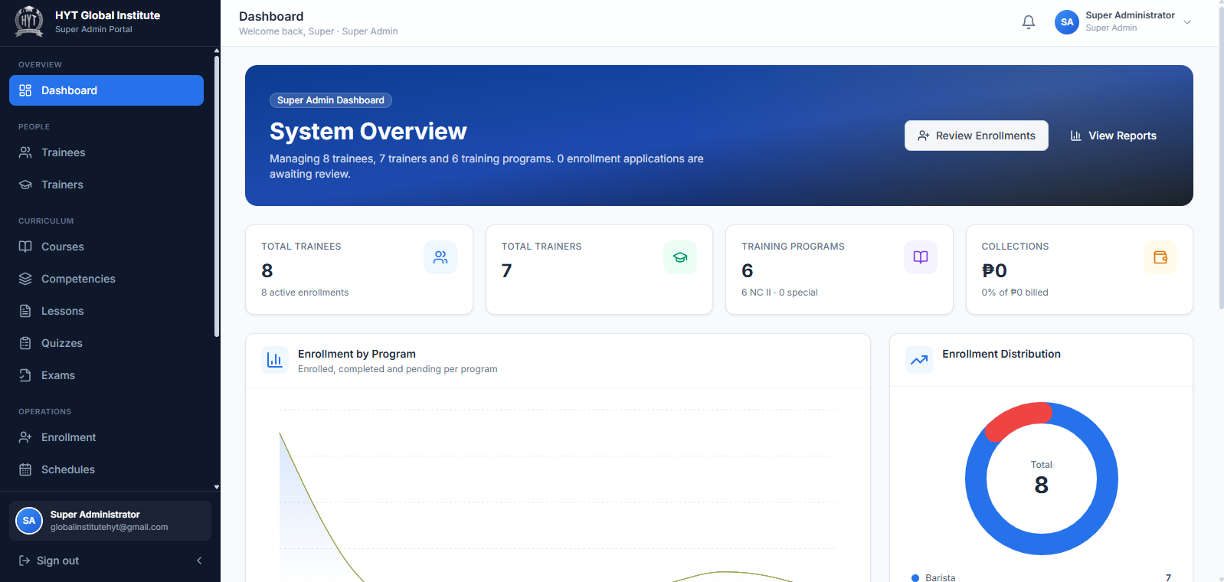

Trainer
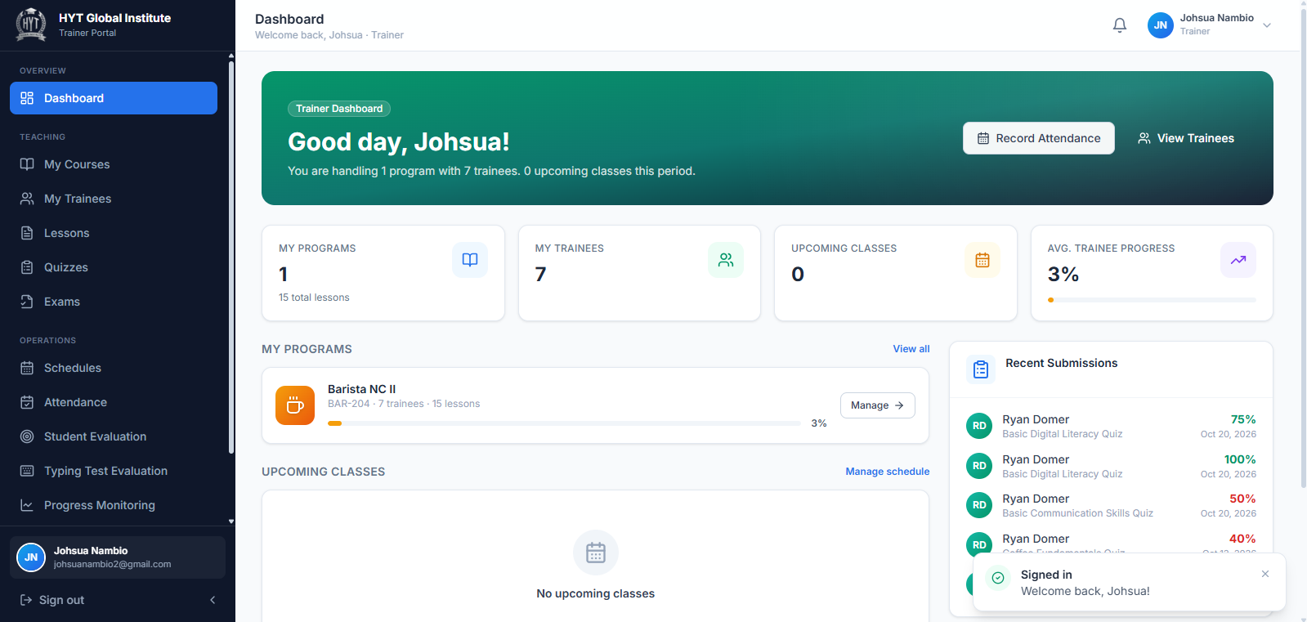
Trainee
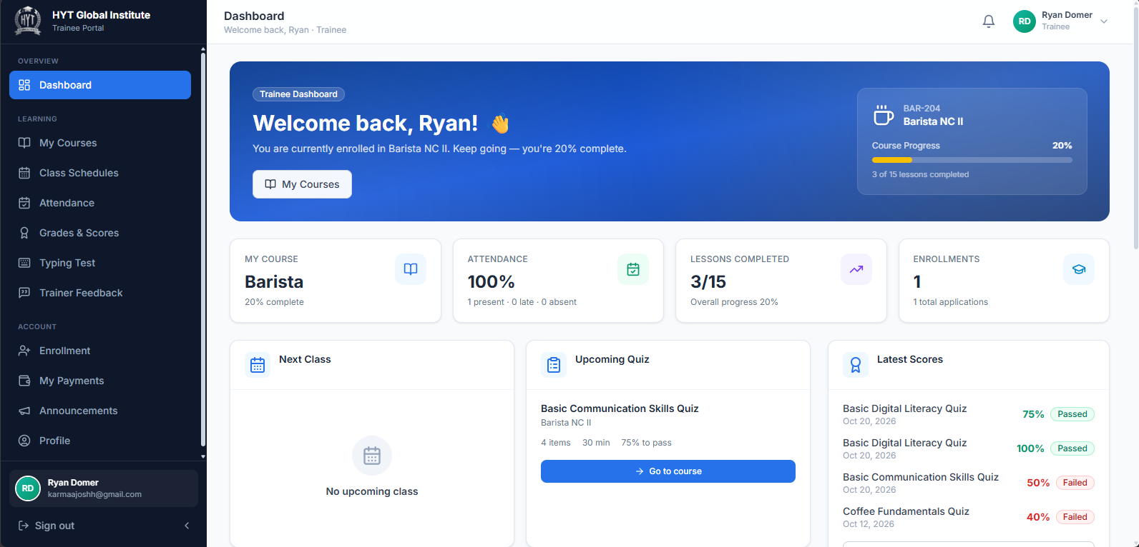
Caption: The shared layout used by all three roles.
What to look for:
(1) the grouped sidebar
(2) the page title and description
(3) the primary action button on the right of the title
(4) the bell icon
(5) the user menu with My Profile and Sign out.

6. Super Admin User Manual
The Super Admin is the highest role in the system. Only the Super Admin can create trainer and trainee accounts, set up courses, approve enrollments, view institution-wide reports, and read trainee feedback about trainers.
Note The system stores the Super Admin role internally as admin, but every screen labels it Super Admin. Treat the two names as identical.

6.1 Understanding the Super Admin workspace
After signing in you land on /admin. The sidebar contains five groups:
Group | Menu item | Opens
Overview | Dashboard | Institution summary and recent activity
People | Trainees | Trainee directory, accounts, program assignments
People | Trainers | Trainer directory, accounts, program assignments
Curriculum | Courses | Training programs (courses)
Curriculum | Competencies | Competency structure per program (read-only)
Curriculum | Lessons | Lesson library across all programs (read-only)
Curriculum | Quizzes | Quiz bank across all programs (read-only)
Curriculum | Exams | Exam registry across all programs (read-only)
Operations | Enrollment | Review and process applications
Operations | Schedules | Class schedules for all programs
Operations | Attendance | Attendance monitoring across all programs
Operations | Accounting | Fees, payments, and balances
Administration | Reports | Analytics and CSV export
Administration | Trainer Feedback | Trainee feedback about trainers
Administration | Announcements | Post and manage announcements
Administration | System Settings | Institution details, thresholds, preferences, MFA

Tip The sidebar collapses on narrow screens. Use the menu icon at the top-left to open it.

6.2 The Dashboard
The dashboard is a read-only overview. Nothing on this page changes data.
What you see
1. Four summary cards at the top:
– Total Trainees — number of trainee accounts.
– Total Trainers — number of trainer accounts.
– Training Programs — number of courses.
– Collections — total amount collected from paying trainees.
2. Enrollment by Program — a bar chart comparing enrolled, completed, and pending counts per program.
3. Enrollment Distribution — a donut chart of enrollment statuses.
4. Recent Enrollment Applications — the newest applications, with status badges.
5. System Health — two progress bars: Overall attendance and Fee collection rate.
6. Latest Announcements — the most recent posts.
Actions on this page
1. Click Review Enrollments to jump to the Enrollment page.
2. Click View Reports to jump to Reports & Analytics.
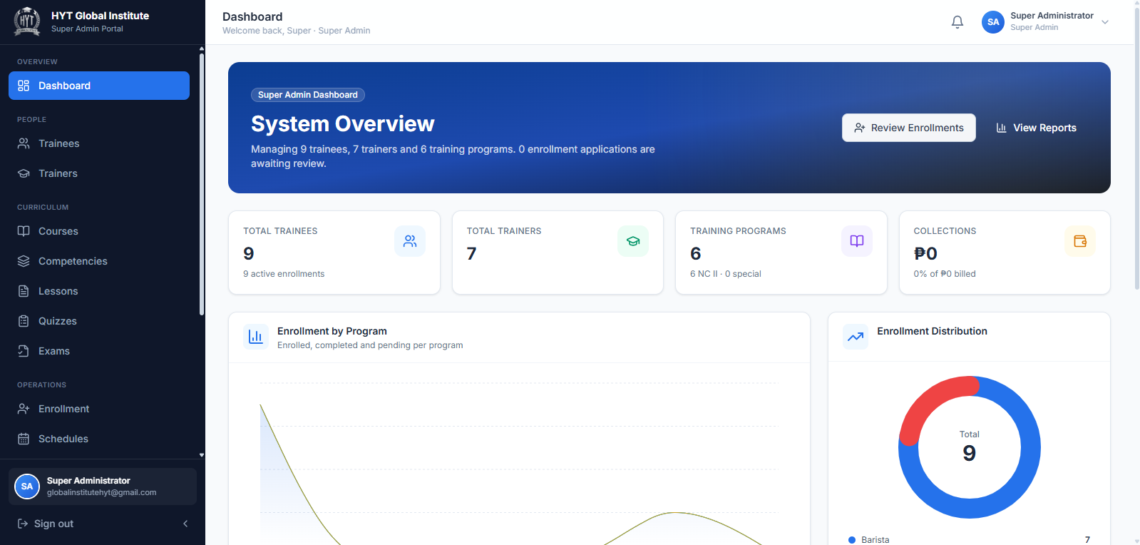
Caption: Super Admin dashboard.
What to look for: (1) the four summary cards across the top
(2) the Enrollment by Program bar chart
(3) System Health with its two progress bars
(4) Recent Enrollment Applications
(5) the Review Enrollments and View Reports buttons in the page header.

6.3 Managing trainee accounts
Open Trainees in the sidebar.
What the page shows
• Three cards: Total Trainees, With Active Enrollment, Avg Progress.
• A searchable Trainee Directory table with columns: Trainee (name and email), Programs, Trainer, Progress, Attendance, Enrolled Since, and row actions.

6.3.1 Creating a trainee account
1. Click Add Trainee (top-right).
2. In the Add New Trainee dialog, complete:
Field | Required | Notes
Full Name | Yes | As it should appear on records
Email Address | Yes | Becomes the login name; the activation email is sent here
Phone Number | No | Must be exactly 11 digits if entered
Date of Birth | No | Date picker
Gender | No | Male / Female
Education | No | Defaults to High School Graduate
Address | No | Free text
Program Assignments | No | Tick each program the trainee should take

3. For every program you tick, choose a trainer in the drop-down beside it.
4. Click Create Trainee.
5. A Trainee account created dialog appears. Read the green or amber banner:
– Green: "An activation email has been sent. The trainee will create their OWN password from the link…"
– Amber: "Account created, but the activation email could not be sent. Check the email/SMTP settings, then resend it below."
6. If the email failed, click Resend email.
7. Click Done.
Warning A program can only be assigned together with a trainer. If you tick a program that has no trainer assigned, the system stops you with "Select a trainer for: [program]. Uncheck any course with no assigned trainer." Assign a trainer to that course first (Section 6.4), or untick the course.
Note There is no temporary password to give out. The trainee chooses their own password from the email link. Assigning programs also creates the trainee's enrollments, so the assigned programs immediately appear as their courses.

6.3.2 Viewing a trainee's record
1. In the row, click the eye icon.
2. The detail dialog shows attendance rate, progress, number of programs, contact details, education, and the list of enrollments with their statuses.
3. Click Close.

6.3.3 Editing a trainee
1. Click the pencil icon in the row.
2. Change any field, including program assignments and the trainer per program.
3. Click Save Changes.
Note Editing reconciles the trainee's courses with the ticked programs. Unticking a program removes that course from the trainee's assignments; existing enrollment records are kept for audit.

6.3.4 Deleting a trainee
1. Click the trash icon.
2. Read the confirmation: "[Name] and their account will be permanently removed."
3. Click Delete to confirm, or close the dialog to cancel.
Warning Deleting an account cannot be undone. If a trainee has simply finished training, do not delete the account — their completion record and feedback history would be lost.

6.3.5 Searching the directory
Type a name or email in the search box above the table. The table filters as you type. Use the column headers to sort, and the paging controls under the table to move between pages (10 rows per page).
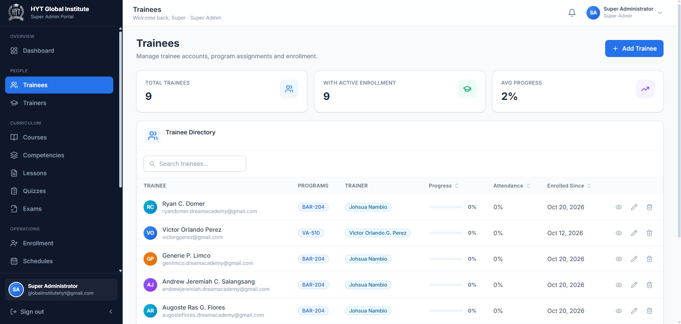

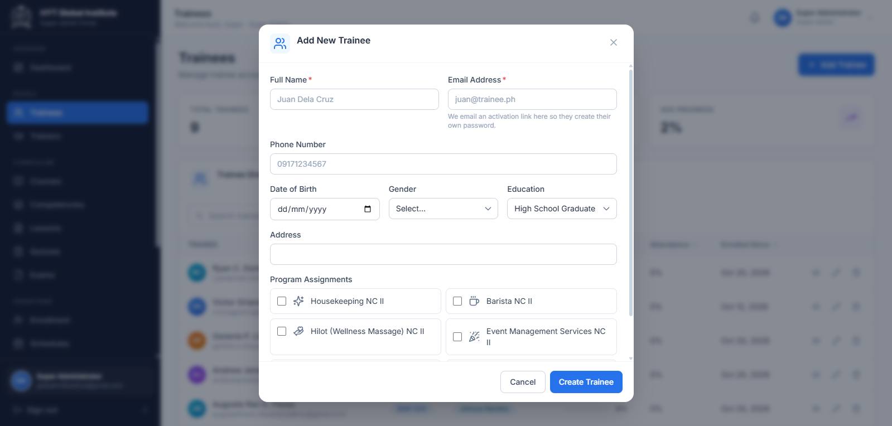
Caption: Trainee management.
What to look for:
(1) the three summary cards
(2) the search box
(3) the eye, pencil, and trash icons at the end of each row
(4) the Add Trainee button
(5) inside the dialog, the Program Assignments section where each ticked program needs a trainer.

6.4 Managing trainer accounts
Open Trainers in the sidebar.
What the page shows
• Cards: Total Trainers, Programs Assigned, Avg Rating (with a hint showing how many trainers have been rated).
• A Trainer Directory table: Trainer (name, position, and an Awaiting activation badge when relevant), Assigned Programs, Trainees, Rating (stars and count), Since, and row actions.

6.4.1 Creating a trainer account
1. Click Add Trainer.
2. Complete:
Field | Required | Notes
Full Name | Yes
Email Address | Yes | Login name; activation email is sent here
Phone Number | No | Exactly 11 digits if entered
Position | No | For example Trainer / Assessor
Specialization | No | For example Housekeeping NC II
Address | No
Assigned Programs | No | Tick every program this trainer will handle

3. Click Create Trainer.
4. The Trainer account created dialog appears. If the banner is amber, click Resend email.
5. Click Done.
Note A trainer's Rating is never typed in by an administrator. It is calculated automatically from the star ratings that trainees submit after completing a program.

6.4.2 Handling "Awaiting activation"
A trainer who has not yet opened the invitation email shows an amber Awaiting activation badge.
1. Find the row with the badge.
2. Click the envelope icon at the end of the row. It only appears for accounts awaiting activation.
3. The message "Activation email sent to [email]." confirms the resend.

6.4.3 Viewing, editing, and deleting a trainer
1. View: click the eye icon to see programs, trainee count, rating, contact details, specialization, and account status.
2. Edit: click the pencil icon, change details or tick/untick Assigned Programs, then click Save Changes.
3. Delete: click the trash icon, read the warning, and click Delete.
Warning Unticking a program removes the trainer from that course. Trainees already assigned to that trainer keep their enrollment but lose their trainer link for that program until a new trainer is assigned.

6.4.4 Assigning a trainer to a program
There are two equivalent routes:
• From the trainer record: Trainers → pencil icon → tick Assigned Programs → Save Changes.
• From the course record: Courses → open a course → Edit → change Assigned Trainer → Save Changes.
Tip A program can have more than one qualified trainer. The trainer a trainee actually belongs to is chosen per trainee in Trainees → Program Assignments.
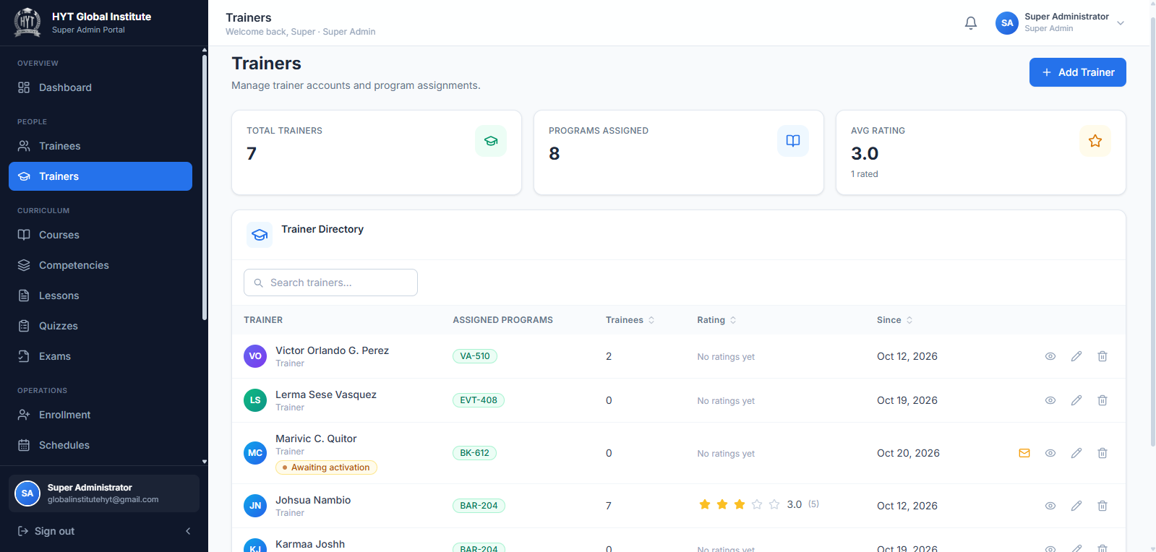Caption: Trainer management, including activation status.
What to look for: (1) the Awaiting activation badge under a trainer's name; (2) the envelope icon that resends the invitation; (3) the Rating column showing stars and the number of ratings; (4) the Avg Rating card.

6.5 Managing courses (training programs)
Open Courses in the sidebar. Cards show Total Programs, Total Lessons, Total Enrollments. Below them is the course list with search and filters.

6.5.1 Creating a course
1. Click Add Course.
2. Complete the form:
Field | Required | Notes
Course Title | Yes | For example Bread and Pastry Production NC II
Course Code | Yes | Short code, for example BP-201
Category | Yes | Free text, for example Tourism & Hospitality
Level | Yes | NC level or equivalent
Training Fee (₱) | Yes | Used by Accounting and self-pay enrollment
Duration | Yes | For example 3 months
Total Hours | Yes | Numeric
Assigned Trainer | No | The trainer who owns the course
Description | No | Short text shown to trainees

3. Click Create Course.
4. The new course appears in the list.
Note A new course starts empty. Add lessons, quizzes, and exams afterwards from the Trainer account, or review what exists in the read-only Curriculum pages.

6.5.2 Opening and editing a course
1. Click a course card or row.
2. The detail dialog shows the course banner (title, code, category, duration, hours), the overview text, and key values: Trainer, Training Fee, Lessons, Quizzes, plus the competency structure and admission requirements.
3. Click Edit, change the values, and click Save Changes.

6.5.3 Deleting a course
1. Open the course.
2. Click Delete in the dialog header area.
3. Confirm with Delete course.
Warning Deleting a course removes it from the catalogue. Trainees who were enrolled in it lose access to its lessons and assessments. Prefer leaving a finished course in place.
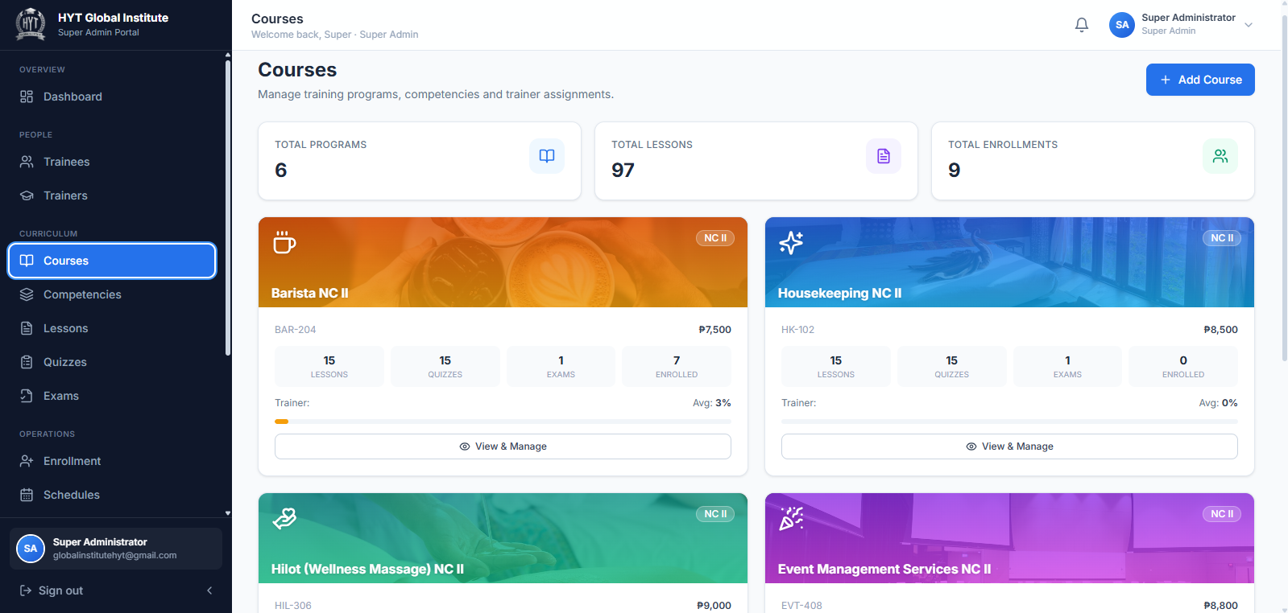

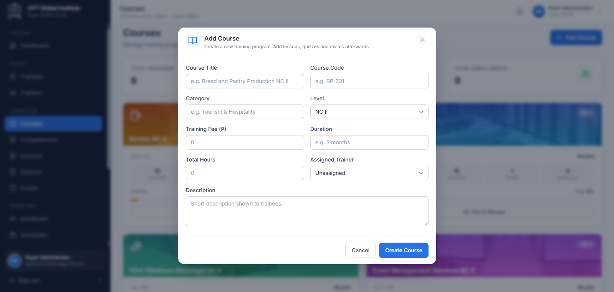
Caption: Course (training program) management.
What to look for: (
1) the summary cards
(2) the Add Course button
(3) the field group that defines fee, duration, and hours
(4) the Assigned Trainer selector.

6.6 Reviewing competencies
Open Competencies.
• Cards: Competency Groups, Total Lessons, Total Quizzes.
• Each program is listed with its competency groups and the lessons and quizzes attached to each group.
Note This page is read-only for the Super Admin. Competencies, lessons, quizzes, and exams are authored by trainers inside their assigned programs.

6.7 Reviewing lessons, quizzes, and exams
These three pages are institution-wide registries. They are read-only.
Page | Cards | Table
Lessons | Total Lessons, Core Lessons, With Materials | Lesson Library — lesson, program, competency, materials, order
Quizzes | Total Quizzes, Total Attempts, Avg Score | Quiz Bank — quiz, program, questions, time limit, passing score, attempts
Exams | Total Exams, Attempts, Avg Score | Exam Registry — exam, program, questions, time limit, passing score, exam date

1. Type in the search box to find a record by title or program.
2. Read the row. There are no edit or delete controls on these pages.
Note If a lesson, quiz, or exam needs a change, ask the trainer assigned to that program. This separation is deliberate: the Super Admin oversees, the trainer authors.

6.8 Processing enrollment applications
Open Enrollment. Four cards summarise the pipeline: Pending Review, Enrolled, Completed, Rejected / Cancelled.
The page is divided into four tabs:
Tab | Contains
Pending Review | Applications with status Pending or Under Review
Enrolled | Status Approved or Enrolled
Completed | Status Completed
Rejected / Cancelled | Status Rejected or Cancelled

Each row shows the trainee, program, type (Scholarship or Self-Pay), payment status, applied date, status, and a Review button.

6.8.1 Approving an application
1. Open the correct tab (usually Pending Review).
2. Find the application. Use Search by trainee… if the list is long.
3. Click Review.
4. Read the dialog: trainee, program, type, applied date, training fee, and — for scholarship applications — the voucher name, number, sponsor, and date; or — for self-pay applications — fee, amount paid, balance, reference number, and payment date.
5. Click Approve.
6. The status badge changes to Approved and the toast "Status updated to…" confirms the change.
Tip Use Mark Under Review while you are still checking documents. This keeps the application out of the "new" pile without approving it.

6.8.2 Rejecting or cancelling
1. Open the application.
2. For a new application, click Reject. For an approved or enrolled one, click Cancel.
3. Confirm in the dialog.
Warning A rejected or cancelled application blocks the trainee's access to that course and stops further payments on it. Reject only after the trainee has been informed.

6.8.3 Marking a program complete
Completion is normally automatic: when a trainee finishes every lesson and passes every quiz and exam, the system changes the enrollment to Completed on its own.
To complete an enrollment manually:
1. Open the application from the Enrolled tab.
2. Click Mark Completed.
3. Confirm the status badge changes to Completed.
Note A program with no lessons can never auto-complete. If a course has no content yet, use Mark Completed deliberately, or add the content first.

6.8.4 Recording a full payment from the enrollment record
1. Open a self-pay application with a remaining balance.
2. In the Payment Details block, click Record Full Payment.
3. The balance becomes zero and the payment status becomes Fully Paid.

6.8.5 Changing status with the status chips
Inside the review dialog there is an Update Status row with every status: Pending, Under Review, Approved, Enrolled, Completed, Rejected, Cancelled.
1. Click the chip for the status you need.
2. The current status is highlighted, and the toast confirms the update.
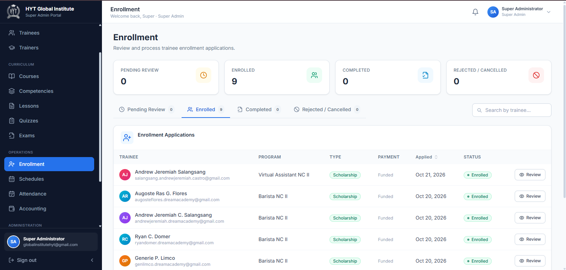Caption: Reviewing an enrollment application.
What to look for:
(1) the four tabs with counts
(2) the Review button at the end of each row
(3) the Update Status chips
(4) the Approve, Mark Under Review, and Reject buttons in the dialog footer
(5) the Record Full Payment button for self-pay applications.

6.9 Managing class schedules
Open Schedules. Cards show Total Sessions, Upcoming, Online / Hybrid. The Class Schedule table lists every session across all programs.

6.9.1 Creating a schedule
1. Click New Schedule.
2. Complete:
Field | Required | Notes
Program | Yes | Which course the session belongs to
Lesson / Session | Yes | The lesson or topic covered
Trainer | Yes | Who teaches it
Room / Venue | No | Room name or address
Date | Yes
Start Time | Yes
End Time | Yes | Must be after the start time
Class Type | Yes | Online, Face-to-Face, or Hybrid
Google Meet Link | For online classes | Paste the full meeting URL

3. Save the schedule.
4. If any required field is empty, the message "Please complete the required fields." appears and nothing is saved.
5. If the end time is not after the start time, the dialog Invalid schedule date/time appears. Correct the times and save again.

6.9.2 Editing, copying the link, and deleting
1. Edit: click Edit on the row, change values, save.
2. Copy Meet link: click Copy Meet link. The toast "Meeting link copied." confirms it is on your clipboard.
3. Delete: click Delete, read the confirmation, click Delete again.
Note Trainers can also create schedules, but only for their own programs. Sessions created by a trainer appear in this table immediately.

6.10 Monitoring attendance
Open Attendance. This page is read-only.
• Cards: Present, Late, Absent, Excused.
• Overall Attendance Rate and Attendance Rate by Program.
• Attendance Records table with trainee, program, session date, status, time in, and time out.
1. Use the table search to find a trainee.
2. Read the rate per program to spot a program with low attendance.
3. If a record looks wrong, ask the trainer of that session to correct it in Trainer → Attendance.

6.11 Recording payments (Accounting)
Open Accounting.
• Cards: Total Billed, Collected, Outstanding, Paying Trainees.
• Collections by Program chart: billed versus collected versus balance.
• Payment Records table: trainee, program, fee, paid, balance, status, and a Record Payment button.

6.11.1 Recording a payment
1. Find the trainee in Payment Records. Click Record Payment.
2. In the dialog, review Training Fee, Amount Paid, and Balance.
3. In Amount to Pay (₱), type the amount received.
4. Click Save Payment.
5. The paid amount increases, the balance decreases, and the status is recalculated automatically:
– balance is zero → Fully Paid
– some amount paid → Partially Paid
– nothing paid → Unpaid
Warning If the amount is empty or zero, the message "Enter a valid amount." appears and nothing is saved. An amount larger than the balance is capped at the balance, so a record can never be overpaid.
Tip For a payment that settles the whole balance at once, Enrollment → Review → Record Full Payment is faster.

6.12 Reports and analytics
Open Reports. This page combines every report in one place.
Filters (top of the page)
Filter | Effect
From date | Start of the reporting period
To date | End of the reporting period
Course | Limit to one program
Search | Match a course or trainer name
Export CSV | Download the current report as a spreadsheet file

Summary cards: Total Enrollments, Active Trainees, Attendance Rate, Total Revenue.
Charts: Enrollment by Course (approved, pending, completed) and Attendance Distribution.
Report tables
Report | Contents
Enrollment Report | Total, Pending, Approved, Completed, Rejected
Trainee Report | Total Trainees, Active, Avg Progress
Trainer Report | Total Trainers, Assignments
Attendance Report | Present, Late, Absent, Excused, Rate
Performance Report | Quiz Average, Exam Average, Completion, Passed, Failed
Accounting Report | Paid, Partially Paid, Unpaid, Outstanding

1. Set From date and To date to the period you need.
2. Optionally choose a Course or type in Search.
3. Read the cards and tables. They all reflect the same filters.
4. Click Export CSV to download lms-report-YYYY-MM-DD.csv. The toast "Report exported as CSV." confirms the download started.
Tip Export before you change the filters. The file always contains exactly what is on screen at the moment you click.
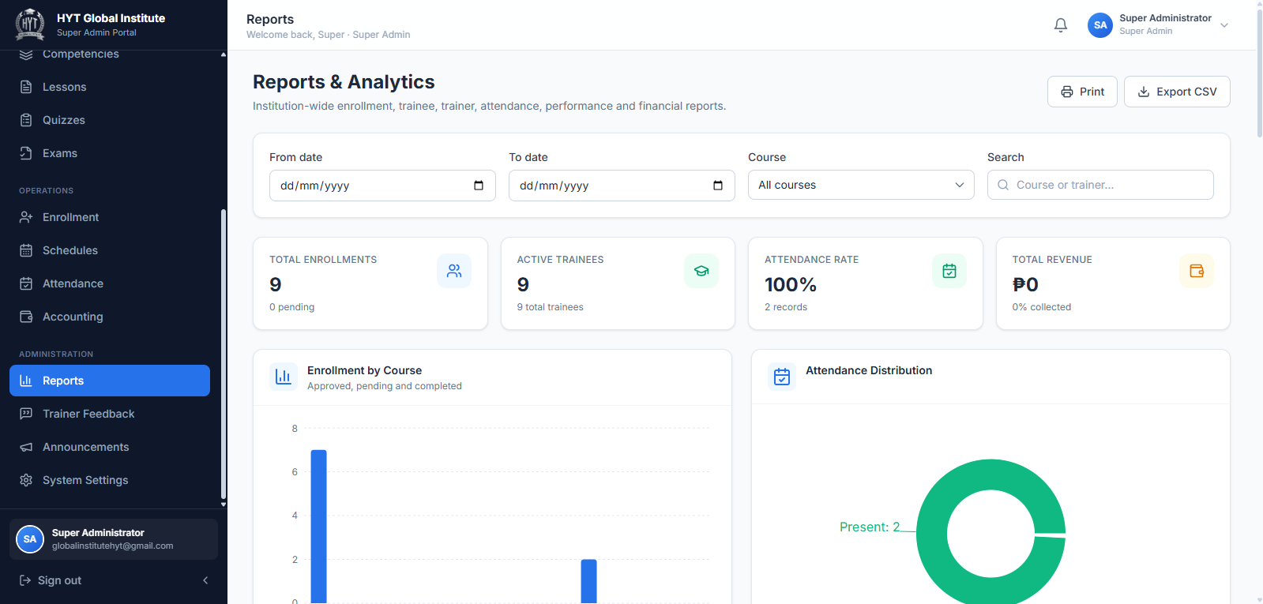Caption: Reports page with filters and the six report tables.
What to look for:
(1) the filter bar including From date, To date, Course, and Search
(2) the four summary cards
(3) the Export CSV button
(4) the separate report sections, each with its own mini statistics.

6.13 Trainer feedback (read, correct, export)
Open Trainer Feedback. This is the only place in the system where the written feedback trainees give about trainers can be read.
Note Trainers never see feedback about themselves — not the stars and not the text. Only the Super Admin can read it.
Filters
Filter | Purpose
Trainer | Show feedback about one trainer
Program | Show feedback for one program
Search | Find words in the feedback text
Submitted from / Submitted to | Date range
Apply filters | Run the query
Reset | Clear every filter

The table shows one row per submission with the trainee, trainer, program, date, and star rating. Pages hold 25 rows; use the paging controls to move on.

6.13.1 Reading one submission
1. Click View on a row.
2. The Feedback detail dialog shows:
– Feedback — the main written comment
– Learning experience
– Trainer strengths
– Areas for improvement
– Recommendation
– the star rating, and a note if the record was ever corrected
3. Click Close.

6.13.2 Correcting a submission
Use this only to fix a factual error (for example, a typo reported by the trainee). The original values are archived.
1. Click View on the row, then Correct feedback.
2. Edit the text fields. Feedback cannot be empty.
3. In Reason for correction, type why the change is being made. This field is required and is stored in the audit trail.
4. Click Save correction.
5. The message "Correction saved. The original values were kept in the revision history." confirms the change.
Warning Do not rewrite a trainee's opinion. A correction must preserve meaning; the reason field exists so the change can be reviewed later.

6.13.3 Exporting feedback to CSV
1. Apply the filters you need.
2. Click Export CSV.
3. The message "Export started. The download was recorded in the audit log." appears and the file downloads.
Note — two-factor authentication required Exporting feedback and saving corrections are protected operations. If two-factor authentication is not active on your session, the page shows an MFA notice instead of the data. Sign in with your authenticator code (Section 5.2) and try again. Every export is recorded in the audit log.
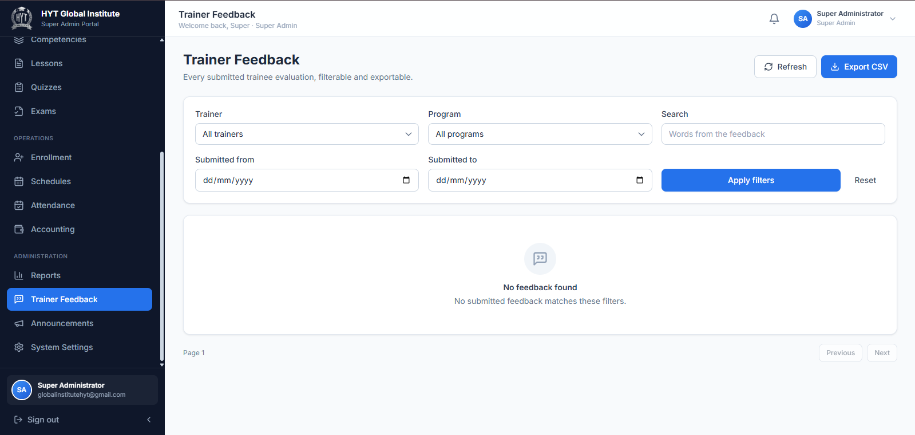Caption: Super Admin view of trainee feedback.
What to look for: (1) the filter row; (2) the star rating column; (3) the View button; (4) the Export CSV button in the header; (5) the MFA notice that appears when a second factor is required.

6.14 Announcements
Open Announcements. As Super Admin you can post to everyone.

6.14.1 Creating an announcement
1. Click New Announcement.
2. Complete:
Field | Required | Notes
Title | Yes
Message | Yes | The body of the announcement
Audience | Yes | Everyone, Trainees, or Trainers
Program (optional) | No | Limit to one program; leave All programs otherwise
Priority | Yes | High, Normal, or Low
Pin this announcement to the top | No | Keeps it above newer posts

3. Save. If the title or message is empty, "Title and body are required." appears.

6.14.2 Editing, pinning, and deleting
1. Use the row menu: Edit, Pin / Unpin, or Delete.
2. Deleting asks for confirmation with Delete.
Tip High-priority announcements are highlighted in red. Use them only for deadlines and urgent changes, otherwise people stop noticing them.

6.15 System settings
Open System Settings. Changes take effect only after you click Save Settings, which stays disabled until something is modified.

6.15.1 Institution Information
Field | Meaning
Institution Name | Shown on documents and reports
Academic Year | Current school year label

6.15.2 Assessment Thresholds
Field | Default | Effect
Default Passing Score (%) | 75 | Applied to quizzes and exams that do not set their own passing score
Typing Test Passing Rate (%) | 40 | Passing mark for the typing test
Attendance Requirement (%) | 80 | Attendance target used in monitoring

Warning Changing the default passing score affects how new assessments are interpreted. Agree the value with your academic head before changing it, and tell trainers.

6.15.3 System Preferences
Toggle | Effect when on
Allow online self-enrollment | Trainees can submit enrollment applications themselves
Email notifications | The system sends email notifications for enrollment and assessment updates
Maintenance mode | Restricts access for maintenance

Note — To Be Confirmed The visible effect of Maintenance mode in the current build has not been verified end to end. Test it outside working hours before relying on it.

6.15.4 System Information
A read-only count of records: Users, Trainees, Trainers, Programs, Enrollments, Attendance Records, Quiz Attempts, Typing Tests. Use it to confirm that data was created or removed as expected.

6.15.5 Data Management
The Reset All Data button restores the original demonstration dataset and discards changes.
Warning This button is intended for demonstration environments. On a live installation, do not use it without written approval and a verified backup. There is no undo.
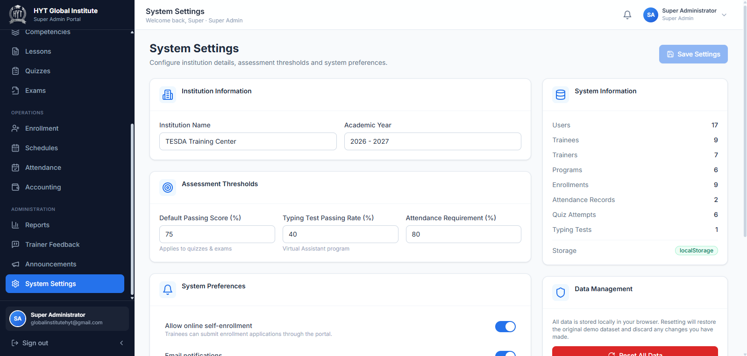Caption: System Settings page.
What to look for: (1) Institution Information; (2) the three threshold fields; (3) the preference toggles; (4) System Information counts; (5) Data Management with the red reset button; (6) the Two-factor authentication card.

6.16 Account security and two-factor authentication (MFA)
The Two-factor authentication card sits at the bottom of System Settings. It protects sensitive Super Admin actions — exporting feedback and saving feedback corrections — with a 6-digit code from an authenticator app.

6.16.1 Turning MFA on for the first time
1. Open System Settings and scroll to Two-factor authentication.
2. Switch the toggle on.
3. A QR code dialog opens. Scan it with your authenticator app (Google Authenticator, Microsoft Authenticator, Authy, or similar).
4. Type the 6-digit code shown in the app into the dialog.
5. Confirm.
6. The message "MFA enabled. You will be asked for a code on each sign-in." appears.

6.16.2 Turning MFA off
1. Switch the toggle off.
2. The system removes the authenticator factor and confirms "MFA disabled."
Warning Turning MFA off removes the second factor from every sensitive action. Only do this if you have lost the authenticator and cannot recover it, and switch it back on immediately afterwards.
Tip If the code is rejected, check that your phone's clock is set to automatic time. A clock that is a minute behind produces codes the server rejects.

6.17 Changing your own password
1. Top-right menu → My Profile.
2. In Account Security, enter Current Password, New Password, and Confirm New Password.
3. Click Update Password.
4. The fields clear on success.
If you have forgotten the password entirely, sign out and use Forgot password? on the sign-in page (Section 5.3).

6.18 Troubleshooting for Super Admins
Problem | Likely cause | What to do
"Select a trainer for: …" when saving a trainee | A ticked program has no trainer assigned | Assign a trainer to that course in Courses, or untick the course
Trainer still shows Awaiting activation | Invitation email not opened | Click the envelope icon to resend; ask the trainer to check Spam
Activation email never arrives | Email settings or spam filtering | Check SMTP configuration, resend, and ask the recipient to whitelist the sender
Trainee cannot see a course | No enrollment, or the enrollment is Pending/Rejected | Open Enrollment and approve the application
A program never becomes Completed | The program has no lessons, so completion cannot be calculated | Add lessons and assessments, or use Mark Completed
Trainer Feedback page shows an MFA notice instead of data | Session is not at the second-factor level | Sign out and sign in with your authenticator code
CSV export downloads an empty file | Filters excluded every row | Reset the filters, confirm rows are visible, export again
Rating column shows "No ratings yet" for a trainer | No trainee has submitted feedback for a completed program | Expected — ratings appear only after completion and submission
Cannot delete a course | Course is referenced by enrollments | Remove or reassign enrollments first, or keep the course for the record

7. Trainer User Manual
The Trainer role delivers the training. You can author content, schedule classes, record attendance, evaluate trainees, and watch progress — but only inside the programs assigned to you.
Note What you can see is limited by assignment, not just by role. If a course is not in My Courses, it has not been assigned to you. Ask the Super Admin to assign it.

7.1 Understanding the Trainer workspace
After signing in you land on /trainer. The sidebar contains four groups:
Group | Menu item | Opens
Overview | Dashboard | Your teaching summary
Teaching | My Courses | Programs assigned to you
Teaching | My Trainees | Trainees enrolled in your programs
Teaching | Lessons | Lesson authoring for your programs
Teaching | Quizzes | Quiz authoring and access requests
Teaching | Exams | Exam authoring
Operations | Schedules | Class schedules for your programs
Operations | Attendance | Attendance recording per session
Operations | Student Evaluation | Competency evaluation of trainees
Operations | Typing Test Evaluation | Typing test results and remarks
Operations | Progress Monitoring | Progress, grades, and at-risk trainees
Communication | Announcements | Post announcements

7.2 The Dashboard
What you see
1. Four cards: My Programs, My Trainees, Upcoming Classes, Avg. Trainee Progress.
2. Recent Submissions — the latest assessment submissions from your trainees.
3. Typing Test Results — recent typing test scores (Virtual Assistant program).
4. Evaluations — evaluations you have recorded.
5. Upcoming classes — your next sessions, with a Manage link.
Actions
1. Record Attendance — opens Attendance with a session preselected.
2. View Trainees — opens My Trainees.
Note If the dashboard shows No assigned programs, your account has no program assignments yet. Contact the Super Admin.
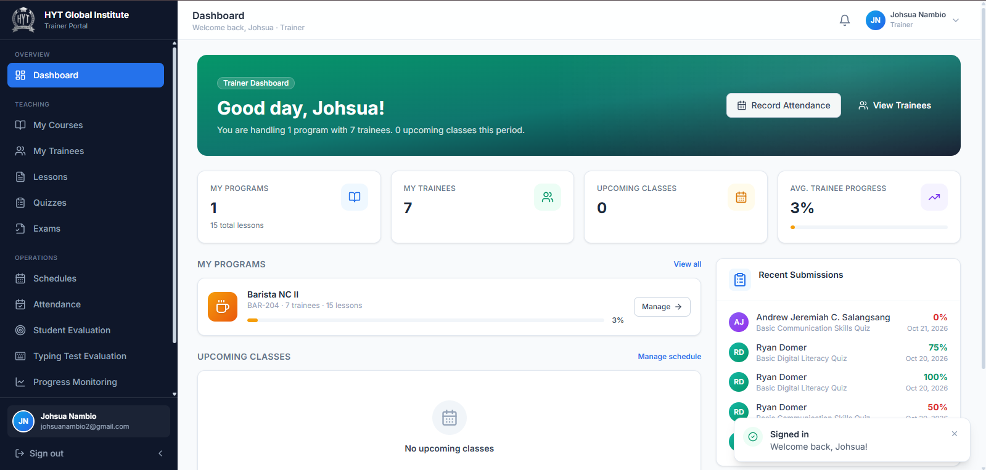Caption: Trainer dashboard.
What to look for:
(1) the four summary cards
(2) Recent Submissions
(3) Upcoming classes
(4) the Record Attendance and View Trainees buttons.

7.3 Viewing assigned courses
Open My Courses.
1. Each card shows the course title, code, and counts for Trainees, Lessons, Quizzes, and Exams.
2. Click Manage Course to open the course.
3. The course page has tabs: Overview, Lessons, Quizzes, Exams, and a Trainees section, plus values for Avg Progress, Duration, Training Hours, Category, Fee, Exam Date, and Total Enrolled.
4. From the header, use Manage lessons, Manage quizzes, or Manage exams to jump straight to authoring.
Note An empty program shows No assigned courses only when nothing is assigned to you. A course you own but have not filled yet still appears, with zero counts.

7.4 Viewing enrolled trainees
Open My Trainees.
• Cards: Total Trainees, Average Progress, Average Attendance.
• Trainee List with one row per trainee. Open a row to see tabs:
– Progress — lessons completed and overall percentage
– Scores — quiz and exam results
– Typing — typing test results (Virtual Assistant program)
– Profile — email, phone, address, education
Tip Use this page before a parent or supervisor meeting: it combines progress, scores, and attendance for the same person.

7.5 Creating and managing lessons
Open Lessons. The page lists lessons for your programs only.

7.5.1 Creating a lesson
1. Click New Lesson.
2. Complete:
Field | Required | Notes
Program | Yes | Only your assigned programs are listed
Competency | Yes | The competency this lesson belongs to
Unit | No | Sub-grouping inside the competency
Lesson Title | Yes | For example Introduction to the Profession
Short Description | No | One line shown on lesson cards
Lesson Content | Yes | Full notes, shown to trainees on the lesson page
Duration (minutes) | No | Estimated study time
Lesson Order | No | Controls the sequence in the course
Video Link | No | Full URL to a video
Learning Materials | No | Files or links (see below)
Published (visible to enrolled trainees) | — | Off by default; trainees cannot see an unpublished lesson

3. Click Save Lesson. If the title is empty, "Lesson title is required." appears.

7.5.2 Adding learning materials
1. In the Learning Materials section, click Add material.
2. For each material:
– Type a name (this is what trainees see).
– Either click Choose file to upload a document, or paste a link in the URL field.
– Choose the type (PDF, document, image, video, link).
3. Add as many materials as the lesson needs.
4. Remove one with the Remove material (trash) button beside it.
Tip Upload only small files. For large videos or manuals, host the file in your institution's shared drive and paste the link instead — links keep the lesson light and load faster for trainees.

7.5.3 Editing and deleting a lesson
1. Click the lesson row to edit it, change the fields, and click Save Lesson.
2. To delete, use Delete lesson and confirm with Delete.
Warning Deleting a lesson removes it from the trainee's course and can lower their completion percentage. Unpublish it instead if you only want to hide it temporarily.
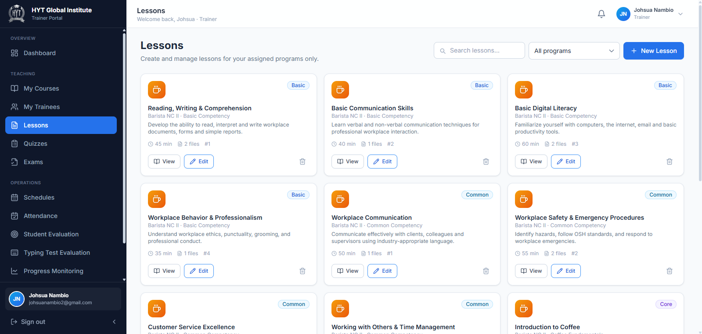

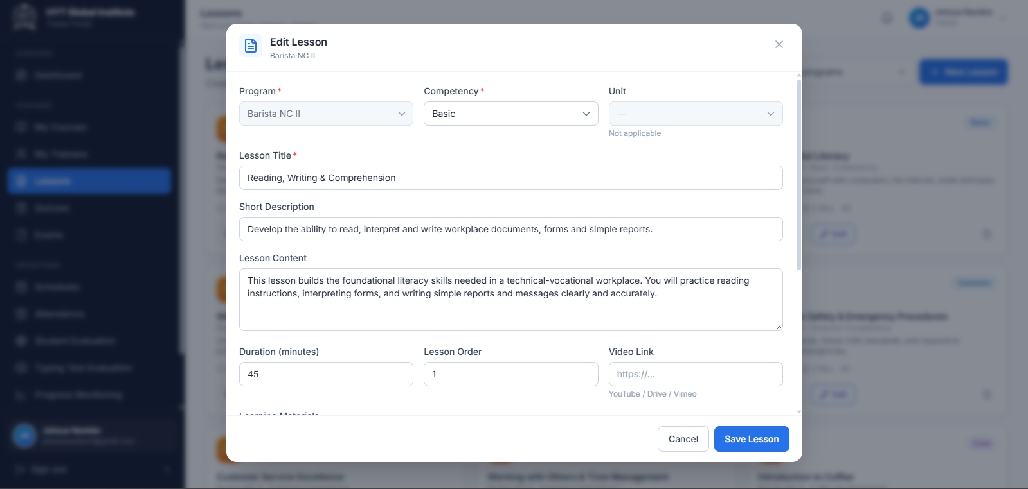
Caption: Authoring a lesson.
What to look for:
(1) the Program and Competency selectors
(2) the Lesson Content editor
(3) Learning Materials with Add material
(4) the Published toggle
(5) Save Lesson.

7.6 Creating and managing quizzes
Open Quizzes.
• Cards: Total Quizzes, Total Attempts, Average Score.
• A Quiz Access Requests panel appears when trainees are waiting for approval.
• The quiz table lists each quiz with program, questions, time limit, passing score, and attempts.

7.6.1 Creating a quiz
1. Click New Quiz.
2. Complete:
Field | Required | Notes
Program | Yes | Your assigned programs only
Quiz Title | Yes | For example Module 1 Assessment
Passing Score (%) | Yes | Defaults to the institution threshold (75)
Start Date / Start Time | Yes | When the quiz opens
Deadline Date / Deadline Time | Yes | When it closes
Questions | Yes | At least one question
Published (visible to enrolled trainees) | — | Trainees cannot take an unpublished quiz

3. Build the questions:
– Choose the question type (multiple choice or true/false).
– Type the question text.
– Add the answer options and mark the correct one.
– Set the points if the builder asks for them.
– Repeat with Add question.
4. Click Save Quiz.
Validation messages
• "Quiz title is required." — the title is blank.
• "Add at least one question." — the question list is empty.
• Invalid schedule — the start is in the past, the deadline is in the past, or the deadline is not after the start. Correct the dates and times.
Warning A quiz with no schedule at all cannot be started by anyone. Always set both the start and the deadline.
Note The time limit is per attempt. If you leave it empty, the attempt uses the standard quiz clock of 30 minutes.

7.6.2 Editing and deleting a quiz
1. Open the quiz from the table, change fields or questions, and click Save Quiz.
2. Use Delete quiz and confirm with Delete.
Warning Deleting a quiz deletes its questions. Existing attempt records stay in the grade history but no longer have a quiz to open.

7.7 Creating and managing exams
Open Exams. The form mirrors quizzes, with two differences: an exam belongs to a Competency, and it carries its own Exam Title.
1. Click New Exam.
2. Complete Program, Competency, Exam Title, Passing Score (%), Status, Start Date/Time, Deadline Date/Time, Questions, and Published.
3. Build the questions the same way as for a quiz.
4. Click Save Exam.
Validation messages
• "Exam title is required."
• "Add at least one question."
• Invalid schedule — same rules as quizzes.
Note The exam attempt clock is 60 minutes unless a time limit is set on the exam.
Tip Publish an exam only when you are ready for trainees to see it. Publishing is what makes it appear on the trainee's Exams tab.

7.8 Handling quiz access requests
Trainees get one attempt per quiz. If they miss the deadline, or need another try, they send a request that only you can approve.
Where requests appear
• Quizzes page → Quiz Access Requests panel.
• Inside a quiz → the Access Requests section, with a count.
Each request shows: the trainee's name, the type (Late access or Retake), and the date requested.
To decide a request
1. Read the request.
2. Click the green check (Approve) to grant one additional attempt, or the red cross (Reject).
3. The request moves to the decided list with an Approved or Rejected badge.
What the trainee sees
• While pending: "Your late access request is waiting for trainer approval."
• When approved: the quiz unlocks with a Start Approved Attempt button.
• When rejected: a notice that the request was rejected.
Tip Approve late access only for a genuine reason (illness, connection outage). The request record keeps the decision visible to the Super Admin.
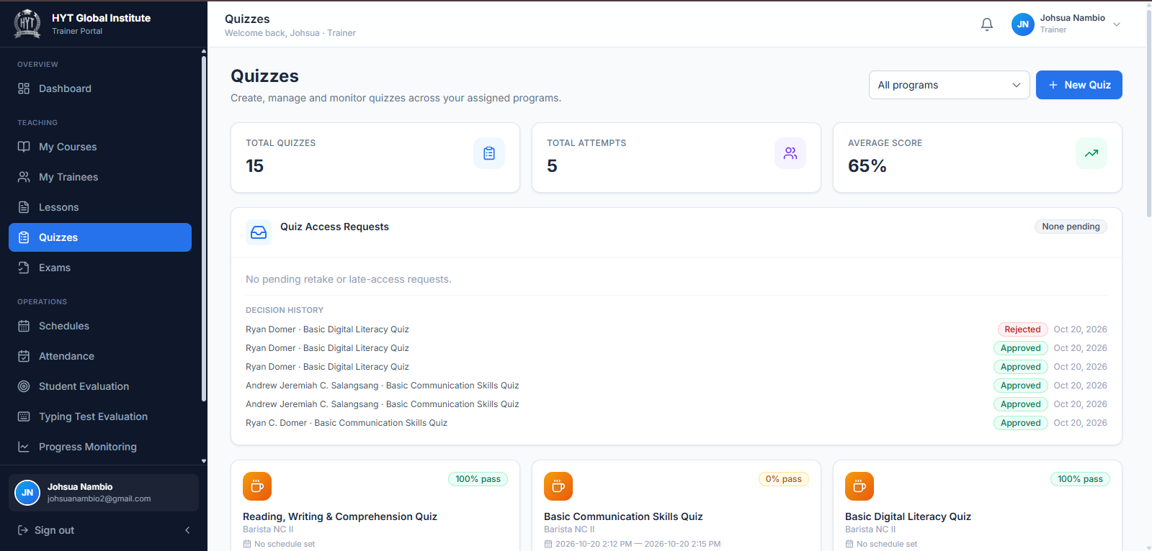Caption: Approving a retake or late-access request.
What to look for:
(1) the request type (Late quiz access or Retake request)
(2) the trainee name and request date
(3) the approve and reject icons
(4) the decided list with status badges.

7.9 Managing class schedules
Open Schedules. You can only schedule sessions for your own programs.

7.9.1 Creating a session
1. Click New Schedule.
2. Complete Program, Lesson / Session, Date, Start Time, End Time, Class Type (Online, Face-to-Face, Hybrid), Room / Venue, and Google Meet Link for online classes.
3. Save.
4. "Please complete the required fields." means a required field is empty; Invalid schedule date/time means the end time is not after the start.

7.9.2 Session actions
Action | Result
Take attendance | Opens Attendance with this session selected
Edit | Reopens the session form
Copy Meet link | Copies the meeting URL; "Meeting link copied." confirms
Delete | Asks for confirmation, then removes the session

7.10 Recording attendance
Open Attendance.
Note Only sessions that have already started can be recorded. Future sessions do not appear in the session selector, and the page shows No sessions to record until a class begins.
Steps
1. In the session selector, choose the class session. Sessions are grouped by program.
2. The list shows every trainee enrolled in that program.
3. For each trainee, choose one status:
Status | Meaning | Time fields
Present | Attended the whole session | Filled automatically from the schedule (start to end)
Late | Arrived after the start | Type the actual time in and time out
Absent | Did not attend | None
Excused | Absent with a valid reason | None

4. For Late, the time in cannot be earlier than the session start, and the time out cannot be later than the session end. The system adjusts out-of-range entries automatically.
5. Use Mark all present to set everyone to Present, then change the exceptions.
6. Click Save Attendance.
Validation
• If any trainee is left unmarked, the message "Please mark every trainee before saving." appears and nothing is saved.
• If no trainees are enrolled, the page shows No trainees enrolled in this program.
Tip Record attendance during or immediately after the class. Late entries are easy to forget, and attendance feeds the trainee's attendance rate and the institution's reports.
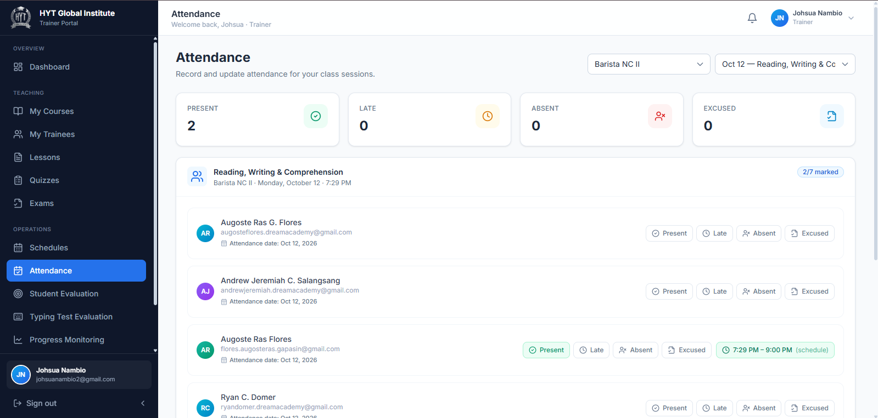Caption: Recording attendance for a session.
What to look for:
(1) the session selector
(2) the four status buttons per trainee
(3) the time-in and time-out fields that appear for Late
(4) Mark all present
(5) Save Attendance.

7.11 Evaluating trainee performance
Open Student Evaluation.
• Cards: Evaluations, Average Rating, Trainees Evaluated.
• The table lists each evaluation with trainee, program, period, overall rating, and remarks.
Creating an evaluation
1. Click New Evaluation.
2. Choose the Trainee. If none is chosen, "Please select a trainee." appears.
3. Choose the Program.
4. Type the Evaluation Period, for example Mid-Term Evaluation or Final Evaluation.
5. Rate each criterion from 1 to 5 stars:
– Work Attitude
– Attendance & Punctuality
– Skills & Competence
– Safety Practices
– Teamwork & Communication
6. Check Overall Rating — it is the average of the five, shown out of 5.0.
7. Add Remarks / Comments.
8. Click Submit Evaluation.
Tip Write remarks that a trainee can act on. "Improve speed on pastry shaping" is useful; "needs improvement" is not.

7.12 Reviewing typing test results
Open Typing Test Evaluation. This page covers the typing test used by the Virtual Assistant program.
• Cards: Tests Taken, Pass Rate, Average WPM, Average Accuracy.
• Typing Test Scores table: trainee, words per minute, accuracy, errors, total words, correct words, incorrect words, test duration, date, and result.
Adding remarks
1. Find the trainee's row.
2. Type in Trainer Remarks.
3. Click Save Remarks.
Note The passing mark is 40%. Trainees below it appear as failed in the results column and in their Grades page.

7.13 Monitoring trainee progress
Open Progress Monitoring.
• Cards: Trainees, Avg Progress, At Risk, Avg Grade.
• Performance Comparison chart: progress, grade, and attendance per trainee.
• Trainee Progress table with each trainee's progress bar, grade, and attendance.
1. Sort by progress or attendance to find the lowest rows.
2. Treat At Risk as your follow-up list: these trainees are behind on progress or attendance.
3. Contact the trainee, or raise the case with the Super Admin.
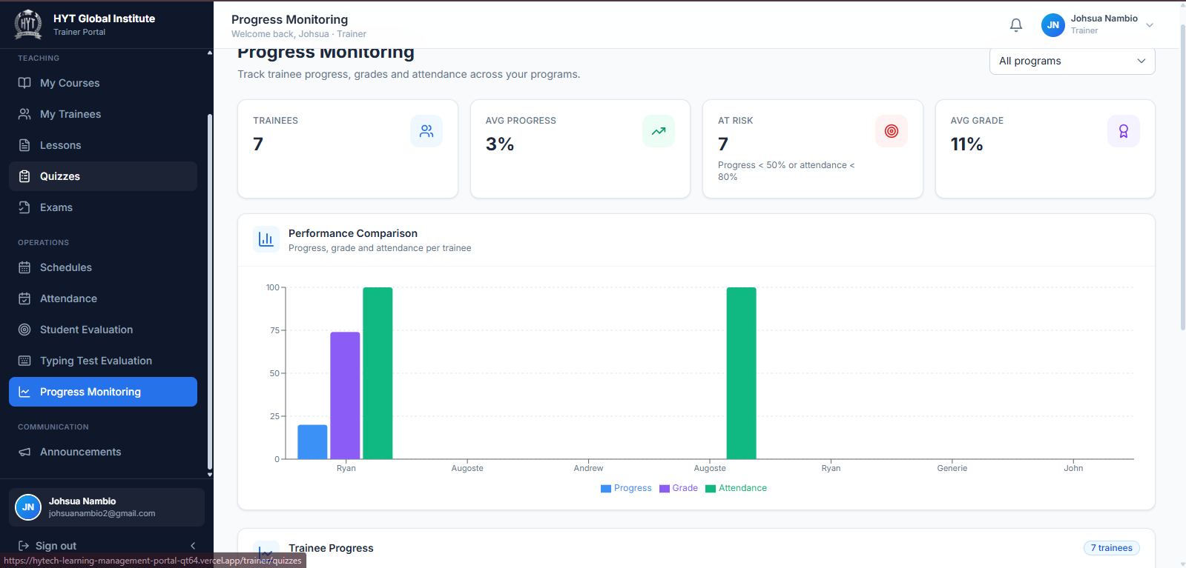Caption: Progress monitoring for a trainer's programs.
What to look for:
(1) the four cards, especially At Risk
(2) the comparison chart
(3) the per-trainee progress bars.

7.14 Posting announcements
Open Announcements. Trainers can create announcements for their own classes.
1. Click New Announcement.
2. Complete Title, Message, Audience (Everyone, Trainees, Trainers), Program (optional), Priority, and optionally Pin this announcement to the top.
3. Save.
4. Use the row menu to Edit, Pin/Unpin, or Delete.
Tip Choose the specific Program when the announcement only affects one class. It keeps other trainees from being notified about something irrelevant to them.

7.15 Updating your profile and password
1. Top-right menu → My Profile.
2. Edit Full Name, Email Address, Phone Number, and Address. Position and Specialization are managed by the Super Admin and appear read-only.
3. Click Save Changes.
4. Your Assigned Programs and your trainee rating summary are shown on the same page.
5. To change your password, use Account Security at the bottom: Current Password, New Password, Confirm New Password, then Update Password.
Note You can see the average star rating trainees gave you, but not the written feedback or individual ratings. Feedback is visible only to the Super Admin.

7.16 Troubleshooting for Trainers
Problem | Likely cause | What to do
A course is missing from My Courses | Not assigned to you | Ask the Super Admin to assign the program
Trainees cannot see a lesson | Published is off | Edit the lesson and switch Published on
Trainees cannot start a quiz or exam | No schedule set, or it is outside the window | Edit the assessment and set a valid start and deadline
"Invalid schedule" when saving | Start in the past, deadline in the past, or deadline before start | Correct the dates and times
"Please mark every trainee before saving" | A trainee has no status | Mark the remaining trainees, or use Mark all present
"No sessions to record" | No session has started yet | Wait for the class start time, or check the schedule date
A trainee says they already submitted | One attempt per quiz is enforced | Check Quiz Access Requests; approve a retake if justified
Evaluation will not save | No trainee selected | Choose a trainee in the Trainee field
Typing test page is empty | No Virtual Assistant trainee has taken the test | Expected; results appear after the first attempt
Cannot open another trainer's program | Assignment-based access | Ask the Super Admin for an assignment if you should have access

8. Trainee User Manual
The Trainee role is where learning happens. You enroll, study, take assessments, and track your own progress.

8.1 Understanding the Trainee workspace
After signing in you land on /trainee. The sidebar contains two groups:
Group | Menu item | Opens
Overview | Dashboard | Your learning summary
Learning | My Courses | Programs you are enrolled in
Learning | Class Schedules | Your sessions, with join links
Learning | Attendance | Your attendance record
Learning | Grades & Scores | Quiz, exam, and typing results
Learning | Typing Test | Typing test (Virtual Assistant program)
Learning | Trainer Feedback | Feedback form for completed programs
Account | Enrollment | Apply for a program, track applications
Account | My Payments | Fees, balances, and payment history
Account | Announcements | Notices from your trainer and the institution
Account | Profile | Personal details and password

Note You only see courses you are enrolled in. If a program is missing from My Courses, your application is probably still Pending, or it was rejected — check Enrollment.

8.2 The Dashboard
What you see
1. Cards: My Course, Attendance, Lessons Completed, Enrollments.
2. Next Class — the next session, with Join next class (or Join Class on the day).
3. Upcoming Quiz — the next quiz to take, with Go to course. When everything is done, it shows All quizzes completed.
4. Latest Scores — your most recent results.
5. My Enrollments — each program with its status and progress.
6. Quiz Access Requests — pending or decided requests.
7. Announcements — the newest posts.
8. Pay Now — appears when a payment is due.
Actions
1. My Courses — opens your course list.
2. Join next class — opens the meeting link for the next online session.
3. Go to course — opens the course containing the upcoming quiz.
4. View all grades — opens Grades & Scores.
5. Pay Now — opens the payment form.
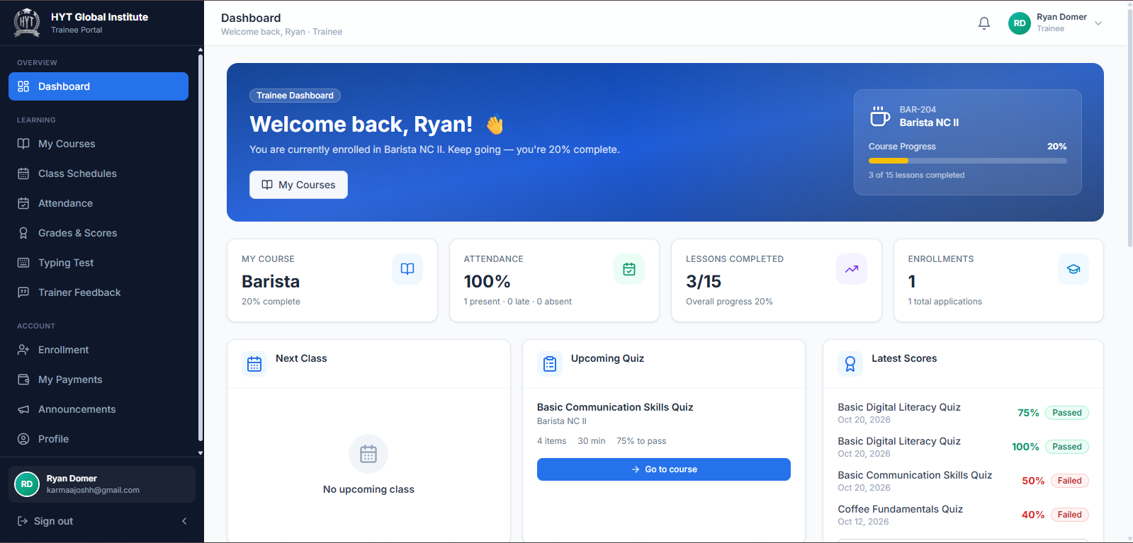Caption: Trainee dashboard.
What to look for:
(1) the four cards
(2) Next Class with its join button
(3) Upcoming Quiz
(4) Latest Scores
(5) My Enrollments with progress bars
(6) the Pay Now button when a balance exists.

8.3 Viewing your courses
Open My Courses.
1. Use the tabs to filter: In Progress, Pending, Completed.
2. Type in Search course… to find a program quickly.
3. Click a course card to open it.
4. Inside the course, use the tabs:
– Overview — description, duration, training hours, level, start and end dates, trainer
– Competencies — the competency structure and its lessons
– Quizzes — every quiz with its status (Not taken, Passed, Failed, Pending approval, In progress)
– Exams — every exam with its status and a Take Exam button when open
Note If you open a course you are not enrolled in, the page shows You are not enrolled in this program with a Browse programs button.

8.4 Enrolling in a program
Open Enrollment.
Part 1 — your applications
The My Applications list shows each application with the program, type (Scholarship / Voucher or Self-Pay), applied date, status, and — for self-pay — a Pay Now button when a balance remains.
Part 2 — applying for a new program
1. Click Enroll in another program (or Browse programs if the list is empty).
2. In Program Details, read Duration, Training Hours, Level, Category, Training Fee, Admission Requirements, and Competency Structure.
3. Click Continue.
4. Under Choose Enrollment Type, select one:
– Scholarship / Voucher — funded by TESDA or a sponsor. No payment is required.
– Self-Pay / Paying Trainee — you pay the training fee shown.
5. Click Continue.
6. Complete the form for your chosen type.
For Scholarship / Voucher
Field | Required
Voucher / Scholarship Name | Yes
Voucher Number | Yes
Sponsor | Yes
Training Program | Pre-filled
Date | Yes
Full Name | Yes
Email | Yes
Contact Number | Yes
Date of Birth | Yes
Educational Background | Yes
Emergency Contact | Yes
Preferred Schedule | No
Address | Yes

For Self-Pay
Field | Required
Course | Pre-filled
Training Fee | Pre-filled, read-only
Amount Paid (₱) | Yes
Payment Date | Yes
Reference Number | Yes
Full Name, Email, Contact Number, Date of Birth, Educational Background, Emergency Contact, Preferred Schedule, Address | Yes, except Preferred Schedule

7. Click Submit Enrollment.
8. Your application appears in My Applications with status Pending.
Note An application is not an enrollment. You get access to the course only after the Super Admin approves it. Until then the course shows as Pending.
Tip Keep the voucher number and reference number exactly as printed. The reviewer matches them against the sponsor's or bank's record.

8.5 Studying a lesson and downloading materials
1. Open My Courses → your course → Competencies or Overview.
2. Click a lesson to open it. The Course Lessons list stays on the side so you can move between lessons.
3. Read Lesson Content. If the lesson has a video, it appears above the content.
4. In Learning Materials, each item shows a name and a download icon. Click it to open or download the file.
5. When you finish, click Mark as Complete.
6. The toast "Lesson marked as complete!" confirms it, and your progress increases.
7. Click Mark as Incomplete to undo the mark.
Note Marking lessons complete is what moves your progress bar. Reading without marking keeps your progress unchanged, and the program cannot reach Completed status.
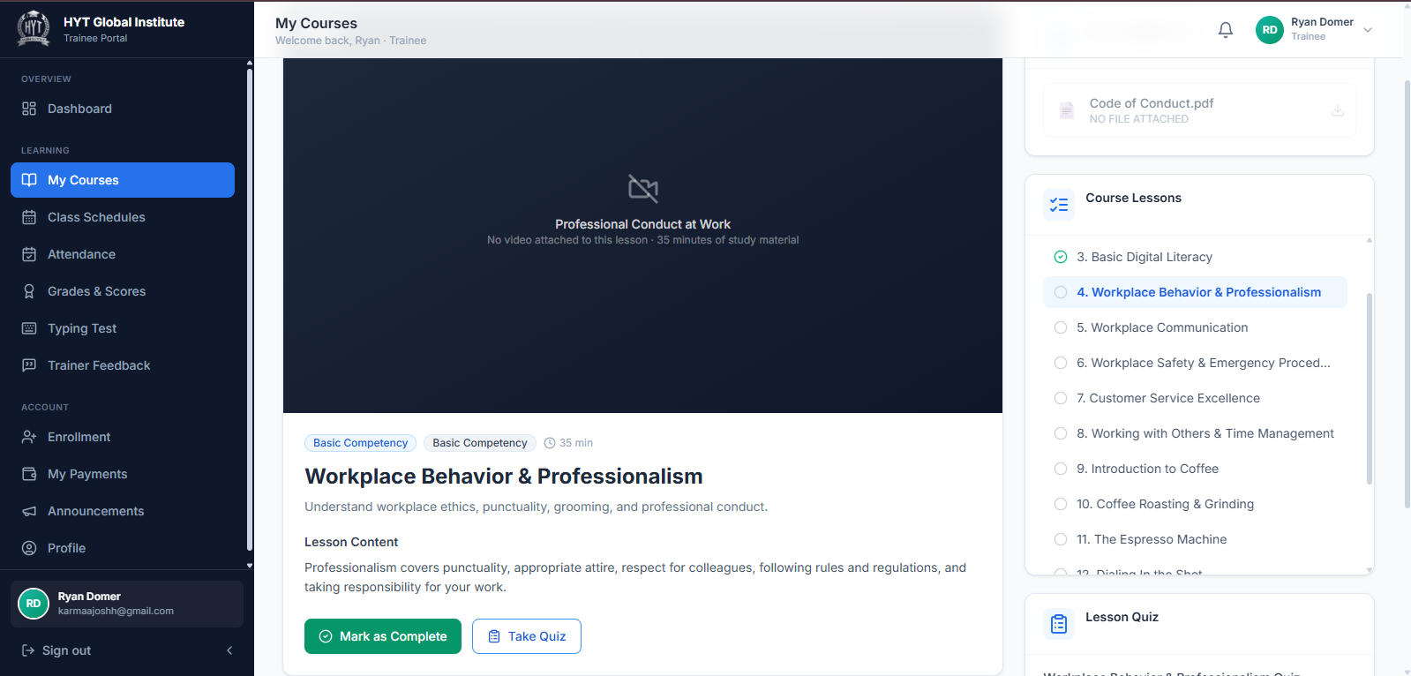Caption: A lesson with content and materials.
What to look for:
(1) the Course Lessons list on the side
(2) the video area
(3) the Learning Materials list with download icons
(4) the Mark as Complete button
(5) the lesson quiz section when the lesson has one.

8.6 Taking a quiz
1. Open the course and go to the Quizzes tab.
2. Find the quiz. The card shows its status and schedule.
3. Click Start Quiz (or Take Quiz / Resume Quiz if you already started).
4. Read the quiz header: Questions, Time limit, and Passing score.
5. Answer each question. Use the question navigation to move between items.
6. Click Submit when you are done, and confirm.
Rules you should know
• One attempt per quiz. After you submit, the quiz shows Done and cannot be retaken without your trainer's approval.
• The quiz can only be started inside its start and deadline window. If the trainer has not scheduled it, the card shows Not scheduled.
• The countdown is 30 minutes unless the trainer set a different time limit. The timer is checked against the server, so changing your device clock does not add time.
• If you close the page mid-attempt, the clock keeps running. Reopen the quiz and click Resume Quiz — you continue with the time that is left.
• If the time runs out, the attempt is forfeited. You can request a retake.
• After submitting, the result panel is marked Verified by the server and shows your correct answers, score, percentage, and incorrect answers.
Warning Do not open the quiz in two tabs. Only one attempt session exists per quiz, and the newest tab wins.
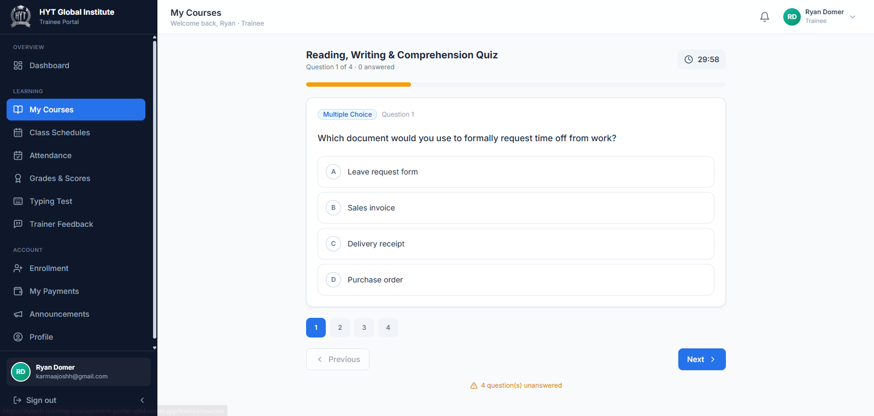Caption: Taking a quiz.
What to look for:
(1) the quiz title and instructions
(2) Questions, Time limit, and Passing score
(3) the countdown and the Server deadline label
(4) the question navigation
(5) the Submit button.

8.7 Taking an exam
1. Open the course and go to the Exams tab.
2. Find the exam. The card shows Exam Date, passing score, and whether you have taken it.
3. Click Take Exam.
4. Answer all questions, then submit and confirm.
5. The result panel marked Verified by the server shows correct answers, score, percentage, and incorrect answers.
Rules you should know
• The exam must be open: before Start Date/Time it shows This exam is not open yet; after the Deadline it shows The exam deadline has passed.
• An exam with no schedule shows Your trainer has not scheduled this exam yet.
• The exam clock is 60 minutes unless the trainer set a time limit.
• Every attempt is recorded. Your Grades page shows each attempt with its date, score, and pass/fail result.
Note If the result cannot be saved because of a connection problem, the page offers Retry save. Use it before leaving the page, otherwise the attempt may not appear in your grades.
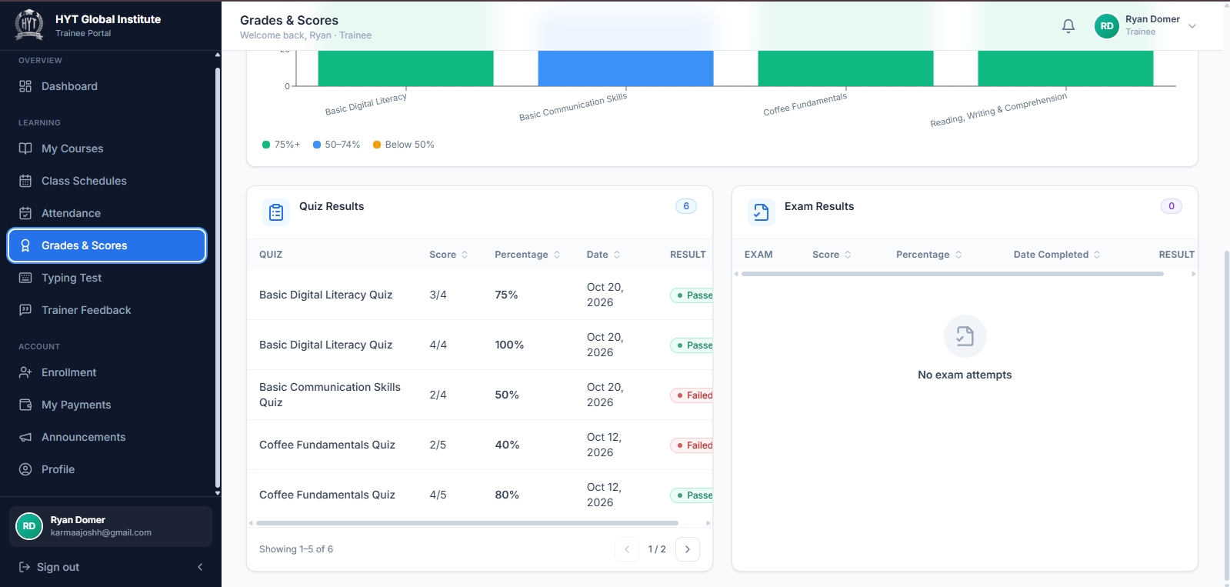Caption: Exam result after submission.
What to look for:
(1) the Verified by the server badge
(2) correct answers and total questions
(3) percentage and incorrect count
(4) Back to course.

8.8 Requesting late access or a retake
If you missed the deadline or used your attempt, you can ask your trainer for another chance.
1. Open the quiz from the Quizzes tab.
2. Read the reason shown on the card:
– "You have already taken this quiz. Request a retake from your trainer."
– "Your attempt time is up. Request a retake from your trainer."
– Late access is offered when the deadline has passed and you never attempted the quiz.
3. Click Request Retake (or the late-access request button).
4. The card changes to Retake request pending or Waiting for trainer approval.
5. When your trainer decides, the card updates:
– Approved → Start Approved Attempt becomes available.
– Rejected → a notice explains that the request was rejected.
Tip Request once, then wait. Sending several requests does not speed up approval and makes the queue harder for your trainer.

8.9 Viewing class schedules
Open Class Schedules.
1. Use the tabs: Ongoing, Upcoming, Past Sessions.
2. Each session shows the lesson or topic, date, start and end time, class type, room or venue, and trainer.
3. For an online session, click the meeting button to join. The dashboard also shows Join next class for the next session.
Note Classes appear here only after your trainer or the Super Admin schedules them. If the list is empty, no session has been created yet.

8.10 Viewing your attendance
Open Attendance.
• Cards: Present, Late, Absent, Excused.
• Attendance Rate as a percentage.
• Attendance Records table: date, program, session, status, time in, time out.
1. Check the rate against the institution's requirement (default 80%).
2. If a record is wrong, tell your trainer — only the trainer can correct it.

8.11 Viewing grades and results
Open Grades & Scores.
• Overall Grade — the average of all your assessments, shown as a percentage. Green means 75% or above; amber means below.
• Quizzes Taken and Exams Taken — counts.
• Performance Overview — a chart of your results.
• Quiz Results — each quiz attempt with date, score, percentage, and pass/fail.
• Exam Results — each exam attempt with the same details.
• Typing Test Results — WPM, accuracy, errors, and pass/fail (passing is 40%).
Tip If a result is missing, open the assessment again and use Retry save — an attempt that never reached the server cannot appear in your grades.

8.12 Taking the typing test
Open Typing Test.
Note The typing test is exclusive to the Virtual Assistant program. If you are not enrolled in it, the page tells you so.
1. Read Passing Requirement (40%), Best Score, Best WPM, and Attempts.
2. Click the passage area to focus it.
3. Start typing. The timer starts with your first keystroke. "Start typing to begin the test." reminds you if you have not begun.
4. Type the passage as accurately and quickly as you can.
5. Click Submit Test when you finish (or when the time is up).
6. The result shows Time, WPM, Accuracy, Errors, Score, Total Words, Correct Words, Incorrect Words, and Duration.
7. Click Take Another Test to try again. Every attempt is listed in My Typing Test History.
Tip Accuracy counts more than raw speed. Slow down slightly and your score usually improves.

8.13 Submitting trainer feedback
Open Trainer Feedback. This is where you rate the trainer of a program you have completed.
When the form appears
Feedback opens only after a program is completed. Programs still in progress show Not yet available. A completed program shows Awaiting your feedback.
Submitting
1. Find the program marked Awaiting your feedback.
2. Under Your rating, choose 1 to 5 stars. This is required — the system stops with "Please choose a star rating first." if you skip it.
3. In Your feedback, write your main comment. This is required — "Please write your feedback before submitting."
4. Optionally complete:
– Learning experience — what you learned and how the pace suited you
– Trainer strengths — what your trainer did well
– Areas for improvement — what could be better
– Recommendation — whether you would recommend the trainer or program
5. Click Submit feedback.
6. The toast "Thank you — your feedback was submitted." confirms it.
After submitting
• The program moves to Submitted, showing your stars and the date.
• Click it to read Your submitted feedback in a read-only view.
• The form cannot be submitted again. You rate each trainer once, together with your written feedback.
Warning Feedback is permanent once submitted. Check your stars and text before clicking Submit feedback. If something is factually wrong afterwards, contact the Super Admin — only they can correct a record, and the correction is logged.
Note Your trainer cannot see your feedback — not the stars and not the text. Only the Super Admin can read it.
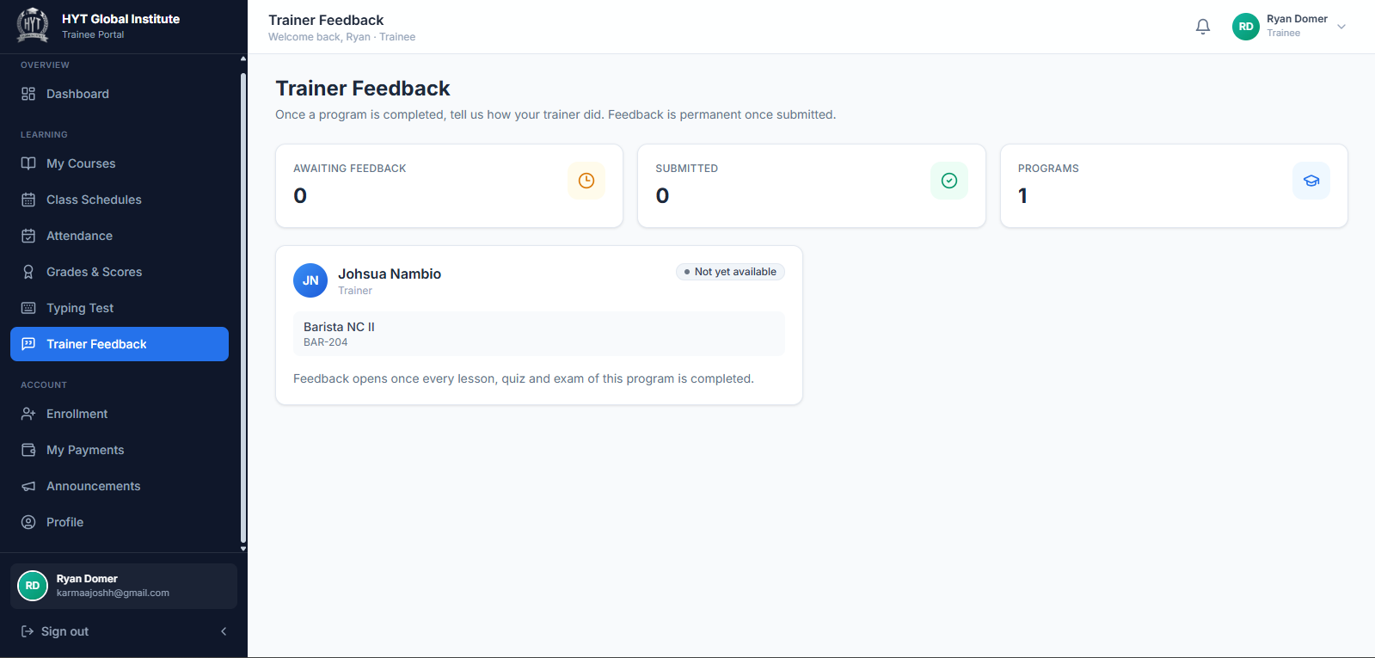Caption: Trainee feedback form for a completed program.
What to look for:
(1) the Awaiting your feedback and Submitted counters
(2) the star selector marked with a red asterisk
(3) Your feedback
(4) the four optional sections
(5) Submit feedback.

8.14 Making a payment
Open My Payments.
• Cards: Total Billed, Total Paid, Outstanding Balance, Pending Payments.
• My Payments table: program, fee, paid, balance, status, and payment history with method, reference number, and date.
Steps
1. Find the program with a balance. Click Pay Now (also available on the dashboard and in Enrollment).
2. In the Make a Payment dialog, review the fee and balance.
3. In Amount to Pay (₱), type the amount you are paying.
4. Choose the Payment Method: GCash, Maya, Bank Transfer, or Over-the-Counter.
5. Type the Reference Number from your receipt or transaction confirmation.
6. Set the Payment Date.
7. Check the preview: the new balance and the new status (Unpaid, Partially Paid, or Fully Paid).
8. Click Pay Now to confirm.
9. The payment appears in your history and the balance updates.
Warning Type the reference number exactly. The institution matches it against the actual transaction; a wrong reference can delay confirmation of your payment.
Note Payments can only be made on programs with a balance that are not Cancelled or Rejected. Scholarship enrollments show Funded and need no payment.

8.15 Reading announcements
Open Announcements.
1. Use the priority filter: All priorities, High priority, Normal, Low.
2. Read the cards. Pinned announcements appear at the top with a pin badge.
3. High-priority posts are highlighted in red — read those first.

8.16 Updating your profile and password
1. Top-right menu → My Profile.
2. Edit Full Name, Email Address, Phone Number, Date of Birth, Gender, Educational Attainment, and Address.
3. Click Save Changes.
4. My Enrolled Programs on the same page shows each active program with its progress.
5. To change your password, scroll to Account Security: Current Password, New Password, Confirm New Password, then Update Password.
Note Your password must be rated Good or higher. The strength meter updates as you type.

8.17 Troubleshooting for Trainees
Problem | Likely cause | What to do
A program is missing from My Courses | Application pending or rejected | Open Enrollment and check the status; ask the Super Admin if it should have been approved
"You are not enrolled in this program" | Opened a course you are not enrolled in | Return to My Courses and open one of your own courses
A quiz shows Not scheduled | The trainer has not set a start and deadline | Wait for your trainer to schedule it
"This quiz is not open yet" | The start date and time have not arrived | Check the schedule on the quiz card and return later
"You have already taken this quiz" | One attempt per quiz | Use Request Retake
The countdown jumps or ends early | The timer follows the server clock | Do not change your device time; if it ends early, request a retake
Retry save appears after submitting | The result could not reach the server | Click Retry save before leaving the page
A lesson will not increase progress | Not marked complete | Open the lesson and click Mark as Complete
Typing test page says it is exclusive to Virtual Assistant | You are not in that program | Expected; the test is only for Virtual Assistant trainees
Trainer Feedback shows Not yet available | The program is not completed | Finish all lessons and pass the assessments; feedback opens automatically
"Please choose a star rating first" | Stars not selected | Choose 1–5 stars before submitting
Payment does not appear | Reference not yet matched, or the page was closed early | Check My Payments; contact the Super Admin with your reference number

9. Role-Based Permissions and Access Comparison

9.1 Master permissions table
Legend: ✓ = available · — = not available · Assigned = only for programs assigned to the trainer · Own = only the user's own records
Feature / Screen | Super Admin | Trainer | Trainee
Sign in and sign out | ✓ | ✓ | ✓
Change own password | ✓ | ✓ | ✓
Two-factor authentication setup | ✓ | — | —
View own profile | ✓ | ✓ | ✓
Edit own profile details | ✓ | ✓ (position and specialization read-only) | ✓
Dashboard | ✓ institution-wide | ✓ own programs | ✓ own learning
Create trainee accounts | ✓ | — | —
Edit / delete trainee accounts | ✓ | — | —
Create trainer accounts | ✓ | — | —
Edit / delete trainer accounts | ✓ | — | —
Resend activation email | ✓ | — | —
Assign a trainer to a program | ✓ | — | —
Assign a trainee to a program and trainer | ✓ | — | —
Create / edit / delete courses | ✓ | — | —
View course catalogue | ✓ | Assigned | Own enrollments
Author lessons | — | Assigned | —
Author quizzes | — | Assigned | —
Author exams | — | Assigned | —
Read-only lesson / quiz / exam registries | ✓ | — | —
Review competencies | ✓ | Assigned (in course view) | Own (in course view)
Submit an enrollment application | — | — | ✓
Approve / reject / cancel enrollments | ✓ | — | —
Mark an enrollment completed | ✓ | — | —
Record a payment | ✓ | — | —
Make a payment | — | — | ✓
View fees and balances | ✓ all | — | ✓ own
Create class schedules | ✓ all programs | Assigned | —
Edit / delete class schedules | ✓ all programs | Assigned | —
View class schedules | ✓ all | Assigned | Own enrollments
Record attendance | — | Own sessions | —
View attendance records | ✓ all | Assigned trainees | ✓ own
Take a quiz | — | — | ✓
Take an exam | — | — | ✓
Approve late access / retake requests | — | Assigned | —
Request late access / retake | — | — | ✓
Create student evaluations | — | Assigned | —
View student evaluations | ✓ (via reports and records) | Assigned | —
Review typing test results | — | ✓ (Virtual Assistant) | ✓ own
Take the typing test | — | — | ✓ (Virtual Assistant only)
Monitor trainee progress | ✓ all | Assigned | ✓ own
Reports and analytics | ✓ | — | —
Export reports to CSV | ✓ | — | —
Submit trainer feedback | — | — | ✓ (completed programs)
Read trainer feedback | ✓ (requires MFA for export) | — | ✓ own submission
Correct trainer feedback | ✓ (requires MFA) | — | —
Post announcements | ✓ all audiences | ✓ own programs | —
Read announcements | ✓ | ✓ | ✓
System settings | ✓ | — | —
Reset demonstration data | ✓ | — | —
View the audit trail | — (records are written server-side; no viewer in the interface) | — | —

9.2 Features available to all roles
• Sign in, sign out, and password reset.
• My Profile: view and edit personal details, change password.
• Personal dashboard with role-specific summary.
• Announcements relevant to the user.
• Toast confirmations for every save, update, and failure.

9.3 Features exclusive to the Super Admin
• All account creation and deletion.
• Course setup and trainer assignment.
• Enrollment decisions and manual completion.
• Institution-wide attendance, accounting, and reports.
• Reading, correcting, and exporting trainee feedback.
• System settings, thresholds, and data reset.
• Two-factor authentication.

9.4 Features exclusive to the Trainer
• Authoring lessons, quizzes, and exams.
• Approving late access and retake requests.
• Recording attendance for their sessions.
• Creating student evaluations.
• Adding remarks to typing test results.

9.5 Features exclusive to the Trainee
• Submitting enrollment applications.
• Taking quizzes, exams, and the typing test.
• Marking lessons complete.
• Making payments.
• Submitting trainer feedback.

9.6 Features that depend on assignment or status
Feature | Condition
Trainer sees a course, its trainees, lessons, quizzes, exams, schedules | The program must be assigned to that trainer
Trainer records attendance | The session must belong to an assigned program and must have started
Trainee sees a course | An enrollment must exist and be Approved or Enrolled (or Completed)
Trainee takes a quiz | The quiz must be published, scheduled, inside its window, and unused
Trainee takes an exam | The exam must be published, scheduled, and inside its window
Trainee takes the typing test | Enrolled in the Virtual Assistant program
Trainee submits trainer feedback | The program must be Completed, and no feedback submitted yet
Trainer appears in a trainee's Program Assignments | The trainer must be assigned to that course

10. Common Errors and Troubleshooting

10.1 How to troubleshoot in general
1. Read the message. The system names the exact field or rule that failed. Toasts appear at the bottom-right; inline errors appear under the field.
2. Check your role and assignment. Most "missing screen" problems are assignment problems, not bugs.
3. Refresh the page once. A stale tab can hide a change made by another user.
4. Sign out and sign in again. This refreshes your session and permissions.
5. Try a different browser if a control does not respond.
6. Report with details: the page, the exact message, the time, and what you clicked. Screenshots help, but never include passwords or full personal data.

10.2 Message index
Message | Where it appears | Meaning | Action
"Name and email are required." | Add/Edit Trainee or Trainer | A required field is blank | Fill both fields
"Phone number must be exactly 11 digits." | Add/Edit Trainee or Trainer | Phone format is wrong | Enter 11 digits, no spaces or dashes
"Select a trainer for: [program]…" | Add/Edit Trainee | A ticked program has no trainer | Assign a trainer to that course or untick it
"Activation email sent again." / "Activation email sent to [email]." | Trainee/Trainer pages | The invitation was resent | Ask the user to check inbox and Spam
"Please complete the required fields." | Schedules | A required schedule field is blank | Complete the form
"Invalid schedule date/time" | Schedules | End time is not after start | Correct the times
"Meeting link copied." | Schedules | Link is on the clipboard | Paste it where needed
"Enter a valid amount." | Accounting | Payment amount is blank or zero | Enter a positive amount
"Status updated to [status]." | Enrollment | Status change succeeded | No action
"Please choose a star rating first." | Trainer Feedback | Stars missing | Select 1–5 stars
"Please write your feedback before submitting." | Trainer Feedback | Main comment empty | Write your feedback
"Thank you — your feedback was submitted." | Trainer Feedback | Success | No action
"Please mark every trainee before saving." | Trainer Attendance | A trainee has no status | Mark everyone, or use Mark all present
"Please select a trainee." | Student Evaluation | No trainee chosen | Choose a trainee
"Quiz title is required." / "Exam title is required." | Trainer Quizzes/Exams | Title blank | Enter a title
"Add at least one question." | Trainer Quizzes/Exams | No questions | Add a question
"Lesson title is required." | Trainer Lessons | Title blank | Enter a title
"Title and body are required." | Announcements | Title or message blank | Fill both
"Feedback text cannot be empty." | Super Admin feedback correction | Main text cleared | Restore the text
"A reason is required for the audit trail." | Super Admin feedback correction | Reason blank | State the reason
"This link is invalid or has expired." | Activation page | Invitation link used or expired | Ask the Super Admin to resend
"This reset link is invalid or has expired." | Password reset page | Reset link used or expired | Request a new reset email
"Password is too weak…" | Sign up / Welcome / Reset / Profile | Strength below Good | Use a longer password with mixed characters
"The passwords do not match." | Sign up / Reset / Profile | Confirmation differs | Retype both
"If an account exists for that email, a reset link is on its way." | Sign in | Reset request accepted | Check the inbox, including Spam

10.3 Symptom-based troubleshooting
Symptom | Check first | Then
Page will not load | Internet connection, correct URL | Try another browser; ask IT whether the site is reachable
Signed in but the dashboard is empty | Role and assignment | Super Admin: check Trainees/Trainers; Trainer: check Assigned Programs; Trainee: check Enrollment status
Menu item missing | Role | The item belongs to another role; this is expected
"No trainers" or "No trainees" | Filters and search box | Clear the search; check the correct tab
Data changed but the screen did not update | Cached tab | Refresh the page
Button does nothing | Required field above the button | Scroll up for an inline error or toast
Cannot export CSV | MFA status (feedback export) | Sign in with the authenticator code
Report totals look wrong | Date filters | Reset From date and To date
Trainer rating is blank | Feedback not yet submitted | Ratings appear only after a program is completed and feedback is submitted

10.4 When an expected option is unavailable
If a button, tab, or menu described in this manual is missing:
1. Confirm you are signed in with the correct role (shown in your profile badge).
2. Confirm the record belongs to you: trainers need an assignment, trainees need an approved enrollment.
3. Confirm the record's state: an unpublished lesson, an unscheduled quiz, or an unapproved enrollment hides the next action.
4. Refresh once.
5. If it is still missing, report it to the Super Admin with the page name and a screenshot. Do not attempt to work around a permission control.

11. Security Guidelines and Best Practices

11.1 Passwords
• Use a password rated Good or higher. Prefer a long passphrase over a short complicated word.
• Never reuse your LMS password on another website.
• Never share your password — not with a colleague, not with IT, not with the Super Admin. Administrators never need it.
• Change your password immediately if you suspect it was seen.
• Do not write passwords on paper stuck to a monitor or under a keyboard.

11.2 Two-factor authentication
• Super Admins should keep MFA switched on. It protects feedback data and every export.
• Keep the authenticator app on a device you control.
• If you lose the device, turn MFA off from a signed-in session, then re-enrol immediately.

11.3 Shared and public computers
• Always click Sign out; closing the tab is not enough.
• Never tick "remember me" on a shared machine.
• Clear the download folder after exporting reports or feedback.
• Do not open the portal on a public kiosk.

11.4 Phishing and impersonation
• The system never asks for your password by email or chat.
• Activation and reset emails contain a link only. If an email asks you to reply with your password, it is not from the institution.
• Check the sender address before clicking. When in doubt, open the portal directly and sign in instead of using the link.

11.5 Handling trainee and trainer data
• Feedback is confidential. Only the Super Admin may read it, and only for legitimate administrative purposes.
• Exported CSV files contain personal data. Store them in the institution's approved location, not on personal drives or chat apps.
• Do not screenshot learner records for social media.
• Share the minimum necessary: a trainer needs their own trainees' data, not the whole institution's.
• When a correction is needed in feedback, record the reason — the system keeps the original values and the reason in its audit history.

11.6 Account lifecycle
• Create accounts only for people who are officially enrolled or employed.
• When a person leaves, ask the Super Admin to remove access promptly.
• Never create a shared account for several people. Every action is attributed to the signed-in account.
• Do not reuse an email address that belonged to a previous person.

11.7 Device hygiene
• Keep your browser and operating system updated.
• Avoid installing unknown extensions that can read page content.
• Lock your screen when stepping away during a class or an exam.

12. Frequently Asked Questions
1. I forgot my password. What do I do?
Click Forgot password? on the sign-in page, enter your email, and open the link in the email. The link expires, so use the newest one.
2. I never received my activation email.
Check Spam or Junk first. If it is not there, ask the Super Admin to resend the invitation from the Trainees or Trainers page, then open the newest link.
3. Can I change my email address?
Yes, from My Profile. Your email is also your login name, so use the new address the next time you sign in. If your institution requires administrator approval for email changes, the field may be read-only — ask the Super Admin.
4. Why can't I see a course I was told about?
Either the program is not assigned to you (trainer) or your enrollment is not approved (trainee). Ask the Super Admin to check the assignment or the application status.
5. Why is my progress still 0% after reading a lesson?
Reading does not count. Open the lesson and click Mark as Complete.
6. How many times can I take a quiz?
One attempt per quiz. If you need another, click Request Retake and wait for your trainer's approval.
7. Can I take an exam more than once?
An exam can be opened again while its window is still open, and each attempt is recorded in your grades. Your trainer controls the window.
8. The timer ended before I finished. Can I get the time back?
No. The attempt is forfeited. Request a retake and explain what happened.
9. Why does the quiz say "Not scheduled"?
Your trainer has not set a start date and deadline. The quiz cannot be opened until they do.
10. When can I submit trainer feedback?
Only after the program is Completed. Then open Trainer Feedback and submit your stars and comment together. You can submit once per program.
11. Can my trainer see the feedback I wrote?
No. Neither the stars nor the text are visible to trainers. Only the Super Admin can read feedback.
12. Why can't I submit feedback twice?
Feedback is recorded once per program and is permanent. Contact the Super Admin if a factual correction is needed.
13. How do I know my enrollment was approved?
Open Enrollment and check My Applications. Approved or Enrolled means you have access. The course also appears under My Courses.
14. My payment is not showing.
Check My Payments for the record. If it is missing, give the Super Admin your reference number and payment date.
15. Can I use the system on my phone?
Yes, but wide tables are easier on a laptop. Quizzes and exams are best taken on a stable connection.
16. Why does the Super Admin page ask for a code?
Two-factor authentication is enabled. Enter the 6-digit code from your authenticator app.
17. What happens when a program is completed automatically?
When every lesson is marked complete and every quiz and exam is passed, the enrollment becomes Completed, and trainer feedback opens for that trainee.
18. Who do I contact for a technical problem?
Your Super Admin first. See Section 14 for the escalation contacts.

13. Glossary of Terms
Term | Meaning in this system
Activation email | The message containing the one-time link a new trainer or trainee uses to create their own password
Announcement | A notice posted to everyone, all trainees, or all trainers, optionally limited to one program
Assessment | A quiz, an exam, or the typing test
Attempt | One submission of an assessment by one trainee
Audit trail | The server-side record of sensitive actions such as feedback exports and corrections
Competency | A unit of skill inside a program; groups lessons and quizzes
Course / Program | The training offering (for example, Bread and Pastry Production NC II). The menu calls it Courses; records are called programs
Dashboard | The landing page for a role, showing summary cards and recent activity
Deadline | The date and time after which a quiz or exam can no longer be started
Enrollment | The link between a trainee and a program, carrying a status and payment details
Evaluation | A trainer's 1–5 star assessment of a trainee across five criteria, with remarks
Feedback | The trainee's star rating plus written comments about a trainer, submitted after program completion
Late access | Permission to take a quiz after its deadline when the trainee never attempted it
Lesson | A unit of content inside a competency, with text, an optional video, and materials
MFA (two-factor authentication) | A second sign-in step using a 6-digit code from an authenticator app
Passing score | The percentage a trainee must reach to pass an assessment (default 75%)
Program assignment (trainer) | The link that lets a trainer work on a specific course
Program assignment (trainee) | The courses attached to a trainee's account by the Super Admin
Published | A lesson, quiz, or exam that trainees are allowed to see
Retake | A trainer-approved additional attempt at a quiz
RLS (Row Level Security) | The database rule set that limits every user to their own permitted rows
Role | Super Admin, Trainer, or Trainee
Scholarship / Voucher | An enrollment funded by TESDA or a sponsor, with no payment required
Self-Pay | An enrollment where the trainee pays the training fee
Session | One scheduled class meeting with a date, time, venue, and class type
Super Admin | The administrator role; stored internally as admin
Toast | The small confirmation or error message that appears at the bottom-right
Typing test | A timed typing assessment available to Virtual Assistant trainees; passing is 40%
WPM | Words per minute, the typing speed measure
Under Review | An enrollment status meaning the application is being checked

14. Support and Contact Information

14.1 Who to contact
Concern | Contact | Details
Cannot sign in, account locked, activation email missing | Super Admin | To Be Confirmed
Enrollment status, program assignment, fees | Super Admin / Registrar | To Be Confirmed
Course content, quiz schedule, grades | Your assigned Trainer | To Be Confirmed
Technical fault, page errors, data not saving | IT Support | To Be Confirmed
Data privacy request | Data Protection Officer | To Be Confirmed

14.2 What to include in a support request
1. Your full name, role, and email address.
2. The page and, if possible, the web address shown in the browser.
3. The exact message you saw (copy the text).
4. The date and time it happened.
5. What you clicked immediately before the problem.
6. A screenshot, with personal data of other people masked.
Warning Never send your password, an authenticator code, or a full export of learner data in a support request.

14.3 Service expectations
Item | Target
Response to a sign-in problem | Same working day
Response to a data error | Within two working days
Planned maintenance notice | At least three working days in advance

Targets are institutional commitments and must be confirmed by the Super Admin.

15. Appendix A — Screenshot Checklist
The manual uses placeholders because screenshots must be captured from your live deployment, with real data removed or masked. Capture each item below at 1440 px width or wider, in the default theme, with sample data that contains no real personal information.
# | Placeholder | Where it belongs | What must be visible
1 | Login Page | Section 4.1 | Email, password, show/hide icon, Forgot password, Sign in, Sign up
2 | Login Page with error message | Section 5.1 | Red inline error under Password
3 | Dashboard Layout with callouts | Section 5.6 | Sidebar groups, page title, action button, bell, user menu
4 | Super Admin Dashboard | Section 6.2 | Four cards, Enrollment by Program, System Health, Recent Applications
5 | Trainee Directory and Add Trainee dialog | Section 6.3 | Search, row icons, Program Assignments with trainer selectors
6 | Trainer Directory | Section 6.4 | Awaiting activation badge, resend icon, Rating column
7 | Courses list and Add Course form | Section 6.5 | Summary cards, Add Course, fee/duration/hours, Assigned Trainer
8 | Enrollment review dialog | Section 6.8 | Tabs, Review, status chips, Approve/Reject, Record Full Payment
9 | Reports and Analytics | Section 6.12 | Filters, four cards, Export CSV, report sections

10 | Trainer Feedback page | Section 6.13 | Filters, rating column, View, Export CSV, MFA notice
11 | System Settings | Section 6.15 | Institution info, thresholds, toggles, System Information, Data Management, MFA card
12 | Trainer Dashboard | Section 7.2 | Four cards, Recent Submissions, Upcoming classes
13 | Lesson editor with Learning Materials | Section 7.5 | Program/Competency, content, Add material, Published, Save Lesson
14 | Quiz Access Requests | Section 7.8 | Request type, trainee, date, approve/reject, decided list
15 | Attendance recording | Section 7.10 | Session selector, four statuses, time fields, Mark all present, Save
16 | Progress Monitoring | Section 7.13 | Four cards with At Risk, comparison chart, progress bars
17 | Trainee Dashboard | Section 8.2 | Four cards, Next Class, Upcoming Quiz, Latest Scores, My Enrollments
18 | Lesson page | Section 8.5 | Course Lessons list, video, materials, Mark as Complete
19 | Quiz runner with countdown | Section 8.6 | Questions/time/passing, countdown, Server deadline, Submit
20 | Exam result panel | Section 8.7 | Verified by the server, correct/total, percentage, Back to course
21 | Trainer Feedback form | Section 8.13 | Awaiting/Submitted counters, stars, Your feedback, optional sections, Submit

Note Do not present these placeholders as real screenshots. Replace each one with an image captured from the deployed system, and keep the caption and "What to look for" text consistent with the final image.

16. Appendix B — Items To Be Confirmed
The following items could not be confirmed from the system itself. They must be answered by the institution before this manual is published as final.
# | Item | Why it is unconfirmed | Owner
1 | Production web address | The URL is deployment-specific and not stored in the application | Super Admin / IT
2 | Support contacts and response times | Institutional policy, not system data | Institution Head
3 | Certificate or completion document issuance | No certificate screen exists in the current interface; completion is recorded as an enrollment status only | Academic Head
4 | Activating, deactivating, or suspending an account from the interface | Account statuses exist in the data layer, but the interface exposes only create, edit, and delete | Super Admin
5 | Viewing the audit trail in the interface | Audit records are written server-side; there is no viewer screen | Super Admin / IT
6 | Exact behaviour of Maintenance mode | The toggle exists; its end-to-end effect has not been verified | IT
7 | Managing course categories as a list | Category is a free-text field on the course form; there is no category management page | Academic Head
8 | Assignment submission (file uploads by trainees) | Not part of the current build; assessments are quizzes, exams, and the typing test | Academic Head
9 | Email deliverability guarantees | Depends on the institution's mail configuration | IT
10 | Data retention period for feedback and audit records | Institutional policy | Data Protection Officer

16.1 Features intentionally absent from this manual
To avoid implying functions that do not exist, note that the current build has no screens for:
• Issuing or downloading certificates.
• Submitting file-based assignments.
• Bulk importing users.
• A built-in audit log viewer.
• A category manager.
• Trainer self-registration.
If any of these becomes available in a future release, add a new section and update the version history.
End of document
HYTech Learning Management System — User Manual, Version 1.0, 21 October 2026.

