Arduino

[Arduino](http://arduino.cc/) is an open-source platform used for building electronics projects. Arduino consists of both a physical programmable circuit board (often referred to as a [microcontroller](http://en.wikipedia.org/wiki/Microcontroller)) and a piece of [software](http://arduino.cc/en/Main/Software), or IDE (Integrated Development Environment) that runs on your computer, used to write and upload computer code to the physical board.

The Arduino platform has become quite popular with people just starting out with electronics, and for good reason. Unlike most previous programmable circuit boards, the Arduino does not need a separate piece of hardware (called a programmer) in order to load new code onto the board -- you can simply use a USB cable. Additionally, the Arduino IDE uses a simplified version of C++, making it easier to learn to program. Finally, Arduino provides a standard form factor that breaks out the functions of the micro-controller into a more accessible package.

## What's on the board?

There are many varieties of Arduino boards  that can be used for different purposes. Some boards look a bit different from the one below,

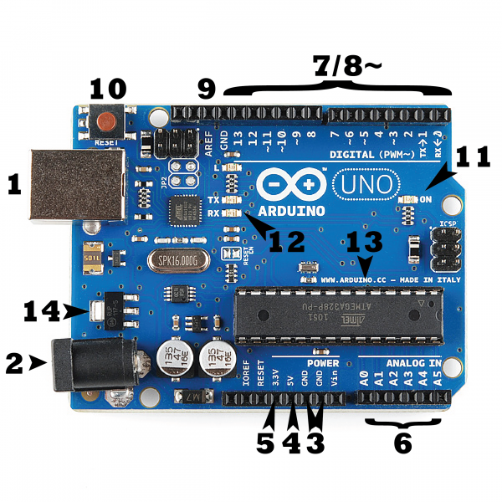

### Power (USB / Barrel Jack)

Every Arduino board needs a way to be connected to a power source. The Arduino UNO can be powered from a USB cable coming from your computer or a wall power supply ([like this](https://www.sparkfun.com/products/8269)) that is terminated in a barrel jack. In the picture above the USB connection is labeled **(1)** and the barrel jack is labeled **(2)**.

### Pins (5V, 3.3V, GND, Analog, Digital, PWM, AREF)

The pins on your Arduino are the places where you connect wires to construct a circuit (probably in conjuction with a [breadboard](https://learn.sparkfun.com/tutorials/how-to-use-a-breadboard/) and some [wire](https://learn.sparkfun.com/tutorials/working-with-wire). They usually have black plastic ‘headers’ that allow you to just plug a wire right into the board. The Arduino has several different kinds of pins, each of which is labeled on the board and used for different functions.

* **GND (3)**: Short for ‘Ground’. There are several GND pins on the Arduino, any of which can be used to ground your circuit.
* **5V (4) & 3.3V (5)**: As you might guess, the 5V pin supplies 5 volts of power, and the 3.3V pin supplies 3.3 volts of power. Most of the simple components used with the Arduino run happily off of 5 or 3.3 volts.
* **Analog (6)**: The area of pins under the ‘Analog In’ label (A0 through A5 on the UNO) are Analog In pins. These pins can read the signal from an analog sensor (like a [temperature sensor](https://www.sparkfun.com/products/10988)) and convert it into a digital value that we can read.
* **Digital (7)**: Across from the analog pins are the digital pins (0 through 13 on the UNO). These pins can be used for both digital input (like telling if a button is pushed) and digital output (like powering an LED).
* **PWM (8)**: You may have noticed the tilde (~) next to some of the digital pins (3, 5, 6, 9, 10, and 11 on the UNO). These pins act as normal digital pins, but can also be used for something called Pulse-Width Modulation (PWM). We have [a tutorial on PWM](https://learn.sparkfun.com/tutorials/pulse-width-modulation), but for now, think of these pins as being able to simulate analog output (like fading an LED in and out).
* **AREF (9)**: Stands for Analog Reference. Most of the time you can leave this pin alone. It is sometimes used to set an external reference voltage (between 0 and 5 Volts) as the upper limit for the analog input pins.

### Reset Button

Just like the original Nintendo, the Arduino has a reset button **(10)**. Pushing it will temporarily connect the reset pin to ground and restart any code that is loaded on the Arduino. This can be very useful if your code doesn’t repeat, but you want to test it multiple times. Unlike the original Nintendo however, blowing on the Arduino doesn't usually fix any problems.

### Power LED Indicator

Just beneath and to the right of the word “UNO” on your circuit board, there’s a tiny LED next to the word ‘ON’ **(11)**. This LED should light up whenever you plug your Arduino into a power source. If this light doesn’t turn on, there’s a good chance something is wrong. Time to re-check your circuit!

### TX RX LEDs

TX is short for transmit, RX is short for receive. , there are two places on the Arduino UNO where TX and RX appear -- once by digital pins 0 and 1, and a second time next to the TX and RX indicator LEDs **(12)**. These LEDs will give us some nice visual indications whenever our Arduino is receiving or transmitting data

### Main IC

The black thing with all the metal legs is an IC, or Integrated Circuit **(13)**. Think of it as the brains of our Arduino. The main IC on the Arduino is slightly different from board type to board type, but is usually from the ATmega line of IC’s from the ATMEL company. This can be important, as you may need to know the IC type (along with your board type) before loading up a new program from the Arduino software. This information can usually be found in writing on the top side of the IC

### Voltage Regulator

The voltage regulator **(14)** is not actually something you can (or should) interact with on the Arduino. But it is potentially useful to know that it is there and what it’s for. The voltage regulator does exactly what it says -- it controls the amount of voltage that is let into the Arduino board. Think of it as a kind of gatekeeper; it will turn away an extra voltage that might harm the circuit. Of course, it has its limits, so don’t hook up your Arduino to anything greater than 20 volts.

# Raspberry Pi

**Raspberry Pi** ([/paɪ/](https://en.wikipedia.org/wiki/Help:IPA/English)) is a series of small [single-board computers](https://en.wikipedia.org/wiki/Single-board_computer). It is widely used in many areas, such as for [weather monitoring](https://en.wikipedia.org/wiki/Automatic_weather_station),[[19]](https://en.wikipedia.org/wiki/Raspberry_Pi" \l "cite_note-19) because of its low cost, modularity, and open design. It is typically used by computer and electronic hobbyists, due to its adoption of [HDMI](https://en.wikipedia.org/wiki/HDMI) and [USB](https://en.wikipedia.org/wiki/USB) devices.

The Raspberry Pi hardware has evolved through several versions that feature variations in the type of the central processing unit, amount of [memory](https://en.wikipedia.org/wiki/Computer_memory) capacity, networking support, and peripheral-device support.

The Raspberry Pi is a very cheap computer that runs Linux, but it also provides a set of GPIO (general purpose input/output) pins, allowing you to control electronic components for physical computing and explore the Internet of Things (IoT).

# Jumper Wire

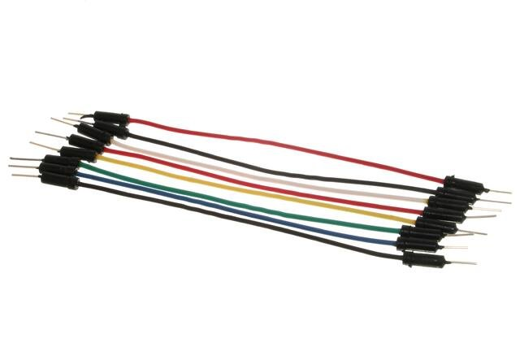

Jumper wires are simply wires that have connector pins at each end, allowing them to be used to connect two points to each other without soldering. Jumper wires are typically used with [breadboards](https://blog.sparkfuneducation.com/what-is-a-breadboard) and other prototyping tools in order to make it easy to change a circuit as needed.

Jumper wires typically come in three versions: male-to-male, male-to-female and female-to-female. The difference between each is in the end point of the wire. Male ends have a pin protruding and can plug into things, while female ends do not and are used to plug things into. Male-to-male jumper wires are the most common and what you likely will use most often

And two types of head shapes: **square head** and **round head**.

Ultrasonic sensor

An ultrasonic sensor is an electronic device that measures the distance of a target object by emitting ultrasonic sound waves, and converts the reflected sound into an electrical signal. Ultrasonic waves travel faster than the speed of audible sound (i.e. the sound that humans can hear). Ultrasonic sensors have two main components: the transmitter (which emits the sound using piezoelectric crystals) and the receiver (which encounters the sound after it has travelled to and from the target).

## Temperature Sensor

A temperature sensor is a device used to measure temperature. This can be air temperature, liquid temperature or the temperature of solid matter.

There are different types of temperature sensors available and they each use different technologies and principles to take the temperature measurement

# Breadboard

An electronics breadboard (as opposed to the type on which sandwiches are made) is actually referring to a **solderless breadboard**. A breadboard is a solderless device for temporary prototype with electronics and test circuit designs. Most electronic components in electronic circuits can be interconnected by inserting their leads or terminals into the holes and then making connections through wires where appropriate. The breadboard has strips of metal underneath the board and connect the holes on the top of the board. The metal strips are laid out as shown below. Note that the top and bottom rows of holes are connected horizontally and split in the middle while the remaining holes are connected vertically.

PIR Sensors

A passive infrared sensor is an electronic sensor that measures infrared light radiating from objects in its field of view. They are most often used in PIR-based motion detectors. PIR sensors are commonly used in security alarms and automatic lighting applications.

PIR sensor can detect infrared radiation that is emitted by particles.

# buzzers

Buzzers, they’re essentially an audio signalling device . Buzzers are electric sounding devices that generate sounds. Typically powered by DC voltage, they can be categorised as Piezo buzzer and magnetic buzzer

# Register

Registers are data storage devices that are more sophisticated than latches. A register is a group of binary cells suitable for holding binary information. A group of cascaded flip-flops used to store related bits of information is known as a register.

## LED

A light-emitting diode (LED) is a semiconductor device that emits light when an electric current flows through it.

LEDs have a wide range of applications ranging from your mobile phone to large advertising billboards. They mostly find applications in devices that show the time and display different types of data.

LEDs work on the principle of Electroluminescence. On passing a current through the diode, minority charge carriers and majority charge carriers recombine at the junction. On recombination, energy is released in the form of photons. As the forward voltage increases, the intensity of the light increases and reaches a maximum.

**Servomotor**

 A **servomotor** (or servo motor) is a simple electric motor, controlled with the help of servomechanism. If the motor as a controlled device, associated with servomechanism is [DC motor](https://www.electrical4u.com/dc-motor-or-direct-current-motor/), then it is commonly known as a **DC Servo Motor**. If AC operates the controlled motor, it is known as a AC Servo Motor.

Soil Moisture Sensor

A Soil Moisture Sensor is one kind of low-cost electronic sensor that is used to detect the moisture of the soil. This sensor can measure the volumetric content of water inside the soil. This sensor is consists of mainly two parts, one is **Sensing Probs** and another one is the **Sensor Module**. The probes allow the current to pass through the soil and then it gets the resistance value according to moisture value in soil. The Sensor Module reads data from the sensor probes and processes the data and converts it into a digital/analog output. So, the Soil Moisture Sensor can provide both types of output **Digital output (DO)** and **Analog output(AO)**.

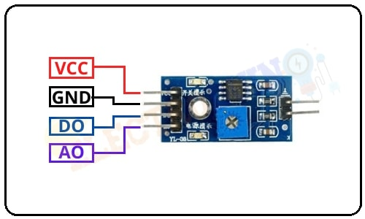

|  |  |  |
| --- | --- | --- |
| **Pin Number** | **Pin Name** | **Description** |
| 1 | **VCC** | +5 v power supply |
| 2 | **GND** | Ground (-) power supply |
| 3 | **DO** | Digital Output  (0 or 1) |
| 4 | **AO** | Analog Output  (range 0 to 1023) |

## [relay switches](https://www.bing.com/ck/a?!&&p=79b5e006a1efc4eab09d0cb19910253c193a019a73f49b721e5a5c84c9a9eaddJmltdHM9MTY1NDU5MjQ4NyZpZ3VpZD1jMDlhOWU5ZS03OGJjLTQ0OTctODFiYy0xZTg3NWE0YzU0MmUmaW5zaWQ9NTY5OQ&ptn=3&fclid=6a02805a-e640-11ec-8460-54ec696f6283&u=a1L3Nob3A_cT1yZWxheStzd2l0Y2hlcyZGT1JNPVNIT1BQQSZvcmlnaW5JR1VJRD1DMDlBOUU5RTc4QkM0NDk3ODFCQzFFODc1QTRDNTQyRQ&ntb=1)

Relays control circuits by opening and closing contacts in another circuit. It take a relatively small amount of power to operate the coil, but this itself can be used to control motors, heaters, lamps or AC circuits which themselves can draw a lot more electrical power.

These switches are used to open and close circuits electromechanically or electronically. When the contact is open, it is not energized. When it is closed, there is a closed contact when it is not energized. In either case, applying an electrical current to the contacts will change their state.

They are generally used to switch smaller currents in a control circuit and do not usually control power consuming devices except for small motors and Solenoids that draw low amps. Nonetheless, It can “control” larger voltages and amperes by having an amplifying effect because a small voltage applied to a coil can result in a large voltage being switched by the contacts.