Xbee to Pi
///////////////////////////////////////////////////////////////////////////////////////////////////////////////////////////
make zigbee coordinator to API mode using XCTU,
install xbee library to Rpi using source code found in link :https://pypi.python.org/pypi/XBee
and sudo python setup.py install
zigbee endnode to AT mode .
////////////////////////////////////////////////////////////////////////////////////////////////////////////////////////
use code in RPI:
“””
This example continuously reads the serial port and processes IO data
received from a remote XBee.
"""
from xbee import ZigBee
import serial
import struct
import time
def hex(bindata):
return ''.join('%02x' % ord(byte) for byte in bindata)

PORT = '/dev/ttyUSB3'
BAUD_RATE = 9600

# Open serial port
ser = serial.Serial(PORT, BAUD_RATE)

# Create API object
xbee = ZigBee(ser,escaped=True)

# Continuously read and print packets
while True:
try:
response = xbee.wait_read_frame()
print response
sa=hex(response['source_addr_long'][4:])
#rf=hex(response['rf_data'][0:5])
#datalength=len(rf)

print(time.strftime('%x %X %Z'),' ',response['source_addr_long'][4:7]+response['source_addr_long'][7:],response['rf_data'][0:2])

except KeyboardInterrupt:
break

ser.close()
/////////////////////////////////////////////////////////////////////////////////////////////////////////
useful link:
https://serdmanczyk.github.io/XBeeAPI-PythonArduino-Tutorial/
https://pypi.python.org/pypi/XBee
https://github.com/andrewrapp/xbee-arduino
https://resources.oreilly.com/examples/9780596807740/
///////////////////////////////////////////////////////////////////////////////////////////////////////

arduino-> xbee <---> xbee ->pi3

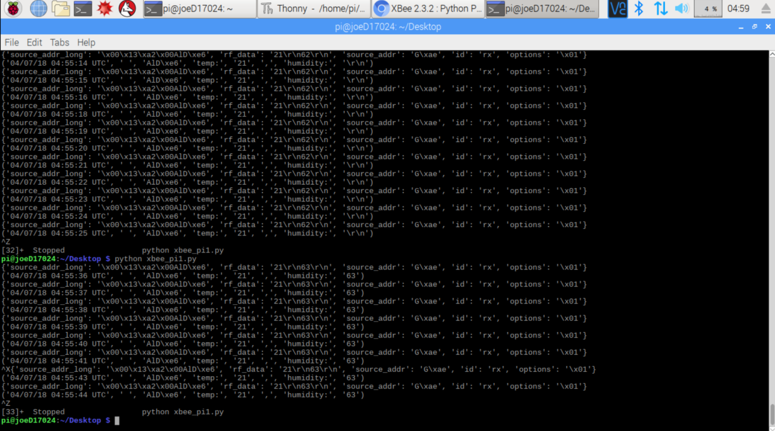
arduino code

//dht11
#include "DHT.h" // including the library of DHT11 temperature and humidity sensor
#define DHTTYPE DHT11 // DHT 11
#define dht_dpin 8
DHT dht(dht_dpin, DHTTYPE);

int t;
int h;

void setup() {
dht.begin();
//delay(1000);
pinMode(LED_BUILTIN, OUTPUT);
Serial.begin(9600);

}

void loop() {
digitalWrite(LED_BUILTIN, HIGH);
h = dht.readHumidity();
t = dht.readTemperature();
Serial.println(t);
//Serial.print(",");
Serial.println(h);

delay(1000);
}
////////////////////////////////////////////
python code

"""
by joe
This example continuously reads the serial port and processes IO data
received from a remote XBee.
"""

from xbee import ZigBee
import serial
import struct
import time
def hex(bindata):
return ''.join('%02x' % ord(byte) for byte in bindata)

PORT = '/dev/ttyUSB3'
BAUD_RATE = 9600

# Open serial port
ser = serial.Serial(PORT, BAUD_RATE)

# Create API object
xbee = ZigBee(ser,escaped=True)

# Continuously read and print packets
while True:
try:
response = xbee.wait_read_frame()
print response
sa=hex(response['source_addr_long'][4:])
#rf=hex(response['rf_data'][0:5])
#datalength=len(rf)

print(time.strftime('%x %X %Z'),' ',response['source_addr_long'][4:7]+response['source_addr_long'][7:],"temp:",response['rf_data'][0:2],",","humidity:",response['rf_data'][4:6])

except KeyboardInterrupt:
break

ser.close()
//////////////////////////////////////////////////////////////////////////////////////

