EE592P- Selected Topics on IoT
Assisgnment 2
2-D mapping of objects using HC-SR04 sensor + Arduino/RPi

1) Fritzing circuit diagram of your setup
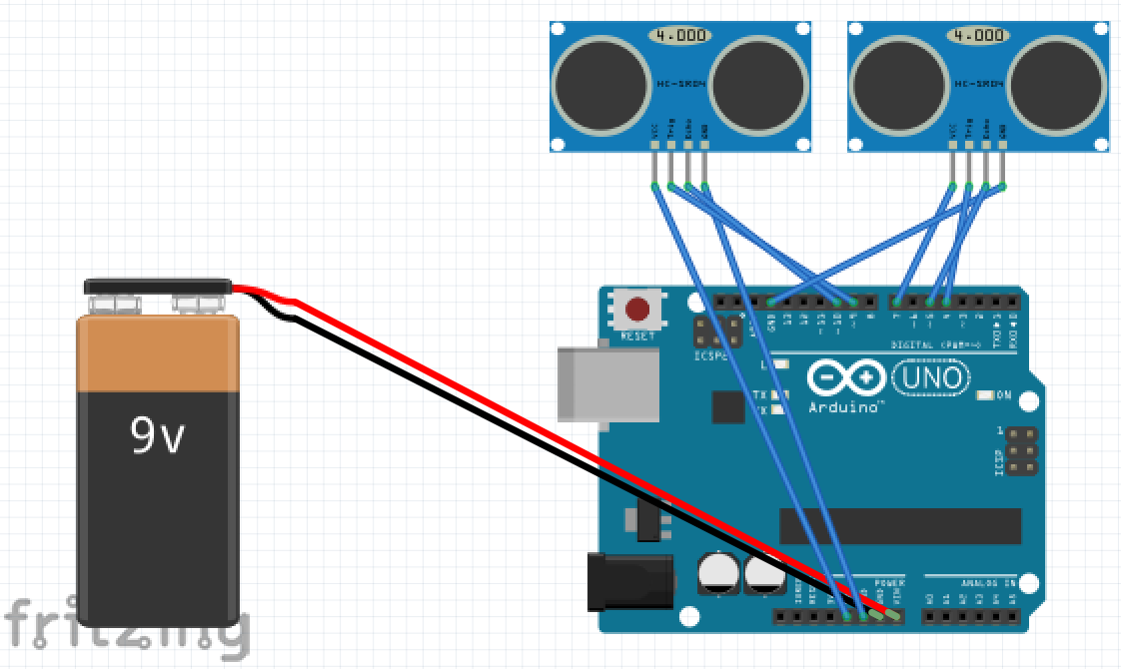
2) Code
Arduino code
#define trigPin1 9
#define echoPin1 10
#define trigPin2 4
#define echoPin2 5
int power_us = 7;
long duration, distance, X_Sensor,Y_Sensor;
void setup()
{
Serial.begin (9600);
pinMode(trigPin1, OUTPUT);
pinMode(echoPin1, INPUT);
pinMode(trigPin2, OUTPUT);
pinMode(echoPin2, INPUT);
pinMode(power_us, OUTPUT);
}
void loop() {
digitalWrite(power_us, HIGH);
SonarSensor(trigPin1, echoPin1);
if (distance>=100){
distance=100;
}
X_Sensor = distance*5;
SonarSensor(trigPin2, echoPin2);
if (distance>=100){
distance=100;
}
Y_Sensor = distance*5;
Serial.print(X_Sensor);
Serial.print(",");
Serial.println(Y_Sensor);
delay(20);
}
void SonarSensor(int trigPin,int echoPin)
{
digitalWrite(trigPin, LOW);
delayMicroseconds(2);
digitalWrite(trigPin, HIGH);
delayMicroseconds(10);
digitalWrite(trigPin, LOW);
duration = pulseIn(echoPin, HIGH);
distance = (duration/2) / 29.1;
}

Processing code

//us _XYplot_joe_D17024
import processing.serial.*;
Serial myPort;
//int values;
int[] values=new int[2];
float xPos=0;
float yPos=0;

void setup(){
size(500,500);
printArray(Serial.list()); //list all the available serial ports
String portName = Serial.list()[0];//index 1 in serial list for arduino
myPort = new Serial(this, portName, 9600);//don't generate a serialEvent() until you get a newline character
myPort.bufferUntil('\n');
}

void draw(){
/*if (myPort.available()>0) {
values=myPort.read();
}*/
background(255); //0for blk and 255 for white
stroke(0,0,200);
strokeWeight(5);
line(values[0],0,values[0],values[1]);
stroke(0,200,0);
line(0,values[1],values[0],values[1]);
}
void serialEvent(Serial myPort){

String inString=myPort.readStringUntil('\n');//get the ASCII string

if(inString!=null){
inString=trim(inString);//trim off any whitespace
values=int(splitTokens(inString,", \t")); //split the string, delimiter can be comma or tab
printArray(values);
}
}
3) Actual demonstration in class
