Introduction

In the given assignment, three dataset type of two-dimensional feature vector is given with three class. Each dataset of which 75 percentage of data to be used for training and rest for testing. Decisions should be based fundamentally on task or cost specific. For all the dataset the classifier used is Bayes classifier which is known statistical pattern recognition and non-discriminatory learning method. Its determinant function is in terms of probability, assumption made for class-conditional densities are natural or Gaussian densities due to its analytical track-ability (1). With intention of easy assessment, decision region and training data will be plotted in following colour and symbol throughout the report i.e., class region and training data will plotted using symbols ‘.’ and ‘*’ respectively. Red, green and blue colours are for class1, class2 and class3 representation respectively. Each dataset is superposed by its two dimensional contours of hyperellipsoidals which measures the scale of scatter of samples about the mean, plotted in black colour. For programming Matlab software is used and a generalized two programs with interactive features are made for artificial and real datasets respectively. Report has been divided into four sections according to different cases for Bayes classifier and subsections consisting of performance derivations from confusion matrix, confusion matrix based on test data, decision region plot for every pair of classes together with training data superposed, decision region plot for all classes together with the training data superposed and observations. Bayes’ formula for feature vector x given that state of nature is W1 and known both prior probabilities and conditional densities is given by:
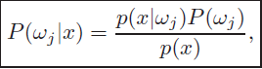
F11
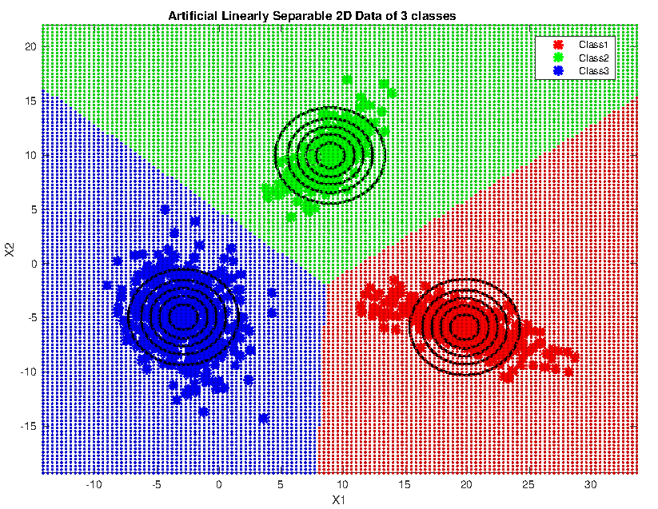
-This is the simples case and is also called as Naive Bayes classifier.
-For this case, the covariance matrix has same variance and off-diagonal covariance matrix value are equal to zero such that features are statistically independent and such matrix is also called isotropic covariance matrix.
-Geometrically, this corresponds to the situation in which the samples fall in equal-size hyperspherical clusters, the cluster for the ith class being centered about the its mean vector.
- The computation of the determinant and the inverse of covariance matrix is particularly easy.

-it can be observed that for this case the discriminant functions are linear.
-the covariances of each pair of distributions are equal and proportional to the identity matrix, then the distributions are spherical in two dimensions, and the boundary is a generalized hyperplane of one dimension or line, perpendicular to the line separating the mean vectors.
-wi0 the threshold or bias
-A classifier that uses linear discriminant functions is called a linear machine.
-This equation defines a hyperplane through the point x0 and orthogonal to the vector w. Since w = μi − μj , the hyperplane separating Ri and Rj is orthogonal to the line linking the means.
- If P(ωi) = P(ωj ), the second term on the right of vanishes, and thus the point x0 is halfway between the means, and the hyperplane is the perpendicular bisector of the line between the means.
-The optimum decision rule can be stated very simply: to classify a feature vector x, measure the Euclidean distance x − μi from each x to each of the c mean vectors, and assign x to the category of the nearest mean.
-Such a classifier is minimum called a minimum distance classifier.
-major and minor axis of contour are parallel to coordinate axis

Fc1c2
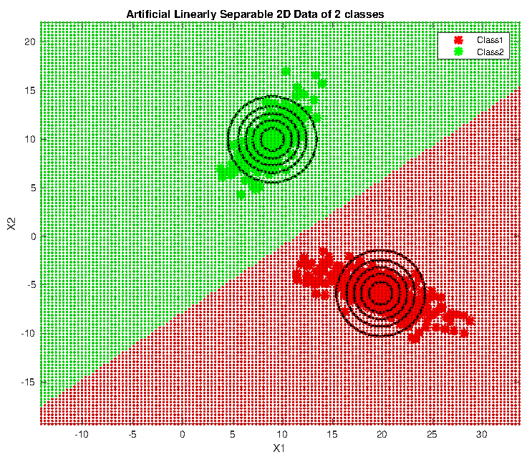
-discriminant functions
gi(x) > gj(x) for all j = i.
-The two-category case is just a special instance of the multicategory case, it has traditionally received separate treatment.
-classifier that places a pattern in one of only two categories has a special name — a dichotomizer. -Thus, a dichotomizer can be viewed as a machine that computes a single discriminant function g(x), and classifies x according to the algebraic sign of the result.
-The sample space is divided into two region by applying the feature vector in discriminant functions.
-Contour is circular from top view as the covariance matrix is diagonal and equal variance.
f11c2c3

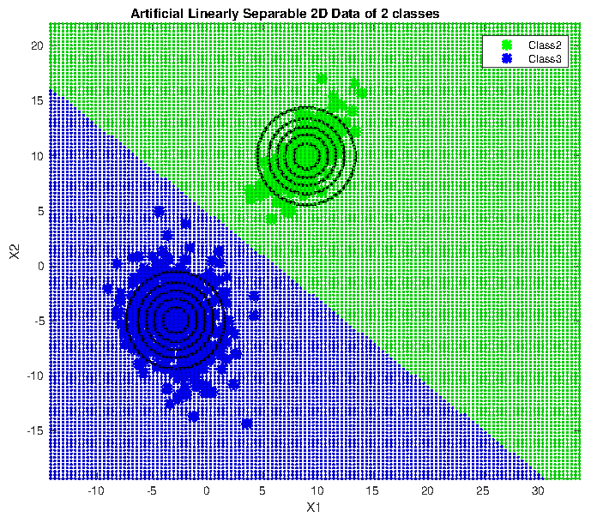
f11c3c1
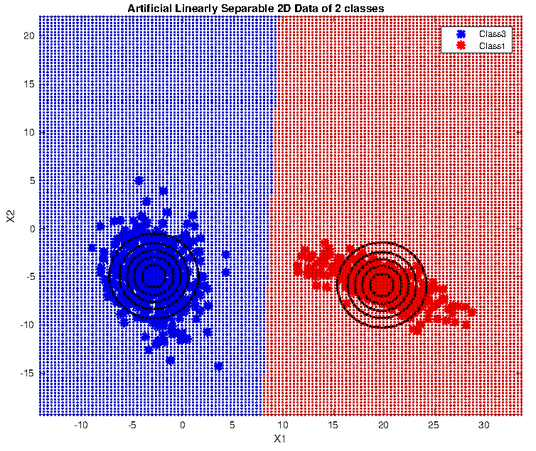
f11 cdc
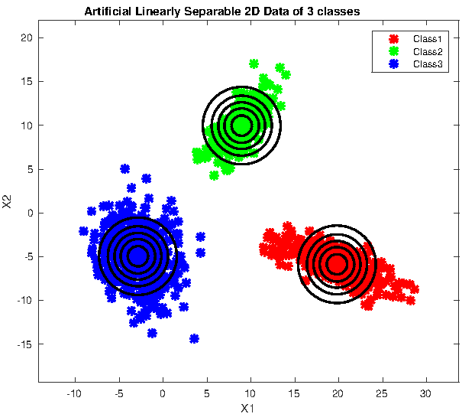
f12
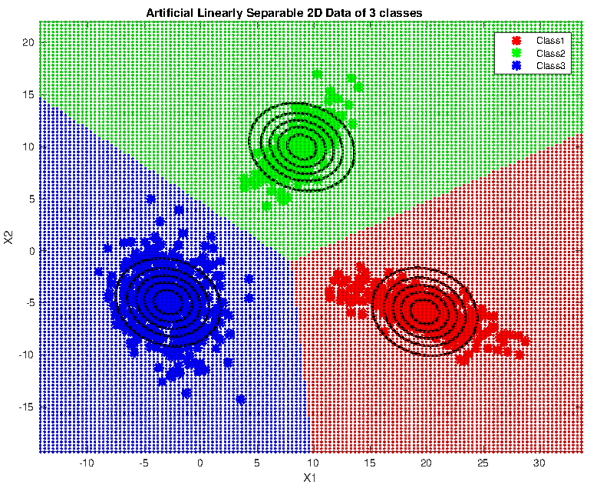
-covariance matrix same for all and arbitrary
-shape of constant density contour are identical with different mean
-major and minor axis of contour is not parallel to coordinate axis
-hyperplane will not be orthogonal to line joining the two mean vector.
-linear decision boundary

The covariance matrices for all of the classes are identical but otherwise arbitrary. Geometrically, this corresponds to the situation in which the samples fall in hyperellipsoidal clusters of equal size and shape, the cluster for the ith class being centered about the mean vector μi. Since both |Σi| and the (d/2) ln 2π term in Eq. 47 are independent of i, they can be ignored as superfluous additive constants.
prior probabilities P(ωi) are the same for all c classes, then the ln P(ωi) term can be ignored.
In this case, the optimal decision rule can once again be stated very simply: to classify a feature vector x, measure the squared Mahalanobis distance (x − μi)tΣ−1(x − μi) from x to each of the c mean vectors, and assign x to the category of the nearest mean
Since w = Σ−1(μi −μj) is generally not in the direction of μi −μj , the hyperplane separating Ri and Rj is generally not orthogonal to the line between the means.
However, it does intersect that line at the point x0 which is halfway between the means if the prior probabilities are equal.
The decision hyperplanes need not be perpendicular to the line connecting the means.

f12c1c2
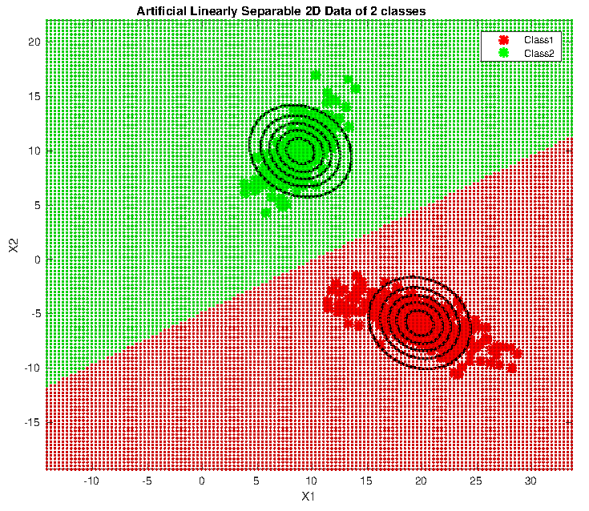
f12c2c3
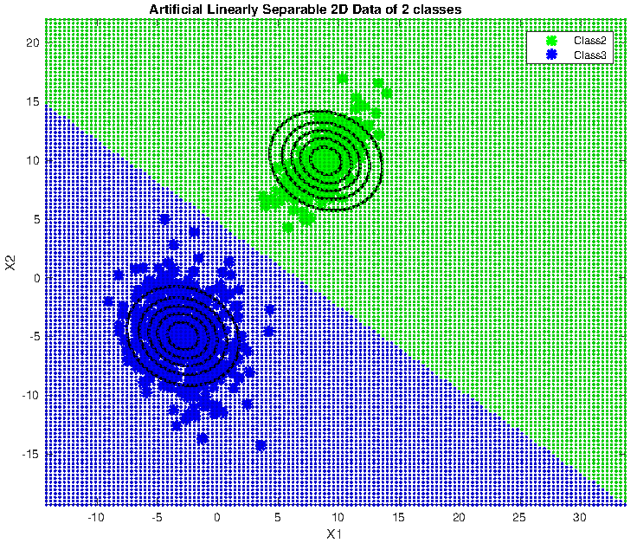
f12c3c1
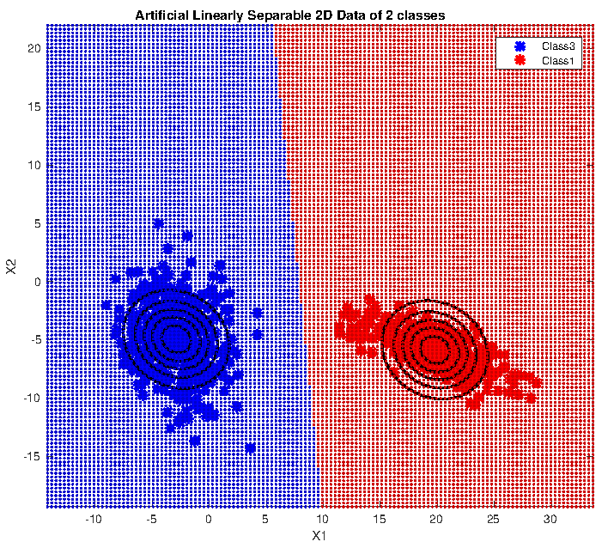
f12cdc
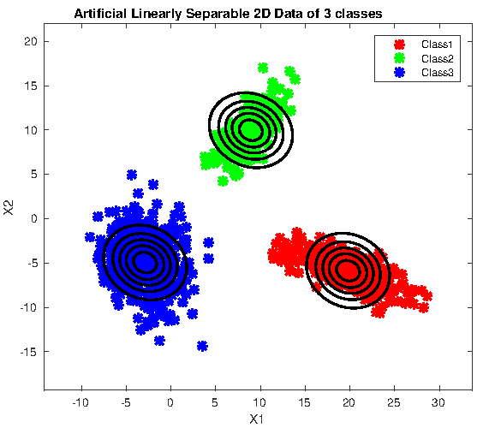
f13
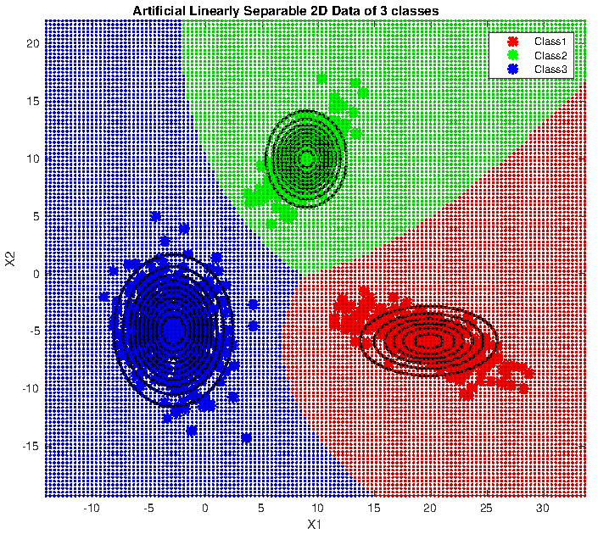
f13c1c2
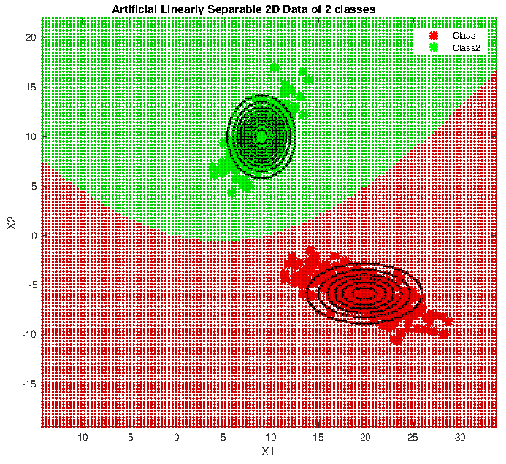
f13c2c3
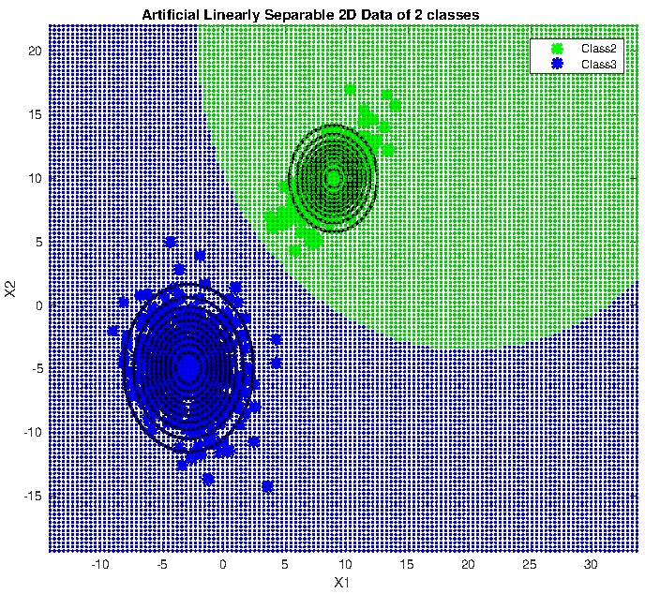
f13c3c1
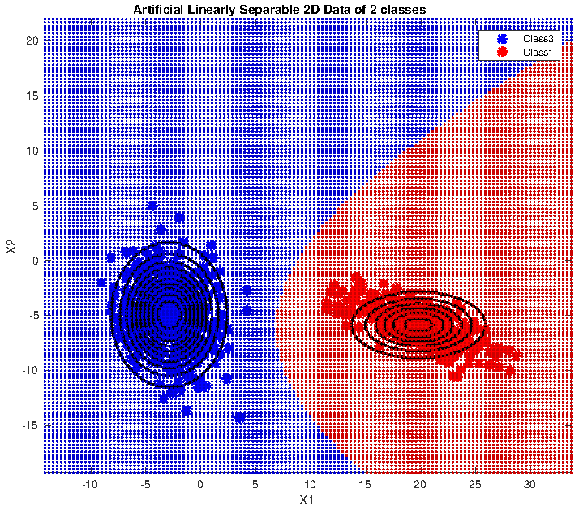
f13cdc
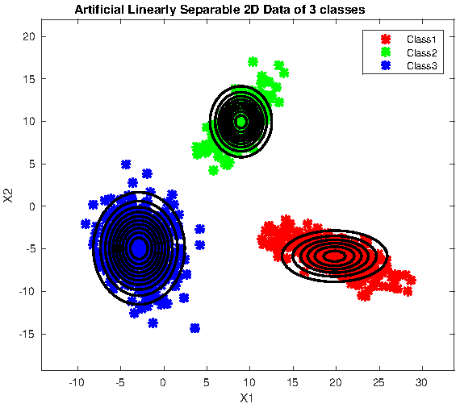
f14
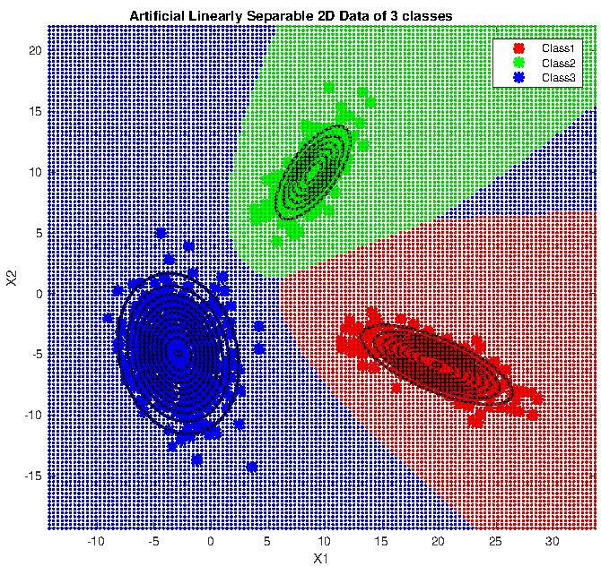
-covariance matrix is full and different for each class
-discriminant functions are inherently quadratic
-decision region is hyperbola
-decision surfaces are hyperquadrics.
-because of class 1 distribution, the probability distribution is “squeezed” more than for class 2 distribution.
-squared Mahalanobis distance from x to μ.
-the contours
distance of constant density are hyperellipsoids of constant Mahalanobis distance to μ and the
volume of these hyperellipsoids measures the scatter of the samples about the mean.
-hyperplanes, pairs of hyperplanes, hyperspheres, hyperellipsoids, hyperparaboloids, quadric
and hyperhyperboloids of various types
-Arbitrary Gaussian distributions lead to Bayes decision boundaries that
are general hyperquadrics.
-The decision regions for four normal distributions. Even with such a low
number of categories, the shapes of the boundary regions can be rather complex.

f14c1c2
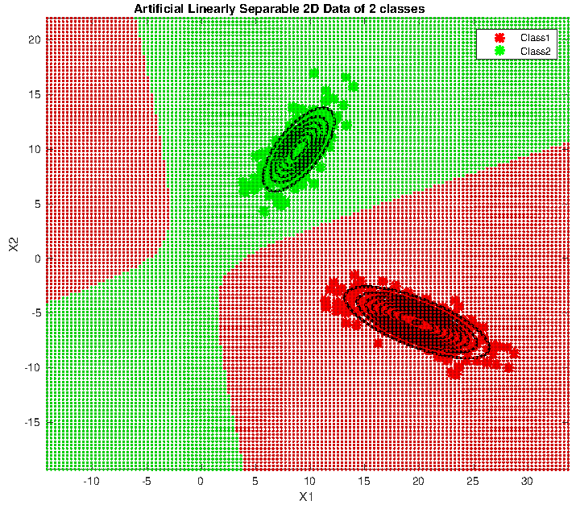
f14c2c3
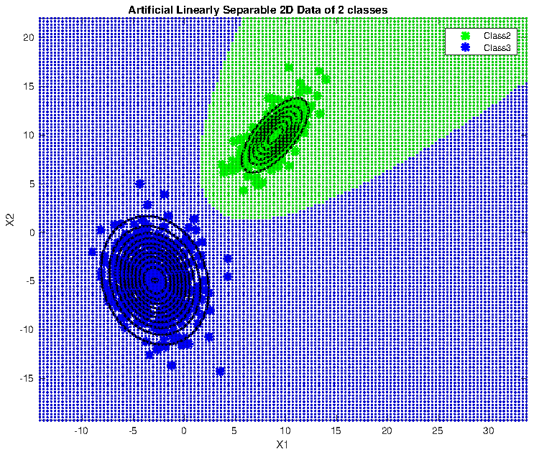
f14c3c1
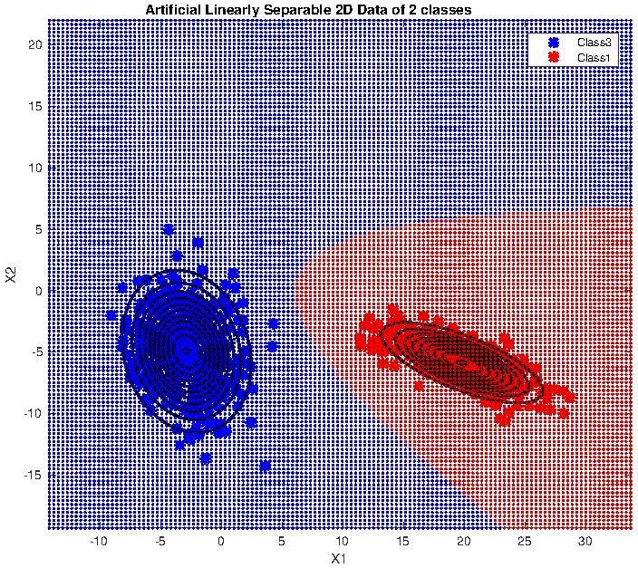
f14cdc
