Custody proposal for BlackRock
Appoint Citigroup as successor custodian for SLV, combining bullion safekeeping with trading execution and a 50:50 share of net trading revenue with BlackRock.

Custody flows and the trading opportunity

Deployment and tariff scenarios
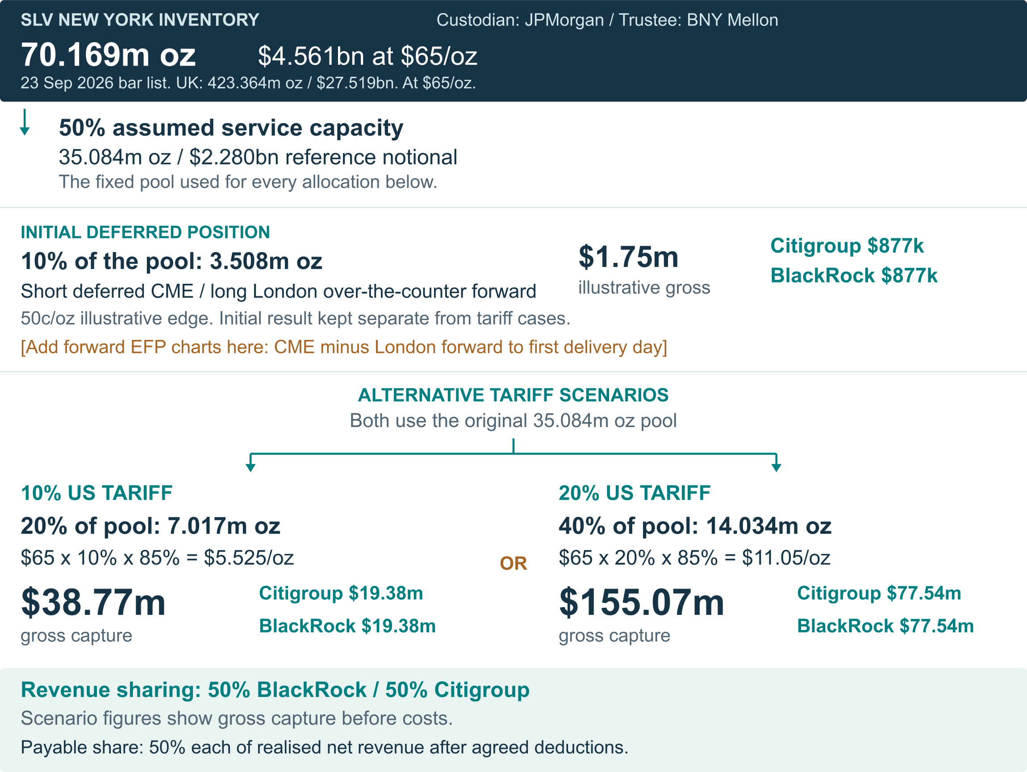

Custody flows and the trading opportunity

Worked example: 50 lots / 250,000 oz · CME premium
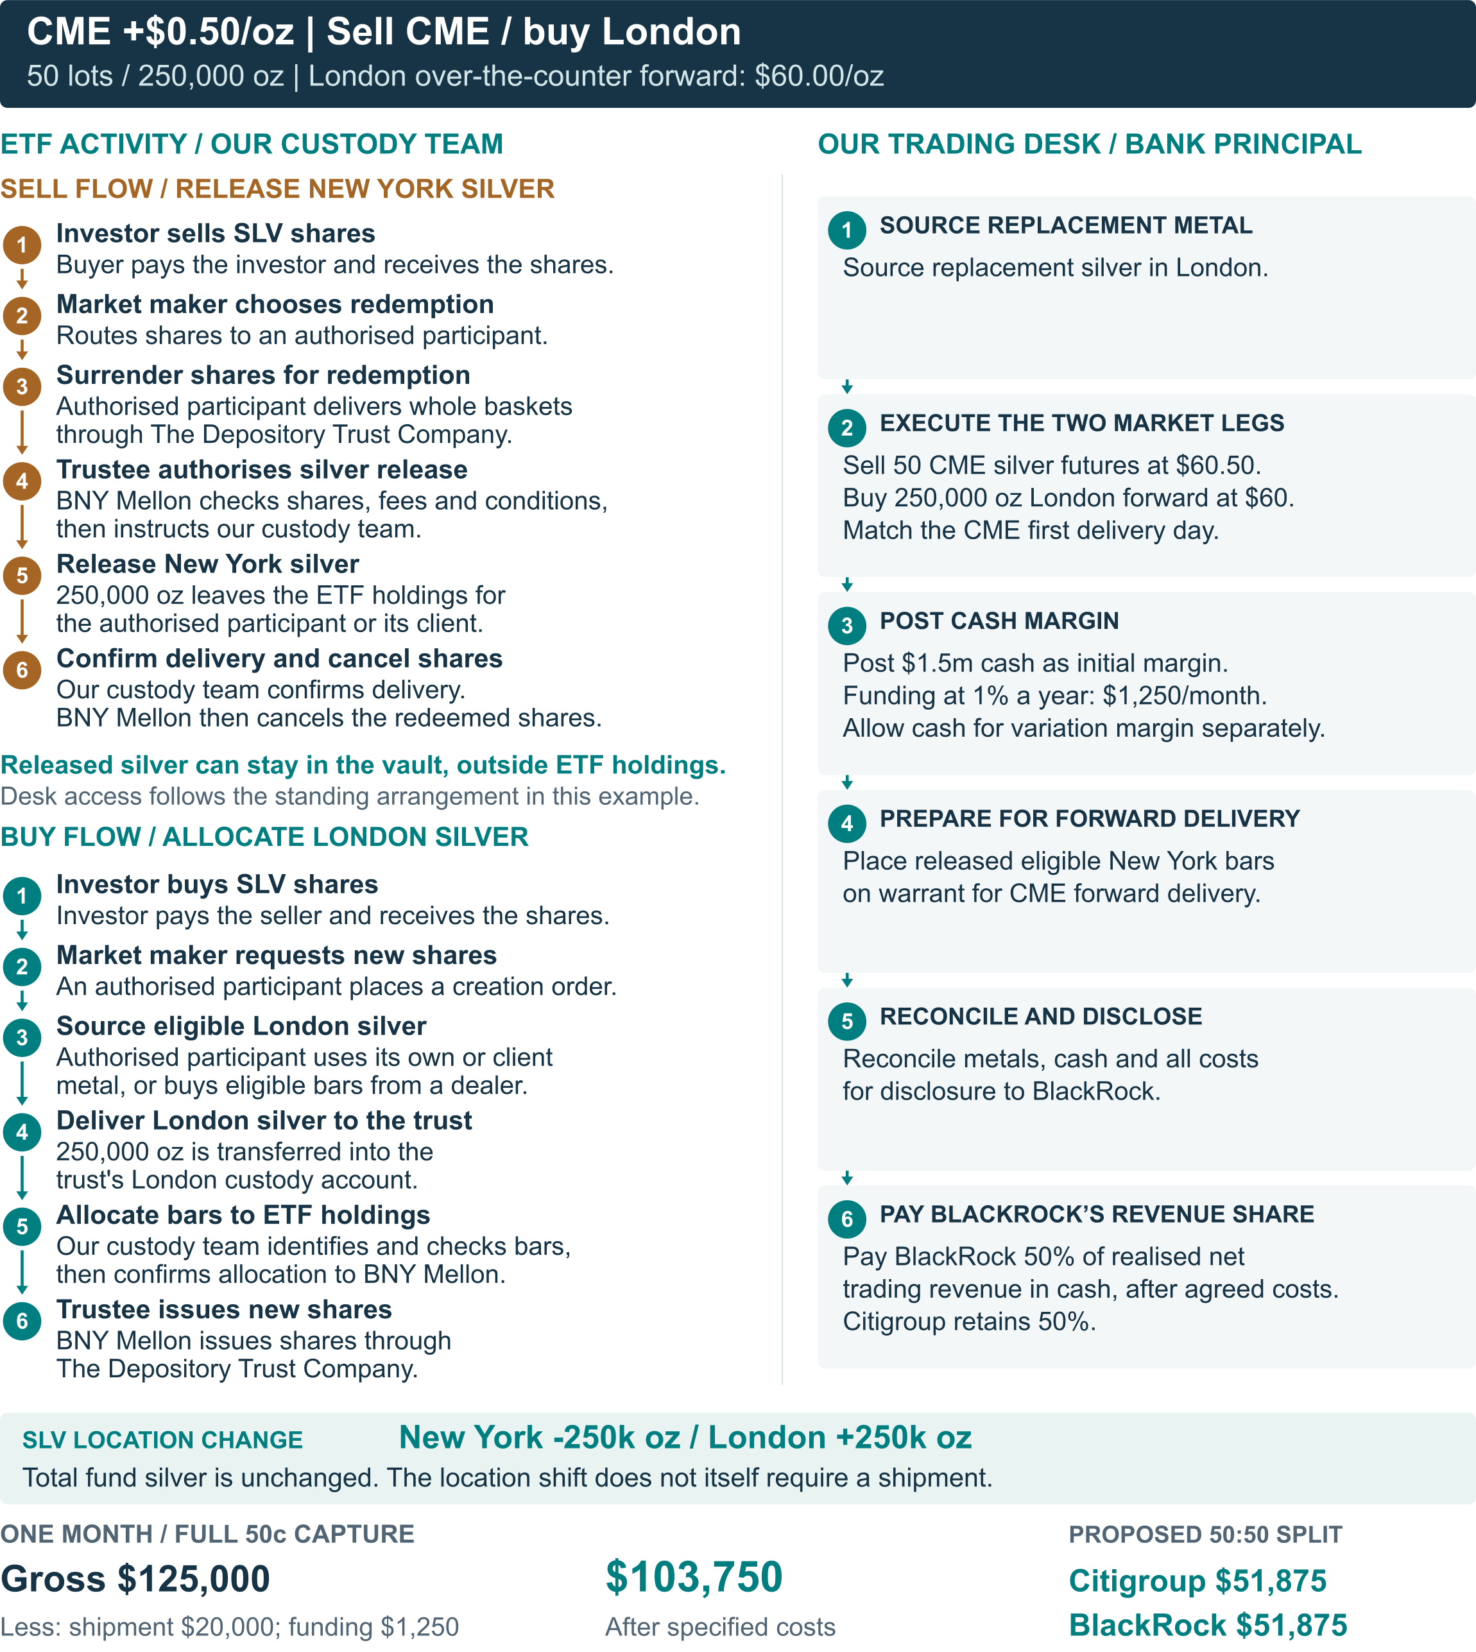

Custody flows and the trading opportunity

Worked example: 50 lots / 250,000 oz · CME discount
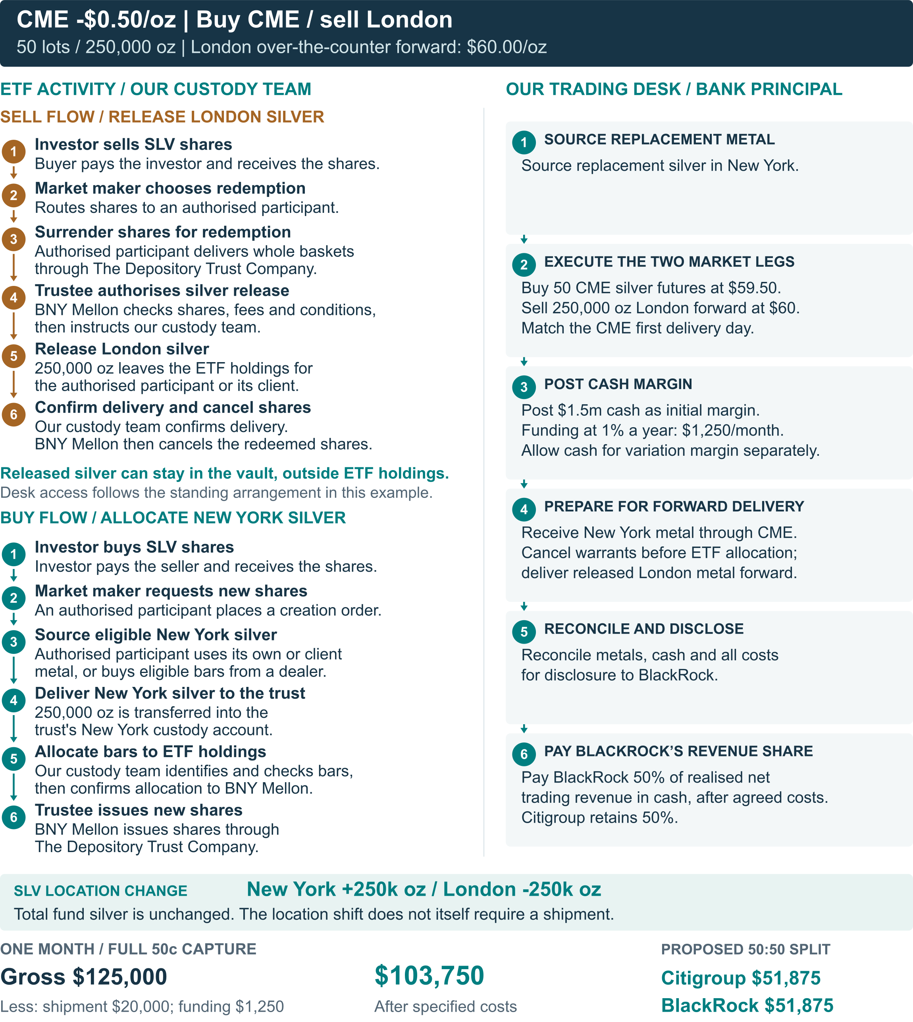

Revenue sharing

Turn physical logistics bottlenecks into revenue opportunities.
Combine custody, inventory positioning and Citi’s trading reach to capture value when metal is scarce in one location and available in another. Share the realised net trading revenue equally with BlackRock.

Future growth ideas
Grow the Citigroup / BlackRock revenue share and partnership.
FIRST-EVER AMBITION  A dividend from location revenue  Aim to be the first physical precious-metals ETF to pay a dividend funded by location revenue. Reinvest part of BlackRock’s share in a distinctive investor proposition. |  | BONDED MARKET ACCESS  India, China and IIBX  Add approved bonded locations: IIBX routes in India and international gold vaults in China. Aim to reduce onshore customs friction; use Citi’s client base and expertise to monetise regional dislocations.

NEW MULTI-LOCATION FUNDS  Platinum and palladium  Extend the revenue-share model to more metals and locations. Our desk expects higher tariff risk in platinum and palladium, opening more opportunities to capture dislocations. |  | TRADING OPTIONALITY  More bar formats and purities  Approve commonly traded shapes, sizes and purities. Give Citi’s desk more sourcing and delivery choices to capture location and format spreads for the shared revenue pool.

Operational and regulatory risk
Tariff uncertainty shifts demand. A multi-location custody network creates more ways to respond.
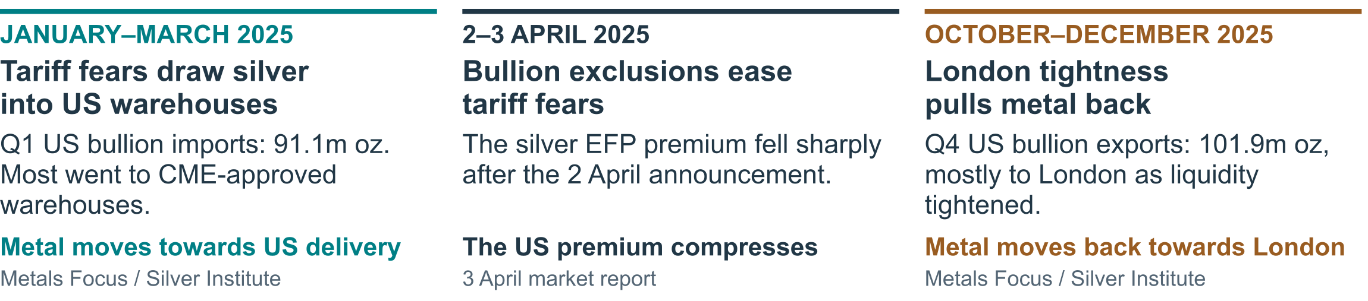
PROTECT THE METAL  Insurance and security  Insured custody, secure transport and independent bar audits across the vault network. |  | KEEP FLOWS MOVING  Settlement and liquidity  Coordinate metal availability, cash and release instructions as creations and redemptions settle. |  | MANAGE LOCATION  Customs and geography  Build origin, tariff treatment and bonded routes into inventory and delivery decisions.

Operational innovation
Citi is already delivering blockchain-enabled cash payments.
“Citi’s Services Business Pioneers Live Transactions on Swift’s Ledger”
Citi headline excerpt · 2 September 2026
LIVE CASH SERVICE  24/7 payments  Siam Commercial Bank went live with Citi’s integrated Token Services and USD Clearing in July 2026. |  | RECENT MILESTONE  Minutes, on a weekend  DBS and Citi completed a Singapore–US payment in minutes on 5 September, using Swift’s ledger pilot. |  | PARTNERSHIP OPPORTUNITY  Connect cash and metal  Bring eligible cash services into BlackRock’s workflow: payment, title confirmation and shared reconciliation.

Proposed appointment and next steps
The ask: a joint custody and execution assessment with BlackRock, the trustee and authorised participants.
Agree the custody mandate, revenue-sharing terms and transition plan with BlackRock, the trustee and authorised participants.

