**MIND STORM SOFTWARE PVT LTD **  
**Google App Engine Training**

# ExamResults – Step 1 – Basic Application Template and

In this session, we will generate the following:

1. Basic Application Template for ExamResults application
2. Deploy the application in Google App Engine cloud.

# Generate New Project for ExamResults

We will generate the default template for the application using the New Project Wizard of the Google Eclipse Plugin.

Follow these steps:

* Click **File 🡪 New 🡪 Project ...** . This will bring up the New Project dialog as shown below. Select **Google 🡪 Web Application Project** and click on **Next.**

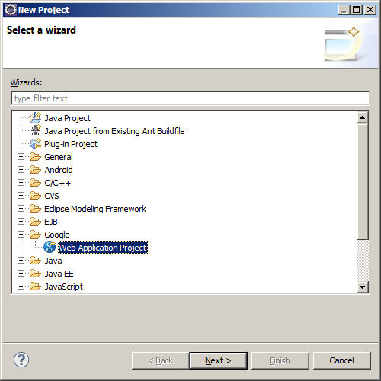

* This will bring up the project details project which you will need to fill up as shown below:
  + **Project Name** : Enter this as ExamResults
  + **Package**: Enter a unique package name. This is the same as a Java package name. Select any one of your choice. E.g. **com.<some-company-name>.app-name** is a good convention to go with. E.g. **com.mindstormsoftware.examresults**
  + Deselect the Google Web Toolkit option
  + Ensure that the latest/default version of App Engine is selected. If you have multiple versions of SDK installed, you can select any one of them. For our scenario, most likely you will have just one version of the SDK installed.

Click on **Finish** button. This will generate the Eclipse project.

# Running the Application

1. Select the project **ExamResults** in the Eclipse Package Explorer
2. Right-click and select **Run As 🡪 Web Application**
3. This will start the Jetty Web Server locally and deploy your web application to it. On successful starting up, you should see the following message in your Eclipse Console View.

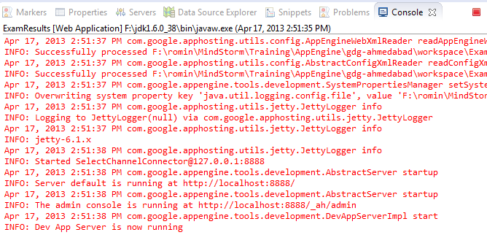

*If you do not see the Console View in your Eclipse IDE, select* ***Window* 🡪 *Show View* 🡪 *Console*** *from the main menu*

1. The Web Server runs on default port 8888.
2. To visit your application, launch your browser and visit <http://localhost:8888>. This should bring up the default **index.html** page as shown below:

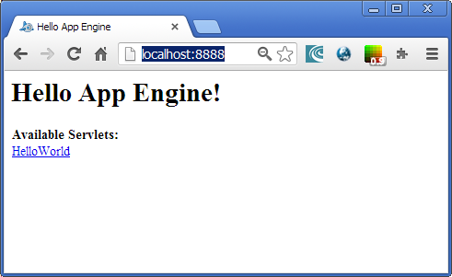

1. When you click on Hello World link, it will invoke the **Java Servlet** mapped on **/examresults** url and which will stream out the Hello World response as shown below:

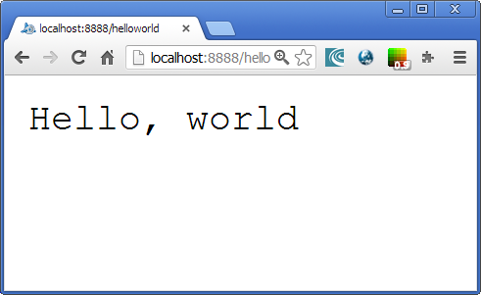

# Deploy the App Engine application

We should also deploy the application to the App Engine cloud so that we complete that step right now.

* Ensure that you have successfully signed up for Google App Engine and that your account has been verified.
* Create an Application using the application at <http://appengine.google.com> . Note down the Application Id that you successfully got. Assume that is **<APPID>.**
* Login to your Google Account from Eclipse. You will see in the right bottom corner, the following : 
* Click on the link and follow the instructions to login to your Google App Engine Account. If it prompts you to request for your permission, please allow it by clicking on **Allow Access.**
* Once you are successfully logged in, it will display your account id in the right bottom corner and which means that you are logged in. Eclipse will remember this across restarts too, so it is not required to login every time.
* Now that we are logged in, it is time to deploy the application. Select the project **ExamResults** in the Eclipse Package Explorer
* Right-click and select **Google 🡪 Deploy to App Engine** as shown below:

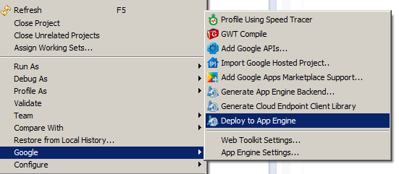

* This will bring up the dialog that will complain that you do have **not set an application ID.** Click on **App Engine project settings** and enter your **<APPID>** in the **Application Id** field. Click on OK to move forward and then **Deploy** button to deploy the application.
* It will take a while since this will package and upload the web application and load it to the Google Servers.
* On successful deployment you can access your application directly in the browser with the following URL: http://<APPID>.appspot.com