**MIND STORM SOFTWARE PVT LTD **  
**Google App Engine Training**

# ExamResults – Step 6 – Cron Job

In this session, we are going to see how to write a Cron Job. A Cron Job is any code that you wish to execute repeatedly at a certain time.

Examples include:

* Fetch the latest news every 1 hour
* Update App statistics every 6 hours
* Check system to send any email reminders every 12 hours
* Take a backup every week on Wednesday at 12:00 AM

**Add schedules to cron.xml**

Cron Schedules are specified in a **cron.xml** file that is placed in the **/WEB-INF** directory. It can contain multiple entries and for each job, it will tell the schedule and what code to execute.

The code to be executed is specified as a URL that points to your Servlet that will get invoked automatically.

An example of the cron.xml file is shown below:

<cronentries>

<cron>

<url>/cron/checkstatus</url>

<description>Check Status every 60 minutes</description>

<schedule>every 60 minutes</schedule>

</cron>

</cronentries>

This file contains one cron entry. It is scheduled to run every 60 minutes. The scheduling is taken care of by App Engine. And when it is time for the Cron Job to fire, App Engine will simply invoke the end point that you have specified in the **<url>** element for your cron job entry above.

In our case, it will invoke the **/cron/checkstatus** url, so all we have to do next is to write a servlet that will contain our functionality and specify the mapping in the **web.xml** file with the above url.

# Add the Cron Job Servlet (ExamResultsEmailHandlerServlet.java)

We will write a new Servlet **CheckStatusCronJobSerlvet.java** that will only print a dummy message that it is executing. In reality, you will put in your logic over there but the idea here is to demonstrate the mechanism.

Refer to **hands-on-exercises/Exam Results App/ExamResults-Step 6** for full project source code. You can also import it directly into Eclipse and study the code.

The Steps to import the project are:

1. Click on **File --> Import**
2. Select **General --> Existing Projects into Workspace.** Click on **Next.**
3. In the **Import Projects** dialog, Browse to the folder **hands-on-exercises/Exam Results App/ExamResults-Step 6** and tab out
4. It should show a dialog as given below. Select the Exam Results-Step6 project and ensure that Copy projects into workspace is checked as given below:

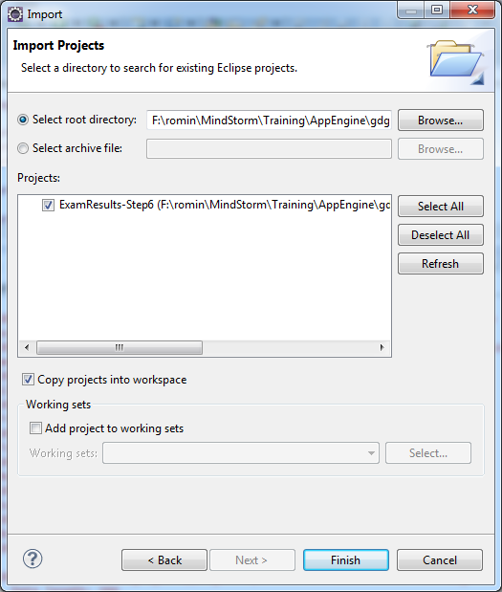

1. Click on Finish.
2. **Resolve AppEngine SDK:** Select your App Engine SDK. For that, select the Project, Right-click and go to Properties. Then visit Java Build Path and in the Order and Export tab, select the App Engine SDK that you have installed and click on OK.

Take a look at the source code for the **CheckStatusCronJobSerlvet..java**. The entire source code is present in **hands-on-exercises/Exam Results App/step 6/src/com/mindstormsoftware/examresults/ CheckStatusCronJobSerlvet.java** file

You will find that it is a normal Java Servlet and in the doGet() method, it logs the fact that it is executed and as a sample, we get the latest Twitter tweet for a particular hashtag and send it via an IM. You can always replace this functionality with any other functionality that you want.

# Add Servlet entry to web.xml

We need to add the servlet entry to **web.xml**. Add the following servlet entries to **web.xml**

<!-- Cron Jobs Handler -->

<servlet>

<servlet-name>CheckStatusCronJob</servlet-name>

<servlet-class>com.mindstormsoftware.examresults.CheckStatusCronJobServlet</servlet-class>

</servlet>

<servlet-mapping>

<servlet-name>CheckStatusCronJob</servlet-name>

<url-pattern>/cron/checkstatus</url-pattern>  
 </servlet-mapping>

# Instructions to Test locally

Once you made the changes, test out the changes locally first. Stop the Web Application if it is already running by clicking on the Stop icon in the Console window. Restart the application i.e. Right-click on Project and select **Run As 🡪 Web Application**.

The local Development Server does not ship with a Cron Scheduler, so the only way to test out your code is to execute it via the URL. i.e. **/cron/checkstatus** since that the same url that will be invoked when it is time to fire your job.

Sample output is shown below:

Jan 8, 2013 1:10:55 AM com.mindstormsoftware.examresults.CheckStatusCronJobServlet doGet

INFO: Executing Cron Job ....

//Rest of the output for the Twitter search result

# Instructions to Deploy and Test Live

To deploy to the cloud, right-click on project and then **Google 🡪 Deploy to App Engine.**

Visit the Admin console for your application and click on the **Main 🡪 Cron Jobs** link as shown below:

It should show you the Cron Jobs that are configured to execute including their last execution status.

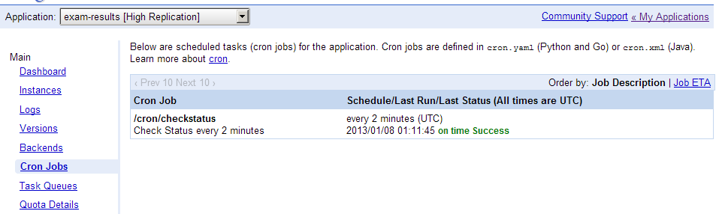

You can view the Logs to see the execution messages.

