I have designed three classes to complete this assignment
They are
- MetroSim: the simulator to finish the simulation of train movement and passenger queuing, getting on and off the train.
- Passenger: this is a Cpp Struct representing passengers.
- PassengerQueue: a queue whose element is Passenger type. I implement it by using the <list> of C++ STL.
Also there is a main driver module to parse the command line arguments and then initialize the Simulator, continuously fetch commands from the input stream and pass the commands to the Simulator to execute.

The following is the Program Flow of the main driver module.
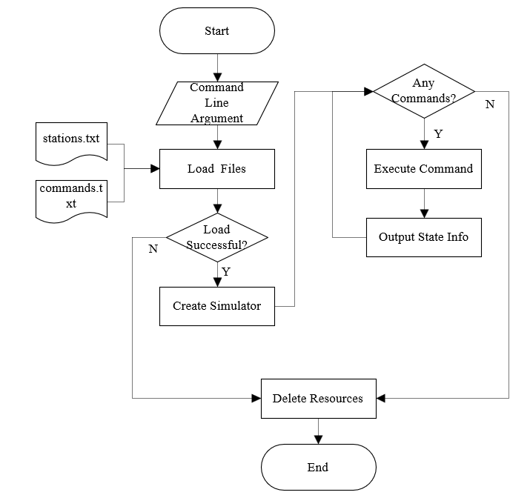

Passenger is a simple struct containing the basic information of a passenger. (id, from where and to where)
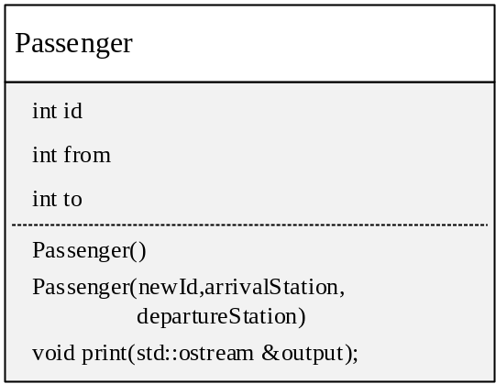

And the PassengerQueue is a list of Passenger, which has the following interfaces that mentioned in the assignment requirements:
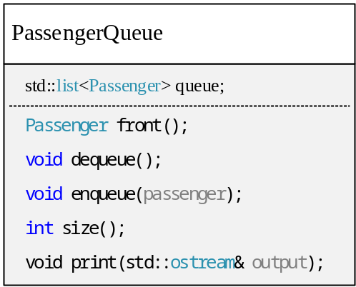
This class was implemented by C++ <list> , so it is very easy to implement this class.

The important part is about how I will implement the MetroSim:

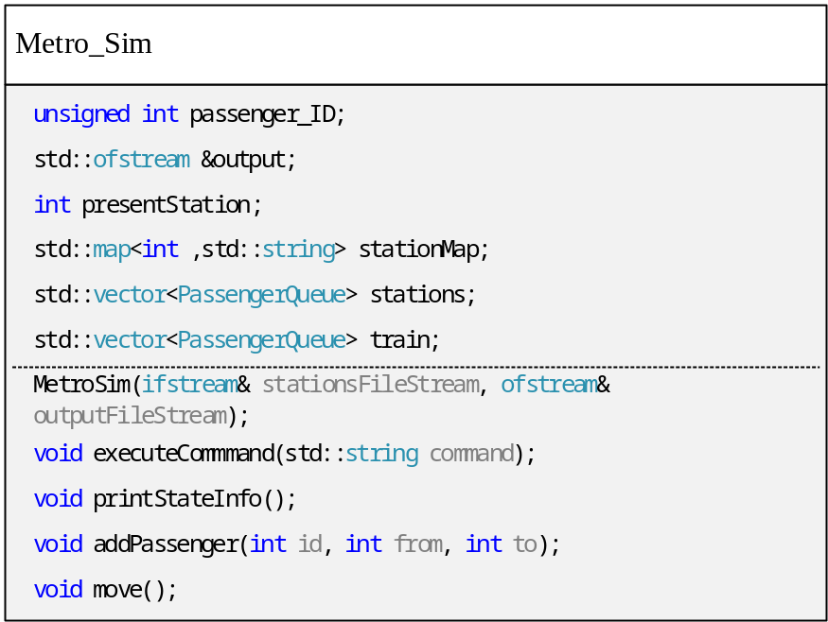
Member Explanation
- std::vector<PassengerQueue> train:
The “train” is implemented as a list of PassengerQueue instances.
I use STL vector to implement it. The index of the vector represents the destination station. Each element of the vector is a PassengerQueue, which contains those passengers with the same destination.
For example, train[2] is a PassengerQueue whose passenger’s destination is station 2.

- std::vector<PassengerQueue> stations;
stations is also a vector, whose subscript represents the ID of the station, so that we can directly access the passenger queue of the corresponding station by the station’s id.

- std::map<int ,std::string> stationMap;
This is a mapping table of station ID and stationName. Its element is key-value<station ID, station Name> .
We can easily get the station name by the station id. Of course this mapping can also be done by subscripts of vectors as in the case of “stations” and “trains” mentioned above.

- int presentStation;
this member represents the station where the train is currently stopping.
When we use command “m m” the value of it will change to the next station id.

How to implement the circulation of the stations ? It is easy to implement by a MOD operation.
For example, there are 26 stations, and the first station id is 0. (0-25)
So the next station id is (presentID+1)%26 .

- std::ofstream &output;
this is a output file stream which will bind a output file. The simulator will output the Passenger leaving log information into it;

- unsigned int passenger_ID;
This is a passenger id generator that will self-increment each time a new passenger is added when we use command “p ARRIVAL DEPARTUR”

- MetroSim(std::ifstream& stationsFileStream, std::ofstream& outputFileStream);
A constructor with 2 arguments. It will read the station information from the file and store them into the member vector “stations” and then print the information of that. It also bind the output stream and the output log file.

- void executeCommmand(std::string command);
this method will receive a string command

And 2 private function to help the executeCommmand(std::string command) :

- void addPassenger(int id, int from, int to);
add a passenger to a station Queue. this will be called by executeCommand when the command is "p from to"

- void move();
move the train to next station. this will be called by executeCommand when the command is "m m"

Schedule of plan

Day | Plan
1 | Finish the class Passenger and its unit_test functions.
2 | Finish the class PassengerQueue and its unit_test functions.
3 | Finish MetorSim class including the unit_test functions.
4 | Assemble the above modules. Test and debug.

Possible Edge tests that may be tested.

1.A test that will deque from an empty PassengerQueue object. This invalid invocation will throw an exception.
2.A test that will invoke front() from an empty PassengerQueue. This invalid invocation will throw an exception.
3.Pass invalid arguments (more or less arguments) to the program. This will print error information like:
Usage: ./MetroSim stationsFile outputFile [commandsFile]
4.Pass a file that could not be open to the program, this will print error information like
Error : could not open file FILENAME
5.Move the train from the last station to the first station, this will test if the simulator could make the train run in a loop.
6. Pass invalid command to the simulator.
7. Pass invalid number of station (for example -1) to command.

