I have designed three classes to complete this assignment
They are
- RPNCalc: the RPN calculator class. It has the run() function to keep the program running and continuously fetch and execute commands from the std::in.( it also has other helper functions to handle the execution of a rstring or a File see following).
- DatumStack: a stack data structure whose element is Datum. This is implemented by C++ STL <list>
- Datum: the given Datum class, which can be Int Bool or RString type.
And a parser.cpp file which has a function parseRString(istream& input). It will be used by RPNCalc to parse a RString from a input stream ( std::cin, file stream, rstring stream).

Also there is a main driver module to create a RPNCalc object when the program starts, and then call the run() function of RPNCalc. The program will keep running until it getting the “quit” command.

The possible interfaces and data members that I designed of RPNCalc class are:
public:
void run();
this function will start the calculator, keep running until an quit command is received.

Some private helper functions and data members are:
private:
DatumStack stack;
This is a DatumStack object, it will store the datums while executing commands.

void execCommands(std::istream& input);
the public function run() will call this function firstly, pass the std::cin to the parameter. Function execCommands() will continuously read and execute commands from the given input stream until reaching the end of this stream or getting the “quit” command. The given input stream could be std::cin , FileInputStream and std::istringstream., so this function may be called in other positions of the program when we need to read from a string stream or a file stream.

void execCommandsWithException(std::string cmd);
it will be called by execCommands(std::istream& input) . This function is designed to distinguish between commands that can throw exceptions. The parameter std::string cmd can be some commands that would throw “Empty Stack” exception (such as “drop”, “print”, “swap” and so on), type wrong exception of Datum (e.g. + - * / on non int Datum , “exec” on non RString ), and other error (such as “file” on files that could not be open). This function is designed to make the execCommands() function more easily when handling exceptions and errors.

void ArithmeticOperation(std::string op);
when do some arithmetic operations, this function will be called. ( “+” “-” “*” “/” “mod”). It will pop 2 Datum (expected INT) from the stack and then do the given operation on them, push the result into stack.

void RelationOperation(std::string op);
when do some relation operations, this function will be called ( “<“ “==“ “>“ “<=“ “>=“ ). 2 operands in stack will be popped and the BOOL result will be pushed.

void execIF();
this function will be called when the command is “if”, it will pop 2 RString and 1 Bool Datums from the stack first, and then check their type. If the types of these Datums are ok, it will execute the right RString branch:
- push the bench Datum (a Rstring) into the stack
- call the execRstring() to execute the Rstring on the top of the stack

void execRstring();
this function will pop a Rstring from stack, and then remove the bracket and white space at the beginning and end of the string to make it a sequence of command strings. Then:
- create a istringstream by the Rstring
- pass the istringstream to the execCommand(std::istream& input), and invoke it. So the program flow will jump to execCommand() again, execute commands until reaching the end of istringstream.
- execRstring() returns to the caller of it, continue to read and execute other input stream of the outer caller.

void execFile();
this function will be called when the command is “file”. This function will pop a Rstring, and remove the bracket and white space at the beginning and end of the string to make it a valid file name. Then open the file as a input stream, pass this FileInputStream to the parameter of execCommands(std::istream& input), then call it. These behaviors are very similar to execRstring() function.

The following is the Program Flow :

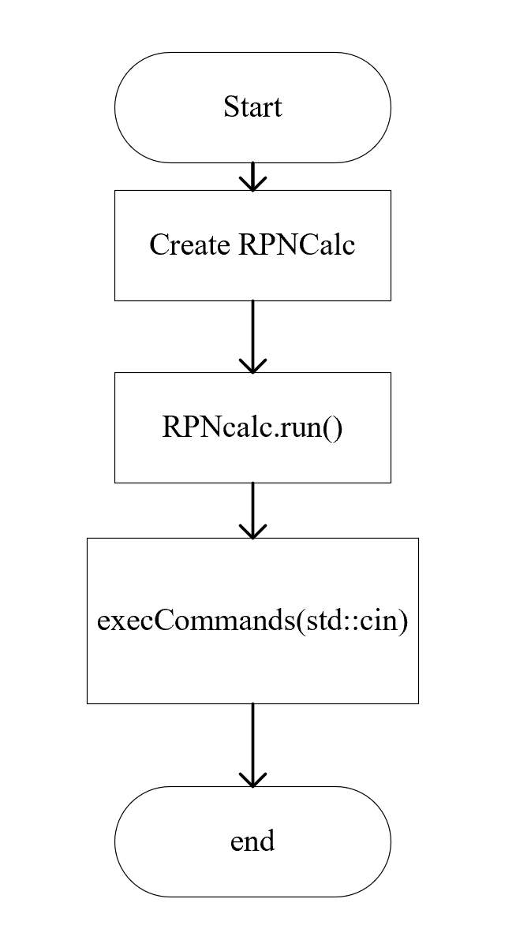
The execCommands(std::istream input) is so important, the following are the function flow of it. It shows how some complex commands works.
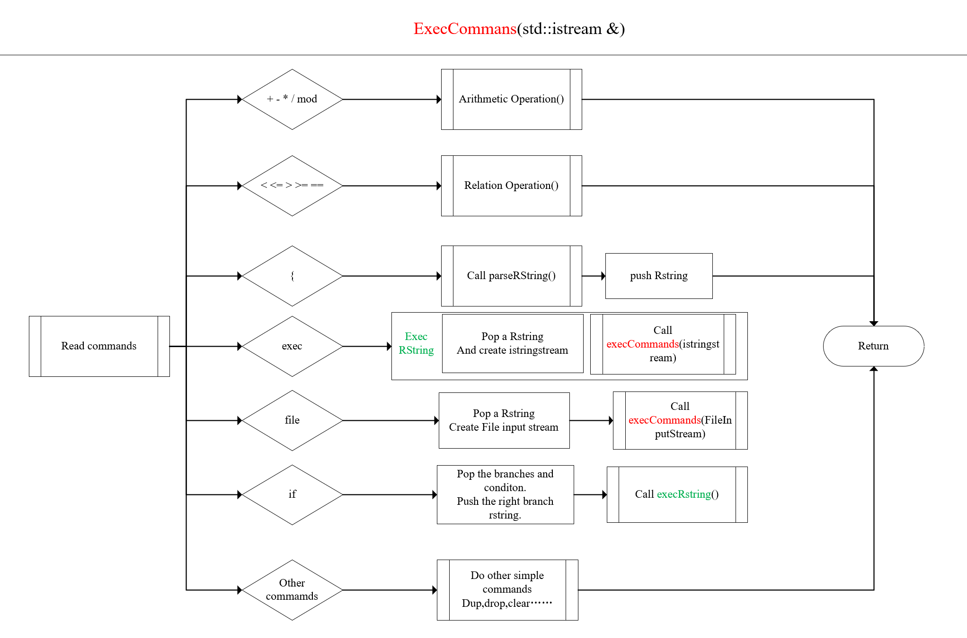
Making the parameter of execCommands to be the Abstract Class std::isream & is essential. It allows other position of the program to pass any kinds of input stream to it and make the program jump to read from that stream.
Once inner execCommands is return , the outer one will continue to read on its own input stream, keeping the program running.

Schedule of plan

Day | Plan
1 | Finish the class DatumStack and its unit_test functions.  Finish the RString parser and test it.
2 | Design the RPNCalc interface.
3 | Implement the RPNCalc.
4 | Assemble the above modules. Test and debug.

Possible Edge tests that may be tested.

- Type “1 #t +” see if the program could catch a type exception thrown by Datum
- Try doing some operations that popping or getting top from an empty stack, such as “drop” “swap” “dup”
- Type “1 { ttt } ==“ see if the program could catch a type exception thrown by Datum
- Type “ 1 exec” to see if the program could cerr the error massage of executing non rstring.
- Type “1 file “to see if the program could cerr the error massage “Error: file operand not rstring”
- Try giving a unopenable filename to the “file” command. see if the program could cerr the error massage "Unable to read filename\n";
- Give Datums with wrong type to “if” commands. See if the program could cerr the right error massage.

