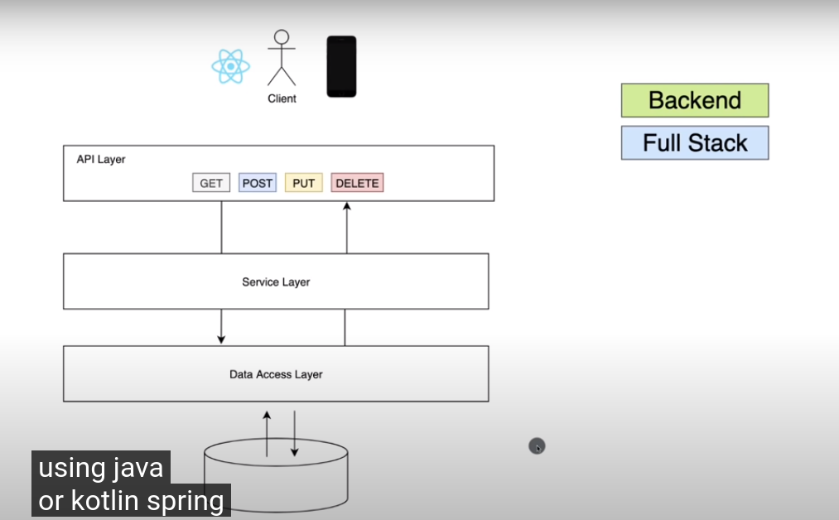
You can build backend, full-stack, kotlin springboot is framework to work.
Framework is everything you need to make application.

Using maven
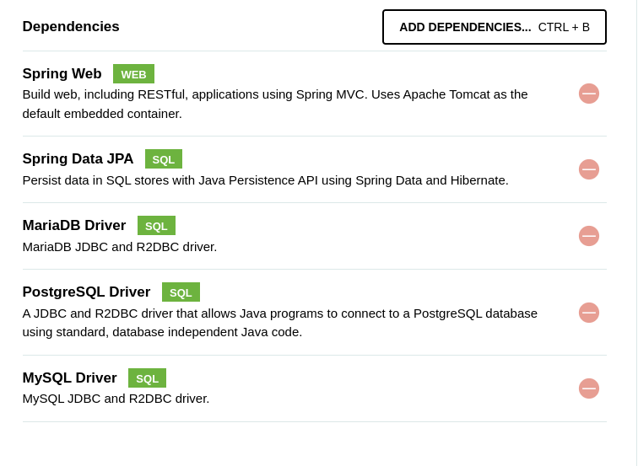

pom.xml contains project metadata here and dependencies that we have downloaded. Parent is where spring boot start up/
demo/main/test this is where all test code goes
eg: demo application this is where we put all test code

main/java here we will put our code
first demoapplication this is bare bone springboot appliciation. (note:- barebone refers to things that will eventually have more elements)

main/resources/application.properties we find all properties for application and environmental specific properties.eg:- we can see this content after we connect to database.

Main/templates when working with web eg:-html,css,JS etc.

now run program from main/java/demoapplication
first the program will fail as no driver class
no we will open pam.xml then we will comment starter-data-jpa
then right click pom.xml then maven and reload project
now tomcat will run normally in 8080 but as nothing is there nothing is shown

* Lets create simple API

go to localhost:8080 we get error page
so now we will implement to give JSON back

@RestController this annotate helps to make down annotate get or post to make as restful endpoint to server as rest end point.
in demoapplication.java we have created a method hello() with @restcontroller
here to now serve this method as restful end point we annote with @GETMapping or post.

Now refresh the page we will have hello world.
Eg:-
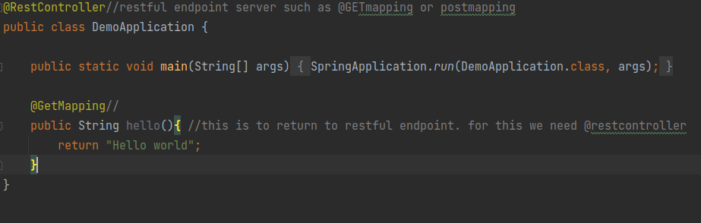
you can also try this to give JSON back.
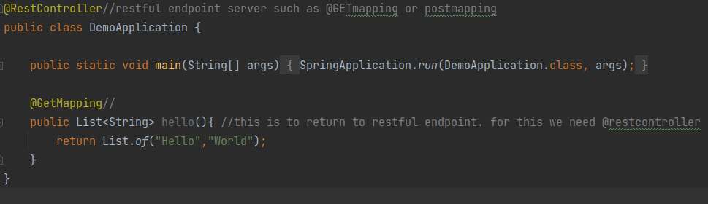
till now we have created a simple API but we want all of mentioned figure in above first page.

So now we are going to do this:-
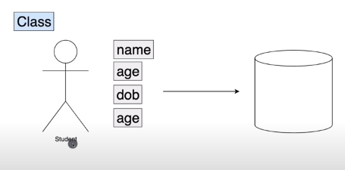
and on based on class student we will formulate all of API.

Go and create package named student in main/java/com.example.demo and every code student related is here.
Create class Student inside it.

Then create constructor(overloading),getter,setter and toString() and everything here.in code--------
shortcut is alt+insert

and in code you can do and change it to:-
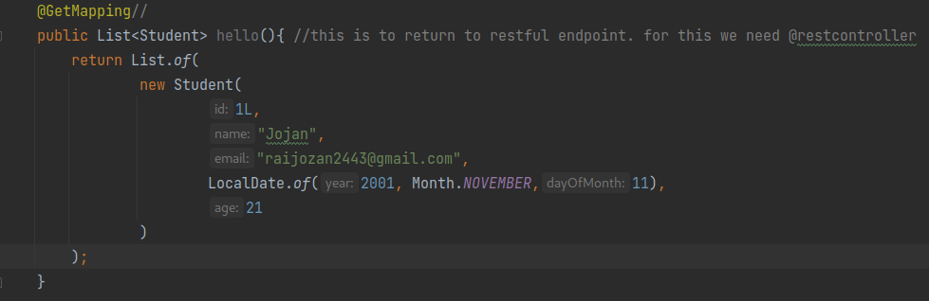
now we will structure application in the required architecture API,service,data access layer
now we will create class that will server as API layer.

main/java/student/ create StudentController.java

now we will remove getmapping and restcontroller from demoapplication as it was in previous state and also imports(ctrl+alt+o)

then in StudentController,java do these:-

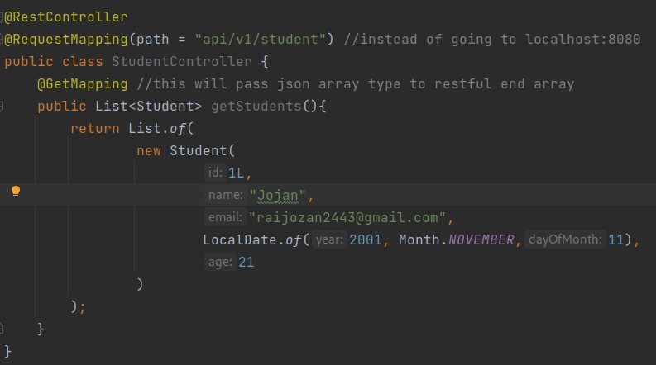
now goto http://localhost:8080/api/v1/student to open the required.

* Business Layer

Now we will create class for service layer/business logic that will serve business logic for managing student.
Api layer should talk to service layer to get some data similarly service layer should talk to data access layer to get the data and does round trip.

Now make changes :-

StudentController.java

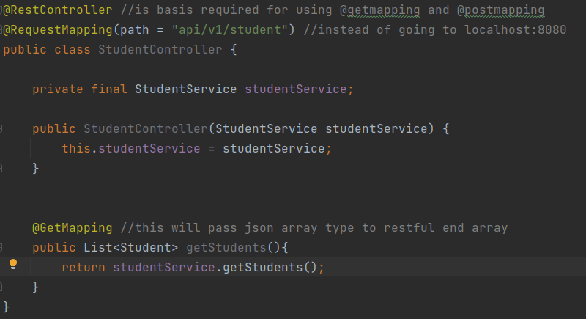
StudentService.java

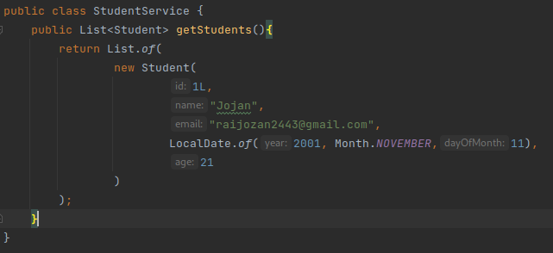

* Dependency injection

now how should tell program to inject StudentService to studentService constructor?
@Autowired //here we are basically saying upper StudentService should be autowired or upper studentservice will be instansiated and be injected on down studentservice constructor

now we also that this student service is a class that has to be instansiated I.e spring bean for that we use
@Component in StudentService.java

till now:-

StudentCOntroller.java
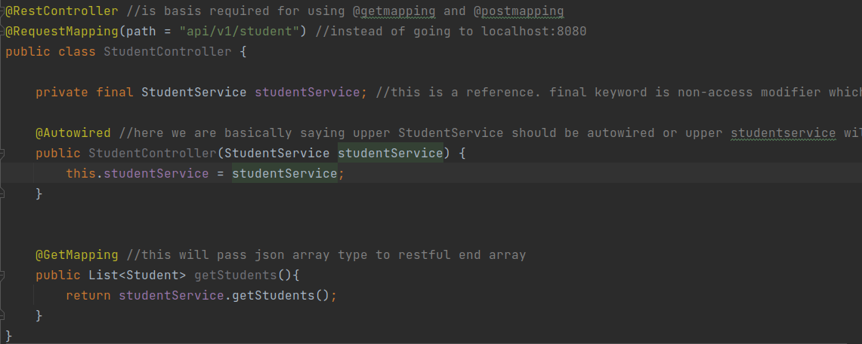
StudentService.java

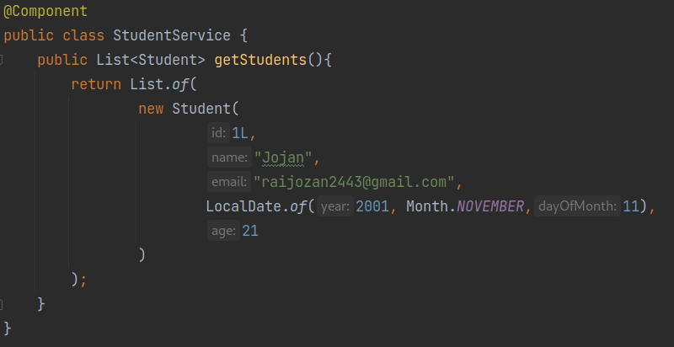
now we just don’t want it to be component so we change @component to @service(change in upper code)

now you can refresh your browser.

Now we have used dependency injection and have split things into layer.

Now we will focus on database layer:-

* Properties file

now in application properties:-

spring.datasource.url=jdbc:mysql://localhost:3306/student
#spring.datasource.driverClassName=com.mysql.cj.jdbc.Driver
spring.datasource.username=root
spring.datasource.password=redhat
# this will have clean state everytime we run application create-drop
spring.jpa.hibernate.ddl-auto=create-drop
# shows query executed in consoloe
spring.jpa.show-sql=true
# update every time table create is updated but create deletes old table and creates new or overwtire
spring.jpa.properties.hibernate.dialect=org.hibernate.dialect.MariaDB53Dialect
spring.jpa.properties.hibernate.format_sql=true

* Connection to database

create database now:-
create database student;

uncomment pom.xml commented dependency and reload project with right click to pom.xml, maven and reload project.

Now reload project.
Now we need table and such.

* JPA and entity

now we map Student class to JPA simply type below:-

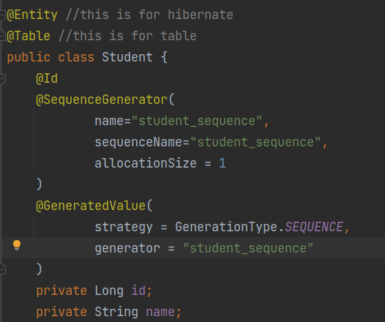
now run the application and run the logs.
And check your database now there is content;

note:-
Hibernate will scan that package for any Java objects annotated with the @Entity annotation. If it finds any, then it will begin the process of looking through that particular Java object to recreate it as a table in your database! Before Hibernate will start it's scan, not only do we need to invoke the sessionFactory.

now we are missing data access layer. Now we will implement this that will interact with database;

* JPA repository

now create interface inside student StudentRepository.

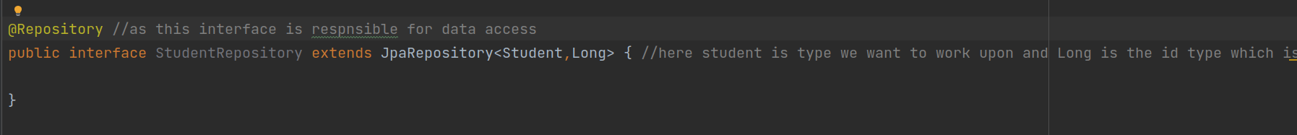
Now lets connect things using dependency injection.

And you do this in StudentService

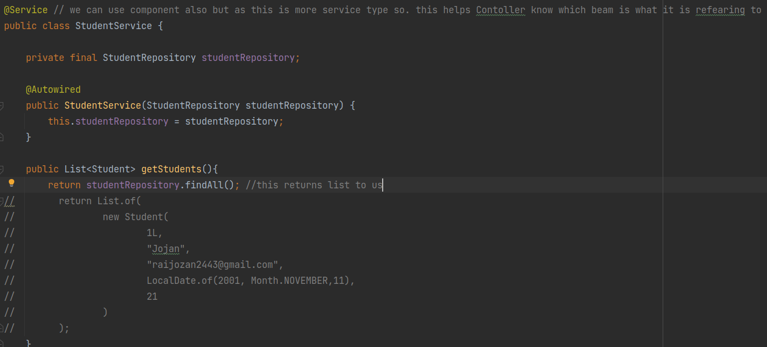
now you can go in interface StudentRepository and navigate to JpaRepository(i.e after extends) and press ctrl+b you will be redirected to interface showing all method available to us.

Now we will add student to database using StudentRepository and see if every layer is working and see response to our client.

Now reload project and reload page. There will be empty array.

Now create a new class and name it as StudentConfig.

Note:-In terms of a Spring boot application, a bean is simply a Java object which is created by Spring framework when the application starts. The purpose of the object can be pretty much anything - a configuration, a service, database connection factory etc

JavaBeans is a portable, platform-independent model written in Java Programming Language. Its components are referred to as beans. In simple terms, JavaBeans are classes which encapsulate several objects into a single object. It helps in accessing these object from multiple places.

Now in StudentConfig:-
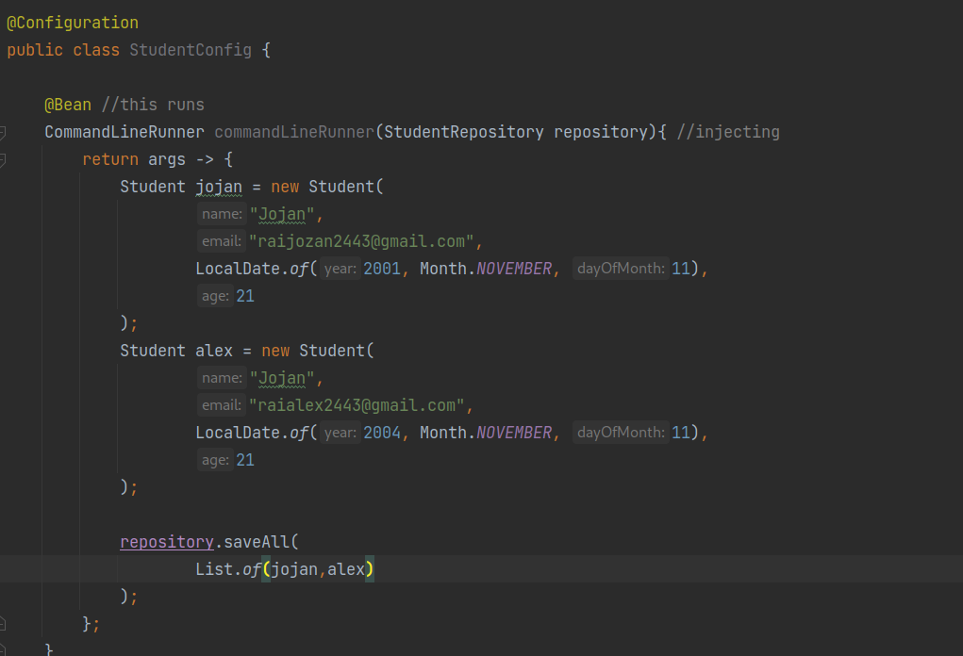
now restart server and see the logs and see the web page.

Output:-

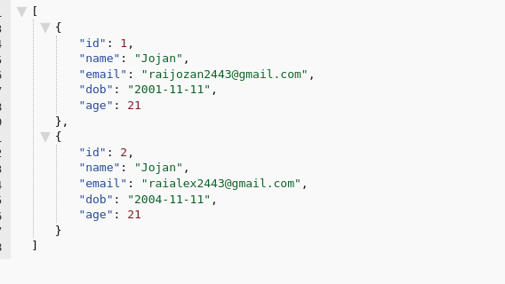
now we will perform post(for saving new resources),put(for updating) and delete.

Now I don’t want age as we can calculate it basis in DOB.
Note:- while importing use java.persistence as when implementing to another everything will still work.

To do above we can do:-

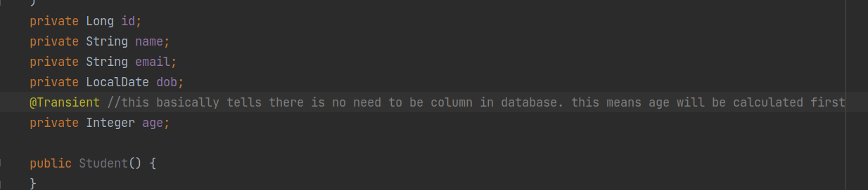
then we remove age from constructors only and from StudentConfig inserting part as it gives error.

Now we want to calculate age for us.
Note:-The Period Class in Java class obtains a quantity or amount of time in terms of years, months and days.

We do :-

public Integer getAge() {
return Period.between(dob,LocalDate.now()).getYears();
}

this is on student class in getter section updating it.

Now reload server and see output:-

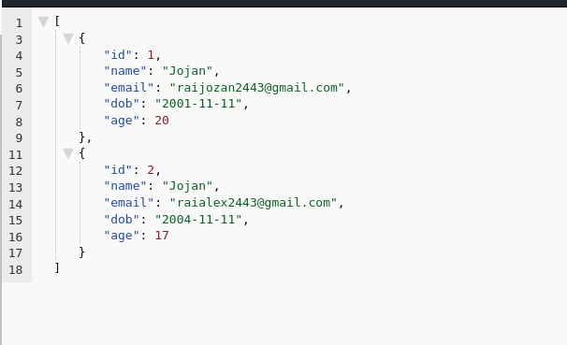
also check database as there is no age column.

* Post mapping

what we wanna do is:-

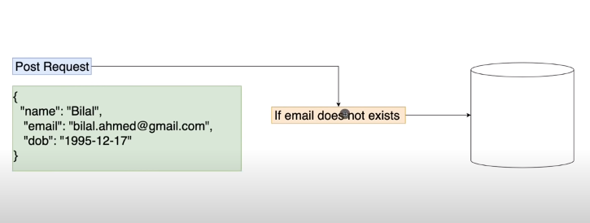
now in StudentController.java

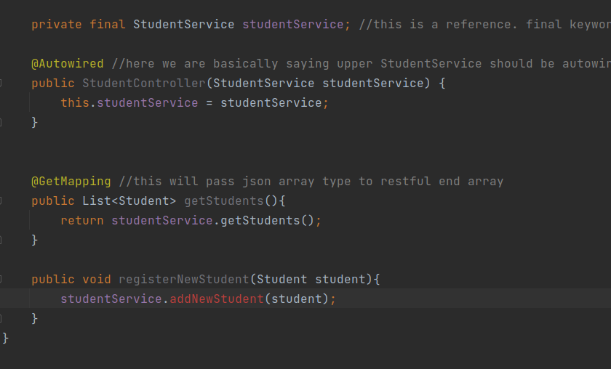
we then press on addNewStudent and choose given warning create thing and go along with it then red line is gone.(you will be redirected to studentservice)

go back to StudentController and

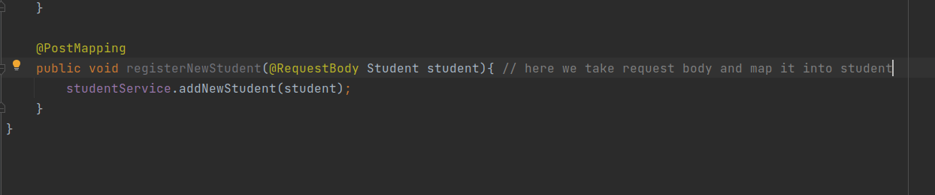
then in StudentService:-

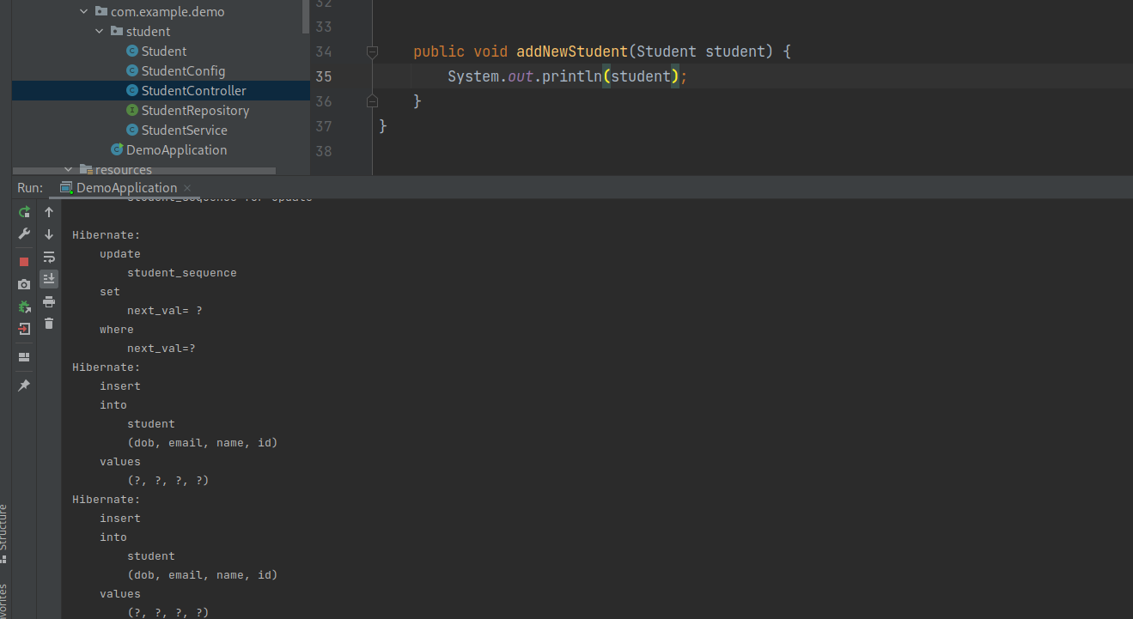
now use postman like this:-
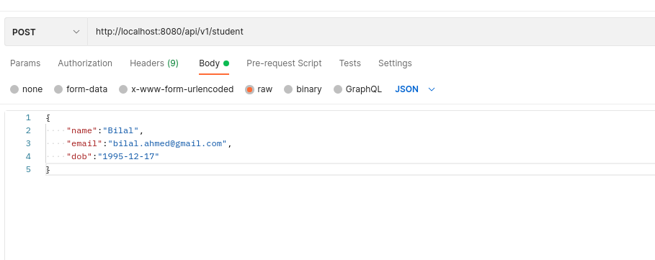
and check log there will be some detail.

We have managed to take payload and send it to server.

* Writing business logic

in student repo:-

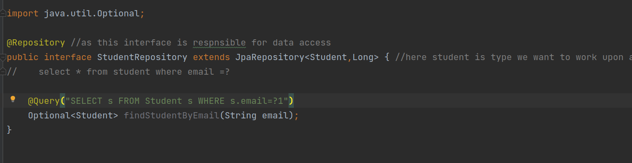
in studentservice we can perform logic validation :-

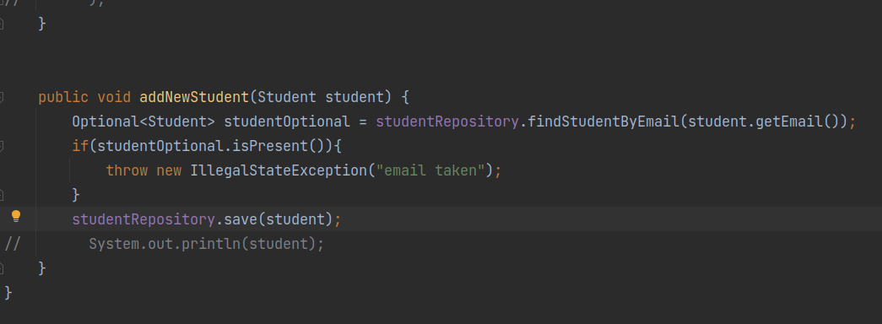
now check your request in post and database after reloading project.

Now new user can be added using post request.

If found user with same email error is thrown you can check.

* Deleting Students

delete student by id

in StudentController

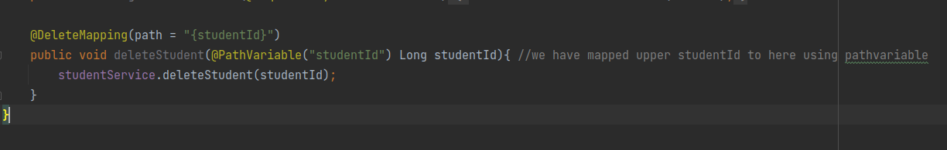
in Student Service

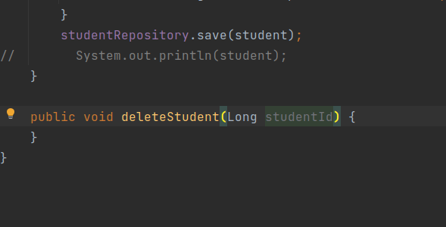
then:-

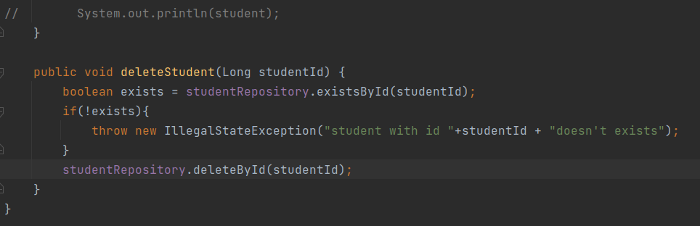
then reload server

in postman

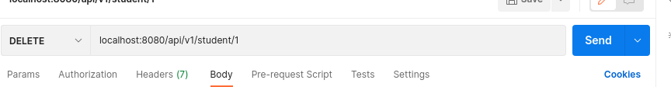
and then send request. Now the student with id 1 is deleted.

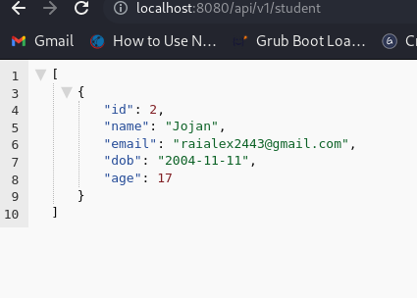

* Put functionalities

- we will update here using put.

@Transactional – this annotation means we don’t have to apply any jpql quey. So we cab use the setters from your entity that you check weather you can or cannot update and then can use setter to automatically use to update entity in database.

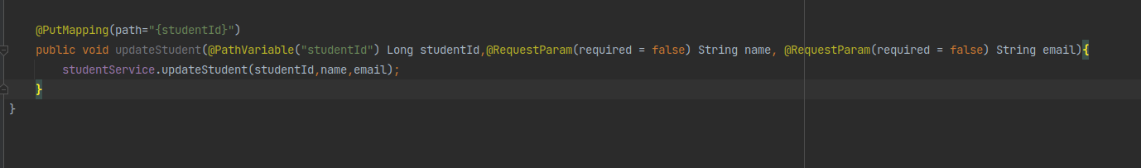
@RequestParam required false means that they are both not required. Then I pass it down to service with name updateStudent

in student service

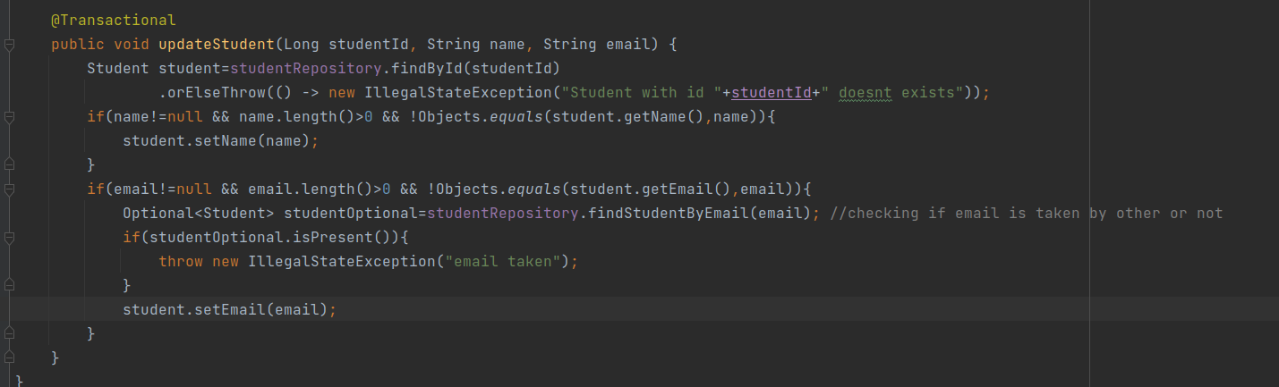
now reload program and send this request:-

in id one we have changed name

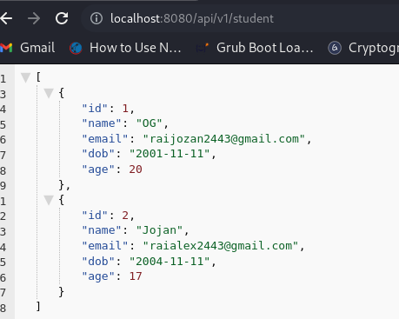

now reload server again

and send :-

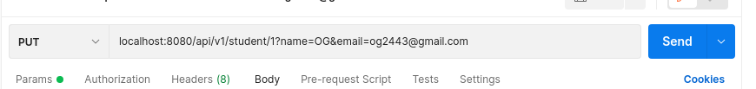
and check output email should be changed by now.

* Mother Fuc go and learn testing Jojan

* Packing and running applications

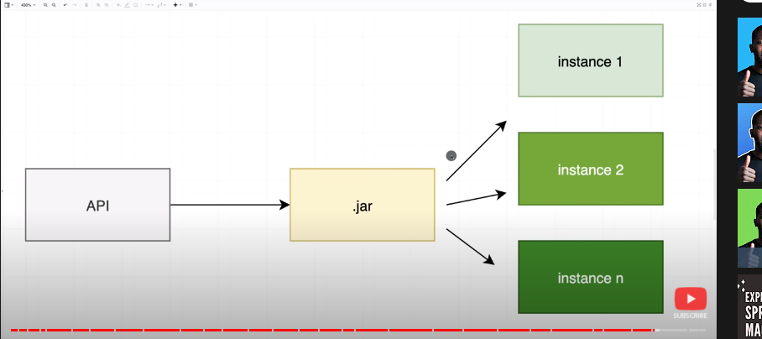
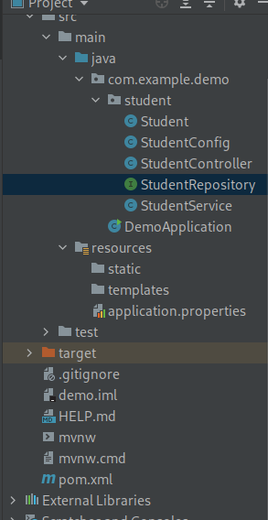

now delete this target folder.
This folder basically contains everything after we run.

Now go to maven at top right of screen and do clean first.

Now do install by clicking which will do all of above after clean setup.

Then inside we will have jar file which we can run manually.

Now go inside target folder you will see .jar files

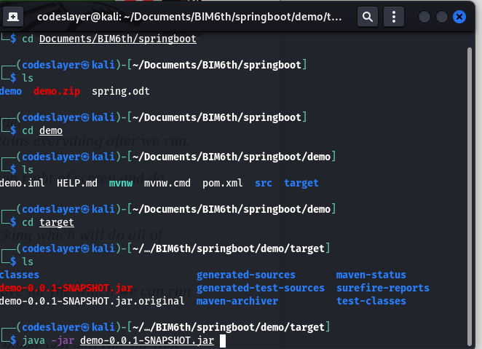
now basically you can do this ans start application and go to localhost and check applications.
Now we can run application as desired.
You can run as many instance as you want but you have to define port.

If you want to run on different port do
java -jar demo.0.0.1.-SNAPSHOT.jar –server.port=8081

next we can do more spring framework.Amigoscode

