package Assignments.assignment3Swing;
// Write a program to create a frame having a form to take 2 numbers from user and a button to add those numbers.
import javax.swing.*;
import java.awt.*;
import java.awt.event.ActionEvent;
import java.awt.event.ActionListener;
public class AddSwing {
AddSwing(){
JFrame f=new JFrame("Learning Swing");
JTextField ts1=new JTextField(10);
JTextField ts2=new JTextField(10);
JLabel l=new JLabel(" ");
JButton b=new JButton("ADD");
b.addActionListener(new ActionListener() {
@Override
public void actionPerformed(ActionEvent actionEvent) {
int n1=Integer.parseInt(ts1.getText());
int n2=Integer.parseInt(ts2.getText());
int sum=(n1+n2);
l.setText("Sum is = "+String.valueOf(sum));
}
});
f.add(ts1);
f.add(ts2);
f.add(b);
f.add(l);
f.setSize(300,400);
f.setLayout(new FlowLayout());
f.setVisible(true);
}
public static void main(String[] args) {
new AddSwing();
}
}

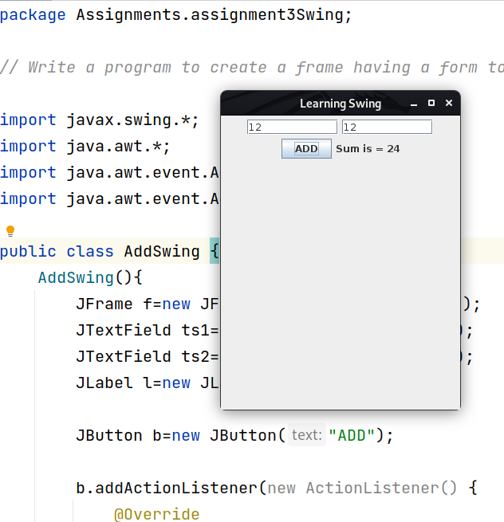

package Assignments.assignment3Swing;
import javax.swing.*;
import java.awt.*;
import java.awt.event.ActionEvent;
import java.awt.event.ActionListener;
//Make a form with three radio button and 5 checkboxes.
public class FormLearnSwing {
JRadioButton rb1,rb2,rb3; // after this we define vaiable down below
FormLearnSwing(){
JFrame f=new JFrame("Learning Swing");
// JRadioButton rb1=new JRadioButton();// as doing this for each is boring so we do
// JRadioButton rb1,rb2,rb3;// doing this we need to initalize it outside constructor
rb1 =new JRadioButton("Jojan",true);
rb2 =new JRadioButton("Nalin");
rb3 =new JRadioButton("Dristy");
ButtonGroup bg=new ButtonGroup();
bg.add(rb1);
bg.add(rb2);
bg.add(rb3);
JCheckBox ch1=new JCheckBox("Cleaning");
JCheckBox ch2=new JCheckBox("Playing");
JCheckBox ch3=new JCheckBox("Learning");
JCheckBox ch4=new JCheckBox("Music");
JCheckBox ch5=new JCheckBox("Others");
JButton b=new JButton("NAME");
JButton b1=new JButton("HOBBY");
JLabel l1=new JLabel(" ");
// b.addActionListener(this);
b.addActionListener(new ActionListener() {
@Override
public void actionPerformed(ActionEvent actionEvent) {
if(rb1.isSelected()){
// JOptionPane.showMessageDialog(this,"Hello Jojan"); ?? why not working
l1.setText("Jojan Handsome");
}
if(rb2.isSelected()){
l1.setText("Nalin Chor");
}
if(rb3.isSelected()){
l1.setText("Hi Dristy");
}
}
});
b1.addActionListener(new ActionListener() {
@Override
public void actionPerformed(ActionEvent actionEvent) {
if(ch1.isSelected()){
// l2.setText(""); every checkbox needs different label so
System.out.println("Cleaning"); // and so on for others if you want to do it
}
}
});
f.add(rb1);
f.add(rb2);
f.add(rb3);
f.add(b);
f.add(l1);
f.add(ch1);
f.add(ch2);
f.add(ch3);
f.add(ch4);
f.add(ch5);
f.add(b1);
// f.setLayout(new GridLayout(1,3));
f.setLayout(new FlowLayout());
f.setSize(250,400);
f.setVisible(true);
}
public static void main(String[] args) {
new FormLearnSwing();
}
}

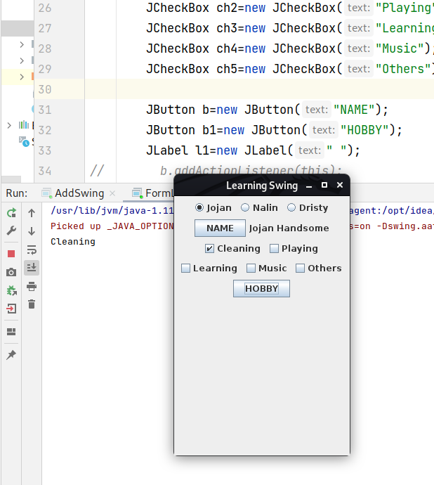

package Assignments.assignment3Swing;
import javax.swing.*;
import java.awt.*;
import java.awt.event.ActionEvent;
import java.awt.event.ActionListener;
//Create a swing GUI that contains a combo box and text feild. When a option is selected in combo box, display it in text feild.
public class ComboxBox {
ComboxBox(){
JFrame f=new JFrame();
JTextField ts=new JTextField(10);
String[] PeopleBand={"Freddie","Arthur","Hillsong","BTS","Halsey"};
JComboBox<String> cb=new JComboBox<>(PeopleBand);
cb.addActionListener(new ActionListener() {
@Override
public void actionPerformed(ActionEvent actionEvent) {
String st=(String) cb.getSelectedItem(); // wht does this string do?
ts.setText(st);
}
});
f.add(cb);
f.add(ts);
f.setLayout(new FlowLayout());
f.setSize(300,400);
f.setVisible(true);
}
public static void main(String[] args) {
new ComboxBox();
}
}

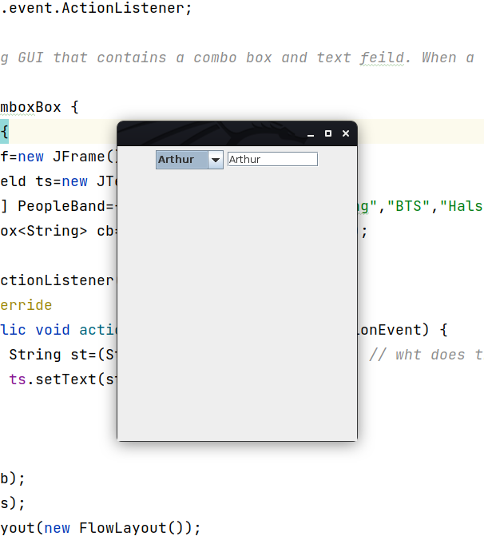
package Assignments.assignment3Swing;
import javax.swing.*;
import java.awt.*;
import java.awt.event.ActionEvent;
import java.awt.event.ActionListener;
//Write a program that read number from a user and display the factorial of the output in text feild when user press a button.
public class FactorialSwing {
FactorialSwing(){
JFrame f=new JFrame("Learning swing lolll");
JLabel l1=new JLabel("Enter number for factorial");
JLabel l2=new JLabel();
JTextField t1=new JTextField(5);
JButton b=new JButton("FACT");
b.addActionListener(new ActionListener() {
@Override
public void actionPerformed(ActionEvent actionEvent) {
int num=Integer.parseInt(t1.getText());
if(num<0){
l2.setText("Less than o so no fact done");
}
else if(num==0){
l2.setText("The factorail is = 0");
}
else{
int fact=1;
for(int i=1;i<=num;i++){
fact=fact*i;
}
l2.setText("The factorial is = "+String.valueOf(fact));
}
}
});
f.add(l1);
f.add(t1);
f.add(b);
f.add(l2);
f.setVisible(true);
f.setLayout(new FlowLayout());
f.setSize(300,400);
}
public static void main(String[] args) {
new FactorialSwing();
}
}

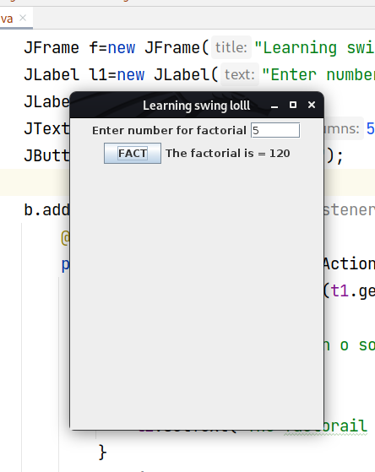

package Assignments.assignment3Swing;
import javax.swing.*;
import java.awt.*;
import java.awt.event.ActionEvent;
import java.awt.event.ActionListener;
// Write a program that contains two button and a text feild. When first button is clicked, a messgae "Hello world" is
// shown in the text feild, when second button is clicked text in the textfield is cleared.
public class MagicSwing {
MagicSwing(){
JFrame f=new JFrame("LOLL");
JTextField t1=new JTextField(10);
JLabel l1=new JLabel();
JButton b1=new JButton("Show");
JButton b2=new JButton("Clear");
b1.addActionListener(new ActionListener() {
@Override
public void actionPerformed(ActionEvent e) {
t1.setText("Hello World");
}
});
b2.addActionListener(new ActionListener() {
@Override
public void actionPerformed(ActionEvent e) {
t1.setText("");
}
});
f.add(t1);
f.add(b1);
f.add(b2);
f.setLayout(new FlowLayout());
f.setSize(600,400);
f.setVisible(true);
}
public static void main(String[] args) {
new MagicSwing();
}
}

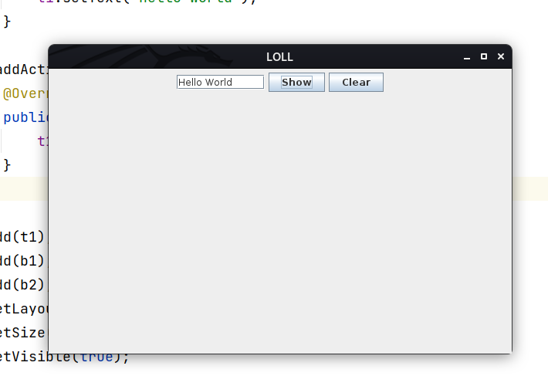

package Assignments.assignment3Swing;
//write a program to display simple interet. (Hint: formula : S.I = P* T*R /100).
// User enters the required value in textfeild.
import javax.swing.*;
import java.awt.*;
import java.awt.event.ActionEvent;
import java.awt.event.ActionListener;
public class SimpleInterestSwing {
SimpleInterestSwing(){
JFrame f=new JFrame("LOL");
JLabel l1=new JLabel("Enter P T and R");
JLabel l2=new JLabel();
JTextField t1=new JTextField(5);
JTextField t2=new JTextField(5);
JTextField t3=new JTextField(5);
JButton b=new JButton("SUBMIT");
b.addActionListener(new ActionListener() {
@Override
public void actionPerformed(ActionEvent e) {
int p=Integer.parseInt(t1.getText());
int t=Integer.parseInt(t2.getText());
int r=Integer.parseInt(t3.getText());
int si=(p*t*r)/100;
l2.setText("The SI is = "+String.valueOf(si));
}
});
f.add(l1);
f.add(t1);
f.add(t2);
f.add(t3);
f.add(b);
f.add(l2);
f.setVisible(true);
f.setLayout(new FlowLayout());
f.setSize(350,400);
}
public static void main(String[] args) {
new SimpleInterestSwing();
}
}

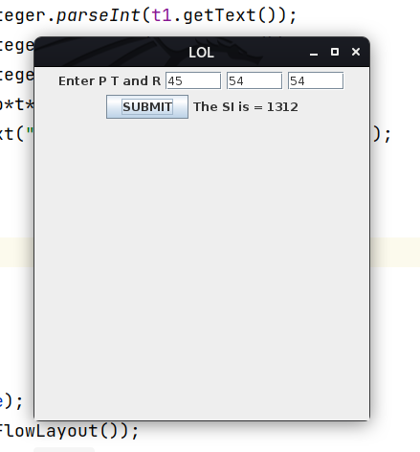

package Assignments.assignment3Swing;
// Create a swing GUI that contains a List of countries and text feild. When a option is selected in list, display it in text feild.
import javax.swing.*;
import java.awt.*;
import java.awt.event.ActionEvent;
import java.awt.event.ActionListener;
public class CountriesSwing {
// String store;
CountriesSwing(){
JFrame f=new JFrame();
JLabel l1=new JLabel();
JTextField t1=new JTextField(10);
String[] countries={"Nepal","India","China","Korea","Japan"};
JList<String> list=new JList<>(countries);
JButton b=new JButton("SHOW");
b.addActionListener(new ActionListener() {
@Override
public void actionPerformed(ActionEvent actionEvent) {
// JOptionPane.showMessageDialog(f,"you selected"+list.getSelectedValuesList());
// String items[]= list.getSelectedValuesList().toArray(new String[0]); // this is for multiple but doesnt work correctly
// for(int i=0;i<items.length;i++){
// store+=items[i]+",";
// }
// t1.setText(store);
t1.setText(list.getSelectedValue());
}
});
f.add(list);
f.add(b);
f.add(t1);
f.setVisible(true);
f.setSize(200,400);
f.setLayout(new FlowLayout());
}
public static void main(String[] args) {
new CountriesSwing();
}}

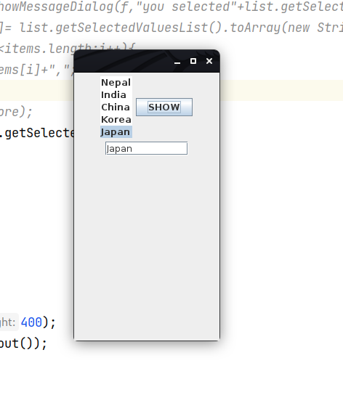

package Assignments.assignment3Swing;
//Write a program to open three tabbed pane where :
// 1st pane contains two text feild.
// 2nd pane contains two button.
// 3rd pane contains three label
import javax.swing.*;
import java.awt.*;
public class TabbedPaneSwing {
TabbedPaneSwing(){
JFrame f=new JFrame("Laerning Here");
JPanel jp1=new JPanel();
JTextField t1=new JTextField(10);
JTextField t2=new JTextField(10);
jp1.add(t1);
jp1.add(t2);
JPanel jp2=new JPanel();
JButton b1=new JButton("HAHA");
JButton b2=new JButton("HAHA");
jp2.add(b1);
jp2.add(b2);
JPanel jp3=new JPanel();
JLabel l1=new JLabel("FUN");
JLabel l2=new JLabel("FUN");
JLabel l3=new JLabel("FUN");
jp3.add(l1);
jp3.add(l2);
jp3.add(l3);
JTabbedPane tp=new JTabbedPane();
// tp.setBounds(50,50,200,200);
tp.add("TextField",jp1);
tp.add("Button",jp2);
tp.add("Label",jp3);
f.add(tp);
f.setSize(800,400);
// f.setLayout(new FlowLayout());
f.setVisible(true);
}
public static void main(String[] args) {
new TabbedPaneSwing();
}
}

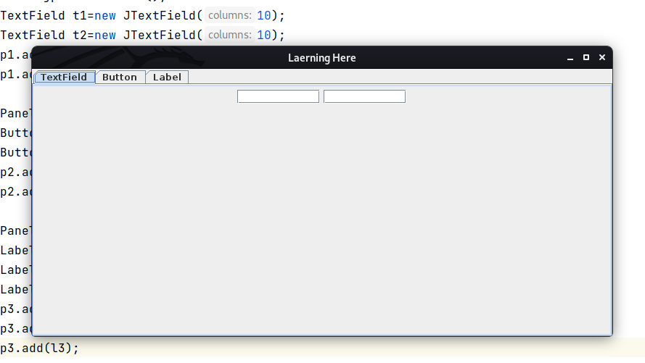

package Assignments.assignment3Swing;
import javax.swing.*;
public class JTableSwing {
JTableSwing(){
JFrame f=new JFrame();
String[] head={"Name","Faculty"};
String[][] data={
{"Jojan","BIM",},
{"Nalin","BIM",},
{"Subin","BIT"},
};
JTable ht=new JTable(data,head);
f.add(ht);
f.setSize(400,200);
f.setVisible(true);
}
public static void main(String[] args) {
new JTableSwing();
}
}

