**SUPPLEMENTARY 2: Sources of Above Ground Biomass (AGB) Data**

|  |  |
| --- | --- |
| **Name of the Source** | **Author** |
| Supplementary material of the journal paper: “Global patterns of aboveground carbon stock and sequestration in mangroves” | [[1]](http://sciwheel.com/work/citation?ids=8957403&pre=&suf=&sa=0) |
| Data provided Dr Akira Komiyama | [[2]](http://sciwheel.com/work/citation?ids=10461615&pre=&suf=&sa=0) |
| Data provided by Dr Luitgard Schwendenmann | [[3]](http://sciwheel.com/work/citation?ids=10462872&pre=&suf=&sa=0) |
|  |  |

**SUPPLEMENTARY 3: Summary of statistical performance of the RF models used to predict carbon stocks for the present and future climate scenarios**

|  |  |  |  |  |
| --- | --- | --- | --- | --- |
| **Performance of predicted carbon stocks vs actual carbon stocks** | **Present Scenario** | **RCP 2.6 (2070)** | **RCP 4.5(2070)** | **RCP 8.5(2070)** |
| **AGC** | 0.876 | 0.848 | 0.839 | 0.80 |
| **BGC** | 0.827 | 0.862 | 0.855 | 0.864 |
| **SOC** | 0.844 | 0.813 | 0.826 | 0.842 |

**SUPPLEMENTARY 4: The Most Important Variables Influencing the Carbon Stock Values Under Different Scenarios**

**(I) RCP 2.6**

1. **Above Ground Carbon**

Importance of the Predictors in Influencing AGC

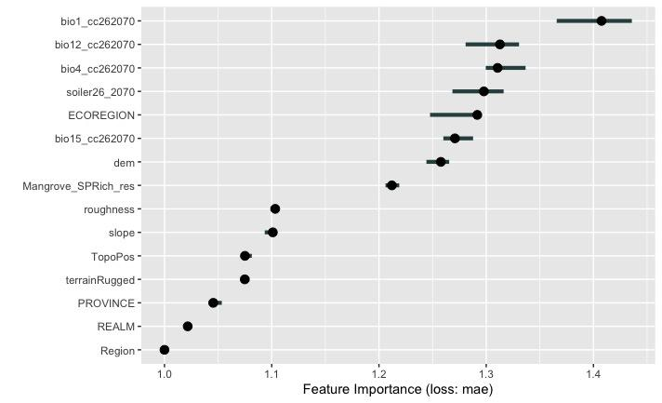

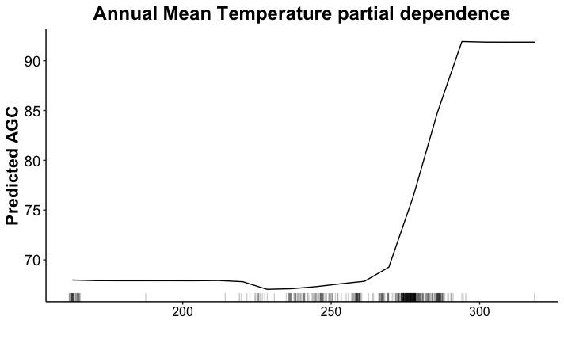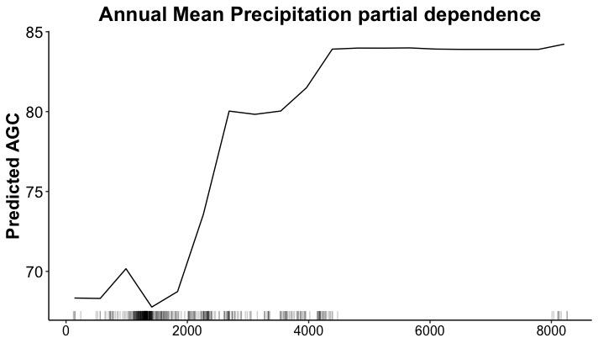

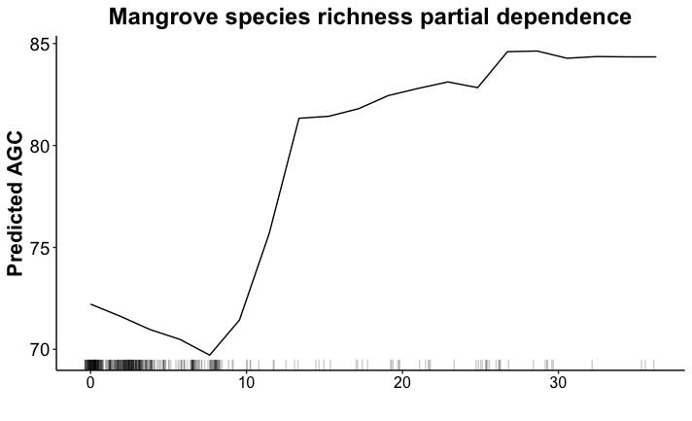

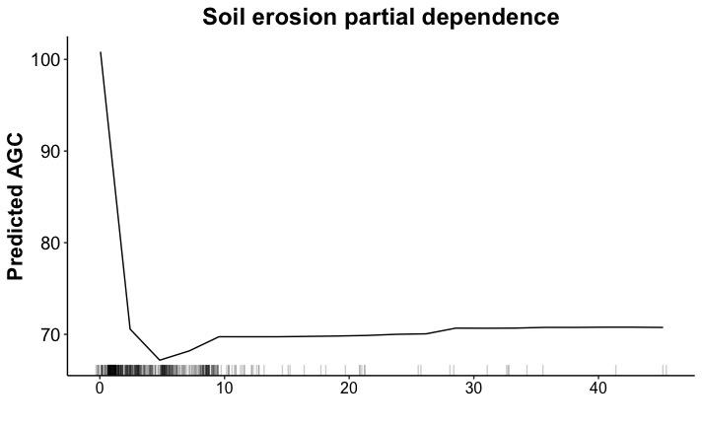

1. **Below Ground Carbon (BGC)**

Importance of the Predictors in Influencing BGC

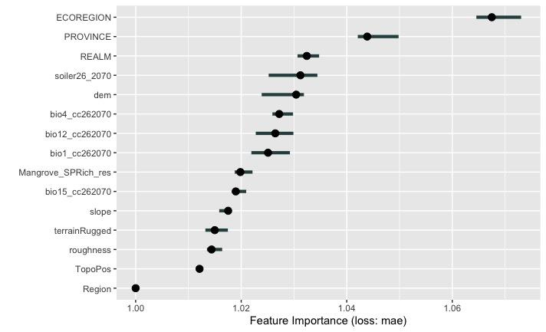

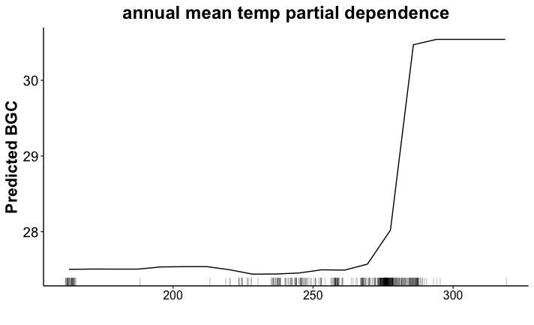

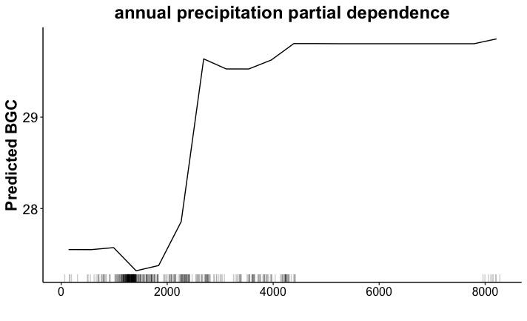

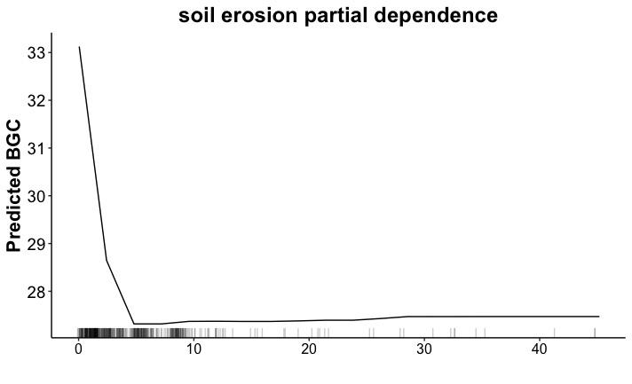

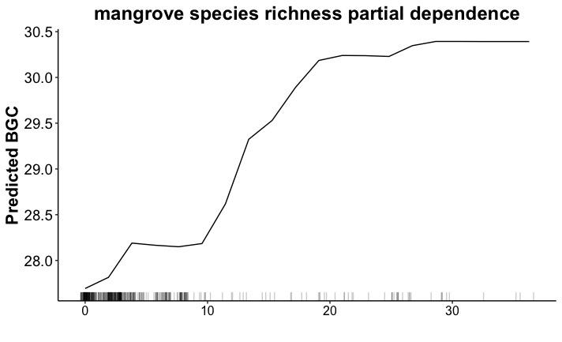

1. **SOC**

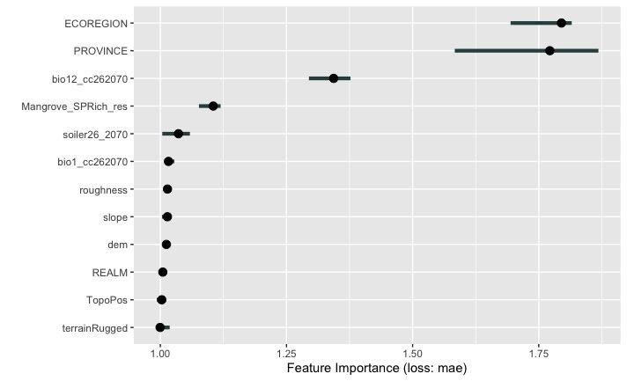

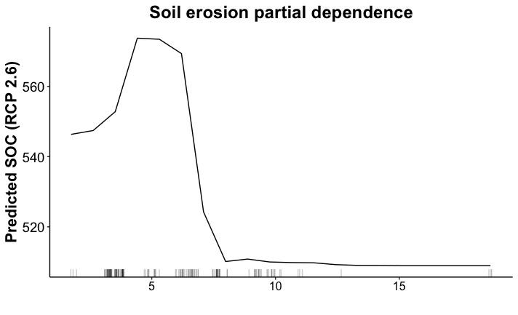

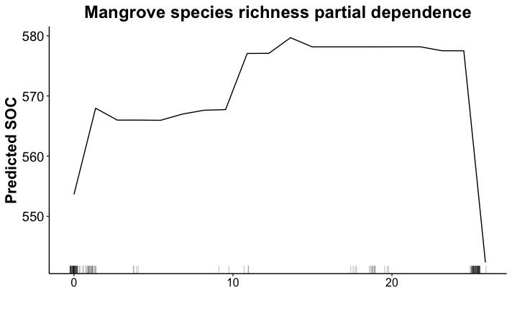

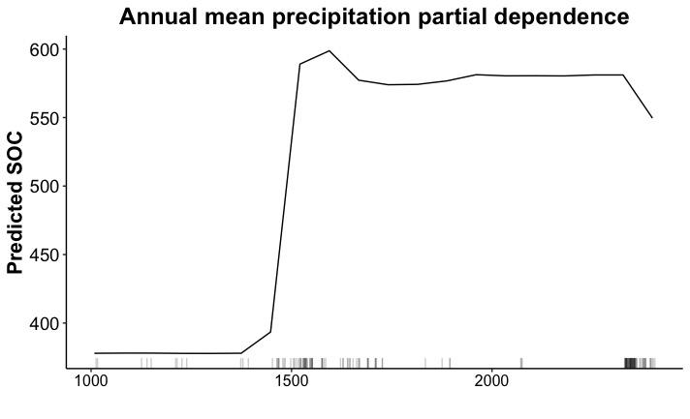

**(II) RCP 4.5**

1. **Above Ground Carbon**

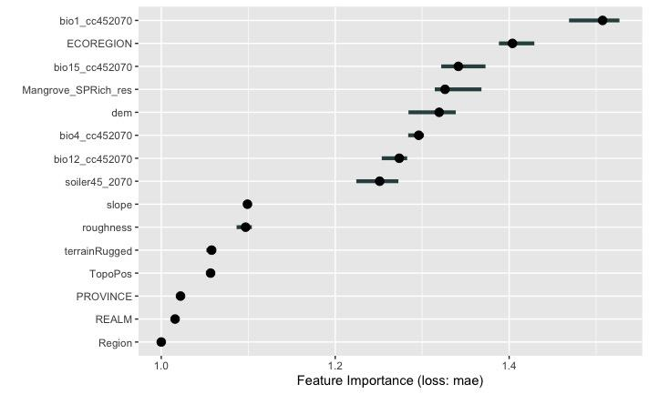

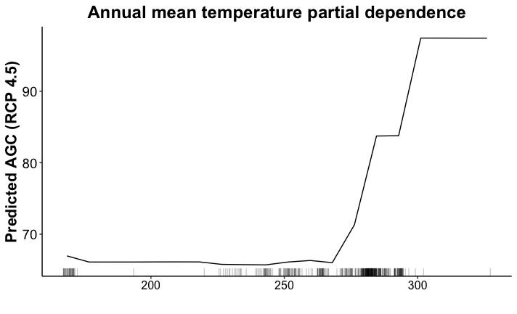

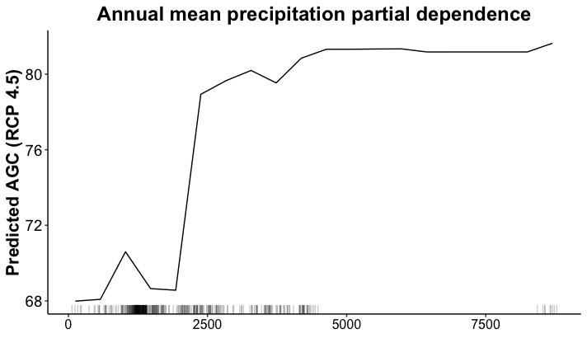

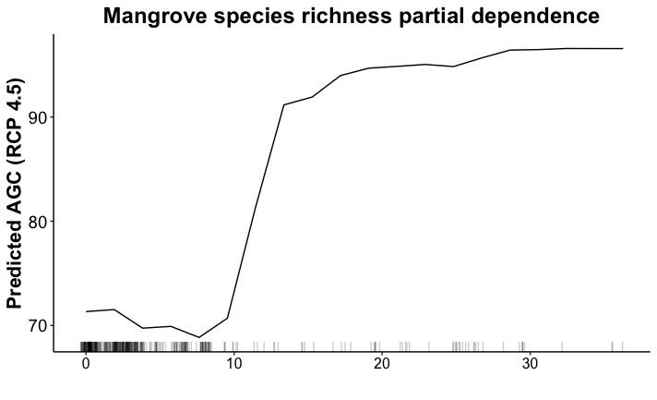

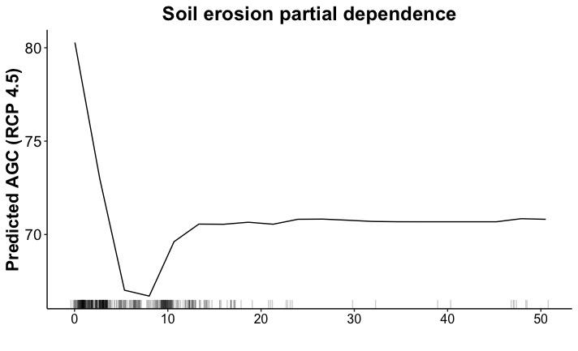

1. **Below Ground Carbon (BGC)**

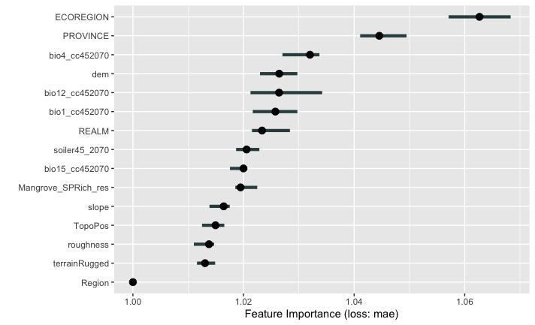

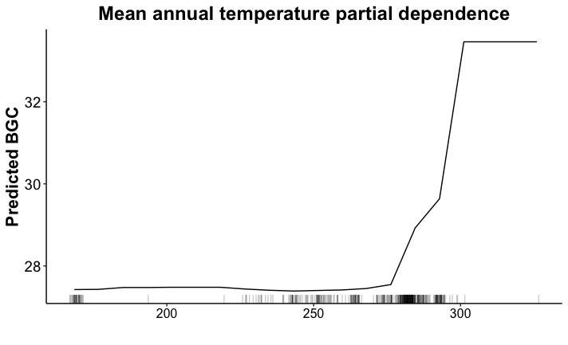

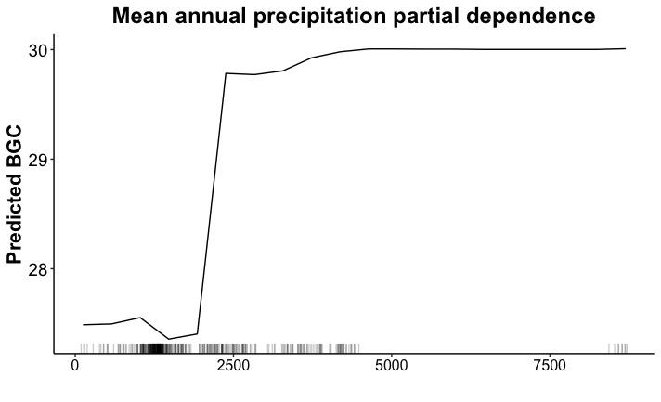

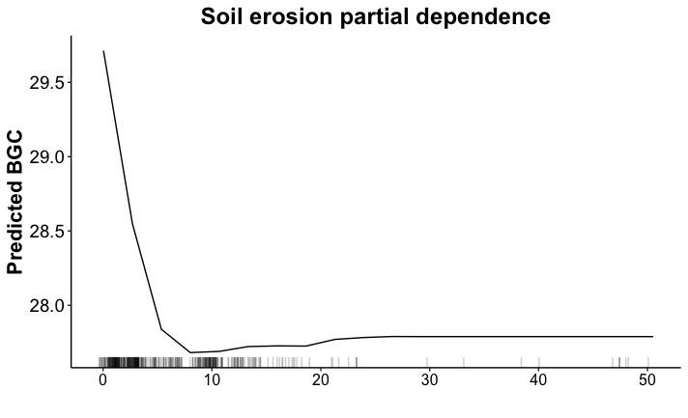

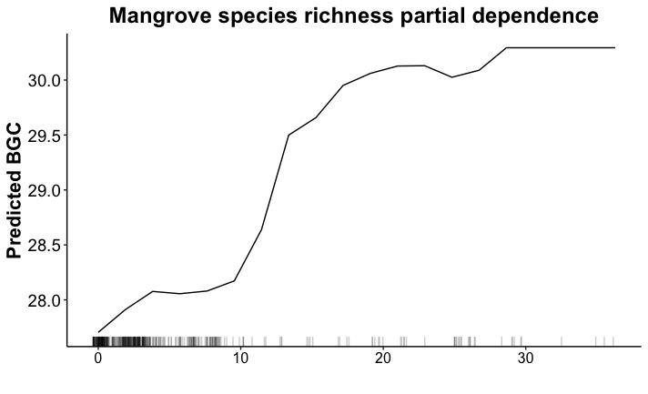

1. **SOC**

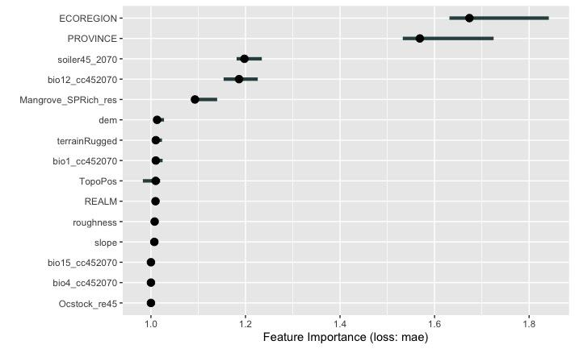

**(III) RCP 8.5**

1. **Above Ground Carbon (AGC)**

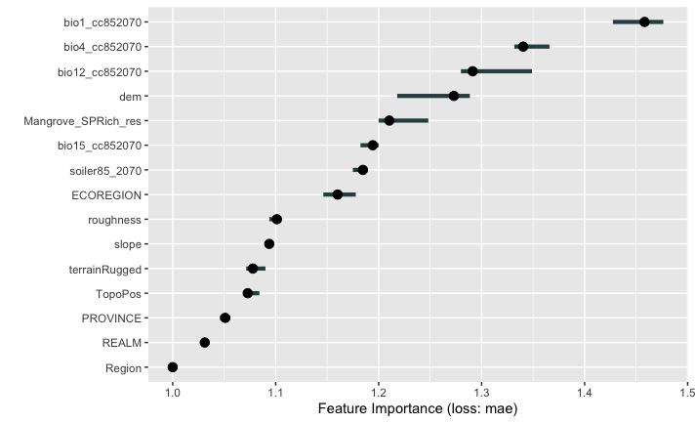

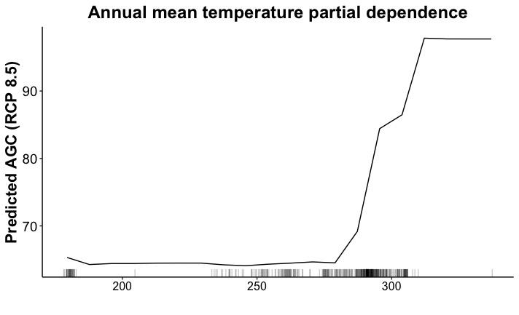

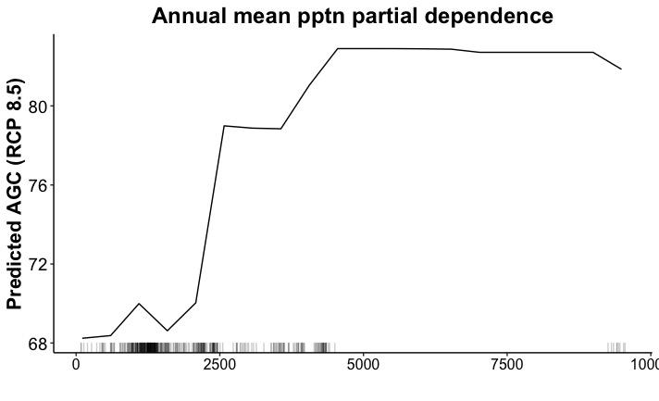

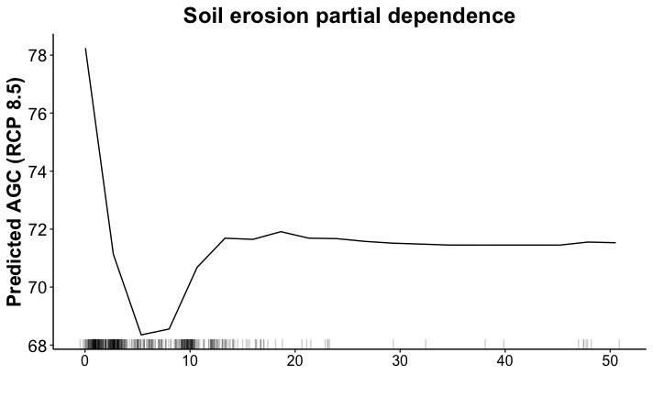

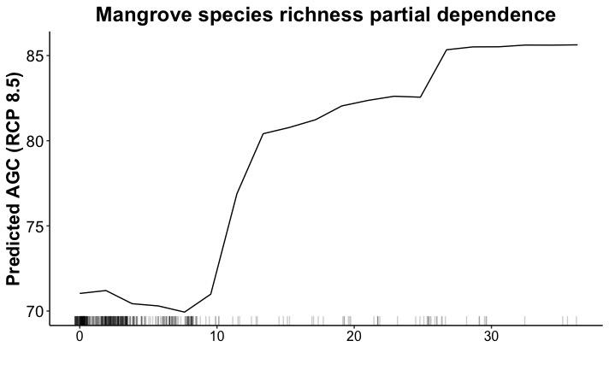

1. **Below Ground Carbon (BGC)**

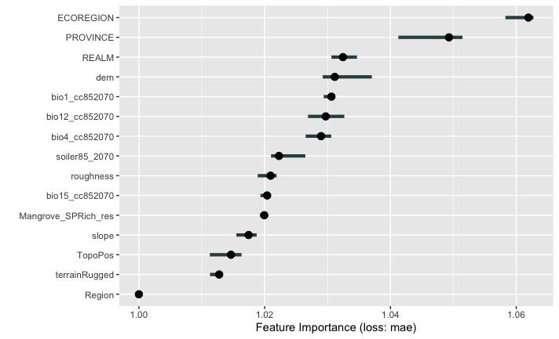

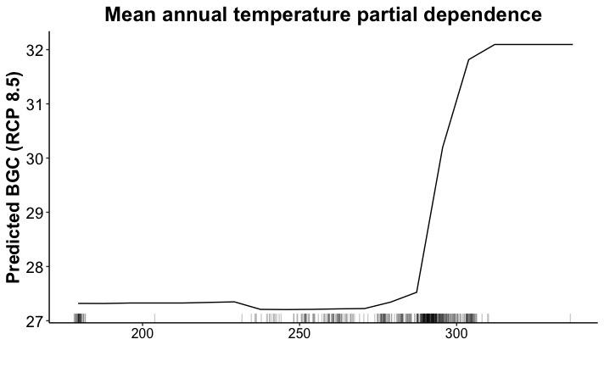

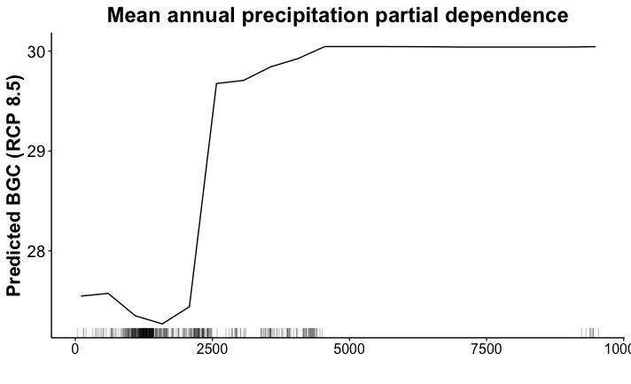

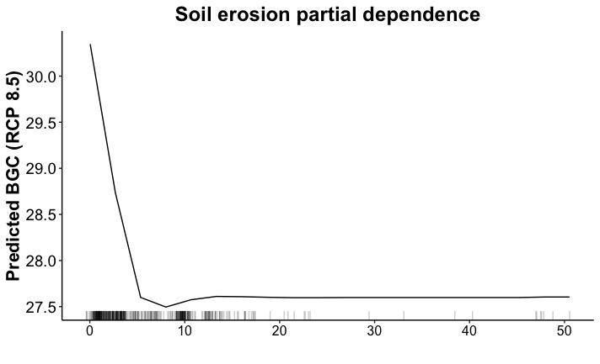

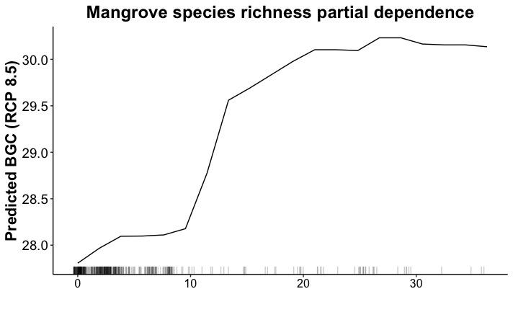

[Bibliography](http://sciwheel.com/work/bibliography)

[1. Estrada GCD, Soares MLG. Global patterns of aboveground carbon stock and sequestration in mangroves. An Acad Bras Cienc. 2017;89: 973–989. doi:10.1590/0001-3765201720160357](http://sciwheel.com/work/bibliography/8957403)

[2. Komiyama A, Kato S, Poungparn S, Sangtiean T, Maknual C, Piriyayotha S, et al. Comprehensive dataset of mangrove tree weights in Southeast Asia. Ecol Res. 2017;32: 3–3. doi:10.1007/s11284-016-1417-0](http://sciwheel.com/work/bibliography/10461615)

[3. Suyadi, Gao J, Lundquist CJ, Schwendenmann L. Aboveground carbon stocks in rapidly expanding mangroves in new zealand: regional assessment and economic valuation of blue carbon. Estuaries Coast. 2020;43: 1456–1469. doi:10.1007/s12237-020-00736-x](http://sciwheel.com/work/bibliography/10462872)