Name: Jojo Fynn Mensah.

ID: 80282022.

**Individual Portfolio**

In the quiz application written by my team members and me, my most invaluable contribution was to write the main class called PersonMain.java to take a test takers information and print questions set by the examiner from the MultipleChoicetester.java class. The data structure used in my code is **Array**. The code is below.

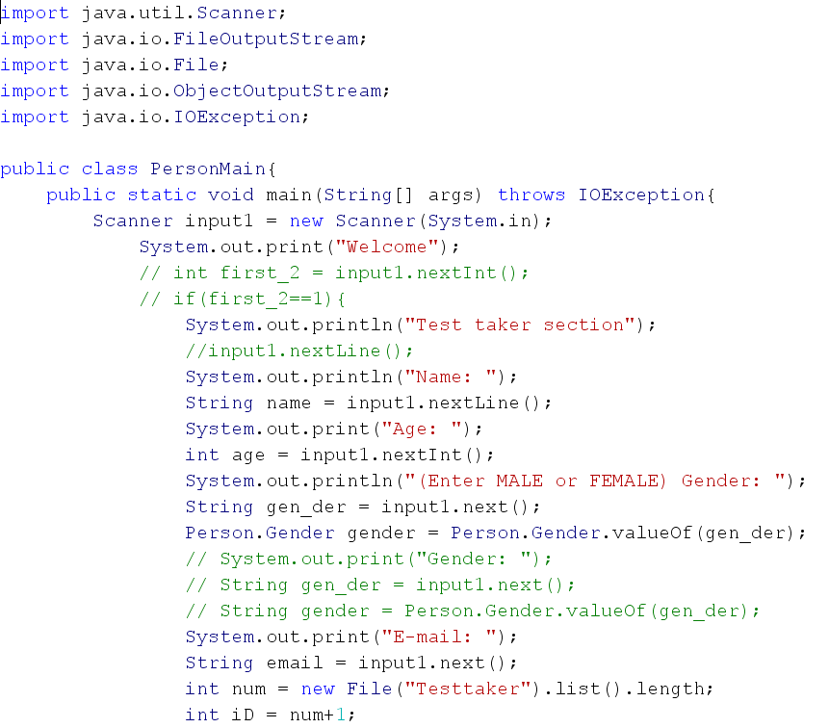

This portion of the code above shows how a scanner object was used to store test-takers information in respective variables. An ID number is generated for a test-taker currently about to take a quiz.

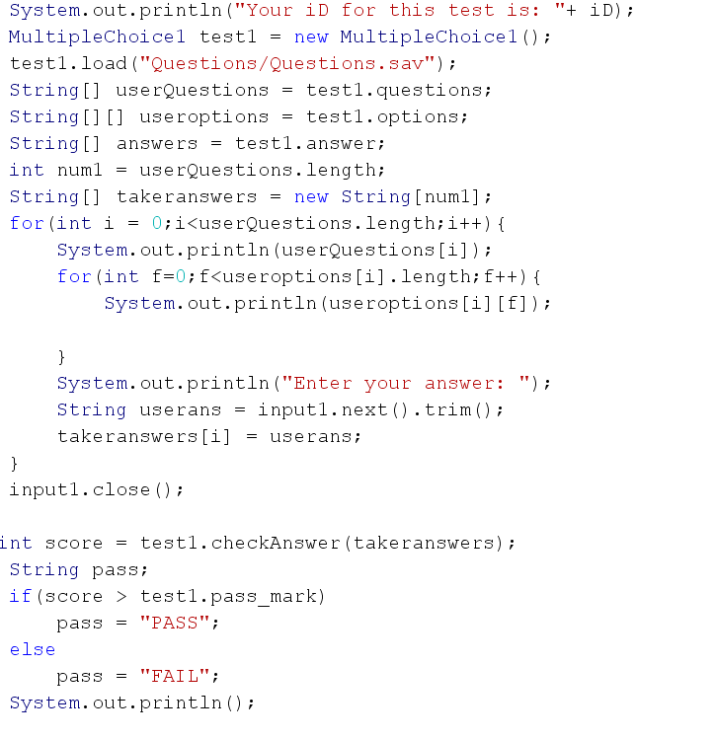

The ID number is printed out for the user. The MultipleChoice1 class instantiated, and Questions.sav file is loaded using the load method from the Multiplechoice1 class. The questions, options and answers from the Questions file stored into new string array variables for easier manipulation. A string array variable was then created to store test-takers answers. A nested for loop printed out questions and options and asked for user input in every iteration until the loop stopped. Immediately after the loop stops, a variable called int score then checks the answers given by the test taker, and an if-else statement was used to determine whether the test taker passed or failed.

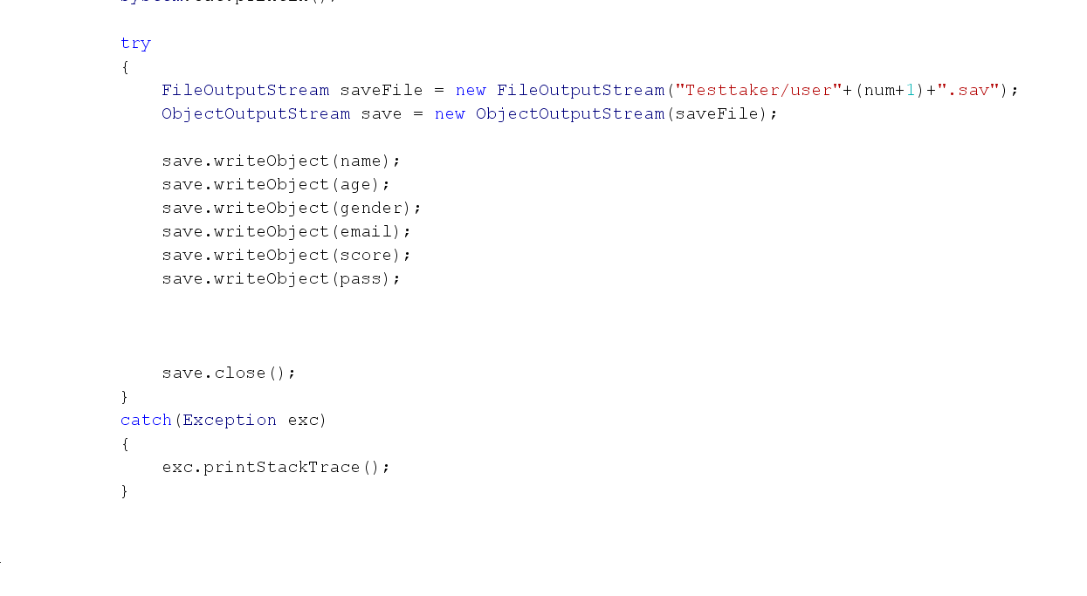

Finally, a try-catch statement creates a .sav file for a user containing all their information.