**TASK 1.1**

**Introduction**

**An Examination Management System for Universities.**

Due to the COVID-19 pandemic, many universities have resorted to using online platforms to facilitate the teaching and learning between teachers and students. All examinations are held online due to remote learning and there is a need of a system that can manage all that information. Thus Examination Management System automates the activities carried around the Examination processes. A good examination management system provides institutions with the mechanism to easily create a streamlined exam pattern that is the most conducive for the academic development of students. It also benefits faculty by : Eliminating overwhelm, shifting administration to a single, central system in order to simplify execution of examination processes, significantly reduces time spent fulfilling pre-prep, during and after examinations processes, simplifying exam scheduling, and providing accuracy and cuts unreliability (Govendor, 2021). The six **main** entities would be **students, university, marks, courses, papers, and faculties.**

The functionalities includes:

1. List of students and faculty members and their respective ID numbers in a university.

2. Searching for highest scores in the Marks entity above 50 and the UserID associated with the scores in alphabetical order.

3. Inspecting names of faculty and the university course they handle.

4. Inspecting how many universities exist in alphabetical order.

5. Searching for papers being written and their date in alphabetical order.

6. Searching for average between the student score and score lecturer gave.

**Task 1.2**

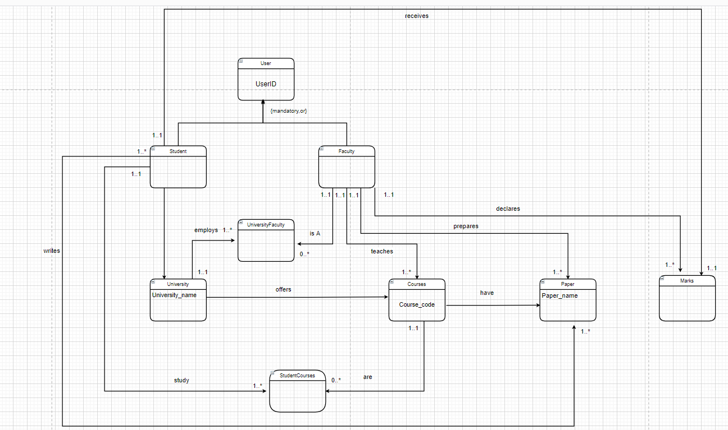

**Figure 1: ER diagram of examination management system**

**Entities and their non-key attributes.**

Student

* Username
* Mobile number
* Hostel number
* Name of Parent
* Year Group
* Major

Faculty

* Username
* Email
* Department room number
* Year employed
* Salary
* Academic rank

Marks

* Score
* Type

Courses

* Course name
* Course type
* Course year
* Course description
* Student course Capacity

Papers

* Start time
* End time
* Date
* Type Description
* Number of scripts

University

* Location
* Name
* Year founded
* Student Capacity
* Faculty Capacity
* Address
* Maximum Number of courses offered

**Enterprise rules**

1 - A student can receive several marks for papers written.

One mark is awarded to one student for one paper.

2 - A student can write one paper for one course.

One paper can be written by multiple students.

3 - A student enrolls in one university.

A university can enroll one or multiple students.

4 - A student can study multiple courses.

A course can be studied by zero or multiple students.

5 - A faculty member can be employed by zero or multiple universities.

A university can employ multiple faculty members.

6 - A faculty member can teach multiple courses.

A course is taught by only one faculty member.

7 - A faculty member prepares multiple papers.

A paper is prepared by only one faculty member.

8 - A faculty member can declare multiple student marks.

A student mark is declared by one faculty member.

9 - A university can offer one or more courses.

One course is offered by one university.

10 - One course has only one paper written by students.

One paper is written per course by students.

11. A paper has one or more marks for a course.

One mark goes to one paper for a course.

**Assumptions**

* A student cannot write a two or more papers for courses that have the same start time and end time on the same date.
* The total number of published marks for a paper cannot exceed the course capacity.
* The total student capacity for all courses offered in a university cannot exceeded the university student capacity.
* The student capacity for a university will be greater than faculty capacity.
* All scores are graded out of 100.0.
* A course is run once a year in a university.
* If a score is below 50 it is a low score. If it is above then it’s a high score. 50 is average mark.

**Task 2.1**

**Logical table derivation**

N/B: All primary keys are represented by bold, hash, and underline, foreign keys are represented by italic, and composite keys are represented by bold, hash, italic, and underline.

User (**UserID#**, username, email)

Student (***UserID#***, mobile, hostel number, name of parent, year group, major, *universityID#*)

Faculty (***UserID#***, department room number, salary, year employed, academic rank)

University (**universityID#**, university name, year founded, location, student capacity, faculty capacity, address, maximum number of courses offered)

UniversityFaculty (*universityID#,* *UserID#*)

Courses (**course_code#**, course name, course type, course year, course description, student course capacity, paper_name#, start time, end time, date, type description, number of scripts, *universityID#, UserID#* )

StudentCourses (*UserID#, course_code#)*

Marks (*course_code#,* Score, Type, *UserID#*)

**YouTube video below**

https://youtu.be/oNWwV2WShY0

References

Govendor, P. (2021, May 5th). *Examination Management System: Benefits and Features - Adapt IT Education*. Retrieved from Adapt IT Education: https://education.adaptit.tech/blog/examination-management-system-benefits-and-features/