1. Navigate to <https://www.cloudflare.com/en-au/developer-platform/solutions/s3-compatible-object-storage/>
2. Click on Get Started
3. Signup with your email account
4. Add PayPal/CC and Add Billing address and Add R2 subscription to account
5. Create bucket

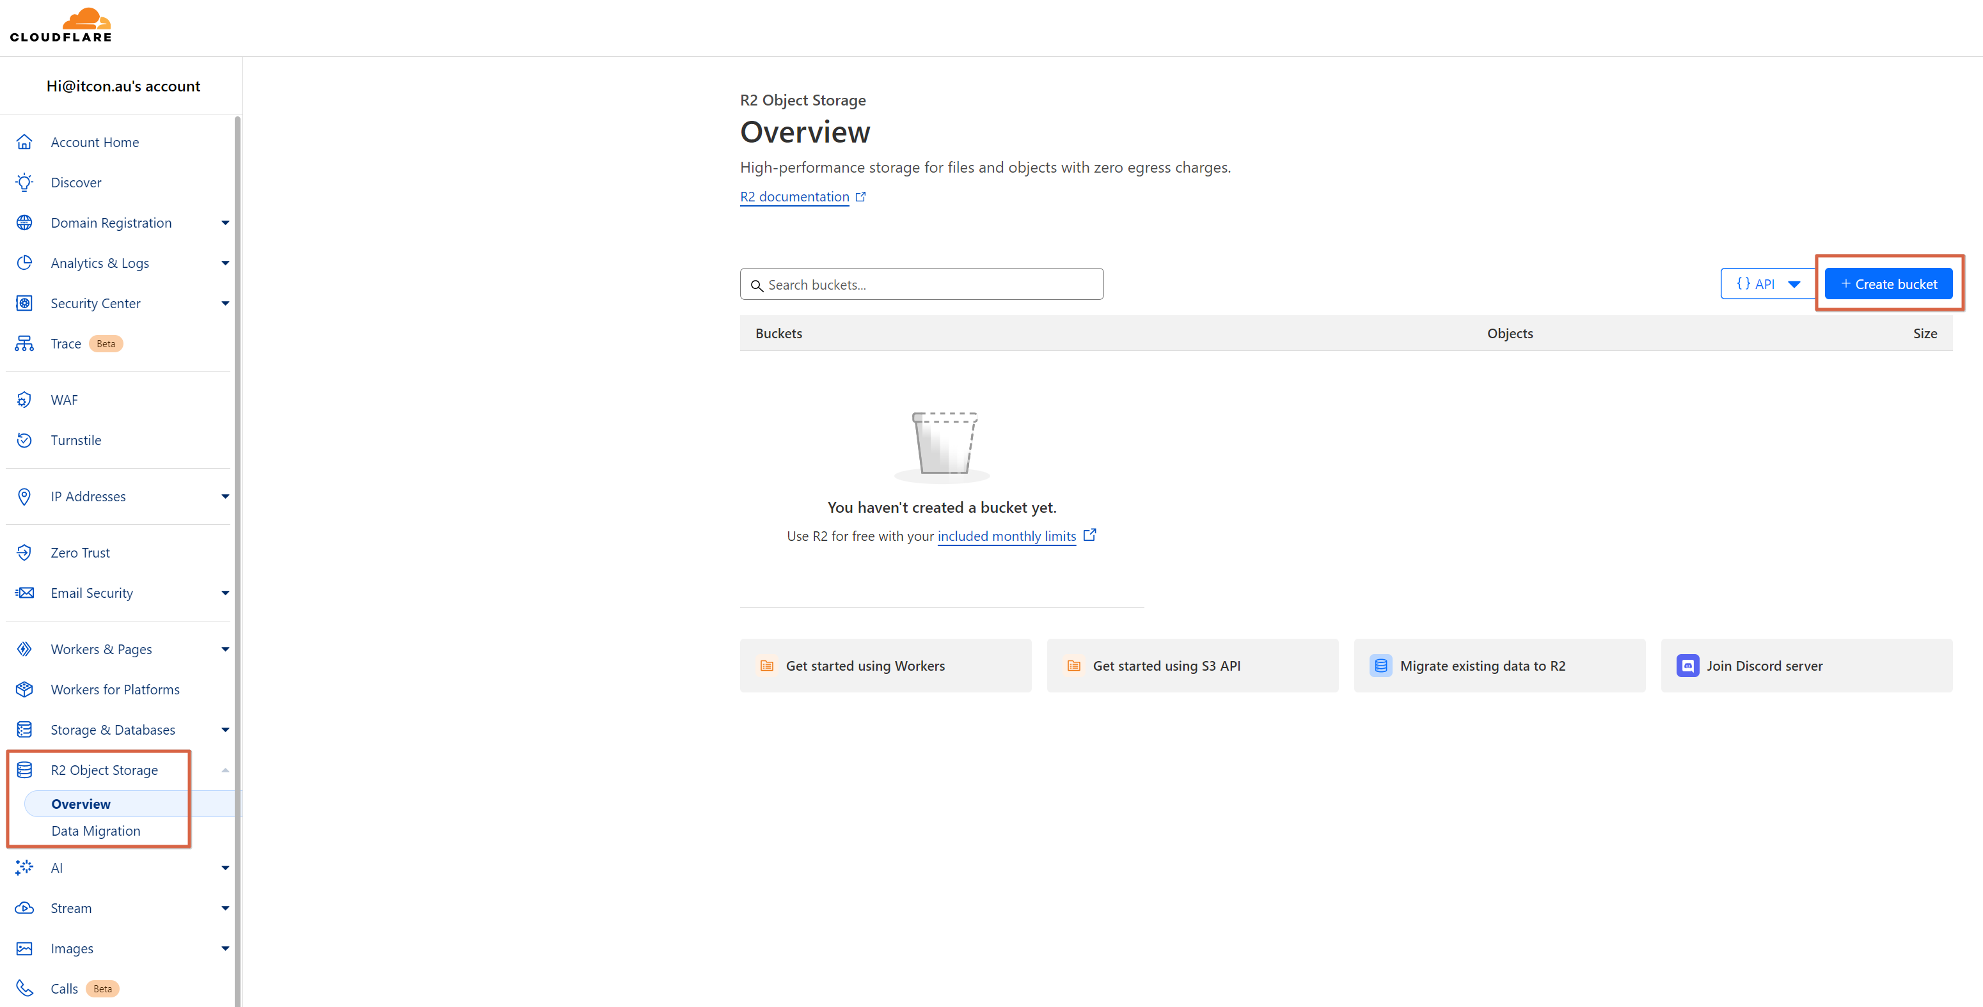

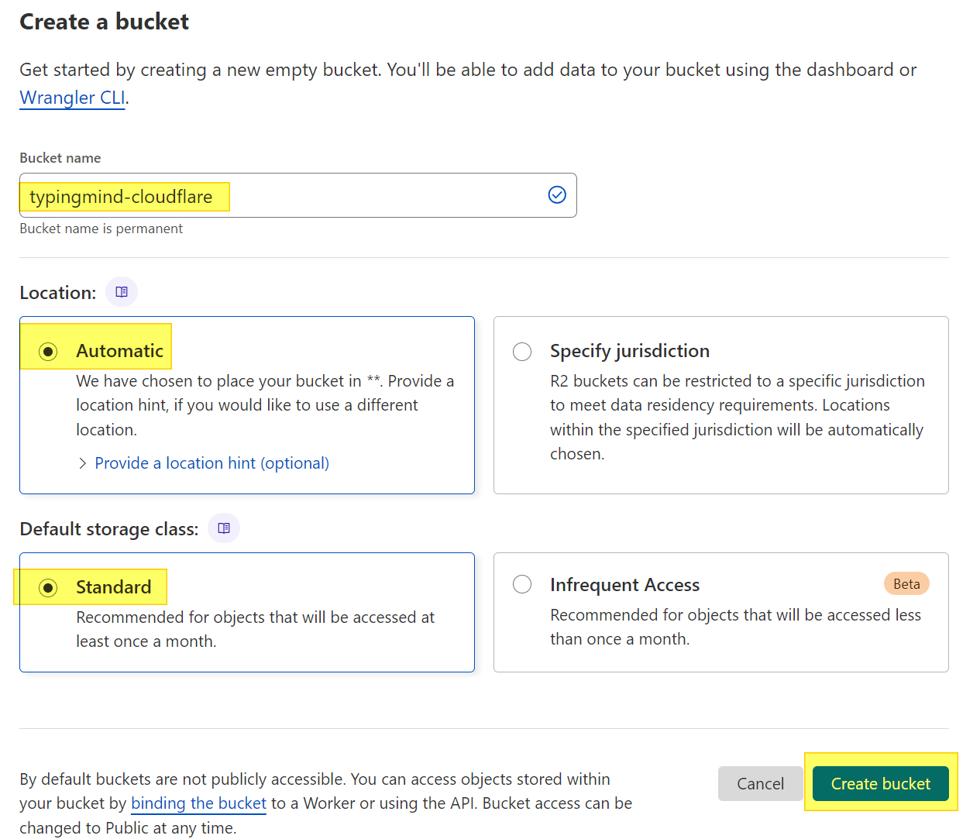

Open Bucket Settings

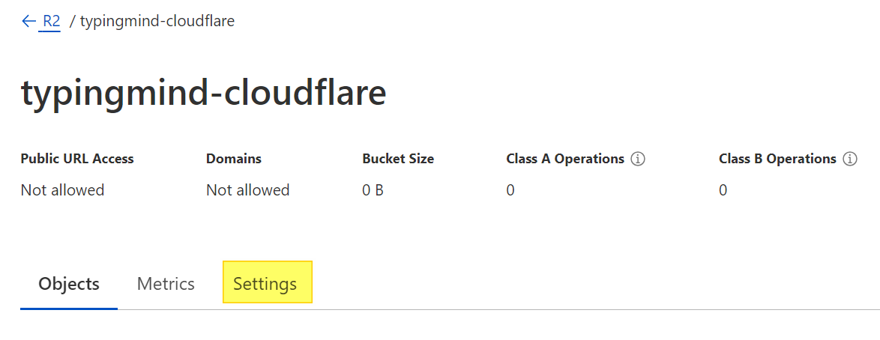

Add CORS policy – Get the CORS from Github readme. There are 2 different versions – one for self-hosted instances and another for typingmind.com. Below is an example for self hosted.

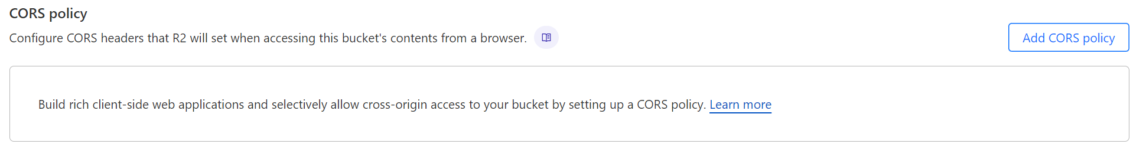

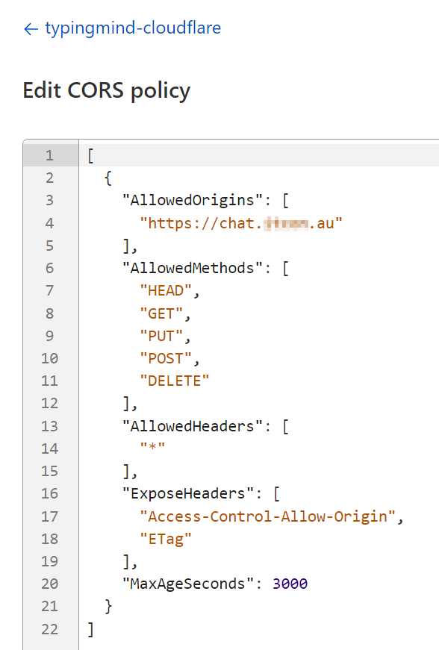

Create API Token

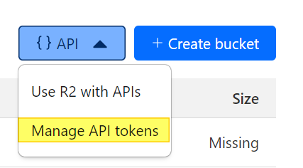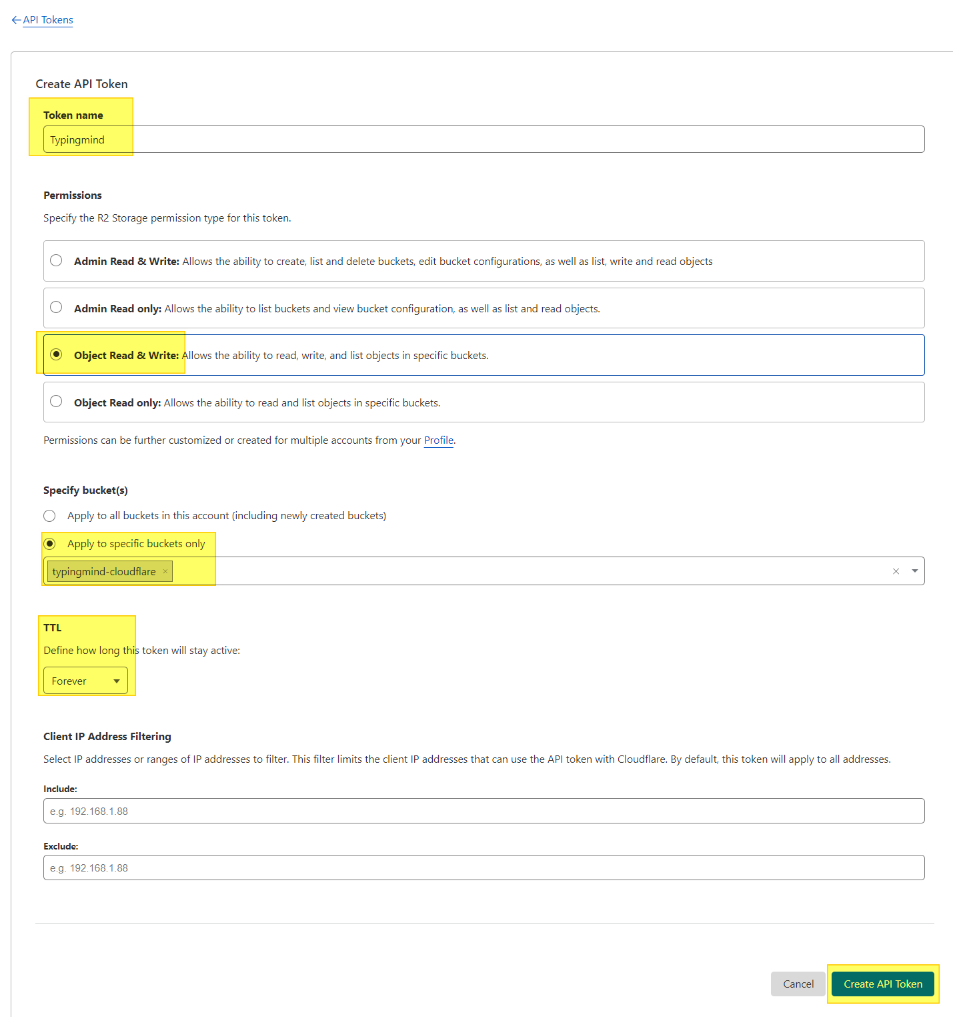

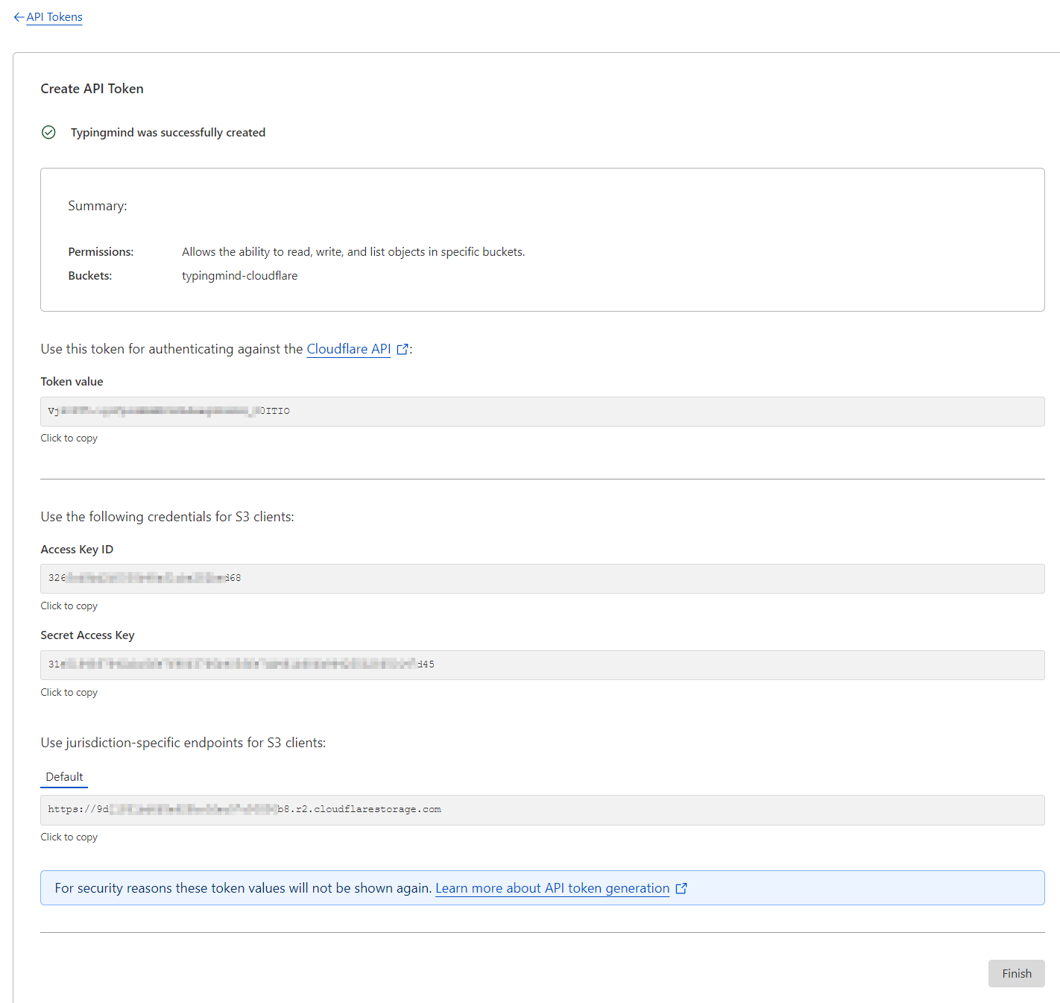

|  |  |
| --- | --- |
| Config to be entered in extension   1. Bucket name 2. AWS Region – ‘auto’ 3. AWS Access Key – This is the Access Key ID displayed when the token was generated 4. AWS Secret Key – This is the Secret Access Key displayed when the token was generated 5. AWS/S3 compatible Storage endpoint – This is the “Use Jurisdiction specific endpoints for S3 clients” 6. Backup Interval (sec) – How frequently should the extension backup the data to S3. Minimum is 15 sec. 7. Encryption Key – To secure the backup files in S3, provide an 8+ char password here. Make sure you don’t forget it. Backups can be restored only with this password.   To understand how the extension works, refer GitHub readme -> <https://github.com/itcon-pty-au/typingmind-cloud-backup/tree/main> |  |