iDrive e2

Register for the Free plan.

Enable a region of your choice.

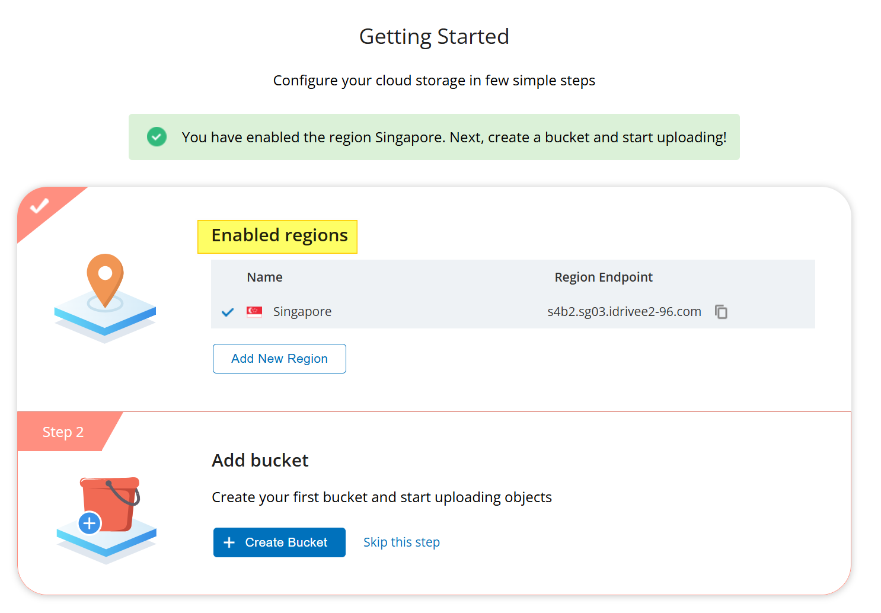

Create bucket

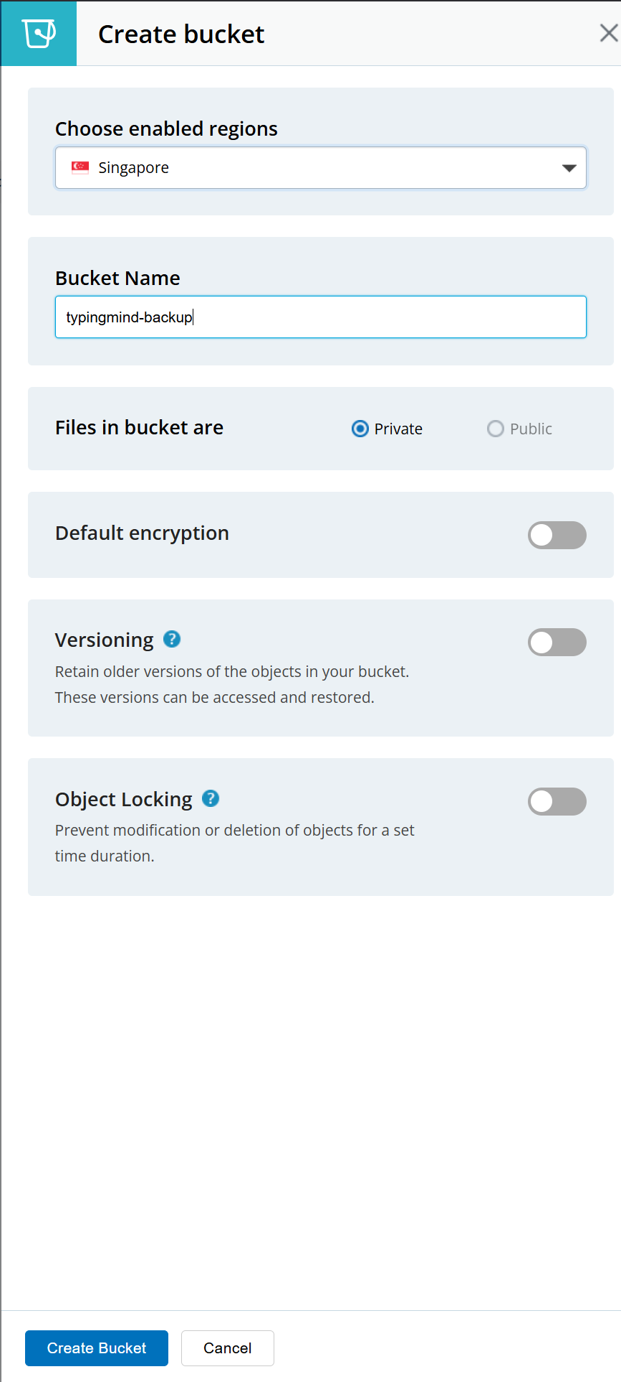

Navigate to Access Keys

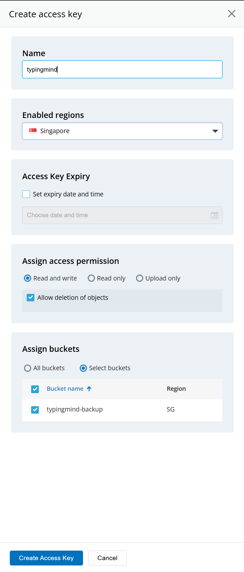

Copy the displayed access key, secret key and endpoint for later use as it will be displayed only once.

Configuration in the extension

