Pac-Man Design Doc

Table des matières
Goal 2
Requirements 2
The game must support 2
Game Loop 3
Detailed Specifications 3
1. Usage 3
2. Configuration file 3
3. Faulty config handling 3
4. Maze generation integration 3
5. Highscore system 4
Game Specifications 4
1. Level structure 4
2. Player 4
3. Ghosts 5
4. Pacgums and Super-pacgums 5
5. Cheat mode 5
6. Scoring 5
7. Game progression 5
8. User Interface 6
Project packaging 6
Approach 6
Usage 7
Configuration file 7
Faulty config handling 9
load_config pipeline 9
Maze generation integration 9
Highscore system 10
Level Structure 10
Application architecture 11
Initial placement 13
Entities 14
Player 14
Ghosts 15
Pacgums & Super-pacgums 16
Cheat mode 17
Scoring 17
Game progression 17
User Interface 17
Main Menu 17
In-game HUD 17
Pause Menu 17
Game Over Screen 17
Victory Screen 17
Architecture Scheme 17
Alternatives (pros/cons) 17
Open Questions 17

Goal
The goal of this project is to build the popular Pac-man game following the original game behavior and the multiple requirements of the subject. The game must be deployable on a public game platform such as Steam/Itch.io or similar.

Requirements

The game must support
- Custom configuration file (JSON with comments) to set game parameters.
- Robust error handling
- Level generation based on an external ‘A-maze-ing’ package.
- Persistent highscore system (storage method not imposed).
- Graphical UI with main menu, game view, game-over handling using MLX or similar library.
- Cheat mode for evaluation purposes.
- Deployment to a public game platform.

Game Loop
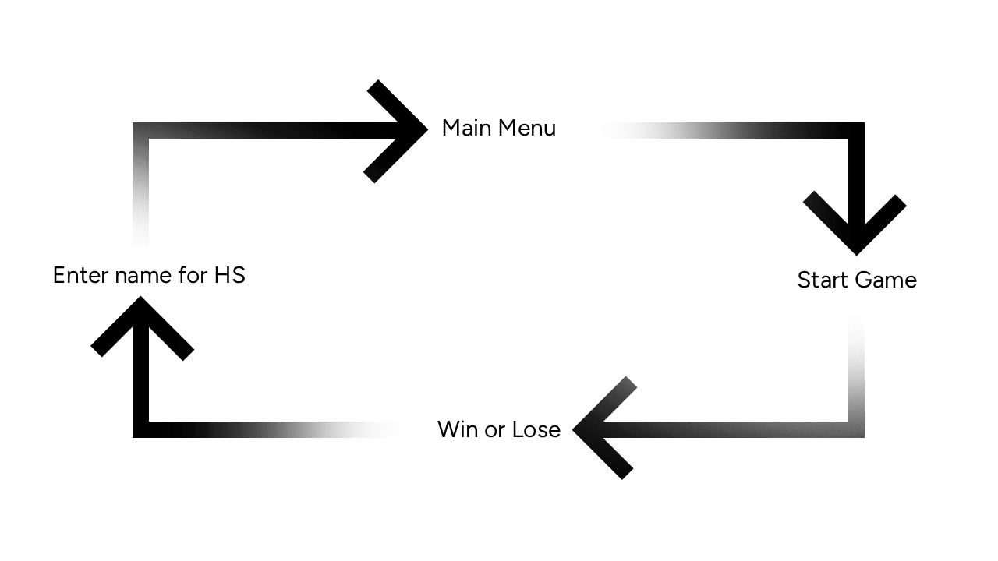

Detailed Specifications

Usage
The program must be launched from the CLI as follows:
$> python3 pac-man.py config.json
- It must take exactly one argument.
- Any error (missing file, invalid value, missing key) must be handled cleanly with clear messages never with a Python traceback.
- Filename does not matter, but the file must be a JSON file.

Configuration file
The config file uses JSON. In addition to the standard JSON format, comments must be handled. Lines starting with # are comments and must be ignored. Additional comment styles such as C or C++ may be handled as well.
The exact structure is not imposed, but the keys must be documented in the README and provide robust defaults.

Faulty config handling
On missing or invalid values, clamp to safe defaults, log clear message and the program must continue. Unknown keys are ignored. No traceback.

Maze generation integration
- The A-Maze-ing package must be used as it is, without modifying it.
- The loader must adapt to the package’s interface not the opposite.
- The parameter PERFECT is set to False to produce Pac-Man-compatible corridors.
- If the generator fails, the error must be handled gracefully.

Highscore system
A persistent highscore system must be implemented.
The exact implementation is not imposed but must be documented in the README.
Requirements:
- Exact highscore system is not imposed.
- Must be robust to file errors.
- Player name handling (max 10 characters, alphanumeric and spaces only).
- Scores handling (non-negative integers)
- Keep the top 10 highscores, player names with scores.
- Load highscores at game start and save at game end.
- Allow players to enter their name when they end the game (Win or Lose).
- Display highscores in the main menu.

Game Specifications

Level structure
- A maze with walls and corridors generated by the A-Maze-ing package.
- The first level is generated with the fixed seed 42, then, each subsequent level is composed of a maze randomly generated.
- Pacgums (small dots) in most corridors (nb pacgums determined in the config file).
- Super-pacgums (power pellets) in the 4 corners of the maze.
- 4 ghosts, one in each corner of the maze.
- The player starts in the center of the maze.

Player
- Can move through corridors only (no walls).
- Can move in 4 directions (up, down, left, right) using arrow keys or WASD.
- Starts with 3 lives.
- Loses a life when touched by a ghost.
- Respawns in the middle of the maze after losing a life.
- Game over when all lives are lost.
- Wins the level when all pacgums are eaten.
- Eating a pacgum increases the score by X points.
- Eating a super-pacgum increases the score by Y points and makes ghosts edible for a short time.
- Eating an edible ghost increases the score by Z points.
- Wins the game when all levels are completed.

Ghosts
- Move autonomously through corridors.
- Chase the player when not edible. Chase behavior is not imposed (distance-based, random, etc.).
- Run away from player when edible.
- Respawn in their corner after a while when eaten (e.g., after 5 or 10 seconds).

Pacgums and Super-pacgums
- Pacgums are small dots placed in most corridors.
- Super-pacgums (power pellets) are larger dots placed in the 4 corners of the maze.
- Points per pacgum/super-pacgum are determined in the config file.

Cheat mode
- Can be activated to facilitate peer review.
- Suggested features:
  - Invincibility
  - Level skip
  - Ghost freeze
  - Extra lives
  - Increased speed

Scoring
- The score increases when:
  - Eating a pacgum.
  - Eating a super-pacgum.
  - Eating an edible ghost.
- The score does not decrease.

Game progression
- The game consists of multiple levels (at least 10).
- Each level has a time limit (e.g., 90 seconds).
- If the time limit is reached, behavior is not imposed.
- If the player completes a level, they move to the next one.
- The player keeps their score and remaining lives between levels.
- The game ends when all levels are completed or when the player loses all lives.
- During the game, the player can pause and resume the game.
- When the game ends (win or lose), the final score is displayed, and the player can enter their name to save the highscore.
- After the game ends, the player is returned to the main menu.

User Interface
- Main Menu:
  - Start Game - Allows the player to start a new game.
  - View Highscores - Displays the Top 10 scores with player names.
  - Instructions - Shows the game controls and rules.
  - Exit - Closes the game application.
- In-Game HUD (always visible during gameplay):
  - Current score
  - Remaining lives
  - Current level
  - Remaining time for the level
- Pause Menu:
  - Resume the game - Allows the player to return to the ongoing game.
  - Return to the main menu - Allows the player to exit the current game and go back to the main menu.
- Game Over Screen:
  - Displays the final score.
  - Prompts the player to enter their name to save the score in the highscores list.
- Victory Screen:
  - Displays the final score and a congratulatory message.
  - Prompts the player to enter their name to save the score in the highscores list.

Project packaging
- The complete game must be installable and launchable from a public platform as a free but unlisted/private build.
- The packaged game must be fully functional.
- Minimal in-package instructions (controls, options, configuration).
- Git repository must contain the full source and the packaging script/spec at the root

Approach
In this section, each point of the requirements will be discussed with a suggestion on its implementation.
First, we will approach the detailed specification part.

Usage
The program takes exactly one argument: the path to the configuration file.
This is handled by a dedicated cli.py module, exposing a single function:
def command_line(args: list[str]) -> str:
pac-man.py calls it with sys.argv. The function:
- Checks that exactly one argument was given. Otherwise, it raises a ValueError with the message expected 1 argument, got N, followed by the usage python3 pac-man.py <config.json>.
- Opens and reads the file. Any OSError (missing file, permission denied…) is raised to the caller.
- Returns the raw content of the file as a string.
Invalid values and missing keys are not handled here: they are the responsibility of config.py.

Configuration file
The configuration file contains the following keys (names are indicative, additional keys can be implemented):
- highscore_filename
  - only the filename is accepted. If a path is given, a clear message is logged and the default filename is used. The file is stored in the user’s data folder, provided by the platformdirs package, regardless of the OS Pack-man runs on.
- levels - array of levels
  - Exactly 10 levels are used. If fewer are given, the missing ones are filled with default levels. If more are given, the extra ones are ignored and a message is logged.
  - An invalid level (missing or invalid dimensions) is replaced by a default level, without affecting the others.
  - width, height : positive integers, minimum 10 and maximum 50. The size of each cell in pixel is computed dynamically to fit the window.
- lives : 3
  - rule: positive integer, minimum 1, maximum 5.
- pacgums : 42
  - rule: positive integer, minimum 10. The maximum is the number of free corridor cells (excluding corners and the player’s spawn). Since this number is only known once the maze is generated, the value is clamped at generation time.
- points_per_pacgum : 10
  - rule: positive integer. Max 1000
- points_per_super_pacgum : 50
  - rule: positive integer. Max 5000
- points_per_ghost : 200
  - rule: positive integer. Max 20 000
- seed : 42
  - rule: positive integer. Only used for the first level; the following levels use random seeds.
- level_max_time : 90
  - rule: positive integer (seconds), minimum 30, maximum 600.
- cheat_mode : false
  - rule: Boolean only (true or false, no strings or integers).
Note: integers keys must reject Booleans explicitly. In Python, True and False are a subtype of int, so a simple integer check would accept them.
The configuration file will be handled by the config.py module, in which we define a Config dataclass with the default values. A Level dataclass holds the dimensions of a level (width and height). Config stores a list of 10 Level objects. Then we implement a public function:
def load_config(content: str) -> Config:
and a set of private validation functions :
- _validate_int(value: object, min_value: int, max_value: int) -> int:
  - Exclude booleans and not integer values. Clamps if off bound.
  - Usage:
    - lives, pacgums, points_per*, seed, level_max_time, width, height
- _validate_bool(value: object) -> bool:
  - Only accepts true and false.
    - Usage:
      - cheat_mode
- _validate_filename(value: object) -> str:
  - Only accepts non-empty strings without path separator.
  - Usage:
    - highscore_filename
- _validate_level(value: object) -> Level:
  - Verifies if the level is an object with width and height using _validate_int.
- _validate_levels(value: object) -> list[Level]:
  - Verifies if the object is a list and calls _validate_level on object of the list then completes or cuts at 10.

Faulty config handling
Validation functions report missing or invalid values; load_config catches them, logs a clear message, clamps to safe default and continues.

load_config pipeline
- Strip comments: lines starting with # (after leading whitespace) are removed. Other comments styles are not supported.
- Parse JSON: the remaining content is parsed with json.loads. If the JSON is invalid, a message is logged and the default configuration is used.
- Check root type: the parsed result must be a dict. Otherwise, a message is logged and the default configuration is used.
- Validate each key: for each expected key:
  - If the key is missing (key not in data), a message is logged and the default value is kept.
  - Otherwise, the value is passed to its validator. If a ConfigError is raised, a message is logged and the default value is kept. The other keys are still processed.
- Ignore unknown keys: keys that are not expected are ignored.
- Build the Config: a Config object is created with the validated values; missing or invalid keys keep their dataclass defaults.

Maze generation integration
Once the configuration file has been validated, the maze generator is used to create each level, the next one being generated when the previous one is completed.
The A-Maze-ing package is used as is, without any modification. It is wrapped in a dedicated maze_loader.py module, which adapts to the package’s interface and converts its output into the game’s format, if the interface changes, only this module needs to be updated.
The generator is configured as follows:
- Dimensions are taken from the Config object.
- PERFECT is set to False, which produces Pac-Man-compatible corridors with no dead ends.
- The first level uses the fixed seed from the config (default: 42). Each following level uses a random seed.
The generator returns a matrix in which each cell is an integer between 0 and 15, representing its walls as a bitmask (one bit per direction: N, E, S, W). This matrix is then passed to the rendering module.
If the generation fails, a new attempt is made with the default parameters. If it fails again, a clear error message is displayed and the game exits cleanly, without traceback.

Highscore system
For the highscore system, JSON file storage is a simple and robust solution. The file is in the user’s data folder, obtained with platformdirs package, and its name comes from the config. Only the top 10 entries are kept. Each entry has the following format: {"name": "Sydney", "score": 1200}. Highscores are loaded when the game starts and saved when a game ends. To ensure robustness, the following cases are handled:
- Corrupt or missing file:
  - If the file is corrupted (length of the name greater than max, negative score etc.), the corrupted entry is removed.
  - If the file is missing or not valid JSON, the game starts with an empty list.
- Name entry:
  - The name entry verification operates during the entry itself; forbidden characters or 11th character is blocked.
  - The name is stripped before validation; an empty name is refused.
- Ties:
  - In case of a tie, the oldest score is ranked first.
- Save:
  - The new list is written to a .tmp file, which then replaces the original with os.replace. If the game crashed during the writing, only the .tmp file is affected.
Now let’s get through the game specifications.

Level Structure
Now that the reading and writing parts are covered, we use the A-Maze-ing package in the dedicated maze_loader.py module, which exposes the following function:
def process_maze(width: int, height: int, seed: int) -> Grid:

It calls the generator with the given parameters and converts its output into the format used by our game. It returns a Grid object; the Grid class is defined in a dedicated grid.py module.
The grid is composed of a matrix of Cell objects. Each cell stores its walls as a bitmask, as provided by the generator, and exposes a has_wall(direction) method that return True if the cell has a wall in the given direction.
Directions are represented by a Direction enum, based on IntFlag and defined in a dedicated direction.py module, since it is shared by the cells, the grid, the player, the ghosts and the input handling. Each direction holds:
- Its bit value, used to test the walls of a cell: N = 1, E = 2, S = 4, W = 8.
- Its offset (dx, dy), used to find the neighboring cell. Ex: Direction.E.offset -> (1, 0).
- Its opposite, used to turn around. Ex: Direction.N.opposite -> Direction.S.
The grid is never generated on its own: it is requested by the Game class, which knows the current level and chooses its parameters. To understand when and how Game is used, we first need to describe how the application itself is organized.

Application architecture
The application is organized as a state machine. Each screen of the game is a state, and only one state is active at a time.

App
The App class, defined in app.py, owns the main loop of the program and the current state (self.state: State). At startup, the current state is MainMenu. App also holds a Settings object (theme, etc.), which persists across games.
The main loop runs in App.run():
- The window is opened.
- While the window is not closed:
  - dt is computed: the elapsed time since the previous frame, measured with time.perf_counter(). This keeps the game independent of the graphical library.
  - The screen is cleared.
  - state.handle_input() is called.
  - state.update(dt) is called. It returns the next state.
  - state.render() is called.
  - The frame is displayed.
  - If update returned a different state, it replaces the current one. If it returned None, the loop stops (ex: Exit in the main menu).
- The window is closed.
This loop is the same for every screen: only the current state changes. It must not be confused with the Game Loop of the subject, which describes the sequence of screens and corresponds here to the transitions between states.

State
State is an abstract base class (abc.ABC) declaring three abstract methods:
- handle_input(): reads the keys relevant to this screen and stores the player’s intentions in the state. It does not act on them.
- update(dt) -> State | None: acts on the stored intentions and returns the next state (itself if nothing changes).
- render(): draws the screen. It never modifies anything.
Each screen inherits from State:
- MainMenu: Start Game, View Highscores, Instructions, Settings, Exit.
- Playing: holds the current Game (see below).
- Paused: keeps a reference to the Playing state (not a copy). Offers Resume, Settings and Return to main menu. On Resume, the same Playing state is returned, so the game resumes exactly where it stopped. While paused, Game is not updated, so the level timer stops automatically.
- Settings: keeps a reference to the state it was opened from and returns to it when closed. Reachable from the main menu and the pause menu.
- GameOver / Victory: receive the final score and let the player enter their name. On Enter, the highscore is saved and a MainMenu is returned.
- Highscores / Instructions: display information and return to the main menu.
States are created at transition time with the data they need (ex: GameOver receives the final score).

Playing
Playing is the link between the screen and the game mechanics. It stores only a reference to the Game and the intentions of the current frame. Its methods:
- handle_input(): first resets the intentions of the previous frame, then translates keys into intentions, grouped in an Intents dataclass (wanted direction, cheat requests) and a pause flag. Ex: left arrow -> Direction.W. Resetting at the start of each frame ensures that a pause request does not persist when the game is resumed.
- update(dt):
  - If a pause was requested, returns Paused(self).
  - Otherwise, calls game.update(dt, intents).
  - Checks the game status: no lives left -> returns GameOver(score); last level completed -> returns Victory(score); otherwise returns self.
- render(): draws the maze, the entities and the HUD from the state of the Game.
Playing never moves an entity itself: it only forwards what the player wants.

Game
The game logic is centralized in the Game class, defined in game.py and held by the Playing state. It contains:
- The current level number and its Grid.
- The player, the ghosts and the pacgums.
- The score, the remaining lives and the level timer.
It exposes a single update method, update(dt, intents), which advances the game by one frame:
- Forwards the wanted direction to the player, which applies it as soon as possible (input buffering).
- Updates the player and the ghosts (Player.update, Ghost.update).
- Handles collisions, score and lives.
- Decreases the level timer by dt.
- When a level is completed, generates the next one (see Level generation).
Game knows nothing about keys or screens and draws nothing. It can therefore be tested without a window: an Intents object is built by hand, and the resulting state is checked. Game also exposes read-only information about its status (score, remaining lives, whether the game is over or won), used by Playing to decide the next state.
The full update chain at each frame is: App -> Playing.update(dt) -> Game.update(dt, intents) -> Player.update(…), Ghost.update(…).

Level generation
When a level starts, Game takes its dimensions from config.levels and chooses its seed: config.seed for the first level, a random seed for the following ones. The seed is always passed explicitly to generate_grid and logged, so that any maze can be reproduced. When a level is completed, Game repeats this process for the next one.

Initial placement
When a level is generated, Game places the elements on the grid:
- Player: in the center cell of the maze (width // 2, height // 2).
- Ghosts: one in each of the 4 corners.
- Super-pacgums: one in each of the 4 corners.
- Pacgums: config.pacgums pacgums are placed of free corridor cells, excluding the corners and the player’s spawn. If there are fewer free cells than requested, the value is clamped and a message is logged.
The pacgums cells are chosen randomly, using a dedicated random.Random instance seeded with the level’s seed. This makes the placement reproducible: the same seed always gives the same maze and the same pacgums.
The behavior of each element is described in its own section.

Entities
Player and ghosts share the same movement logic, defined in an abstract base class Entity (abc.ABC), in entities/entity.py.
An entity holds:
- Its position, stored as continuous coordinates (ex: (5.4, 3.0) ), so that movement is smooth.
- Its current direction (Direction).
- Its speed, in cells per second. It can be modified at any time (ex: speed cheat, ghost acceleration).
At each frame, the entity moves by speed x dt in its current direction. Since it moves by small steps, it almost never lands exactly on the center of a cell. To avoid missing a turn, the movement works as follows:
- If the step crosses the center of a cell, the entity stops exactly at the center.
- It calls choose_direction() to decide where to go next.
- It continues with the remaining distance in the chosen direction.
If the chosen direction is blocked by a wall, the entity stops at the center of the cell.
choose_direction() is an abstract method: Entity defines the movement, each subclass only decides the direction (Template Method pattern)

Player
The Player class, in entities/player.py, inherits form Entity. It adds a wanted direction, updated by Game from the player’s intentions (arrow keys or WASD, translated by Playing).
Its choose_direction() implements input buffering:
- If the wanted direction is free, the player takes it.
- Otherwise, if the current direction is free, the player keeps going, and the wanted direction stays pending until it becomes possible.
- Otherwise, the player stops against the wall.
As in the original game, turning around (wanted direction = current.opposite) is allowed at any time, not only at the center of a cell.

Handled by Game
The rules involving the player are applied by Game, not by Player:
- Lives: the player starts with config.lives lives and loses one when touched by a non-edible ghost (unless invincibility is active). It then respawns in the center of the maze.
- Game over: when no lives are left.
- Eating: when the player reaches a cell containing a pacgum or a super-pacgum, it is removed and the corresponding points are added.
- Level completion: when no pacgums are left.

Ghosts
The ghosts are defined in entities/ghost.py. An abstract Ghost class inherits from Entity, and each of the 4 ghosts is a subclass: Blinky, Pinky, Inky and Clyde.

Modes
The behavior of a ghost depends on its mode, defined by a GhostMode enum in the same file:
- WAITING: the ghost waits in its corner before leaving.
- CHASE: the ghost chases its target.
- EDIBLE: the ghost can be eaten and runs away from the player.
- EATEN: the ghost has been eaten and waits in its corner before respawning.

Choosing a direction
Ghost implements choose_direction(), common to the 4 ghosts. At the center of a cell, the ghost picks, among the free directions, the one whose neighboring cell is the closest to its target (straight-line distance). Two rules apply:
- The ghost never turns around.
- In case of a tie, the priority order is: up, left, down, right.
This greedy approach, taken from the original game, makes the ghosts imperfect: they do not always take the shortest path, which keeps the game playable.
The target depends on the mode:
- CHASE: given by get_target(), an abstract method implemented by each ghost.
- EDIBLE: the ghost picks the direction that takes it the furthest from the player.
- EATEN and WAITING: the ghost does not move.

Targets in CHASE mode
Each ghost has its own target, as in the original game:
- Blinky: the player’s cell.
- Pinky: 4 cells ahead of the player, in the player’s current direction.
- Inky: the vector from Blinky to the cell 2 cells ahead of the player, doubled. Inky and Blinky catch the player in a pincer.
- Clyde: the player’s cell if he is more than 8 cells away, his own corner otherwise.

Mode transitions
All transitions are triggered by Game:
- WAITING → CHASE: the ghost’s departure delay has elapsed. Ghosts leave one after another, with a fixed delay between each.
- CHASE → EDIBLE: the player eats a super-pacgum.
- EDIBLE → CHASE: the effect has elapsed. It lasts 6 seconds on the first level and gets shorter at each level (see Open Questions).
- EDIBLE → EATEN: the player touches the ghost. It is immediately sent back to its corner.
- EATEN → CHASE: the respawn delay (5 seconds) has elapsed.
When the player loses a life, all ghosts go back to their corner in WAITING mode, with their departure delays.

Collisions
Collisions are handled by Game, and only with ghosts in CHASE mode (the player loses a life, unless invincibility is active) or EDIBLE mode (the ghost is eaten and the player earns config.points_per_ghost points). Ghosts in WAITING or EATEN mode are ignored.
While EATEN, the ghost blinks in its corner. Blinking is handled by the renderer only, based on the ghost’s mode and remaining respawn time. If the player stands in the corner when the respawn delay ends, the ghost reappears in CHASE mode and the player loses a life: the blinking is the warning.

Blinky’s acceleration
When 10% or less of the level’s pacgums remain, Game increases Blinky’s speed, as in the original game (Cruise Elroy mode).

Pacgums & Super-pacgums
Pacgums and super-pacgums are defined inside of game.py and owned by class Game. We know the number of pacgums from the config file (config.pacgums) if this number overcomes the number of cells then we clamp the amount of cells – 5 (edge and start position).
super-pacgums are located on the cells of the edge of the maze. The super -pacgums will change the state of the ghost to EDIBLE.

Cheat mode
Cheat mode is defined in state.py that will be used in the class Game from game.py can be activated from settings and will influence the game such as a key press to activate the following states:
S: Skip Level
I: Invisibility
F: Freeze Ghosts
L: Extra Lives
Space: Increase speed
[TO ADD]

Scoring
Will be defined in game.py, regarding the number of pacgums that has been eaten it will increment the score (+= config.points_per_*) it will be used for the high score from game_over/victory

Game progression
Iterate and retrieve information from config.levels => game will handle levels upgrading by itself

User Interface
App/App.py will call rendering describe in state/rendering that will handle the generation of the HUD elements

Main Menu
Defined in state. Needs to have top ten high scores, start button, exit, settings, name of the project.

In-game HUD
Timer, Score, Level, Nbr of lives => Class HUD

Pause Menu
% of the main screen, will be defined in state => Resume, settings, back to main menu

End of the game screen:
prompt the name for high score (validate the input), % of the main screen, store the high score

Game Over Screen
Lost the level that it has end / total levels inherit from end of the game

Victory Screen
Congratulated the winner, inherit from end of the game

Architecture Scheme
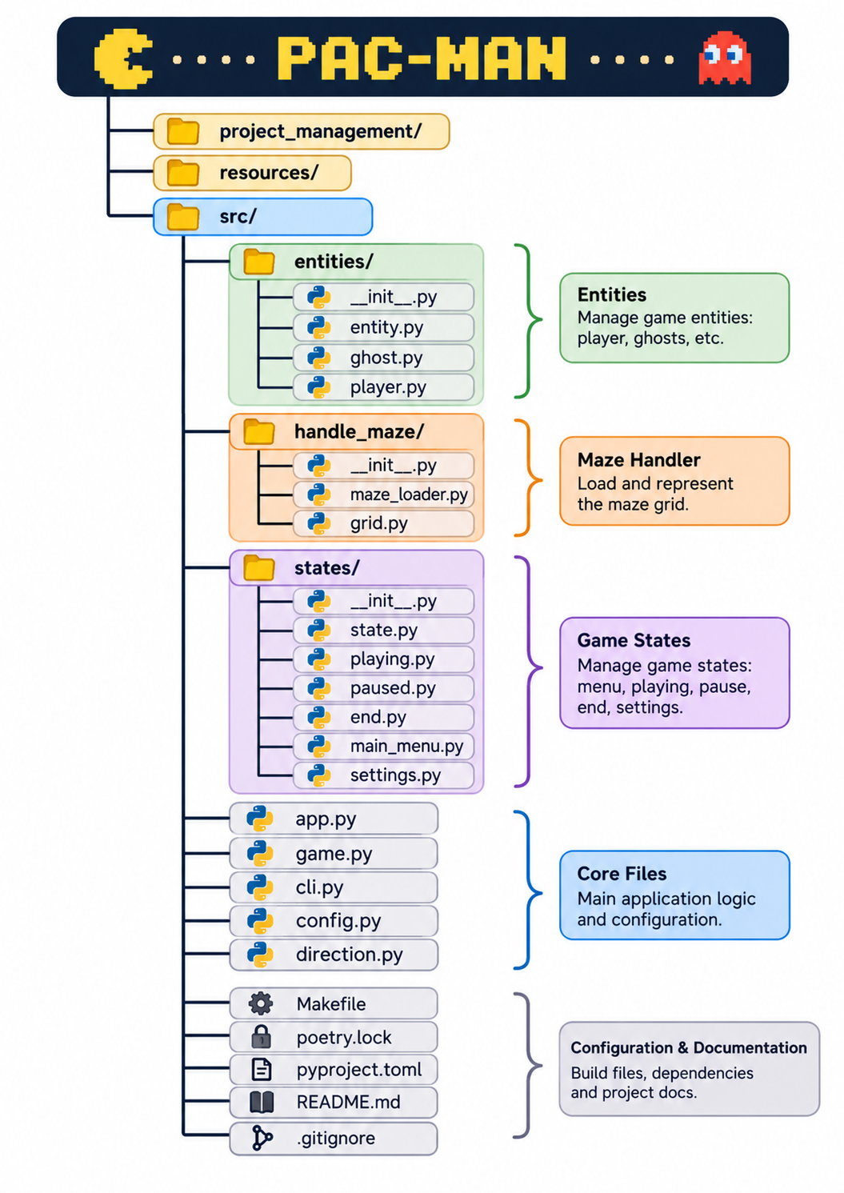

Alternatives (pros/cons)

Open Questions
- Ghost departure delay : how long between each ghost leaving its corner?
- EDIBLE duration per level: starting at 6 seconds on the first level, how much shorter at each level, and with which minimum?
- Level time limit: what happens when the timer reaches zero (restart the level, lose a life, game over)?
- Cheat mode in the pause menu: can it be enabled from the pause menu if cheat_mode is false in the config?
- Graphical library: does raylib comply with the MLX constraint (every function used must have an MLX equivalent)?
- Player spawn: does the center cell always fall in the gap of the “42” pattern, whatever the parity of the maze dimensions?

