MEMORANDUM
Crain & Wooley — Intake Engine
TO | Haron "Q" Wilson — FutreEng
FROM | Joseph Panetta — FutreEng
DATE | May 17, 2026
RE | Crain & Wooley Intake Engine — Build Status & Outstanding Credentials
CLIENT | Crain & Wooley

1. Where the build stands
The Crain & Wooley intake engine is functionally complete on our side. The public-facing intake flow, $300 Stripe payment gate, four-day Ghost Assistant nurture sequence, TCPA opt-out handling, audit trail, and admin dashboard are all built, wired together, and running cleanly against staging data. The system that Crain & Wooley asked for in the project description — a lead going from website to scheduled consult without human help, with an instant response inside sixty seconds — is in place.
The firm has now confirmed the architecture: Clio Grow is the source of truth for leads and scheduling, Clio Manage holds the matter once a client is hired, and Stripe handles the $300 consultation fee. The firm has also issued a Clio Grow user account to FutreEng, which lets us self-serve several items previously on the firm’s plate.
We are not blocked on code. We are blocked on third-party access. The remaining work is one Clio integration sprint and one production deployment, and a small set of items only Crain & Wooley can provide. This memo is a single reference you can forward — to Crain & Wooley directly, or rephrased into your own outreach — to pull those items loose.
I have included three rendered views of the system as it exists today, so the request lands with proof rather than promises.

2. What is built today

Public intake — qualification before payment
A four-step intake form captures the lead, asks the firm’s qualifying questions, auto-disqualifies anyone who falls outside the firm’s criteria, and gates everything behind the $300 consultation fee. Failed qualification kills the funnel cleanly so no staff time is spent on poor-fit leads. The form’s look and feel match the firm’s estate-planning positioning.
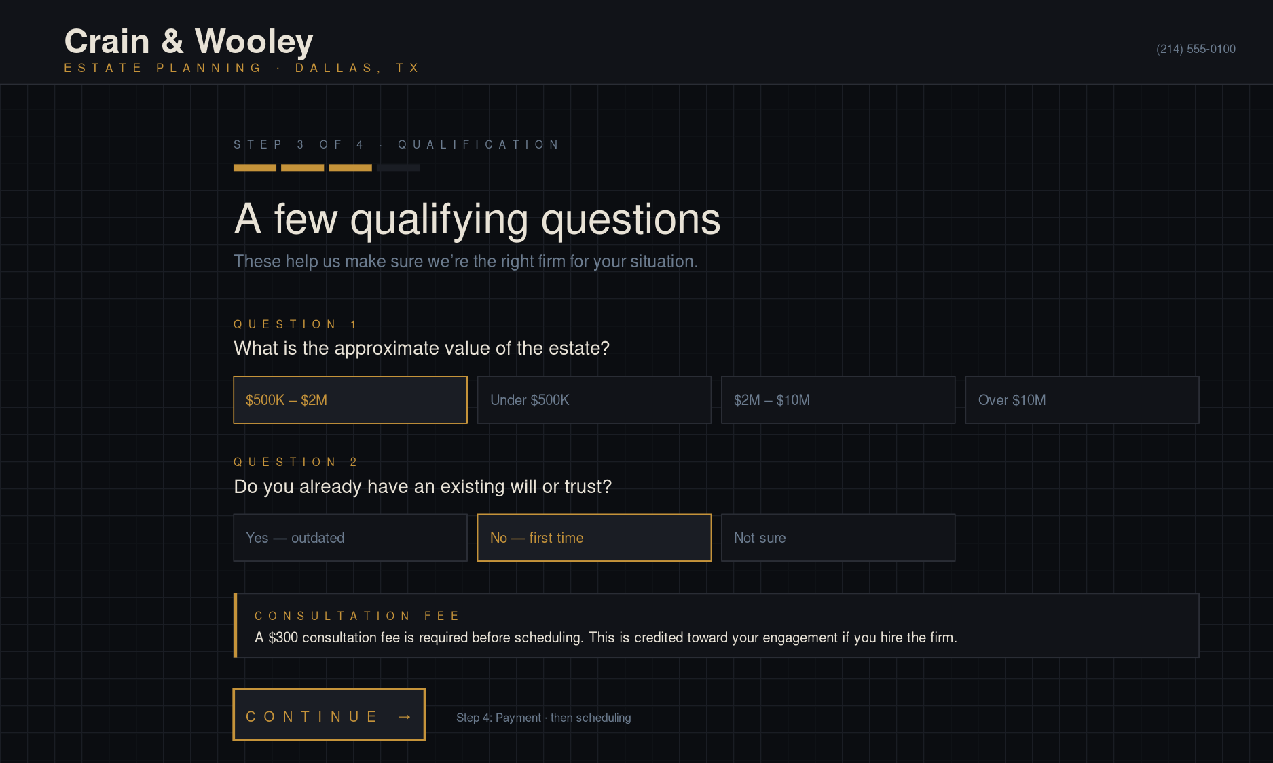
Figure 1 — Intake form, Step 3 of 4 (qualification). $300 fee is disclosed before the payment step.

Admin pipeline — every lead, every status
The internal dashboard shows the firm a single view of every lead, current status, payment state, and matter type. CSV export of leads and the full audit trail is one click. Staff can filter, pause sequences, mark hired, or pull an export without touching code. Role-based access (SUPER_ADMIN / ADMIN / VIEWER) is enforced server-side; the system will not let a viewer accidentally trigger sends.
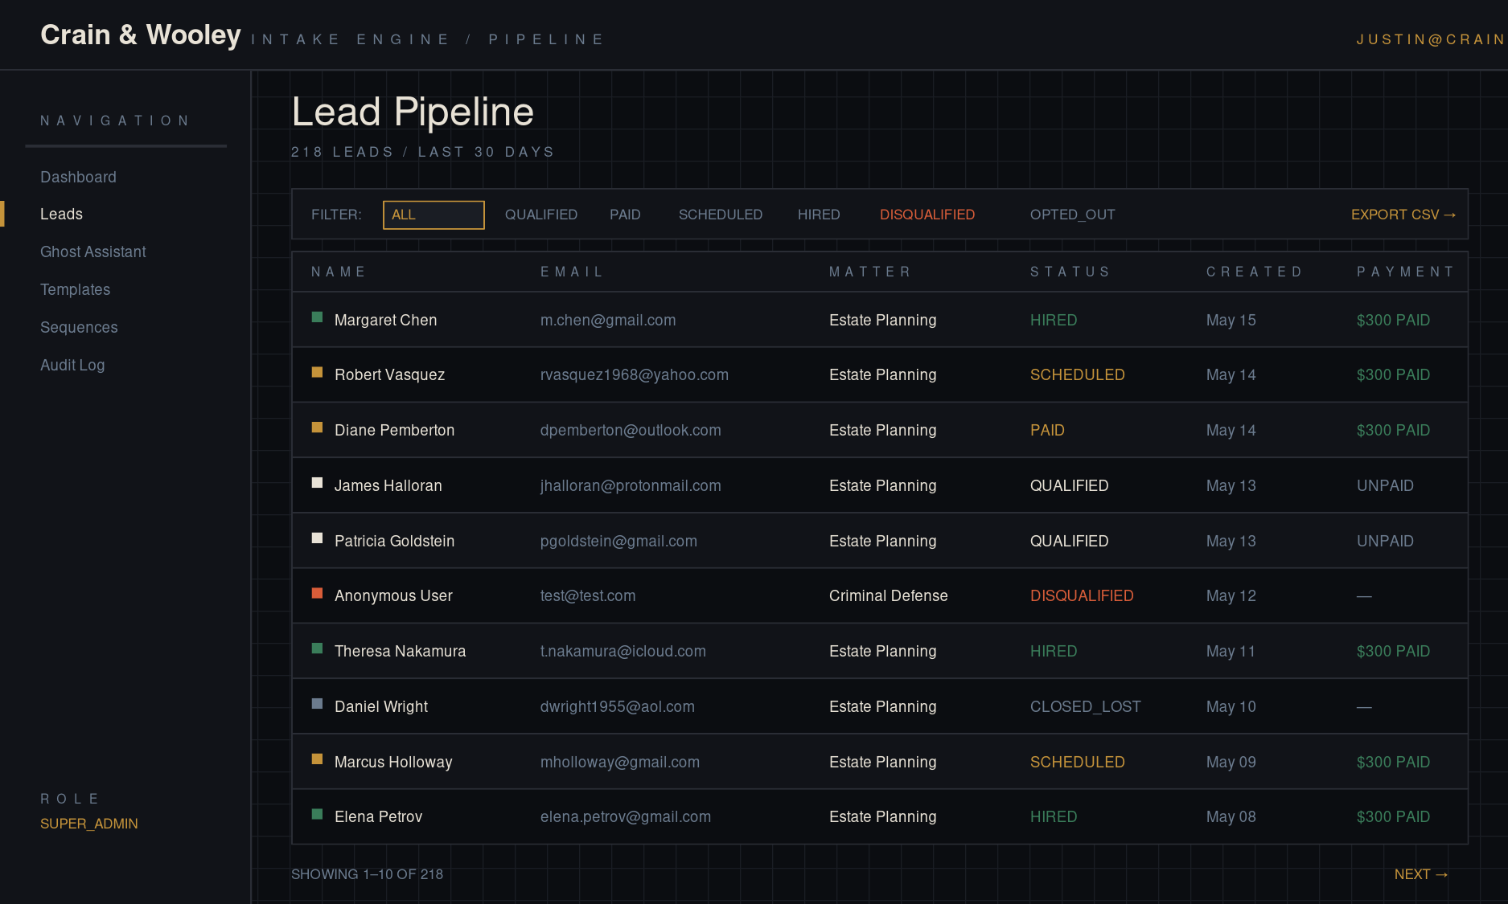
Figure 2 — Lead pipeline showing status, payment, opt-out indicators, and CSV export.

Ghost Assistant — automated four-day nurture
Every qualified lead is enrolled in a four-day SMS and email sequence the moment they finish the intake. Day 0 is the instant confirmation. Day 1 is an SMS nudge. Day 2 is an email with common estate-planning questions. Day 4 is a final SMS. The sequence auto-cancels the second the lead pays, books a consult, opts out, or is marked closed. Failed sends retry with exponential backoff; after three consecutive failures the sequence dead-letters and notifies a super-admin by email.
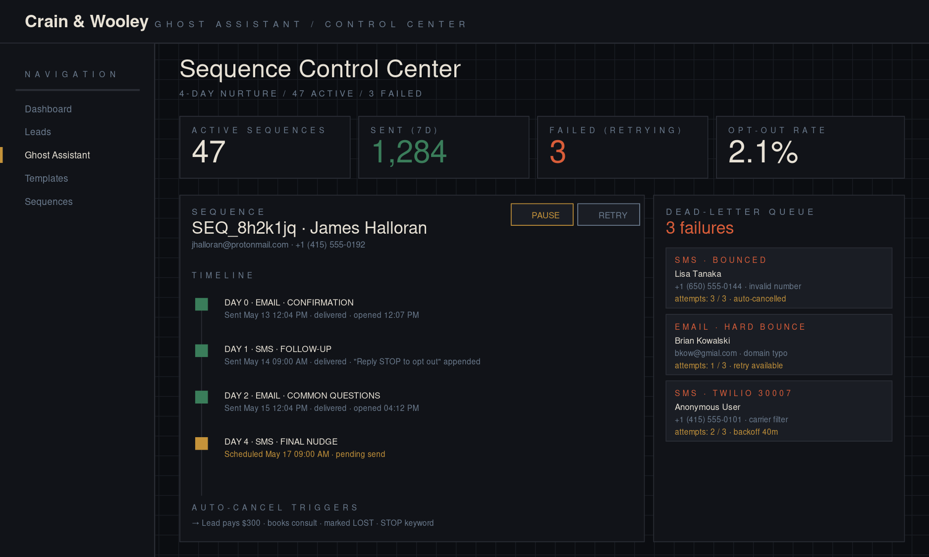
Figure 3 — Sequence Control Center with per-lead timeline and the dead-letter queue.

Compliance and reliability — shipped
- TCPA opt-out — inbound STOP / UNSUBSCRIBE / CANCEL / END / QUIT keyword on the Twilio webhook flips the lead to opted-out and cancels every pending send. START re-subscribes. Every outbound SMS carries the required footer.
- Email unsubscribe — every nurture email links to a no-auth unsubscribe page tied to a per-lead token. Click once, opt out, sequences cancel, audit event written.
- Idempotency — Twilio and Resend sends are deduplicated by an externalId stored on the sequence record, so a retried job will not double-send.
- Audit log — every state change writes a row with type, actor, IP, user-agent, and a JSON metadata blob. Exportable as CSV with date and lead filters.
- Hardened webhooks — Stripe, Twilio, and the QStash cron handler validate signatures on every request. The four production webhook routes are locked.

3. Confirmed architecture
The firm has settled the open questions from earlier scoping. The system uses Clio across the lead and matter lifecycle, with Stripe retained for the consultation fee.
- Clio Grow — source of truth for leads. Every qualified lead from the website is posted into the firm’s Clio Grow account. Staff continue to see and work leads in the tool they already use every day. Our admin dashboard mirrors Grow for operational tasks (sequence pause, dead-letter retry, audit trail) but does not become a parallel system.
- Clio Grow scheduler — replaces Cal.com. The scheduling step embeds Grow’s native scheduler so consults sync directly with the firm’s Outlook calendar without a third tool in the middle. The Cal.com integration we built earlier is retired.
- Clio Manage — matter and tasks on hire. The moment a lead is marked hired, our system creates the Contact, Matter, and standard onboarding task list inside Clio Manage. This part of the integration is already coded against the Manage API and only needs the Developer App credentials from Crain & Wooley to come online.
- Stripe — $300 consultation fee, unchanged. Clio Payments was considered and ruled out. The consultation fee is a one-off charge, not a trust deposit; Stripe is wired, tested, and reliable. We keep it.

3.1 What the Grow login lets us self-serve
Now that the firm has issued FutreEng a Clio Grow user account, several items previously earmarked for Crain & Wooley can be handled from inside Grow directly:
- The Inbox webhook URL for posting leads into Grow programmatically — visible under Grow’s Settings.
- The exact practice area names the firm has configured, so our intake form maps cleanly into Clio.
- The scheduler event type Crain & Wooley uses for consultations, including duration and availability rules.
- The current pipeline stages in Grow (Lead → Consult → Hired or whatever the firm has configured) so our status transitions match what staff already see.

3.2 What still requires Crain & Wooley
A small set of items only Crain & Wooley can do. These are what this memo is asking the firm to deliver.
- Clio Developer Application credentials. Only Crain & Wooley (as Clio account admin) can create this. It lives in Clio Manage at app.clio.com under Settings → Developer Applications, not in Grow.
- Stripe account and three keys. Money lands in the firm’s bank, so this account must be in the firm’s name and EIN.
- DNS access for crainwooley.com, or a contact for whoever manages the domain.
- Twilio area-code preference for the SMS-sending number.
- Standard onboarding task checklist for a new estate-planning matter — the actual list his paralegal uses today.
- Definition of the "Hired" trigger — what event flips a lead into a Manage matter.

4. What we need from Crain & Wooley
A short list. In priority order:
- Clio Developer Application credentials. Crain & Wooley creates this once at app.clio.com under Settings → Developer Applications. Redirect URI is https://intake.crainwooley.com/api/clio/callback. Scopes: contacts:read, contacts:write, matters:read, matters:write, calendar:read, tasks:write. Send Client ID and Client Secret over a secure channel (1Password share or Signal — never plain email). This is the single biggest unblock for the Clio Manage side of the integration.
- Stripe account and three keys. Crain & Wooley creates a Stripe account in the firm’s name with the firm’s EIN and bank. After business verification, he creates a one-time $300 product titled "Initial Consultation" and sends three values: Publishable Key, Secret Key, and the Price ID (starts with price_). The $300 fee gates the consultation calendar — once this is live, the firm starts capturing fees from leads who would otherwise drop off.
- Standard onboarding task checklist for a new estate-planning matter. The actual list of tasks his paralegal currently sets up when a new client is hired (e.g. "Send retainer," "Request asset list," "Schedule initial document review," "Open client folder"). These become the auto-generated task list inside Clio Manage at the moment of hire.
- Definition of the "Hired" trigger. Is "Hired" the moment the lead pays the $300 consult fee, the moment they sign the engagement agreement, or the moment Crain & Wooley manually flips a status in Clio Grow? This determines what fires the Manage onboarding chain.
- DNS access for crainwooley.com. Either Crain & Wooley gives us the registrar login or points us at the firm’s web person. Four records need adding: a CNAME for the intake subdomain to Vercel, plus SPF, DKIM, and DMARC for email deliverability through Resend. We will provide exact values.
- Twilio area-code preference. What area code does Crain & Wooley want on the SMS-sending number — Dallas-local, an area code matching the firm’s office, or no preference?
Items previously asked of Crain & Wooley that are now handled by FutreEng directly using the Grow login: practice area names, scheduler event type, pipeline stage names, and the Grow Inbox URL. Those drop off Crain & Wooley’s list entirely.

5. Recommended sequence once unblocked
Order of operations that gets us live the fastest:
- FutreEng inventories the Grow account end-to-end (practice areas, scheduler, pipeline, Inbox URL) and finalizes the intake-to-Grow push. Already in motion now that the login is active.
- Crain & Wooley completes Stripe business verification and sends the three keys. One to two business days for verification.
- Crain & Wooley creates the Clio Developer Application and sends Client ID and Client Secret. Fifteen minutes of the firm’s time.
- Crain & Wooley sends the onboarding task checklist and confirms the "Hired" trigger definition. Email or phone.
- FutreEng wires the Clio Manage contact → matter → task chain against a sandbox lead, end to end.
- Crain & Wooley adds DNS records — we provide the exact four values.
- FutreEng deploys to intake.crainwooley.com and points Stripe and Twilio webhooks at the production URL.
- Joint end-to-end test with Crain & Wooley watching: anonymous intake submission → payment → Grow lead → scheduled consult → hire toggle → matter and tasks appear in the firm’s real Clio Manage account.

6. The honest framing for Crain & Wooley
The system is built. It has been ready to demonstrate for over a week. Every additional day before we have Stripe and Clio credentials is a day the firm’s intake staff is still answering basic questions, qualifying leads by hand, and chasing payment — work the engine is built to do without them. The $300 consultation gate alone, once live, recovers more than the full cost of our infrastructure on the first booking. The longer it sits, the more value it is leaving on the table.
That is the message I would put in front of Crain & Wooley if I were sending this directly. Adjust as needed.

Signed,
Joseph Panetta
FutreEng — Intake Systems & Revenue Automation
giuseppe.panetta@superbuilders.school

