Intermediate R Workshop Homeworks

09/10/2020

## Questions

## Give your solutions in R mark down output form, word document or pdf document

## Read your data called portal_data_joined.csv and call it surveys.

1. Select plot_id,species_id and weight from surveys.
2. Subset data to include animals collected before 1995, and retain the columns year, sex, and weight.
3. Create a new data frame from the surveys data that meets the following criteria: contains only the species_id column and a column that contains values that are half the hindfoot_length values (e.g. a new column hindfoot_half). In this hindfoot_half column, there are no NA values and all values are < 30.
4. Find the min and the mean weight for the animals grouped by sex and species_id. Arrange the mean weight in descending order and print the first 15 rows.
5. How many animals were caught in each plot_type surveyed?
6. Find the mean, min, and max hindfoot length for each species (using species_id). Also add the number of observations (hint: see ?n).
7. What was the heaviest animal measured in each year? Return the columns year, genus, species_id, and weight.
8. Make the following plot from survey data

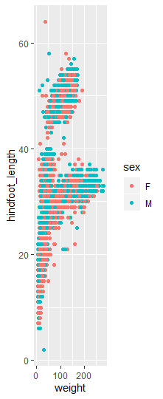

For more details on using R Markdown see <http://rmarkdown.rstudio.com>. To learn more about dplyr and tidyr after the workshop, you may want to check out this <https://github.com/rstudio/cheatsheets/raw/master/data-transformation.pdf> and <https://github.com/rstudio/cheatsheets/raw/master/data-import.pdf>