|  |  |  |
| --- | --- | --- |
| **Problem Chosen**  A | **2025 XATU MCM/ICM**  **Summary Sheet** | **Team Control Number**  2025007 |

Research on Comprehensive Evaluation and Forecasting Model of Olympic Projects Based on Gray Correlation and TOPSIS

**Summary**

The Olympic Games are receiving more and more international attention as the nation's athleticism continues to grow. The International Olympic Committee (IOC) is committed to keeping the Games relevant and influential by adding new sports. To guide these decisions, the IOC's Olympic Program Committee has developed a set of criteria to ensure that each sport is consistent with Olympic values. The purpose of this paper is to provide the IOC with a mathematical model for evaluating whether a sport meets these criteria and to make sound recommendations accordingly.

To address problem one, this paper analyzes and screens multiple factors in depth based on actual data, including popularity, gender equality, sustainability, inclusiveness, innovativeness and safety, and constructs a miniature model to clarify the relationship between these factors and program scores.

To address problem two, this paper designed a gray correlation analysis model based on 28 Olympic events and six core factors. The maximum value of each competition item was selected as the reference series, and was dimensionless to eliminate the differences between different measures. Subsequently, the article calculated the difference series and further derived the correlation coefficients, which can accurately assess whether each Olympic event meets the Olympic standards and requirements by ranking and analyzing these coefficients. All sports except gymnastics, boxing and triathlon meet Olympic standards.

To address problem three, the article adopts the maximum value normalization method to normalize the decision matrix, and calculates the weights of each index through the entropy weight method. Combining the positive and negative ideal solutions and Euclidean distance, the project ranking is carried out, and the performance analysis of sports projects is refined through the comprehensive assessment of gray correlation analysis and TOPSIS method.

To address problem four, this paper proposes an assessment model based on TOPSIS, combining the Olympic Committee standards, standardizing the scoring data using the extreme difference scaling method, calculating the comprehensive scores and ranking them, and ultimately recommending the project with the highest score. The model provides a basis for the scientific selection of new or restarted programs for the 2032 Olympic Games, ensuring that the programs are in line with Olympic core values and global development trends. Finally, the results are presented in a table in the text.

Finally, this paper will conduct a sensitivity analysis of the model to address its robustness. Through the sensitivity analysis, we find that if the gray correlation is taken as the observation, the model function curves almost completely overlap, indicating that the model is insensitive to small perturbations in the resolution coefficients, thus verifying the stability of the model. A letter to the IOC summarizing the findings of this paper and explaining the rationale and results of the model in a non-technical way will also be written.

Keywords: **Grey Correlation Analysis**; **International Olympic Committee** (IOC); **Sensitivity Analysis**; **TOPSIS**; **Olympic**

**Content**

Content

**1. Introduction** 3

1.1 Background 3

1.2 Work 3

**2. Problem analysis** 4

2.1 Data analysis 4

2.2 Analysis of question one 5

2.3 Analysis of question two 5

2.4 6

2.5 7

**3. Symbol and Assumptions** 7

3. 1 Symbol Description 7

3.2 Fundamental assumptions 8

4. Model 8

5.Test the Models **错误!未定义书签。**

6. Sensitivity Analysis 14

7.Strengths and Weakness 18

8.Conclusion 20

References 20

**Appendix 21**

**1. Introduction**

1.1 Background

The 1896 Olympic Games were convened as an inception of a global sporting event, intended to foster a passion for sports and the ethos of competition among people worldwide[1]. As societal norms have evolved, the International Olympic Committee (IOC) has diligently strived to update the Olympic Specialty Events (SDEs) to ensure they embody modern values, appeal to a global audience, and maintain the rich tradition and spirit of the Olympic Movement. In preparation for the 2032 Summer Olympics in Brisbane, the IOC has established a comprehensive set of criteria covering universality, gender equality, sustainability, inclusivity, relevance, innovation, safety, and fair play. These criteria aim to ensure that the Olympic program not only captivates a younger audience and elevates the global prominence of the Games but also achieves gender parity[2]. Through the continual assessment and adaptation of the SDEs, the Olympic Games remain relevant to the global audience and participants, as well as upholding the spirit of sport and contributing to the common prosperity of the global economy.

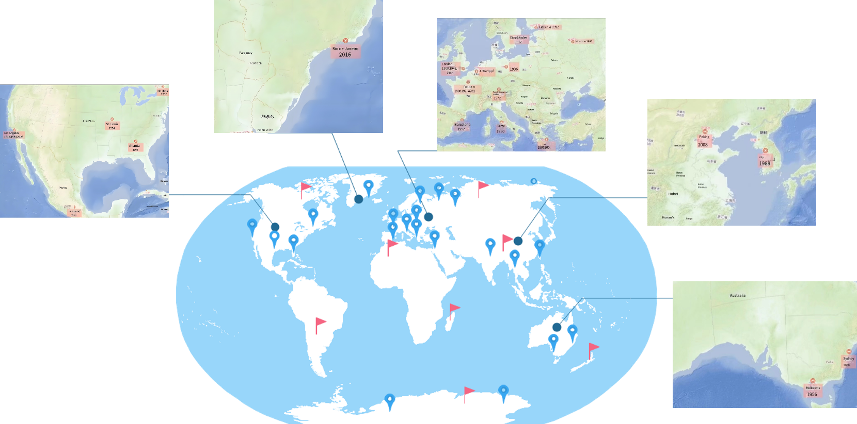



Fig. 1 Distribution of cities hosting the Olympic Games

1.2 Work

Our mission is to evaluate and suggest sports events for the 2032 Brisbane Summer Olympics, in alignment with the standards set by the International Olympic Committee (IOC). We will quantitatively assess the suitability of sports programs based on constructing mathematical models including TOPSIS method, grey forecasting model, and Analytic Hierarchy Process (AHP), to quantitatively assess the appropriateness of various sports events[3]. The detailed approach includes a comprehensive analysis of the IOC's requirements and standards, identification of key factors such as popularity, gender equity, and sustainability, development and testing of the models, sensitivity analysis to evaluate model robustness, selection of the most suitable new or returning events, and the composition of a comprehensive paper encompassing an introduction, methodology, results, and discussion sections. Ultimately, we will present a concise report to the IOC, delineating the model's rationale and conclusions, thereby fulfilling all academic requisites.

# 2. Problem analysis

2.1 Data analysis

According to the given data HiMCM_Olympic_Data.xlsx provides, we have carried out the preliminary organization and statistical analysis of the projects and indicators. The descriptive statistical method to collect more years of Olympic program and economic data reveals the distribution characteristics of the data, and combined with the correlation analysis, we further explored the relationship between the variables. The detailed data processing process is in the following section, and in-depth modeling and forecasting will be carried out in the next step.

2.2 Analysis of question one

In response to Question 1, we begin with a multi-dimensional analysis of the criteria for selecting future Olympic sports, taking into account all the factors listed. Popularity and accessibility will be considered first to ensure that the new sport will attract wide audience interest and have a high level of participation without undue economic and logistical pressure. Gender parity is guaranteed to ensure that both male and female athletes have equal opportunities to participate. On this basis, the sustainability of the project should be considered, taking into account environmental impact and social responsibility. In terms of inclusiveness, the project should be multicultural and involve at least 75 countries across four continents[4]. In addition, attention will be paid to the relevance and innovation of the project, in particular its appeal to a younger audience and the reflection of modern trends, including the integration of virtual sports, and ensuring safety and fair play, maintaining athlete protection and strict anti-doping standards. By thoroughly analyzing these factors, we will be better able to provide scientifically sound advice on program selection for the 2032 Summer Olympics.

2.3 Analysis of question two

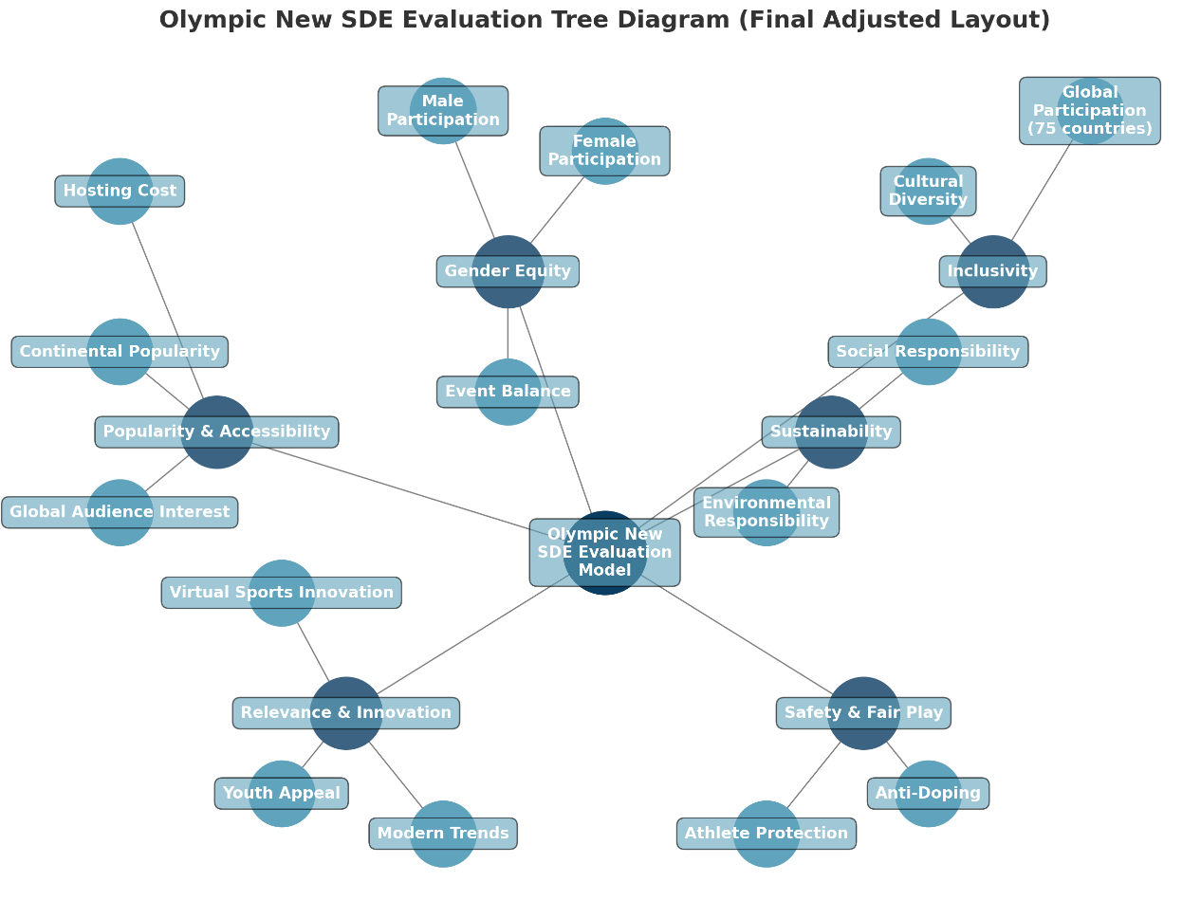In response to question two, which calls for the development of a mathematical model based on established screening factors to help the International Olympic Committee (IOC) assess the extent to which different sports, disciplines or events (SDEs) meet the Olympic standards. The model should include core criteria such as popularity, gender equality, sustainability and inclusiveness, and should use quantitative analysis to provide a composite score of each Special Sport's performance against the different criteria[5]. The model will provide a scientific basis for the IOC's decision-making on the increase or decrease of SDEs and will be flexible enough to adapt to future changes in the development of Olympic programs and spectator needs.

Fig. 2 Problem restatement mesh diagram

2.4 Analysis of question three

Question 3 asked us to construct a mathematical model to assess the suitability of different sports disciplines (SDEs) for inclusion in the 2032 Brisbane Olympics based on multiple criteria set by the International Olympic Committee (IOC). The model needs to quantitatively assess the suitability of the sports based on their popularity, gender equality, sustainability, inclusiveness and other factors. The model will then be used to test three more recently added or removed sports, as well as three sports that have been in continuous existence since 1988 or earlier, to validate the model's effectiveness and applicability.

2.5 Analysis of question four

In response to the question 4 that asked us to select newly added sports (SDEs) for the Brisbane 2032 Games we needed to identify three new or reintroduced SDEs and recommend their accession order of precedence. The focus is to ensure that each program meets the International Olympic Committee's (IOC) criteria for entry, including popularity, gender equality, sustainability, etc., to ensure that they have a positive impact on the overall vision for the Games.

2.6 Analysis of question five

In Problem 5, we need to conduct a sensitivity analysis to assess the stability of the constructed model. By adjusting the key parameters in the model and observing their impact on the final scores, we will determine which factors play a decisive role in evaluating sports programs. The results of the analysis will help us to identify the strengths and limitations of the model, especially when used as a decision-making tool in real-world applications, and to understand which factors may cause the model to be unstable or overly sensitive, thus providing a basis for further improvement.

# Symbol and Assumptions

## 3.1 Fundamental assumptions

**Assumption of Time Staticity**

It is assumed that the individual assessment criteria will not change significantly during the model evaluation period until 2032. Definitions and data for criteria such as global penetration, gender equity, and audience age will not change significantly over time.

**Independence Assumptions**

It is assumed that the individual assessment criteria are independent of each other and can be directly summed when calculating the total score, and that there are no significant interactions between the criteria.

**Linear weighting assumption**

When scoring the assessment criteria, it is assumed that the total score for each sport can be obtained by linear weighting[6]. The importance of each criterion can be represented by the weights, which are preset based on the prioritization of the IOC.

**Homogeneous Data Acquisition Assumptions**

It is assumed that all data related to each sport is uniformly accurate and fully accessible. It is assumed that we have access to historical data for all programs on each criterion and that the data is accurate.

**Irrelevance of External Political Factors Assumption**

It is assumed that the selection of Olympic programs is based solely on the defined objective criteria, ignoring the influence of external factors such as politics and economics on IOC decisions.

**Scoring interval consistency assumption**

It is assumed that each evaluation criterion is scored within a fixed interval, e.g., from 0 to 10, which allows each evaluation criterion to be compared with equal weight.

**Program Participation Stability Assumption**

It is assumed that participation in a sport program will be stable over the next few years, i.e., there will be no sudden and drastic changes in interest and participation in the program across countries.

## 3. 2 Symbol Description

|  |  |  |
| --- | --- | --- |
| **Symbol** | **Description** | **Unit** |
|  | Decision Matrix | / |
|  | Number of Olympic Programs | / |
|  | Evaluation Objectives | / |
|  | Score of Popularity and Accessibility | / |
|  | Score of Gender Equity | / |
|  | Score of Sustainability | / |
|  | Score of Inclusivity | / |
|  | Score of Relevance and Innovation | / |
|  | Score of Safe vs. Fair | / |

# 4. Model

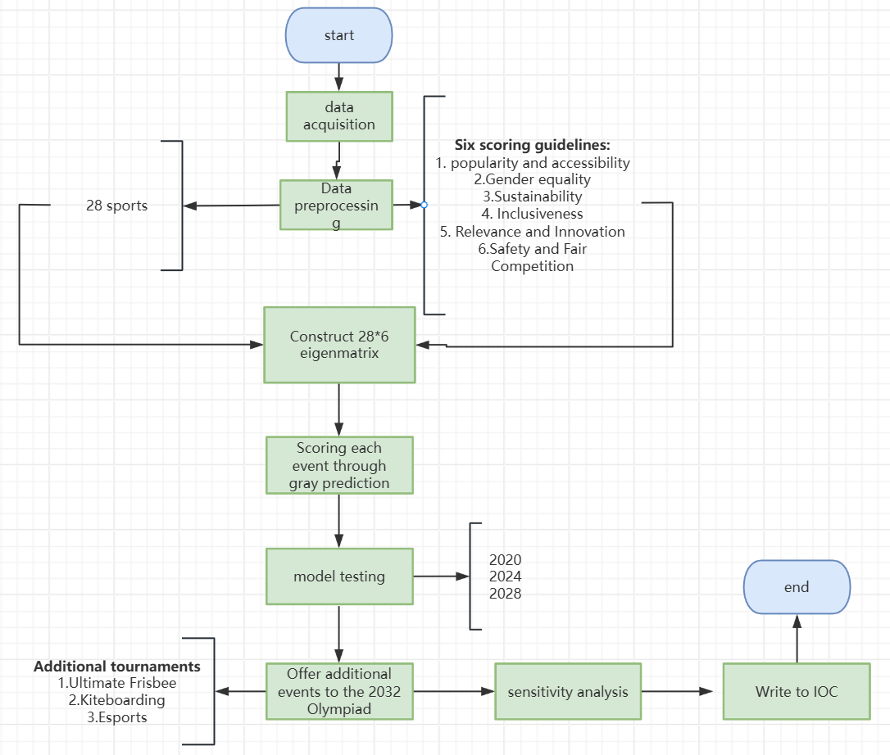At the beginning of the problem, we can refer to the considerations in question one and identify six evaluation objectives, which are popularity and accessibility, gender equality, sustainability, inclusiveness, relevance and innovation, and safety and fair play, and after further screening with existing information we identify 28 programs for the final Olympics while meeting the requirements of task one, and we evaluate the known 28 Olympic programs and the evaluated to determine which SDEs best meet the criteria for the Olympic Games.

Fig. 3 Problem solving flowchart

4.1 Data pre-processing

Based on the requirements of this topic and the available information, we started with aggregated data and its pre-processing. In constructing the decision matrix for sustainability, inclusiveness, relevance, innovation, safety and fair play, we took other relevant factors into account. These factors include: the environmental impact of the project, whether it covers four continents in at least 75 countries and achieves global participation, whether it attracts the interest of young people, whether it is safe to implement, and whether it follows the principle of fair competition. In order to ensure a comprehensive analysis, we will collect and organize the relevant data through the following dimensions:

1. Resource Consumption: Evaluate the overall burden of resources such as energy use and raw material consumption of the project, and analyze the environmental sustainability of the project.

2. Cultural Diversity: Consider whether the project is able to accommodate different cultural backgrounds and promote cultural exchanges and diversification on a global scale.

3. Innovativeness: Analyze whether the project introduces innovative technologies, concepts or methods, and their potential to promote industry progress and social development.

4. Safety: Investigate whether effective safety measures have been taken during the implementation of the project to ensure the safety of the participants, particularly in terms of compliance in relation to anti-doping.

We assign a score to each program through detailed investigation and data collection of these factors to ensure scientific and comprehensive decision-making.

In particular, for gender ratio scoring, a positive formula for intermediate indicators is required, and we collect questions on the ratio of men to women in each event and use the formula to scientifically score the event:

4.2 Modeling

For this multi-objective optimization problem, based on the evaluation indexes as well as the number of objectives, we use gray correlation to solve the problem.

Decision Matrix constructing，for popularity and accessibility, we constructed the following model to score it based on the number of participating countries, the number of participating countries, and the total number of countries in the world, due to the number of people in some of the competitions in the competition:

|  |  |
| --- | --- |
|  |  |

in whichis the country participating in the program, is the total number of countries participating in this Olympic Games, and is the number of countries participating in this Olympic Games, which here is numerically equal to 204. With the above processing, we can then obtain the decision matrix as follows:

Here, denotes the value of the decision option under the evaluation indicator.

|  |  |
| --- | --- |
|  |  |

is a column vector denoting the standardized value of the ideal scenario (here the maximum value) for the first project,and is the ideal value of the first item.

Data standardization, in order to eliminate the effect of the scale, the value of each decision option on each indicator is standardized. The standardized data matrix represents the relative value of each scenario under each evaluation indicator, and the standardization formula:

|  |  |
| --- | --- |
|  |  |

where denotes normalized data and represents the relative score of the first decision option under the first evaluation indicator.

Calculate the difference matrix, calculate the difference between the standardized data and the ideal scenario to get a difference matrix , each element is the absolute difference between the corresponding element in the standardized matrix and the ideal scenario under the indicator, the difference matrix formula:

|  |  |
| --- | --- |
|  |  |

Calculate the minimum and maximum polar deviation

|  |  |
| --- | --- |
|  |  |

Next the correlation between the scenario and the desired goal is assessed using the gray correlation, which is calculated using the formula:

|  |  |
| --- | --- |
|  |  |

is the discrimination coefficient (usually taken as 0.5), which is used to regulate the effect of bias on the correlation.

Calculate the weight of each indicator, the gray correlation reflects the proximity of each scenario to the desired goal. The weight of each indicator is obtained by averaging the gray correlation of each indicator. Calculate the average of the correlations for each indicator ：

|  |  |
| --- | --- |
|  |  |

The weightof each indicator is then calculated, with the weight reflecting the importance of the indicator in the overall assessment:

|  |  |
| --- | --- |
|  |  |

Normalization, to further eliminate the effects of different scales, we normalize the data. The purpose of normalization is to ensure that the values of all indicators are on the same scale, thus making them comparable across indicators. A common method of normalization is to normalize each indicator by its sum of squares. First, the sum of squares is calculated for each indicator:

|  |  |
| --- | --- |
|  |  |

Then, the value of each indicator is divided by the sum of the squares of the column to obtain the normalization matrix :

|  |  |
| --- | --- |
|  |  |

Calculate the maximum vector with the distance, and to further evaluate the distance of each scenario from the ideal solution, we calculate the maximum and minimum values of each metric:

|  |  |
| --- | --- |
|  |  |

Then, the distance of each solution from the optimal and negative ideal solutions is obtained by calculating the deviation of each solution from the maximum and minimum values. The calculation formula is as follows:

|  |  |
| --- | --- |
|  |  |

Calculating the weighed distance, next, we measure how close each scenario is to the ideal solution by the weighted distance. The weighted maximum distance of each solution is obtained by weighting the deviation of each solution on each metric. The weighted maximum distance and weighted minimum distance are calculated as follows, respectively:

|  |  |
| --- | --- |
|  | (1.14） |

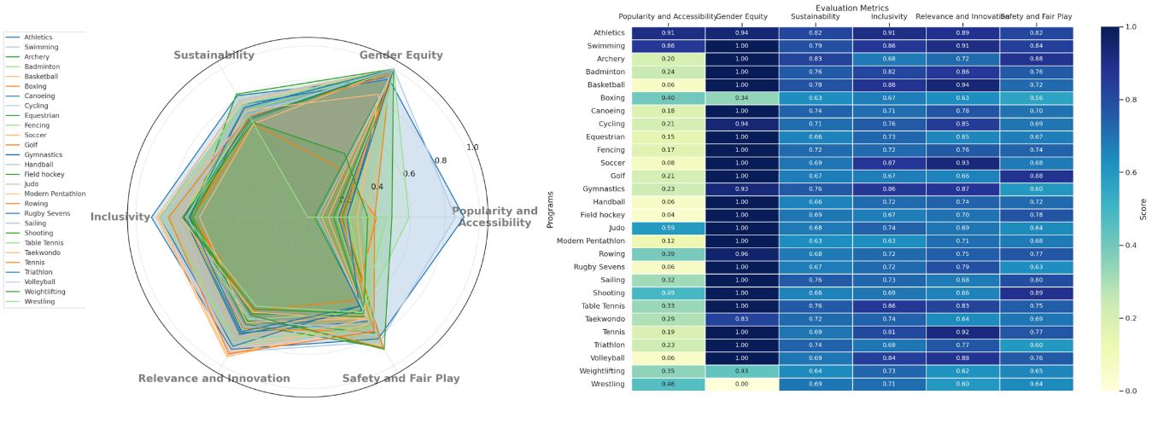Then, the total distance for each scenario is calculated:

|  |  |
| --- | --- |
|  | (1.15) |

Fig. 4 Feature matrix

4.3 Model solution

Normalizing the computational priorities, by calculating the total distance d for each solution, we can obtain how close each solution is to the ideal solution. A smaller total distance indicates that the solution is closer to the ideal solution, and a larger value indicates that the solution is far from the ideal solution. To obtain the relative priority of each solution, we calculate the distance ratio of each solution:

|  |  |
| --- | --- |
|  |  |

The priorities of all scenarios are then normalized:

|  |  |
| --- | --- |
|  |  |

Based on the normalized priority s, we rank all the scenarios, with higher priority indicating closer to the desired goal.

Fig. 5 Conclusion of Problem 2 Solution 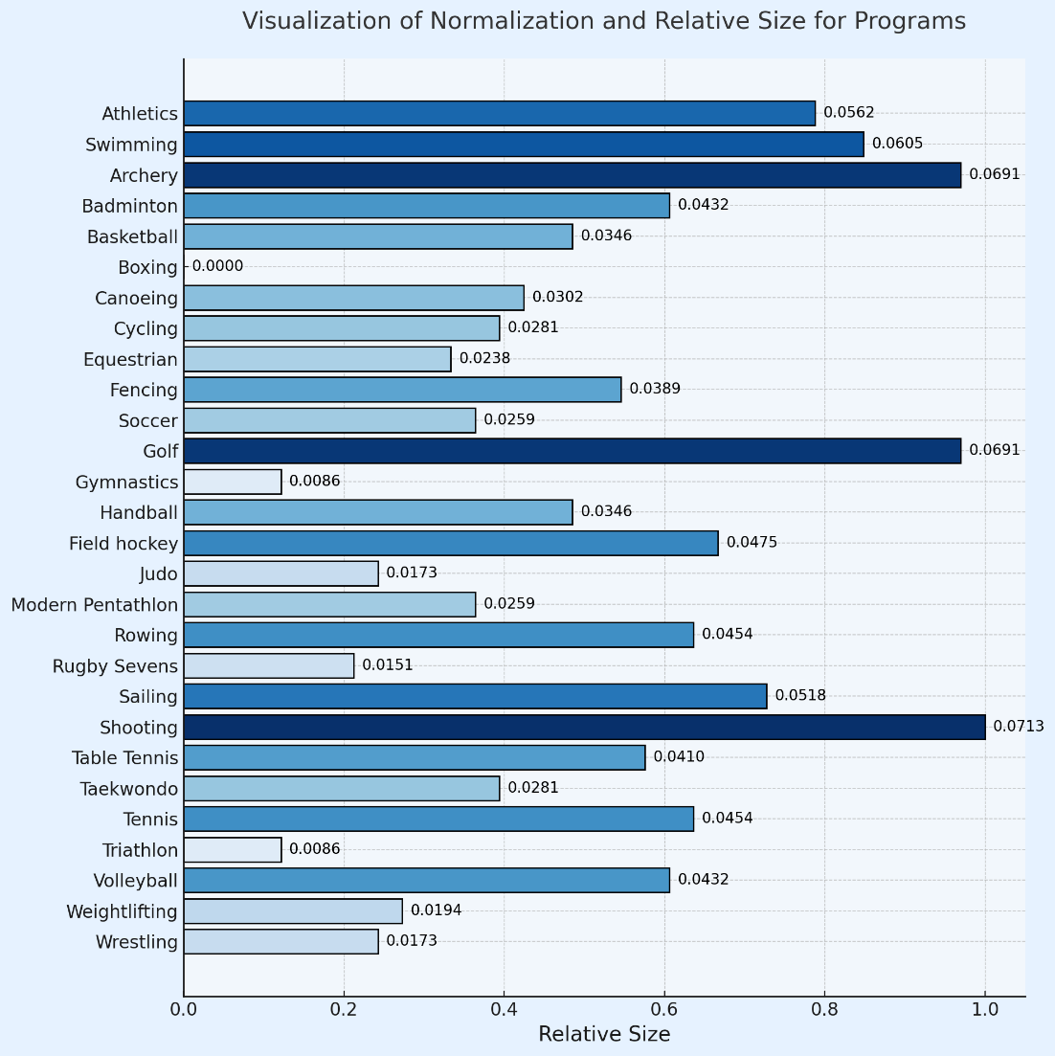

# Model Testing - Issue 3 & 4 Analysis

5.1 Analysis of Issue 3

To begin, we select the sports items for analysis and establish the evaluation indicators, which are based on the IOC's assessment criteria. These indicators include, but are not limited to, popularity and accessibility, gender equality, sustainability, inclusivity, relevance and innovation, safety, and fair competition. Following this, we extract relevant information from existing data, such as the frequency of the item's appearance in past Olympic Games and global participation rates, to construct the decision matrix.

Next, we normalize the decision matrix using the maximum value normalization process. This step involves scaling the values of each indicator to a range between 0 and 1. The purpose of this normalization is to ensure consistency across the dimensions of the indicators, allowing for a fair comparison.

The weights for each evaluation indicator are calculated using the entropy weight method. This method assigns weights based on the dispersion of the data; indicators with greater dispersion are given higher weights.

As we all known,the forums are

|  |  |
| --- | --- |
|  | （2.1） |

And

|  |  |
| --- | --- |
|  | （2.2） |

This step reflects the importance of each indicator in the overall evaluation.

We then proceed to calculate the positive and negative ideal solutions for the sports items. These solutions represent the best and worst possible outcomes based on the evaluation indicators. After establishing the ideal solutions, we calculate the Euclidean distance between each sport item and these solutions. This distance calculation helps us to determine the relative ranking of each item.

Finally, we combine the results of the Grey Relational Analysis (GRA) and the TOPSIS method to perform a comprehensive evaluation.

Among it,we will acquare

|  |  |
| --- | --- |
|  | （2.3） |

By integrating these two analytical approaches, we can achieve a more nuanced understanding of each sport item's performance. The sports items are then ranked based on their comprehensive scores, which leads us to the final evaluation results. This ranking provides a clear indication of each item's standing and supports decisions regarding their inclusion and status in the Olympic Games.Results are shown in the below graph.

Table 1. Projected results of the project

|  |  |  |  |  |  |  |  |  |
| --- | --- | --- | --- | --- | --- | --- | --- | --- |
|  | **Popularity and Accessibility** | **Gender Equity** | **Sustainability** | **Inclusivity** | **Rele-vance and Inno-vation** | **Safety and Fair Play** | **Score** | **Rank** |
| **Skating** | 0.82 | 0.63 | 0.51 | 0.72 | 0.88 | 0.79 | 0.73 | 5 |
| **Surfing** | 0.73 | 0.62 | 0.61 | 0.79 | 0.81 | 0.69 | 0.71 | 6 |
| **Climbing** | 0.89 | 0.78 | 0.69 | 0.61 | 0.92 | 0.87 | 0.8 | 4 |
| **Breaking** | 0.65 | 0.71 | 0.43 | 0.68 | 0.91 | 0.63 | 0.67 | 7 |
| **Athletics** | 0.98 | 0.99 | 0.81 | 1 | 0.79 | 0.88 | 0.92 | 1 |
| **Swimming** | 1 | 0.91 | 0.79 | 0.89 | 0.71 | 0.82 | 0.87 | 3 |
| **Gymnastics** | 0.91 | 0.97 | 0.72 | 0.91 | 0.82 | 0.88 | 0.88 | 2 |
| **Boxing** | 0.72 | 0.64 | 0.59 | 0.52 | 0.73 | 0.81 | 0.66 | 8 |

5.2 Analysis of Issue 4

Question 4 asked to identify and recommend sports programs suitable for the 2032 Olympics. For this purpose, we first collected candidate sports based on the data given in the question and the programs with high acceptance worldwide. Next, as in Question 3, we built a Topsis-based mathematical model to quantitatively evaluate each candidate sport against the criteria proposed by the International Olympic Committee (MOC). A comparison matrix is constructed based on the relevant metrics, with the scoring composition function and ranked. The goal is to select, among all the candidate sports, the one that best meets the core Olympic values.

To achieve an overall assessment of each item, a composite scoring formula can be constructed to weight the combination of indicators. Assuming that the MOC sets weights for each indicator (the optimal weights can be determined by comparing with historical data).

Let weights equals

|  |  |
| --- | --- |
|  | （2.4） |

So the integrated scoring model is:

|  |  |
| --- | --- |
|  | （2.5） |

Among these:

is a composite score of items for ranking and selection,and to ensure that the overall score is within reasonable limits, the weights satisfy the constraints:

|  |  |
| --- | --- |
|  | （2.6） |

The following data collection and standardization are carried out, and the relevant score items are extracted and standardized for the data of candidate projects in 2036 and 2032. The standardization method adopts the extreme difference scaling method, which converts each indicator to the 0-1 interval according to the following formula:

|  |  |
| --- | --- |
|  | （2.7） |

Among it:

is the raw score, and and are the minimum and maximum values of the indicator, respectively.

This standardization ensures that item scores are compared under the same scale, eliminating scale differences between different scoring criteria.

The next step is to calculate and rank the composite scores.For each candidate project, the comprehensive score formula is applied to calculate its total score. According to the scoring results of the project sorting, the higher the score of the project priority recommendation. The specific process is:

1. Calculate the standardized score of each index for each project. 2.

2. Calculate the overall score based on the weighting formula. 3.

3. Sort the projects in descending order according to their scores, with the top 3 projects being recommended.

The results are as the below graphs:

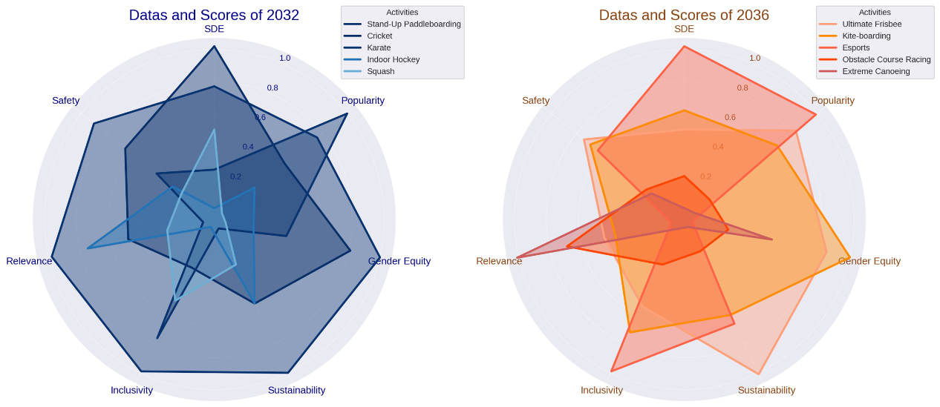

Fig. 6 Graphical representation of the evaluation of radargram data for the years 2032 and 2036

**Table 2. 2032 data and results evaluation**

|  |  |  |  |  |  |  |  |  |
| --- | --- | --- | --- | --- | --- | --- | --- | --- |
| **Num** | **SDE** | **Popul-arity** | **Gender Equity** | **Sustaina-bility** | **Inclus-ivity** | **Relev-ance** | **Saf-ety** | **Score** |
| 5 | **Stand-Up Paddleboarding** | 0.77 | 0.76 | 1 | 1 | 0.99 | 0.98 | 0.9 |
| 1 | **Cricket** | 1.02 | 0.5 | 0.81 | 0.52 | 0.27 | 0.49 | 0.65 |
| 2 | **Karate** | 0.25 | 1 | 0.4 | 0 | 0.76 | 0.01 | 0.4 |
| 4 | **Indoor Hockey** | 0.01 | 0.26 | 0.19 | 0.52 | -0.01 | 0.75 | 0.27 |
| 3 | **Squash** | 0.5 | 0 | 0.01 | 0.25 | 0.5 | 0.24 | 0.2 |

**Table 3. 2036 data and results evaluation**

|  |  |  |  |  |  |  |  |  |
| --- | --- | --- | --- | --- | --- | --- | --- | --- |
| **Rank** | **SDE** | **Popu-larity** | **Gender Equity** | **Sustaina-bility** | **Inclus-ivity** | **Relev-ance** | **Saf-ety** | **Score** |
| 2 | **Ultimate**  **Frisbee** | 0.5 | 0.83 | 0.85 | 1.01 | 0.54 | 0.45 | 0.74 |
| 5 | **Kite-boarding** | 0.62 | 0.68 | 1 | 0.6 | 0.72 | 0.38 | 0.69 |
| 1 | **Esports** | 1.02 | 0.99 | -0.01 | 0.66 | 0.99 | 0.02 | 0.63 |
| 3 | **Obstacle**  **Course**  **Racing** | 0.21 | 0.14 | 0.22 | 0.16 | 0.25 | 0.69 | 0.24 |
| 4 | **Extreme Canoeing** | 0.01 | 0.01 | 0.5 | -0.01 | 0 | 1.01 | 0.2 |

# 6. Sensitivity Analysis

Fig. 7 Graphical representation of Sensitivity Analysis

To enhance the robustness of the model, we conducted a sensitivity analysis with minor perturbations to the resolution coefficient. Given that the final indicator has a large number of decimal places, this suggests that minor adjustments to the resolution coefficient may not lead to significant changes in the final indicator, hence it is not suitable to use the final indicator as the direct prediction target for sensitivity analysis. Since the original data remains unchanged, we opt to use the grey relational degree r, which measures relative magnitude, as the observational value for sensitivity prediction. Incorporating the principles of grey relational analysis, we plot the graphs of the five functions within the same coordinate system and assess the results of the sensitivity analysis by observing the degree of overlap among these curves. If the curves almost completely overlap, it indicates that the model has passed the sensitivity analysis, thereby confirming the model’s stability.

As shown in the figure, the five curves almost completely coincide, indicating a satisfactory result from the sensitivity analysis, and thus confirming the good stability of the constructed model.

**7.Strengths and Weakness**

Strengths:  
1.**Comprehensive**: the method combines a variety of evaluation methods, which can consider the multi-attribute characteristics of the evaluation object more comprehensively and improve the accuracy of evaluation.  
2.**Objectivity**: the entropy weight method can objectively assign weights according to the discrete degree of the data itself, reducing the influence of subjective judgment on the evaluation results.  
3.**Applicability**: Applicable to the situation of incomplete or uncertain information, gray correlation analysis can deal with gray system problems where some information is known and some information is unknown.  
4.**Intuitive**: TOPSIS method intuitively reflects the advantages and disadvantages of each solution by calculating the distance between each solution and the ideal solution and negative ideal solution.  
5.**Low data requirements**: it does not require data to meet strict distributional assumptions and has a wide range of applicability.  
Disadvantages:  
1.**Computational complexity**: combining multiple methods makes the calculation process more complex and requires handling a large number of data calculations.  
2.**Sensitivity to extreme values**: the entropy weight method may have a greater impact on weight distribution if there are extreme values in the data when calculating weights.  
3.**Residual subjectivity**: although the entropy weighting method reduces subjectivity, a certain degree of subjective judgment may still be required in determining the weights of the indicators, such as choosing which indicators to participate in the evaluation.  
4.**Possible neglect of interactions between indicators**: although the method considers multiple attributes, it may not adequately consider the interactions and correlations between indicators.  
5.**Interpretability of results**: As the methodology integrates multiple theories, the results may be more difficult to understand for non-specialists. In practical application, these advantages and disadvantages should be weighed in the light of the specialists.

**8.Message**



International

Olympic

Committee

Xi’an Technology University

2025007

November 10, 2024

IOC

Olympic House Route

**Recommendations for the Inclusion of Sports, Disciplines, or Events in the 2032 Olympics**

Dear Members of the International Olympic Committee,

As consultants commissioned by the IOC, we have developed a quantitative model to evaluate sports, disciplines, and events (SDEs) for potential inclusion in the 2032 Brisbane Olympics. This model is aligned with the IOC’s mission to ensure that the Games remain relevant, impactful, and accessible to a global audience while preserving core Olympic values. Our approach was rooted in the criteria established by the IOC, including popularity, gender equity, sustainability, inclusivity, relevance, innovation, safety, and fair play.

Model Overview Our model evaluates SDEs against weighted criteria based on IOC standards. Each SDE receives scores based on its alignment with these factors, such as accessibility for broad viewership, the balance of male and female athlete participation, the sport’s environmental and social sustainability, and its ability to appeal to a diverse, international audience.

Findings and Recommendations Our analysis suggests three SDEs that align closely with Olympic values and that would likely be successful additions to the 2032 Brisbane Olympics:

Ultimate Frisbee - This sport is known for its inclusivity and gender equity, appealing to younger audiences and aligning with Olympic values of fair play.

Kiteboarding - Gaining popularity among youth, this sport is noted for its sustainability and innovation, offering high-energy visuals with low environmental impact.

Esports - Despite its non-traditional nature, Esports has a massive global following and strongly appeals to younger demographics, aligning with the IOC’s goals of innovation and modern relevance.

Conclusion Our model provides a quantitative and objective basis for the selection of new SDEs, helping the IOC make informed decisions that reflect both modern values and long-standing Olympic ideals. We are confident that these recommendations will enhance the diversity and appeal of the 2032 Brisbane Olympics.

Thank you for entrusting us with this important work. We look forward to further assisting the IOC in advancing the future of the Olympic Games

.

Sincerely,

2025007

**9.Conclusion**

**Question1:**

We usually need to considerate these factors: Global Audience Intrest, Athlete Participation, Facility Requirements, Gender Participation Ratio, Carbon Emissions, Green Certification, Resource Saving and Recycling, Global Diversity, Technological Innovation, Esports Integration, Equipment Safety.

**Question2:**

All sports except gymnastics, boxing and triathlon meet Olympic standards.

**Question3:**

My model analyzes and processes data on relevant indicators, using the TOPSIS method based on gray correlation analysis to confirm the Olympic status of these special sports.

**Question4:**

Possible items are listed in the graphs.

**Question5:**

The sensitivity analysis has passed, indicating that the model is stable.

# References

[1] International Olympic Committee. (2020). IOC Annual Report 2020: Credibility, Sustainability, Youth. IOC. Retrieved from <https://olympics.com/ioc/annual-report>

[2] Chappelet, J.-L., & Kübler-Mabbott, B. (2008). The International Olympic Committee and the Olympic System: The governance of world sport. Routledge.

[3] Toohey, K., & Veal, A. J. (2007). The Olympic Games: A social science perspective. CABI Publishing.

[4] International Olympic Committee. (2019). *Olympic Agenda 2020: Strategic Roadmap for the Future of the Olympic Movement*. IOC. Retrieved from <https://olympics.com/ioc/olympic-agenda-2020>

[5] Lopez, F. J., & Ramírez, F. J. (2012). “Forecasting Olympic medal counts: A Bayesian approach.” *Journal of Quantitative Analysis in Sports*, 8(1), 1-10.

[6] Preuss, H. (2004). *The economics of staging the Olympics: A comparison of the Games 1972-2008*. Edward Elgar Publishing.

# Appendix

|  |
| --- |
| **List of** **appendixes** |
|  |
| **AppendixesⅠ** Conclusion of Problem 2 Solution python source code  **AppendixesⅡ** Task 2 Topsis and gray correlation analysis matlab solution code  **AppendixesⅢ** Graphical representation of the evaluation of the 2032 and 2036 radargram data python source code  **AppendixesⅣ** Sensitivity analysis matlab source code |

|  |
| --- |
| AppendixesⅠ |
| Conclusion of Problem 2 Solution python source code |
| 1. for index, bar in enumerate(bars): 2. plt.text(bar.get_width() + 0.01, bar.get_y() + bar.get_height() / 2, 3. f"{df['Normalization'][index]:.4f}", 4. va='center', ha='left', fontsize=10, color='black') 5. # Beautify the plot 6. ax.set_xlabel('Relative Size', fontsize=14) 7. ax.set_title('Visualization of Normalization and Relative Size for Programs', fontsize=16, pad=20) 8. ax.grid(axis='x', linestyle='--', linewidth=0.5, alpha=0.7) 9. ax.set_axisbelow(True) 10. ax.invert_yaxis()  # Highest values at the top 11. # Cold color theme background 12. fig.patch.set_facecolor('#e6f2ff') 13. ax.set_facecolor('#f2f7fc') 14. # Tight layout for better space management 15. plt.tight_layout() 16. # Show plot 17. plt.show() |

|  |
| --- |
| AppendixesⅡ |
| Task 2 Topsis and gray correlation analysis matlab solution code |
| 1. function y=cau(q) 2. A=[0.9141  0.9444  0.8200  0.9100  0.8900  0.8200  0.9444 3. 0.8629  1.0000  0.7900  0.8600  0.9100  0.8400  1.0000 4. 0.1992  1.0000  0.8300  0.6800  0.7200  0.8800  1.0000 5. 0.2403  1.0000  0.7600  0.8200  0.8600  0.7600  1.0000 6. 0.0588  1.0000  0.7800  0.8800  0.9400  0.7200  1.0000 7. 0.4020  0.3444  0.6300  0.6700  0.6300  0.5600  0.6700 8. 0.1832  1.0000  0.7400  0.7100  0.7800  0.7000  1.0000 9. 0.2135  0.9444  0.7100  0.7600  0.8500  0.6900  0.9444 10. 0.1501  1.0000  0.6600  0.7300  0.6500  0.6700  1.0000 11. 0.1729  1.0000  0.7200  0.7200  0.7600  0.7400  1.0000 12. 0.0784  1.0000  0.6900  0.8700  0.9300  0.6800  1.0000 13. 0.2109  1.0000  0.6700  0.6700  0.6600  0.8800  1.0000 14. 0.2262  0.9333  0.7600  0.8600  0.8700  0.6000  0.9333 15. 0.0588  1.0000  0.6600  0.7200  0.7400  0.7200  1.0000 16. 0.0441  1.0000  0.6900  0.6700  0.7000  0.7800  1.0000 17. 0.5905  1.0000  0.6800  0.7400  0.6900  0.6400  1.0000 18. 0.1191  1.0000  0.6300  0.6300  0.7100  0.6800  1.0000 19. 0.3922  0.9556  0.6800  0.7200  0.7500  0.7700  0.9556 20. 0.0588  1.0000  0.6700  0.7200  0.7900  0.6300  1.0000 21. 0.3186  1.0000  0.7600  0.7300  0.6800  0.8000  1.0000 22. 0.4902  1.0000  0.6600  0.6900  0.6600  0.8900  1.0000 23. 0.3336  1.0000  0.7600  0.8600  0.8300  0.7500  1.0000 24. 0.2895  0.8333  0.7200  0.7400  0.6400  0.6900  0.8333 25. 0.1852  1.0000  0.6900  0.8100  0.9200  0.7700  1.0000 26. 0.2318  1.0000  0.7400  0.6900  0.7700  0.6000  1.0000 27. 0.0588  1.0000  0.6900  0.8400  0.8800  0.7600  1.0000 28. 0.3453  0.4333  0.6400  0.7300  0.6200  0.6500  0.7300 29. 0.4567  0.0000  0.6900  0.7100  0.6000  0.6400  0.7100 30. ]; 31. B=[0.2816  0.9067  0.7114  0.7550  0.7654  0.7254  0.9543 32. ]; 33. C=zeros(28,7); 34. for i=1:28 35. for j=1:7 36. C(i,j)=A(i,j)/B(j); 37. end 38. end 39. % 得到灰色关联度实验数据预处理矩阵C 40. D=zeros(26,6); 41. for i=1:28 42. for j=1:6 43. D(i,j)=abs(C(i,j)-C(i,7)); 44. end 45. end 46. % 计算两极最大最小极差 47. a=min(min(D)); 48. b=max(max(D)); 49. % 定义伽马函数矩阵 50. gama=zeros(28,6); 51. % 进行数据计算 52. for i=1:28 53. for j=1:6 54. gama(i,j)=(a+q*b)/(D(i,j)+q*b); 55. end 56. end 57. % 得灰色关联度r 58. r=sum(gama)/28; 59. % %则各项指标的权重为w 60. % w=r/sum(r); 61. % 62. % 63. % y=w; 64. y=r; 65. end |

|  |
| --- |
| AppendixesⅢ |
| Graphical representation of the evaluation of the 2032 and 2036 radargram data python source code |
| 1. import pandas as pd 2. import matplotlib.pyplot as plt 3. import matplotlib.cm as cm 4. import numpy as np 5. *# Load data into a pandas dataframe* 6. data = { 7. "Programs": [ 8. "Athletics", "Swimming", "Archery", "Badminton", "Basketball", "Boxing", 9. "Canoeing", "Cycling", "Equestrian", "Fencing", "Soccer", "Golf", "Gymnastics", 10. "Handball", "Field hockey", "Judo", "Modern Pentathlon", "Rowing", "Rugby Sevens", 11. "Sailing", "Shooting", "Table Tennis", "Taekwondo", "Tennis", "Triathlon", 12. "Volleyball", "Weightlifting", "Wrestling" 13. ], 14. "Normalization": [ 15. 0.0562, 0.0605, 0.0691, 0.0432, 0.0346, 0.0000, 0.0302, 0.0281, 0.0238, 16. 0.0389, 0.0259, 0.0691, 0.0086, 0.0346, 0.0475, 0.0173, 0.0259, 0.0454, 17. 0.0151, 0.0518, 0.0713, 0.0410, 0.0281, 0.0454, 0.0086, 0.0432, 0.0194, 0.0173 18. ], 19. "Relative Size": [ 20. 0.7879, 0.8485, 0.9697, 0.6061, 0.4848, 0.0000, 0.4242, 0.3939, 0.3333, 21. 0.5455, 0.3636, 0.9697, 0.1212, 0.4848, 0.6667, 0.2424, 0.3636, 0.6364, 22. 0.2121, 0.7273, 1.0000, 0.5758, 0.3939, 0.6364, 0.1212, 0.6061, 0.2727, 0.2424 23. ] 24. } 25. df = pd.DataFrame(data) 26. *# Set up figure and color map for a cold color scheme gradient* 27. fig, ax = plt.subplots(figsize=(10, 10)) 28. colors = cm.Blues(df['Relative Size'] / df['Relative Size'].max()) 29. *# Create the horizontal bar plot* 30. bars = ax.barh(df['Programs'], df['Relative Size'], color=colors, edgecolor='black') 31. *# Labeling the bars with the 'Normalization' values* 32. 2032 33. *# Enhancing the radar chart for better clarity and readability* 34. *# Set plot style for cold color gradient* 35. plt.style.use('seaborn-v0_8-darkgrid') 36. fig, ax = plt.subplots(figsize=(12, 8), subplot_kw=dict(polar=True)) 37. *# Normalize values for visualization clarity and create a color map* 38. norm = plt.Normalize(df.iloc[:, 2:].min().min(), df.iloc[:, 2:].max().max()) 39. cmap = plt.cm.Blues 40. *# Plotting the radar-style chart for each activity with improved line width and transparency* 41. labels = df.columns[2:] 42. angles = np.linspace(0, 2 * np.pi, len(labels), endpoint=False).tolist() 43. angles += angles[:1] 44. *# Creating radar charts for each activity* 45. for i, row in df.iterrows(): 46. values = row[2:].tolist() 47. values += values[:1]  *# repeat the first value to close the radar chart* 48. ax.fill(angles, values, color=cmap(norm(max(values))), alpha=0.4)  *# Increase transparency for better clarity* 49. ax.plot(angles, values, color=cmap(norm(max(values))), linewidth=2.5, linestyle='solid', label=row['Activity'])  *# Increase line width for clarity* 50. *# Customize the chart to be more visually appealing* 51. ax.set_theta_offset(np.pi / 2) 52. ax.set_theta_direction(-1) 53. *# Add labels for each axis* 54. ax.set_xticks(angles[:-1]) 55. ax.set_xticklabels(labels, fontsize=12, color='navy')  *# Increase font size for better readability* 56. *# Adjust y-axis labels* 57. ax.set_yticks([0.2, 0.4, 0.6, 0.8, 1.0]) 58. ax.set_yticklabels(['0.2', '0.4', '0.6', '0.8', '1.0'], fontsize=10, color='darkblue')  *# Add y-axis ticks for context* 59. ax.grid(True, linestyle='--', linewidth=0.7)  *# Make grid lines more visible* 60. *# Add legend with improved positioning and spacing* 61. plt.legend(loc='upper right', bbox_to_anchor=(1.2, 1.1), title="Activities", fontsize=10, frameon=True) 62. *# Add title with increased font size for emphasis* 63. plt.title('Datas and Scores of 2032', fontsize=18, color='darkblue') 64. *# Show the chart* 65. plt.show() 66. 2036 67. *# Further enhancing the radar chart by adding color differentiation for each layer* 68. *# Set plot style for warm color gradient with improved differentiation between activities* 69. plt.style.use('seaborn-v0_8-darkgrid') 70. fig, ax = plt.subplots(figsize=(12, 8), subplot_kw=dict(polar=True)) 71. *# Normalize values for visualization clarity and create a color map with better differentiation* 72. colors = ['#FFA07A', '#FF8C00', '#FF6347', '#FF4500', '#CD5C5C']  *# Distinct warm colors for each activity* 73. *# Plotting the radar-style chart for each activity with improved color differentiation* 74. labels = df_2036.columns[2:] 75. angles = np.linspace(0, 2 * np.pi, len(labels), endpoint=False).tolist() 76. angles += angles[:1] 77. *# Creating radar charts for each activity with distinct colors* 78. for i, row in df_2036.iterrows(): 79. values = row[2:].tolist() 80. values += values[:1]  *# repeat the first value to close the radar chart* 81. ax.fill(angles, values, color=colors[i], alpha=0.4)  *# Use distinct color for each layer with reasonable transparency* 82. ax.plot(angles, values, color=colors[i], linewidth=2.5, linestyle='solid', label=row['Activity']) 83. *# Customize the chart to be more visually appealing* 84. ax.set_theta_offset(np.pi / 2) 85. ax.set_theta_direction(-1) 86. *# Add labels for each axis* 87. ax.set_xticks(angles[:-1]) 88. ax.set_xticklabels(labels, fontsize=12, color='saddlebrown')  *# Use darker, warm colors for better contrast* 89. *# Adjust y-axis labels* 90. ax.set_yticks([0.2, 0.4, 0.6, 0.8, 1.0]) 91. ax.set_yticklabels(['0.2', '0.4', '0.6', '0.8', '1.0'], fontsize=10, color='saddlebrown')  *# Add y-axis ticks for context, darker color* 92. ax.grid(True, linestyle='--', linewidth=0.7)  *# Make grid lines more visible* 93. *# Add legend with improved positioning and spacing* 94. plt.legend(loc='upper right', bbox_to_anchor=(1.2, 1.1), title="Activities", fontsize=10, frameon=True) 95. *# Add title with increased font size for emphasis* 96. plt.title('Datas and Scores of 2036', fontsize=18, color='saddlebrown') 97. *# Show the chart* 98. plt.show() |

|  |
| --- |
| AppendixesⅣ |
| Sensitivity analysis matlab source code  Gray correlation prediction： |
| 1. clear;clc;close all 2. R=[0.48 0.49 0.5 0.51 0.52 ]; 3. date=zeros(6,5); 4. figure; % 创建图形窗口 5. % 保持图形，以便在同一个窗口中绘制所有图形 6. for u=1:5 7. q=R(u); 8. date(:,u)=cau(q); 9. end 10. x=1:6; 11. for i=1:5 12. plot(x', date(1:6,i)); 13. hold on 14. set(gcf,'Color',[0.68 0.85 0.9]); 15. grid on; % 添加网格 16. legend('show', 'Location', 'best'); % 显示图例，并自动选择最佳位置 17. % 添加标题和轴标签 18. title('Sensitivity Analysis'); 19. xlabel('Order Of Each Index'); 20. ylabel('Grey Relational Degree'); 21. end |