Problem Chosen  A | 2026 XATU MCM/ICM  Summary Sheet | Team Control Number  2026024

Use this template to begin typing the first page (summary page) of your electronic report. This template uses a 12-point Times New Roman font. Submit your paper as an Adobe PDF electronic file (e.g. 1111111.pdf), typed in English, with a readable font of at least 12-point type.

Do not include the name of your college, advisor, or team members on this or any page.

Papers must be within the 25 page limit.

Be sure to change the control number and problem choice above.
You may delete these instructions as you begin to type your report here.

Content
Content 2
1. Introduction 3
1.1. Background 3
1.2. Problem Restatement 4
1.3. Our Work 5
1.4. Problem Analysis 5
2. Assumptions and Rationale 6
3. Symbol and Assumptions 7
4. Problem 1: Constructing the Basic Layout and a Unified Environmental and Physical Model 8
4.1. Spatial Layout Analysis 8
4.2. Visual Radius Attenuation Model 9
4.3. Speed and Efficiency Coupling Model 9
4.4. Self-Adaptive Path Generation Algorithm 10
4.5. Global Optimization 11
4.6. Strategy Analysis 11
5. Problem 2:Developing a Multiple Traveling Salesman (TSP) Planning Model 12
5.1. Spatial Configuration Remodeling - Solution I 13
5.1.1. Three-Dimensional Spatial Topological Model 13
5.1.2. Global Optimization Models 14
5.1.3. Strategic Analysis 14
5.2. Spatial Pattern Restructuring Plan Two 17
5.2.1. Room Heterogeneous Model 18
5.2.2. Room-Level Visual Attenuation Model 18
5.2.3. Global Optimization Models 19
5.2.4. Strategy Analysis 20
6. Problem 3: Developing a Time-varying Multi-agent Cooperative Planning Model 22
6.1. Dynamic Environment Modeling 23
6.2. Strategy Analysis 24
7. Strengths and Weakness 28
7.1. Strengths 28
7.2. Weaknesses 28
8. Sensitivity Analysis 28
8.1. Impact of Team Size on Rescue Time 28
8.2. Non-linear Impact of Response Delay 30
9. Conclusion 30
10. Message 31
11. References 31
12. Appendix 31

Introduction
  - Background
Emergency evacuation is critical for safeguarding lives during sudden public safety incidents. The “clearance” operations conducted by professional responders aim to ensure no one is left behind, with their efficiency directly impacting rescue outcomes. However, traditional experience-based clearance faces challenges such as complex building structures and limited information, often leading to redundant paths and uneven resource allocation, thereby jeopardizing the safety of both responders and trapped individuals.
Commissioned by the Multi-Purpose Public/Private Space Clearance Organization (XATU), our team is developing mathematical models to optimize evacuation clearance strategies in multi-story buildings. Prioritizing occupant safety, we minimize clearance time by enhancing team coordination efficiency. By integrating building complexity, information uncertainty, and dynamic risks into quantifiable systems problems, we provide decision support for emergency rescue operations.
  - Problem Restatement
When faced with buildings of varying layouts, design a model that ensures occupant safety in the shortest possible time during fires or other emergencies, while enabling emergency personnel to clear rooms as efficiently as possible.
Problem 1: There are three similarly sized rooms on each side of the corridor, connected only to the central corridor. Plan how two firefighters can clear the building in the shortest possible time.
Problem 2: Under conditions of increased building layout, altered number of floors, and consideration of occupant types, plan the optimal number of responders and their starting positions, along with their cleaning routes and minimum cleaning times.
Problem 3: In buildings with non-standard layouts, greater emphasis must be placed on practical considerations such as reduced visibility, the dynamic movement of occupants during evacuation, and prioritization of high-risk zones. Key challenges include allocating responders effectively, planning evacuation and clearance strategies, and ensuring maximum safety within the shortest possible timeframe.
  - Our Work
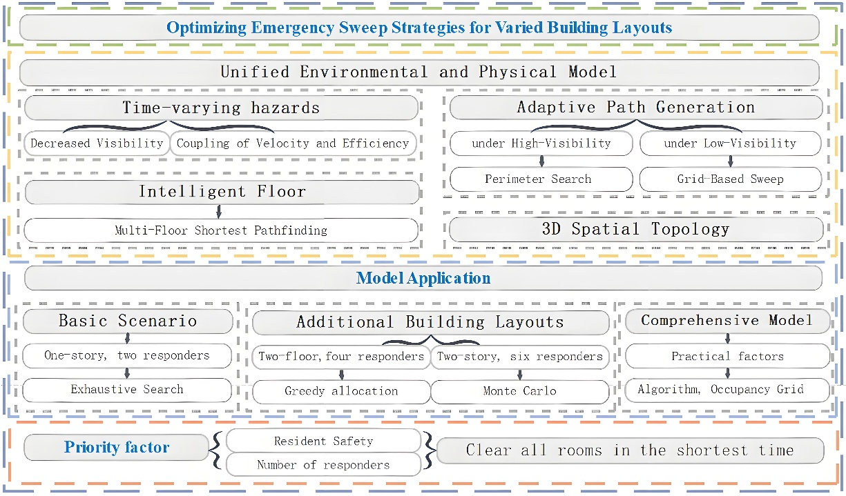
Figure 1-1 Our Work
  - Problem Analysis
This study aims to construct an optimized sweep model to maximize occupant safety and responder efficiency, and to clear all rooms in the shortest possible time. The criterion for a room being "all-clear" is that a responder has successfully swept it. The minimum time is defined as when all responders have completed sweeping their assigned rooms and have evacuated via an exit.
The problem is decomposed into three progressive levels:
(1) Problem 1: Baseline Model A one-story building with six rooms and two responders. This scenario is used to validate a zoning strategy and the effectiveness of a "full-space search" baseline algorithm in an ideal environment.
(2) Problem 2: Multiple Layouts and Scalability Introduce multi-floor layouts (e.g., two floors, six rooms; two floors, multi-rooms) and a varying number of responders to address 3D spatial topology and complex task assignment problems.
Two-floor, six-room: Employ "brute-force full permutation" and "greedy assignment."
Two-floor, multi-room: To handle the "combinatorial explosion," use "Monte Carlo sampling" and "greedy load balancing" to find a near-optimal solution.
(3) Problem 3: High-Fidelity Dynamics and Special Scenarios In a realistic, non-standard building layout, the environment is high-dimensional and time-varying. New variables are introduced, such as "occupant locating," "prioritization of high-risk areas," "dynamic movement," and "redundancy rules." A hybrid strategy is adopted. At the "micro-grid level," A* and Dijkstra algorithms are used for path planning. At the "macro-level," a "greedy complex decision-making" process is used to assign prioritized tasks.

Assumptions and Rationale
Given that real-world problems often involve numerous complex factors, we must first establish reasonable assumptions to simplify the model:
1. Search and rescue paths must cover all four corners of the room.
2. The effect of wind on smoke is negligible.
3. Response personnel shall conduct sweeping operations using visual exploration only.
4. Assume all rooms fill with smoke simultaneously and uniformly.
5. Assume no unexpected events impact response personnel during search and rescue, such as building collapse or staircase failure.

Symbol and Assumptions
Symbol | Description | Unit
 | 房间对角线长度 | m
 | 最小视场 | m
 | 视觉半径衰减系数
 | 能见度降至最低所需时间 | s
 | 效率因子
 | 响应人员基本移动速度 | m/s
 | 最低视场半径 | m
 | 清扫重叠系数  清扫救援总耗时  响应人员数量 | s  个
Note: Any symbols (or notation) not mentioned in the symbol explanation are specifically defined within the text of this paper.

Problem 1: Constructing the Basic Layout and a Unified Environmental and Physical Model
This section develops a dynamic environment model to determine the optimal sweeping path and duration under ideal assumptions, accounting for multiple critical factors that substantially impact sweeping time.
  - Spatial Layout Analysis
As shown in Figure 4-1, the building layout features offices arranged on both sides with a central corridor. There are six identical offices in total, three on each side. Each office measures 6 meters in length and 5 meters in width, with a floor height of 2.5 meters. The hallway connecting all areas has a width of 3 meters.。
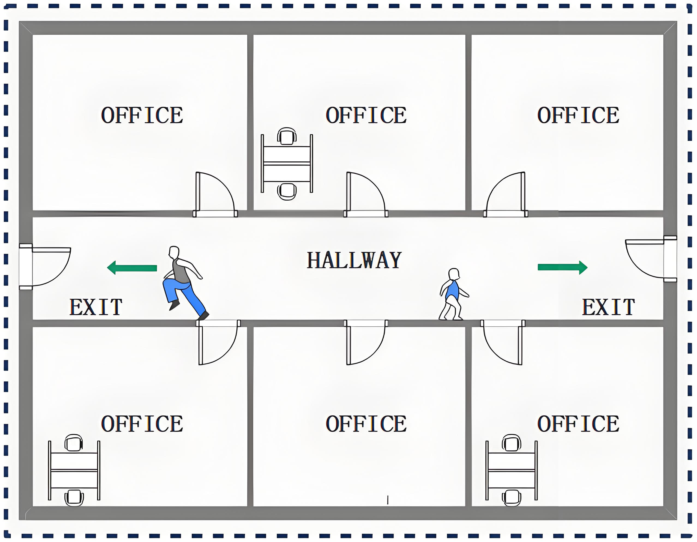
Figure 4-1 Floor Plan Layout
  - Visual Radius Attenuation Model
Since smoke generated during fires significantly impairs human visual range, this program introduces a Visual Radius Attenuation Model to quantify the relationship between responders' effective visual radius and smoke concentration, expressed as:
（4.1）
- denotes the room diagonal length.
- represents the minimum field of view.
- is the attenuation coefficient, determined by the critical time (i.e., the time required for visibility to degrade to its minimum level).
  - Speed and Efficiency Coupling Model
During the search process, the movement speed of rescue personnel is constrained by their visual radius. Therefore, this program introduces a Speed and Efficiency Coupling Model to investigate the relationship, revealing that the movement speed and field-of-view radius of rescue personnel follow a piecewise function, expressed as:
（4.2）
Furthermore, to simulate scenarios where rescue personnel need to repeatedly scan, crouch, and clear obstacles in dense smoke, an efficiency factor is introduced under low visibility conditions. The effective search speed is defined as.
  - Self-Adaptive Path Generation Algorithm
Each responder adopts distinct search strategies based on the level of visual visibility when clearing rooms:
(1) When (set to 2.5 meters), it is considered high visual visibility, indicating a clear environment. During indoor rescue operations, the responder sequentially traverses the four corners of the room and finally returns to the doorway. The total sweeping path length is approximately equal to the perimeter of the room. Under high visual visibility, the sweeping time is calculated as:
（4.3）
(2) When , it is considered low visual visibility, indicating an obscured environment. During indoor rescue operations, the responder adopts a zigzag path to cover the entire room, ensuring at least 95% of the area is swept. The spacing between scan lines is determined by the current field of view:
（4.4）
- is the overlap coefficient.
Under low visual visibility, the sweeping time is:
（4.5）
（3） Visual Coverage Constraint: The scanned area of each room must exceed 95% of the total room area, as shown in the formula(4.6). Here, represents the time required for a single room:

（4.6）
  - Global Optimization
For this problem, responders need to clear all rooms within a timeframe . This can be formulated as a Multiple Traveling Salesman Problem
(1) Decision Variables:.
- : Sets of rooms assigned to Responder 1 and Responder 2, respectively.
- : Visiting sequences for the rooms within each subset.
（2）Objective Function and Constraints:
（4.7）
Therefore, the total time required is determined by the moment the last responder completes the search and evacuation. Here,。
  - Strategy Analysis
Figure 4-2 Sweep Path

As shown in Figure 4-2, two responders adopt a symmetric collaboration strategy to clear a corridor with six rooms (R1-R6) distributed on both sides. The core route planning is as follows:
（1）Responder 1 (responsible for left-side rooms R1, R2, R3):Enters R3 from the starting point and conducts a systematic clockwise search of the four corners, forming a closed loop before exiting R3. Subsequently proceeds to R2, completing the search using the identical clockwise path. Finally enters R1 and executes the clockwise search again.
（2）Responder 2 (responsible for right-side rooms R6, R5, R4):Enters R6 from the starting point but adopts a counterclockwise direction to search the four corners. After completion, sequentially proceeds to R5 and R4, maintaining the fixed counterclockwise search pattern in each room.
Assuming a delay time of 120 seconds from fire detection to the start of search and rescue by responders, the actual time consumption of the two responders is shown in Table 4-1.
Table 4-1 Responder Sweep Time
Responder | Time（s）
Responder 1 | 151.17
Responder 2 | 151.17
Under the condition of a 120-second delayed start, this strategy achieves parallel operations and synchronized completion by two rescue personnel through rational zoning and path planning. The total search and rescue time is controlled at 151.17 seconds, with an overall evacuation completion time of 271.17 seconds.

Problem 2:Developing a Multiple Traveling Salesman (TSP) Planning Model
This section reshapes the spatial layout and establishes a multi-traveler planning model under hypothetical conditions to determine the optimal cleaning path and cleaning time. This model incorporates numerous factors, each of which significantly impacts cleaning duration.
  - Spatial Configuration Remodeling - Solution I
As shown in Figure 5-1, the building has two floors, each containing three rooms. Staircases and exits are located on both sides. Each room measures 6 meters in length, 5 meters in width, and 2.5 meters in height, with a 3-meter-wide corridor.
For multi-story building search and rescue operations with dual evacuation routes, this paper establishes a multi-traveling salesman problem model based on topological graph theory.
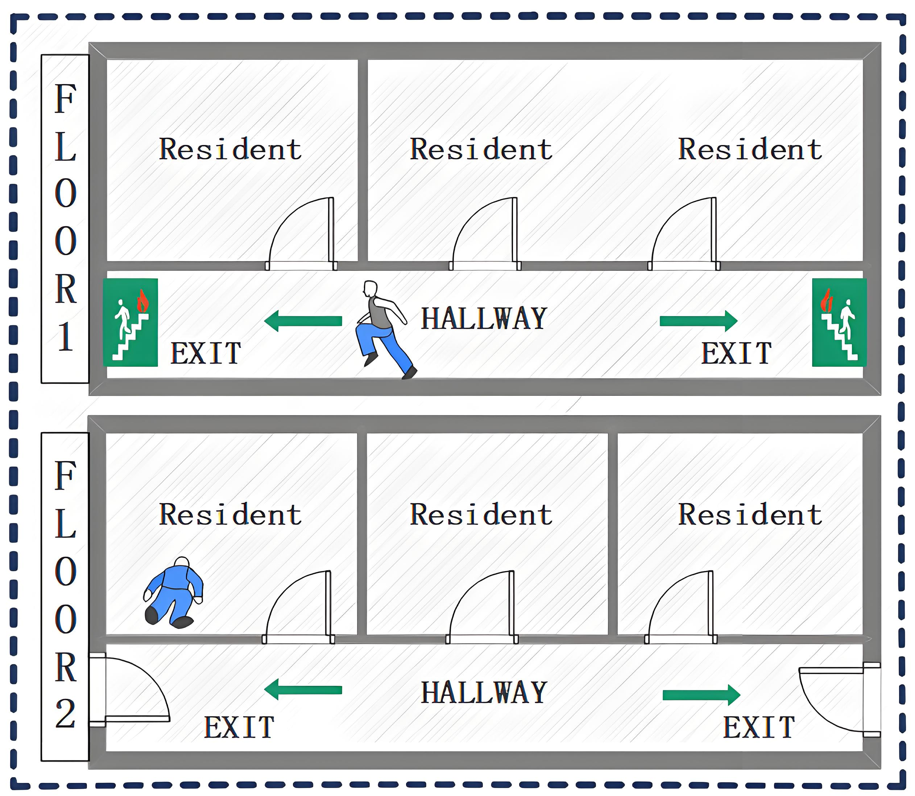
Figure 5-1 Spatial Layout Restructuring 1

Three-Dimensional Spatial Topological Model
This paper abstracts the search and rescue scenario into a weighted graph comprising three types of nodes: target nodes, connecting nodes, and entrance/exit nodes.
Define the movement cost between any two points A and B as:
（1）Same-floor movement：
（5.1）
（2Cross-floor movement：
Given the presence of two staircases, letdenote the left staircase path and denote the right staircase path. By calculating the cost of traversing between floors, we determine which staircase offers the more time-efficient entry. The paths for the left and right staircases are respectively:
The time taken for responders to choose the shortest path is:
（5.2）
Among these,combines horizontal velocity and vertical velocity

Global Optimization Models
（1）Decision variables:
Number of personnel：。
Task Assignment and Sequence: Room Access Sequence for Each Responder
（2）Objective function
（5.3）
- :After completing the final task, the time required to descend to the first floor via the nearest staircase and reach the exit.

Strategic Analysis
1.Analysis of Response Personnel Numbers
Figure 5-2 Relationship between Responders and Sweep Time
As shown in Figure 5-2, during search and rescue operations, the search time decreases as the number of responders increases. According to optimal resource allocation rules, while deploying four responders achieves the shortest search time (163.7 seconds), the time savings compared to a three-person configuration (4.0 seconds) are negligible. However, considering redundancy rules, it is necessary to repeat search operations. Therefore, four responders are still deployed.
2.Response Personnel Path Analysis
Figure 5-3 3D Sweep Path

Figure 5-4 2D Sweep Path

As shown in Figures 5-3 and 5-4, this search and rescue operation employs a collaborative strategy of “layered parallelism and zone-based responsibility.” Four responders simultaneously execute sweep tasks on a two-story building. Their total task duration includes the time required to move from the entrance to the second floor. Consequently, their start and end times on the timeline are later than those of the first-floor team. Their specific routes and division of labor are as follows:
Response Team Member 1: Enter through the first-floor entrance on the left side of the building. Follow a clockwise closed route to systematically search rooms F1-1 and F1-3 in sequence.
（2）Response Team Member 2: Enter through the first-floor entrance on the left side of the building. Search the central rooms F1-2 to complement Team Member 1's route, ensuring rapid and thorough coverage of the entire first-floor section.
（3）Response Personnel Three and Response Personnel Four: Replicate the search patterns of Personnel One and Personnel Two on the first floor, respectively.Both are responsible for searching F2-1 and F2-3, as well as F2-2, respectively.
Assuming a 120-second delay from fire detection to the initiation of search and rescue operations by responders, the actual time taken by four responders is shown in Table 5-1.
Table 5-1 Responder Sweep Time
Responder | Time（s）
Responder 1 | 146.7
Responder 2 | 141.7
Responder 3 | 163.7
Responder 4 | 158.7
Under a 120-second delay in activation, this strategy achieved parallel operations and simultaneous completion by four search and rescue personnel through rational zoning and path planning. The total search and rescue time was controlled at 163.7 seconds, with the overall evacuation completion time recorded at 287.7 seconds.
  - Spatial Pattern Restructuring Plan Two
As shown in Figure 5-5, the building has two floors. The first floor consists of four rooms and four exits; the second floor comprises seven rooms and two stairwells. Large rooms measure 6 meters in length and 5 meters in width, while small rooms occupy half the area of large rooms. Corridors are 3 meters wide.
Due to volume differences between rooms, smoke diffusion rates will exhibit non-uniform dispersion, resulting in varying visual visibility within each room. This layout is therefore established. The issue is addressed through three-dimensional spatial topology and differentiated smoke diffusion dynamics.

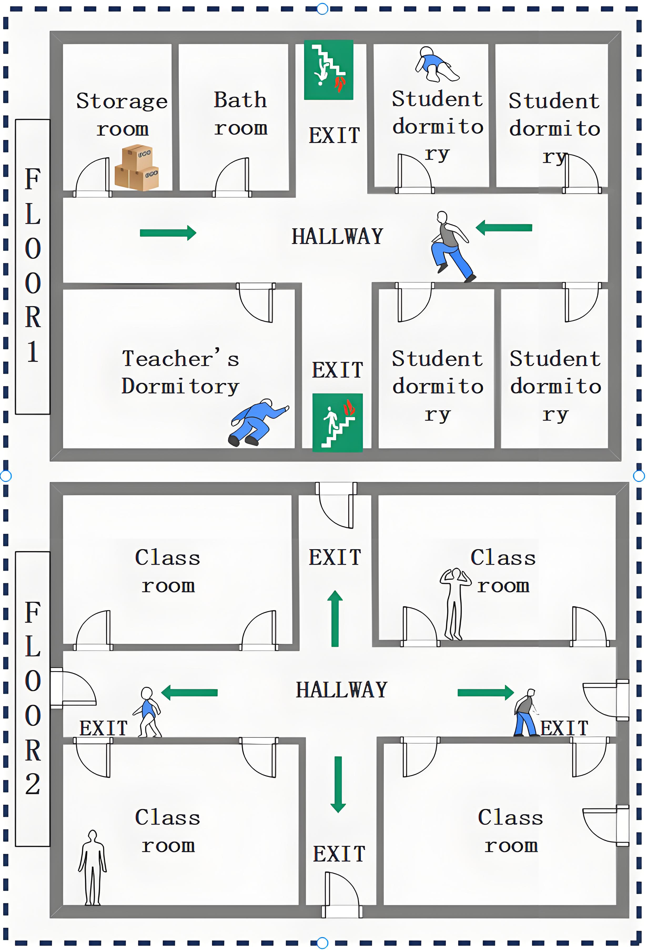
Figure 5-5 Spatial Layout Restructuring 2

Room Heterogeneous Model
In addition to the geometric properties of each room, we introduce a risk attenuation coefficient to reflect how quickly it is affected by smoke. We classify rooms into two categories:
Critical Failure Time Setting for Large-Volume Rooms：=10分钟
Critical Failure Time Setting for Small-Volume Rooms：=6分钟
Time required for cross-floor movement:
（5.4）
- =2.5 is the floor-to-ceiling height.
- is the horizontal movement speed.
- is the vertical velocity.

Room-Level Visual Attenuation Model
Let denote absolute time. For room , its effective internal visual radius follows a specific exponential decay law:
（5.5）
Among these, the attenuation coefficient is determined by the critical time of the room:
（5.6）
Compared to the previous model's nonlinear mapping of search time and visibility, we incorporate the arrival time at the room, thereby deriving a new piecewise function:
（5.7）
- =0.3 is the efficiency factor

Global Optimization Models
- Decision variables: We seek the optimal number of personnel , the task assignment scheme , and the visit sequence for each team member.
（2）Objective function
（5.8）
Among these,
- is the time when the -th responder passes node A.
- is the time when the -th responder passes node B.
- is the delayed start time for responders
- is the time taken by the responder to travel from node A to node B.
- is the time taken by the response personnel to clean the room.

Strategy Analysis
1.Analysis of Response Personnel Numbers
Figure 5-6 Number of Responders vs. Sweep Time

Based on Figures 5 and 6, applying the principles of optimal resource allocation and diminishing marginal returns, deploying six rescue personnel represents the optimal strategy for this emergency cleanup task. This approach ensures the shortest operational time while avoiding redundancy and waste of human resources.
2.Response Personnel Path Analysis
Figure 5-7 3D Sweep Path
Figure 5-8 2D Sweep Path
As shown in the diagram: This search and rescue operation employs a coordinated strategy of “layered parallelism and zone-based responsibility,” with six responders simultaneously conducting sweep operations on a two-story building. Their specific routes and assignments are as follows:
(1)Response Personnel 1: Follow a clockwise closed route to systematically search the two rooms on the left. First search F1-L-Top, then proceed to search F1-L-Bot upon completion.
(2)Response Personnel 2: Follow the same clockwise closed route, covering the right-hand area. Search in sequence: F1-R-Top and F1-R-Bot.
(3)Remaining personnel: The remaining four individuals are responsible for searching the entire second-floor area. Their search route must ensure comprehensive coverage of every corner on the second floor without omission.
Assuming a delay of 120 seconds from fire detection to the initiation of search and rescue operations by responders, the actual time required per responder is shown in Table 5-2.
Table 5-2 Responder Sweep Time
Responder | Time（s）
Responder 1 | 158.9
Responder 2 | 169.4
Responder 3 | 149.1
Responder 4 | 168.5
Responder 5 | 169.4
Responder 6 | 161.9
Conclusion: Under the condition of a 120-second delay before initiation, this strategy achieved parallel operations and simultaneous completion by six search and rescue personnel through rational zoning and path planning. The total search and rescue time was controlled at 169.4 seconds, with the overall evacuation completion time recorded at 289.4 seconds.

Problem 3: Developing a Time-varying Multi-agent Cooperative Planning Model
In this section, the spatial pattern is reshaped, and a time-varying multi-agent collaborative planning approach is established in light of practical scenarios to identify the optimal paths and cleaning time for both cleaning and rescue operations.
Considering the actual situation, the proposed model incorporates multiple influential factors:
- Inclusion of trapped personnel awaiting rescue
- Integration of different types of response personnel
- Adoption of realistic movement rules
- Incorporation of diverse types of residents
- Addition of redundancy rules
- Integration of a labyrinthine complex warehouse structure
Each of these factors exerts a significant impact on the cleaning time.
Figure 6-1 Spatial Layout Restructuring
A complex layout is constructed as illustrated in Figure 6-1. The shaded areas represent complex fixed goods, which block visibility and are impassable. The blue dots denote trapped personnel awaiting rescue, and the red dots indicate exits. On the second floor, Apt 1 is occupied by a pregnant woman, Apt 2 by shop staff, Apt 3 by warehouse management personnel, and Apt 4 by a family with an infant, with the floor height being 2.5 meters. On the ground floor, Shop 1, Shop 2, and Shop 3 correspond to three separate commercial establishments.
  - Collaborative Planning Model
复用问题一的视觉半径衰减模型和速度与效率
Objective Function and Constraints
（6.3）
- ：Total Rescue Time
- ：Total Number of Responders
- ：The absolute time when the -th responder completes all tasks and evacuates.
- ：Response Delay
- ：Classified by scenarios (1.2 m/s on flat ground, 1.1 m/s on stairs, and 1.0 m/s when turning).
- ：Minimum movement speed for rescue personnel in smoke: 0.2 m/s
  - Strategy Analysis
For task allocation, prioritize tasks in descending order of importance: high-risk personnel zones, standard floor sweeps, and warehouse scans conducted concurrently.
The total execution time for responders comprises the sum of macro-path and micro-path durations.
At the macro level, locations are abstracted into a weighted graph. Using Dijkstra's algorithm, the shortest path from one vertex to all others is calculated.
At the micro level, a two-dimensional discrete grid is introduced. Using the A* algorithm for parallel bow-shaped scanning, point-to-point pathfinding is performed within the warehouse, accumulating dynamic time from the starting point to each node.
The cleaning results are as follows:
Figure 6-2 3D Sweep Path

Figure 6-3 2D Sweep Path
Conclusion: The total time for all rescue and cleanup operations (calculated from the moment of response) was 536.32 seconds.
Compared to previous models, this model accounts for the evacuation of different types of personnel by different types of responders, as follows:
Figure 6-4 Three-dimensional Sweep Path
Figure 6-5 Two-dimensional Sweep Path
=== Rescue Mission Simulation Report (Smoke Limit: 30 Minutes) ===
Table 6-1 Sweep Simulation Report
Target | Team | Priority | Status | Total Time
Apt 4 (Infant) | Fire/Security | Level 1 | Success | 42.03s
Apt 1 (Pregnant) | Medical | Level 1 | Success | 42.03s
Shop 2 | Security | Level 2 | Success | 12.83s
WH Corner | Firefighter A | Level 2 | Success | 30.48s
WH Maze | Firefighter B | Level 2 | Success | 29.36s

Strengths and Weakness
  - Strengths
•(1)Robustness and Optimality: The model we established is robust, effectively identifying optimal sweep paths and minimum sweep times across various building layouts.
•(2)Prioritization: The model is "humane," prioritizing the sweep of high-risk areas (based on occupant type) to maximize the positive outcomes of the sweep.
  - Weaknesses
Computational Complexity: For buildings with a large number of rooms, it may require more computational time to determine task assignments and sweep paths.

Sensitivity Analysis
  - Impact of Team Size on Rescue Time
This experiment tested the effect of the number of responders on the task completion time ($T_{total}$) under baseline conditions of a fixed communication delay (60s) and a baseline movement speed (1.2m/s). The experimental results are shown in Figure 8-1.
Figure 8-1 Relationship between Number of Responders and Sweep Time

As shown in Figure 8-1, when the number of rescuers increased from 1 to 2, the total time required plummeted from 11,540.4 seconds to 1,762.3 seconds, demonstrating a remarkably significant efficiency gain.
As the number continued to increase from 6 to 10 rescuers, the time required decreased from 623.6 seconds to 295.8 seconds, indicating diminishing marginal returns in time savings per additional rescuer. When the number of rescuers reached 11, the system achieved its optimal time of 284.2 seconds. Increasing the number to 12, however, caused the time to slightly increase to 317.8 seconds.
This suggests that having too many personnel in a confined space may lead to task fragmentation or resource competition. Therefore, the optimal cost-effectiveness configuration is recommended to be between 6 and 10 rescuers.
  - Non-linear Impact of Response Delay
To quantify the importance of the "golden rescue time," the experiment tested the impact of the initial delay (in seconds) on the sweep process. The experimental results are shown in Figure 8-2.
Figure 8-2 Communication Delay and Sweep Time
Non-linear Growth Phenomenon: The experimental results show that the increase in total sweep time is not a simple linear addition of the delay time. In the ideal zero-delay ($T_{delay}=0$) scenario, task completion requires 623.6 seconds. When the delay reaches 600 seconds, the task completion time increases to 2110.8 seconds.
Time Penalty of Smoke Diffusion: From the data comparison, a 600-second physical delay resulted in a total time increase of 1487.2 seconds ($2110.8s - 623.6s$). Of this, 600 seconds is the pure time shift. The remaining 887.2 seconds ($2110.8 - 623.6 - 600$) is the additional "environmental penalty" incurred because the delay caused smoke concentration ($C_{smoke}$) to rise, forcing responders to reduce their movement speed (e.g., from $V_{fast}$ down to $V_{slow}$).

Conclusion
This result quantitatively demonstrates the necessity of "every second counting" in fire rescue—a delay not only consumes time but also worsens the operational environment, leading to a non-linear decay in subsequent sweep efficiency.
Meanwhile, in a limited space (such as the warehouse and apartment hallways), too many responders may lead to task fragmentation or potential path resource competition, no longer yielding positive returns.


Message
To: Local Emergency Planning Committee (LEPC)

Xi’an Technology University
2025024
November 17, 2025

Emergency
Planning
Committee
From: Team 2026024
Date: November 17, 2025
Subject: Practical Recommendations for Optimizing Emergency Evacuation Sweep Strategies —
Based on Findings from Team 2026024's Dynamic Model
Dear Members of the Local Emergency Planning Committee:
We are Team 2026024. As commissioned by the Clearing Of Multi-use Assembly Public/Private
spaces (XATU), our team has successfully developed and validated a dynamic, multi-objective
mathematical model aimed at optimizing "sweep" strategies for responders in multi-floor
buildings during emergency evacuations, such as fires or gas leaks.
The core advantage of our model is that it is not merely a static pathfinding tool, but rather a decision support system capable of coupling with dynamic risks in real-time. Specifically, our model (as seen in Problems 1 and 3) innovatively introduces a "Visual Radius Attenuation Model" that directly links smoke concentration and decreased visibility to responder search speed and strategy (e.g., "Perimeter Search" vs. "Zigzag Search"). Combined with a Multi-Traveling Salesperson Problem (M-TSP) algorithm (Problem 2) and a time-varying multi-agent coordination algorithm (Problem 3), our model finds the optimal balance between minimizing total sweep time and maximizing occupant safety (e.g., prioritizing high-risk occupants).
Based on the rigorous simulations and findings from our model, we have distilled the following key evacuation sweep strategies and actionable recommendations.
I. An Evacuation Sweep Strategy Based on Our Findings Our research indicates that the most efficient sweep strategy is dynamic, quantifiable, and often counter-intuitive.
1. How to Plan Sweeps:

Dynamic Zoning and Parallel Operations: For multi-floor or complex layouts (Problems 2 and 3), a "Layered Parallel, Zoned Responsibility" strategy is far superior to a single-line sweep. The model (e.g., M-TSP in Problem 2) automatically calculates the optimal zoning plan to ensure balanced workloads among teams. Environment-Adaptive Search: The sweep strategy must change as the environment degrades. Our model (Problem 1) quantifies this process: in the initial phase (high visibility), use a "Perimeter Search" for speed; when smoke reduces visibility below a threshold (e.g., 2.5 meters), teams must switch to a "Zigzag/Grid-search" to ensure full coverage.
2. How to Assign Responders:
The "Marginal Utility" of Optimal Team Size: Adding more responders does not always increase efficiency. Our sensitivity analysis shows a "sweet spot" for team size (e.g., 6 to 10 responders). Beyond a saturation point (e.g., 11+ responders), a "congestion effect" may slightly decrease efficiency. Our model can calculate the optimal cost-benefit ratio for team size in any given layout.
Task-Based Specialization: In complex scenarios (Problem 3), responders should be assigned tasks based on their expertise (e.g., Fire/Security vs. Medical). The model supports prioritizing a medical responder for a pregnant occupant (Apt 1) while fire responders handle an infant (Apt 4) and a complex warehouse (WH Maze).
3. Strategies to Ensure Redundancy and Speed without Sacrificing Safety: Speed (Countering the Non-Linear Time Penalty): A key finding from our sensitivity analysis is that the cost of response delay is non-linear. A 600-second delay is not just 600 seconds lost; it also results in an additional 887.2 seconds of "environmental cost" as smoke degradation slows subsequent operations. This provides robust data supporting the "golden rescue time" and the absolute necessity of speed.
Redundancy (Ensuring Safety): Our model (Problem 2) shows that increasing from 3 to 4 responders, while offering minimal time savings, provides critical redundancy . This extra responder is essential for re-checking areas to guarantee no one is left behind, especially in low-visibility, perfectly aligning with the "without sacrificing safety" principle.
II. Actionable Recommendations for Strategies
Our model's adaptability (Advantage 7.1) and human-centric focus (Advantage 7.3) allow for specific recommendations.
- Based on Different Building Types and Floor Plan Layouts:
Symmetrical Layouts (e.g., Problem 1 Office): Employ a "symmetric coordination" strategy. Two responders mirroring each other's paths on opposite sides of the hallway is most efficient.
Multi-Floor Buildings (e.g., Problem 2 Apartments): Use the "Layered Parallel" strategy. Our 3D topological model (Problem 2) automatically calculates which stairwell (left or right) a responder should use to reach their assigned floor via the shortest path.
Heterogeneous Rooms (e.g., Problem 2, Scenario 2): Our model reveals that small-volume rooms must be prioritized. Smoke fills them faster (e.g., 6 min vs. 10 min for large rooms), causing their hazard level to escalate more quickly.
Complex/Maze Layouts (e.g., Problem 3 Warehouse): Standard intuition fails. These require advanced pathfinding (our Dijkstra macro-path + A* micro-path algorithm) to find the true optimal path, which is often obscured by obstacles.

2. Based on Various Types of Occupants:
High-Risk Occupants (e.g., Infants, Pregnant Women): These are the highest priority (Level 1) in our model (Problem 3). Responders must be assigned to these areas (Apt 1, Apt 4) first.
Standard Occupants (e.g., Shops, Offices): These areas are swept via the optimal path after high-risk targets are addressed.
We are confident that this dynamic optimization model, developed by Team 2026024, can significantly enhance your committee's capabilities in creating emergency plans, training personnel, and commanding live incidents.
We are available to provide a more detailed demonstration of our model at your convenience.
Sincerely,
Team 2026024

References
[1] Liu Hu. Research on Indoor Positioning and Trapped Person Identification Methods for Building Fire Rescue Robots [D]. Anhui University of Architecture, 2024. DOI:10.27784/d.cnki.gahjz.2024.000117.
[2] Liu Wei, Ge Hui. Causes of Fires in Cold Storage Warehouses and Similar Indoor Entertainment Venues, and Key Firefighting and Rescue Techniques [J]. Industry and Technology Forum, 2022, 21(19): 53-55.
[3] Jiang Yuancai. Research on Escape Methods for Residential Building Fires [J]. Fire Protection World (Electronic Edition), 2022, 8(11): 111-113. DOI:10.16859/j.cnki.cn12-9204/tu.2022.11.044.
[4] Zhong, Fawen. Simulation and Optimization of Emergency Evacuation Pathways for Indoor Fires in Large Public Buildings [D]. Anhui University of Technology, 2018. DOI:10.27790/d.cnki.gahgy.2018.000019.
[5] Lin, Xiaochen; Ni, Jielei. Design of an Improved Indoor Positioning Algorithm for Fire Rescue Operations [J]. Technology and Market, 2018, 25(03): 153.
[6] Du, Xiao; Ge, Xiaofei. Positioning Technology for Rescue Personnel in Indoor Fire Scenarios [J]. Modern Occupational Safety, 2017, (01): 50-51.

Appendix

