Problem Chosen  A | 2026 XATU MCM/ICM  Summary Sheet | Team Control Number  2026024
Use this template to begin typing the first page (summary page) of your electronic report. This template uses a 12-point Times New Roman font. Submit your paper as an Adobe PDF electronic file (e.g. 1111111.pdf), typed in English, with a readable font of at least 12-point type.

Do not include the name of your college, advisor, or team members on this or any page.

Papers must be within the 25 page limit.

Be sure to change the control number and problem choice above.
You may delete these instructions as you begin to type your report here.

Content
Content 2
1. Introduction 3
1.1. Background 3
1.2. Problem Restatement 4
1.3. Our Work 5
1.4. Problem Analysis 5
2. Assumptions and Rationale 6
3. Symbol and Assumptions 7
4. Problem 1: Constructing the Basic Layout and a Unified Environmental and Physical Model 8
4.1. Spatial Layout Analysis 8
4.2. Visual Radius Attenuation Model 9
4.3. Speed and Efficiency Coupling Model 9
4.4. Self-Adaptive Path Generation Algorithm 10
4.5. Global Optimization 11
4.6. Strategy Analysis 11
5. Problem 2:Developing a Multiple Traveling Salesman (TSP) Planning Model 12
5.1. Spatial Configuration Remodeling - Solution I 13
5.1.1. Three-Dimensional Spatial Topological Model 13
5.1.2. Global Optimization Models 14
5.1.3. Strategic Analysis 14
5.2. Spatial Pattern Restructuring Plan Two 17
5.2.1. Room Heterogeneous Model 18
5.2.2. Room-Level Visual Attenuation Model 18
5.2.3. Global Optimization Models 19
5.2.4. Strategy Analysis 20
6. Problem 3: Developing a Time-varying Multi-agent Cooperative Planning Model 22
6.1. Dynamic Environment Modeling 23
6.2. Strategy Analysis 24
7. Strengths and Weakness 28
7.1. Strengths 28
7.2. Weaknesses 28
8. Sensitivity Analysis 28
8.1. Impact of Team Size on Rescue Time 28
8.2. Non-linear Impact of Response Delay 30
9. Conclusion 30
10. Message 31
11. References 31
12. Appendix 31

Introduction
  - Background
In public safety emergencies such as fires or gas leaks, efficient emergency evacuation is critical for saving lives. The "sweep" operations executed by trained responders, which aim to guarantee no one is left behind, are a critical part of the evacuation process. The efficiency and strategy behind these sweeps can directly determine the success or failure of the rescue.
However, this task faces severe challenges. Real-world buildings vary in layout, number of floors, and location of exits. Responders must make decisions under immense pressure to act quickly, often with limited information. Traditional, experience-based sweep methods are prone to redundant search paths, inefficient resource allocation, and time delays, placing both responders and any remaining occupants in true peril. Therefore, designing rational sweep paths for them is critically important.
This year, our team has been asked by the Clearing Of Multi-use Assembly Public/Private spaces (XATU) to design a mathematical model to optimize sweeping strategies in multi-floor buildings during emergency evacuations. We will maximize the collaborative efficiency of the responder team—while strictly prioritizing occupant safety —to ensure all rooms are cleared in the shortest possible time. This study incorporates building complexity, information uncertainty, and dynamic risks into a unified framework. It is dedicated to transforming the sweep task into a quantifiable and optimizable systematic problem, providing decision support for scientific rescue.
  - Problem Restatement
The challenge is to design a mathematical model to optimize sweeping strategies during fires or other emergencies in buildings that vary in layout. The goal is to ensure all rooms are cleared in the shortest possible time , while prioritizing occupant safety and responder efficiency.
Problem 1: For a one-story office building with three similar-sized rooms on each side of a central hallway, where rooms are only connected to the hallway , determine a model for how two fire fighters can sweep the building efficiently and find the minimum time to complete this sweep.
Problem 2: For at least two additional building layouts with a varying number of responders , which must include changes to the number of floors, the floor plan, and the occupants of the rooms , use the model to determine:
The optimal number of responders and their starting positions.
The paths used during the sweep (order of rooms to be checked).
The minimum time to fully sweep the building.
Problem 3: Extend the model to incorporate more realistic constraints in non-standard building layouts. This includes factors such as decreased visibility , people moving dynamically during evacuation , and the prioritization of high-risk areas. Determine how to assign responders and plan an evacuation sweep strategy to ensure maximum safety in the shortest possible time.
  - Our Work
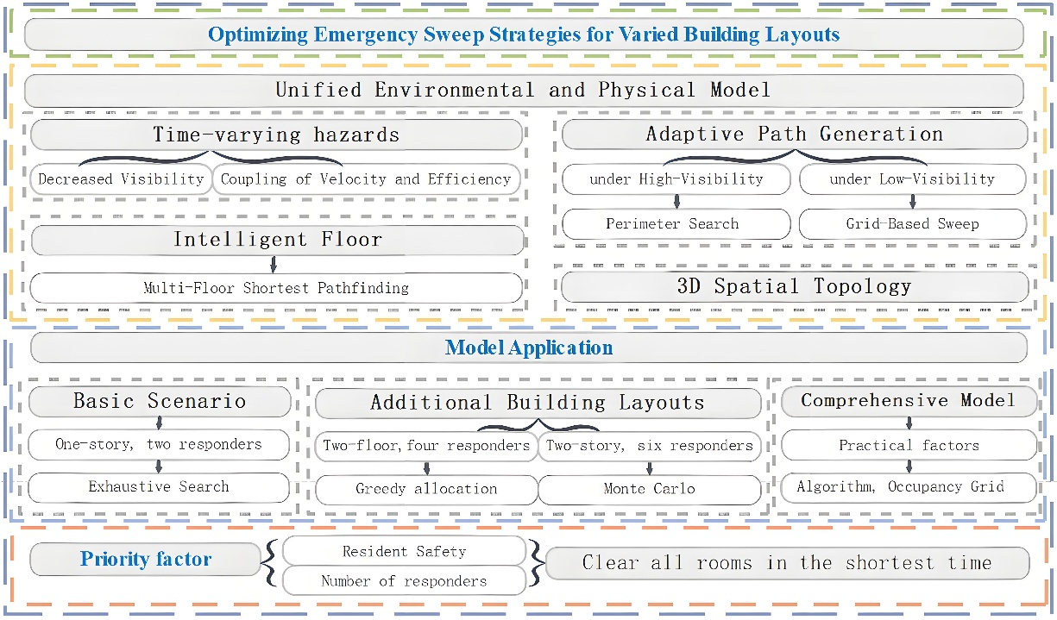
Figure 1-1 Our Work
  - Problem Analysis
This study aims to construct an optimized sweep model to maximize occupant safety and responder efficiency, and to clear all rooms in the shortest possible time. The criterion for a room being "all-clear" is that a responder has successfully swept it. The minimum time is defined as when all responders have completed sweeping their assigned rooms and have evacuated via an exit.
The problem is decomposed into three progressive levels:
(1) Problem 1: Baseline Model A one-story building with six rooms and two responders. This scenario is used to validate a zoning strategy and the effectiveness of a "full-space search" baseline algorithm in an ideal environment.
(2) Problem 2: Multiple Layouts and Scalability Introduce multi-floor layouts (e.g., two floors, six rooms; two floors, multi-rooms) and a varying number of responders to address 3D spatial topology and complex task assignment problems.
Two-floor, six-room: Employ "brute-force full permutation" and "greedy assignment."
Two-floor, multi-room: To handle the "combinatorial explosion," use "Monte Carlo sampling" and "greedy load balancing" to find a near-optimal solution.
(3) Problem 3: High-Fidelity Dynamics and Special Scenarios In a realistic, non-standard building layout, the environment is high-dimensional and time-varying. New variables are introduced, such as "occupant locating," "prioritization of high-risk areas," "dynamic movement," and "redundancy rules." A hybrid strategy is adopted. At the "micro-grid level," A* and Dijkstra algorithms are used for path planning. At the "macro-level," a "greedy complex decision-making" process is used to assign prioritized tasks.

Assumptions and Rationale
Given that real-world problems often involve numerous complex factors, we must first establish reasonable assumptions to simplify the model:
1.Indoor-Outdoor Environment Isolation Assumption In the context of this study, the effect of wind on smoke is assumed to be negligible. The indoor and outdoor environments are considered relatively isolated, meaning indoor smoke diffusion is not correlated with outdoor wind factors.
2.Responder Sweep Method Assumption Responders are assumed to rely solely on visual inspection when executing sweep tasks, without the aid of other auxiliary detection equipment or methods.
3.Uniform Smoke Onset Assumption All rooms are assumed to start producing smoke synchronously and uniformly at the same time. The onset time, rate of smoke production, and initial smoke distribution within each room are identical.
4.Exclusion of Catastrophic Events Assumption It is assumed that responders will not be affected by any unforeseen catastrophic events during the sweep, such as building collapse, stairwell failure, or fire-induced explosions. The search environment is assumed to remain relatively stable.
5.Environmental Geometry Assumption The overall office environment is treated as a 2D rectangular planar structure, with rooms interconnected by hallways. Obstacles within rooms are not considered in the model. However, to ensure sweep verification, the sweep path is mandated to cover the four corners of each room to account for potential "dead spots."
6.Smoke Diffusion Assumption Smoke concentration is assumed to increase monotonically over time, causing visibility (effective visual radius) to decay exponentially. All rooms are assumed to follow the same smoke diffusion pattern. Due to differences in volume, large rooms take significantly longer to fill with smoke than small rooms, and their visibility also decays exponentially over time.
7.Responder Behavior Assumption Responders strictly follow established protocols. When visibility is high, they employ a Perimeter Search. When visibility is low, they switch to a Zigzag Search (or "Z-pattern search") to enhance sweep efficiency and thoroughness.
8.Speed Limitation Assumption All responders share the same baseline movement speed. However, in smoky conditions, their speed is not constant but is directly affected by the current visibility. As visibility decreases, responders move more cautiously to ensure their safety, resulting in a slower movement speed.
9.Spatial Topology Assumption The building is abstracted as a 3D discrete network. Each floor is treated as a 2D plane. Floors are connected only by two stairwell nodes (bottlenecks), located at the two ends of the hallway. Vertical movement between floors can only be accomplished via these stairwells.
10.Intelligent Decision-Making Assumption
(1) Pathfinding: When responders need to change floors, they are capable of calculating and selecting the closest stairwell (left or right) based on their current position and target destination to optimize their movement path.
(2) Completion Constraint: The criterion for task completion is defined as: all rooms have been swept, AND all responders have safely evacuated to a ground-floor safe exit, ensuring both task completeness and personnel safety.

Symbol and Assumptions
Symbol | Description | Unit
 | 房间对角线长度 | m
 | 最小视场 | m
 | 视觉半径衰减系数
 | 能见度降至最低所需时间 | s
 | 效率因子
 | 响应人员基本移动速度 | m/s
 | 最低视场半径 | m
 | 清扫重叠系数  清扫救援总耗时  响应人员数量 | s  个
Note: Any symbols (or notation) not mentioned in the symbol explanation are specifically defined within the text of this paper.

Problem 1: Constructing the Basic Layout and a Unified Environmental and Physical Model
This section develops a dynamic environment model to determine the optimal sweeping path and duration under ideal assumptions, accounting for multiple critical factors that substantially impact sweeping time.
  - Spatial Layout Analysis
As shown in Figure 4-1, the building layout features offices arranged on both sides with a central corridor. There are six identical offices in total, three on each side. Each office measures 6 meters in length and 5 meters in width, with a floor height of 2.5 meters. The hallway connecting all areas has a width of 3 meters.。
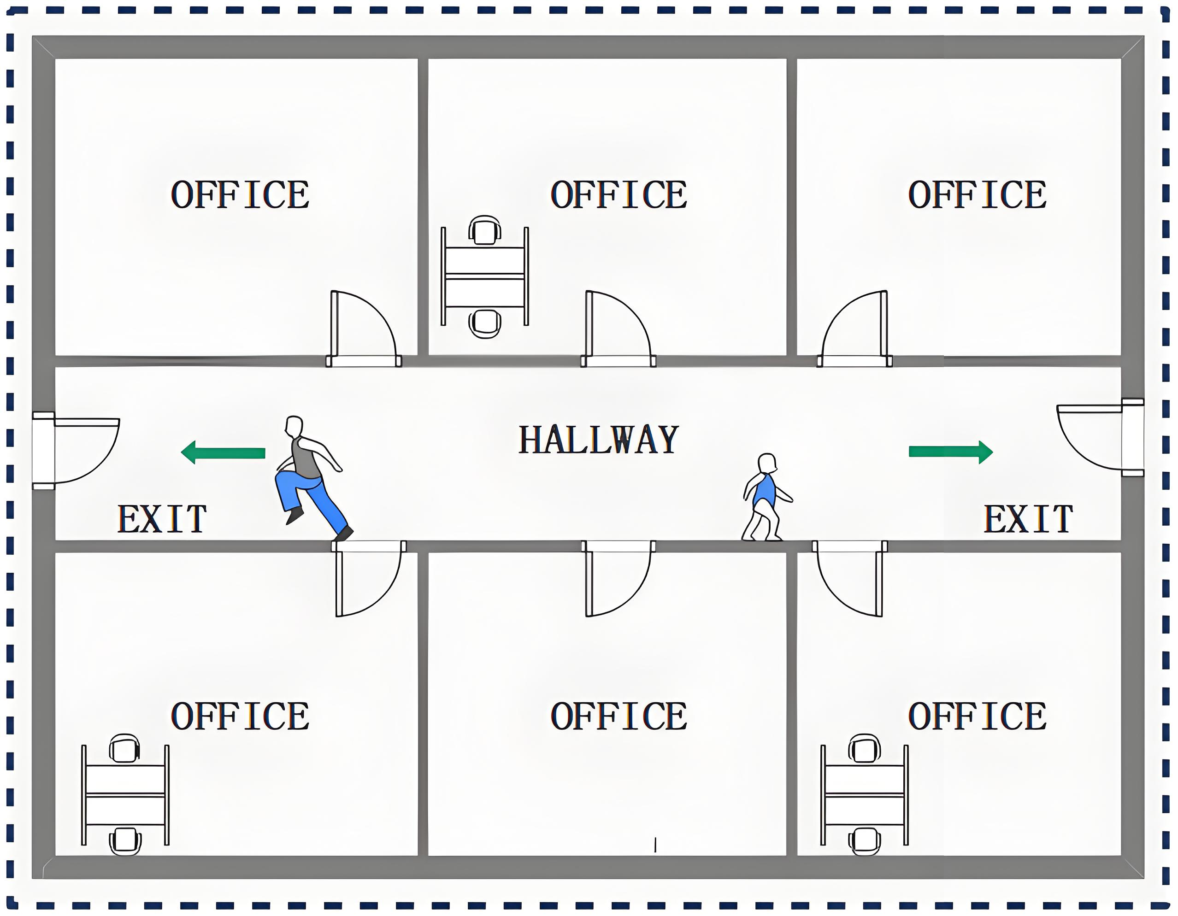
Figure 4-1 Floor Plan Layout
  - Visual Radius Attenuation Model
Since smoke generated during fires significantly impairs human visual range, this program introduces a Visual Radius Attenuation Model to quantify the relationship between responders' effective visual radius and smoke concentration, expressed as:
（4.1）
- denotes the room diagonal length.
- represents the minimum field of view.
- is the attenuation coefficient, determined by the critical time (i.e., the time required for visibility to degrade to its minimum level).
  - Speed and Efficiency Coupling Model
During the search process, the movement speed of rescue personnel is constrained by their visual radius. Therefore, this program introduces a Speed and Efficiency Coupling Model to investigate the relationship, revealing that the movement speed and field-of-view radius of rescue personnel follow a piecewise function, expressed as:
（4.2）
Furthermore, to simulate scenarios where rescue personnel need to repeatedly scan, crouch, and clear obstacles in dense smoke, an efficiency factor is introduced under low visibility conditions. The effective search speed is defined as.
  - Self-Adaptive Path Generation Algorithm
Each responder adopts distinct search strategies based on the level of visual visibility when clearing rooms:
(1) When (set to 2.5 meters), it is considered high visual visibility, indicating a clear environment. During indoor rescue operations, the responder sequentially traverses the four corners of the room and finally returns to the doorway. The total sweeping path length is approximately equal to the perimeter of the room. Under high visual visibility, the sweeping time is calculated as:
（4.3）
(2) When , it is considered low visual visibility, indicating an obscured environment. During indoor rescue operations, the responder adopts a zigzag path to cover the entire room, ensuring at least 95% of the area is swept. The spacing between scan lines is determined by the current field of view:
（4.4）
- is the overlap coefficient.
Under low visual visibility, the sweeping time is:
（4.5）
（3） Visual Coverage Constraint: The scanned area of each room must exceed 95% of the total room area, as shown in the formula(4.6). Here, represents the time required for a single room:

（4.6）
  - Global Optimization
For this problem, responders need to clear all rooms within a timeframe . This can be formulated as a Multiple Traveling Salesman Problem
(1) Decision Variables:.
- : Sets of rooms assigned to Responder 1 and Responder 2, respectively.
- : Visiting sequences for the rooms within each subset.
（2）Objective Function and Constraints:
（4.7）
Therefore, the total time required is determined by the moment the last responder completes the search and evacuation. Here,。
  - Strategy Analysis
Figure 4-2 Sweep Path

As shown in Figure 4-2, two responders adopt a symmetric collaboration strategy to clear a corridor with six rooms (R1-R6) distributed on both sides. The core route planning is as follows:
（1）Responder 1 (responsible for left-side rooms R1, R2, R3):Enters R3 from the starting point and conducts a systematic clockwise search of the four corners, forming a closed loop before exiting R3. Subsequently proceeds to R2, completing the search using the identical clockwise path. Finally enters R1 and executes the clockwise search again.
（2）Responder 2 (responsible for right-side rooms R6, R5, R4):Enters R6 from the starting point but adopts a counterclockwise direction to search the four corners. After completion, sequentially proceeds to R5 and R4, maintaining the fixed counterclockwise search pattern in each room.
Assuming a delay time of 120 seconds from fire detection to the start of search and rescue by responders, the actual time consumption of the two responders is shown in Table 4-1.
Table 4-1 Responder Sweep Time
Responder | Time（s）
Responder 1 | 151.17
Responder 2 | 151.17
Under the condition of a 120-second delayed start, this strategy achieves parallel operations and synchronized completion by two rescue personnel through rational zoning and path planning. The total search and rescue time is controlled at 151.17 seconds, with an overall evacuation completion time of 271.17 seconds.

Problem 2:Developing a Multiple Traveling Salesman (TSP) Planning Model
This section reshapes the spatial layout and establishes a multi-traveler planning model under hypothetical conditions to determine the optimal cleaning path and cleaning time. This model incorporates numerous factors, each of which significantly impacts cleaning duration.
  - Spatial Configuration Remodeling - Solution I
As shown in Figure 5-1, the building has two floors, each containing three rooms. Staircases and exits are located on both sides. Each room measures 6 meters in length, 5 meters in width, and 2.5 meters in height, with a 3-meter-wide corridor.
For multi-story building search and rescue operations with dual evacuation routes, this paper establishes a multi-traveling salesman problem model based on topological graph theory.
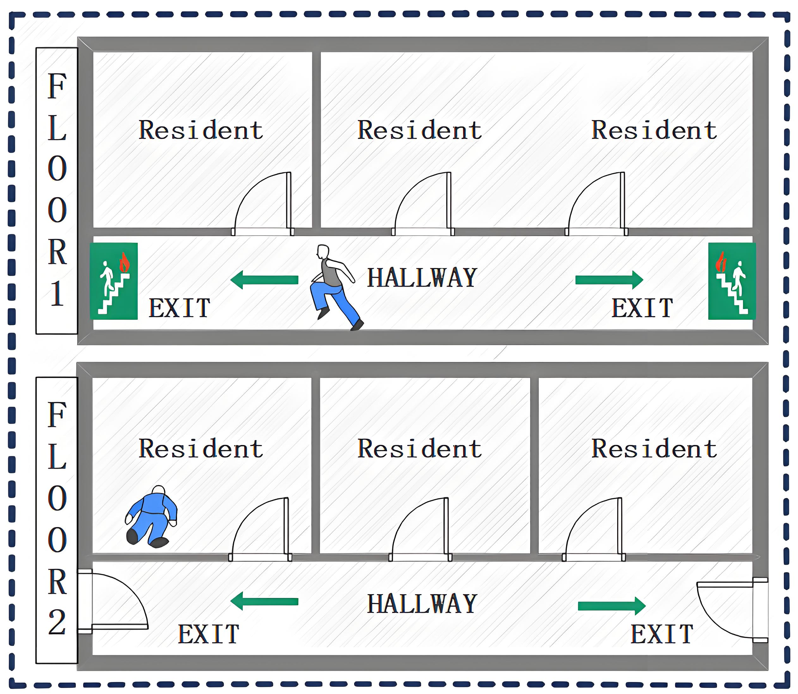
Figure 5-1 Spatial Layout Restructuring 1

Three-Dimensional Spatial Topological Model
This paper abstracts the search and rescue scenario into a weighted graph comprising three types of nodes: target nodes, connecting nodes, and entrance/exit nodes.
Define the movement cost between any two points A and B as:
（1）Same-floor movement：
（5.1）
（2Cross-floor movement：
Given the presence of two staircases, letdenote the left staircase path and denote the right staircase path. By calculating the cost of traversing between floors, we determine which staircase offers the more time-efficient entry. The paths for the left and right staircases are respectively:
The time taken for responders to choose the shortest path is:
（5.2）
Among these,combines horizontal velocity and vertical velocity

Global Optimization Models
（1）Decision variables:
Number of personnel：。
Task Assignment and Sequence: Room Access Sequence for Each Responder
（2）Objective function
（5.3）
- :After completing the final task, the time required to descend to the first floor via the nearest staircase and reach the exit.

Strategic Analysis
1.Analysis of Response Personnel Numbers
Figure 5-2 Relationship between Responders and Sweep Time
As shown in Figure 5-2, during search and rescue operations, the search time decreases as the number of responders increases. According to optimal resource allocation rules, while deploying four responders achieves the shortest search time (163.7 seconds), the time savings compared to a three-person configuration (4.0 seconds) are negligible. However, considering redundancy rules, it is necessary to repeat search operations. Therefore, four responders are still deployed.
2.Response Personnel Path Analysis
Figure 5-3 3D Sweep Path

Figure 5-4 2D Sweep Path

As shown in Figures 5-3 and 5-4, this search and rescue operation employs a collaborative strategy of “layered parallelism and zone-based responsibility.” Four responders simultaneously execute sweep tasks on a two-story building. Their total task duration includes the time required to move from the entrance to the second floor. Consequently, their start and end times on the timeline are later than those of the first-floor team. Their specific routes and division of labor are as follows:
Response Team Member 1: Enter through the first-floor entrance on the left side of the building. Follow a clockwise closed route to systematically search rooms F1-1 and F1-3 in sequence.
（2）Response Team Member 2: Enter through the first-floor entrance on the left side of the building. Search the central rooms F1-2 to complement Team Member 1's route, ensuring rapid and thorough coverage of the entire first-floor section.
（3）Response Personnel Three and Response Personnel Four: Replicate the search patterns of Personnel One and Personnel Two on the first floor, respectively.Both are responsible for searching F2-1 and F2-3, as well as F2-2, respectively.
Assuming a 120-second delay from fire detection to the initiation of search and rescue operations by responders, the actual time taken by four responders is shown in Table 5-1.
Table 5-1 Responder Sweep Time
Responder | Time（s）
Responder 1 | 146.7
Responder 2 | 141.7
Responder 3 | 163.7
Responder 4 | 158.7
Under a 120-second delay in activation, this strategy achieved parallel operations and simultaneous completion by four search and rescue personnel through rational zoning and path planning. The total search and rescue time was controlled at 163.7 seconds, with the overall evacuation completion time recorded at 287.7 seconds.
  - Spatial Pattern Restructuring Plan Two
As shown in Figure 5-5, the building has two floors. The first floor consists of four rooms and four exits; the second floor comprises seven rooms and two stairwells. Large rooms measure 6 meters in length and 5 meters in width, while small rooms occupy half the area of large rooms. Corridors are 3 meters wide.
Due to volume differences between rooms, smoke diffusion rates will exhibit non-uniform dispersion, resulting in varying visual visibility within each room. This layout is therefore established. The issue is addressed through three-dimensional spatial topology and differentiated smoke diffusion dynamics.

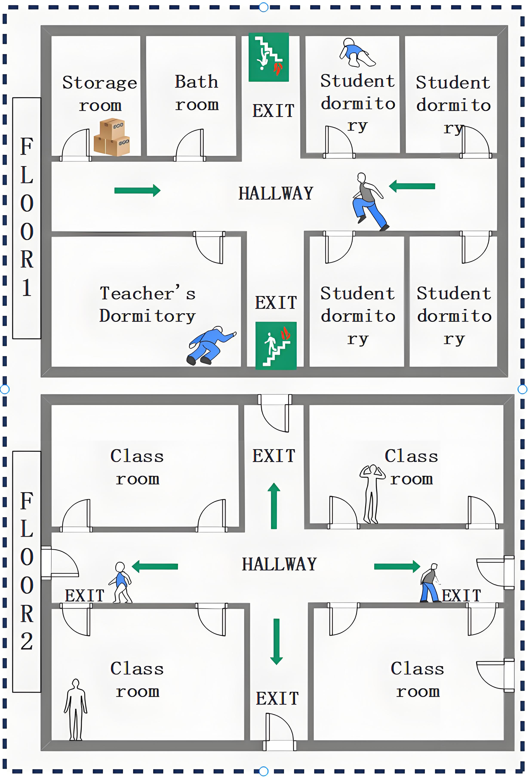
Figure 5-5 Spatial Layout Restructuring 2

Room Heterogeneous Model
In addition to the geometric properties of each room, we introduce a risk attenuation coefficient to reflect how quickly it is affected by smoke. We classify rooms into two categories:
Critical Failure Time Setting for Large-Volume Rooms：=10分钟
Critical Failure Time Setting for Small-Volume Rooms：=6分钟
Time required for cross-floor movement:
（5.4）
- =2.5 is the floor-to-ceiling height.
- is the horizontal movement speed.
- is the vertical velocity.

Room-Level Visual Attenuation Model
Let denote absolute time. For room , its effective internal visual radius follows a specific exponential decay law:
（5.5）
Among these, the attenuation coefficient is determined by the critical time of the room:
（5.6）
Compared to the previous model's nonlinear mapping of search time and visibility, we incorporate the arrival time at the room, thereby deriving a new piecewise function:
（5.7）
- =0.3 is the efficiency factor

Global Optimization Models
- Decision variables: We seek the optimal number of personnel , the task assignment scheme , and the visit sequence for each team member.
（2）Objective function
（5.8）
Among these,
- is the time when the -th responder passes node A.
- is the time when the -th responder passes node B.
- is the delayed start time for responders
- is the time taken by the responder to travel from node A to node B.
- is the time taken by the response personnel to clean the room.

Strategy Analysis
1.Analysis of Response Personnel Numbers
Figure 5-6 Number of Responders vs. Sweep Time

Based on Figures 5 and 6, applying the principles of optimal resource allocation and diminishing marginal returns, deploying six rescue personnel represents the optimal strategy for this emergency cleanup task. This approach ensures the shortest operational time while avoiding redundancy and waste of human resources.
2.Response Personnel Path Analysis
Figure 5-7 3D Sweep Path
Figure 5-8 2D Sweep Path
As shown in the diagram: This search and rescue operation employs a coordinated strategy of “layered parallelism and zone-based responsibility,” with six responders simultaneously conducting sweep operations on a two-story building. Their specific routes and assignments are as follows:
(1)Response Personnel 1: Follow a clockwise closed route to systematically search the two rooms on the left. First search F1-L-Top, then proceed to search F1-L-Bot upon completion.
(2)Response Personnel 2: Follow the same clockwise closed route, covering the right-hand area. Search in sequence: F1-R-Top and F1-R-Bot.
(3)Remaining personnel: The remaining four individuals are responsible for searching the entire second-floor area. Their search route must ensure comprehensive coverage of every corner on the second floor without omission.
Assuming a delay of 120 seconds from fire detection to the initiation of search and rescue operations by responders, the actual time required per responder is shown in Table 5-2.
Table 5-2 Responder Sweep Time
Responder | Time（s）
Responder 1 | 158.9
Responder 2 | 169.4
Responder 3 | 149.1
Responder 4 | 168.5
Responder 5 | 169.4
Responder 6 | 161.9
Conclusion: Under the condition of a 120-second delay before initiation, this strategy achieved parallel operations and simultaneous completion by six search and rescue personnel through rational zoning and path planning. The total search and rescue time was controlled at 169.4 seconds, with the overall evacuation completion time recorded at 289.4 seconds.

Problem 3: Developing a Time-varying Multi-agent Cooperative Planning Model
In this section, the spatial pattern is reshaped, and a time-varying multi-agent collaborative planning approach is established in light of practical scenarios to identify the optimal paths and cleaning time for both cleaning and rescue operations.
Considering the actual situation, the proposed model incorporates multiple influential factors:
- Inclusion of trapped personnel awaiting rescue
- Integration of different types of response personnel
- Adoption of realistic movement rules
- Incorporation of diverse types of residents
- Addition of redundancy rules
- Integration of a labyrinthine complex warehouse structure
Each of these factors exerts a significant impact on the cleaning time.
Figure 6-1 Spatial Layout Restructuring
A complex layout is constructed as illustrated in Figure 6-1. The shaded areas represent complex fixed goods, which block visibility and are impassable. The blue dots denote trapped personnel awaiting rescue, and the red dots indicate exits. On the second floor, Apt 1 is occupied by a pregnant woman, Apt 2 by shop staff, Apt 3 by warehouse management personnel, and Apt 4 by a family with an infant, with the floor height being 2.5 meters. On the ground floor, Shop 1, Shop 2, and Shop 3 correspond to three separate commercial establishments.
  - Dynamic Environment Modeling
(1)Visual Distance Attenuation Model
(6.1)
- ：Initial Maximum Visual Distance of the Region
- ：Minimum Visual Distance
- ：Attenuation Coefficient
- ：Critical Safety Time
- ：Current Time
(2)Dynamic Speed Piecewise Function
(6.2)
Among them, denotes the basic speed（1.2m/s on flat ground,1.1m/s on stairs, and 1.0m/s when turning）,
(3)Objective Function and Constraints
（6.3）
- ：Total Rescue Time
- ：Total Number of Responders
- ：The absolute time when the -th responder completes all tasks and evacuates.
- ：Response Delay
- ：Classified by scenarios (1.2 m/s on flat ground, 1.1 m/s on stairs, and 1.0 m/s when turning).
- ：Minimum movement speed for rescue personnel in smoke: 0.2 m/s
  - Strategy Analysis
Establish a global queue containing all pending tasks. Sort tasks in the queue in descending order of priority, categorizing them as high-risk personnel areas, routine floor sweeps, and warehouse parallel scans. During task execution, the task at the front of the queue is assigned to the fastest available responder.
The total time taken by the responder to execute a specific task can be divided into the sum of macro-path time and micro-path time.
The macro level is a three-dimensional weighted graph with the following node types:
Entrances/Exits: External rescue access points
Room Centroid: Logical centers of functional zones (warehouses, shops, apartments)
Connection Points: Key locations linking rooms to public areas
Transition Points: Stairwells and corridor junctions facilitating floor transitions
An edge represents the physical connectivity between two nodes.
Using Dijkstra's algorithm, calculate the shortest path from a given vertex to every other vertex.
At the microscopic level, a two-dimensional discrete grid is introduced, where the value of each grid cell is defined as:
（6.4）
All micro-paths planned on M must satis
Using parallel bow-shaped scanning with the A* algorithm, perform point-to-point pathfinding within the warehouse, accumulating dynamic time from the starting point to each node.
The cleaning results are as follows:
Figure 6-2 3D Sweep Path

Figure 6-3 2D Sweep Path
Conclusion: The total time for all rescue and cleanup operations (calculated from the moment of response) was 536.32 seconds.
Compared to previous models, this model accounts for the evacuation of different types of personnel by different types of responders, as follows:
Figure 6-4 Three-dimensional Sweep Path
Figure 6-5 Two-dimensional Sweep Path
=== Rescue Mission Simulation Report (Smoke Limit: 30 Minutes) ===
Table 6-1 Sweep Simulation Report
Target | Team | Priority | Status | Total Time
Apt 4 (Infant) | Fire/Security | Level 1 | Success | 42.03s
Apt 1 (Pregnant) | Medical | Level 1 | Success | 42.03s
Shop 2 | Security | Level 2 | Success | 12.83s
WH Corner | Firefighter A | Level 2 | Success | 30.48s
WH Maze | Firefighter B | Level 2 | Success | 29.36s

Strengths and Weakness
  - Strengths
•(1)Robustness and Optimality: The model we established is robust, effectively identifying optimal sweep paths and minimum sweep times across various building layouts.
•(2)High-Fidelity & Realism: The model more closely aligns with real-world scenarios, such as the impact of smoke concentration on responders during emergencies and the handling of insurmountable obstacles.
•(3)Prioritization: The model is "humane," prioritizing the sweep of high-risk areas (based on occupant type) to maximize the positive outcomes of the sweep.
•(4)Adaptability: The model has good adaptability. Even with fewer than optimal responders, it can still design the optimal paths for the given situation, enhancing sweep efficiency.
  - Weaknesses
Computational Complexity: The "brute-force permutation" method used by the model is highly efficient when the number of rooms is small. However, for buildings with a large number of rooms, it may require more computational time to determine task assignments and sweep paths.

Sensitivity Analysis
  - Impact of Team Size on Rescue Time
This experiment tested the effect of the number of responders on the task completion time ($T_{total}$) under baseline conditions of a fixed communication delay (60s) and a baseline movement speed (1.2m/s). The experimental results are shown in Figure 8-1.
Figure 8-1 Relationship between Number of Responders and Sweep Time

Significant Initial Benefits: When the number of responders ($N$) is small, adding personnel yields significant time benefits. Data shows that when $N=1$, the total time is 11,540.4 seconds, as the single responder must perform all tasks serially. When increased to just $N=2$, the time drops sharply to 1,762.3 seconds, a significant efficiency improvement.
Diminishing Marginal Returns: As the number of responders continues to increase, the time benefits gradually narrow. When $N$ increases from 6 to 10, the time shortens from 623.6 seconds to 295.8 seconds. Although the sweep speed is still improving, the time reduction per additional responder has markedly slowed.
Congestion and Saturation Point: Notably, when the number of responders reaches 11, the system achieves the optimal time of 284.2 seconds. However, when $N=12$, the time slightly increases to 317.8 seconds. This indicates that in a limited space (such as the warehouse and apartment hallways), too many responders may lead to task fragmentation or potential path resource competition, no longer yielding positive returns. Therefore, the recommended optimal cost-effectiveness configuration for this scenario is 6 to 10 responders.

  - Non-linear Impact of Response Delay
To quantify the importance of the "golden rescue time," the experiment tested the impact of the initial delay (in seconds) on the sweep process. The experimental results are shown in Figure 8-2.
Figure 8-2 Communication Delay and Sweep Time
Non-linear Growth Phenomenon: The experimental results show that the increase in total sweep time is not a simple linear addition of the delay time. In the ideal zero-delay ($T_{delay}=0$) scenario, task completion requires 623.6 seconds. When the delay reaches 600 seconds, the task completion time increases to 2110.8 seconds.
Time Penalty of Smoke Diffusion: From the data comparison, a 600-second physical delay resulted in a total time increase of 1487.2 seconds ($2110.8s - 623.6s$). Of this, 600 seconds is the pure time shift. The remaining 887.2 seconds ($2110.8 - 623.6 - 600$) is the additional "environmental penalty" incurred because the delay caused smoke concentration ($C_{smoke}$) to rise, forcing responders to reduce their movement speed (e.g., from $V_{fast}$ down to $V_{slow}$).

Conclusion
This result quantitatively demonstrates the necessity of "every second counting" in fire rescue—a delay not only consumes time but also worsens the operational environment, leading to a non-linear decay in subsequent sweep efficiency.
Meanwhile, in a limited space (such as the warehouse and apartment hallways), too many responders may lead to task fragmentation or potential path resource competition, no longer yielding positive returns.

Message

References
- 刘虎.建筑火灾救援机器人的室内定位与被困人员识别方法研究[D].安徽建筑大学,2024.DOI:10.27784/d.cnki.gahjz.2024.000117.
- 刘未,葛惠.冷冻仓库及同类型室内娱乐场所发生火灾原因和灭火救援处置技术要点[J].产业与科技论坛,2022,21(19):53-55.
- 蒋远才.居民楼火灾逃生方法研究[J].消防界(电子版),2022,8(11):111-113.DOI:10.16859/j.cnki.cn12-9204/tu.2022.11.044.
- 种法雯.大型公共建筑室内火灾应急疏散路径仿真及优化研究[D].安徽工业大学,2018.DOI:10.27790/d.cnki.gahgy.2018.000019.
- 林晓晨,倪杰雷.面向火灾救援现场的室内定位改进算法设计[J].技术与市场,2018,25(03):153.
- 杜潇,葛晓飞.室内火灾场景下救援人员定位技术[J].现代职业安全,2017,(01):50-51.

Appendix

