VirtualCompanySim: Explainable Personality Parameterization for Multi-Agent Career Exploration Simulation

Zhuoyi WANG, School of Computer and Software Engineering, Hohai University, Nanjing, China；3029264402@qq.com
Xushen LIN, School of Computer and Software Engineering, Hohai University, Nanjing, China; 2406010123@hhu.edu.cn
Rui SUN, School of Computer and Software Engineering, Hohai University, Nanjing, China；514973426@qq.com
Tingjin WANG, School of Computer and Software Engineering, Hohai University, Nanjing, China；885206998@qq.com

Abstract
This paper presents VirtualCompanySim, a reusable research software package for multi-agent career exploration simulation. Its core contribution is explainable personality parameterization: MBTI dimensions are converted into inspectable action weights and multipliers rather than opaque prompt attributes. The software models a three-floor virtual company with 16 autonomous agents, incorporating a four-layer decision architecture with deterministic fallback, persistent social memory, adaptive task generation, and a dynamic event engine. Reproducible experiments yield a 98.0% MBTI behavioral consistency rate and a 65.33% loss in type distinctiveness upon removing the mapping. The package includes diagnostic APIs, fixed-seed scripts, and stored results for inspection and reuse.
Keywords: Career exploration; Multi-agent simulation; Explainable personality parameterization; Virtual workplace simulation

Metadata
Code metadata (mandatory)
Nr. | Code metadata description | Metadata
C1 | Current code version | v1.0.1
C2 | Permanent link to the code/repository used for this version | https://github.com/Joker-Xue/softwarex-virtual-company-simulator/releases/tag/v1.0.1
C3 | Permanent link to Reproducible Capsule | Not available
C4 | Legal Code License | MIT License
C5 | Code versioning system used | Git
C6 | Software code languages, tools, and services used | Python 3.11+, TypeScript, Vue 3, FastAPI, PostgreSQL, Redis, WebSocket, Node.js 20+
C7 | Compilation requirements, operating environments & dependencies | Full interactive system: Windows 10/11 or Linux; Python 3.11+; Node.js 20+; PostgreSQL 15+; Redis 7+; FastAPI backend; Vue 3 frontend; Experiment-only mode: fixed-seed scripts under experiments/ can run in Python-only mode without PostgreSQL/Redis/frontend.
C8 | If available Link to developer documentation/manual | Included in README.md and the repository documentation: docs/DEPLOYMENT.md, docs/EXPERIMENTS.md, and docs/softwarex_submission_boundary.md.
C9 | Support email for questions | 3029264402@qq.com

1 Motivation and significance
Most existing career planning systems remain in a static recommendation paradigm ^{[1-2]}: users complete a questionnaire, provide personal information, and subsequently receive job rankings or reports. While this approach is useful for screening, it provides limited support for experiential validation ^{[3-4]}. In actual decision-making scenarios, users not only want to know "which job theoretically suits me," but also aspire to understand daily work content, team interactions, and workplace pace, thereby forming authentic awareness before committing to a direction.
This work extracts the virtual company component from a larger-scale career planning platform and encapsulates it as an independent software artifact. This contribution is not the entire surrounding platform, but the direct implementation of the core simulation declared by the software: a personality-driven organizational environment wherein agents can work, socialize, participate in events, accumulate memories, and evolve across consecutive simulation ticks.
The design prioritizes three requirements: inspectable parameters (not opaque prompts), LLM-independent operation (for reproducibility), and runtime inspectability via APIs and fixed-seed scripts.
Under these requirements, the simulator is not merely an application module, but a reusable experimental environment for multi-agent personality-conditioned behavior in organizational scenarios. To our knowledge, no publicly available research software package currently combines explicit MBTI personality parameterization^{[5]}, organizational multi-agent simulation^{[6]}, and virtual workplace interactions oriented toward career exploration while forming a single reproducible system. This claim is more precise than “no virtual workplace or digital twin work exists”—relevant digital twin research does exist in manufacturing^{[7]}, laboratory training^{[8]}, and workforce decision support^{[9]}, but the specific combination this paper focuses on remains scarce.
In a typical session, a user creates a personal agent by selecting an MBTI type and initial attributes, then starts the simulation. The three-floor virtual office populates automatically with 16 pre-seeded NPC agents covering all MBTI types. The user observes real-time agent behaviors—working, chatting, attending meetings, resting—through the browser-based frontend, and can inspect any agent's decision log, personality trace, and social relationships via diagnostic panels. Experimental users can alternatively run the deterministic scripts in the experiments/ directory to reproduce the validation results reported in this paper without launching the full frontend.
2 Software description
2.1 Scope and submission boundaries
This software bridges the gap between static job recommendations and dynamic workplace simulation. The submission boundary is defined as the VirtualCompanySimulator and the minimal supporting services required for its operation, inspection, and validation. This boundary is narrower than a complete career planning platform, aiming to keep the artifact aligned with the actual software contribution. Therefore, the recommended public submission repository contains the simulation engine, minimal visualization frontend, simulation control and diagnostic APIs, deterministic experimental scripts, and machine-readable result files used in the paper. Figure 1 shows the design of the virtual company’s main interface.Target users include researchers, career educators, and software engineers seeking hybrid simulation architectures. For reproducibility, the package provides two execution paths: a full interactive stack (PostgreSQL, Redis, FastAPI backend, and Vue frontend) with a one-command Docker Compose workflow, and a lightweight Python-only path for fixed-seed experiment scripts.
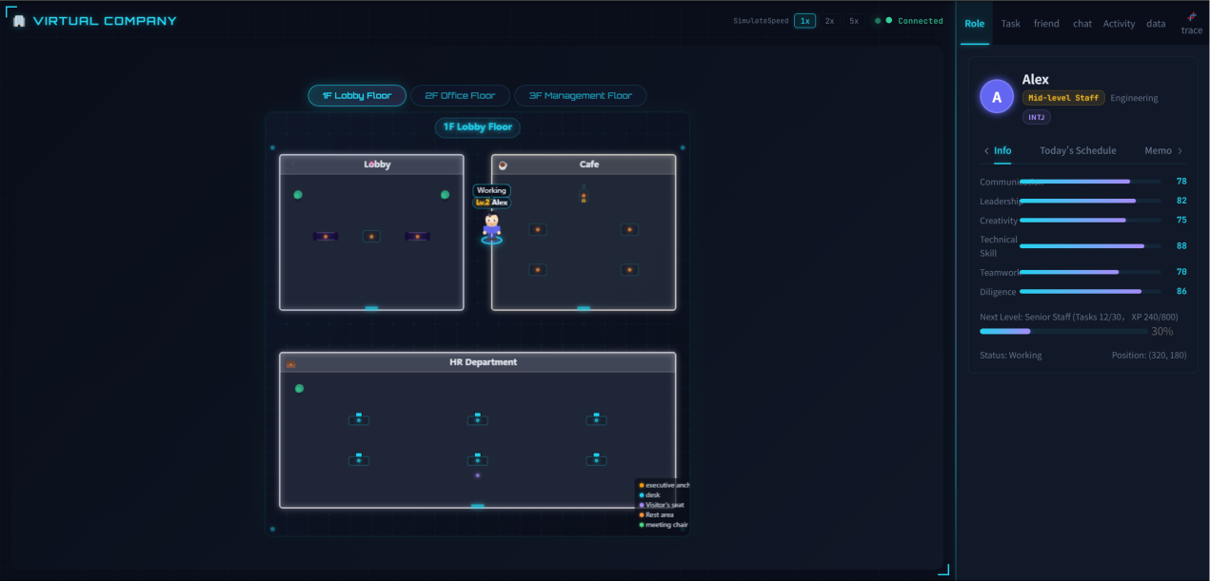
Fig. 1. Screenshot of the Virtual Company's main interface in real-time simulation
2.2 Key software contributions
This software integrates features typically dispersed across different systems:
(1) Explicit MBTI behavior mapping—rather than pure prompt-driven personality descriptions. MBTI dimensions are converted into inspectable action weights and multipliers, covering five behavior categories: work, chat, rest, movement, and meeting. Behavioral differences are traceable to specific weights, reproducible under fixed seeds, and modifiable without rewriting the engine.
(2) Four-layer decision flow—integrating event participation, schedule logic, optional LLM reasoning ^{[10]}, and deterministic degradation. This design ensures the software functions in constrained environments while remaining experimentally accessible, without forcing dependency on online reasoning services.
(3) Social continuity—implemented through memory retrieval and dynamic intimacy mechanisms. Significant events influence subsequent behavior; relationships are strengthened through interaction and weakened through time-based decay.
(4) Adaptive task and event generation—perturbing behavior over time. Task difficulty scales according to agent context; company events are dynamically created based on runtime conditions (such as accumulated experience points, departmental performance).
(5) Runtime diagnostics—exposing fingerprints, floor distributions, hotspot ratios, and personality tracking information.
Our core novelty lies not in simply simulating a virtual company, but in making personality differences computationally explicit: MBTI dimensions are converted into inspectable action weights and multipliers, such that behavioral differences are traceable, reproducible, and modifiable. This is the key distinction between this software package and pure prompt-driven personality agents ^{[11]}—the latter's behavioral mechanisms are largely opaque. The same structure also makes the software adaptable to other personality models (such as Big Five ^{[12],} Holland's occupational interests ^{[13]}).
2.3 Positioning relative to related work
This contribution is positioned by comparison with adjacent lines of work, rather than by broad claims of absolute novelty. Table 1 summarizes the intended positioning of VirtualCompanySim across generative agent systems, general simulation frameworks, and career guidance systems.
Table 1
Positioning of VirtualCompanySim relative to adjacent software categories
System type | Examples | Reproducibility | Interpretability | Computational cost | Career-exploration specificity
Generative agent systems | Generative Agents; AutoGen; CAMEL; MetaGPT | Medium (service/prompt sensitive) | Low to medium (often prompt-implicit) | High when LLM-heavy | General social/task simulation
Multi-agent simulation frameworks | Mesa; AgentPy; NetLogo | High | High | Low to medium | Not career-specific by default
Career guidance systems | RIASEC/Holland tools; job-matching pipelines | High | Medium | Low | Usually static recommendation
VirtualCompanySim (this work) | - | High (fixed-seed scripts+deterministic fallback;full-stack deployment path) | High (explicit personality parameters + diagnostic APIs) | Low in rule-priority mode; optional LLM | Virtual workplace career exploration
Compared with prompt-driven generative agent systems, VirtualCompanySim prioritizes explicit personality parameterization and deterministic fallback behavior, improving interpretability and rerun stability under fixed seeds. Compared with general-purpose simulation frameworks, it contributes a career-exploration-oriented software package with built-in organizational APIs and diagnostics rather than only domain-agnostic modeling infrastructure. Compared with static career guidance systems, it supports dynamic workplace interaction processes over time instead of recommendation-only outputs. Therefore, VirtualCompanySim is positioned as a reproducible and explainable organizational simulation package for career-exploration scenarios.
This positioning supports VirtualCompanySim as a reusable and explainable research software contribution rather than only an application demonstration.
2.4 Software architecture
The simulator employs a layered architecture. Figure 2 shows the overall software architecture of VirtualCompanySim.
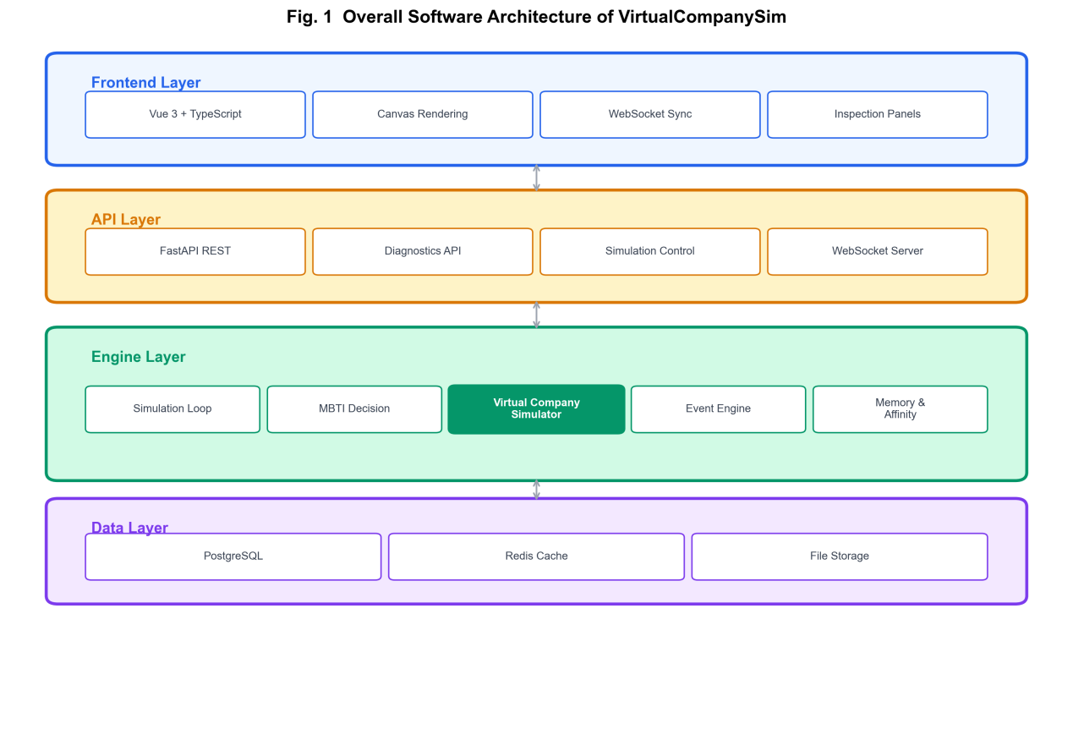Fig. 2. System architecture diagram
The frontend is implemented with Vue 3 and TypeScript, rendering a three-floor office environment and providing inspection panels via WebSocket synchronization. The backend uses FastAPI for REST and WebSocket endpoints covering simulation control, diagnostics, and NPC state reconstruction. Core behavior is distributed across nine engine modules，as shown in Table 2.
The engine adopts a tick-based simulation model. During each tick, agents can continue current actions, complete actions, respond to ongoing events, or select new behaviors via the decision stack.
Table 2
Key software modules and responsibilities
Module | Path | Responsibility
Simulation Loop | “simulation_loop.py” | 30-second tick scheduling, state transitions, XP/promotion settlement
AI Decision Engine | “agent_ai.py” | MBTI weight calculation, four-layer decision stack, task preference scoring
NPC Presets | “npc_seeder.py” | 16 NPC creation (covering all 16 MBTI types), attribute assignment
Event Engine | “event_engine.py” | Dynamic event detection (XP milestones/departmental performance/emergency mobilization)
Schedule Engine | “schedule_engine.py” | Basic schedule management, J/P time variance
Compatibility Scoring | “mbti_compat.py” | Temperament group classification, hierarchical compatibility calculation
Memory Engine | “memory_engine.py” | 7-level importance stratification, memory retrieval and summarization
Affinity Engine | “affinity_engine.py” | Interaction incentives, forgetting threshold decay, background maintenance
Task Generator | “task_generator.py” | 60 templates, difficulty scaling, chained rewards

2.5 MBTI-driven parameterization
The software converts MBTI preferences into explicit action weights and multipliers for five primary behavior categories (work, chat, rest, movement, meeting). This design decision is central to the contribution: personality is not merely stored as descriptive text, but exists as an inspectable computational layer.
Let the MBTI type of an agent be $m=(m_{1},m_{2},m_{3},m_{4})$,where $m_{i}∈\{0,1\}$ correspond respectively to the two preferences for E/I, S/N, T/F, J/P dimensions. Define the action space$A=\{work,chat,rest,meeting,move\}$, base weight vector $W_{0}∈ℝ^{5}$. The influence of MBTI on actions is described through the dimension weight increment matrix Δ∈R^{4×5}, with the mapping process defined as:
$$W(m)=W_{0}+\sum_{i=1}^{4}{m_{i}}⋅Δ_{i}$$ | (1)
Action probabilities are obtained through normalization:
$$P(a∣m)=\frac{W_{a}(m)}{\sum_{a'∈A}{W_{a'}}(m)}$$ | (2)
The specific dimension weight increment matrix Δ is shown in Table 3.

Table 3
MBTI-driven parameterization rules across action weighting, task preference, and efficiency layers
Dimension | Preference | Behavior Adjustment | Weight Increment | Behavioral Explanation
E/I | E (Extroversion) | chat, move | +15, +10 | Extroverts derive energy from social interactions
E/I | I (Introversion) | work | +15 | Introverts prefer independent, deep work
S/N | S (Sensing) | work | +4 | Sensing types focus on concrete task execution
S/N | N (Intuition) | meeting | +6 | Intuitive types prefer abstract discussion and strategic planning
T/F | T (Thinking) | work | +10 | Thinking types are logic and efficiency-oriented
T/F | F (Feeling) | chat | +10 | Feeling types value interpersonal harmony
J/P | J (Judging) | work | +10 | Judging types proceed with planned work
J/P | P (Perceiving) | Move, rest | +10, +5 | Perceiving types are flexible and inclined toward spontaneous exploration
The values reported in Table 3 are not intended as psychometric estimates of real human behavior. Rather, they are design-calibrated parameters and transparent simulation assumptions used to operationalize qualitative MBTI tendencies into executable and inspectable agent behavior. We first define a workday-oriented base vector $W_{0}$= (30, 20, 15, 25, 10) for work, chat, rest, move, and meeting, respectively. This baseline reflects the prior structure of a virtual company workday: work is the dominant default activity, movement is frequent because agents regularly travel between workstations, meeting rooms, and shared spaces, chat remains available as a medium-frequency social behavior, rest is less frequent but cannot be zero, and meeting is the least frequent because it does not occur at every decision step. On top of this baseline, we use moderate increments of 5, 10, and 15 to encode weak, medium, and strong qualitative behavioral tendencies. In this scheme, +15 denotes a primary tendency, +10 denotes a clear but secondary tendency, and +5 denotes a mild or compensatory adjustment. The final values were selected through fixed-seed calibration runs so that personality-conditioned differences remain visible and reproducible without making any action category deterministic or allowing a single action to dominate the full distribution.
Not all MBTI dimensions are applied at the same layer of the decision process. In the current implementation, E/I, T/F, and J/P directly modify the fallback action-weight vector because they are closely related to observable differences in social orientation, task-versus-affiliation preference, and structured-versus-flexible work rhythm. By contrast, S/N is implemented primarily through task-preference scoring and work-style tendencies rather than as a direct action-frequency increment. More specifically, S-type agents receive higher preference scores for routine and management-oriented task tags, whereas N-type agents receive higher preference scores for creative, innovation-oriented, and difficult tasks. This design separates action-frequency tendencies from task-content preferences while preserving four-dimensional MBTI parameterization across the overall behavior stack.
For example, with ISTJ type, work = 30+15(I)+4(S)+10(T)+10(J) = 69, with normalized work behavior probability of 49.6%, significantly higher than ENFP’s 21.4%. Differences between agent types are traceable to specific weights, reproducible under fixed seeds, and modifiable without rewriting the engine. The same structure also makes the software adaptable to other personality models (such as Big Five, Holland's occupational interests).
Beyond action probabilities, MBTI also affects work efficiency, social gains, and experience point acquisition through multiplicative modifiers. The work efficiency multiplier $η_{work}$ is defined as:
$$η_{work}=\prod_{i=1}^{4}{(}1+α_{i}⋅1[m_{i}={target}_{i}])$$ | (3)
where α₁ = 0.15 (introvert focus), α₂ = 0.10 (sensing execution), α₃ = 0.10 (thinking analysis efficiency), α₄ = 0.15 (judging discipline), and $1[⋅]$ is the indicator function. The ISTJ type has efficiency multiplier 1.15×1.10×1.10×1.15≈1.60, while ENFP type is 1.0. Figure 3 shows a comparison of work speed multipliers across 16 MBTI types.

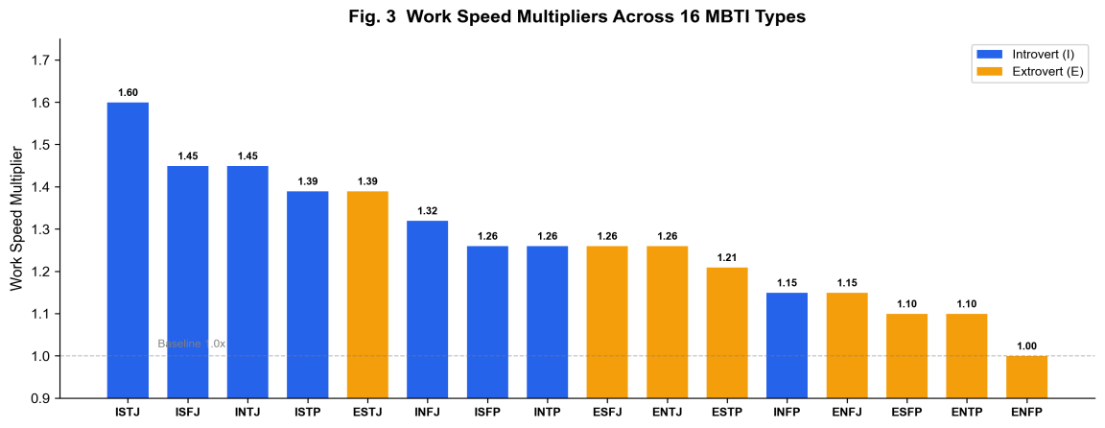
Fig. 3. Bar chart comparing work speed multipliers across 16 MBTI types
The social gain multiplier is:
$$η_{social}=(1+0.3⋅1[m_{1}=E])×(1+0.2⋅1[m_{3}=F])$$ | (4)
ESFP type achieves the highest (1.56), ISTJ type the lowest (1.0).
The experience point acquisition multiplier η_{xp} reflects personality's influence on learning and growth speed:
$$η_{xp}=(1+0.15⋅1[m_{2}=N]⋅1[d≥3])×(1+0.05⋅1[m_{3}=T])$$ | (5)
where d is the task difficulty level. Intuitive types (N) receive a 15% XP bonus when handling complex tasks with difficulty ≥3; Thinking types (T) receive a 5% efficiency bonus on all tasks.
To implement personalized task assignment, the system computes preference scores for each agent toward various tasks:
$$P(a,t)=P_{base}+P_{tag}+P_{attr}+P_{diff}$$ | (6)
Where P_{base} =50 is the baseline score; P_{tag} is the MBTI tag matching score (Sensing types prefer management/routine; Intuitive types prefer creative/innovation; Thinking types prefer technical; Feeling types prefer social); P_{attr} is the attribute bonus (agent attributes divided by 10 and summed); P_{diff} is the difficulty preference bonus (Intuitive types +10 points for tasks with difficulty ≥3). Preference alignment is divided into three tiers: high (P≥70), medium (40≤P<70), low (P<40).
2.6 Four-layer decision architecture
The decision process is organized into four levels. Figure 4 shows the flowchart of the four-layer decision architecture.

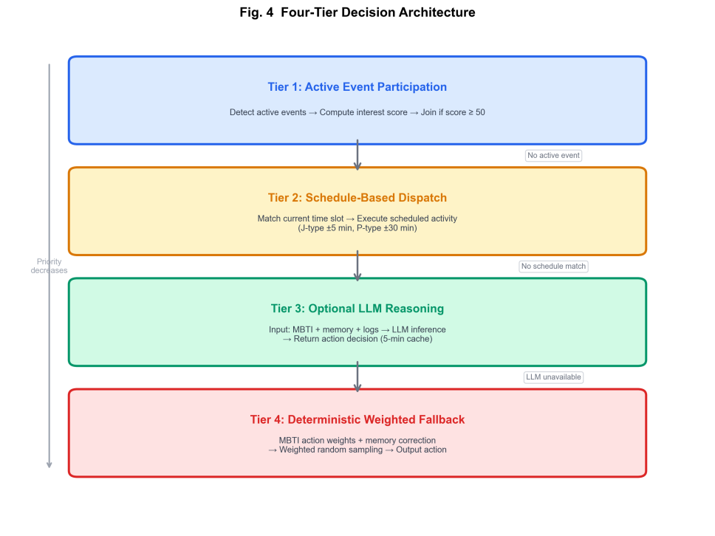
Fig.4. Flowchart of the four-layer decision-making architecture
Layer 1: Active Event Participation—When active events exist, the agent evaluates an interest score:
$$I_{event}=50+Δ_{MBTI}+Δ_{attr}$$ | (7)
Where Δ_{MBTI} is the MBTI dimension adjustment (Extroverts +30 for social events, Introverts +20 for technical events, Judging types -15 when interrupted, Perceiving types +10 for spontaneous participation), and Δ_{attr} is the relevant attribute bonus (communication/10 for social events, technical skill/10 for technical events). The agent participates when I_{event}≥50; when multiple events overlap, the highest-scoring event is selected.
Layer 2: Schedule Dispatch—The system maintains a schedule (9:00 work→10:30 rest→...→18:00 off-duty). MBTI differences manifest in schedule time variance: Judging types ±5 minutes, Perceiving types ±30 minutes.
Layer 3: Optional LLM-Assisted Reasoning—Inputs include MBTI type, recent 5 memories, pending task count, and recent 5 action logs; LLM returns decisions in JSON format (action type, target, and rationale). A 5-minute cache is employed.
Layer 4: Deterministic Weighted Fallback—When LLM is unavailable, action is selected based on MBTI weight vector plus memory correction (high-importance task memories +5 to rest weight; social memories +5 to chat weight; high-importance career memories +10 to work weight) through weighted random sampling.
2.7 Memory, affinity, and dynamic events
The software maintains social continuity through memory retrieval and affinity updates. Events are stratified into 7 importance levels and stored as memories: promotion (10), task completion (7), salary change (6), task failure (5), friendship establishment (4), casual chat (3), spatial movement (1). This stratification is based on the emotional enhancement effect of memory—high emotional arousal events leave stronger memory traces. Memory recall employs a “descending importance + descending recency” strategy, returning top-5 memories by default, which influence subsequent action weights (high-importance task memories +5 to rest weight; social memories +5 to chat weight; high-importance career memories +10 to work weight).
Intimacy (0～100) employs a segmented linear decay function with forgetting threshold:
$$A(d)=\max\left(0, A_{0}−β⋅\max{(}0, d−T)\right)$$ | (8)
The equivalent recursive form is:
$$A(t+1)=\left\{\begin{matrix}A(t), & d_{inactive}≤T \\ \max{(}0, A(t)−β), & d_{inactive}>T\end{matrix}\right.$$ | (9)
where T=3 (days), β=2 (/day). T=3 is based on normal workplace contact intervals; β=2 causes 100-point intimacy (“close friend” relationships) to decay to 0 in approximately 50 days, and 50-point intimacy (“ordinary” relationships) to disappear in approximately 25 days, conforming to the social network principle that “weak ties decay faster than strong ties”. Relationships are strengthened through interaction and modulated by the MBTI social multiplier η_{social} . Different interaction types provide differentiated intimacy increments: casual chat +2 (E×1.3, F×1.2), task collaboration +5, shared event participation +3, departmental task +3, mentorship +4. Intimacy values map to 5-level relationship labels: detached (030), ordinary (3150), friendly (5170), intimate (7185), and close friend (86~100), with different levels affecting NPC dialogue style.
Task difficulty scales according to agent context ^{[14-15]} (level scaling + performance adaptation); company events are dynamically created based on runtime conditions ^{[16]} (XP milestones, departmental performance, emergency mobilization, etc.). Event-driven participation can map to different behaviors (such as chat, meeting, or work), rather than treating all events as a single action.
2.8 Diagnostics and explainability
The software provides the following endpoints:
"GET /api/agent/personality-trace" —— Returns MBTI effective multipliers, action probability distributions, recent 50 decision logs
"POST /api/simulation/rebuild-npcs" —— Rebuilds NPC states
"GET /api/simulation/diagnostics" —— Runtime fingerprints, floor distributions, hotspot ratios
These endpoints are not merely operational tools, but integral to the software's verification interface. Table 4 provides key API endpoints relevant to validation.
Table 4
Key public APIs for validation
Endpoint | Method | Functionality
“/api/agent/personality-trace” | GET | Returns MBTI effective multipliers, action probability distributions, recent 50 decision logs
“/api/simulation/status” | GET | Returns tick count, simulation speed, online agent count
“/api/simulation/diagnostics” | GET | Runtime fingerprints, floor distributions, action hotspot ratios
“/api/simulation/rebuild-npcs” | POST | Idempotent rebuilding of all 16 NPCs
“/api/simulation/speed” | POST | Adjusts simulation speed (0.5×~10×)
3 Illustrative examples
Example 1: Comparing ISTJ and ENFP behavioral profiles
To illustrate how MBTI parameterization produces observable behavioral differences, we create two agents—one ISTJ ("The Inspector") and one ENFP ("The Campaigner")—and run the simulation for 100 ticks under a fixed random seed.
The ISTJ agent's normalized action probabilities are: work 49.6%, chat 7.2%, rest 12.2%, move 9.4%, meeting 21.6%. The ENFP agent's are: work 21.4%, chat 24.3%, rest 10.0%, move 22.9%, meeting 21.4%. Over the 100-tick run, ISTJ spent 53 ticks working and 5 ticks chatting, while ENFP spent 19 ticks working and 27 ticks chatting. These differences are directly traceable to the Δ matrix (Table 3): Introversion adds +15 to work weight, while Extroversion adds +15 to chat and +10 to move.
The personality-trace API (GET /api/agent/personality-trace) returns the full decision log for each agent, allowing users to inspect every tick's decision rationale, including which MBTI factors contributed and whether the decision was made by the event layer, schedule layer, LLM layer, or weighted fallback.
Example 2: Reproducing validation results
By executing python experiments/run_behavior_consistency.py, users can reproduce the validation results reported in this paper. The script uses fixed seeds, runs 1000 action samples per MBTI type, and writes machine-readable CSV output to results/behavior_consistency.csv. No frontend, database, or LLM service is required.
4 Impact
4.1 New research opportunities enabled
The explicit parameterization design opens several research directions that opaque prompt-based agents do not readily support. Researchers can systematically vary individual MBTI dimensions while holding others constant, enabling controlled personality ablation studies. The stored decision logs allow post-hoc analysis of how personality traits interact with organizational context (e.g., how Introversion affects meeting participation frequency under different event densities). The modular weight structure also facilitates comparative studies across personality frameworks: replacing the MBTI Δ matrix with Big Five or Holland trait mappings requires modifying only the parameterization layer, while the simulation infrastructure remains unchanged.
4.2 Improvement over existing approaches
This software provides three concrete improvements. First, behavioral differences are quantitatively traceable to specific weight parameters rather than embedded in opaque language model internals. Second, the deterministic fallback path enables exact reproduction without service variability, reducing experiment cost and improving replicability. Third, the diagnostic API layer allows researchers to query runtime state programmatically rather than relying on manual observation or log parsing.
4.3 Practical adoption and daily practice
The software has been deployed as a career exploration module in a university career education pilot at Hohai University, allowing students to experience simulated workplace dynamics before making career decisions. The repository is publicly available on GitHub. The deterministic experimental scripts lower the barrier for classroom and research adoption because they can run in a Python-only mode; however, the full interactive simulator requires PostgreSQL, Redis, the FastAPI backend, and the Vue frontend.
4.4 Reproducible validation evidence
We distinguish two reproducibility modes. The full interactive system requires PostgreSQL, Redis, the FastAPI backend, and the Vue frontend; Docker Compose is provided to reproduce the full stack with a single command (`docker compose up --build`). In contrast, the fixed-seed evaluation scripts under `experiments/` can run in a lightweight Python-only mode for reproducing behavior-consistency and ablation metrics, without requiring PostgreSQL or Redis.
The script “experiments/run_behavior_consistency.py” uses fixed seeds and the current MBTI behavior mapping, comparing sampled action distributions against the implementation-defined expected distributions. Under the current code version, the average MBTI behavioral consistency score is 98.0%. This result supports the claim that “the implemented mapping produces stable, type-conditioned behavioral patterns”. This result is best interpreted as implementation-level evidence that the executable system follows the declared MBTI parameterization under fixed seeds. It therefore supports reproducibility and behavioral differentiation within the current software, while not being intended as direct evidence of the psychological validity of MBTI itself.
The script “experiments/run_ablation.py” evaluates the current implementation under three conditions: complete system, without MBTI mapping, without event participation. In the current reproducible run:
Removing MBTI mapping reduces the average pairwise KL divergence by 65.33%;
Removing event participation reduces the average action distribution entropy by 1.78%.
This modest entropy change is expected because the event layer is intermittent rather than dominant: events occur with a probability of 0.25 and persist for only two ticks, while the baseline action distribution is still primarily shaped by the MBTI-conditioned weight vector. In addition, event participation maps agents to the same predefined action categories rather than introducing new action types. Therefore, the event mechanism contributes more to contextual variation and action timing than to large shifts in the global action-category entropy.
The first result strongly supports the claim that “MBTI mapping is the primary source of type differentiation in the current software”. The second result indicates that the event mechanism still contributes to behavioral diversity, although the magnitude remains limited under the current ablation protocol and should therefore be interpreted conservatively.
To avoid reporting only aggregate ablation summaries, we further report per-type action distributions across all 16 MBTI types under the full, no-MBTI, and no-event conditions. The per-type ablation table is provided in `results/per_type_ablation.csv`, and Fig. 5 visualizes the action-percentage shifts for `no_mbti - full` and `no_event - full`. This finer-grained analysis shows that the MBTI mapping is the major source of type differentiation, while the event layer mainly changes contextual timing and localized action selection rather than the global action vocabulary.
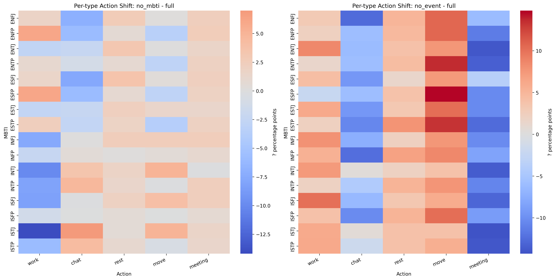
Fig. 5. Per-type action shifts under ablation.
The script “experiments/run_tick_benchmark.py” benchmarks the runtime path of the current deployment. Across 50 measured ticks, the average tick time is 129.08 ms, with median 118.55 ms and p95 160.18 ms. Under the current benchmark setting, the latency distribution remains within a relatively stable range in the tested environment; for stricter cross-system comparison, a dedicated algorithm-only benchmark mode would still be valuable.
We also extend the runtime evaluation from a single benchmark setting to multiple agent-count scenarios. As shown in Table 5 and Fig. 6, tick latency increases monotonically as the number of agents increases from 16 to 100. This supplementary scaling benchmark provides a broader characterization of runtime behavior than the original single-setting evaluation.
Table 5
Tick latency scaling across agent counts
Agents | Ticks | Mean latency(ms) | Median(ms) | p95(ms) | Max(ms)
16 | 50 | 47.93 | 47.71 | 51.59 | 54.35
32 | 50 | 98.58 | 96.40 | 107.97 | 113.45
64 | 50 | 205.16 | 202.26 | 222.83 | 230.25
100 | 50 | 298.42 | 295.20 | 321.06 | 340.23

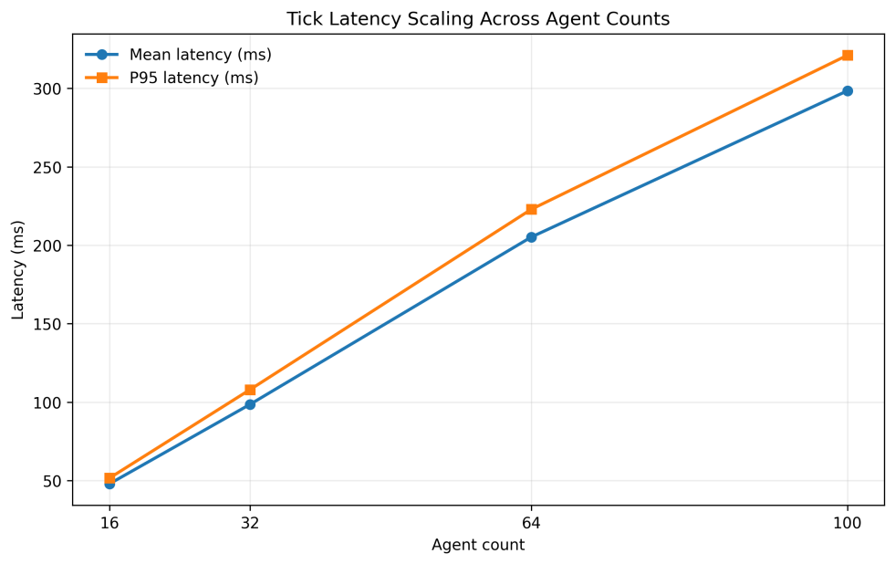
Fig. 6. Tick latency scaling across agent counts.
The script “experiments/run_availability_probe.py” performs repeated probing on “/openapi.json”, “/api/simulation/status”, and “/api/simulation/diagnostics”. In the current 60-second validation run, all 29976 endpoint probes succeeded. This result should be explicitly reported as sustained endpoint availability within the 60-second probe window, rather than as a substitute for long-term production monitoring.
Table 6
Summary of current reproducible validation results
Metric | Result | Supported Claim
MBTI Behavioral Consistency Rate | 98.0% | Mapping produces stable, type-conditioned behavioral patterns
KL Divergence Reduction (MBTI Mapping Removed) | 65.33% | MBTI mapping is the primary source of type differentiation
Shannon Entropy Reduction (Events Removed) | 1.78% | Event mechanism contributes to behavioral diversity, though the effect remains limited under the current protocol
Average Tick Latency | 129.08 ms | System remains operational under benchmark load
Tick Latency Median | 118.55 ms | Median tick latency remains stable in the tested environment
Tick Latency p95 | 160.18 ms | Most ticks complete within a consistent upper range under the current benchmark setting
Endpoint Probe Success Rate | 29976/29976 | Endpoints remained available throughout the 60-second probe window

5 Conclusions
This paper presented VirtualCompanySim, a multi-agent virtual company simulator whose core contribution is an explainable personality parameterization layer converting MBTI dimensions into inspectable action weights and multipliers. Reproducible experiments confirm that the mapping produces stable, type-conditioned behavioral patterns (98.0% consistency), and that removing it causes a 65.33% loss in behavioral distinctiveness.
Several limitations should be noted. The event mechanism's contribution to behavioral diversity remains modest (1.78% entropy reduction) under the current ablation protocol. Tick latency benchmarks are environment-sensitive, and stricter cross-system comparison would benefit from a dedicated algorithm-only benchmark mode. Availability probing covers a 60-second local validation window and does not replace production monitoring.
Future work includes extending the parameterization layer to support Big Five and Holland personality models, conducting user studies with career education students to evaluate perceived realism, and developing a longer-duration stress testing protocol. The modular architecture is designed to accommodate these extensions without modifying the simulation core.

CRediT authorship contribution statement
Zhuoyi WANG: Writing—original draft, visualization, software development, methodology, formal analysis, data curation, conceptualization. Xushen LIN: Software development, data curation, experimental validation, writing—review and editing. Rui SUN: Formal analysis, data curation, writing—review and editing. Tingjin WANG: Visualization, software development, writing—review and editing.
Declaration of competing interest
The authors declare that they have no known competing financial interests or personal relationships that could have appeared to influence the work reported in this paper.
Acknowledgments
This research was supported by the 2026 17th University Student Service Outsourcing Innovation and Entrepreneurship Competition participant project (Team ID: T2600338) and the 2025 Jiangsu Province University Student Innovation and Entrepreneurship Training Program (Project ID: X202510294580). The views and conclusions expressed in this paper represent the academic perspectives of the authors and do not represent the position of the funding agencies.

References
[1]Ministry of Education of the People’s Republic of China. Statistical Bulletin of National Education Development in 2024. http://www.moe.gov.cn/jyb_sjzl/sjzl_fztjgb/202506/t20250611_1193760.html, Accessed on: Oct. 27, 2025.
[2]T. Jin, Y. Chen, K. Zhang. Effects of social media use on employment anxiety among Chinese youth: The roles of upward social comparison, online social support and self-esteem. Front. Psychol., vol. 15, pp. 1-12, 2024.
[3]W. Wan, R. Duffy, Q. Xiong. Linking future decent work perceptions with employment anxiety: A psychology of working perspective. J. Career Assess., vol. 32, no. 3, pp. 445-461, 2024.
[4]C. Huang, T. Wang, Y. Li. AI-assisted English learning beyond the classroom: Understanding the effects of language proficiency on Chinese undergraduate students’ behavioral engagement. Educ. Inf. Technol., vol. 29, no. 8, pp. 10567–10589, 2024.
[5]I. B. Myers, M. H. McCaulley. MBTI Manual: A Guide to the Development and Use of the Myers-Briggs Type Indicator. Palo Alto: Consulting Psychologists Press, 1985:103.
[6]Ismail, Z. H., Sariff, N., Hurtado, E. G. A survey and analysis of cooperative multi-agent robot systems: challenges and directions. Applications of Mobile Robots, no. 5, pp. 8-14, 2018.
[7]Y. Mousavi, Z. Gharineiat, A. Karimi, K. McDougall. Digital twin technology in built environment: A review of applications, capabilities and challenges. Smart Cities, vol. 7, no. 2, pp. 56-89, 2024.
[8]B. Shirazi, A. Safavi, E. Aftabi. The integration of virtual reality and artificial intelligence in educational paradigms. J. E-Learning Teach., vol. 21, no. 2, pp. 178-201, 2024.
[9]Burrus, J., Jackson, T., Xi, N., Steinberg, J. Identifying the most important 21st century workforce competencies: An analysis of the Occupational Information Network. ETS Research Report Series, no. 2, pp. 1-55,2013.
[10]J. S. Park, J. C. O'Brien, C. J. Cai, M. R. Morris, P. Liang, M. S. Bernstein. Generative agents: Interactive simulacra of human behavior. in Proceedings of the 36th Annual ACM Symposium on User Interface Software and Technology, New York: ACM, 2023, pp. 1-22. https://doi.org/10.1145/3586183.3606763.
[11]Liapis, A. Artificial intelligence for designing games. In Artificial Intelligence and the Arts: Computational Creativity, Artistic Behavior, and Tools for Creatives . Cham, Switzerland: Springer International Publishing, 2021: 277–310.
[12]Furnham, A. The big five versus the big four: The relationship between the Myers-Briggs Type Indicator (MBTI) and NEO-PI five factor model of personality. Personality and Individual Differences, vol. 21, no. 2, pp.303-307, 1996.
[13]Coetzee, M., Schreuder, D. Career anchors as a meta-capacity in organizational career development. In Psycho-Social Career Meta-Capacities: Dynamics of Contemporary Career Development. Cham, Switzerland: Springer International Publishing. 2013:139-154.
[14]L. S. Vygotsky. Mind in Society: The Development of Higher Psychological Processes. Cambridge: Harvard University Press, 1978:94.
[15]Rheinberg, F., Engeser, S. Intrinsic motivation and flow. In Motivation and Action. Cham, Switzerland: Springer International Publishing, 2018: 579-622.
[16]Khaleel, F. L., Ashaari, N. S., Wook, T. S. M. T. The impact of gamification on students learning engagement. International Journal of Electrical and Computer Engineering, vol. 10, no. 5, pp. 4965-4972, 2020.

