26/30

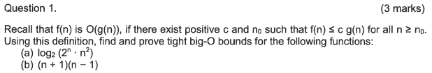

a,

O(n)

b,

O(n^2)

a yes, insertion sort, if the array is partial sorted, O(n).

b the same, f1 = f2

def fib(n):

if n == 1 or n == 2:

return 1

else

return fibn

insertion sort is adaptive

the rest are not adaptive

select a smallest number every loop, , time complexity is always O(n^2)

compare and merge, time complexity is always O(logn)

will be worse, time complexity is O(n^2)

depends on how to arrange buckets, time complexity is O(n+nlogn-nlogm)

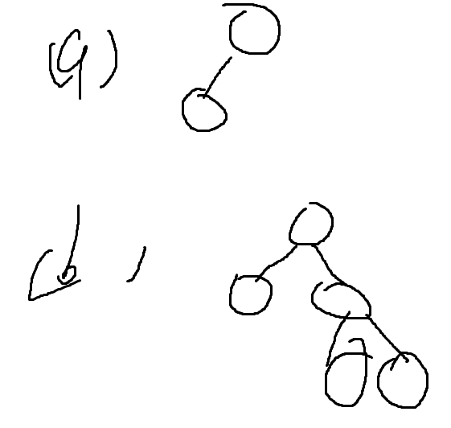

new_head;

def reverse(head):

p1 = head p2 = head.next p3 = p2.next

while (p3.next):

p1 = p2

p2 = p3

p3 = p3.next

end

new_head.next = p3

p2.next = null

reverse(head)

