**Step 1:** Go to [https://github.com/join](https://github.com/join/) in a web browser. Before you can create branches or make any pull requests, you’ll need an account.

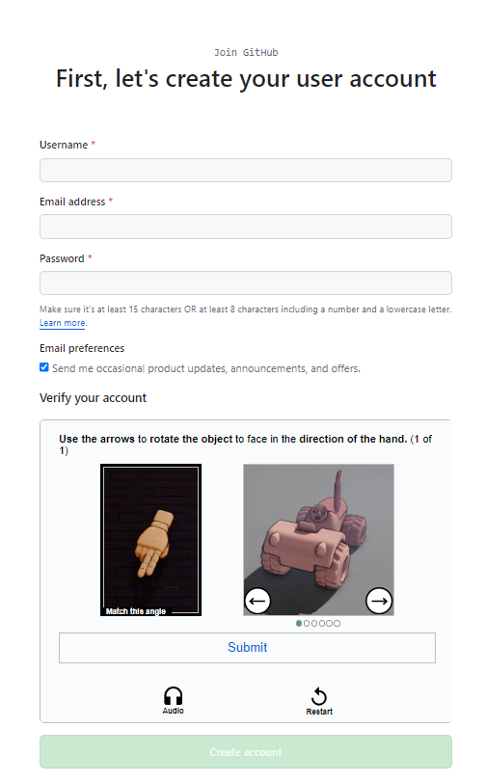Some ad blockers may prevent GitHub's verification CAPTCHA puzzle from appearing. For best results, disable your web browser's ad blocker when signing up for GitHub.

**Step 2:** Enter your personal details. In addition to creating a username and entering an email address, you'll also have to create a password. Your password must be at least 15 characters in length or at least 8 characters with at least one number and lowercase letter.

**Step 3:** Click Verify to start the verification puzzle. The instructions vary by puzzle, so just follow the on-screen instructions to confirm that you are a human. A green checkmark will appear after completing the puzzle.

You can switch to an audio challenge by pressing the speaker button under the Verify button.

**Step 4:** Click the green “Join for Free” button. It's below the form, at the bottom of the page. This will take you to an email verification page.

Carefully review the Terms of Service at *https://help.github.com/en/articles/github-terms-of-service* and the Privacy Statement at

*https://help.github.com/en/articles/github-privacy-statement* before you continue. Continuing past the next step confirms that you agree to both documents.

**Step 5:** Verify your email by entering the code. After clicking Create account, you’ll receive an email with a code. Enter this code on the verification page. Entering the code will automatically take you to the welcome page.

The Home Page…

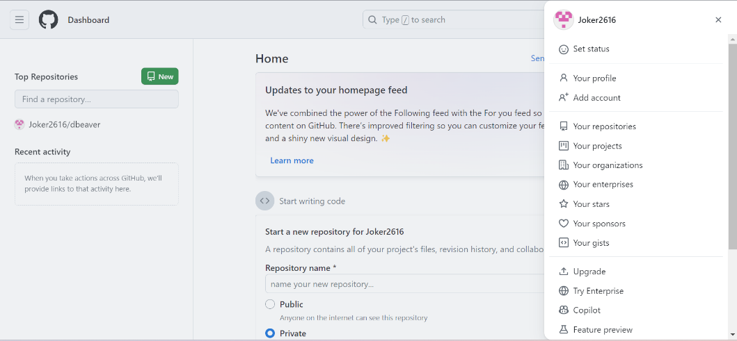

**Step 1:** In the upper-right corner of any page, select +, then click **New repository**.

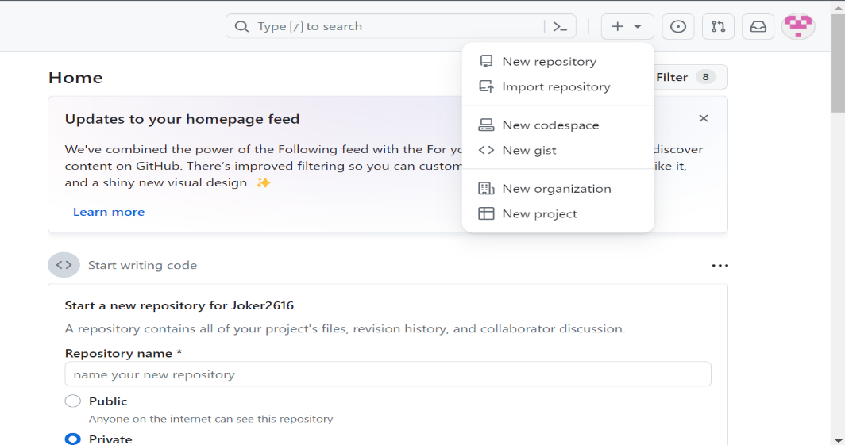

**Step 2:** Type a short, memorable name for your repository. For example, "salesforce-test". Then Optionally add a description for the repository.

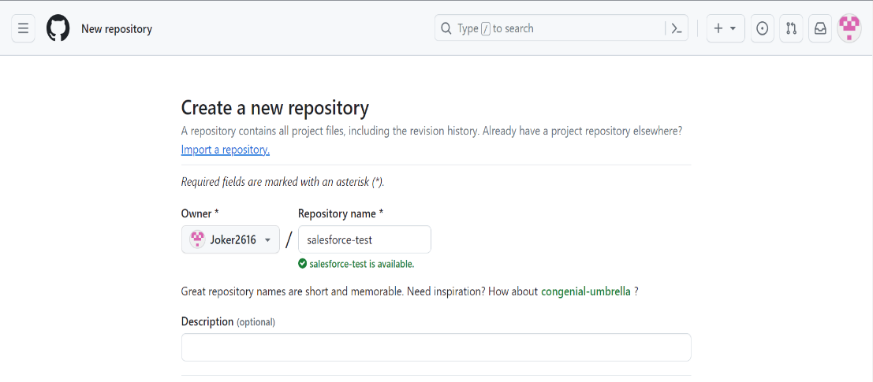

**Step 3:** Select Initialize this repository with a README.

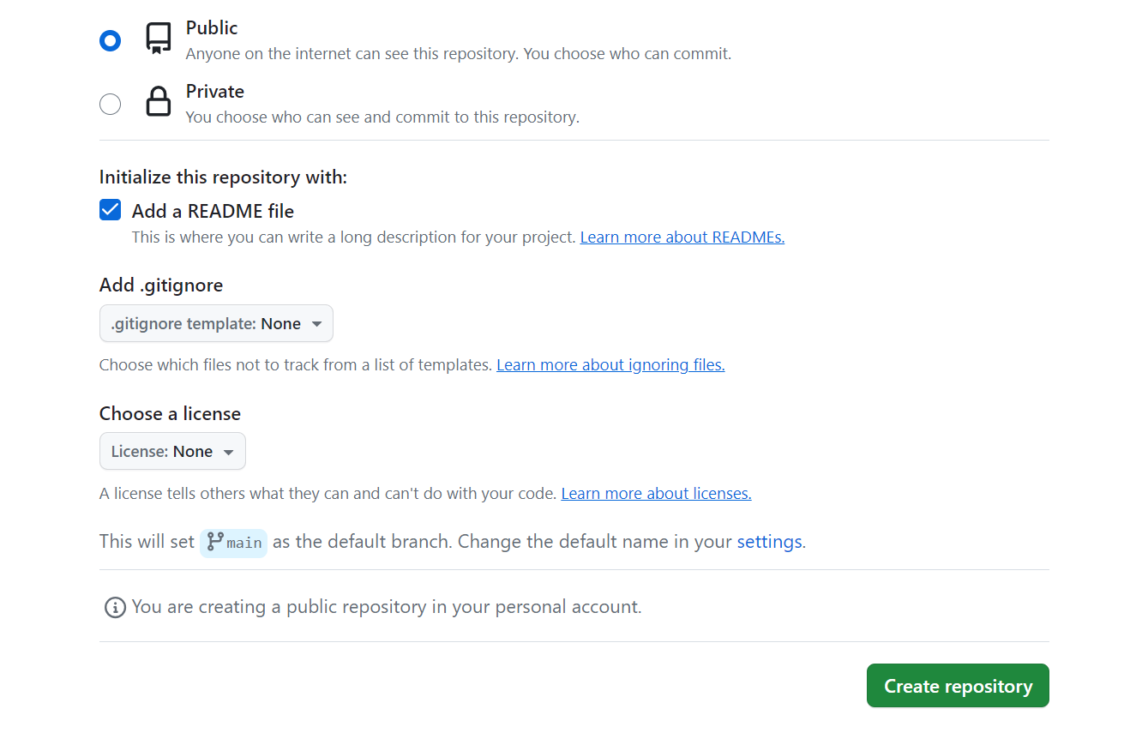

**Step 4:** Click Create Repository.

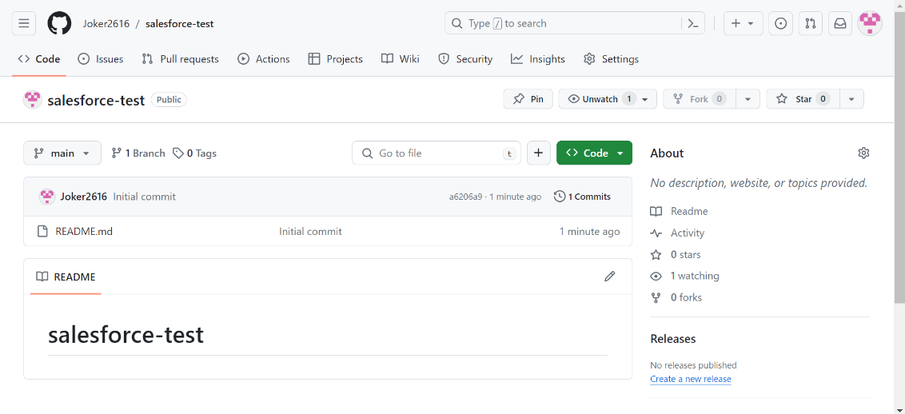

The repository “salesforce-test” has been created successfully.

**Step 1:** To clone and open the repository with GitHub Desktop, click **Open with GitHub Desktop**.

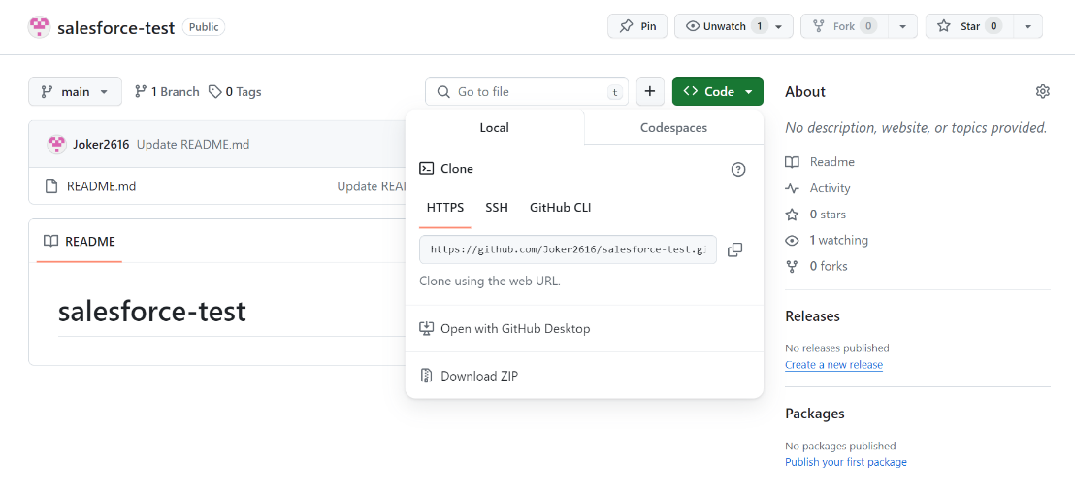

**Step 2:** Click Clone repository and navigate to URL.

**Step 3:** Enter the **<username>/<repository_name>** of the repository under Repository URL & choose the local path where the project to be cloned in the local system.

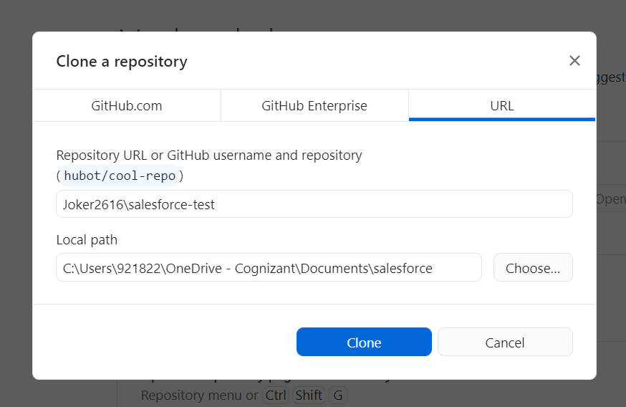

**Step 4:** Click Clone.