The world this week 2

Politics 2

Business 7

The world this week

Politics

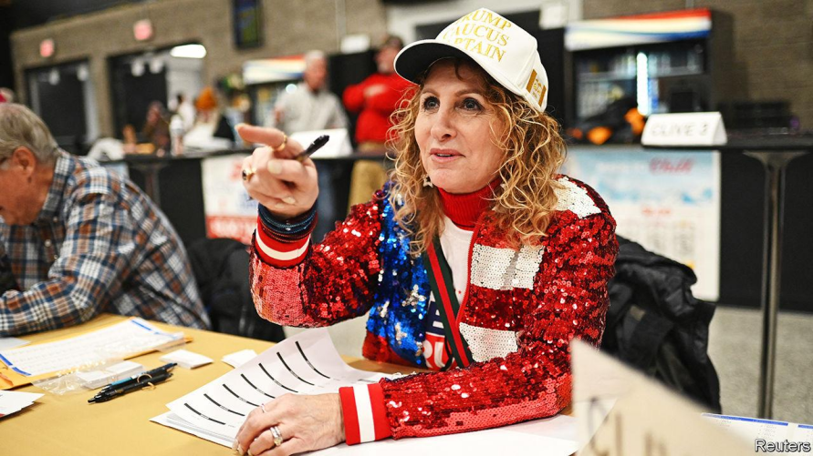Donald Trump stormed to victory in the Iowa caucuses, the first contest in the Republican race to choose the party’s presidential nominee for November’s election. Mr Trump took 51% of the vote, underlining his dominance in the race (in 2016, when Mr Trump started his first presidential campaign, he came second with 24%). Ron DeSantis and Nikki Haley were far behind, taking 21% and 19% of the caucus vote respectively. Some 65% of caucus-goers thought Mr Trump would be fit for the presidency even if he were convicted of a crime.

Donald Trump在爱荷华州党团会议中大获全胜，这是共和党选择11月总统选举候选人的第一场竞争。Trump获得了51%的选票，进一步凸显了他在竞选中的主导地位（在2016年，当特朗普开始他的第一次总统竞选时，他以24%的得票率排名第二）。Ron DeSantis和Nikki Haley远远落后，分别获得了21%和19%的党团会议选票。大约65%的党团会议参与者认为，即使特朗普被判有罪，他也会适合担任总统。

The day after the caucuses Mr Trump’s legal troubles came to the fore again as a trial began in Manhattan to determine how much he should pay in damages for defaming E. Jean Carroll, a writer. Ms Carroll won a civil trial last May that found Mr Trump liable of sexually abusing her and of defamation.

在党团会议的第二天，Trump的法律问题再次成为焦点，因为曼哈顿开始了一项审判，以确定他因诽谤作家E. Jean Carroll而应支付多少赔偿金。去年五月，Carroll女士赢得了一项民事审判，该审判认定Trump对她进行了性虐待和诽谤。

Israel marked 100 days since the Hamas attacks of October 7th. At a big commemorative event in Tel Aviv many carried pictures of the more than 130 hostages still being held in Gaza. Meanwhile, under a deal brokered by France and Qatar, Israel and Hamas agreed that medicines would be given to the hostages while more humanitarian aid would be delivered to Gaza where conditions are increasingly dire. Intense fighting continued in southern Gaza, especially around Khan Younis where Israel believes Hamas’s leaders are holed up. Jordan said Israeli air strikes had damaged its military field hospital there.

以色列纪念了自10月7日哈马斯袭击以来的100天。在特拉维夫举行的大型纪念活动中，许多人手持仍在加沙被扣押的130多名人质的照片。与此同时，在法国和卡塔尔斡旋下达成的一项协议中，以色列和哈马斯同意向人质提供药品，同时向加沙提供更多的人道主义援助，那里的情况日益严峻。加沙南部，特别是在以色列认为哈马斯领导人藏匿的汗尤尼斯地区，激烈的战斗仍在继续。约旦表示，以色列的空袭损坏了那里的军事野战医院。

Israel offered its defence against South Africa’s accusation at the International Court of Justice that the war in Gaza amounted to a genocide against the Palestinians. Israel argued that South Africa had ignored the events of October 7th and that Israel had a right to defend itself. Its lawyers blamed Hamas for the high civilian death toll.

以色列在国际法院对南非的指控进行了辩护，南非指控以色列在加沙的战争构成了对巴勒斯坦人的种族灭绝。以色列辩称南非忽略了10月7日的事件，并声称以色列有权自卫。其律师将高平民死亡人数归咎于哈马斯。

America and Britain bombed dozens of Houthi targets in Yemen in response to almost two months of attacks on commercial vessels in the Red Sea. The Iranian-backed group continued its campaign, however, firing on several ships, which just prompted more American strikes against the militants. The American government put the Houthis back on a list of terrorist groups.

美国和英国对也门的数十个胡塞武装目标进行了轰炸，以回应近两个月来在红海上对商船的袭击。然而，这个得到伊朗支持的组织继续其行动，对几艘船只开火，这进一步促使美国对这些武装分子进行了更多打击。美国政府将胡塞武装重新列入恐怖组织名单。

Tensions increased between Iran and Pakistan after Iran launched a missile attack in western Pakistan targeting Jaish al-Adl, Sunni militants whom it considers to be terrorists. Pakistan then fired missiles into eastern Iran, hitting what it said were “terrorist hideouts”. Each country has accused the other in recent years of harbouring militants in the border region. Iran also hit targets in Iraq and Syria.

伊朗和巴基斯坦之间的紧张局势升级，此前伊朗对巴基斯坦西部发动了导弹袭击，目标是它认为的恐怖分子——逊尼派武装分子Jaish al-Adl。随后，巴基斯坦向伊朗东部发射导弹，声称击中了“恐怖分子藏身之处”。近年来，两国互相指责对方在边境地区窝藏武装分子。伊朗还袭击了伊拉克和叙利亚的目标。

Russia and Niger, whose democratically elected leader was overthrown last year by a soldiers’ junta, agreed to enhance military co-operation.

俄罗斯和尼日尔，其民主选举产生的领导人在去年被士兵组成的军政府推翻，同意加强军事合作。

Azali Assoumani, who came to power in 1999 in a coup, won election to a fourth five-year term as president of the Comoros, an archipelago in the Indian Ocean. His opponents cried foul.

Azali Assoumani这位在1999年通过政变上台的领导人，赢得了科摩罗总统的第四个五年任期的选举，科摩罗是位于印度洋的一个群岛国家。他的对手对此表示抗议。

Britain’s home secretary, James Cleverly, asked Parliament to proscribe the Islamist Hizb ut-Tahrir group under the Terrorism Act 2000. Anybody belonging to the group, or showing support for it, could face up to 14 years in prison. Mr Cleverly said that Hizb ut-Tahrir’s praise of the October 7th

attack by Hamas on Israel constitutes “promoting and encouraging terrorism”.

英国内政大臣James Cleverly要求议会根据2000年《恐怖主义法》将伊斯兰主义者组织Hizb ut-Tahrir列为非法。任何属于该组织或表示支持该组织的人可能会面临长达14年的监禁。克利弗利先生表示，Hizb ut-Tahrir对哈马斯（Hamas）10月7日对以色列的袭击的赞扬构成了“促进和鼓励恐怖主义”。

Rishi Sunak, Britain’s prime minister, survived a challenge from rebels in his own Conservative Party to a new law clearing the way for a controversial plan to deport illegal migrants to Rwanda. Three Tories resigned from their posts because they think the legislation is too weak.

英国首相Rishi Sunak在英国保守党内部的反叛者挑战中幸存下来，这为一项有争议的新法律铺平了道路，该法律计划将非法移民遣送至卢旺达。三名保守党成员因认为该立法过于软弱而辞去了他们的职位。

Donald Tusk, Poland’s new reformist prime minister, and politicians from the previous right-wing Law and Justice (PiS) government continued to row. The Constitutional Tribunal blocked Mr Tusk’s attempt to remove the head of the public prosecutor’s office, after Andrzej Duda, the country’s president, said the dismissal did not have his consent. Mr Duda is from the PiS. A meeting between Mr Tusk and Mr Duda to smooth things over ended in acrimony. And the former deputy foreign minister was arrested over a visa scandal.

Donald Tusk，波兰新任改革派总理，以及来自前右翼法律与正义党（PiS）政府的政客们继续争吵。宪法法庭阻止了Tusk先生试图解除公共检察官办公室负责人的职位，此前，该国总统Andrzej Duda表示，他并未同意这一解雇。Duda先生来自PiS党。Tusk先生与Duda先生之间的会晤以尖锐的言辞结束，试图缓和紧张局势。此外，前副外长因签证丑闻被逮捕。

Keep on truckin’

Polish lorry drivers suspended their blockade of three border crossings into Ukraine, after reaching a deal with the Polish government over driver permits. Ukraine said the blockade had hurt its economy and its war effort.

波兰卡车司机在与波兰政府就司机许可证达成协议后，暂停了对进入乌克兰的三个边境口岸的封锁。乌克兰表示，这次封锁对其经济和战争动员造成了损害。

Ukraine shot down a Russian military spy plane over the Sea of Azov and damaged another Russian aircraft used for airborne command. The planes were being used to co-ordinate Russia’s ground operations. The spy plane could track more than 300 targets simultaneously.

乌克兰在亚速海（Sea of Azov）上空击落了一架俄罗斯军用间谍飞机，并损坏了另一架用于空中指挥的俄罗斯飞机。这些飞机被用来协调俄罗斯的地面行动。间谍飞机能够同时追踪超过300个目标。

The new government of the Maldives said it had asked India to withdraw the 80 or so troops it has stationed there by March 15th. Last year the Indian Ocean archipelago elected a new president, Mohamed Muizzu, who is strengthening ties with China and reducing his country’s long-standing reliance on India. The Indian foreign ministry did not give a timeline for any withdrawal.

马尔代夫新政府表示，已要求印度在3月15日前撤回其驻扎在那里的大约80名士兵。去年，印度洋群岛选举了新总统Mohamed Muizzu，他正在加强与中国的联系，并减少该国长期以来对印度的依赖。印度外交部没有给出任何撤军的时间表。

North Korea’s dictator, Kim Jong Un, pivoted away from his country’s formal desire for unification with South Korea, ordering the closure of all state offices that had been working towards that goal. Mr Kim said his people should no longer think of South Koreans as “fellow countrymen”. Meanwhile North Korea’s foreign minister visited Russia for talks. North Korea is supplying Russia with weapons for its war on Ukraine.

朝鲜的独裁者Kim Jong Un放弃了该国正式的与韩国统一的愿望，下令关闭所有一直致力于这一目标的国家机构。Kim Jong Un先生表示，他的人民不应再将韩国人视为“同胞”。

与此同时，朝鲜的外交部长访问了俄罗斯进行会谈。朝鲜正在向俄罗斯提供武器，以支持其对乌克兰的战争。

One of the ethnic rebel groups fighting the junta in Myanmar said it had captured the port town of Paletwa, a big trading hub that lies close to the border with India and Bangladesh. The Arakan Army has been fighting Burmese troops for several years. Along with other insurgents, it stepped up its operations after the army seized power in a coup in February 2021.

缅甸的一个民族叛军组织表示，他们已经占领了Paletwa，这是一个位于印度和孟加拉国边境附近的大型贸易中心。阿拉干军（Arakan Army）已经与缅甸军队作战多年。在2021年2月军队通过政变夺取政权后，它与其他叛乱分子一起加强了行动。

The presidential zeal

Bernardo Arévalo was sworn in as Guatemala’s president. Since his landslide election victory last August, sections of Guatemala’s political elite have done their utmost to stop the anti-corruption Mr Arévalo from taking office. His swearing-in ceremony was delayed by nine hours amid more shenanigans from his opponents in Congress, underlining the huge battle he faces fighting corruption.

Bernardo Arévalo 宣誓就任危地马拉总统。自从他在去年八月以压倒性胜利当选以来，危地马拉政治精英的一部分一直在竭尽全力阻止这位反腐败的 Arévalo 先生就职。他的宣誓就职仪式因国会对手的更多恶作剧而被推迟了九个小时，这突显了他打击腐败所面临的巨大挑战。

In Ecuador the prosecutor who was leading an investigation into the recent storming of a television station by an armed gang was assassinated, according to the country’s attorney-general. César Suárez was shot dead in the city of Guayaquil, the centre of most of the violence that has rocked the new government.

在厄瓜多尔，该国总检察长表示，负责调查最近一家电视台被武装团伙袭击事件的检察官被暗杀。塞萨尔·苏亚雷斯在瓜亚基尔市被枪杀，该市是新政府所面临的大部分暴力事件的中心。

The pace of deforestation in Brazil’s Amazon forest fell by 50% in 2023 over the previous year, according to the government. Satellite data showed that 5,153 square kilometres (1,990 square miles) were bulldozed, the smallest area since 2018. Deforestation soared under the presidency of Jair Bolsonaro.

根据政府的数据，2023年巴西亚马逊森林的森林砍伐速度比前一年下降了50%。卫星数据显示，有5,153平方公里（1,990平方英里）的区域被推土机推平，这是自2018年以来最小的面积。在贾尔·博尔索纳罗总统任内，森林砍伐量激增。

Business

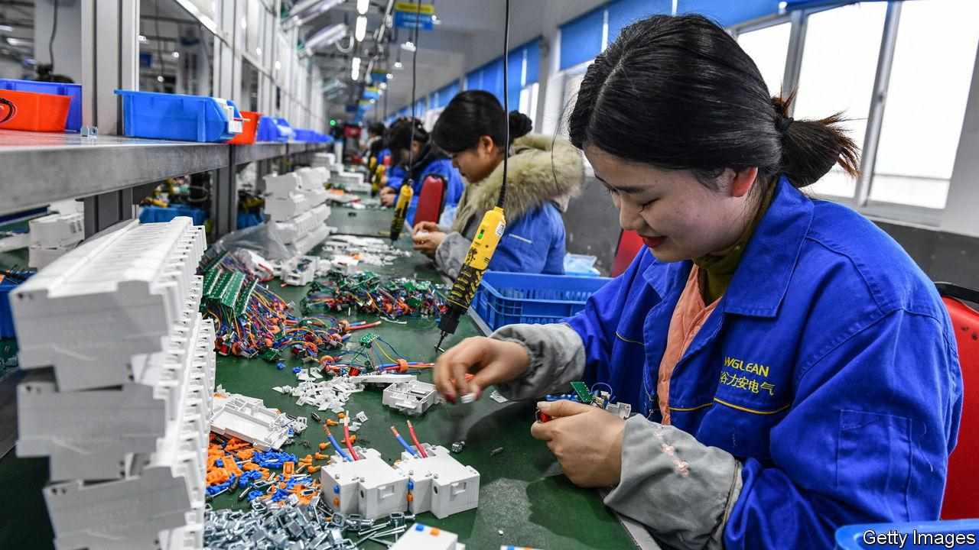China’s economy grew by 5.2% last year, just above the government’s target of 5%. Speaking at Davos, Li Qiang, China’s prime minister, crowed that the government had not had to resort to massive stimulus to achieve an economic rebound. However, the figure is a comparison with the low base of 2022, when GDP expanded by just 3% because of pandemic restrictions. Investors weren’t impressed. Chinese stockmarkets extended their rout from the start of 2024, despite the authorities ordering some institutional investors not to sell shares. China’s population also fell in 2023 for the second year,by 2m people to 1.409bn.

中国去年的经济增长了5.2%，略高于政府设定的5%目标。在达沃斯发言时，中国总理李强表示，政府没有采取大规模刺激措施就实现了经济反弹。然而，这一数字是与2022年的低基数相比，当时由于疫情限制，GDP仅增长了3%。投资者并不买账。尽管当局要求一些机构投资者不要出售股票，但中国股市从2024年初开始继续下跌。此外，中国的人口在2023年连续第二年下降，减少了200万人，降至14.09亿。

German GDP was 0.3% smaller in 2023 than the previous year, as higher prices hit household consumption and trade. The economy may have avoided a recession in the second half of the year, just. An initial estimate showed GDP shrinking by 0.3% in the fourth quarter over the third quarter, but the statistics office now says that in the third quarter the economy merely “stagnated”.

德国2023年的国内生产总值（GDP）比前一年减少了0.3%，因为价格上涨影响了家庭消费和贸易。经济可能在下半年勉强避免了衰退。初步估计显示，第四季度的GDP比第三季度减少了0.3%，但统计局现在表示，在第三季度，经济只是“停滞”。

Britain recorded an unexpected rise in inflation. The annual rate rose to 4% in December, the first increase in ten months. Coming after a surprise increase in America’s inflation rate (to 3.4% in December) and a rise in the euro zone’s (to 2.9%) investors are pushing back their estimates of when central banks will cut interest rates. Christine Lagarde, president of the European Central Bank, hinted this week that the ECB won’t start reducing rates until the middle of the year.

英国记录到了意外的通货膨胀上升。年通胀率在12月份升至4%，这是十个月来的首次上升。这发生在美国通胀率意外上升（12月份升至3.4%）和欧元区通胀率上升（升至2.9%）之后，投资者正在推迟他们对中央银行何时会降息的预测。欧洲央行行长Christine Lagarde本周暗示，欧洲央行直到年中都不会开始降低利率。

America’s big banks reported a mixed bag of earnings. Net profit at Goldman Sachs was $2bn in the fourth quarter, which was better than markets had expected. But its annual profit of $8.5bn was its worst in four years. Morgan Stanley’s 12-month profit of $9.1bn was also its worst since

2019. By contrast, JPMorgan Chase’s net profit of $49.6bn was a record for the bank, which benefited more than its rivals from higher interest rates. Citigroup is slashing at least 20,000 jobs, a tenth of its workforce. It reported a hefty loss for the fourth quarter related in part from its exposure to Russia.

美国大型银行的财报表现参差不齐。高盛在第四季度的净利润为20亿美元，超出了市场的预期。但其年度利润为85亿美元，是四年来最差的表现。摩根士丹利的12个月利润为91亿美元，也是自2019年以来的最差表现。相比之下，摩根大通的净利润为496亿美元，创下了该银行的纪录，这得益于其从较高的利率中获得的比竞争对手更多的收益。花旗集团正在削减至少20,000个工作岗位，占其员工总数的十分之一。它报告了第四季度的重大亏损，这部分与其在俄罗斯的敞口有关。

BlackRock struck a deal to buy Global Infrastructure Partners for $12.5bn. It is the asset manager’s biggest acquisition since 2009, when it bought Barclays Global Investors. GIS owns infrastructure and energy assets, including London’s Gatwick and City airports.

黑石集团达成了以125亿美元收购Global Infrastructure Partners的协议。这是自2009年收购Barclays Global Investors以来，该资产管理公司最大的一笔收购。Global Infrastructure Partners拥有基础设施和能源资产，包括伦敦的Gatwick 和City机场。

Flight cancelled

A federal judge blocked JetBlue Airways’ proposed takeover of Spirit Airlines, finding that the merger of America’s sixth-and seventh-largest carriers would hurt competition. The $3.8bn deal was announced in July 2022 and had been delayed in the courts ever since.

一位联邦法官阻止了JetBlue Airways提议收购Spirit Airlines，认为美国第六大和第七大航空公司的合并将损害竞争。这笔价值38亿美元的交易是在2022年7月宣布的，自那以后一直在法庭上被推迟。

Kroger and Albertsons pushed back the date by which they hope to complete their proposed merger, as talks continue with the Federal Trade Commission and state regulators about combining the two supermarket giants. Meanwhile Washington state asked a judge to halt the deal, arguing that it would lead to higher prices for consumers.

Kroger和Albertsons推迟了他们希望完成合并的日期，因为与联邦贸易委员会（Federal Trade Commission）和州监管机构关于合并这两家超市巨头的谈判仍在继续。与此同时，华盛顿州要求法官暂停这笔交易，认为这将导致消费者价格上涨。

Shell sold its 68-year-old onshore-oil business in Nigeria to a consortium of mostly local companies. Like other energy giants that have withdrawn from the Delta region, Shell has grappled with damage to infrastructure, often blamed on communities suffering from damage to their environment. Meanwhile, BP confirmed Murray Auchincloss as its new chief executive;

he has held the job on an interim basis since the resignation of Bernard Looney last September.

壳牌将其在尼日利亚拥有68年历史的陆上石油业务出售给了主要由当地公司组成的财团。与其他从三角洲地区撤出的能源巨头一样，壳牌一直在努力应对基础设施的损坏，这些损坏通常被归咎于因环境破坏而遭受损失的社区。与此同时，英国石油公司确认穆雷·奥金克洛斯为其新任首席执行官；自从去年9月伯纳德·卢尼辞职以来，他一直担任临时首席执行官。

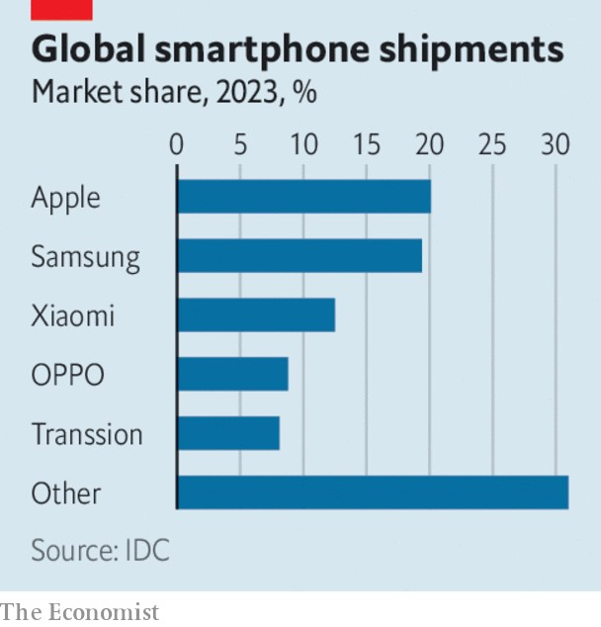Apple passed Samsung last year to become the world’s biggest seller of smartphones by volume, according to IDC, a market-research firm (Apple

has long been the most profitable smartphone-maker). Apple shipped nearly 235m of the devices, 4% more than in 2022 and despite a downturn in the wider market. That compared with Samsung’s 227m, a drop of 14%.Transsion, a Chinese manufacturer, made the top five by selling lots of its phones in Africa.

根据市场研究公司IDC的数据，苹果公司去年超越三星，成为全球智能手机销量最大的公司（苹果长期以来一直是最盈利的智能手机制造商）。苹果公司出货量接近2.35亿台设备，比2022年增加了4%，尽管整个市场出现了下滑。相比之下，三星的出货量为2.27亿台，下降了14%。中国制造商传音（Transsion）通过在非洲大量销售其手机，进入了前五名。

Rising stock

The news was a fillip for Apple in a week when Microsoft pipped it to become the most valuable company. Microsoft is now worth around $2.9trn on the stockmarket, compared with Apple’s $2.8trn.

这则新闻对于苹果公司来说是一个提振，因为在同一周，微软在市值上超过了苹果，成为了最有价值的公司。微软目前在股市上的市值约为2.9万亿美元，而苹果的市值为2.8万亿美元。

The revolution in chipmaking spurred another big takeover, as Synopsys,which makes software tools for chip design, agreed to buy Ansys, which provides engineering simulation software to a variety of industries, for $35bn.

芯片制造领域的革命催生了另一起大型收购案，芯片设计软件工具制造商Synopsys同意以350亿美元收购为多种行业提供工程仿真软件的Ansys。

An annual survey of global chief executives by PwC found that a quarter of them expect to cut their workforce by at least 5% this year because of generative artificial intelligence. Those cuts are already starting to materialise, with Google reportedly laying off hundreds in advertising and Amazon making hundreds of redundancies in its streaming business, both because of AI..

PwC对全球首席执行官进行的年度调查发现，四分之一的受访者预计今年将因生成式AI（generative artificial intelligence）而至少削减5%的员工。这些裁员已经开始显现，据报道，谷歌在广告部门裁员数百人，亚马逊在其流媒体业务中也裁减了数百名员工，两者都是因为人工智能的原因。