《WEB前端开发技术》
课程设计报告

题目： 歌手巡演专辑管理系统

学号：

姓名： 杨欣悦

班级： 信安

评分

目录
目录
1 用户登录 3
2 主页设计 7
3 巡演管理 14
3.1 一巡 16
3.2 二巡 27
3.3 三巡 38
4 专辑管理 50
4.1 前十年 50
4.2后十年 61
6 系统管理 70
7.心得体会 73

1 用户登录
创建工程music
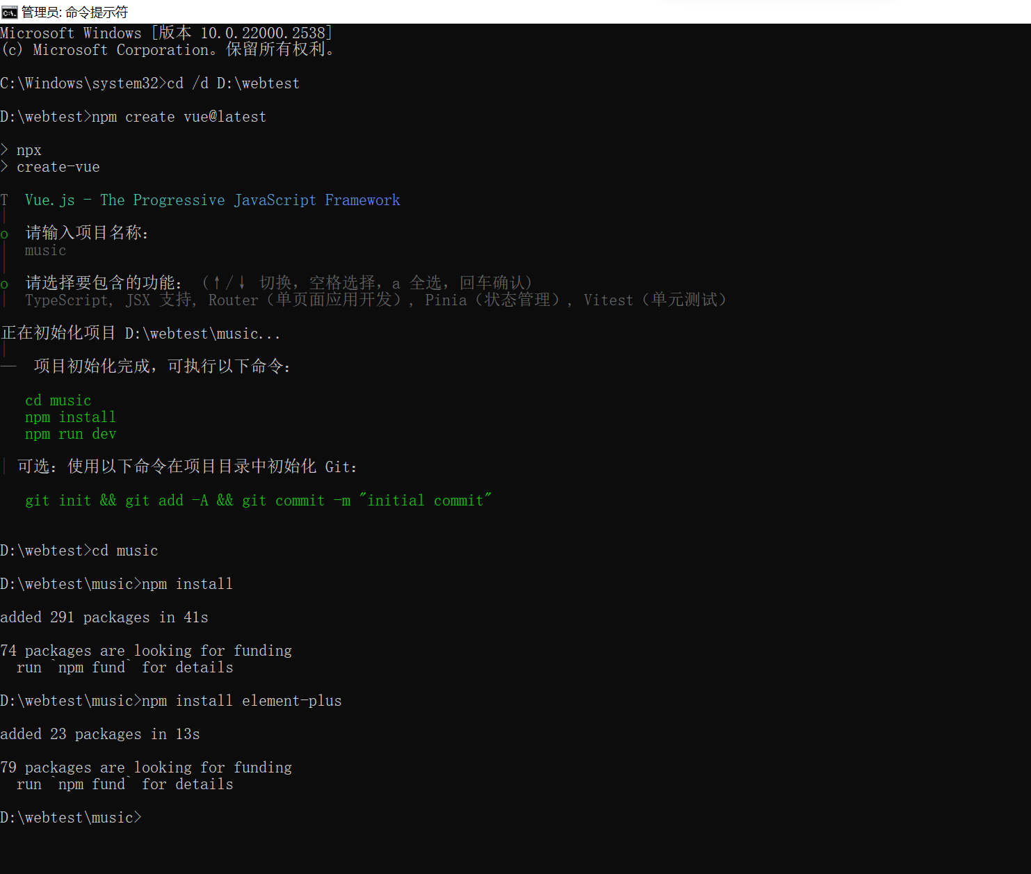
设置后端，保存数据
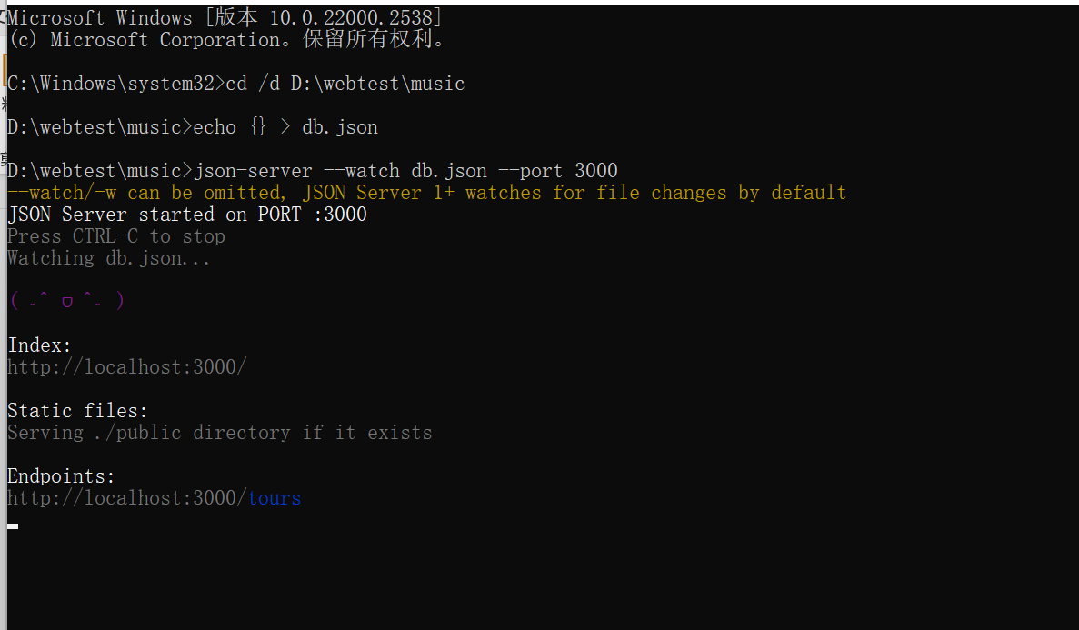
点击登录后直接跳转到Home页面
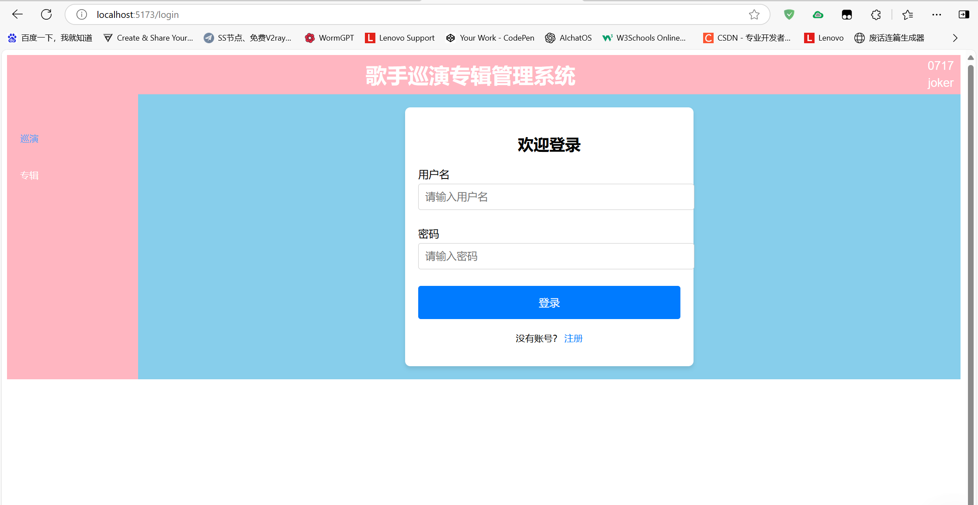
代码如下：
<template>
<div class="login-container">
<div class="login-header">
<!-- 登录标题区 -->
<h2>欢迎登录</h2>
</div>

<!-- 用户名输入框 -->
<div class="form-group">
<label for="username">用户名</label>
<!--
v-model 双向数据绑定：
1. 将输入框的值与组件的username数据属性绑定
2. 输入框变化时自动更新username
3. username变化时自动更新输入框显示
-->
<input type="text" id="username" v-model="username" class="form-control" placeholder="请输入用户名" />
</div>

<!-- 密码输入框 -->
<div class="form-group">
<label for="password">密码</label>
<!-- 同上v-model绑定密码字段 -->
<input type="password" id="password" v-model="password" class="form-control" placeholder="请输入密码" />
</div>

<!-- 登录按钮 -->
<div class="text-center">
<!--
@click 事件绑定：
1. 点击按钮时触发handleLogin方法
2. 使用.prevent可以自动阻止默认事件（这里不需要）
-->
<button class="btn btn-block btn-lg" @click="handleLogin">登录</button>
</div>

<div class="login-footer">
<p>没有账号？ <a href="/register">注册</a></p>
</div>
</div>
</template>

<script>
export default {
// 组件数据定义
data() {
return {
username: '',// 存储用户名输入
password: ''// 存储密码输入
};
},
methods: {
/**
* 登录处理方法
* 功能：
* 1. 设置登录状态到本地存储
* 2. 跳转到首页
* 注意：
* - 实际项目应该先发送请求到后端验证
* - 验证通过后再进行状态存储和跳转
*/
handleLogin() {
// 设置登录状态到localStorage
// 实际项目应该使用更安全的方式存储token
localStorage.setItem('isLoggedIn', 'true'); // 标记用户已登录

// 使用Vue Router进行页面跳转
// 跳转到 Home 页面
// this.$router是Vue Router注入的实例
this.$router.push('/home');
}
}
};
</script>

<style scoped>
/*
scoped 作用域样式：
这些样式只作用于当前组件，不会影响其他组件
原理是通过添加data-v-xxx属性实现样式隔离
*/

.login-container {
width: 100%;
max-width: 400px; /* 限制最大宽度 */
margin: 0 auto; /* 水平居中 */
padding: 20px;
background: #fff;
border-radius: 8px;
box-shadow: 0 4px 6px rgba(0, 0, 0, 0.1); /* 添加阴影效果 */
}

.login-header h2 {
text-align: center;
margin-bottom: 20px;
}

.form-group {
margin-bottom: 15px; /* 表单组间距 */
}

label {
display: block;/* 让label独占一行 */
margin-bottom: 5px;
}

input.form-control {
width: 100%;
padding: 10px;
margin-bottom: 10px;
border: 1px solid #ccc;
border-radius: 4px;
font-size: 16px;
}

.text-center {
text-align: center;
}

.btn {
width: 100%;
padding: 15px;
background-color: #007bff;
color: #fff;
border: none;
border-radius: 4px;
font-size: 16px;
cursor: pointer;
}

.btn:hover {
background-color: #0056b3;/* 鼠标悬停颜色 */
}

.login-footer {
text-align: center;
margin-top: 20px;
}

.login-footer p {
font-size: 14px;
}

.login-footer a {
color: #007bff;
text-decoration: none;
}

.login-footer a:hover {
text-decoration: underline;
}
</style>

2 主页设计
首页显示如下
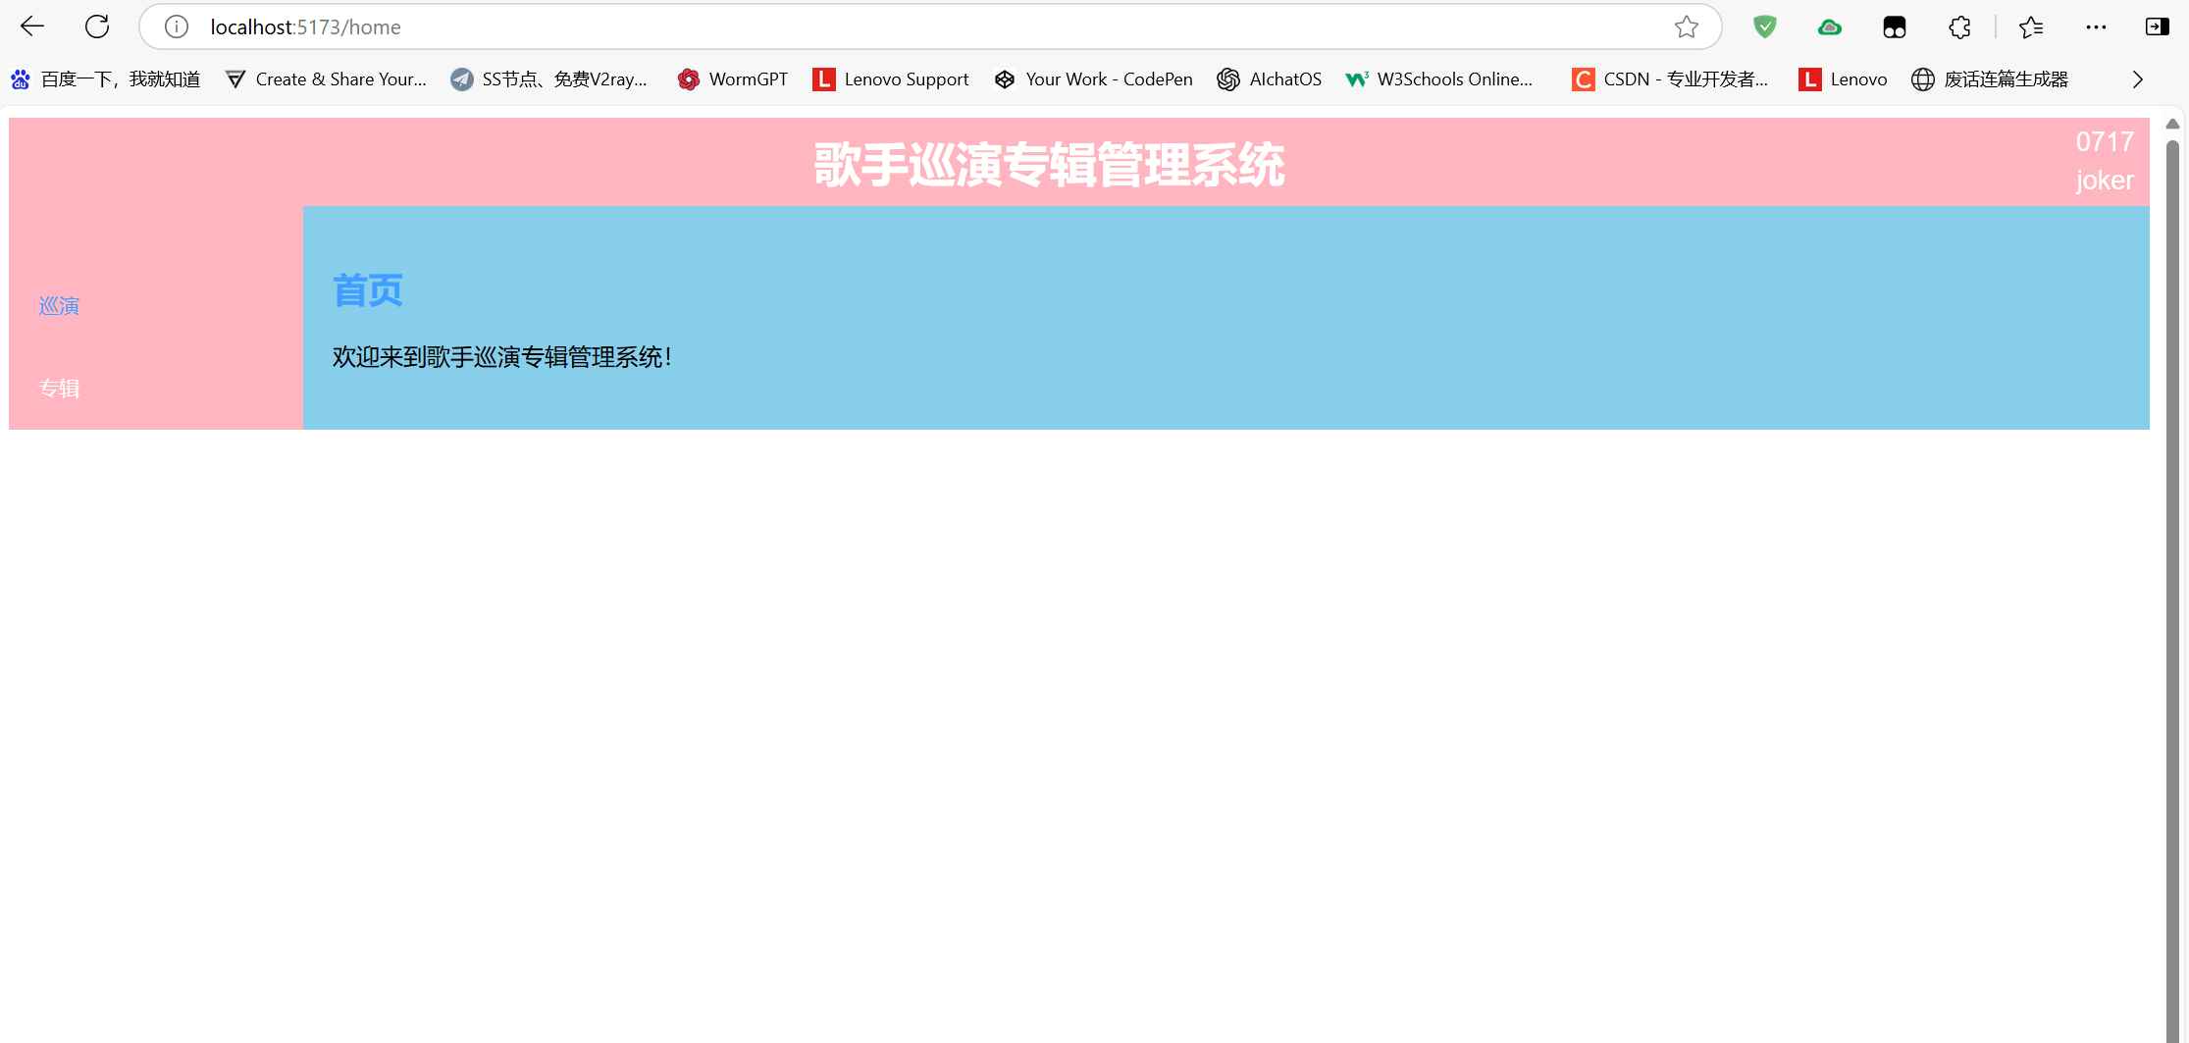
代码如下：
<template>
<div>
<h2>首页</h2>
<p>欢迎来到歌手巡演专辑管理系统！</p>
</div>
</template>

<script lang="ts">
export default {
name: 'Home',
};
</script>

<style scoped>
h2 {
color: #409eff;
}
</style>

路由跳转相关代码如下：
import { createRouter, createWebHistory } from 'vue-router'
import Login from '../views/Login.vue'
import Home from '../views/Home.vue'

const routes = [
{
path: '/',
redirect: '/login' // 初始重定向到登录页
},
{
path: '/login',
name: 'Login',
component: Login
},
{
path: '/home',
name: 'Home',
component: Home,
meta: { requiresAuth: true } // 需要登录才能访问
},
// 保持你原有的其他路由
{
path: '/first-tour',
name: 'FirstTour',
component: () => import('../views/FirstTour.vue'),
meta: { requiresAuth: true }
},
{
path: '/second-tour',
name: 'SecondTour',
component: () => import('../views/SecondTour.vue'),
meta: { requiresAuth: true }
},
{
path: '/third-tour',
name: 'ThirdTour',
component: () => import('../views/ThirdTour.vue'),
meta: { requiresAuth: true }
},
{
path: '/previous-decade',
name: 'PreviousDecade',
component: () => import('../views/ThePreviousDecade.vue'),
meta: { requiresAuth: true }
},
{
path: '/next-decade',
name: 'NextDecade',
component: () => import('../views/TheNextDecade.vue'),
meta: { requiresAuth: true }
}
]

const router = createRouter({
history: createWebHistory(import.meta.env.BASE_URL),
routes
})

// 路由守卫
router.beforeEach((to, from, next) => {
const isLoggedIn = localStorage.getItem('isLoggedIn') === 'true'

if (to.matched.some(record => record.meta.requiresAuth) && !isLoggedIn) {
next('/login')
} else {
next()
}
})

export default router

App.vue提供侧边菜单栏等内容，代码如下：
<template>
<div id="app">
<el-header class="header">
<div class="header-content">
<div class="header-left">歌手巡演专辑管理系统</div>
<div class="header-right">
<div>0717</div>
<div>joker</div>
</div>
</div>
</el-header>
<el-container>
<el-aside width="200px" class="sidebar">
<el-menu default-active="1" class="el-menu-vertical-demo">
<!-- 巡演主菜单 -->
<el-menu-item index="1" @click="toggleTour" class="menu-item">巡演</el-menu-item>
<el-submenu v-if="isTourVisible" index="1-1" class="submenu">
<template #title>巡演子菜单</template>
<el-menu-item index="1-1-1" @click="goToFirstTour" class="menu-item">一巡</el-menu-item>
<el-menu-item index="1-1-2" @click="goToSecondTour" class="menu-item">二巡</el-menu-item>
<el-menu-item index="1-1-3" @click="goToThirdTour" class="menu-item">三巡</el-menu-item>
</el-submenu>

<!-- 专辑主菜单 -->
<el-menu-item index="2" @click="toggleAlbum" class="menu-item">专辑</el-menu-item>
<el-submenu v-if="isAlbumVisible" index="2-1" class="submenu">
<template #title>专辑子菜单</template>
<el-menu-item index="2-1-1" @click="goToPreviousDecade" class="menu-item">前十年</el-menu-item>
<el-menu-item index="2-1-2" @click="goToNextDecade" class="menu-item">后十年</el-menu-item>
</el-submenu>
</el-menu>
</el-aside>
<el-main class="main-content">
<router-view />
</el-main>
</el-container>
</div>
</template>

<script lang="ts">
import { defineComponent, ref } from 'vue'; // 确保导入 ref
import { useRouter } from 'vue-router';

export default defineComponent({
name: 'App',
setup() {
const router = useRouter();

// 控制巡演和专辑菜单的显示/隐藏
const isTourVisible = ref(false);
const isAlbumVisible = ref(false);

const toggleTour = () => {
isTourVisible.value = !isTourVisible.value;
};

const toggleAlbum = () => {
isAlbumVisible.value = !isAlbumVisible.value;
};

// 跳转方法
const goToFirstTour = () => router.push('/first-tour');
const goToSecondTour = () => router.push('/second-tour');
const goToThirdTour = () => router.push('/third-tour');
const goToPreviousDecade = () => router.push('/previous-decade');
const goToNextDecade = () => router.push('/next-decade');

return {
isTourVisible,
isAlbumVisible,
toggleTour,
toggleAlbum,
goToFirstTour,
goToSecondTour,
goToThirdTour,
goToPreviousDecade,
goToNextDecade
};
}
});
</script>

<style scoped>
#app {
height: 100vh;
font-family: Arial, sans-serif; /* 设置全局字体 */
}

.el-header {
background-color: #ffb6c1; /* 粉色背景 */
padding: 10px;
display: flex;
justify-content: center;
align-items: center;
}

.header-content {
display: flex;
width: 100%;
align-items: center;
}

.header-left {
font-size: 32px; /* 加大字体大小 */
font-weight: bold;
text-align: center;
flex-grow: 1;
display: flex;
justify-content: center;
align-items: center;
color: #fff; /* 设置文字颜色为白色 */
}

.header-right {
text-align: center;
font-size: 18px;
margin-left: auto; /* 将其推到最右侧 */
color: #fff; /* 设置文字颜色为白色 */
}

.header-right div {
margin: 5px 0; /* 让0717和joker有间距 */
}

.el-aside {
background-color: #ffb6c1; /* 粉色背景 */
padding-top: 20px;
}

.el-menu-vertical-demo {
width: 100%;
padding-top: 20px;
background-color: #ffb6c1; /* 设置菜单区域背景为粉色 */
border: none;
}

.el-menu-item, .el-submenu {
background-color: #ffb6c1; /* 为菜单项和子菜单项设置粉色背景 */
color: #fff; /* 设置文字颜色为白色 */
}

.el-menu-item:hover, .el-submenu:hover {
background-color: #ff99b3; /* 给菜单项和子菜单项添加悬浮效果 */
}

.el-container {
display: flex;
background-color: #ffb6c1; /* 设置空白区域背景颜色为粉色 */
}

.el-main {
background-color: #87ceeb; /* 天蓝色背景 */
flex-grow: 1;
padding: 20px;
}
</style>

3 巡演管理
设置后端为{}db.json,存储前端提交的数据
代码如下：
{
"tours": [
{
"id": 1,
"tour": 1,
"city": "北京",
"date": "2023-01-01",
"venue": "国家体育馆",
"tourType": "firstTour"
},
{
"id": 2,
"tour": 1,
"city": "上海",
"date": "2024-01-01",
"venue": "梅赛德斯中心",
"tourType": "secondTour"
},
{
"id": "c32d",
"tour": 1,
"city": "重庆",
"date": "2025-04-10",
"venue": "重庆奥体中心体育场",
"tourType": "thirdTour"
},
{
"id": "44ac",
"tour": 2,
"city": "重庆",
"date": "2025-04-02",
"venue": "重庆奥体中心体育场",
"tourType": "firstTour"
}
],
"albums": [
{
"id": 1,
"albumNumber": 1,
"albumName": "首张专辑",
"company": "华纳音乐",
"songCount": 12,
"price": 88.5,
"decade": "previous"
},
{
"id": 2,
"albumNumber": 2,
"albumName": "十年精选",
"company": "索尼音乐",
"songCount": 15,
"price": 120,
"decade": "previous"
},
{
"id": 3,
"albumNumber": 1,
"albumName": "新时代",
"company": "环球音乐",
"songCount": 10,
"price": 99.9,
"decade": "next"
},
{
"albumNumber": 3,
"albumName": "意外",
"company": "海蝶音乐公司",
"songCount": 10,
"price": 77,
"decade": "previous",
"id": "0914"
}
]
}

3.1 一巡
一巡数据独立存放，对其的修改不会影响别的巡演数据或专辑数据，因为巡演场次较少，不设置分页效果。
添加数据
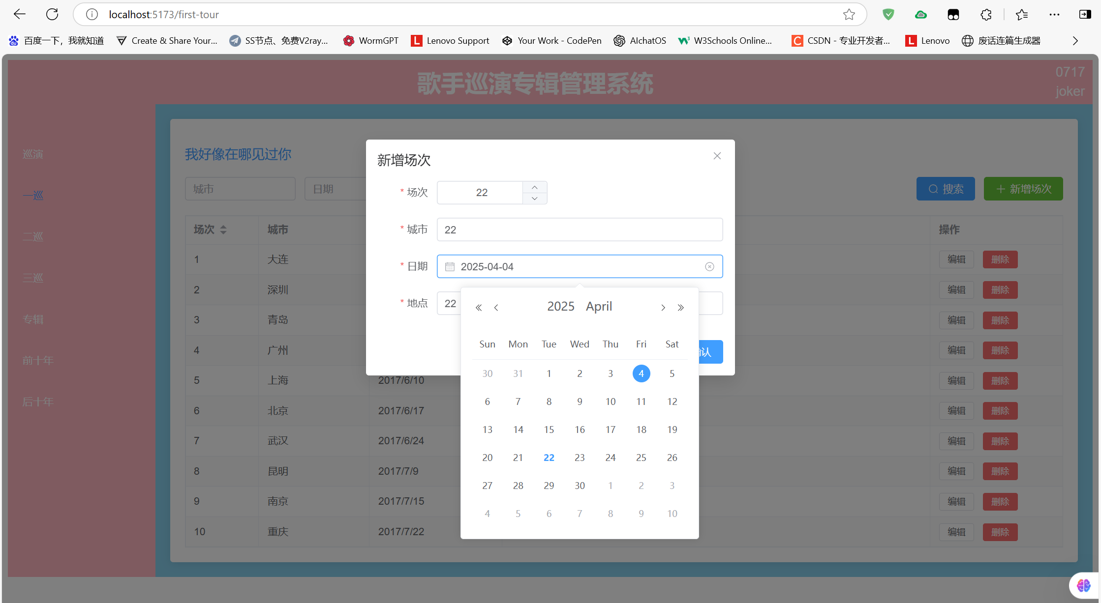
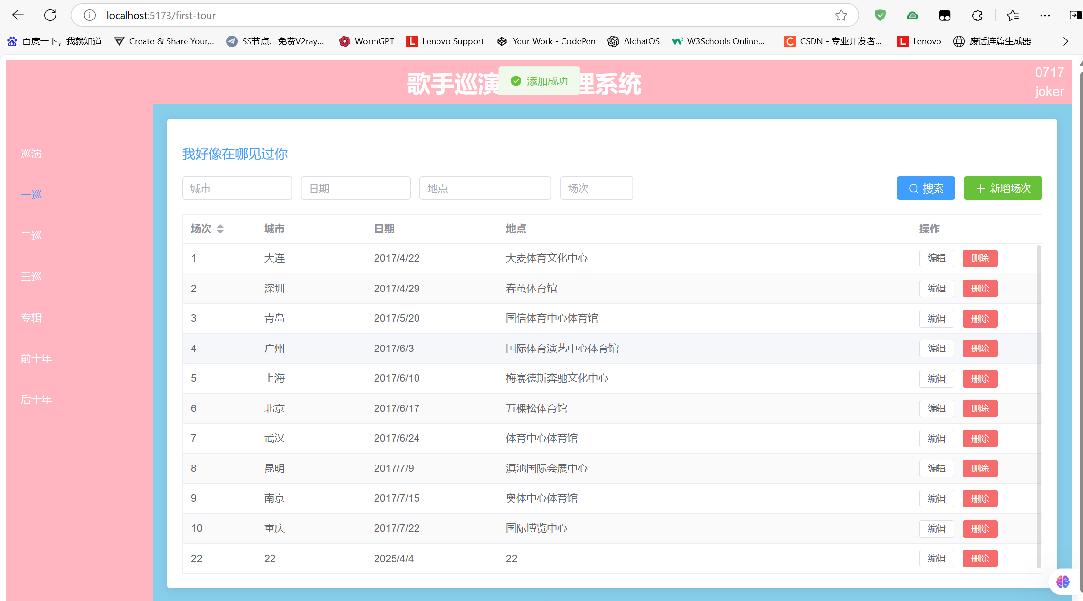
修改数据
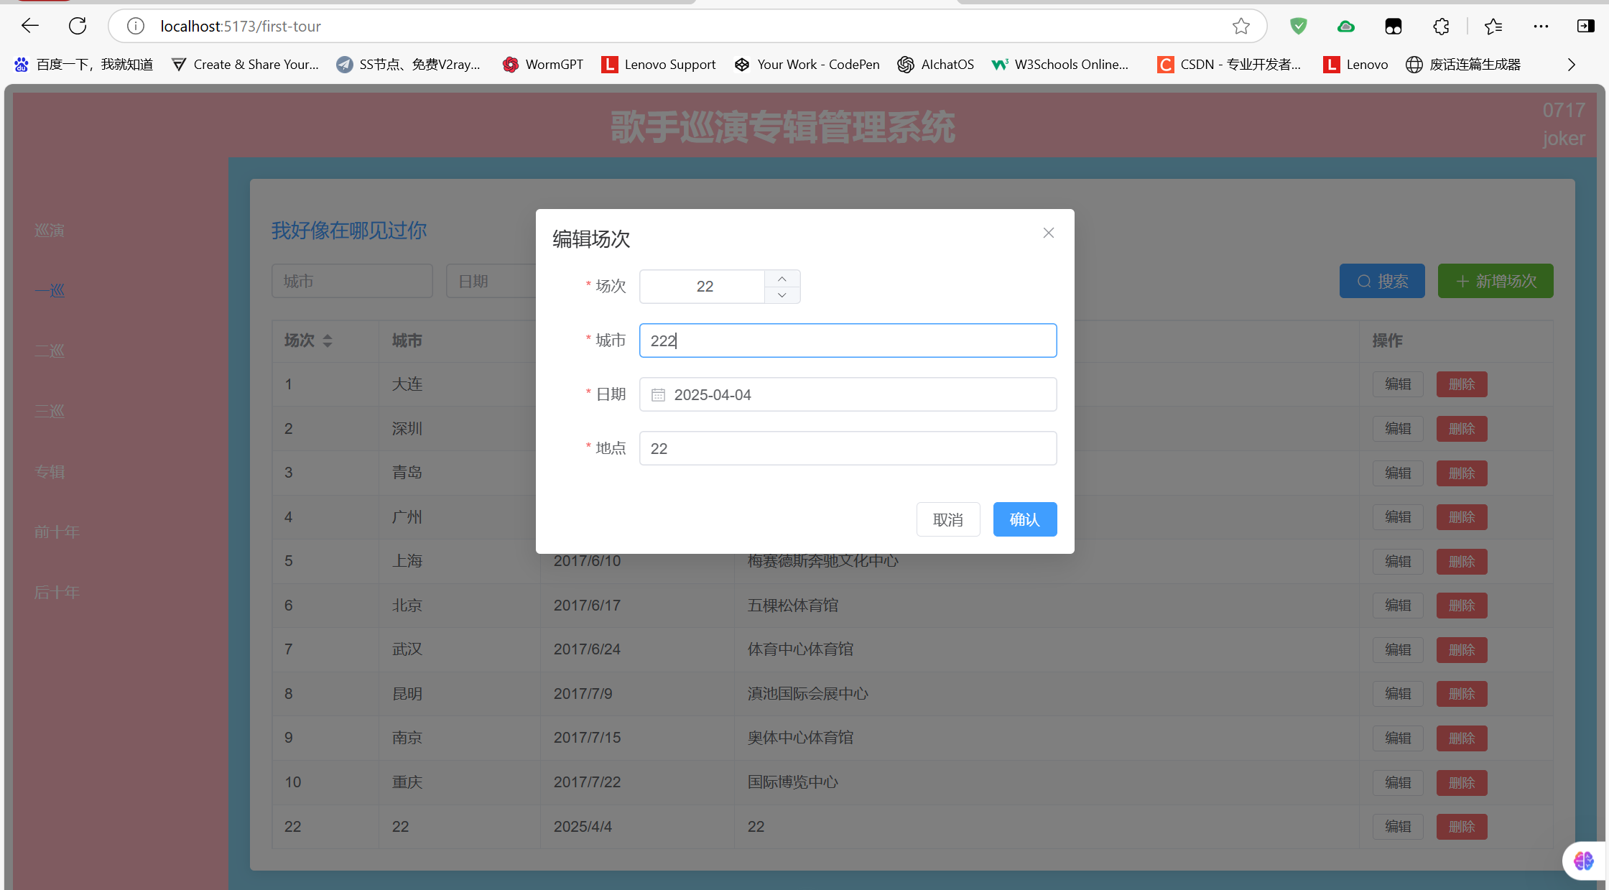
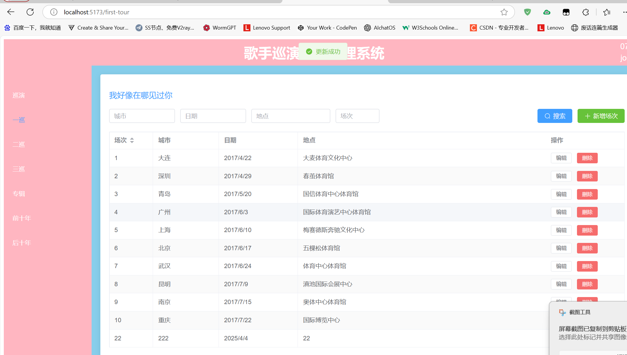
查询数据
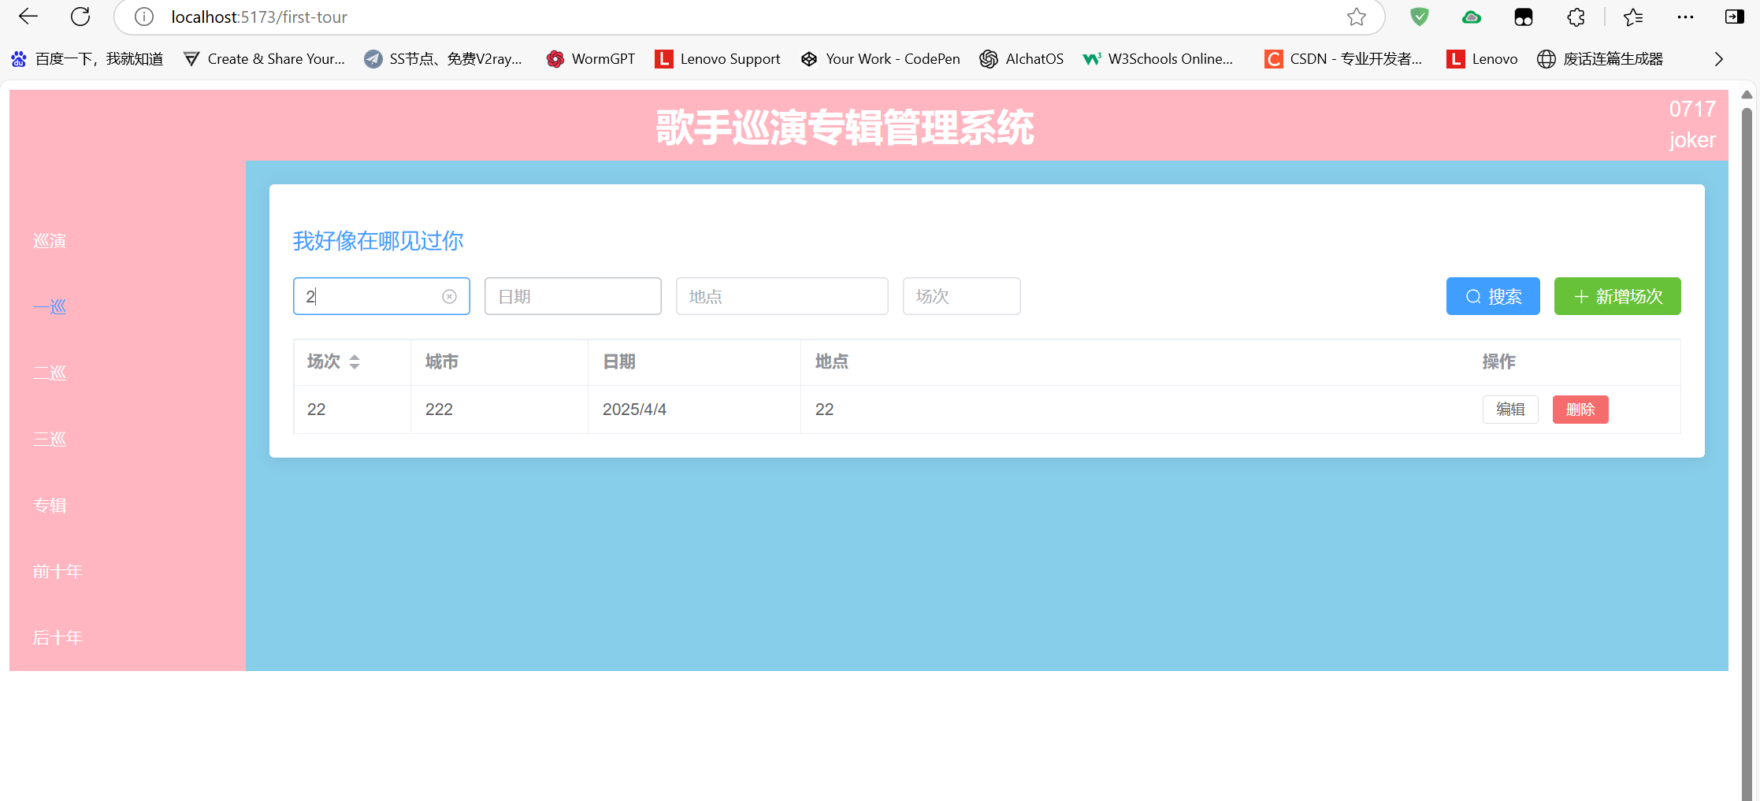
删除数据
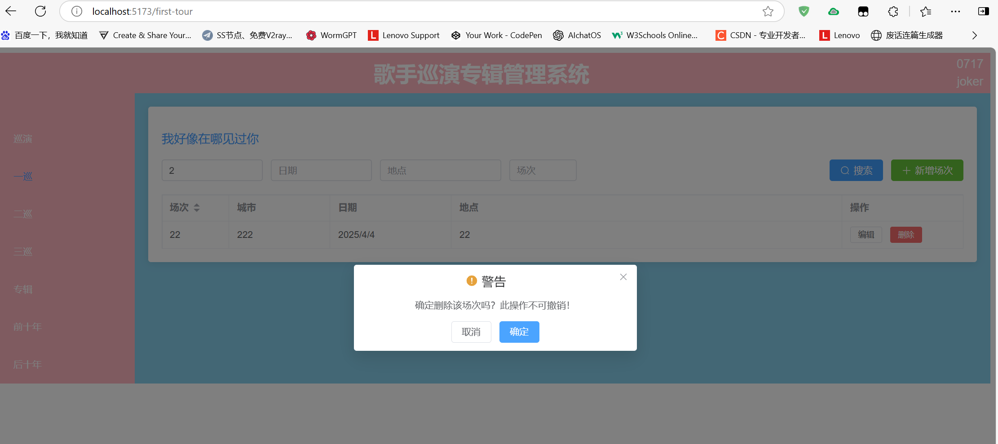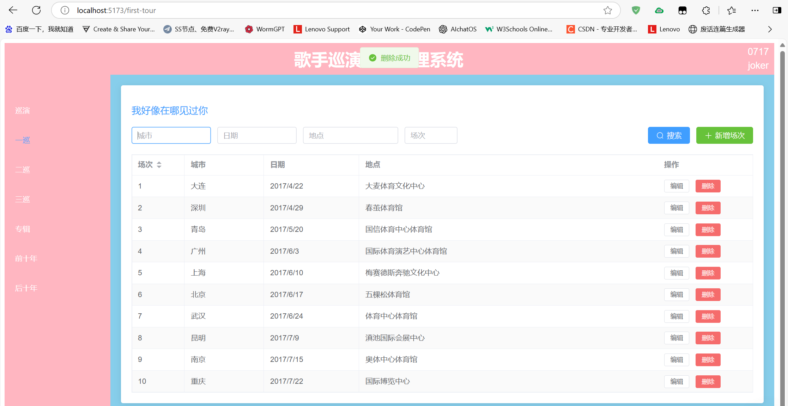
代码如下：
<template>
<div class="tour-management">
<h2>我好像在哪见过你</h2> <!-- 修改标题明确当前巡演 -->

<!-- 搜索和操作区 -->
<div class="action-bar">
<el-input v-model="queryParams.city" placeholder="城市" clearable style="width: 150px" />
<el-input v-model="queryParams.date" placeholder="日期" clearable style="width: 150px" />
<el-input v-model="queryParams.venue" placeholder="地点" clearable style="width: 180px" />
<el-input v-model="queryParams.tour" placeholder="场次" clearable style="width: 100px" />

<div class="action-buttons">
<el-button type="primary" @click="handleSearch" :icon="Search">搜索</el-button>
<el-button type="success" @click="handleAdd" :icon="Plus">新增场次</el-button>
</div>
</div>

<!-- 数据表格 -->
<el-table
:data="filteredData"
border
stripe
v-loading="loading"
style="width: 100%"
empty-text="暂无数据"
@sort-change="handleSortChange"
>
<el-table-column
prop="tour"
label="场次"
width="100"
sortable="custom"
/>
<el-table-column prop="city" label="城市" width="150" />
<el-table-column prop="date" label="日期" width="180">
<template #default="{ row }">
{{ formatDisplayDate(row.date) }}
</template>
</el-table-column>
<el-table-column prop="venue" label="地点" />
<el-table-column label="操作" width="180" fixed="right">
<template #default="{ row, $index }">
<el-button
size="small"
@click="handleEdit(row, $index)"
:disabled="row.status === 'published'"
>
编辑
</el-button>
<el-button
size="small"
type="danger"
@click="handleDelete(row.id)"
:loading="deleteLoading[row.id]"
>
删除
</el-button>
</template>
</el-table-column>
</el-table>

<!-- 编辑弹窗 -->
<el-dialog
:title="dialogTitle"
v-model="dialogVisible"
width="500px"
@closed="handleDialogClosed"
>
<el-form
:model="formData"
:rules="formRules"
ref="formRef"
label-width="80px"
>
<el-form-item label="场次" prop="tour">
<el-input-number
v-model="formData.tour"
:min="1"
:max="100"
controls-position="right"
/>
</el-form-item>
<el-form-item label="城市" prop="city">
<el-input v-model="formData.city" />
</el-form-item>
<el-form-item label="日期" prop="date">
<el-date-picker
v-model="formData.date"
type="date"
value-format="YYYY-MM-DD"
placeholder="选择日期"
style="width: 100%"
/>
</el-form-item>
<el-form-item label="地点" prop="venue">
<el-input v-model="formData.venue" />
</el-form-item>
</el-form>
<template #footer>
<el-button @click="dialogVisible = false">取消</el-button>
<el-button
type="primary"
@click="submitForm"
:loading="submitting"
>
确认
</el-button>
</template>
</el-dialog>
</div>
</template>

<script lang="ts" setup>
import { ref, computed, reactive, onMounted } from 'vue'
import { ElMessage, ElMessageBox } from 'element-plus'
import { Search, Plus } from '@element-plus/icons-vue'
import type { FormInstance, FormRules } from 'element-plus'
import axios from 'axios'

// 类型定义
interface TourItem {
id?: number
tour: number
city: string
date: string
venue: string
status?: string
tourType?: 'firstTour' // 新增巡演类型字段
}

interface QueryParams {
city: string
date: string
venue: string
tour: string
sortField?: string
sortOrder?: string
}

// API 配置
const api = axios.create({
baseURL: import.meta.env.VITE_API_BASE_URL || 'http://localhost:3000',
timeout: 10000,
headers: {
'Content-Type': 'application/json'
}
})

// 当前巡演类型常量
const CURRENT_TOUR_TYPE = 'firstTour'

// 状态管理
const loading = ref(false)
const submitting = ref(false)
const dialogVisible = ref(false)
const isEditMode = ref(false)
const currentEditIndex = ref(-1)
const deleteLoading = reactive<Record<number, boolean>>({})
const formRef = ref<FormInstance>()
const tourList = ref<TourItem[]>([])

const queryParams = reactive<QueryParams>({
city: '',
date: '',
venue: '',
tour: ''
})

const formData = reactive<TourItem>({
id: undefined,
tour: 1,
city: '',
date: '',
venue: '',
tourType: CURRENT_TOUR_TYPE // 设置默认巡演类型
})

const formRules = reactive<FormRules<TourItem>>({
tour: [
{ required: true, message: '请输入场次', trigger: 'blur' },
{ type: 'number', min: 1, max: 100, message: '场次需在1-100之间', trigger: 'blur' }
],
city: [
{ required: true, message: '请输入城市', trigger: 'blur' },
{ min: 2, max: 20, message: '长度在2到20个字符', trigger: 'blur' }
],
date: [
{ required: true, message: '请选择日期', trigger: 'change' }
],
venue: [
{ required: true, message: '请输入地点', trigger: 'blur' },
{ min: 2, max: 50, message: '长度在2到50个字符', trigger: 'blur' }
]
})

// 计算属性
const dialogTitle = computed(() => isEditMode.value ? '编辑场次' : '新增场次')
const filteredData = computed(() => {
return tourList.value.filter(item => {
return (
item.city.includes(queryParams.city) &&
item.venue.includes(queryParams.venue) &&
String(item.tour).includes(queryParams.tour) &&
(queryParams.date ? item.date.includes(queryParams.date) : true)
)
})
})

// 生命周期
onMounted(() => {
fetchData()
})

// 方法定义
const fetchData = async () => {
try {
loading.value = true
const { data } = await api.get('/tours', {
params: {
tourType: CURRENT_TOUR_TYPE, // 只获取当前巡演类型数据
_sort: queryParams.sortField,
_order: queryParams.sortOrder
}
})
tourList.value = data.map((item: any) => ({
...item,
tour: Number(item.tour) || 1
}))
} catch (error) {
handleApiError(error, '获取数据失败')
} finally {
loading.value = false
}
}

const handleSearch = () => {
fetchData()
}

const handleAdd = () => {
isEditMode.value = false
resetFormData()
dialogVisible.value = true
}

const handleEdit = (row: TourItem, index: number) => {
isEditMode.value = true
currentEditIndex.value = index
Object.assign(formData, JSON.parse(JSON.stringify(row)))
dialogVisible.value = true
}

const handleDelete = async (id: number) => {
try {
await ElMessageBox.confirm('确定删除该场次吗？此操作不可撤销！', '警告', {
confirmButtonText: '确定',
cancelButtonText: '取消',
type: 'warning',
center: true
})

deleteLoading[id] = true
await api.delete(`/tours/${id}`)
ElMessage.success('删除成功')
await fetchData()
} catch (error) {
if (error !== 'cancel') {
handleApiError(error, '删除失败')
}
} finally {
deleteLoading[id] = false
}
}

const submitForm = async () => {
try {
await formRef.value?.validate()
submitting.value = true

// 确保保存时带上巡演类型
const payload = {
...formData,
tourType: CURRENT_TOUR_TYPE
}

if (isEditMode.value && formData.id) {
await api.put(`/tours/${formData.id}`, payload)
ElMessage.success('更新成功')
} else {
await api.post('/tours', payload)
ElMessage.success('添加成功')
}

dialogVisible.value = false
await fetchData()
} catch (error) {
if (error !== 'cancel') {
handleApiError(error, '提交失败')
}
} finally {
submitting.value = false
}
}

const handleSortChange = ({ prop, order }: { prop: string; order: string }) => {
queryParams.sortField = prop
queryParams.sortOrder = order === 'ascending' ? 'asc' : 'desc'
fetchData()
}

const handleDialogClosed = () => {
formRef.value?.resetFields()
}

const resetFormData = () => {
Object.assign(formData, {
id: undefined,
tour: 1,
city: '',
date: '',
venue: '',
tourType: CURRENT_TOUR_TYPE // 重置时保持类型
})
}

const formatDisplayDate = (dateStr: string) => {
if (!dateStr) return ''
try {
return new Date(dateStr).toLocaleDateString('zh-CN')
} catch {
return dateStr
}
}

const disabledDate = (time: Date) => {
return time.getTime() < Date.now() - 86400000
}

const handleApiError = (error: unknown, defaultMsg: string) => {
if (axios.isAxiosError(error)) {
ElMessage.error(error.response?.data?.message || defaultMsg)
} else {
ElMessage.error(defaultMsg)
}
console.error(error)
}
</script>

<style scoped>
.tour-management {
padding: 20px;
background: #fff;
border-radius: 4px;
box-shadow: 0 2px 12px 0 rgba(0, 0, 0, 0.1);
}

h2 {
margin-bottom: 20px;
color: var(--el-color-primary);
font-size: 18px;
font-weight: 500;
}

.action-bar {
display: flex;
flex-wrap: wrap;
gap: 12px;
margin-bottom: 20px;
align-items: center;
}

.action-buttons {
margin-left: auto;
}

.el-table {
margin-top: 16px;
}

:deep(.el-table__empty-block) {
min-height: 200px;
}
</style>

3.2 二巡
二巡因为场次较多，不能在一个页面中全部显示出来，所以添加分页功能，并把场次数修改为200的上限，数据存储和一巡一样。
添加删除修改查询和一巡类似，但是多了分页的功能，如下所示：
第一页
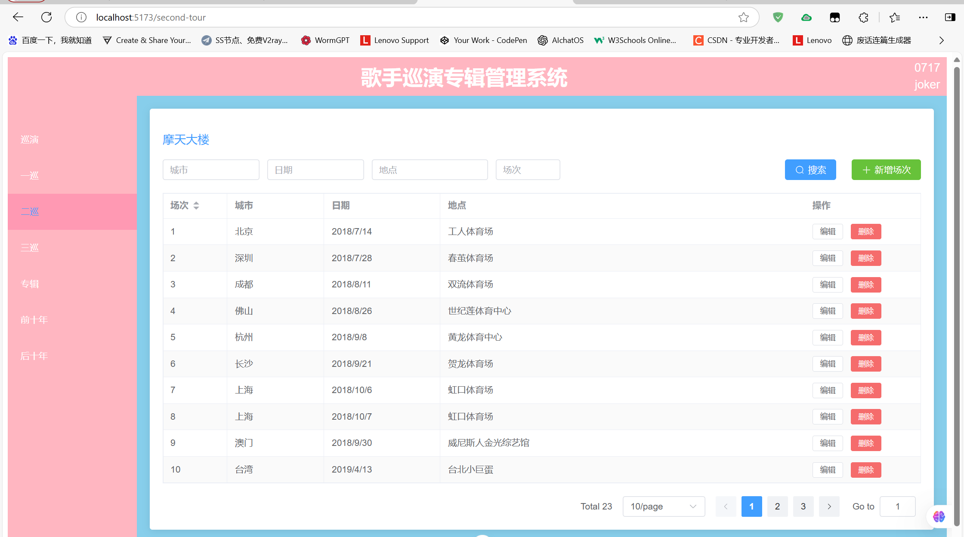
第三页
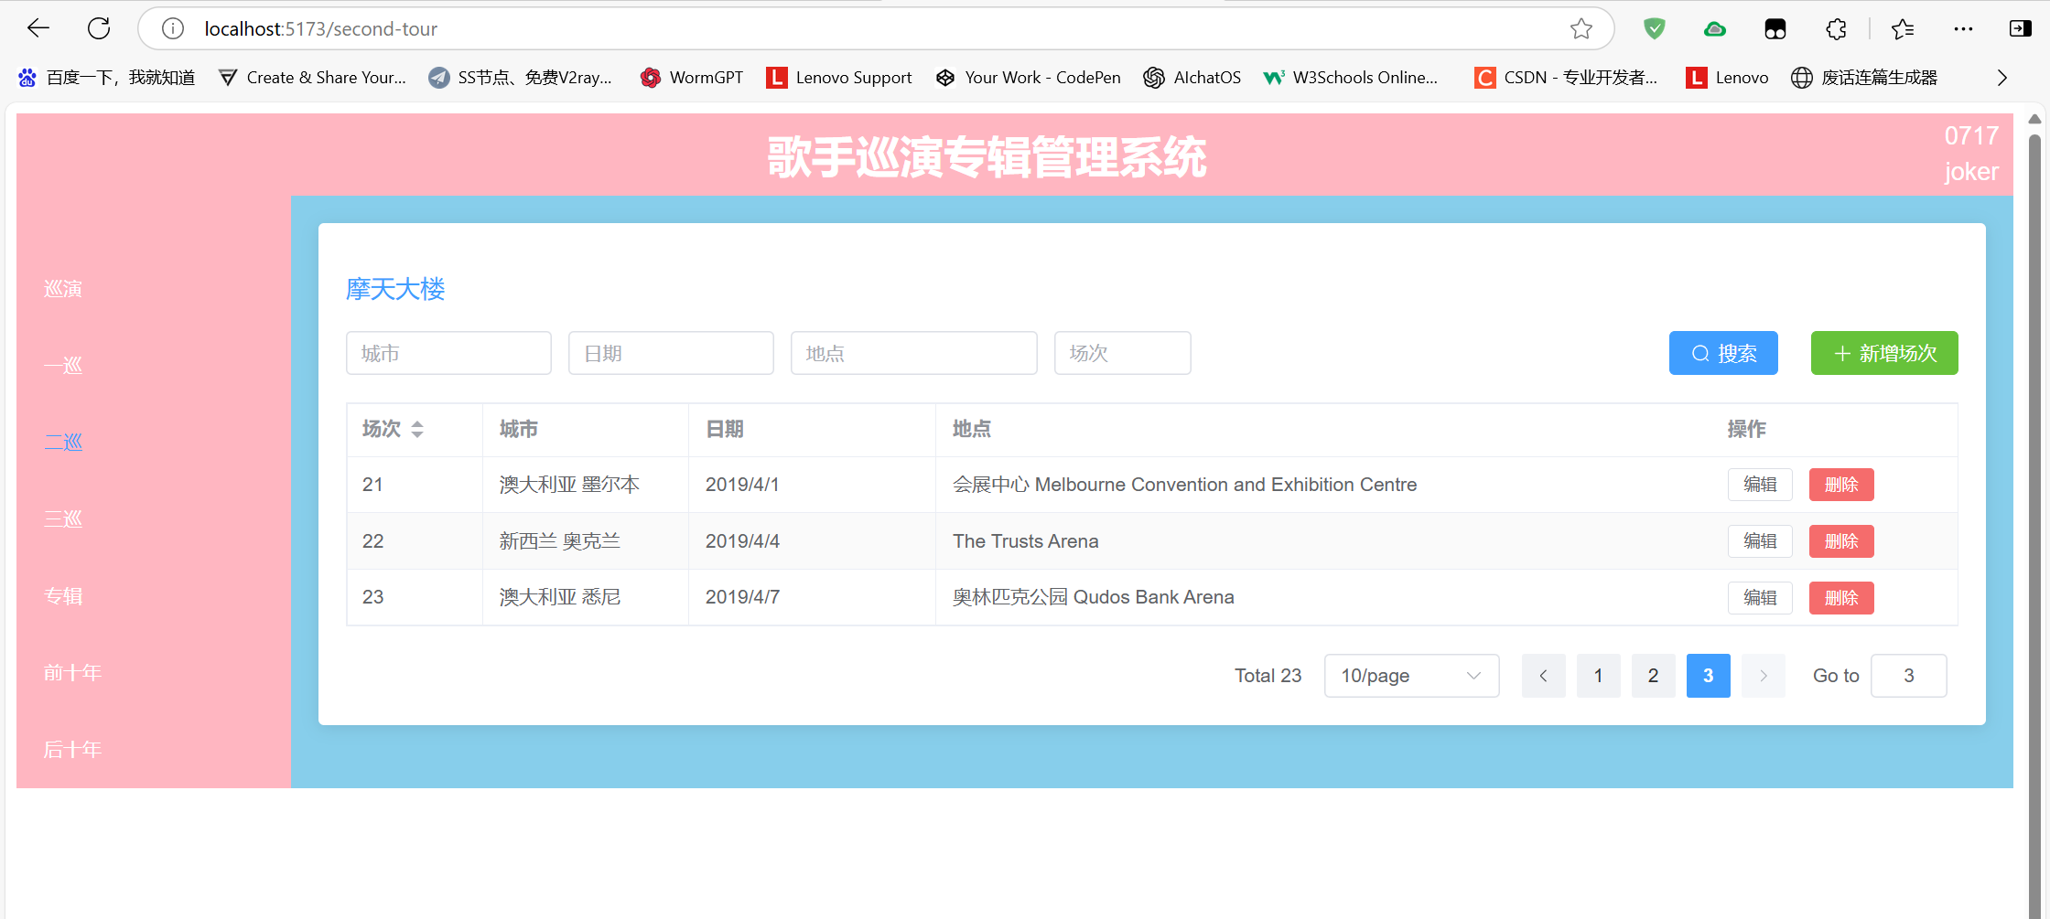
新添加数据会在最后一页上面显示
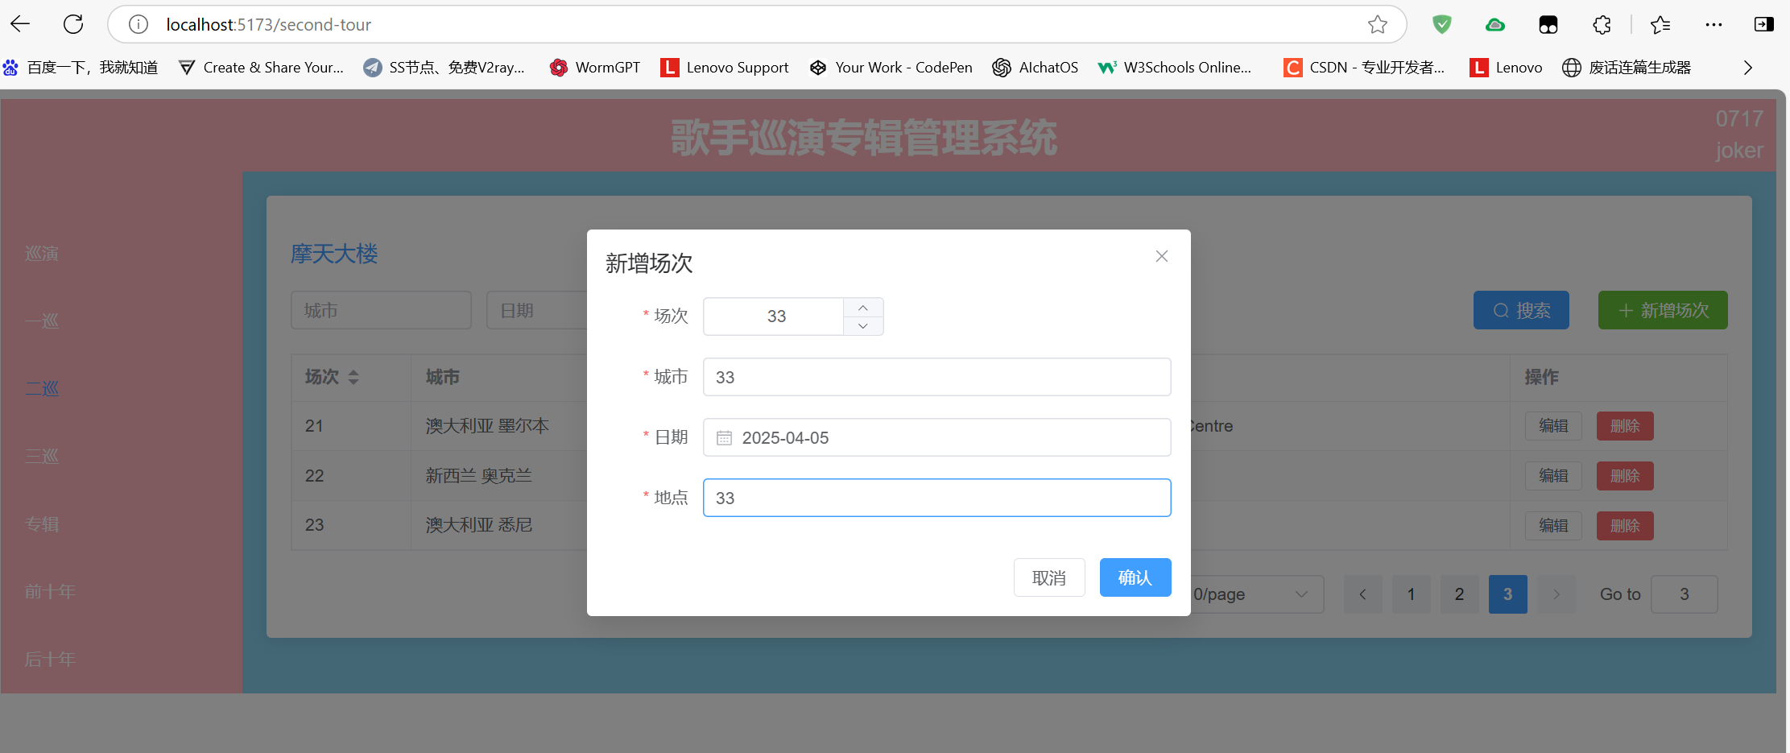
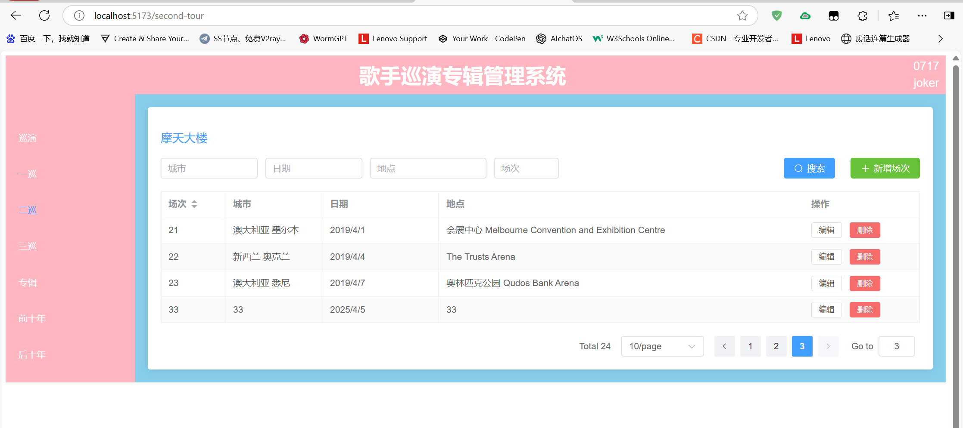
代码如下：
<template>
<div class="tour-management">
<h2>摩天大楼</h2>

<!-- 搜索和操作区 -->
<div class="action-bar">
<el-input v-model="queryParams.city" placeholder="城市" clearable style="width: 150px" />
<el-input v-model="queryParams.date" placeholder="日期" clearable style="width: 150px" />
<el-input v-model="queryParams.venue" placeholder="地点" clearable style="width: 180px" />
<el-input v-model="queryParams.tour" placeholder="场次" clearable style="width: 100px" />

<div class="action-buttons">
<el-button type="primary" @click="handleSearch" :icon="Search">搜索</el-button>
<el-button type="success" @click="handleAdd" :icon="Plus">新增场次</el-button>
</div>
</div>

<!-- 数据表格 -->
<el-table
:data="pagedData"
border
stripe
v-loading="loading"
style="width: 100%"
empty-text="暂无数据"
@sort-change="handleSortChange"
>
<el-table-column
prop="tour"
label="场次"
width="100"
sortable="custom"
/>
<el-table-column prop="city" label="城市" width="150" />
<el-table-column prop="date" label="日期" width="180">
<template #default="{ row }">
{{ formatDisplayDate(row.date) }}
</template>
</el-table-column>
<el-table-column prop="venue" label="地点" />
<el-table-column label="操作" width="180" fixed="right">
<template #default="{ row }">
<el-button
size="small"
@click="handleEdit(row)"
:disabled="row.status === 'published'"
>
编辑
</el-button>
<el-button
size="small"
type="danger"
@click="handleDelete(row.id)"
:loading="deleteLoading[row.id]"
>
删除
</el-button>
</template>
</el-table-column>
</el-table>

<!-- 分页组件 -->
<div class="pagination-container">
<el-pagination
v-model:current-page="currentPage"
v-model:page-size="pageSize"
:total="filteredData.length"
:page-sizes="[10, 20, 50, 100]"
layout="total, sizes, prev, pager, next, jumper"
background
@size-change="handleSizeChange"
@current-change="handleCurrentChange"
/>
</div>

<!-- 编辑弹窗 -->
<el-dialog
:title="dialogTitle"
v-model="dialogVisible"
width="500px"
@closed="handleDialogClosed"
>
<el-form
:model="formData"
:rules="formRules"
ref="formRef"
label-width="80px"
>
<el-form-item label="场次" prop="tour">
<el-input-number
v-model="formData.tour"
:min="1"
:max="200"
controls-position="right"
/>
</el-form-item>
<el-form-item label="城市" prop="city">
<el-input v-model="formData.city" />
</el-form-item>
<el-form-item label="日期" prop="date">
<el-date-picker
v-model="formData.date"
type="date"
value-format="YYYY-MM-DD"
placeholder="选择日期"
style="width: 100%"
/>
</el-form-item>
<el-form-item label="地点" prop="venue">
<el-input v-model="formData.venue" />
</el-form-item>
</el-form>
<template #footer>
<el-button @click="dialogVisible = false">取消</el-button>
<el-button
type="primary"
@click="submitForm"
:loading="submitting"
>
确认
</el-button>
</template>
</el-dialog>
</div>
</template>

<script lang="ts" setup>
import { ref, computed, reactive, onMounted } from 'vue'
import { ElMessage, ElMessageBox } from 'element-plus'
import { Search, Plus } from '@element-plus/icons-vue'
import type { FormInstance, FormRules } from 'element-plus'
import axios from 'axios'

// 类型定义
interface TourItem {
id?: number
tour: number
city: string
date: string
venue: string
status?: string
tourType?: 'secondTour'
}

interface QueryParams {
city: string
date: string
venue: string
tour: string
sortField?: string
sortOrder?: string
}

// API 配置
const api = axios.create({
baseURL: import.meta.env.VITE_API_BASE_URL || 'http://localhost:3000',
timeout: 10000,
headers: {
'Content-Type': 'application/json'
}
})

// 当前巡演类型常量
const CURRENT_TOUR_TYPE = 'secondTour'

// 状态管理
const loading = ref(false)
const submitting = ref(false)
const dialogVisible = ref(false)
const isEditMode = ref(false)
const deleteLoading = reactive<Record<number, boolean>>({})
const formRef = ref<FormInstance>()
const tourList = ref<TourItem[]>([])

// 分页相关
const currentPage = ref(1)
const pageSize = ref(10)

const queryParams = reactive<QueryParams>({
city: '',
date: '',
venue: '',
tour: ''
})

const formData = reactive<TourItem>({
id: undefined,
tour: 1,
city: '',
date: '',
venue: '',
tourType: CURRENT_TOUR_TYPE
})

const formRules = reactive<FormRules<TourItem>>({
tour: [
{ required: true, message: '请输入场次', trigger: 'blur' },
{ type: 'number', min: 1, max: 200, message: '场次需在1-200之间', trigger: 'blur' }
],
city: [
{ required: true, message: '请输入城市', trigger: 'blur' },
{ min: 2, max: 20, message: '长度在2到20个字符', trigger: 'blur' }
],
date: [
{ required: true, message: '请选择日期', trigger: 'change' }
],
venue: [
{ required: true, message: '请输入地点', trigger: 'blur' },
{ min: 2, max: 50, message: '长度在2到50个字符', trigger: 'blur' }
]
})

// 计算属性
const dialogTitle = computed(() => isEditMode.value ? '编辑场次' : '新增场次')
const filteredData = computed(() => {
return tourList.value.filter(item => {
return (
item.city.includes(queryParams.city) &&
item.venue.includes(queryParams.venue) &&
String(item.tour).includes(queryParams.tour) &&
(queryParams.date ? item.date.includes(queryParams.date) : true)
)
})
})
const pagedData = computed(() => {
const start = (currentPage.value - 1) * pageSize.value
const end = start + pageSize.value
return filteredData.value.slice(start, end)
})

// 生命周期
onMounted(() => {
fetchData()
})

// 方法定义
const fetchData = async () => {
try {
loading.value = true
const { data } = await api.get('/tours', {
params: {
tourType: CURRENT_TOUR_TYPE,
_sort: queryParams.sortField,
_order: queryParams.sortOrder
}
})
tourList.value = data.map((item: any) => ({
...item,
tour: Number(item.tour) || 1
}))
currentPage.value = 1 // 获取新数据时重置到第一页
} catch (error) {
handleApiError(error, '获取数据失败')
} finally {
loading.value = false
}
}

// 分页处理方法
const handleSizeChange = (val: number) => {
pageSize.value = val
currentPage.value = 1
}

const handleCurrentChange = (val: number) => {
currentPage.value = val
}

const handleSearch = () => {
fetchData()
}

const handleAdd = () => {
isEditMode.value = false
resetFormData()
dialogVisible.value = true
}

const handleEdit = (row: TourItem) => {
isEditMode.value = true
Object.assign(formData, JSON.parse(JSON.stringify(row)))
dialogVisible.value = true
}

const handleDelete = async (id: number) => {
try {
await ElMessageBox.confirm('确定删除该场次吗？此操作不可撤销！', '警告', {
confirmButtonText: '确定',
cancelButtonText: '取消',
type: 'warning',
center: true
})

deleteLoading[id] = true
await api.delete(`/tours/${id}`)
ElMessage.success('删除成功')
await fetchData()
} catch (error) {
if (error !== 'cancel') {
handleApiError(error, '删除失败')
}
} finally {
deleteLoading[id] = false
}
}

const submitForm = async () => {
try {
await formRef.value?.validate()
submitting.value = true

const payload = {
...formData,
tourType: CURRENT_TOUR_TYPE
}

if (isEditMode.value && formData.id) {
await api.put(`/tours/${formData.id}`, payload)
ElMessage.success('更新成功')
} else {
await api.post('/tours', payload)
ElMessage.success('添加成功')
}

dialogVisible.value = false
await fetchData()
} catch (error) {
if (error !== 'cancel') {
handleApiError(error, '提交失败')
}
} finally {
submitting.value = false
}
}

const handleSortChange = ({ prop, order }: { prop: string; order: string }) => {
queryParams.sortField = prop
queryParams.sortOrder = order === 'ascending' ? 'asc' : 'desc'
fetchData()
}

const handleDialogClosed = () => {
formRef.value?.resetFields()
}

const resetFormData = () => {
Object.assign(formData, {
id: undefined,
tour: 1,
city: '',
date: '',
venue: '',
tourType: CURRENT_TOUR_TYPE
})
}

const formatDisplayDate = (dateStr: string) => {
if (!dateStr) return ''
try {
return new Date(dateStr).toLocaleDateString('zh-CN')
} catch {
return dateStr
}
}

const handleApiError = (error: unknown, defaultMsg: string) => {
if (axios.isAxiosError(error)) {
ElMessage.error(error.response?.data?.message || defaultMsg)
} else {
ElMessage.error(defaultMsg)
}
console.error(error)
}
</script>

<style scoped>
.tour-management {
padding: 20px;
background: #fff;
border-radius: 4px;
box-shadow: 0 2px 12px 0 rgba(0, 0, 0, 0.1);
}

h2 {
margin-bottom: 20px;
color: var(--el-color-primary);
font-size: 18px;
font-weight: 500;
}

.action-bar {
display: flex;
flex-wrap: wrap;
gap: 12px;
margin-bottom: 20px;
align-items: center;
}

.action-buttons {
margin-left: auto;
display: flex;
gap: 12px;
}

.el-table {
margin-top: 16px;
}

:deep(.el-table__empty-block) {
min-height: 200px;
}

.pagination-container {
margin-top: 20px;
display: flex;
justify-content: flex-end;
}
</style>

3.3 三巡
三巡和二巡相比基本无修改，所有数据的变化基本无区别，下面仅展示几张不同页数的截图。
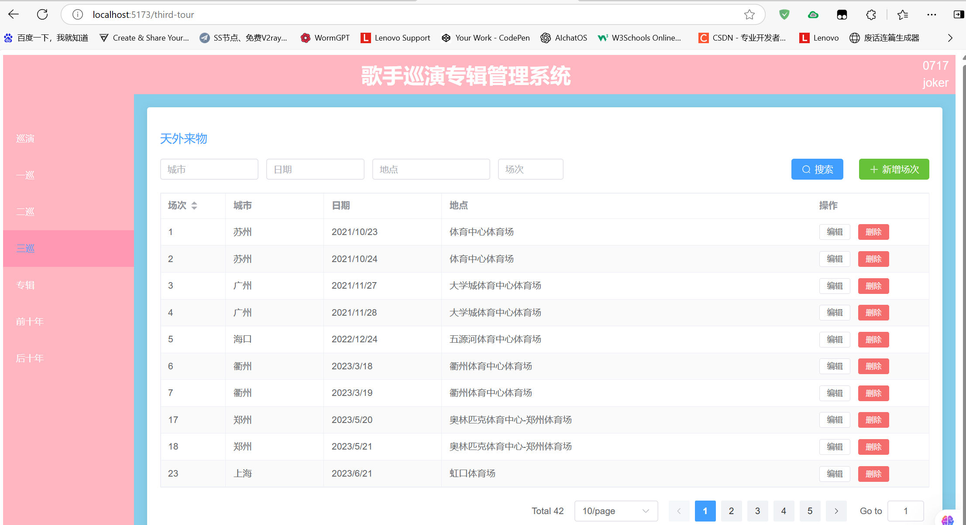
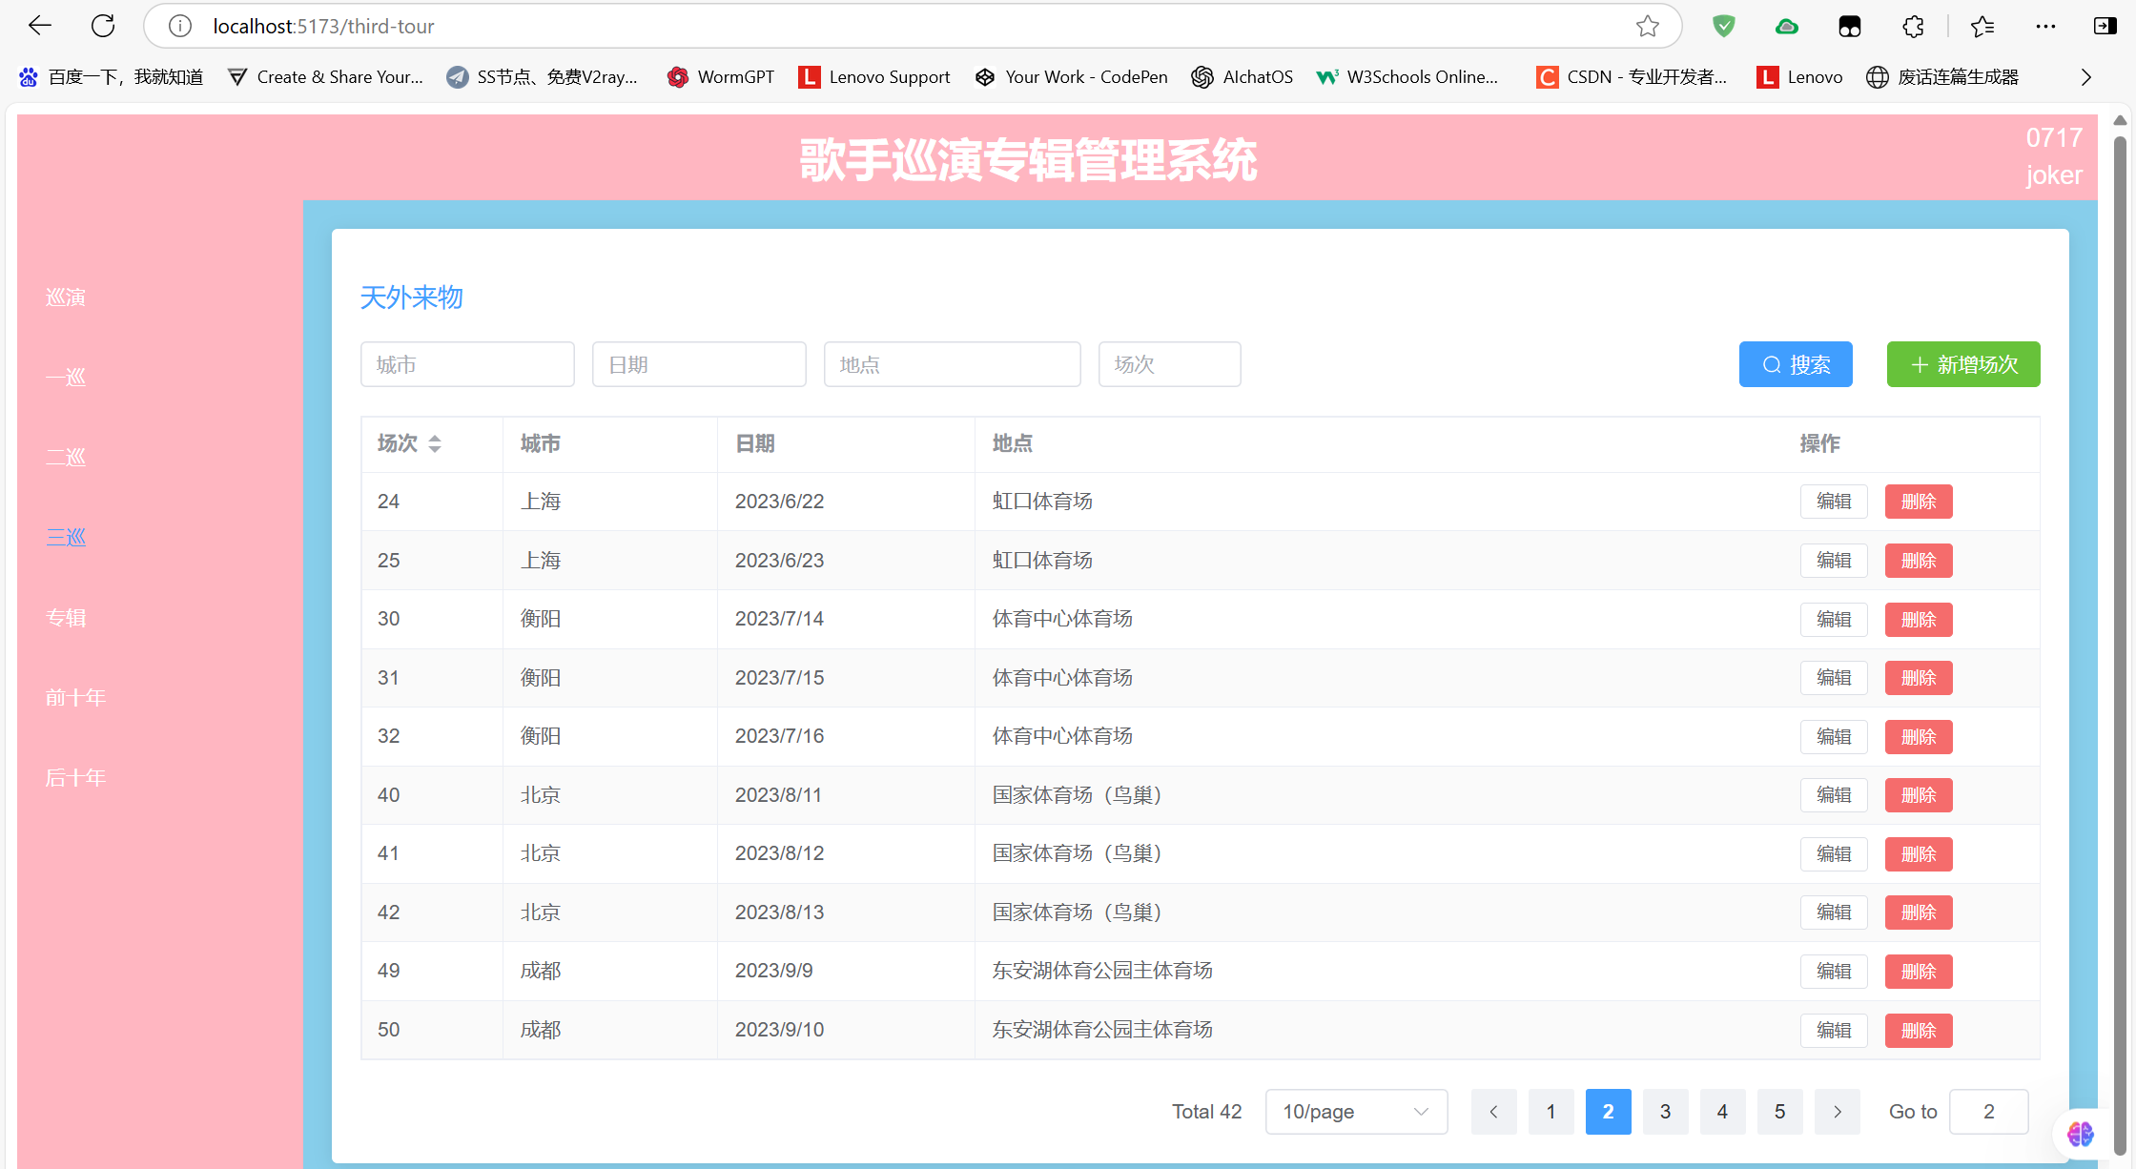
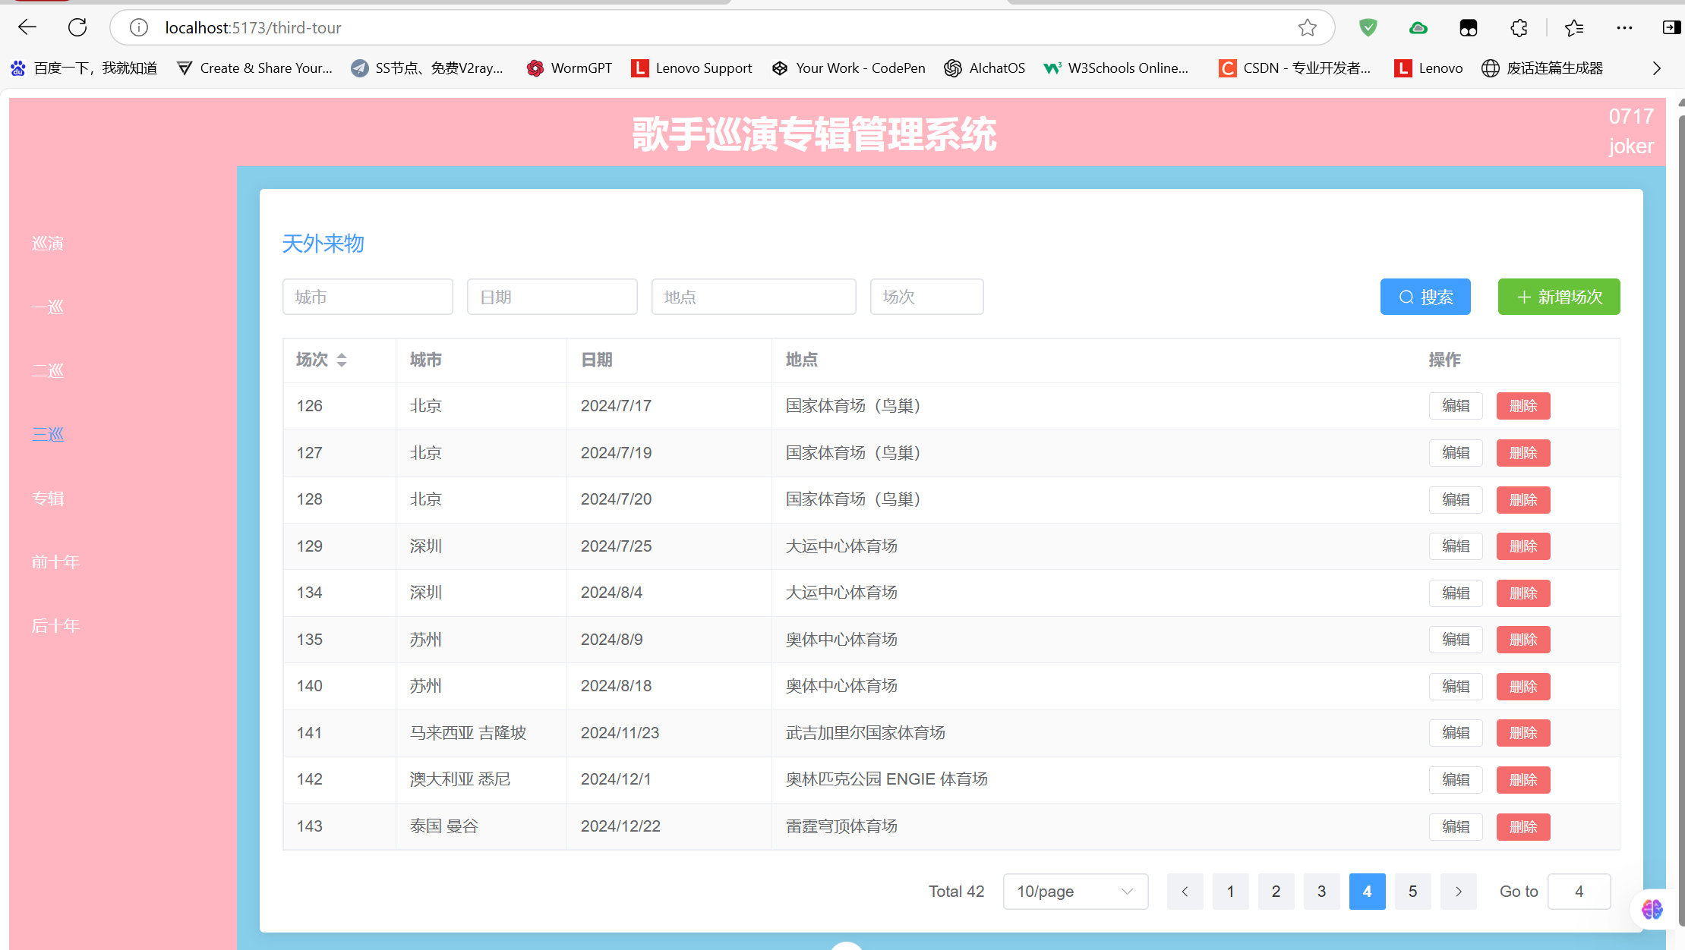
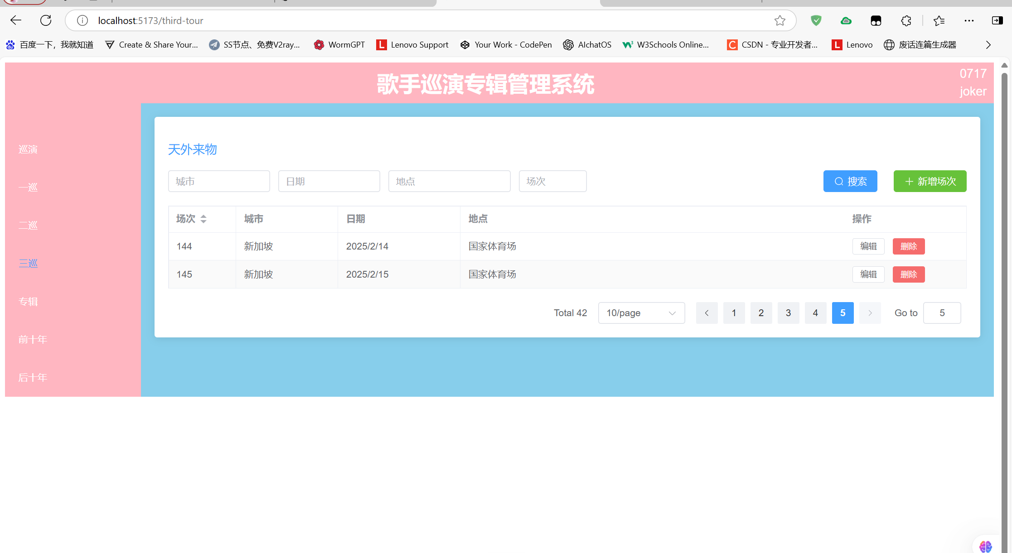
代码如下：
<template>
<div class="tour-management">
<h2>天外来物</h2>

<!-- 搜索和操作区 -->
<div class="action-bar">
<el-input v-model="queryParams.city" placeholder="城市" clearable style="width: 150px" />
<el-input v-model="queryParams.date" placeholder="日期" clearable style="width: 150px" />
<el-input v-model="queryParams.venue" placeholder="地点" clearable style="width: 180px" />
<el-input v-model="queryParams.tour" placeholder="场次" clearable style="width: 100px" />

<div class="action-buttons">
<el-button type="primary" @click="handleSearch" :icon="Search">搜索</el-button>
<el-button type="success" @click="handleAdd" :icon="Plus">新增场次</el-button>
</div>
</div>

<!-- 数据表格 -->
<el-table
:data="pagedData"
border
stripe
v-loading="loading"
style="width: 100%"
empty-text="暂无数据"
@sort-change="handleSortChange"
>
<el-table-column
prop="tour"
label="场次"
width="100"
sortable="custom"
/>
<el-table-column prop="city" label="城市" width="150" />
<el-table-column prop="date" label="日期" width="180">
<template #default="{ row }">
{{ formatDisplayDate(row.date) }}
</template>
</el-table-column>
<el-table-column prop="venue" label="地点" />
<el-table-column label="操作" width="180" fixed="right">
<template #default="{ row }">
<el-button
size="small"
@click="handleEdit(row)"
:disabled="row.status === 'published'"
>
编辑
</el-button>
<el-button
size="small"
type="danger"
@click="handleDelete(row.id)"
:loading="deleteLoading[row.id]"
>
删除
</el-button>
</template>
</el-table-column>
</el-table>

<!-- 分页组件 -->
<div class="pagination-container">
<el-pagination
v-model:current-page="currentPage"
v-model:page-size="pageSize"
:total="filteredData.length"
:page-sizes="[10, 20, 50, 100]"
layout="total, sizes, prev, pager, next, jumper"
background
@size-change="handleSizeChange"
@current-change="handleCurrentChange"
/>
</div>

<!-- 编辑弹窗 -->
<el-dialog
:title="dialogTitle"
v-model="dialogVisible"
width="500px"
@closed="handleDialogClosed"
>
<el-form
:model="formData"
:rules="formRules"
ref="formRef"
label-width="80px"
>
<el-form-item label="场次" prop="tour">
<el-input-number
v-model="formData.tour"
:min="1"
:max="200"
controls-position="right"
/>
</el-form-item>
<el-form-item label="城市" prop="city">
<el-input v-model="formData.city" />
</el-form-item>
<el-form-item label="日期" prop="date">
<el-date-picker
v-model="formData.date"
type="date"
value-format="YYYY-MM-DD"
placeholder="选择日期"
style="width: 100%"
/>
</el-form-item>
<el-form-item label="地点" prop="venue">
<el-input v-model="formData.venue" />
</el-form-item>
</el-form>
<template #footer>
<el-button @click="dialogVisible = false">取消</el-button>
<el-button
type="primary"
@click="submitForm"
:loading="submitting"
>
确认
</el-button>
</template>
</el-dialog>
</div>
</template>

<script lang="ts" setup>
import { ref, computed, reactive, onMounted } from 'vue'
import { ElMessage, ElMessageBox } from 'element-plus'
import { Search, Plus } from '@element-plus/icons-vue'
import type { FormInstance, FormRules } from 'element-plus'
import axios from 'axios'

// 类型定义
interface TourItem {
id?: number
tour: number
city: string
date: string
venue: string
status?: string
tourType?: 'thirdTour'
}

interface QueryParams {
city: string
date: string
venue: string
tour: string
sortField?: string
sortOrder?: string
}

// API 配置
const api = axios.create({
baseURL: import.meta.env.VITE_API_BASE_URL || 'http://localhost:3000',
timeout: 10000,
headers: {
'Content-Type': 'application/json'
}
})

// 当前巡演类型常量
const CURRENT_TOUR_TYPE = 'thirdTour'

// 状态管理
const loading = ref(false)
const submitting = ref(false)
const dialogVisible = ref(false)
const isEditMode = ref(false)
const deleteLoading = reactive<Record<number, boolean>>({})
const formRef = ref<FormInstance>()
const tourList = ref<TourItem[]>([])

// 分页相关
const currentPage = ref(1)
const pageSize = ref(10)

const queryParams = reactive<QueryParams>({
city: '',
date: '',
venue: '',
tour: ''
})

const formData = reactive<TourItem>({
id: undefined,
tour: 1,
city: '',
date: '',
venue: '',
tourType: CURRENT_TOUR_TYPE
})

const formRules = reactive<FormRules<TourItem>>({
tour: [
{ required: true, message: '请输入场次', trigger: 'blur' },
{ type: 'number', min: 1, max: 200, message: '场次需在1-200之间', trigger: 'blur' }
],
city: [
{ required: true, message: '请输入城市', trigger: 'blur' },
{ min: 2, max: 20, message: '长度在2到20个字符', trigger: 'blur' }
],
date: [
{ required: true, message: '请选择日期', trigger: 'change' }
],
venue: [
{ required: true, message: '请输入地点', trigger: 'blur' },
{ min: 2, max: 50, message: '长度在2到50个字符', trigger: 'blur' }
]
})

// 计算属性
const dialogTitle = computed(() => isEditMode.value ? '编辑场次' : '新增场次')
const filteredData = computed(() => {
return tourList.value.filter(item => {
return (
item.city.includes(queryParams.city) &&
item.venue.includes(queryParams.venue) &&
String(item.tour).includes(queryParams.tour) &&
(queryParams.date ? item.date.includes(queryParams.date) : true)
)
})
})
const pagedData = computed(() => {
const start = (currentPage.value - 1) * pageSize.value
const end = start + pageSize.value
return filteredData.value.slice(start, end)
})

// 生命周期
onMounted(() => {
fetchData()
})

// 方法定义
const fetchData = async () => {
try {
loading.value = true
const { data } = await api.get('/tours', {
params: {
tourType: CURRENT_TOUR_TYPE,
_sort: queryParams.sortField,
_order: queryParams.sortOrder
}
})
tourList.value = data.map((item: any) => ({
...item,
tour: Number(item.tour) || 1
}))
currentPage.value = 1 // 获取新数据时重置到第一页
} catch (error) {
handleApiError(error, '获取数据失败')
} finally {
loading.value = false
}
}

// 分页处理方法
const handleSizeChange = (val: number) => {
pageSize.value = val
currentPage.value = 1
}

const handleCurrentChange = (val: number) => {
currentPage.value = val
}

const handleSearch = () => {
fetchData()
}

const handleAdd = () => {
isEditMode.value = false
resetFormData()
dialogVisible.value = true
}

const handleEdit = (row: TourItem) => {
isEditMode.value = true
Object.assign(formData, JSON.parse(JSON.stringify(row)))
dialogVisible.value = true
}

const handleDelete = async (id: number) => {
try {
await ElMessageBox.confirm('确定删除该场次吗？此操作不可撤销！', '警告', {
confirmButtonText: '确定',
cancelButtonText: '取消',
type: 'warning',
center: true
})

deleteLoading[id] = true
await api.delete(`/tours/${id}`)
ElMessage.success('删除成功')
await fetchData()
} catch (error) {
if (error !== 'cancel') {
handleApiError(error, '删除失败')
}
} finally {
deleteLoading[id] = false
}
}

const submitForm = async () => {
try {
await formRef.value?.validate()
submitting.value = true

const payload = {
...formData,
tourType: CURRENT_TOUR_TYPE
}

if (isEditMode.value && formData.id) {
await api.put(`/tours/${formData.id}`, payload)
ElMessage.success('更新成功')
} else {
await api.post('/tours', payload)
ElMessage.success('添加成功')
}

dialogVisible.value = false
await fetchData()
} catch (error) {
if (error !== 'cancel') {
handleApiError(error, '提交失败')
}
} finally {
submitting.value = false
}
}

const handleSortChange = ({ prop, order }: { prop: string; order: string }) => {
queryParams.sortField = prop
queryParams.sortOrder = order === 'ascending' ? 'asc' : 'desc'
fetchData()
}

const handleDialogClosed = () => {
formRef.value?.resetFields()
}

const resetFormData = () => {
Object.assign(formData, {
id: undefined,
tour: 1,
city: '',
date: '',
venue: '',
tourType: CURRENT_TOUR_TYPE
})
}

const formatDisplayDate = (dateStr: string) => {
if (!dateStr) return ''
try {
return new Date(dateStr).toLocaleDateString('zh-CN')
} catch {
return dateStr
}
}

const handleApiError = (error: unknown, defaultMsg: string) => {
if (axios.isAxiosError(error)) {
ElMessage.error(error.response?.data?.message || defaultMsg)
} else {
ElMessage.error(defaultMsg)
}
console.error(error)
}
</script>

<style scoped>
.tour-management {
padding: 20px;
background: #fff;
border-radius: 4px;
box-shadow: 0 2px 12px 0 rgba(0, 0, 0, 0.1);
}

h2 {
margin-bottom: 20px;
color: var(--el-color-primary);
font-size: 18px;
font-weight: 500;
}

.action-bar {
display: flex;
flex-wrap: wrap;
gap: 12px;
margin-bottom: 20px;
align-items: center;
}

.action-buttons {
margin-left: auto;
display: flex;
gap: 12px;
}

.el-table {
margin-top: 16px;
}

:deep(.el-table__empty-block) {
min-height: 200px;
}

.pagination-container {
margin-top: 20px;
display: flex;
justify-content: flex-end;
}
</style>

4 专辑管理

4.1 前十年
简单设计了一个包含专辑相关数据的网页，数据存储独立，修改不影响其他网页信息。
添加数据
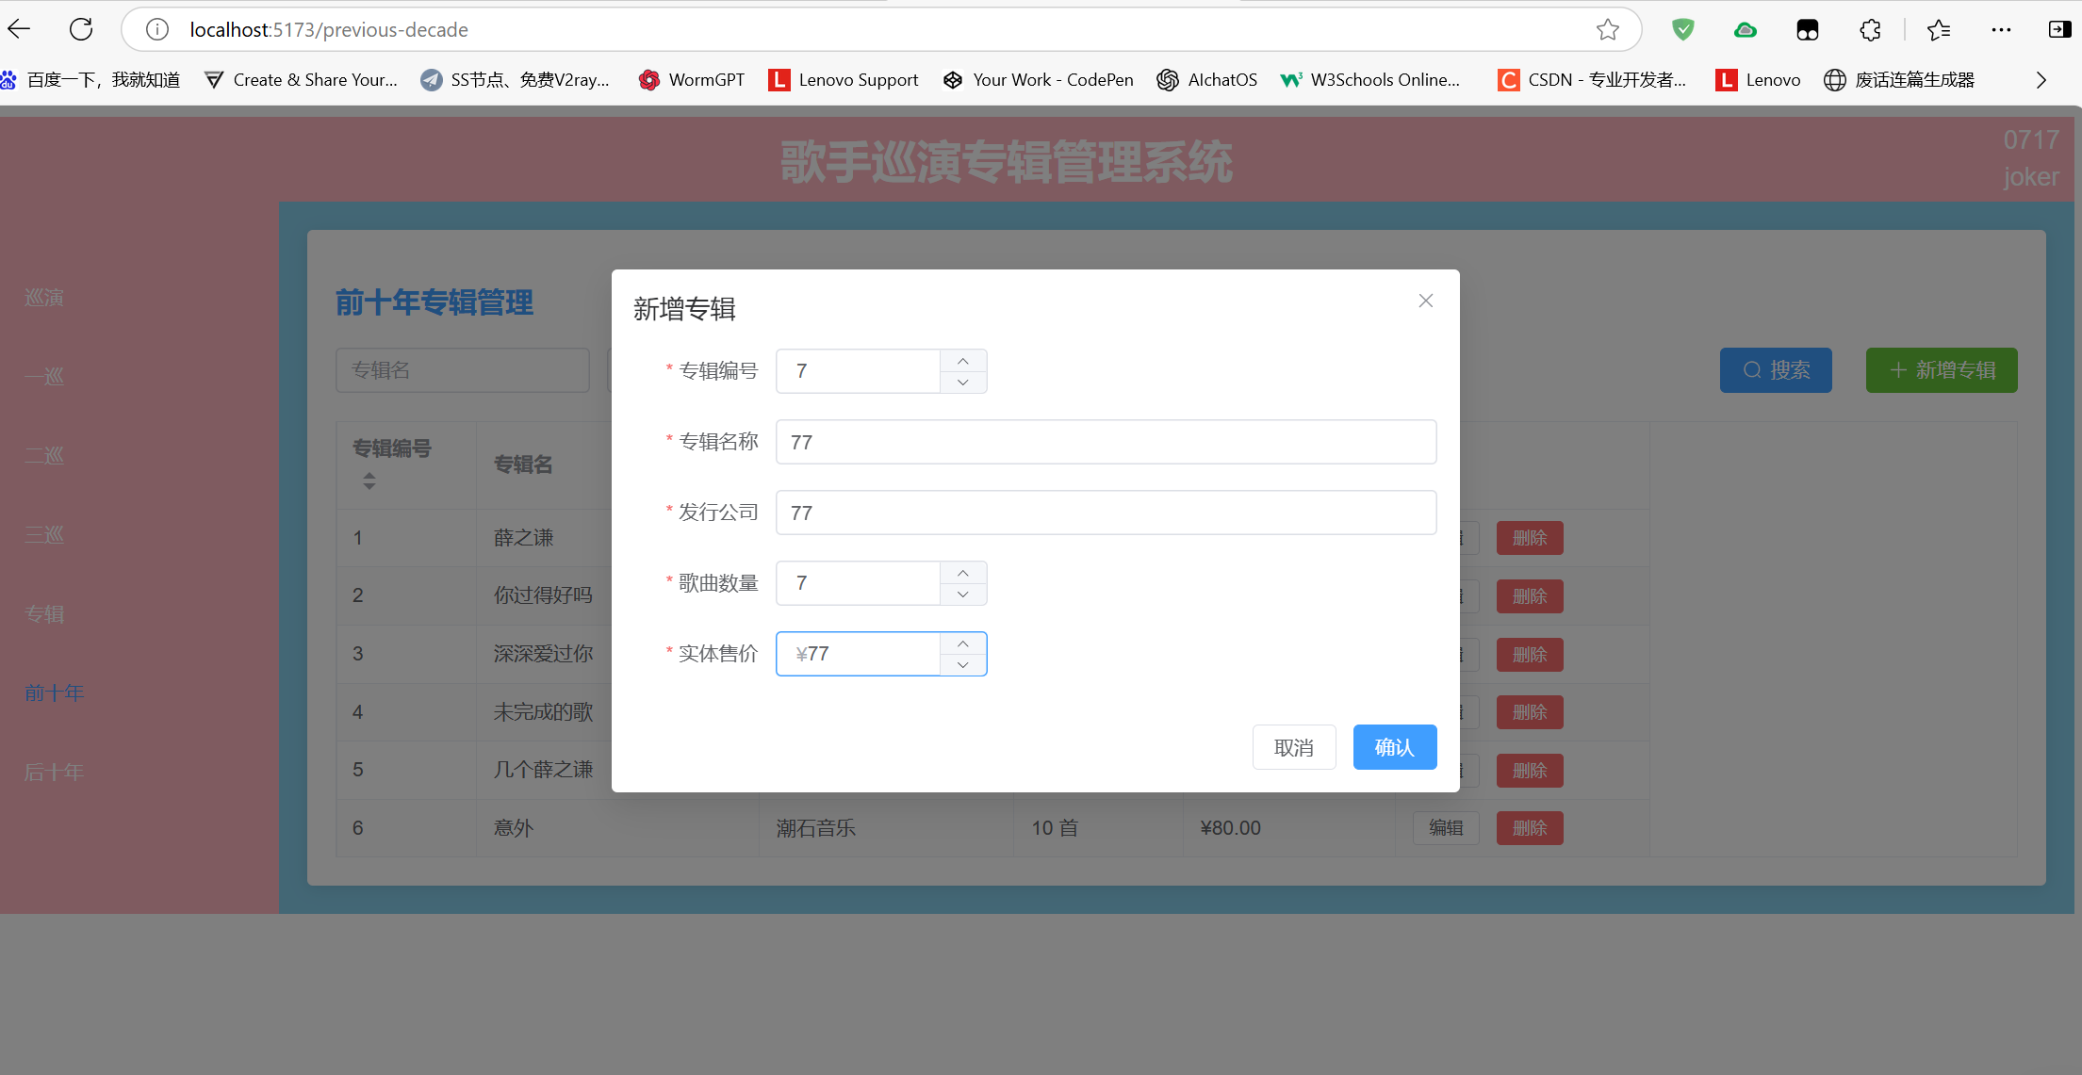
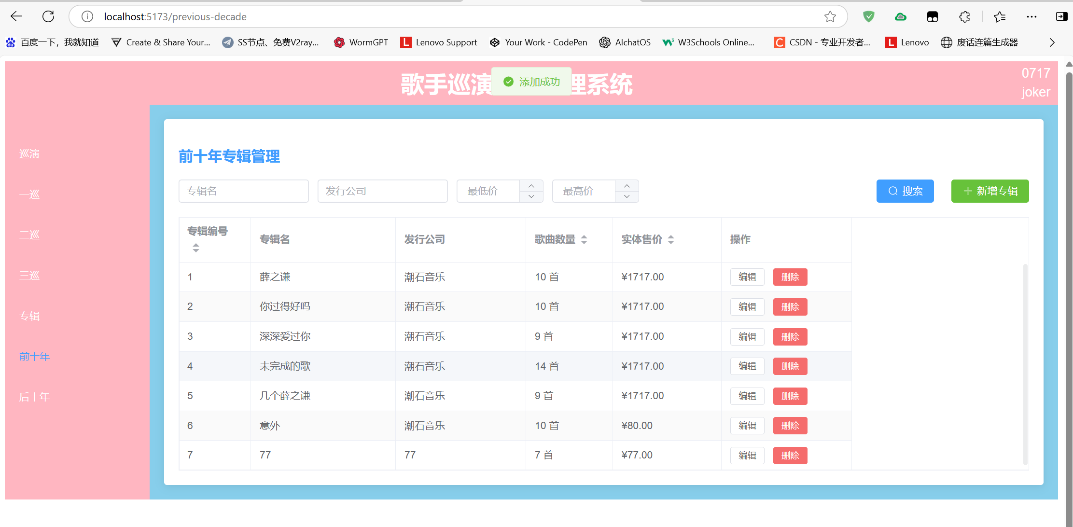
修改数据
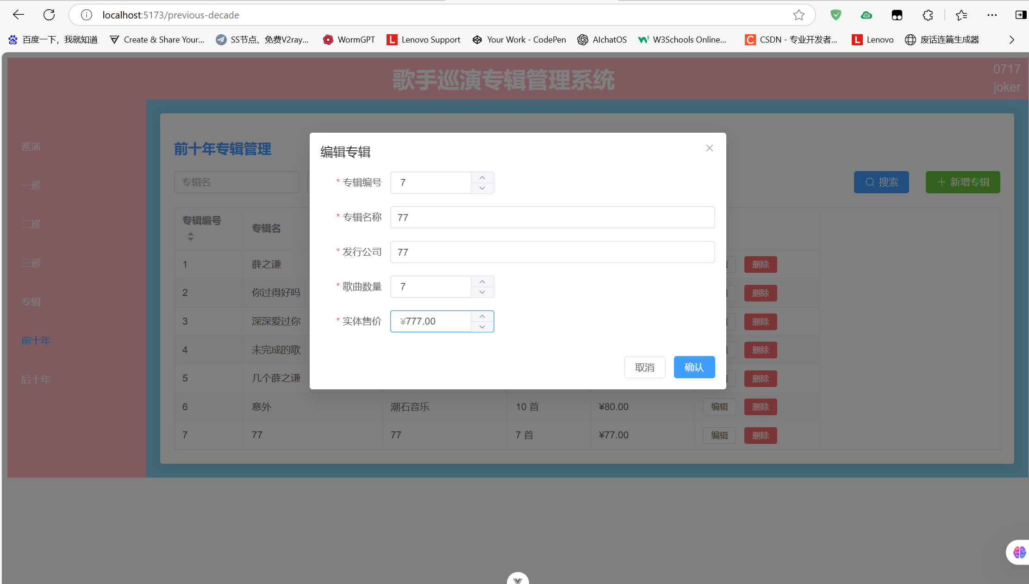
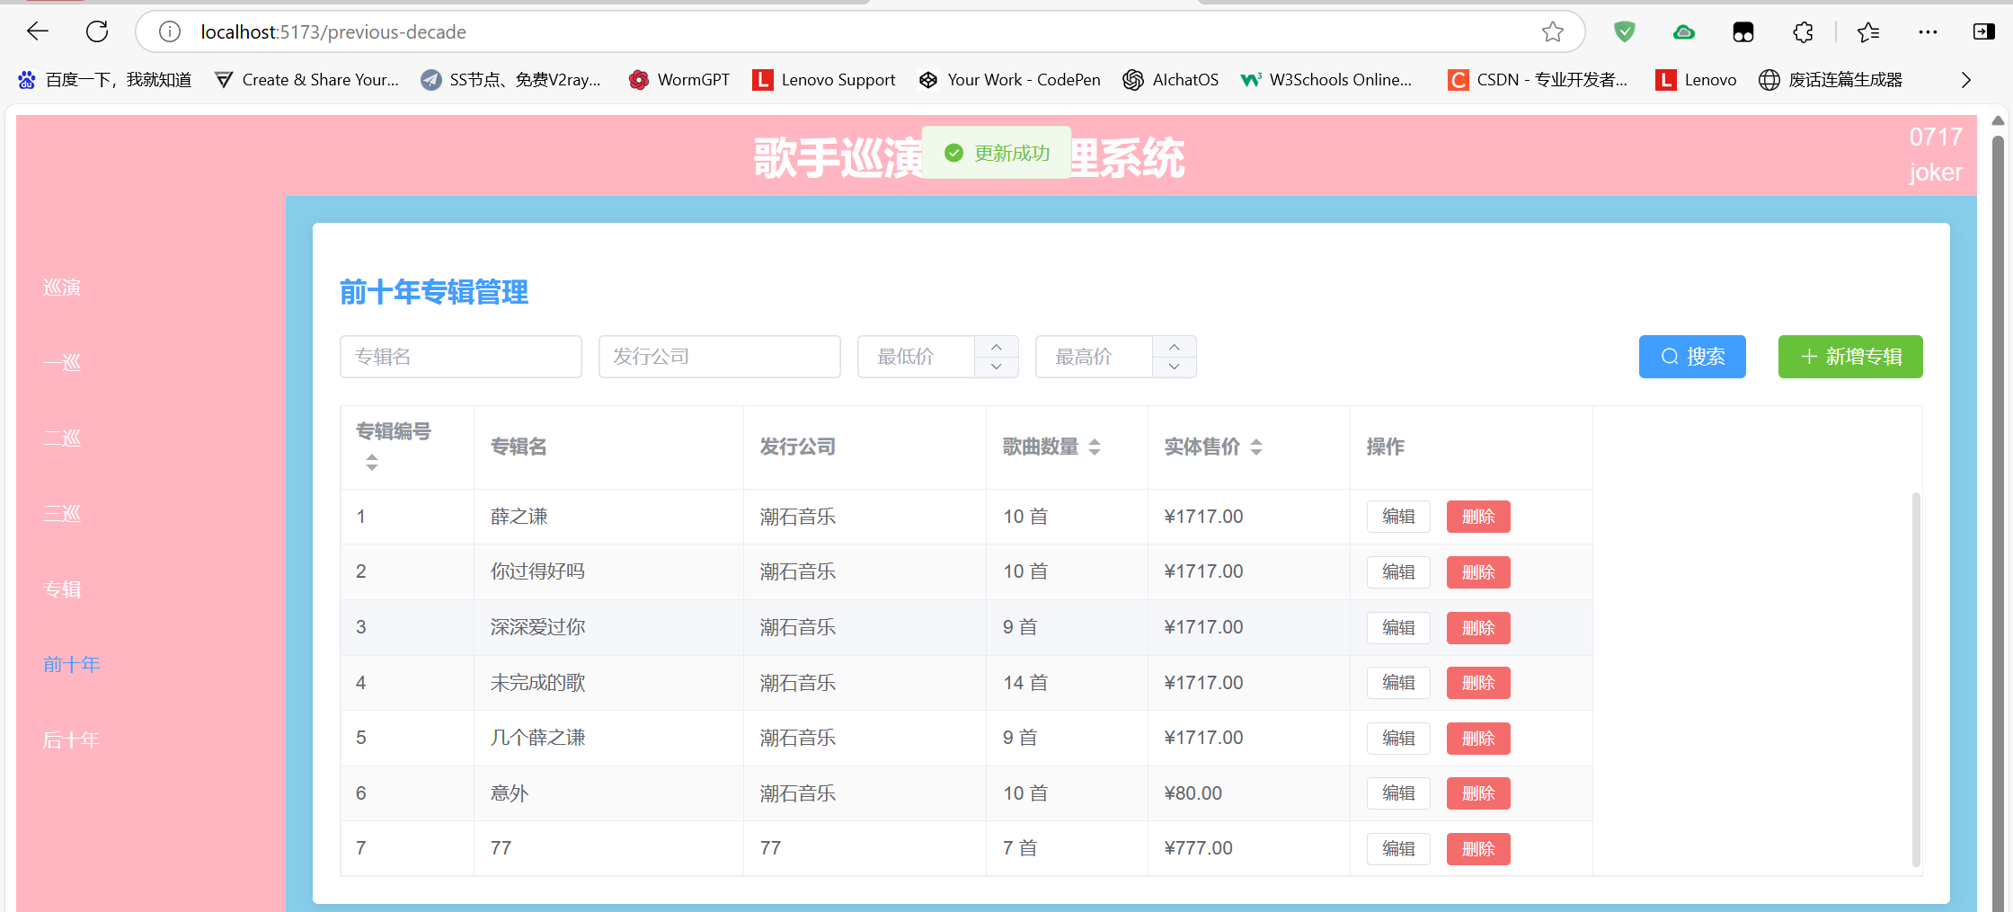
查询数据
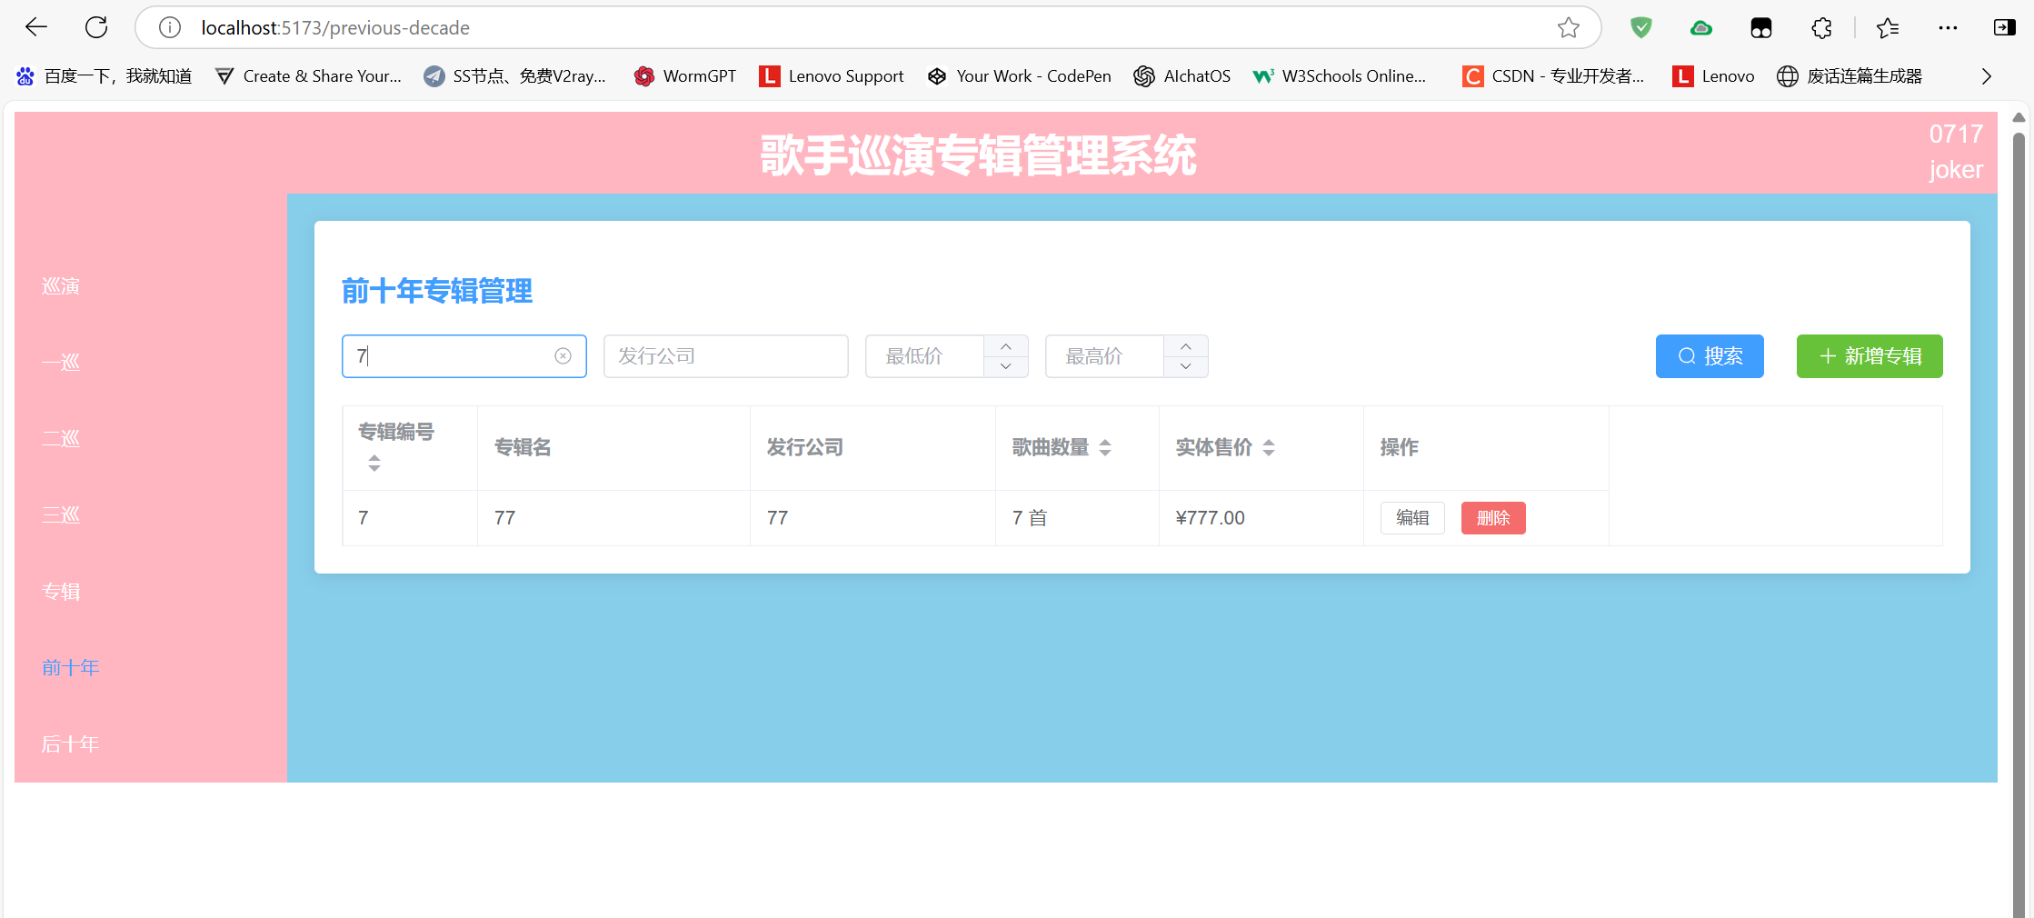
删除数据
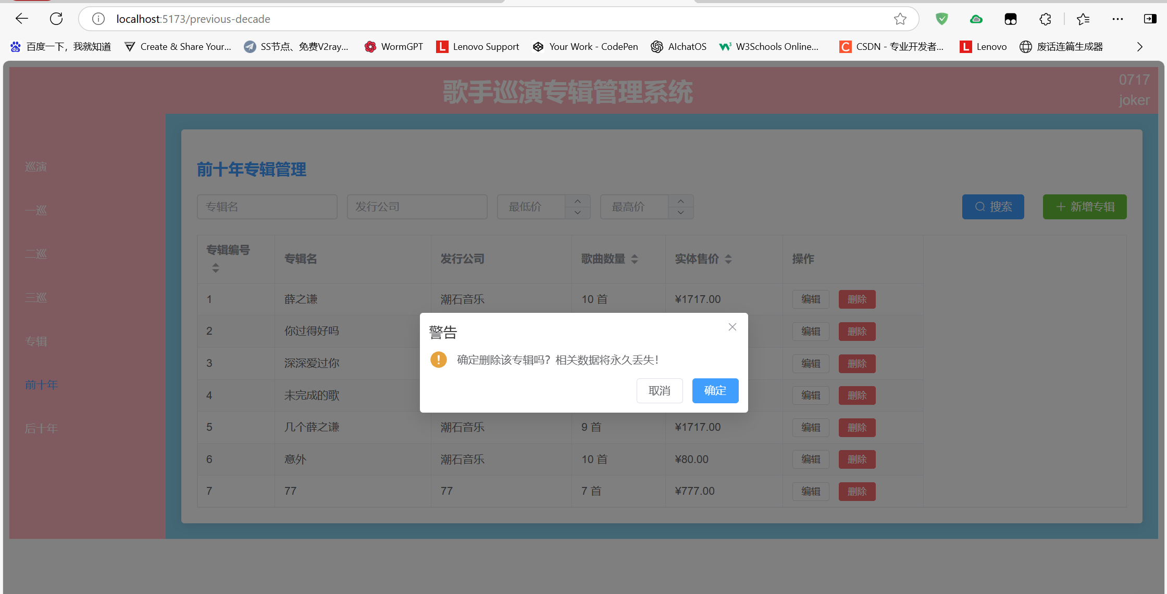
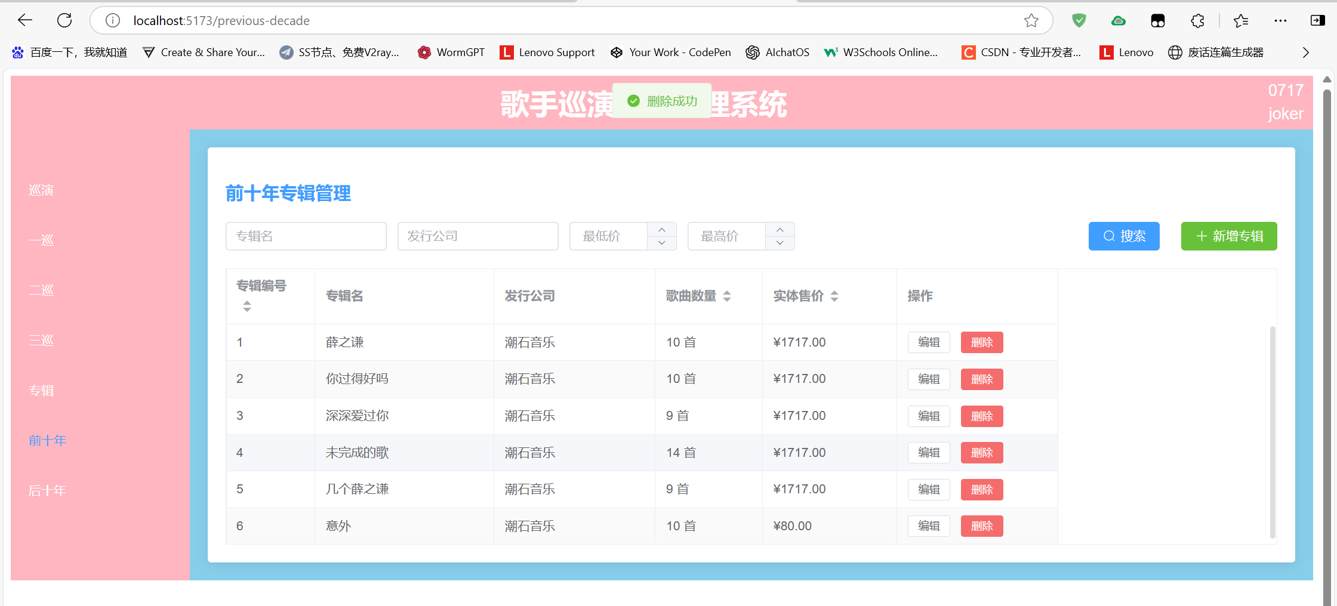
代码如下：
<template>
<div class="album-management">
<h2>前十年专辑管理</h2>

<!-- 搜索和操作区 -->
<div class="action-bar">
<el-input v-model="queryParams.albumName" placeholder="专辑名" clearable style="width: 180px" />
<el-input v-model="queryParams.company" placeholder="发行公司" clearable style="width: 180px" />
<el-input-number v-model="queryParams.minPrice" :min="0" placeholder="最低价" controls-position="right" style="width: 120px" />
<el-input-number v-model="queryParams.maxPrice" :min="0" placeholder="最高价" controls-position="right" style="width: 120px" />

<div class="action-buttons">
<el-button type="primary" @click="handleSearch" :icon="Search">搜索</el-button>
<el-button type="success" @click="handleAdd" :icon="Plus">新增专辑</el-button>
</div>
</div>

<!-- 数据表格 -->
<el-table
:data="filteredData"
border
stripe
v-loading="loading"
style="width: 100%"
empty-text="暂无数据"
@sort-change="handleSortChange"
>
<el-table-column
prop="albumNumber"
label="专辑编号"
width="100"
sortable="custom"
/>
<el-table-column prop="albumName" label="专辑名" width="200" />
<el-table-column prop="company" label="发行公司" width="180" />
<el-table-column prop="songCount" label="歌曲数量" width="120" sortable="custom">
<template #default="{ row }">
{{ row.songCount }} 首
</template>
</el-table-column>
<el-table-column prop="price" label="实体售价" width="150" sortable="custom">
<template #default="{ row }">
¥{{ row.price.toFixed(2) }}
</template>
</el-table-column>
<el-table-column label="操作" width="180" fixed="right">
<template #default="{ row }">
<el-button size="small" @click="handleEdit(row)">编辑</el-button>
<el-button
size="small"
type="danger"
@click="handleDelete(row.id)"
:loading="deleteLoading[row.id]"
>
删除
</el-button>
</template>
</el-table-column>
</el-table>

<!-- 编辑弹窗 -->
<el-dialog
:title="dialogTitle"
v-model="dialogVisible"
width="600px"
@closed="handleDialogClosed"
>
<el-form
:model="formData"
:rules="formRules"
ref="formRef"
label-width="100px"
>
<el-form-item label="专辑编号" prop="albumNumber">
<el-input-number
v-model="formData.albumNumber"
:min="1"
controls-position="right"
/>
</el-form-item>
<el-form-item label="专辑名称" prop="albumName">
<el-input v-model="formData.albumName" />
</el-form-item>
<el-form-item label="发行公司" prop="company">
<el-input v-model="formData.company" />
</el-form-item>
<el-form-item label="歌曲数量" prop="songCount">
<el-input-number
v-model="formData.songCount"
:min="1"
:max="50"
controls-position="right"
/>
</el-form-item>
<el-form-item label="实体售价" prop="price">
<el-input-number
v-model="formData.price"
:min="0"
:precision="2"
controls-position="right"
>
<template #prefix>¥</template>
</el-input-number>
</el-form-item>
</el-form>
<template #footer>
<el-button @click="dialogVisible = false">取消</el-button>
<el-button
type="primary"
@click="submitForm"
:loading="submitting"
>
确认
</el-button>
</template>
</el-dialog>
</div>
</template>

<script lang="ts" setup>
import { ref, computed, reactive, onMounted } from 'vue'
import { ElMessage, ElMessageBox } from 'element-plus'
import { Search, Plus } from '@element-plus/icons-vue'
import type { FormInstance, FormRules } from 'element-plus'
import axios from 'axios'

// 类型定义
interface Album {
id?: number
albumNumber: number
albumName: string
company: string
songCount: number
price: number
decade: 'previous' | 'next' // 年代分类
}

interface QueryParams {
albumName: string
company: string
minPrice?: number
maxPrice?: number
sortField?: string
sortOrder?: string
}

// API 配置
const api = axios.create({
baseURL: import.meta.env.VITE_API_BASE_URL || 'http://localhost:3000',
timeout: 10000
})

// 状态管理
const loading = ref(false)
const submitting = ref(false)
const dialogVisible = ref(false)
const isEditMode = ref(false)
const deleteLoading = reactive<Record<number, boolean>>({})
const formRef = ref<FormInstance>()
const albumList = ref<Album[]>([])

const queryParams = reactive<QueryParams>({
albumName: '',
company: '',
minPrice: undefined,
maxPrice: undefined
})

const formData = reactive<Album>({
albumNumber: 1,
albumName: '',
company: '',
songCount: 10,
price: 99.0,
decade: 'previous' // 固定为前十年
})

const formRules = reactive<FormRules<Album>>({
albumNumber: [
{ required: true, message: '请输入专辑编号', trigger: 'blur' },
{ type: 'number', min: 1, message: '编号必须大于0', trigger: 'blur' }
],
albumName: [
{ required: true, message: '请输入专辑名', trigger: 'blur' },
{ min: 2, max: 50, message: '长度在2-50个字符', trigger: 'blur' }
],
company: [
{ required: true, message: '请输入发行公司', trigger: 'blur' },
{ min: 2, max: 50, message: '长度在2-50个字符', trigger: 'blur' }
],
songCount: [
{ required: true, message: '请输入歌曲数量', trigger: 'blur' },
{ type: 'number', min: 1, max: 50, message: '1-50首之间', trigger: 'blur' }
],
price: [
{ required: true, message: '请输入售价', trigger: 'blur' },
{ type: 'number', min: 0, message: '不能为负数', trigger: 'blur' }
]
})

// 计算属性
const dialogTitle = computed(() => isEditMode.value ? '编辑专辑' : '新增专辑')
const filteredData = computed(() => {
return albumList.value.filter(item => {
const priceValid = (
(queryParams.minPrice === undefined || item.price >= queryParams.minPrice) &&
(queryParams.maxPrice === undefined || item.price <= queryParams.maxPrice)
)
return (
item.albumName.includes(queryParams.albumName) &&
item.company.includes(queryParams.company) &&
priceValid
)
})
})

// 生命周期
onMounted(() => {
fetchData()
})

// 方法定义
const fetchData = async () => {
try {
loading.value = true
const { data } = await api.get('/albums', {
params: {
decade: 'previous', // 关键过滤参数
_sort: queryParams.sortField,
_order: queryParams.sortOrder,
price_gte: queryParams.minPrice,
price_lte: queryParams.maxPrice
}
})
albumList.value = data
} catch (error) {
handleApiError(error, '获取数据失败')
} finally {
loading.value = false
}
}

const handleSearch = () => {
fetchData()
}

const handleAdd = () => {
isEditMode.value = false
resetFormData()
dialogVisible.value = true
}

const handleEdit = (row: Album) => {
isEditMode.value = true
Object.assign(formData, JSON.parse(JSON.stringify(row)))
dialogVisible.value = true
}

const handleDelete = async (id: number) => {
try {
await ElMessageBox.confirm('确定删除该专辑吗？相关数据将永久丢失！', '警告', {
confirmButtonText: '确定',
cancelButtonText: '取消',
type: 'warning'
})

deleteLoading[id] = true
await api.delete(`/albums/${id}`)
ElMessage.success('删除成功')
await fetchData()
} catch (error) {
if (error !== 'cancel') {
handleApiError(error, '删除失败')
}
} finally {
deleteLoading[id] = false
}
}

const submitForm = async () => {
try {
await formRef.value?.validate()
submitting.value = true

const payload = {
...formData,
decade: 'previous' // 确保数据分类正确
}

if (isEditMode.value && formData.id) {
await api.put(`/albums/${formData.id}`, payload)
ElMessage.success('更新成功')
} else {
await api.post('/albums', payload)
ElMessage.success('添加成功')
}

dialogVisible.value = false
await fetchData()
} catch (error) {
if (error !== 'cancel') {
handleApiError(error, '提交失败')
}
} finally {
submitting.value = false
}
}

const handleSortChange = ({ prop, order }: { prop: string; order: string }) => {
queryParams.sortField = prop
queryParams.sortOrder = order === 'ascending' ? 'asc' : 'desc'
fetchData()
}

const handleDialogClosed = () => {
formRef.value?.resetFields()
}

const resetFormData = () => {
Object.assign(formData, {
id: undefined,
albumNumber: 1,
albumName: '',
company: '',
songCount: 10,
price: 99.0,
decade: 'previous'
})
}

const handleApiError = (error: unknown, defaultMsg: string) => {
if (axios.isAxiosError(error)) {
ElMessage.error(error.response?.data?.message || defaultMsg)
} else {
ElMessage.error(defaultMsg)
}
console.error(error)
}
</script>

<style scoped>
.album-management {
padding: 20px;
background: #fff;
border-radius: 4px;
box-shadow: 0 2px 12px 0 rgba(0, 0, 0, 0.1);
}

h2 {
margin-bottom: 20px;
color: var(--el-color-primary);
font-size: 20px;
font-weight: 600;
}

.action-bar {
display: flex;
flex-wrap: wrap;
gap: 12px;
margin-bottom: 20px;
align-items: center;
}

.action-buttons {
margin-left: auto;
display: flex;
gap: 12px;
}

.el-table {
margin-top: 16px;
}

:deep(.el-input-number .el-input__inner) {
text-align: left;
}
</style>

4.2后十年
和前十年基本相同，这里展示页面效果。
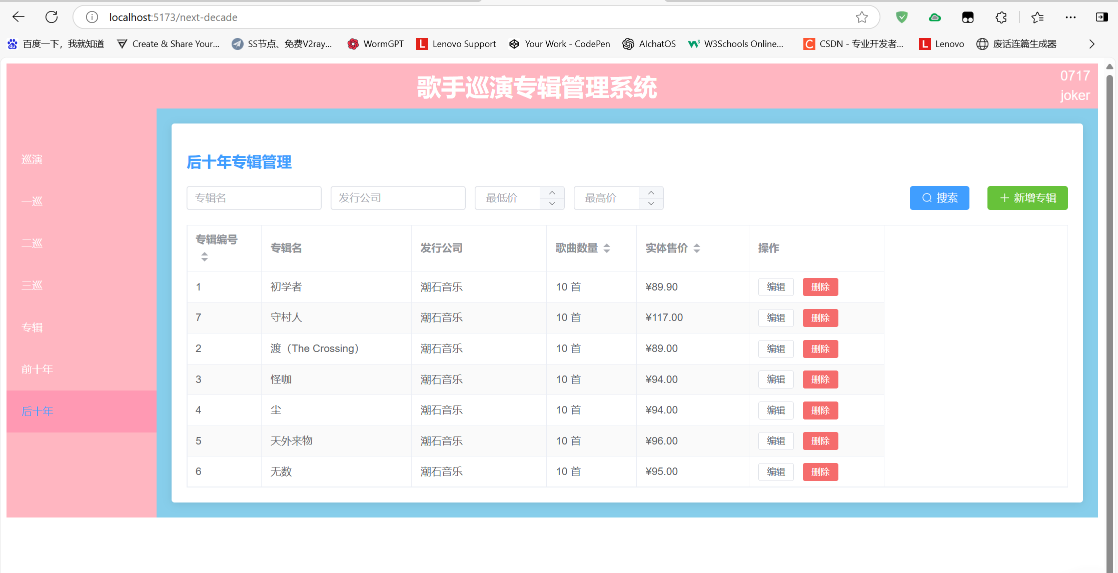
代码如下：
<template>
<div class="album-management">
<h2>后十年专辑管理</h2>

<!-- 搜索和操作区 -->
<div class="action-bar">
<el-input v-model="queryParams.albumName" placeholder="专辑名" clearable style="width: 180px" />
<el-input v-model="queryParams.company" placeholder="发行公司" clearable style="width: 180px" />
<el-input-number v-model="queryParams.minPrice" :min="0" placeholder="最低价" controls-position="right" style="width: 120px" />
<el-input-number v-model="queryParams.maxPrice" :min="0" placeholder="最高价" controls-position="right" style="width: 120px" />

<div class="action-buttons">
<el-button type="primary" @click="handleSearch" :icon="Search">搜索</el-button>
<el-button type="success" @click="handleAdd" :icon="Plus">新增专辑</el-button>
</div>
</div>

<!-- 数据表格 -->
<el-table
:data="filteredData"
border
stripe
v-loading="loading"
style="width: 100%"
empty-text="暂无数据"
@sort-change="handleSortChange"
>
<el-table-column
prop="albumNumber"
label="专辑编号"
width="100"
sortable="custom"
/>
<el-table-column prop="albumName" label="专辑名" width="200" />
<el-table-column prop="company" label="发行公司" width="180" />
<el-table-column prop="songCount" label="歌曲数量" width="120" sortable="custom">
<template #default="{ row }">
{{ row.songCount }} 首
</template>
</el-table-column>
<el-table-column prop="price" label="实体售价" width="150" sortable="custom">
<template #default="{ row }">
¥{{ row.price.toFixed(2) }}
</template>
</el-table-column>
<el-table-column label="操作" width="180" fixed="right">
<template #default="{ row }">
<el-button size="small" @click="handleEdit(row)">编辑</el-button>
<el-button
size="small"
type="danger"
@click="handleDelete(row.id)"
:loading="deleteLoading[row.id]"
>
删除
</el-button>
</template>
</el-table-column>
</el-table>

<!-- 编辑弹窗 -->
<el-dialog
:title="dialogTitle"
v-model="dialogVisible"
width="600px"
@closed="handleDialogClosed"
>
<el-form
:model="formData"
:rules="formRules"
ref="formRef"
label-width="100px"
>
<el-form-item label="专辑编号" prop="albumNumber">
<el-input-number
v-model="formData.albumNumber"
:min="1"
controls-position="right"
/>
</el-form-item>
<el-form-item label="专辑名称" prop="albumName">
<el-input v-model="formData.albumName" />
</el-form-item>
<el-form-item label="发行公司" prop="company">
<el-input v-model="formData.company" />
</el-form-item>
<el-form-item label="歌曲数量" prop="songCount">
<el-input-number
v-model="formData.songCount"
:min="1"
:max="50"
controls-position="right"
/>
</el-form-item>
<el-form-item label="实体售价" prop="price">
<el-input-number
v-model="formData.price"
:min="0"
:precision="2"
controls-position="right"
>
<template #prefix>¥</template>
</el-input-number>
</el-form-item>
</el-form>
<template #footer>
<el-button @click="dialogVisible = false">取消</el-button>
<el-button
type="primary"
@click="submitForm"
:loading="submitting"
>
确认
</el-button>
</template>
</el-dialog>
</div>
</template>

<script lang="ts" setup>
import { ref, computed, reactive, onMounted } from 'vue'
import { ElMessage, ElMessageBox } from 'element-plus'
import { Search, Plus } from '@element-plus/icons-vue'
import type { FormInstance, FormRules } from 'element-plus'
import axios from 'axios'

// 类型定义
interface Album {
id?: number
albumNumber: number
albumName: string
company: string
songCount: number
price: number
decade: 'next' // 年代分类
}

interface QueryParams {
albumName: string
company: string
minPrice?: number
maxPrice?: number
sortField?: string
sortOrder?: string
}

// API 配置
const api = axios.create({
baseURL: import.meta.env.VITE_API_BASE_URL || 'http://localhost:3000',
timeout: 10000
})

// 状态管理
const loading = ref(false)
const submitting = ref(false)
const dialogVisible = ref(false)
const isEditMode = ref(false)
const deleteLoading = reactive<Record<number, boolean>>({})
const formRef = ref<FormInstance>()
const albumList = ref<Album[]>([])

const queryParams = reactive<QueryParams>({
albumName: '',
company: '',
minPrice: undefined,
maxPrice: undefined
})

const formData = reactive<Album>({
albumNumber: 1,
albumName: '',
company: '',
songCount: 10,
price: 99.0,
decade: 'next' // 固定为后十年
})

const formRules = reactive<FormRules<Album>>({
albumNumber: [
{ required: true, message: '请输入专辑编号', trigger: 'blur' },
{ type: 'number', min: 1, message: '编号必须大于0', trigger: 'blur' }
],
albumName: [
{ required: true, message: '请输入专辑名', trigger: 'blur' },
{ min: 2, max: 50, message: '长度在2-50个字符', trigger: 'blur' }
],
company: [
{ required: true, message: '请输入发行公司', trigger: 'blur' },
{ min: 2, max: 50, message: '长度在2-50个字符', trigger: 'blur' }
],
songCount: [
{ required: true, message: '请输入歌曲数量', trigger: 'blur' },
{ type: 'number', min: 1, max: 50, message: '1-50首之间', trigger: 'blur' }
],
price: [
{ required: true, message: '请输入售价', trigger: 'blur' },
{ type: 'number', min: 0, message: '不能为负数', trigger: 'blur' }
]
})

// 计算属性
const dialogTitle = computed(() => isEditMode.value ? '编辑专辑' : '新增专辑')
const filteredData = computed(() => {
return albumList.value.filter(item => {
const priceValid = (
(queryParams.minPrice === undefined || item.price >= queryParams.minPrice) &&
(queryParams.maxPrice === undefined || item.price <= queryParams.maxPrice)
)
return (
item.albumName.includes(queryParams.albumName) &&
item.company.includes(queryParams.company) &&
priceValid
)
})
})

// 生命周期
onMounted(() => {
fetchData()
})

// 方法定义
const fetchData = async () => {
try {
loading.value = true
const { data } = await api.get('/albums', {
params: {
decade: 'next', // 关键过滤参数
_sort: queryParams.sortField,
_order: queryParams.sortOrder,
price_gte: queryParams.minPrice,
price_lte: queryParams.maxPrice
}
})
albumList.value = data
} catch (error) {
handleApiError(error, '获取数据失败')
} finally {
loading.value = false
}
}

const handleSearch = () => {
fetchData()
}

const handleAdd = () => {
isEditMode.value = false
resetFormData()
dialogVisible.value = true
}

const handleEdit = (row: Album) => {
isEditMode.value = true
Object.assign(formData, JSON.parse(JSON.stringify(row)))
dialogVisible.value = true
}

const handleDelete = async (id: number) => {
try {
await ElMessageBox.confirm('确定删除该专辑吗？相关数据将永久丢失！', '警告', {
confirmButtonText: '确定',
cancelButtonText: '取消',
type: 'warning'
})

deleteLoading[id] = true
await api.delete(`/albums/${id}`)
ElMessage.success('删除成功')
await fetchData()
} catch (error) {
if (error !== 'cancel') {
handleApiError(error, '删除失败')
}
} finally {
deleteLoading[id] = false
}
}

const submitForm = async () => {
try {
await formRef.value?.validate()
submitting.value = true

const payload = {
...formData,
decade: 'next' // 确保数据分类正确
}

if (isEditMode.value && formData.id) {
await api.put(`/albums/${formData.id}`, payload)
ElMessage.success('更新成功')
} else {
await api.post('/albums', payload)
ElMessage.success('添加成功')
}

dialogVisible.value = false
await fetchData()
} catch (error) {
if (error !== 'cancel') {
handleApiError(error, '提交失败')
}
} finally {
submitting.value = false
}
}

const handleSortChange = ({ prop, order }: { prop: string; order: string }) => {
queryParams.sortField = prop
queryParams.sortOrder = order === 'ascending' ? 'asc' : 'desc'
fetchData()
}

const handleDialogClosed = () => {
formRef.value?.resetFields()
}

const resetFormData = () => {
Object.assign(formData, {
id: undefined,
albumNumber: 1,
albumName: '',
company: '',
songCount: 10,
price: 99.0,
decade: 'next'
})
}

const handleApiError = (error: unknown, defaultMsg: string) => {
if (axios.isAxiosError(error)) {
ElMessage.error(error.response?.data?.message || defaultMsg)
} else {
ElMessage.error(defaultMsg)
}
console.error(error)
}
</script>

<style scoped>
.album-management {
padding: 20px;
background: #fff;
border-radius: 4px;
box-shadow: 0 2px 12px 0 rgba(0, 0, 0, 0.1);
}

h2 {
margin-bottom: 20px;
color: var(--el-color-primary);
font-size: 20px;
font-weight: 600;
}

.action-bar {
display: flex;
flex-wrap: wrap;
gap: 12px;
margin-bottom: 20px;
align-items: center;
}

.action-buttons {
margin-left: auto;
display: flex;
gap: 12px;
}

.el-table {
margin-top: 16px;
}

:deep(.el-input-number .el-input__inner) {
text-align: left;
}
</style>

6 系统管理
其他相关代码如下。
/src/main.ts代码如下：
// 从 'vue' 包中导入 createApp 函数，创建 Vue 应用实例
import { createApp } from 'vue';

// 导入根组件 App.vue
import App from './App.vue';

// 导入路由配置（router）
import router from './router';

// 导入 ElementPlus UI 库
import ElementPlus from 'element-plus';

// 导入 ElementPlus 的 CSS 样式文件
import 'element-plus/dist/index.css';

// 创建 Vue 应用实例，并将根组件 App 传递给 createApp 函数
const app = createApp(App);

// 使用 Vue 应用实例中的路由配置
app.use(router);

// 使用 ElementPlus UI 库
app.use(ElementPlus);

// 将 Vue 应用挂载到 HTML 中的 id 为 'app' 的 DOM 元素上
app.mount('#app');
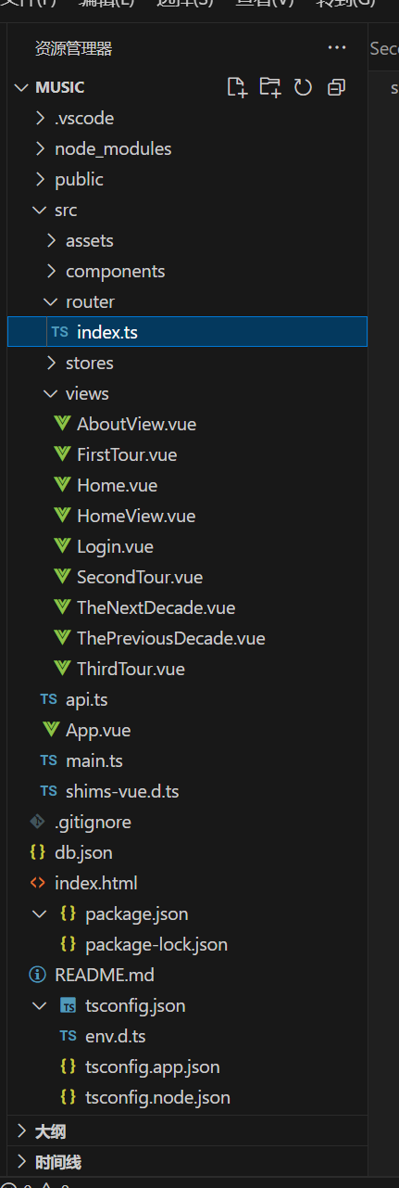
上图是工程的结构，各个代码的存放路径如上所示。

7.心得体会
在本次工程中，我通过创建名为 music 的项目，并新增 db.json 文件，成功模拟了后端服务器的响应，确保在本地开发环境下能进行真实的 API 调用和数据交互。通过这一过程，我深入理解了前后端分离的开发模式，并且能够在没有真实后端的情况下，利用模拟数据进行开发和调试。
在项目开发过程中，我使用了 Element Plus 组件库（基于 Vue 3），为用户界面提供了丰富的交互组件，同时，配合 Vue Router 实现了页面之间的跳转和导航。通过配置路由守卫，我能够实现页面的动态跳转与状态管理，为用户提供更加流畅的体验。
为了更好地展示数据，我在项目中设计了多个功能模块，如巡演板块和专辑板块。在巡演板块中，展示了场次、城市、日期和地点等相关信息，而专辑板块则包括专辑编号、专辑名称、发行公司、歌曲数量和实体售价等内容。考虑到不同板块的数据量和展示需求，我在二巡和三巡板块中实现了分页功能，以提高页面的可用性和用户体验。
通过这次项目的实践，我不仅掌握了 Vue.js 的基本语法和指令，学会了如何使用计算属性、监听器和事件来实现动态交互，还对表单设计、样式绑定和页面美化有了更深入的理解。通过绑定 HTML 样式和内联样式，我能够为页面增添美观的视觉效果，提升了用户体验。
此外，我也在组件化开发、数据请求和单页面应用（SPA）的开发中积累了实际经验。通过项目中的 API 请求，我了解了如何通过 Vue 的生命周期钩子函数管理数据加载，以及如何处理异步请求和数据更新。通过这些技术的结合，我成功开发了一个功能齐全、页面丰富的小型管理系统。
总的来说，这次实践不仅加深了我对前端开发技术栈的理解，也提升了我的开发能力。通过与实际生活场景的结合，我更加明白了前端开发在实际项目中的应用和重要性。我将继续在实践中不断完善自己的技能，努力提高开发效率和代码质量。

