**GEOG 485L/585L Midterm Exam**

**Due Wednesday, March 12, 2014 before Midnight**

*Late Exams will be penalized*

Just as you have done for your milestones and deep-dives, create a web page with your answers to the exam questions and link to the page from your homepage (index.html) in GitHub.

Make sure to *clearly format* your writeup so that your answer’s are understandable.

100 pts

**Question 1** Which command line utility would you use to determine the following (4 pts each) The spatial extent of a GML file (choose one)?

* proj
* cs2cs
* gdalinfo
* ogrinfo

The spatial reference system of a raster file in the format of a GeoTIFF (choose one)?

* proj
* cs2cs
* gdalinfo
* ogrinfo

**Question 2** What combination of OGC Service and Request (e.g. SERVICE=WMS&REQUEST=GetFeatureInfo) would you use to perform the following? (3 pts each)

1. Determine the spatial extent of an available layer from a Web Map Service. SERVICE=WMS&REQUEST= GETCAPABILITIES
2. Obtain a list of coverages from a Web Coverage service. SERVICE=WCS&REQUEST= DescribeCoverage
3. Determine what file formats are supported by a Web Feature Service for the delivery of available data types (i.e. layers) SERVICE=WFS&REQUEST= GETCAPABILITIES
4. Retrieve a map image from a Web Map Service SERVICE=WMS&REQUEST= GETMAP
5. Retrieve data from an available coverage from a Web Coverage Service SERVICE=WCS&REQUEST= GETCOVERAGE

**Question 3** Use the cs2cs command line utility to convert the following latitude-longitude coordinates

(WGS84) to UTM, Zone 13N, NAD83 coordinates (5 pts each)

1. 35.682180 North Latitude -105.939670 East Longitude (New Mexico State Capitol) 414970.04, 3949105.23
2. 34.891983 North Latitude -107.930153 East Longitude (El Malpais National Monument) 232227.14, 3864983.25

**Question 4** Perform the following WMS GetCapabilities request ([Link)](http://neowms.sci.gsfc.nasa.gov/wms/wms?version=1.1.1&service=WMS&request=GetCapabilities) http://neowms.sci.gsfc.nasa.gov/wms/wms?version=1.1.1&service=WMS&request=GetCapabilities And answer the following questions (4 pts each)

1

1. What is the name of the service?

OGC:WMS

1. What file formats are supported by the GetMap request?

image/png

image/jpeg

1. What are the *names* of three of the layers included in the service? Aerosol Particle Radius Cloud Fraction Cloud Particle Radius

**Question 5** Compose a GetMap request for the WMS referenced in Question 4 that includes the following characteristics:

* JPEG image format
* 1200 pixels wide (you will need to calculate the height based upon the aspect ratio of the bounding box)
* Bounding Box (EPSG:4326): Min X = -128 East Longitude, Min Y = 21.5 North Latitude, Max X = -62 East Longitude, Max Y = 54.5 North Latitude
* Layer to be mapped = “MOD_LSTD_CLIM_M”

Include in your answer both the complete WMS GetMap request and the resulting map image that is returned. (15 pts)

<http://neowms.sci.gsfc.nasa.gov/wms/wms?VERSION=1.1.1&SERVICE=WMS&REQUEST=GetMap&BBOX=-128,21.5,62,54.5&LAYERS=MOD_LSTD_CLIM_M&WIDTH=1200&HEIGHT=600&SRS=EPSG:4326&FORMAT=image/jpeg&STYLES>=

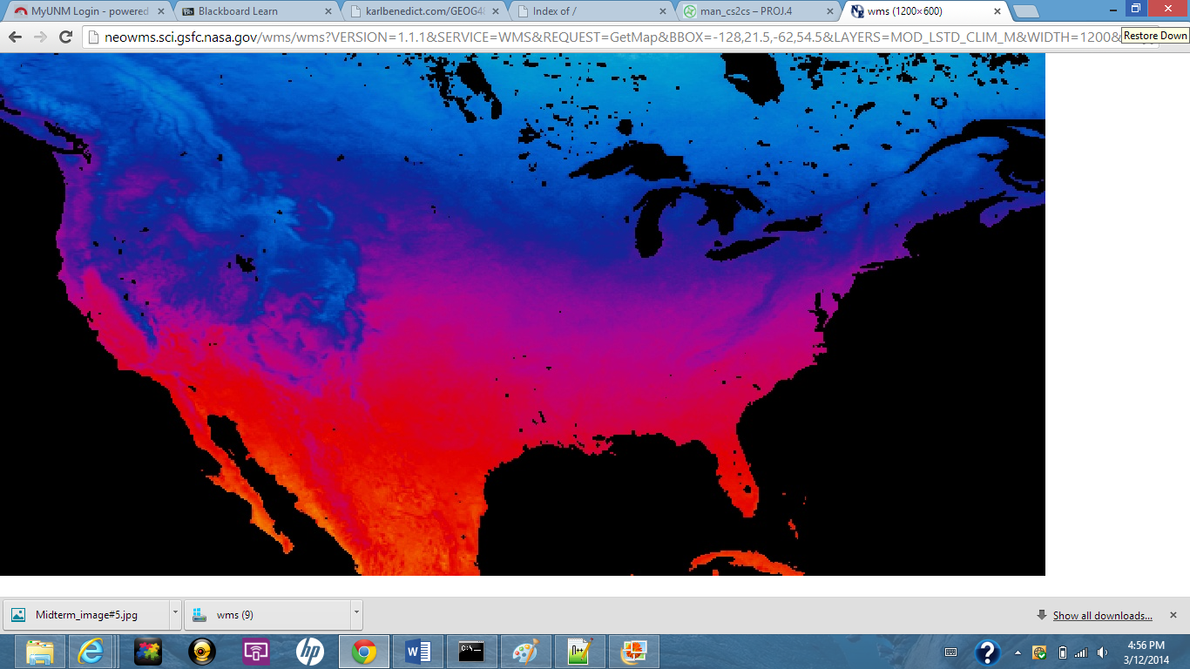

**Question 6** From the XML GetCapabilities returned by the following WFS request ([Link](http://services.nationalmap.gov/arcgis/services/WFS/transportation/MapServer/WFSServer?request=GetCapabilities&service=WFS)) answer the following questions (4 pts each)

http://services.nationalmap.gov/arcgis/services/WFS/transportation/MapServer/WFSServer? request=GetCapabilities&service=WFS

1. What is the title for this service? <ows:Title>WFS_transportation</ows:Title>
2. What file format(s) are supported by this service’s GetFeature request? text/xml; subType=gml/3.1.1/profiles/gmlsf/1.0.0/0
3. What is the DefaultSRS or the FeatureType named “WFS_transportation:Interstate”? urn:ogc:def:crs:EPSG:6.9:4326
4. What is the WGS84BoundingBox of the FeatureType named “WFS_transportation:Interstate”? -158.10419299999992 21.277850000000058 -67.781173999999908 49.002374000000088

**Question 7** From the XML GetCapabilities returned by the following WCS request ([Link](http://sdf.ndbc.noaa.gov/thredds/wcs/hfradar_uswc_500m?request=GetCapabilities&version=1.0.0&service=WCS)) answer the following questions (4 pts each)

http://sdf.ndbc.noaa.gov/thredds/wcs/hfradar_uswc_500m?request=GetCapabilities &version=1.0.0&service=WCS

1. What is the description of the v coverage?

<description>u m s-1 true surface_eastward_sea_water_velocity</description>

1. How many coverages are available from this service? 4 coverage’s are available

**Question 8a** Formulate a complete DescribeCoverage request for the v coverage for the WCS service referenced in Question 7. (4 pts)

1. DescribeCoverage request

http://sdf.ndbc.noaa.gov/thredds/wcs/hfradar_uswc_500m?request=GetCapabilities&version=1.0.0&service=wcs

**Question 8b** From the returned XML document answer the following questions. (4 pts each)

1. What is the spatial domain for the ‘v‘ coverage? [<](http://sdf.ndbc.noaa.gov/thredds/wcs/hfradar_uswc_500m?request=GetCapabilities&version=1.0.0&service=wcs) [lonLatEnvelope srsName="**urn:ogc:def:crs:OGC:1.3:CRS84**">](http://sdf.ndbc.noaa.gov/thredds/wcs/hfradar_uswc_500m?request=GetCapabilities&version=1.0.0&service=wcs)

<gml:pos>-122.59346771240234 37.45548629760742</gml:pos>

1. What file formats are available for ‘v‘ data delivered by this service? <Format>application/vnd.ogc.se_xml</Format> <Format>application/vnd.ogc.se_xml</Format>
2. What SRS(s) are supported by this service for requested data delivery? srsName="urn:ogc:def:crs:OGC:1.3:CRS84">

2