**PROJECT-1, COVID-19 VACCINATIONS TREND ANALYSIS**

**AIM:**

* The aim of the project is to analyze the data in detail by using people vaccinated and people fully vaccinated according to the date and year.

**INTRODUCTION:**

* The main purpose of the project is to analyse various kinds of covid-19 vaccination details so that we can be able to understand different vaccination throughout the world we can derive some recommendations, Insights and can bring out a conclusion.

**PROBLEM STATEMENT:**

* In our project we need to find, how many people are vaccinated and fully vaccinated in the years 2021 and 2022.
* Need to analyze the top 10 vaccinated countries.
* Need to analyze the top 10 daily vaccinated countries.
* Need to analyze all vaccination details.

**Methodology:**

STEP 1- DATA IMPORTING.

* The given dataset CSV file needs to be imported into the power bi software and click the load option.

STEP 2- DATA CLEANING.

* After analyzing the, we have found that the null value has to be changed. For this replace option is used to replace null with 0.

STEP 3- VISULAIZATION

* For visualization I have used some tables, graphs and charts for the best presentation and visualization.

**ANALYSIS:**

* **Chart, bar chart

  Description automatically generated**In this part, first I have analyzed the top 10 countries where people are fully vaccinated. From the image shown below, we know the top 10 countries for people fully vaccinated.
* From the above analysis, India is in first from people fully vaccinated countries. And the top 10 countries are fully vaccinated are shown clearly.
* **Chart, pie chart

  Description automatically generated**In the second analysis, According to country-wise, the total vaccinations are shown in pie chart.
* 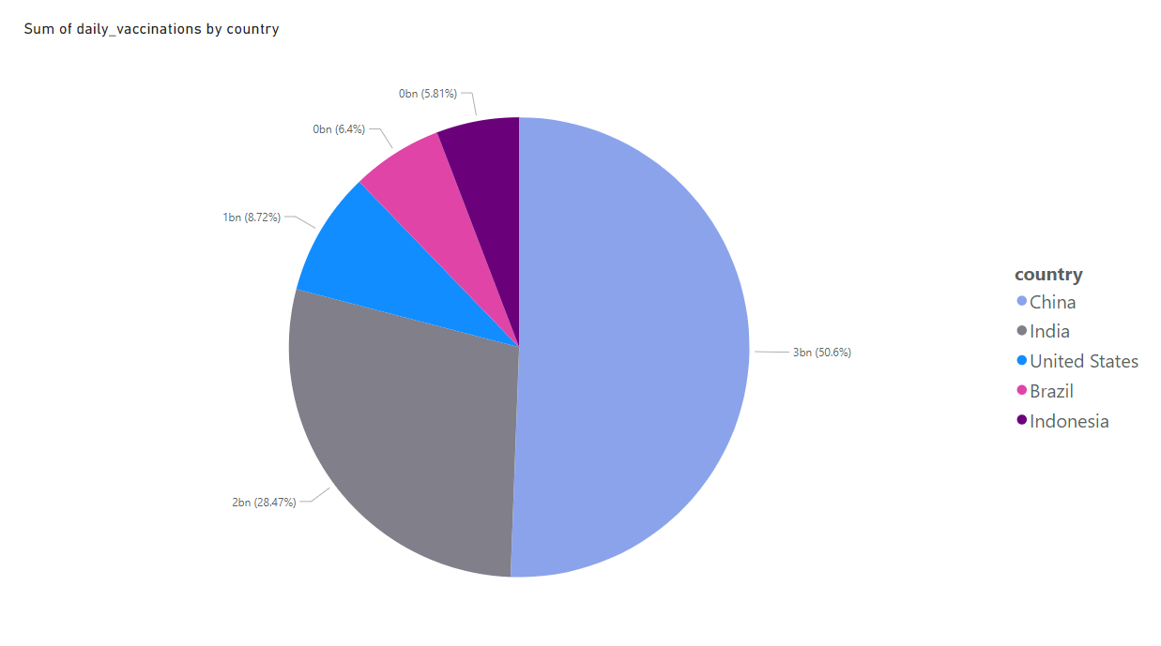In the third analysis, According to country-wise, the daily vaccinations are shown in pie chart.

* **Chart, pie chart

  Description automatically generated**In the fourth analysis, According to year,the vaccinations are shown in pie chart.
* In the fourth analysis, According to year,the vaccinations are shown in pie chart.

* From the above analysis, China is number 1 in total vaccinations compared to other countries.
* In year-wise 2021 is more vaccinated compared to 2022 and In 2020, no one was vaccinated.
* China, India, The united states, Brazil, Indonesia and the remaining countries are top 10 full vaccinations.

**Insights:**

* Here we analyzed the top 10 fully vaccinated countries in which India tops the list which indicates that people in the country were showing lots of interests to get vaccinated.
* And also analyzed the top 5 vaccinated countries here also India tops the list then analyzed the top 5 daily vaccinating countries and here China tops the list also analyse the sum of daily vaccinating details, fully vaccinating and vaccinating people details.
* year wise analysis shows that 2021 was the peak year for every vaccination details.

**Recommendations:**

* We should collect day to day reports, and we should update our records daily to get more accurate details.
* So that we can move forward with more vaccination to the right country which needs the most.

**Conclusion:**

* From the given data, we know that country-wise the people are vaccinated.
* Every country took actions in providing vaccine to people.