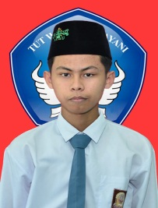 Dayun, 19 May 2022

Dear. MA Bustanul ulum Jl. KH.Ahmad dahlan no 3 Sialang Sakti DayunAA

Yours faithfully,

Based on the information I got from the print media of MA Bustanul ulum on May 16, 2022 that the School Bustanul Ulum is opening a job vacancy as a religion teacher.With this letter, I intend to fill the position that you are currently offering.

Here is my short bio:

Name : Joko Santoso Place and date of birth : Dayun 16 may 2003 Gender : Man Education : SI- Pendidikan Agama Islam Mobile phone number : 082299841605 Email Address : joko74479@gmail.com Address : Jl. Abdul ghani no 2 Sawit Permai

I am currently in good health both physically and mentally. I also master religious material which will greatly support my future work. I can also master Arabic both spoken and written.

For your consideration, I attach the following documents:

1. Curriculum Vitae 2. Copy of Last Grade Transcript 3. Photocopy of the latest diploma 4. Recent 3x4 photo

I hope to be able to take the next test so that I can explain in more detail about my abilities. I will also be happy if I can join the school Bustanul ulum.

Thus, I convey this application letter, for your attention and opportunity, I thank you very much.

Yours faithfully.

Joko Santoso