Mobile Robot Control

TP Qcar

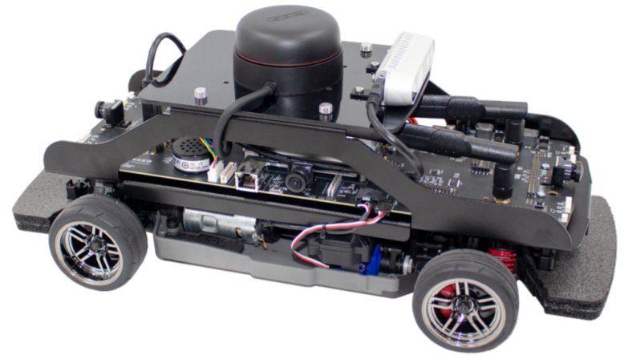

*Nathan MARTIN - Alexandre SPRICH - Dmytro SAVCHUK*

# 

## INTRODUCTION

In the context of autonomous vehicles (vehicles that have the capability to have automatic motions and navigate itself depending on its environments and scheduled tasks), we worked on the control of a small model of autonomous vehicle, named Qcar, which is developed by Quanser.

This small vehicle is equipped with several sensors (RGB camera, LIDAR, side cameras, etc.) allowing it to analyze its environment and thus be able to move around in space in a secure manner.

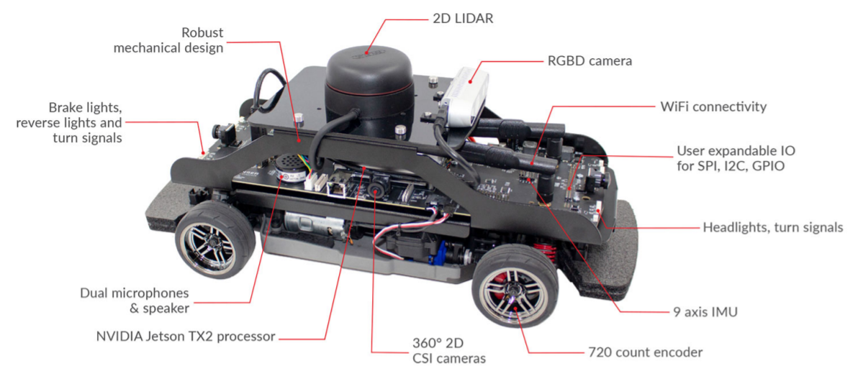

Then, the goal of this lab was to program and control Qcar robot using Matlab and Simulink.

## Control of Qcar

The operation of the Qcar follows the bicycle model, a kinematic model where the two front wheels and the two rear wheels are replaced by one front and one rear wheel respectively.

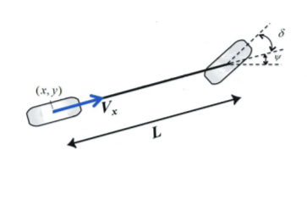

*Bicycle model*

We have 2 command variables to drive the system :

* the velocity of the car.
* the steering angle of the front wheels.

## Lane changing

…

## Moving to a point

…