 | 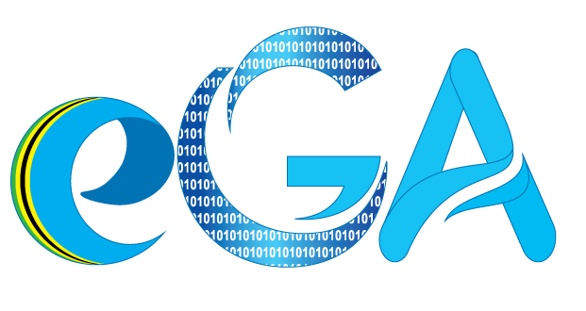
JAMHURI YA MUUNGANO WA TANZANIA · E-GOVERNMENT AUTHORITY (eGA)
PLAIN-LANGUAGE GUIDE
eSiri
An AI agent that completes tasks inside
government web systems, by simply asking

Prepared by Joseph Laurent
Institution e-Government Authority (eGA), Tanzania
Date September 2026
Scope The working proof of concept, built on a replica of e-Mikutano
Companion eSiri Technical Reference and Architecture Guide

About this guide
This guide explains what eSiri is, what was built, and how it works, without technical jargon. Read it first. It gives you the big picture and the words to explain it with confidence. The Technical Reference covers the same system in engineering depth, with file names, data formats and code.
Everything described here is what exists and runs today. Where something is simulated or limited, this guide says so plainly.

REMEMBER THIS
eSiri turns a spoken or typed request into completed, visible, approved and recorded actions inside an existing government web system.
The AI decides what to do. The application's own code does it, checks it, and can refuse it.

1. The problem eSiri solves
Government e-services such as e-Office, permit portals, tax filing and grievance systems already work. The difficulty is using them. Citizens with limited digital skills get lost in multi-step forms and give up, or travel to a physical office instead. Civil servants spend hours clicking through the same screens to file routine reports or pull data for supervisors.
eSiri addresses this gap. Instead of asking people to learn each system's screens, it lets them say what they want, and then does it for them inside the system they already have.

2. What was built
The proof of concept has two parts.
- A replica of e-Mikutano, Tanzania's government video-conferencing system. It looks and behaves like the real one: rooms, room settings, access sharing, presentations, a meeting screen with chat and recording, and a recordings list. It was built as a safe stand-in, because experimenting on the live national system was not an option. The signed-in user is a sample person, Rahma Mbuyu.
- eSiri itself, laid on top of the replica: an animated orb you call up with Alt+S or a click, a side panel that shows the conversation and every step, a voice in English and Swahili, and its own visible cursor that clicks and types on the screen.
What eSiri can do in the replica today:
- Create and open rooms, and change room settings such as "mute users on join".
- Generate access codes and read them aloud; share a room with named colleagues; add presentation documents.
- Start a meeting, send chat messages, write shared notes, mute or unmute, turn the camera on or off, raise a hand, start and stop recording, and leave.
- Answer questions about what is on screen ("What is the viewer code?"), remember the conversation ("Now turn it off again"), and switch language on request.

Real and working | Simulated in this proof of concept
The AI understanding requests and choosing each action | The e-Mikutano system itself: no real video, and all data is stored only in the browser
Voice input and spoken replies, in English and Swahili; the cursor clicking and typing on screen | A single sample user (Rahma Mbuyu), with no real login
Confirmation before important actions, stop at any time, the audit log, 27 passing automated tests | The three "e-Office" documents, which are samples

3. How eSiri works: the loop
Imagine a capable new assistant sitting at your computer. You tell them what you need. They look at the screen, decide the next click, check with you before anything serious, make the click, and look at the screen again to see what happened. They repeat this until the job is done, then tell you it is finished.
eSiri works in exactly this way. The figure below shows the loop.
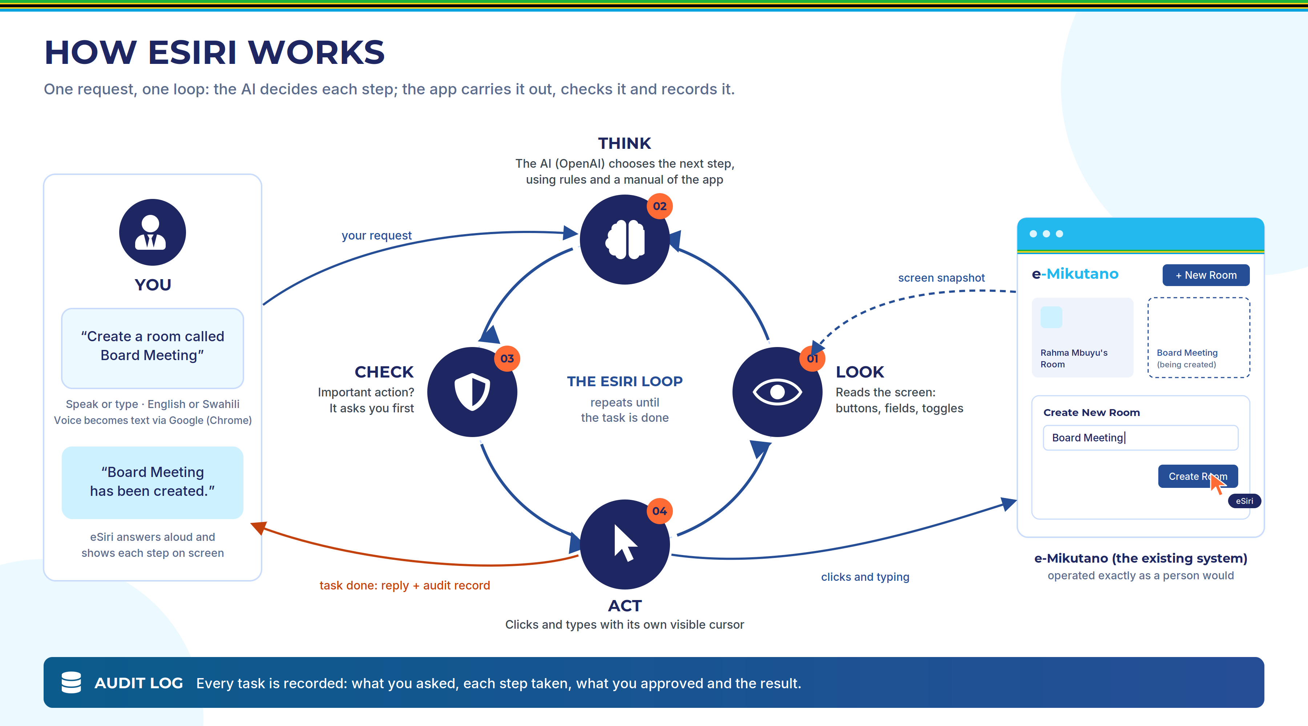
Figure 1. The eSiri loop: Look, Think, Check, Act, repeated until the task is done.
- Look. eSiri builds a written description of the screen: which page is open, what data is shown, and every button, field and switch.
- Think. It sends that description, with your request, to the AI (an OpenAI model). The AI chooses the next step, for example "click the New Room button".
- Check. If the step is important, such as creating a room or starting a recording, eSiri asks you first and waits for your yes.
- Act. eSiri's cursor moves to the button and clicks it, or types into a field, in plain view. Then it looks at the screen again.
THE SINGLE MOST IMPORTANT IDEA
The AI never touches the screen. It only sends back instructions such as "click this" or "type that". eSiri's own code carries them out, checks them, and can refuse them. That is what keeps the system under control.

Does eSiri write itself a full plan first?
Not exactly, and that is a strength. It works step by step: look, decide the next one or few steps, act, look again. When the next steps are obvious, such as clicking "New Room" and then typing the name, the AI sends them together to save time. But it always checks the fresh screen before going further. That lets it notice when something unexpected happens and adjust.

4. How eSiri knows what it can do
At every step, the AI receives four things. Together they answer the question "how does it know which actions exist?"
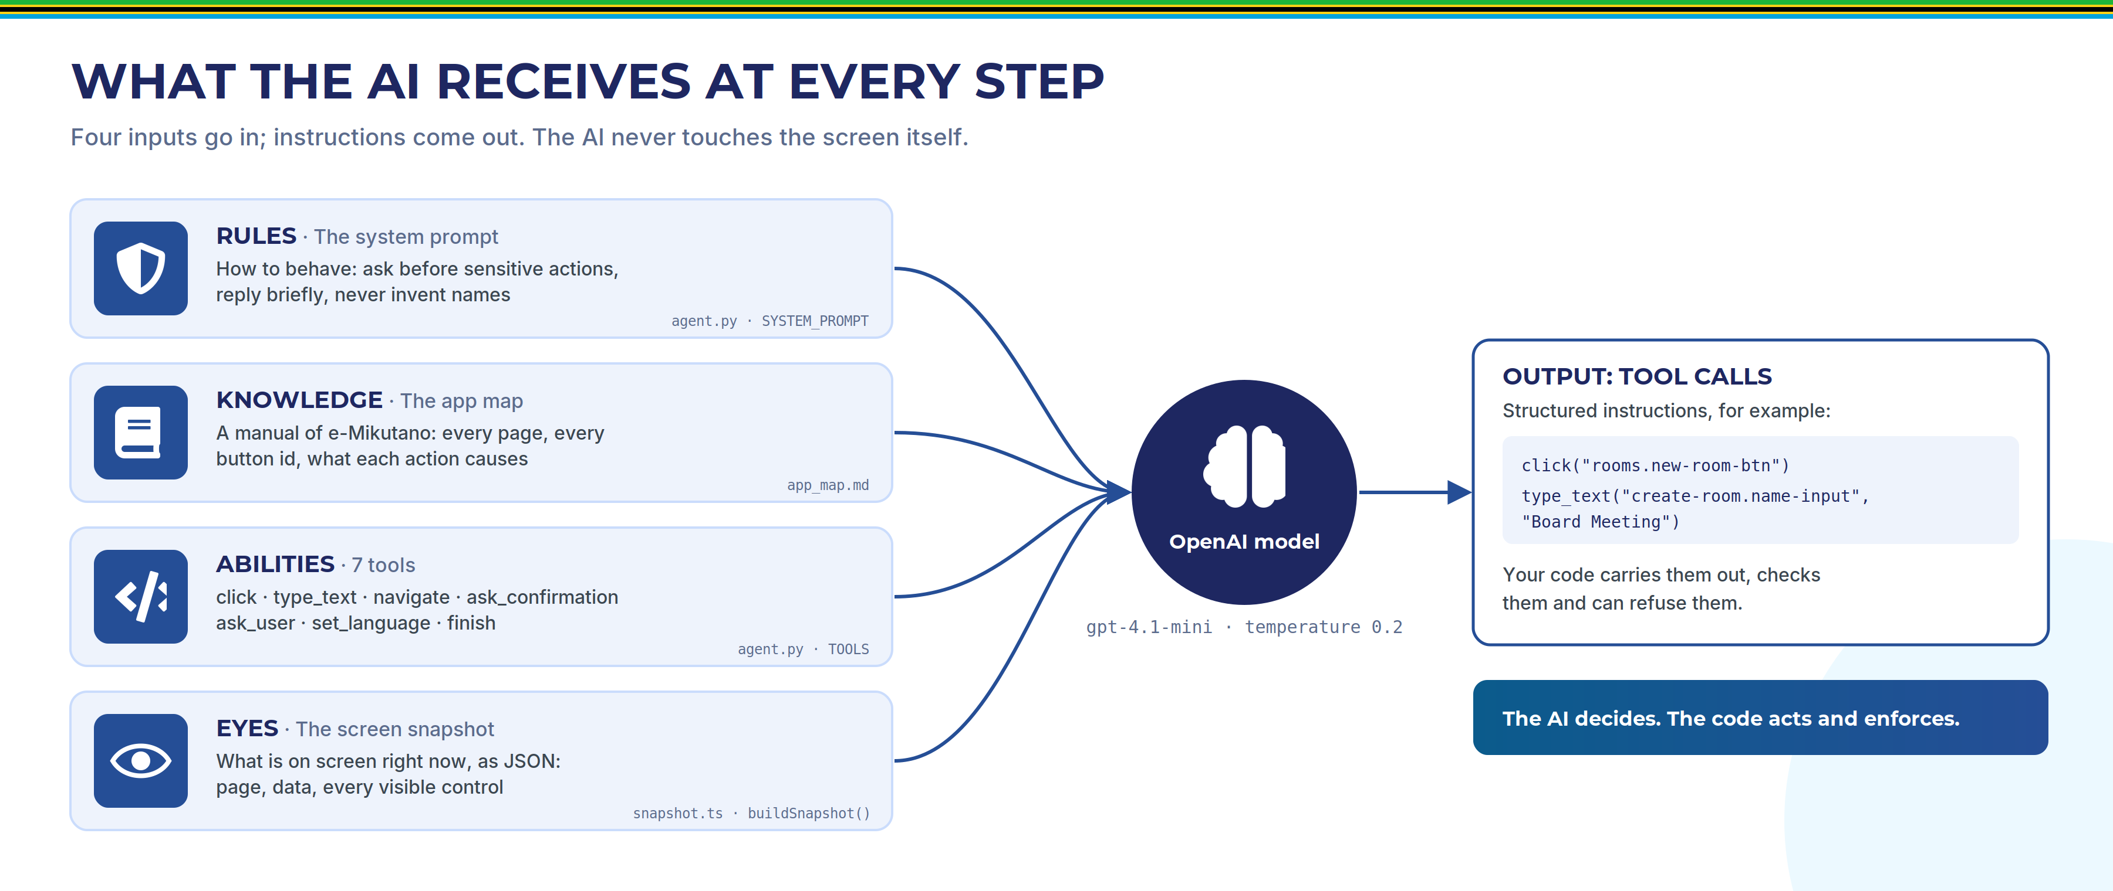
Figure 2. The four inputs the AI receives at every step, and what comes out.
- Rules (the "system prompt"): like a job description. Ask before sensitive actions, reply in one or two short sentences, never invent names, reply in the user's language.
- Knowledge (the "app map"): like a training manual. It describes every page of e-Mikutano, every button, and what each action causes.
- Abilities (seven "tools"): the only things eSiri can do. Click, type, go to a page, ask for confirmation, ask a question, switch language, and finish.
- Eyes (the "snapshot"): a written description of the current screen. It is text, not a picture, so it is fast and exact.
Every button in the replica carries a hidden name tag, such as rooms.new-room-btn for the "+ New Room" button. These tags never change, even when the screen switches to Swahili, so the AI can always point at exactly the right control. Buttons for important actions carry an extra tag marking them as sensitive.

5. One request, from start to finish
This is a real, measured run of the request "Create a room called Board Meeting".
- You press Alt+S (or click the orb) and speak. Google Chrome turns your speech into text.
- eSiri describes the screen and sends it, with your request, to the AI.
- AI call 1 returns two steps: click "+ New Room", then type "Board Meeting". The cursor does both on screen, typing the name letter by letter.
- AI call 2 sees the name is typed. Creating a room is important, so it asks: "Create a new room called Board Meeting?" A Yes/No card appears and eSiri reads the question aloud.
- You say "yes" (or click Yes). eSiri's code now allows exactly one important click.
- AI call 3 returns "click Create Room". The code checks the permission, the click goes through, the room is created and its page opens.
- AI call 4 returns "finish". eSiri says "The room called Board Meeting has been created," and the task is written to the audit log.
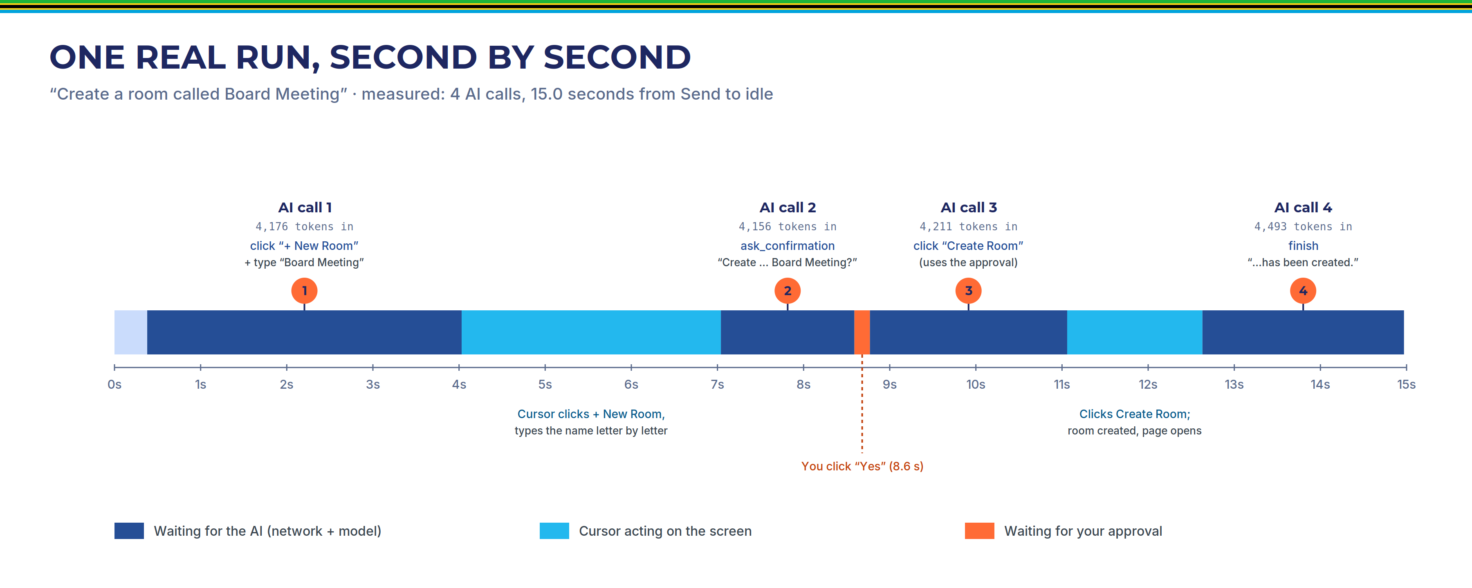
Figure 3. The same run on a timeline. Most of the 15 seconds is spent waiting for the AI to respond.
The whole task took 15 seconds and 4 AI calls. In this recorded test the Yes button was clicked instantly; with a real person, add however long they take to answer.

6. Safety and accountability

It asks before anything important
eSiri asks for your approval before: creating a room, starting or joining a meeting, starting or stopping a recording, leaving a meeting, removing someone's access, deleting a room or a recording, and clearing the audit log. It does not ask for small things like changing a setting or typing a chat message.

The code enforces it, not just the AI
Telling the AI to ask first is not enough, because an AI can misbehave. So the rule is also enforced by eSiri's own code: a click on a sensitive button is refused unless you said yes during that same task.
A TRUE STORY FROM THE BUILD
During testing, a user said "no" to deleting a room. The AI then asked for confirmation seven more times and finally tried to click Delete anyway. The code refused the click and the room survived. The code now also ends the task immediately if the AI asks again after a no.

You can stop it at any moment
Press Esc, click the Stop button or the orb, or say "stop" or "simama". eSiri halts immediately, mid-action if necessary. It also stops on its own after 30 actions in one task, or if the same action fails three times in a row.

Everything is recorded
Every task is written to an audit log: who asked, when, the exact request, every step taken, every approval or refusal, and the outcome (Completed, Declined, Cancelled or Failed). You can view it on the Audit Log page and export it to a spreadsheet file. A copy is also saved on the backend server.

7. The roles of OpenAI and Google
eSiri uses three outside services. It is important to know exactly what each one does and what it receives.
Service | What it does for eSiri | What it receives, and when
OpenAI chat model (gpt-4.1-mini) | The "brain". Reads the request, the rules, the app manual and the screen description, and chooses the next steps. | At every step (usually 3 to 5 times per task): your request, the conversation so far, and the current screen description. That description includes room names, join tokens, access codes and the last 5 chat messages.
OpenAI speech (gpt-4o-mini-tts) | Gives eSiri a natural Swahili voice, because the computer has no Swahili voice of its own. | The text of each Swahili reply.
Google speech recognition (inside Chrome) | Turns your voice into text, in English or Swahili. | Your microphone audio, while eSiri is listening.

Everything else stays on the local machine: the clicking, the safety checks, the conversation memory, the audit log, and the secret OpenAI key, which never reaches the browser.
This is also why voice only works in Google Chrome. Chrome's speech recognition sends audio to Google's service; Chromium, the open-source version of Chrome, does not include access to it.
BE UPFRONT ABOUT THIS
In this proof of concept, screen information and voice do leave the machine. That is acceptable for a demonstration with sample data, and it must be addressed before eSiri handles real government data.

8. Two languages
You can switch between English and Swahili with the language toggle, the chip in the side panel, or simply by saying "speak Swahili" or "ongea Kiingereza". Everything switches together: the screen text, the language eSiri listens in, its voice, and its replies. Names you give, such as room names, are never translated.

9. Honest limitations
Naming the weaknesses yourself shows that you understand the system. These are the important ones.
- The replica was built for eSiri. Every button carries a name tag for the AI. A real government system will not have these tags, so connecting to it needs another way to describe its screens (see question 5 in the next section).
- It needs the internet, for OpenAI and for Google's speech recognition.
- Screen information goes to OpenAI, including sample access codes and chat messages.
- It takes time. A simple task takes around 15 seconds, mostly waiting for the AI.
- The AI can still misunderstand. For example, it once treated the Swahili room name "Kikao cha Bodi" as the same room as "Board Meeting", because one translates the other. This happened once in six full demo runs. For a live demo, use a Swahili name that is not a translation of an existing room.
- Voice was tested by hand, not by the automated tests. The optional wake-word mode can occasionally trigger by mistake.
- One user, no login. All data lives in one browser.
- The safety check runs in the browser. It fully controls the AI, but a technical person with browser tools could get around it, just as they could click the button themselves.

10. Questions you are likely to be asked
Q. Is this just a scripted demo?
No. No sequence of clicks is hard-coded. The AI chooses every step based on the request and the screen. That is why the automated tests check the final result rather than the exact steps: the AI's path can differ from run to run. The Technical Reference includes a real recorded run showing exactly what the AI received and returned.
Q. How does it know which buttons exist?
It receives four things at every step: rules, a manual of the app, a list of seven actions it may take, and a written description of the current screen in which every button has a fixed name tag.
Q. What if the AI makes a mistake?
Important actions need your yes, and that rule is enforced in code, so the AI cannot bypass it. You can stop eSiri at any moment, it gives up after 30 actions or three identical failures, and everything is written to the audit log.
Q. Where does our data go?
The request, the conversation and the current screen description go to OpenAI at each step; microphone audio goes to Google through Chrome; Swahili reply text goes to OpenAI to be spoken. Everything else stays local. This must be addressed before real data is used.
Q. Could the same approach work for e-Mrejesho or another system?
Yes. The loop is reusable: look, decide, check, act, record. What changes per system is how the screen is described and how actions are performed. For a system we cannot modify, that means reading its screen structure or using browser automation; for a system with an API, the actions become API calls. Each system also needs its own app manual.
Q. Why does it take 15 seconds?
Each step is a round trip to the AI, and a simple task needs about four. The cursor movements and letter-by-letter typing are also deliberately visible, so people can follow what is happening.
Q. Why OpenAI?
It offers reliable "tool calling", which lets the model return structured instructions instead of free text, and that made fast development of the proof of concept possible. The AI is called from a single place in the backend, so the rest of the system does not depend on which model is used.
Q. How good is the Swahili?
eSiri understands spoken Swahili through Chrome, replies in Swahili, and speaks through OpenAI's voice. It worked in the tests, including creating a room from a Swahili request, but the quality has not been formally measured.
Q. Is it tested?
Yes: 27 automated tests, all passing. They include eight AI scenarios, such as declining a deletion and cancelling in the middle of a task, and tests proving the safety check works without the AI. Voice was checked by hand.

11. Glossary
Term | Meaning
AI agent | Software that uses an AI model to decide on actions and then carries them out, rather than only answering questions.
The loop | eSiri's cycle of Look, Think, Check, Act, repeated until a task is done.
Tool / tool call | One of the seven actions eSiri may take; a tool call is the AI's instruction to use one, e.g. "click this button".
Snapshot | The written description of the current screen that eSiri sends to the AI.
App map | The manual of e-Mikutano that the AI reads: pages, buttons and what they do.
System prompt | The standing rules the AI must follow.
Name tag (element id) | The fixed hidden name on each button, e.g. rooms.new-room-btn.
Sensitive action | An important action that needs your yes before eSiri may do it.
Audit log | The record of every task: request, steps, approvals and outcome.
Token | The unit an AI model reads text in; about three-quarters of a word. Each AI call here used about 4,200 tokens.
Speech-to-text / text-to-speech | Turning voice into text (Google, in Chrome) and text into voice (Chrome's voice or OpenAI).
Replica (mockup) | The imitation of e-Mikutano that eSiri operates in this proof of concept.

