**HFAC Project**

# Project description

Design an analog interface made of a third order low-pass filter and a programable gain amplifier (PGA). Below are the main specifications:

* **The analog filter**
* Implementation: AO-RC
* Biquad topology: Tow-Thomas
* Filter order: 3
* HO [V/V]: 2 = 6dB
* Cut-off frequency (fc): 16.3 KHz
* Approximation type: Bessel
* Rin_Filtru > 1KΩ
* **PGA**
* Active cell type: AO
* Implementation technique: Sw. in the way of the signal, parallel
* Gain domain, Resolution: 0dB, 9dB, step 3dB
* Rin_PGA > 1KΩ
* BWPGA_min > fc
* **AO specs**
* GBW > 20*fc (or bigger if necessary)
* a0 > 60dB
* phase margin > 60˚

# LPF and PGA sizing

## Sizing of passive devices within the LPF and PGA

The first step is to find the coefficients of the normalized transfer function. Taking into consideration that I have a third order filter with Bessel approximation, those are going to be the following:

* c1 = 1.3270
* c2 = 2.1018
* d2 = 2.1094

Taking into consideration the next formula

$$ω_{c}=2*π*f_{c}$$

and knowing that the cut-off frequency is 16.4 KHz, we can compute the demoralization pulsation. By applying the above formula, the result is the following:

$$ω_{c}=102Krad/sec$$

Using the next formulas, we are going to compute the denormalized coefficients:

$$c_{1d}=c_{1}*ω_{c}$$

$$c_{2d}=c_{2}*ω_{c}$$

$$d_{2d}=d_{2}*{ω_{c}}^{2}$$

The results are the following:

* c1d = 1.36*105
* c2d = 2.15*105
* d2d = 2.21*1010

Knowing the denormalized coefficients, we can find out the next important parameters:

$$ω_{01}=c_{1d}=1.36*{10}^{5}$$

$$ω_{02}=\sqrt{d_{2d}}=1.49*{10}^{5}$$

$$Q=\frac{\sqrt{d_{2d}}}{c_{2d}}=0.691$$

The gain of the filter has to be 2V/V:

$$H_{0}=\frac{2V}{V}=6dB$$

Next, we have the following formulas:

$$H_{0}=\frac{R_{4}}{R}$$

$$ω_{0}=\frac{1}{\sqrt{R_{2}*R_{4}*C_{1}*C_{2}}}$$

$$Q=R_{1}*\sqrt{\frac{C_{1}}{C_{2}}*\frac{1}{R_{2}*R_{4}}}$$

We are going to choose a common value for the two capacitors and for the R2 and R4 for the ease of computation. We are going to choose a value of 4.7nF for the capacitor. The value of the two resistors will result 1.43KΩ. Not having this value in kit, I decided to put a 4.7KΩ and a 2.2KΩ resistors in parallel to obtain a 1.5KΩ resistor, which is pretty close to the desired value.

We are going to take the gain of the Tow-Thomas biquad as 1, which is going to give us the same value for the resistor R as for resistors R2 and R4.

From the computation, the value of R1 results to be 988Ω. Not having this value in kit, I decided to put in parallel a 2.2KΩ and a 1.8KΩ resistors to give me a value of 990Ω, which is very close to the desired value.

This was the implementation of the Tow-Thomas biquad. We also have to design a Lossy Integrator which is going to be placed before it. For the filter to meet the gain condition (H0=2), I am going to design this biquad taking in consideration this gain. We are going to use the next formulas:

$$R_{2i}=\frac{1}{C_{2i}*ω_{01}}$$

$$R_{1i}=\frac{R_{2i}}{H_{0}}$$

Applying these formulas, we are going to obtain the next values for the resistors:

* R1i = 1.665KΩ (1.8KΩ)
* R2i = 3.33KΩ (3.9KΩ)

The values in the brackets represent the physical values that were chosen.

Next, I will design the PGA. This circuit has to meet 4 different gains: 0dB (1V/V), 3dB (1.41V/V), 6dB (2V/V) and 9dB (2.82V/V). The values in the brackets are the ones which the ratios of the resistors have to meet. For the input resistance I have chosen a 2.2KΩ value.

* Rin = 2.2KΩ

The next values result from the value of the gain in the linear domain.

* RF1 = 2.2KΩ
* RF2 = 3.3KΩ (1.5V/V)
* RF3 = 4.5KΩ (2.04V/V, 2.7KΩ+1.8KΩ)
* RF4 = 6.1KΩ (2.77KΩ, 3.9KΩ+2.2KΩ)

The values of the resistors are the physical ones. In the brackets we find the actual value of the gain (the one that could be obtain using the resistors from the kit), and how the value was obtained if it couldn’t be found in the kit.

# Design validation and characterization of the LPF and PGA analog front-end

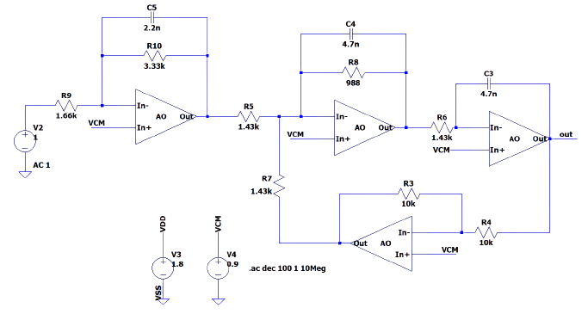

Figure : Low-Pass Filter (Tow-Thomas biquad)



Figure : The Transfer Function of the Low-Pass Filter

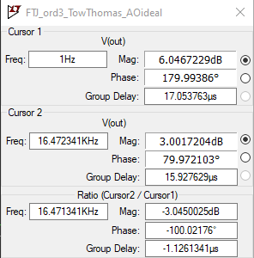

Figure : The gain at low frequency and the Band-Width

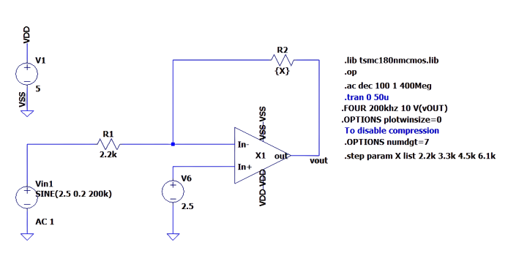

Figure : PGA



Figure : The transfer function of the PGA

# Conclusions

|  |  |  |  |  |  |
| --- | --- | --- | --- | --- | --- |
| The required cut-off frequency | Simulated cut-off frequency | Measured cut-off frequency | The desired low frequency gain | Simulated low frequency gain | Measured low frequency gain |
| 16KHz | 16.47KHz | 14KHz | 2V/V | 2V/V | 1.92V/V |

Table : Comparison for the filter

|  |  |  |  |  |
| --- | --- | --- | --- | --- |
| The feedback resistor | The value of the feedback resistor | Required gain | Simulated gain | Measured gain |
| Rf1 | 2.2KΩ | 1V/V | 997.52913mV/V | 0.92V/V |
| Rf2 | 3.3KΩ | 1.41V/V | 1.4965031V/V | 1.36V/V |
| Rf3 | 4.5KΩ | 2V/V | 2.0406523V/V | 1.92V/V |
| Rf4 | 6.1KΩ | 2.82V/V | 2.7658827V/V | 2.6V/V |

Table : Comparison for the PGA

|  |  |  |  |
| --- | --- | --- | --- |
| Wanted gain | Input amplitude | Maximum amplitude | Minimum amplitude |
| 1V/V | 1V | 920mV | -1.2V |
| 1.41V/V | 1V | 1.36V | -1.68V |
| 2V/V | 1V | 1.92V | -2.24V |
| 2.82V/V | 1V | 2.6V | -2.88V |

Table : PGA measured voltages