Temperature controlling system

My project is a system which is going to adjust the temperature in concordance with the user preferences. On a screen, the respective value will be displayed, as well as the intensity of the light in the room in which the device is being placed.

This type of project can be used in different applications. A device which is used for controlling the temperature in a house is one example. Greenhouses also use such devices to control the specific parameters which are essential for the proper growth of the plants. A user interface is absolutely essential for the versatility of the system, due to the fact that not all human being (or plants), have the same needs.

The working principle is quite simple. If the temperature drops under a certain value, a heater will be turn on. In the other situation, if the temperature is too high, a fan will be turn on.

Here is a generic list with the necessary components:

-a temperature sensor

-a light sensor

-an amplifier

-an ADC

-the microcontroller

-a fan

-a heater

The block diagram:

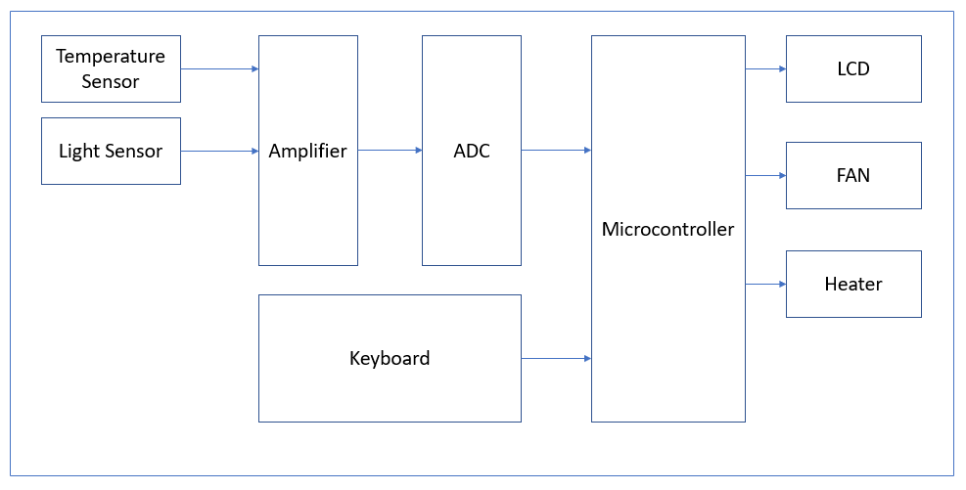

Ways of measuring temperature

Thermocouple

A thermocouple is an electrical device consisting of two dissimilar electrical conductors forming an electrical junction. A thermocouple produces a temperature-dependent voltage, and this voltage can be interpreted to measure temperature.

Commercial thermocouples are inexpensive, interchangeable, are supplied with standard connectors, and can measure a wide range of temperatures. In contrast to most other methods of temperature measurement, thermocouples are self-powered and require no external form of excitation. The main limitation with thermocouples is precision, system errors of less than one degree Celsius (°C) can be difficult to achieve.

Thermistor

A thermistor is a type of resistor whose resistance is strongly dependent on temperature, more so than in standard resistors. There are two types of thermistors:

- **NTC** thermistors: resistance decreases as temperature rises usually due to an increase in conduction electrons bumped up by thermal agitation from valency band

- **PTC** thermistors, resistance increases as temperature rises usually due to increased thermal lattice agitations particularly those of impurities and imperfections

Resistance thermometer

Resistance thermometers, also called resistance temperature detectors (**RTDs**), are sensors used to measure temperature. Many RTD elements consist of a length of fine wire wrapped around a ceramic or glass core but other constructions are also used. The RTD wire is a pure material, typically platinum, nickel, or copper. The material has an accurate resistance/temperature relationship which is used to provide an indication of temperature. As RTD elements are fragile, they are often housed in protective probes.

IC temperature sensor

Semiconductor temperature sensors are the devices which come in the form of integrated circuits (popularly known as IC temperature sensors). Their design results from the fact that semiconductor diodes have temperature-sensitive voltage vs. current characteristics. When two identical transistors are operated at a constant ratio of collector current densities, the difference in base-emitter voltages is directly proportional to the absolute temperature.

Choosing a temperature measuring method

|  |  |  |  |  |
| --- | --- | --- | --- | --- |
|  | **NTC thermistors** | **Thermocouples** | **RTD** | **ICs** |
| **Temperature range** | -50˚C to 250˚C (dependent on type) | -200˚C to 1250˚C (dependent on type) | -196˚C to 850˚C | -40˚C to 120˚C |
| **Stability** | -Epoxy coated: 0.2˚C/year  -Hermetically sealed: 0.02˚C/year | >1˚C/year | 0.1˚C-0.5˚C/year (for rated operations, used under normal conditions it can be less) | Good (for lack of numerical information) |
| **Response time** | 0.12-10s (depending on size and packaging) | 0.2-10s (depending on size and packaging) | 1-7s | Fast (for lack of numerical information) |
| **Price** | Low to moderate | Expensive | Expensive | Low to moderate |
| **Accuracy** | Good | Errors of under 1˚C can be difficult to achieve | Highly accurate | Good/high |
| **Linearity** | Low | Good | Very good | Very good |

Table 1: brief comparison of some temperature measuring methods

Now I am going to choose a measuring method taking into account the advantages that they offer and the application that I want to develop.

When taking about the temperature range, I consider that all the methods offer satisfying parameters. Off course, a bigger range will be the best so, here is the thermocouple that wins.

Stability is an important for long term applications as is the one that I want to implement. So, a hermetically sealed NPC seems the best choice here.

The RTDs response time is quite unsatisfying so I’m going to take a look at the others methods which have quite similar values. ICs have also good response time.

When talking about the price, the thermistors and ICs lead the way, with the thermocouple being the most expensive.

Even though the RTDs are the most accurate on my list, for the application that I’m going to develop I see the accuracy of an NPC or of an IC more than enough. Thermocouple’s value is quite unsatisfying, for at the most thermostats the minimum step being 0.5˚C.

Taking into account all the parameters that I discussed, I consider that for the project that I am going to make the best choice would be an IC sensor. They are also regularly used in those types of applications.

Presenting multiple types of ICs

When speaking about IC temperature sensors, the most popular are AD590 and LM35.

|  |  |  |  |  |
| --- | --- | --- | --- | --- |
|  | **AD590** | **LM35** | **TMP35** | **Units** |
| **Accuracy** | +/-1 | +/-3 | +/-2 | ˚C |
| **Linearity** | +/-0.3 | +/-0.8 | +/-0.5 | ˚C |
| **Price** | 80 | 10 | 13 | RON |
| **Temperature range** | -55 to 150 | -20 to 100 | -40 to 125 | ˚C |

Table 2: Brief comparison of multiple IC sensors

Being known that LM35 and AD590 are the most popular IC sensors, TMP35 can be considered being out of the equation because the disponibility of the other two is for sure bigger. The main two competitors present quite similar parameters, LM35 being at the same time cheaper. So, I consider that this is the sensor that I am going to use for the development of this project.