**Conditioning circuit**

1. **Introduction**

A conditioning circuit is a circuit that modifies the output of a sensor to match the parameters required by the data acquisition system, usually an ADC (Analog to Digital Convertor).

1. **The conditioning circuit**

The conditioning circuit that I realized has as components my analog temperature sensor (LM35), a non-inverting amplifier which has the gain 10, and an ADC0808. The circuit can be seen in the picture below:

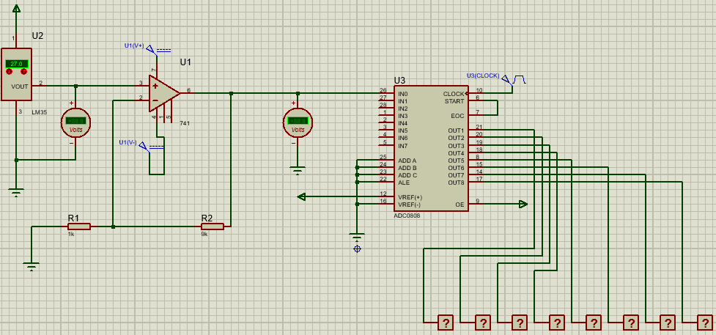

The LM35’s three pins are as follows: +Vs, Vout, GND. The +Vs pin is connected at 5V, while the output of the sensor serves as input signal for the non-inverting amplifier. When the screen shot was made, the sensor was set on 27˚C. The LM35 has a scale factor of 10mV/˚C, which means that at the output of the sensor will be 27*10=270mV. At the output of the sensor was put a DC voltmeter to measure that voltage.

The next stage of the circuit is a non-inverting amplifier. It has as input signal the output of the LM35 sensor. The gain of such an amplifier is as follows: $Av=1+\frac{Rf}{Rg}$. Rf represents the resistance on the feedback loop and Rg the resistance of the inverting input pin. Those resistances were sized in such a way to give a total gain of 10: Rf=9kΩ and Rg=1kΩ. Taking into consideration all that I mentioned above, at the output of the amplifier should be 2.7V. I also put a DC voltmeter at the output of the amplifier to measure that value.

In the third stage of the circuit we have the ADC. The output of the amplifier is connected to one of the analog inputs of the converter. Every digital output is connected to a logicprobe for a better legibility of the output. The clock signal is a square wave with 100 Hz frequency oscillating between 0 and 5 volts.

1. **Making the computations**

As I said earlier, the sensor measure at the time of the simulation 27˚C. This will generate an output of 270 mV, since the scale factor of the sensor is 10 mV/˚C.

$$27℃*10\frac{mV}{℃}=270 mV$$

This value will be the input signal for the amplifier. The gain of this stage is 10. This means that at the output of the amplifier will be 2.7 V. This value is sent to the input of the converter. The equation with which the converter computes the output is the following:

$$N=\frac{Vin-Vref(-)}{Vref\left(+\right)-Vref(-)}*256±Absolute Accuracy$$

The reason why we multiply with 256 is because the converter is on 8 bits: 28=256.

Knowing that information, we should be able to compute the output. At the Vref(-) pin we connected the ground, which means that it’s value is 0V. The result of the computation is ≈139 which in binary is 1000 1011. This is the output that we should get.

1. **Simulating the circuit**

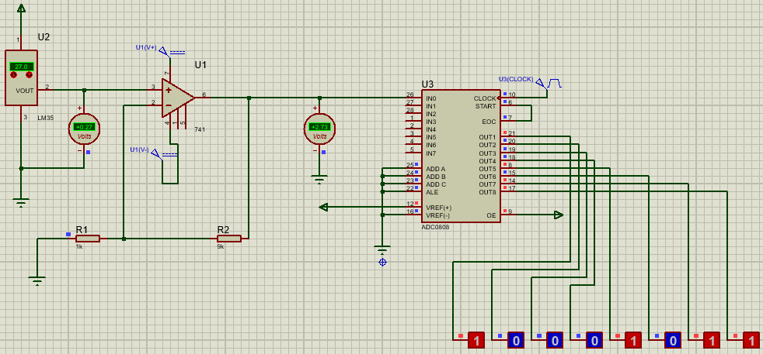

It can be seen that the simulation went as expected. As wanted, I made a 10-gain amplifier. In the next photo I will close up the voltmeter that is found after the amplifier to show that fact that the output of the amplifier is 2.7 V.

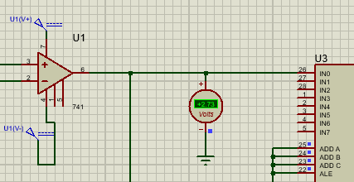

It can be seen that the value is approximatively the wanted one. Also, from the first picture of this chapter can be observed that the digital signal is the expected one.