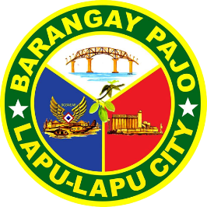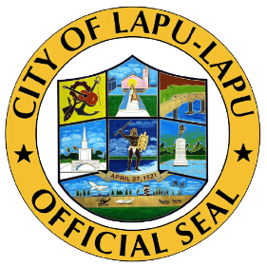

Republic of the Philippines

Region VII

**OFFICE OF THE PUNONG BARANGAY**

BARANGAY PAJO

LAPU-LAPU CITY

CERTIFICATE OF INDIGENCY

**TO WHOM IT MAY CONCERN:**

This is to certify that **{{RES_NAME}}** , **{{RES_AGE}}** years old, **{{RES_CIVILSTATUS}} , {{RES_NATIONALITY}}** , and permanently residing at Barangay Pajo, Lapu-Lapu City, Cebu.

This **CERTIFICATION** is being issued upon the request of the above-mentioned name for whatever legal purpose it may serve.

**ISSUED** this **{{DAY}}** day of **{{MONTH}}** , **{{YEAR}}** at the Office of the Punong Barangay at Barangay Pajo, Lapu-Lapu City, Cebu.

Specimen Signature:

________________

**Lyndel I. Bullos**

Barangay Captain

O.R No**. {{TRANS_ID}}**

Date Issued**: {{DATE}}**

(NOTE: NOT VALID WITHOUT SEAL)