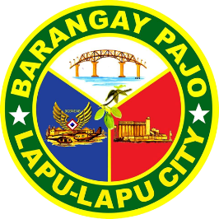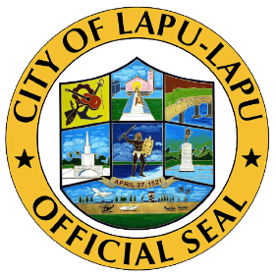

Republic of the Philippines

Region VII

**OFFICE OF THE PUNONG BARANGAY**

BARANGAY PAJO

LAPU-LAPU CITY

BARANGAY CLEARANCE

**TO WHOM IT MAY CONCERN:**

This is to certify that **Aljo Rallos Guba** , **20** years old, **Single** , and a resident of Barangay Pajo, Lapu-Lapu City, Cebu is known to be of good moral character and law-abiding citizen in the community.

To certify further, that he/she has no derogatory and/or criminal records filed in this barangay.

**ISSUED** this **16** day of **6** , **2023** at the Office of the Punong Barangay at Barangay Pajo, Lapu-Lapu City, Cebu upon request of the interested party for whatever legal purpose it may serve.

Specimen Signature:

________________

**Lyndel I. Bullos**

Barangay Captain

O.R No. **10001**

Date Issued: **16 Jun, 2023**

(NOTE: NOT VALID WITHOUT SEAL)