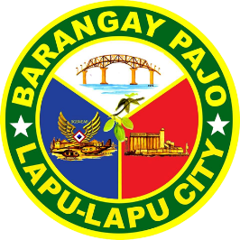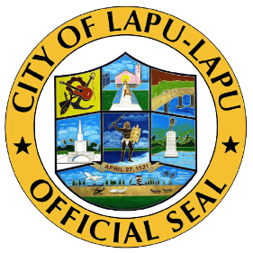

Republic of the Philippines

Region VII

**OFFICE OF THE PUNONG BARANGAY**

BARANGAY PAJO

LAPU-LAPU CITY

CERTIFICATE OF INDIGENCY

**TO WHOM IT MAY CONCERN:**

This is to certify that **Michael Junior Jackson** , **36** years old, **Married , Filipino** , and permanently residing at Barangay Pajo, Lapu-Lapu City, Cebu.

This **CERTIFICATION** is being issued upon the request of the above-mentioned name for whatever legal purpose it may serve.

**ISSUED** this **16** day of **6** , **2023** at the Office of the Punong Barangay at Barangay Pajo, Lapu-Lapu City, Cebu.

Specimen Signature:

________________

**Lyndel I. Bullos**

Barangay Captain

O.R No**. 10001**

Date Issued**: 16 Jun, 2023**

(NOTE: NOT VALID WITHOUT SEAL)