UML – диаграмма
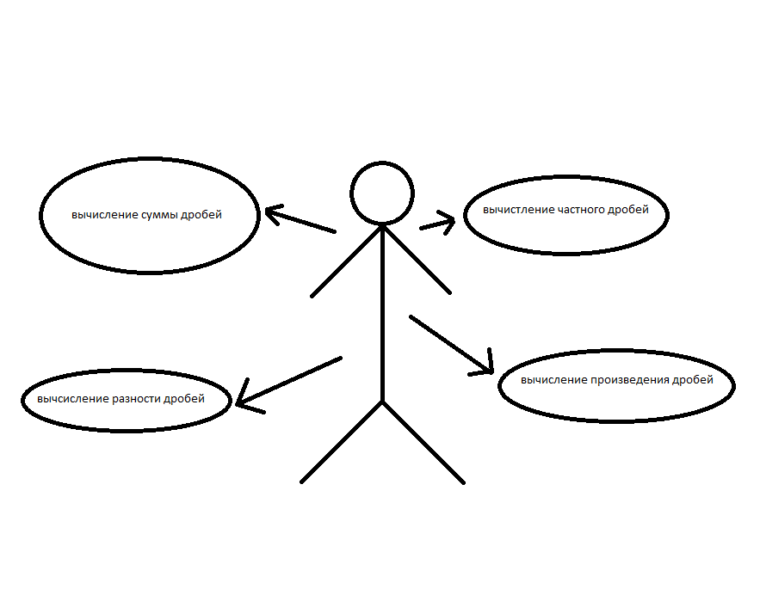
ADT
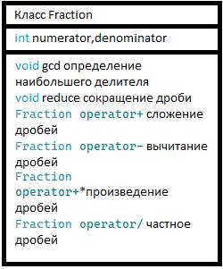

#pragma once
#include <iostream>

using namespace std;

class Fraction {
private:
int numerator;
int denominator;

int gcd(int a, int b) {
a = abs(a);
b = abs(b);
while (b) {
a %= b;
swap(a, b);
}
return a;
}

void reduce() {
if (denominator == 0) {
throw invalid_argument("Знаминатель не может быть равен нулю");
}

if (numerator == 0) {
denominator = 1;
return;
}

int temp = gcd(numerator, denominator);
numerator /= temp;
denominator /= temp;

if (denominator < 0) {
numerator = -numerator;
denominator = -denominator;
}
}

public:
Fraction() : numerator(0), denominator(1) {}

Fraction(int num, int den) : numerator(num), denominator(den) {
if (denominator == 0) {
throw invalid_argument("Ошибка!");
}
reduce();
}

void input() {
cout << "Введите числитель: ";
cin >> numerator;
do {
cout << "Введите знаминатель: ";
cin >> denominator;
if (denominator == 0) {
cout << "ошибка. знаминатель равен нулю.\n";
}
} while (denominator == 0);
reduce();
}
void output() const {
if (denominator == 1) {
cout << numerator;
}
else {
cout << numerator << "/" << denominator;
}
}

Fraction operator+(const Fraction& other) const {
int newNumerator = numerator * other.denominator + other.numerator * denominator;
int newDenominator = denominator * other.denominator;
return Fraction(newNumerator, newDenominator);
}

Fraction operator-(const Fraction& other) const {
int newNumerator = numerator * other.denominator - other.numerator * denominator;
int newDenominator = denominator * other.denominator;
return Fraction(newNumerator, newDenominator);
}

Fraction operator*(const Fraction& other) const {
int newNumerator = numerator * other.numerator;
int newDenominator = denominator * other.denominator;
return Fraction(newNumerator, newDenominator);
}

Fraction operator/(const Fraction& other) const {
if (other.numerator == 0) {
throw invalid_argument("Ошибка!");
}
int newNumerator = numerator * other.denominator;
int newDenominator = denominator * other.numerator;
return Fraction(newNumerator, newDenominator);
}
~Fraction(){}
};
int main() {
setlocale(LC_ALL, "ru");
Fraction fraction1;
Fraction fraction2;

cout << "Введите первую дробь:\n";
fraction1.input();

cout << "Введите вторую дробь:\n";
fraction2.input();

cout << "Первая дробь: ";
fraction1.output();
cout << endl;
cout << "Вторая дробь: ";
fraction2.output();
cout << endl;

cout << "Сумма: ";
(fraction1 + fraction2).output();
cout << endl;

cout << "Разность: ";
(fraction1 - fraction2).output();
cout << endl;

cout << "Произведение: ";
(fraction1 * fraction2).output();
cout << endl;

try {
cout << "Частное: ";
(fraction1 / fraction2).output();
cout << endl;
}
catch (const invalid_argument& e) {
cerr << "Ошибка: " << e.what() << endl;
}
return 0;
}

