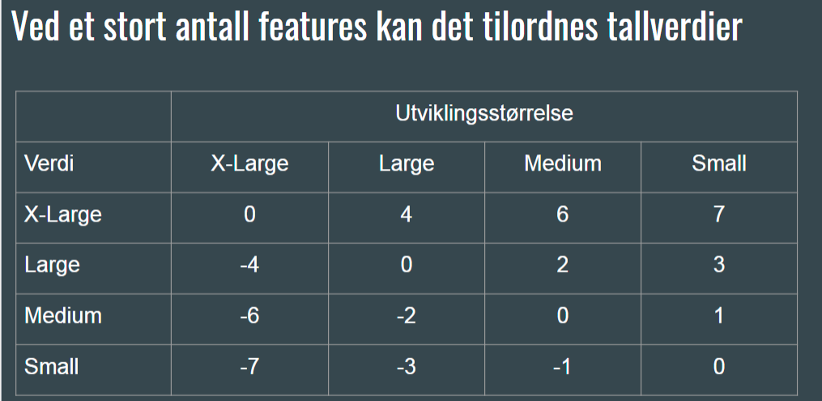

|  |  |  |  |  |  |
| --- | --- | --- | --- | --- | --- |
| Nummer i Trello: | Forklaring: | Utviklingsstørrelse | Verdi: | Total : | MVP? |
| 1 | Innlogging | MEDIUM | X-LARGE |  | Nei |
| 2 | Administrator | LARGE | MEDIUM |  |  |
| 3 | Klage-system |  |  |  |  |
| 4 | Klage-system |  |  |  |  |
| 5 | Tjenesten |  |  |  |  |
| 6 | Klage-system |  |  |  |  |
| 7 | Tjenesten |  |  |  |  |
| 8 |  |  |  |  |  |
| 9 |  |  |  |  |  |
| 10 |  |  |  |  |  |
| 11 |  |  |  |  |  |
| 12 |  |  |  |  |  |
| 13 |  |  |  |  |  |
| 14 |  |  |  |  |  |
| 15 |  |  |  |  |  |
| 16 |  |  |  |  |  |
| 17 |  |  |  |  |  |
| 18 |  |  |  |  |  |
| 19 |  |  |  |  |  |
| 20 |  |  |  |  |  |
| 21 |  |  |  |  |  |
| 22 |  |  |  |  |  |
| 23 |  |  |  |  |  |
| 24 |  |  |  |  |  |
| 25 |  |  |  |  |  |
| 26 |  |  |  |  |  |
| 27 |  |  |  |  |  |
| 28 |  |  |  |  |  |
| 29 |  |  |  |  |  |
| 30 |  |  |  |  |  |
| 31 |  |  |  |  |  |
| 32 |  |  |  |  |  |
| 33 |  |  |  |  |  |
| 34 |  |  |  |  |  |
| 35 |  |  |  |  |  |
| 36 |  |  |  |  |  |
| 37 |  |  |  |  |  |
| 38 |  |  |  |  |  |
| 39 |  |  |  |  |  |
| 40 |  |  |  |  |  |