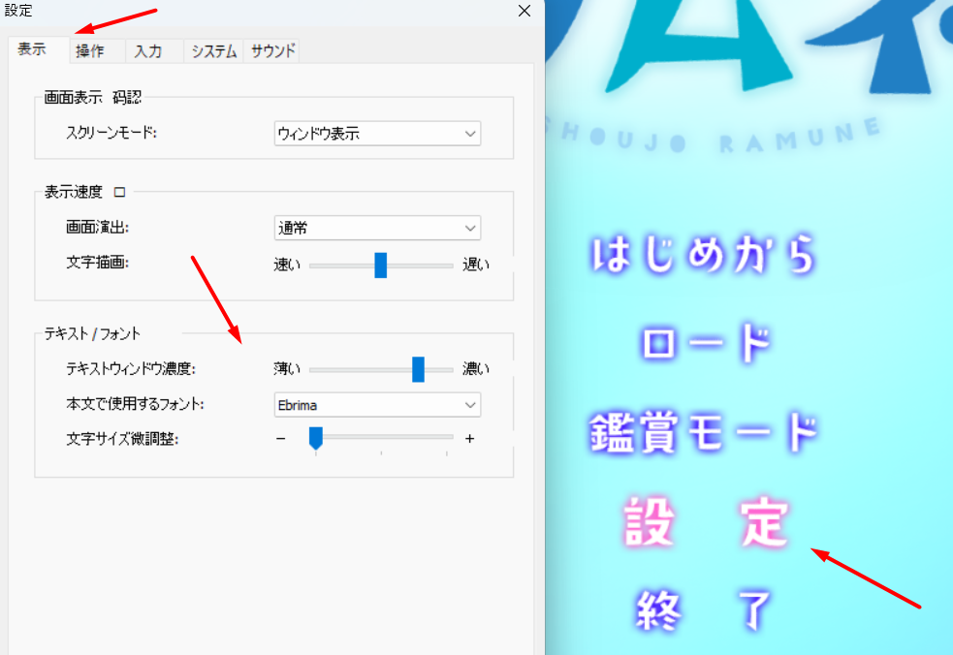
1. Go into game folder and rename "datascn.tac" into something different. Then
unpack archive and move datascn.tac folder into game folder.
2.Run game in japanese locale or with Locale.Emulator
3.Set small font like Ebrima and lowest size in settings, otherwise text wont fit.

