Rough Work
Building a Text to SQL Agent for handling complex database queries | LangChain | Python - YouTube (not implemented)
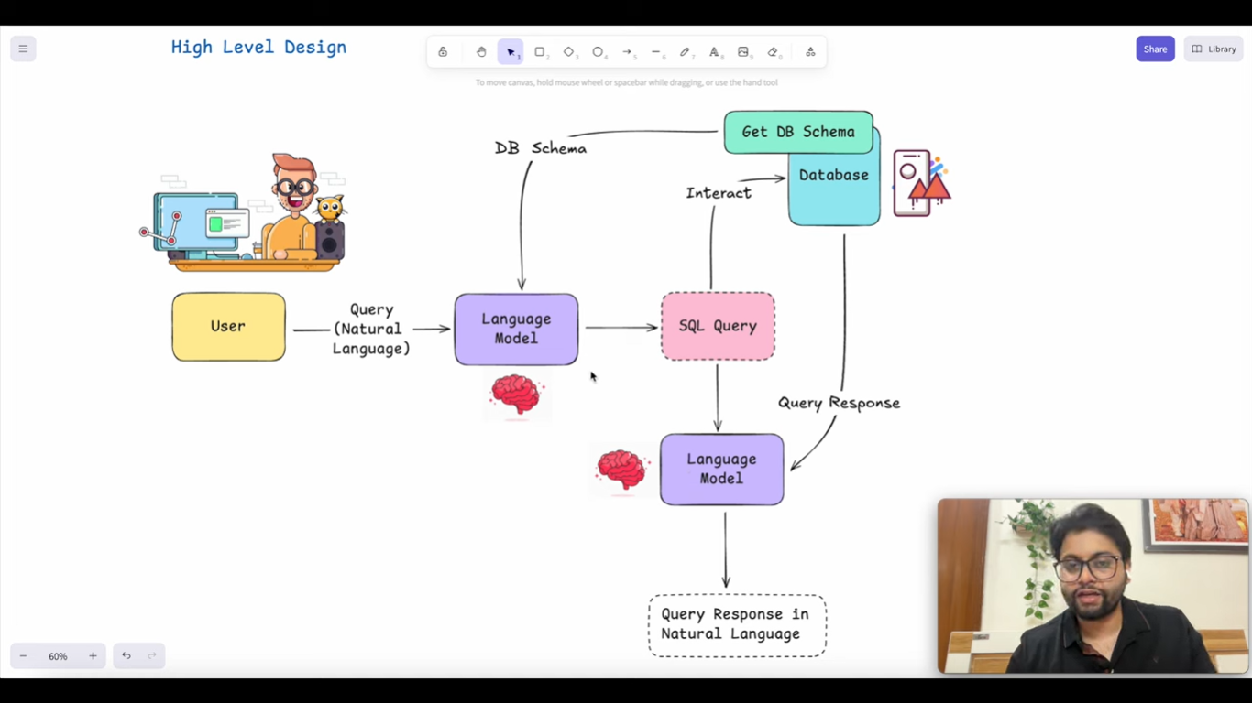
Baby Steps:
Ques1: How to Bring all the Github files into My VS code
Ques2: How to run a. nl_sql_pipeline.ipynb b. agent.ipynb
Ques-3 need to make some changes in original code because I will use Groq or OpenRouter
-------------------------------------------------------------------------------------------------------
Ans-1 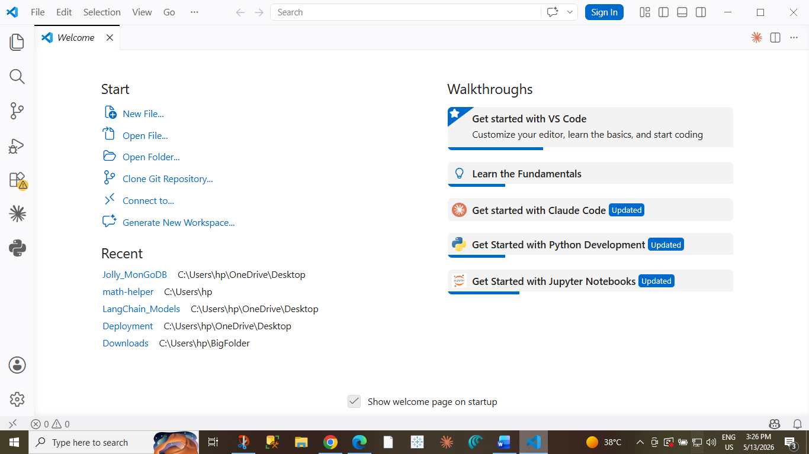

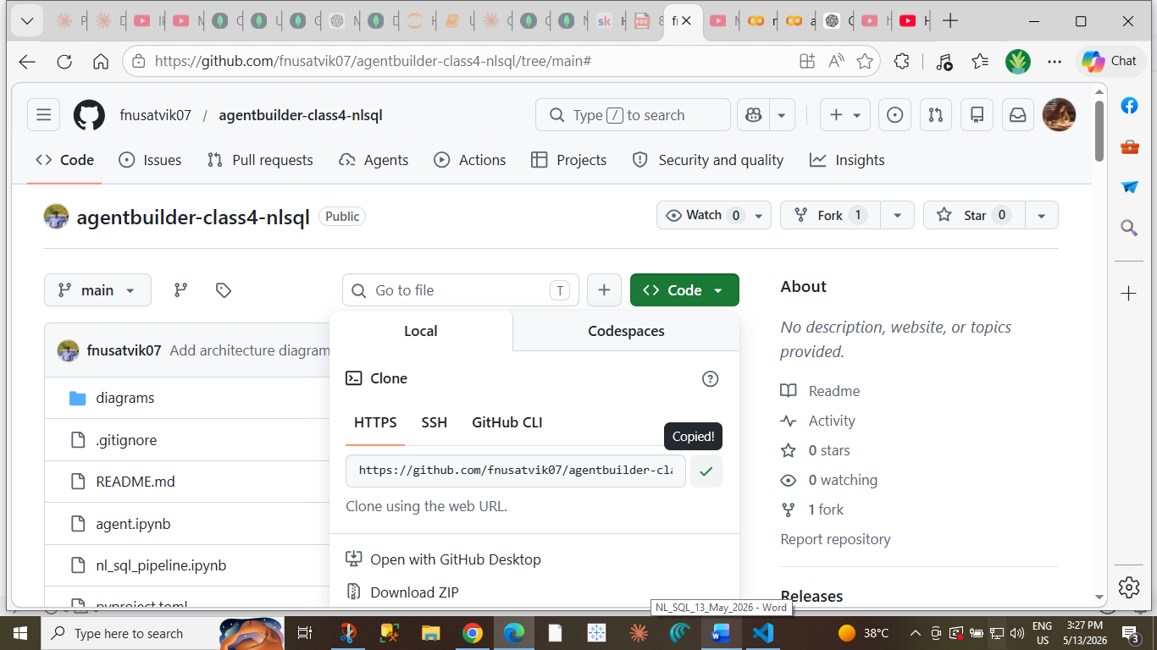
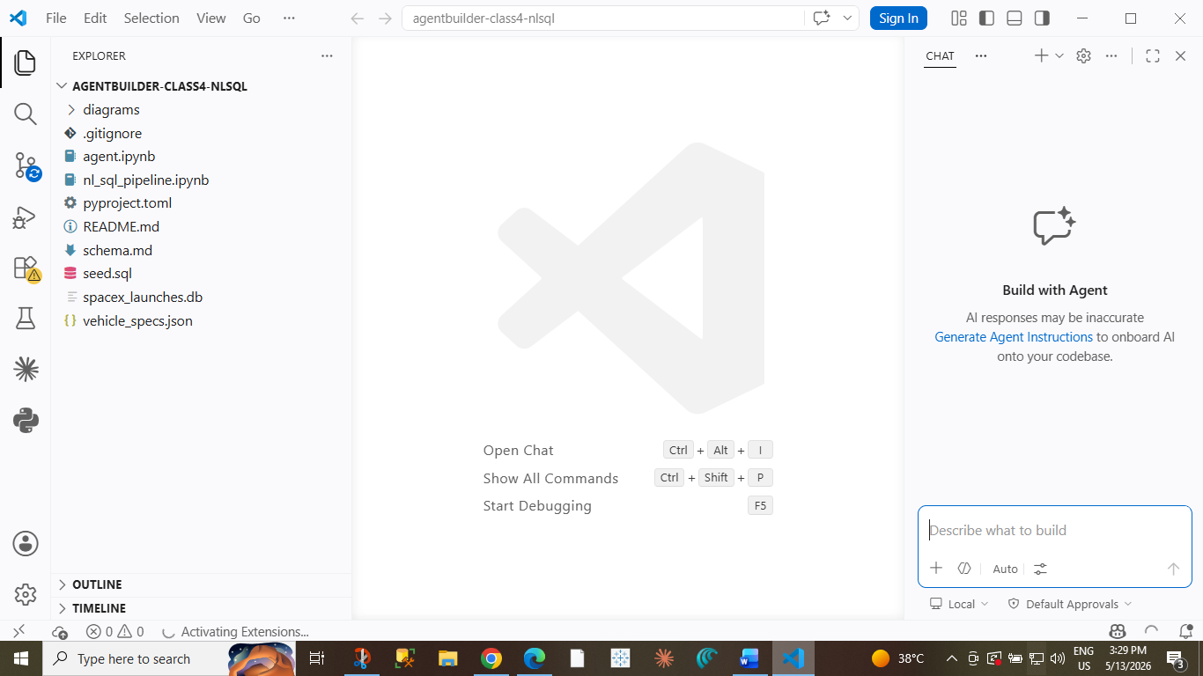
Able to clone but unable to run because no OpenAI api key access
Next I am thinking to open a. nl_sql_pipeline.ipynb b. agent.ipynb in GoogleColab
- Groq free and latest model
- .db and .json already provided

Building an NL to SQL Pipeline
Earlier people used: requirements.txt
Now modern Python uses: pyproject.toml because it is more powerful and organized.
If you don’t have a pyproject.toml file in Google Colab, then you do not need uv.
!pip install langchain-groq langchain-core pandas –quiet 👉 “Install silently with less output.”

For Beautiful Output:
from IPython.display import Markdown
Markdown(response.content)
Latest Model Used
model_name="groq/compound"
import sqlite3
Meaning
Imports Python’s built-in SQLite database library.
Used for:
- creating databases
- storing tables
- running SQL queries
cursor is an object used to communicate with the database.
Think of it like: 👉 a messenger between Python and SQLite database.
What the Database Can and Cannot Tell the LLM
A database contains structure and raw data.
But an LLM still misses a lot of human meaning and business context.
What the Database Can Tell the LLM
The database can provide technical information like:
- Table names
- Column names
- Data types
- Relationships between tables
- Stored values
Example:
Table | Column | Data Type
launches | mission_name | TEXT
launches | payload_kg | INTEGER
launches | success | BOOLEAN
The LLM can read this structure and understand:
- mission_name stores text
- payload_kg stores numbers
- success stores true/false values
What the Database Cannot Tell the LLM
The database does not automatically explain meaning.The AI must guess many things. Sometimes the guess is correct.Sometimes the guess is confidently wrong
1. Allowed Text Values Missing
The database may store text values, but it does not explain:
- spelling rules
- naming conventions
- abbreviations
- valid categories
Example:
rocket_name
Falcon 9
Falcon-9
falcon9
The database cannot tell:
- Are these the same rocket?
- Is one incorrect?
- Which format is official?
So the LLM may generate wrong filters like:
WHERE rocket_name = 'Falcon-9'
while actual data uses:
Falcon 9
Result → incorrect query output.
2. Business / Domain Meaning Missing
Column names do not explain real-world meaning.
Example:
Column
mission_type
Possible values:
- Heavy Launch
- Civilian Mission
- Demo Flight
But the database does not explain:
- What qualifies as a "Heavy Launch"?
- Is "Civilian Mission" non-military?
- Is a test mission included?
Only domain experts know these meanings.
The LLM may assume incorrect definitions.
3. Boolean Meaning Missing
Databases often store booleans as:
success
0
1
But the database may not explain:
Value | Meaning
1 | Success
0 | Failure
Sometimes systems reverse this logic.
Example:
status_flag
0 = Active
1 = Archived
Without documentation, the LLM may misunderstand the meaning completely.
4. Hidden Conventions Missing
Many databases contain silent business rules that are never documented.
Example:
payload_kg
0
Possible meanings:
- No payload
- Secret payload
- Test mission
- Missing data
The database itself cannot explain which interpretation is correct.
Humans inside the company usually know these conventions.
5. Missing Context About Null Values
Example:
landing_status
NULL
What does NULL mean?
Possible interpretations:
- Data not collected
- Landing not attempted
- Unknown result
- Still pending
The LLM cannot know automatically.
6. Time Meaning Is Missing
Example:
launch_date
2026-05-10 12:00:00
Questions the database cannot answer:
- UTC or local time?
- Scheduled time or actual launch time?
- Updated after delays?
The LLM may interpret timestamps incorrectly.
7. Units Are Often Unclear
Example:
altitude
120
What is 120?
- meters?
- kilometers?
- feet?
The database schema usually does not explain units clearly.
8. Historical or Legacy Rules Missing
Older databases often contain outdated logic.
Example:
status = 3
What does 3 mean?
Maybe:
- retired
- delayed
- merged
- soft deleted
Only old documentation or engineers know.
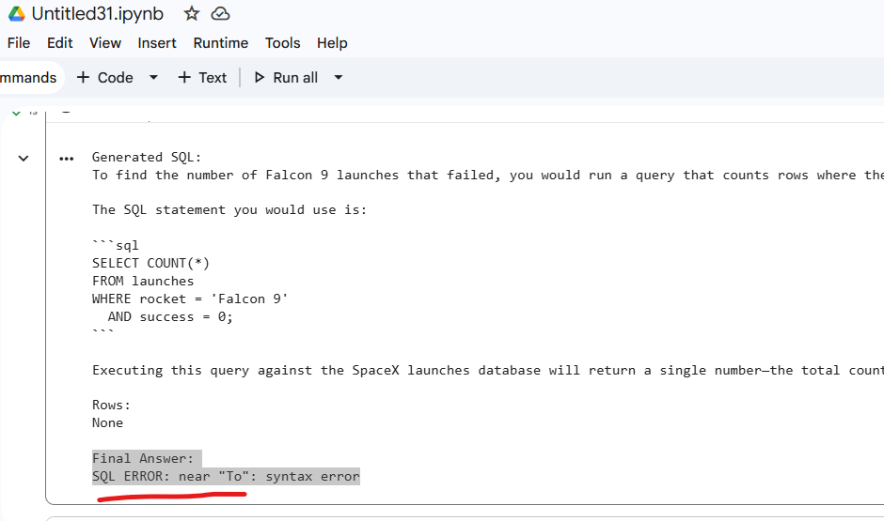
Your LLM returned:
- explanation text
- markdown
- SQL mixed together
instead of pure SQL only.
- Strengthen system prompt
- Validate SQL starts correctly
- temperature=0 Good for deterministic SQL generation.
- Keep prompt smaller
That is a schema grounding problem, very common in Text-to-SQL systems

OpenAI model is probably:
- better at schema grounding
- more obedient to prompts
- stronger at following column names exactly

schema grounding problem in GROQ
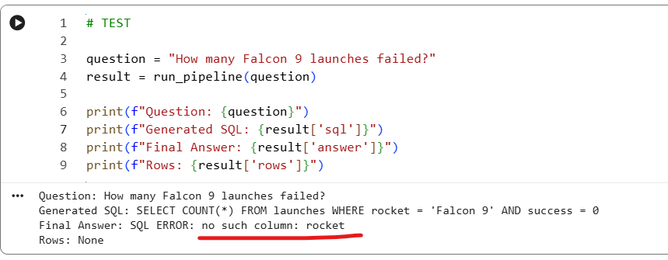

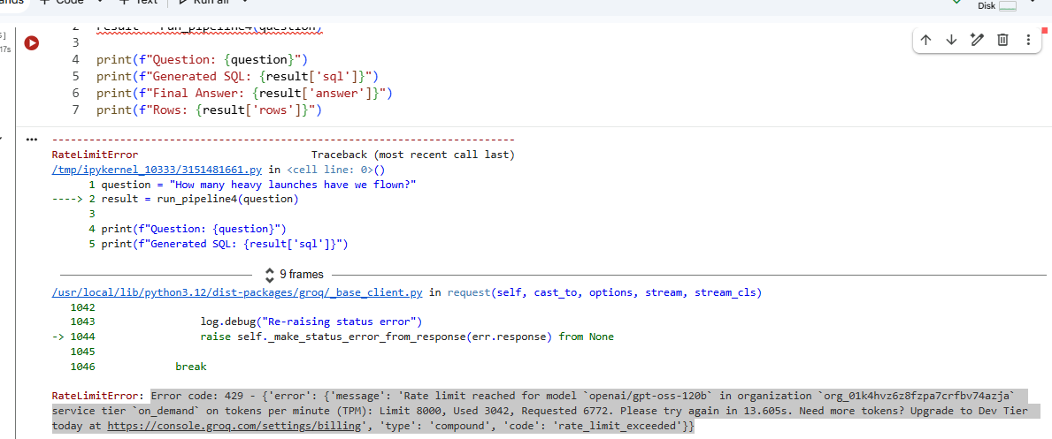

Test Suit Preparation- SQL SERVER MANAGEMENT
Downloads - DB Browser for SQLite
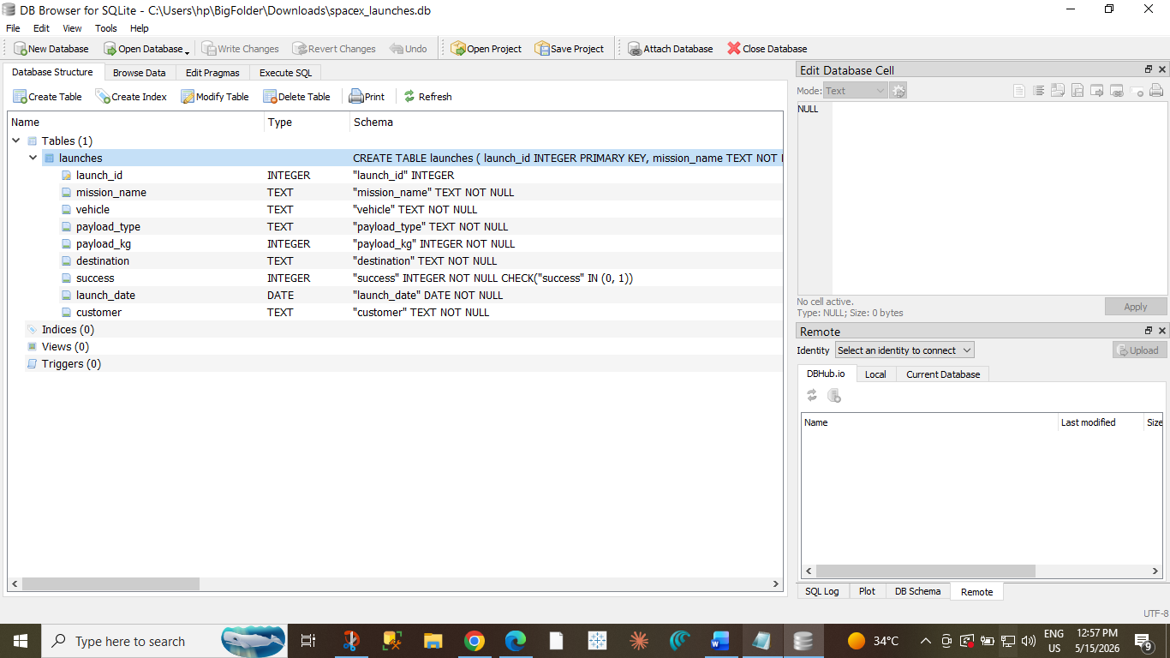
Execute SQL
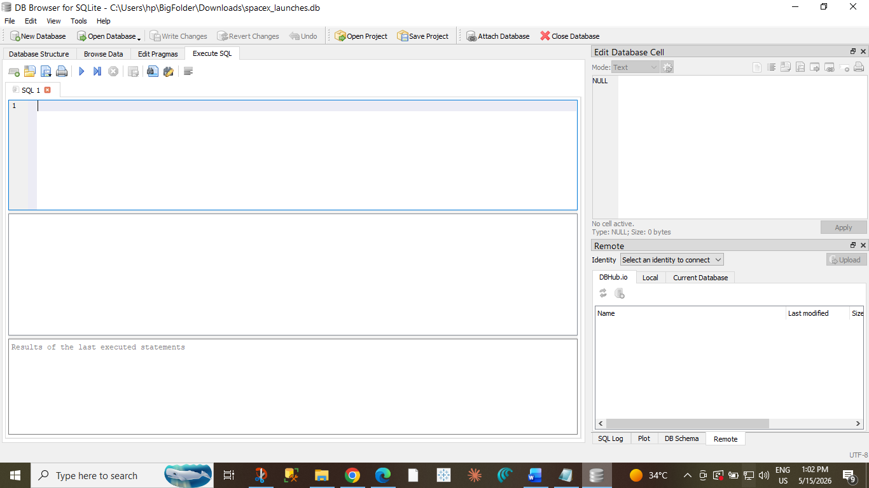
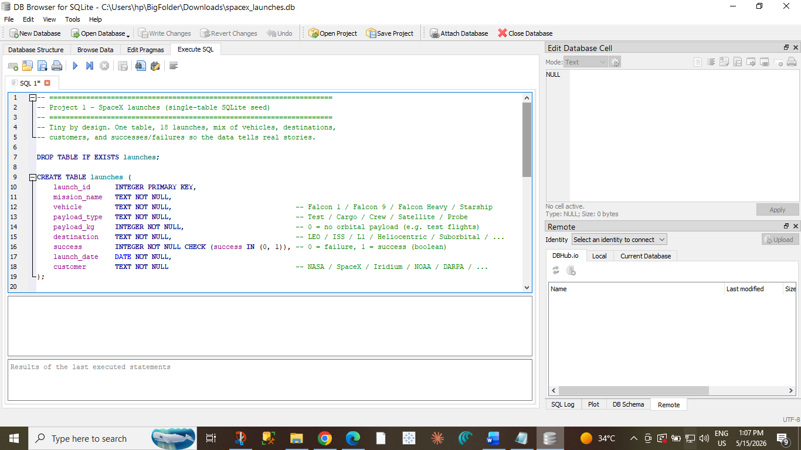
After Pasting, Execute Button,
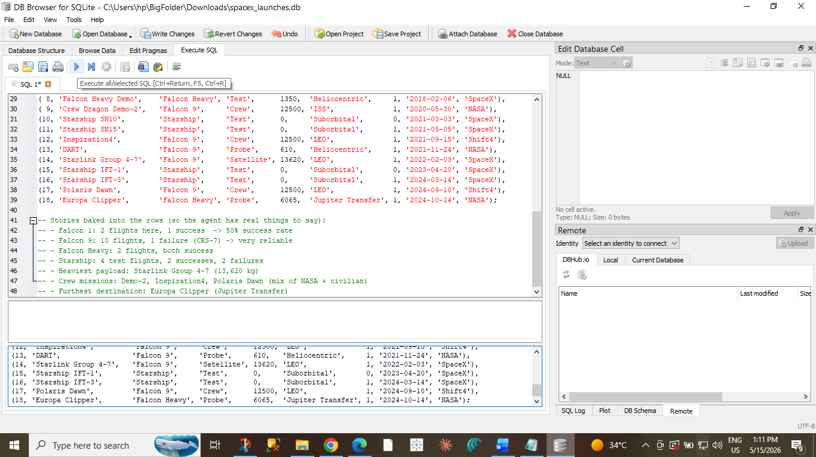
Click on Write Changes to save database permanently.
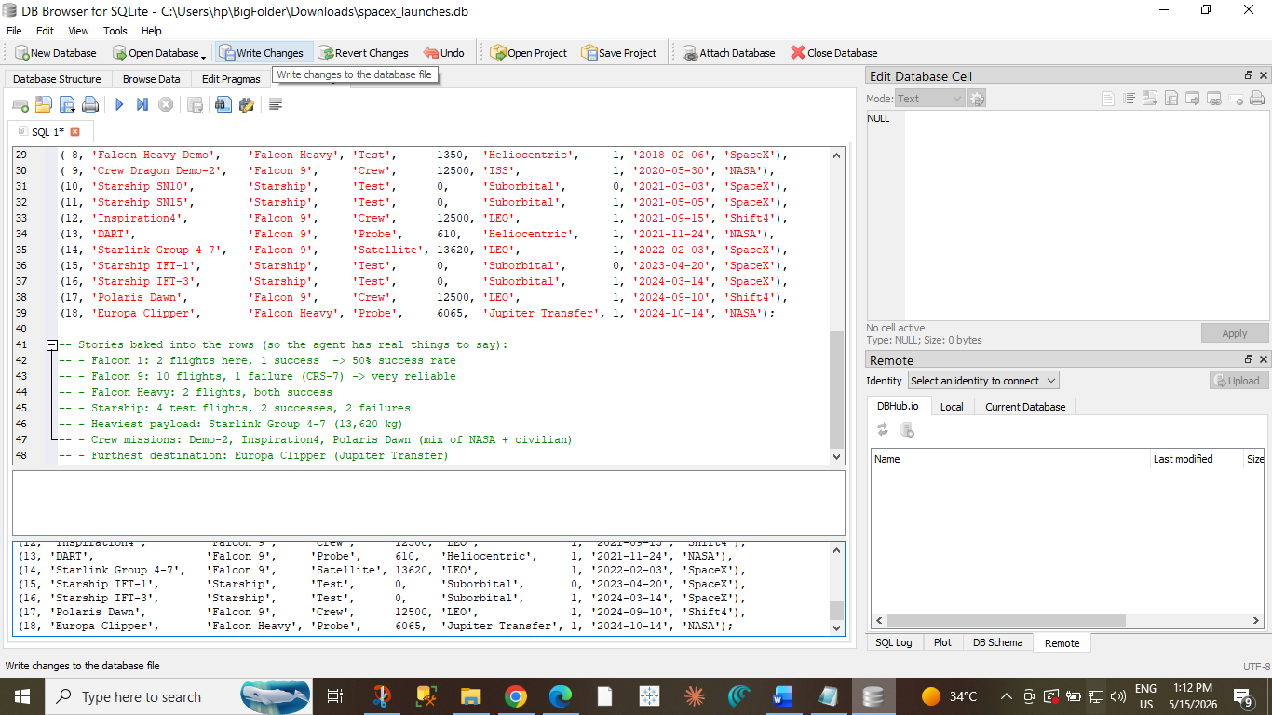
Go to: Browse Data You should now see all 18 launch records.
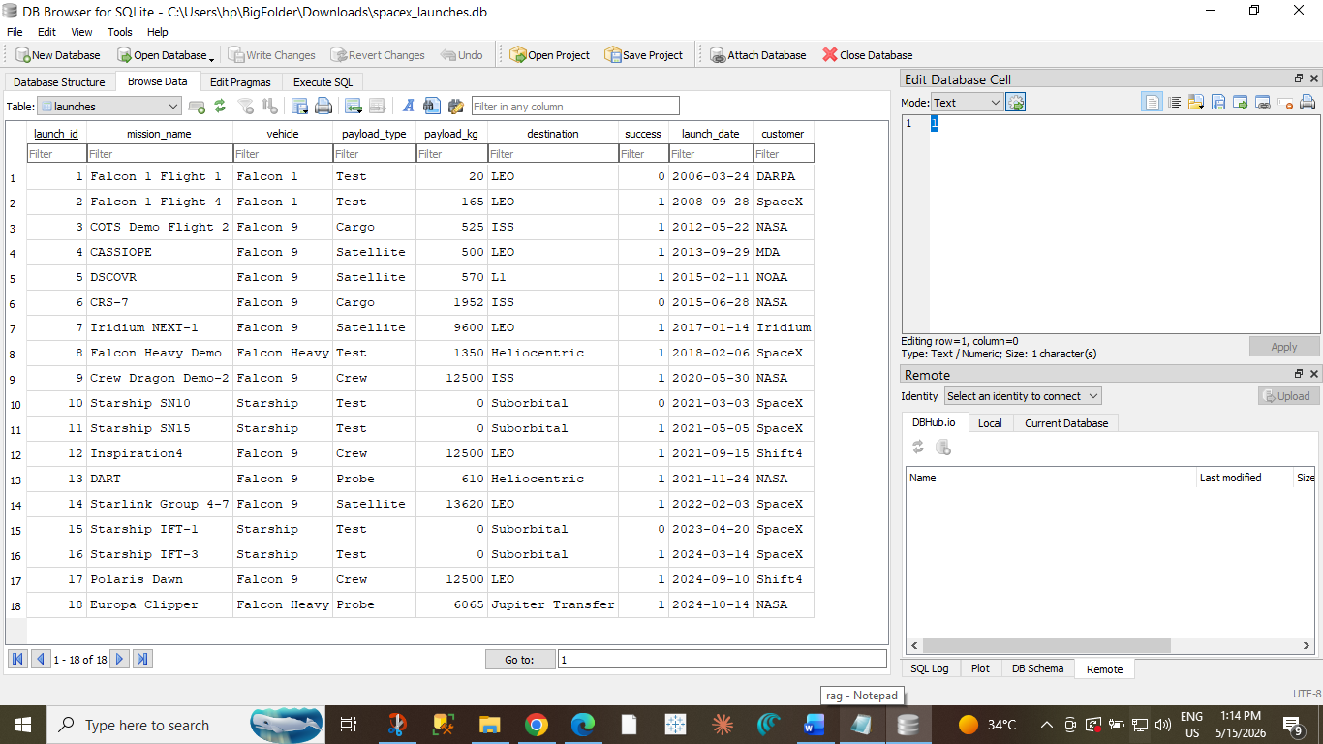

Need to Verify Test Suite
Click on new tab
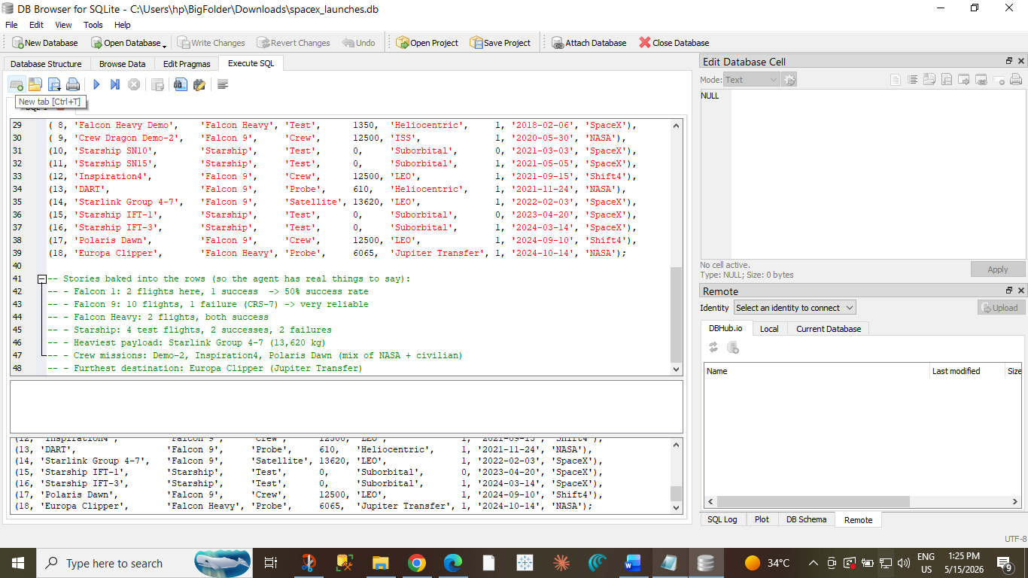
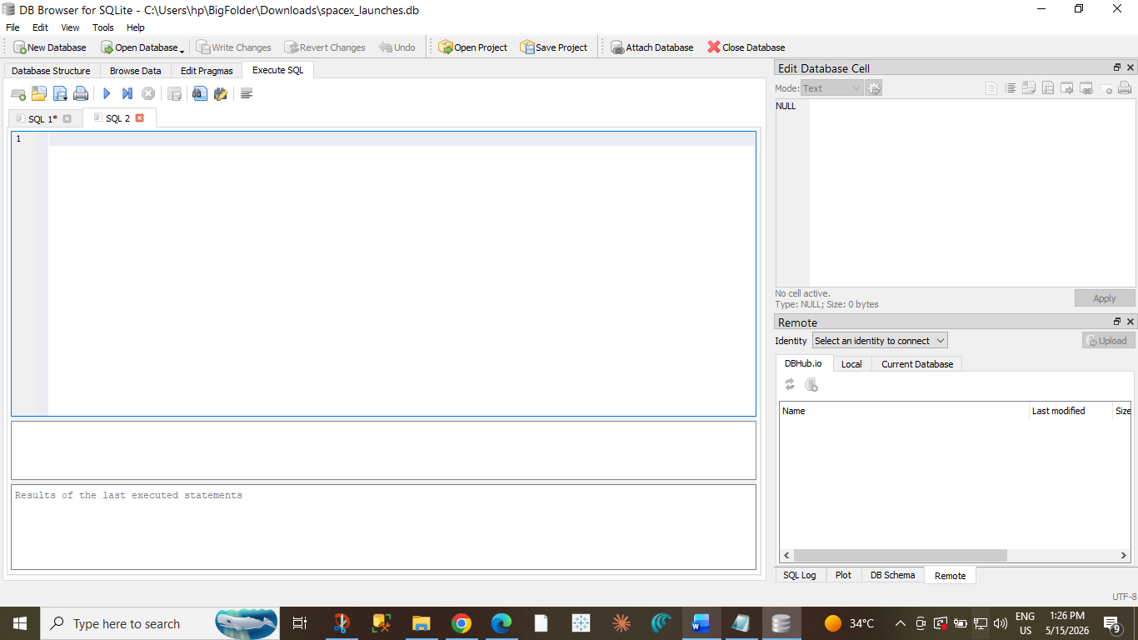
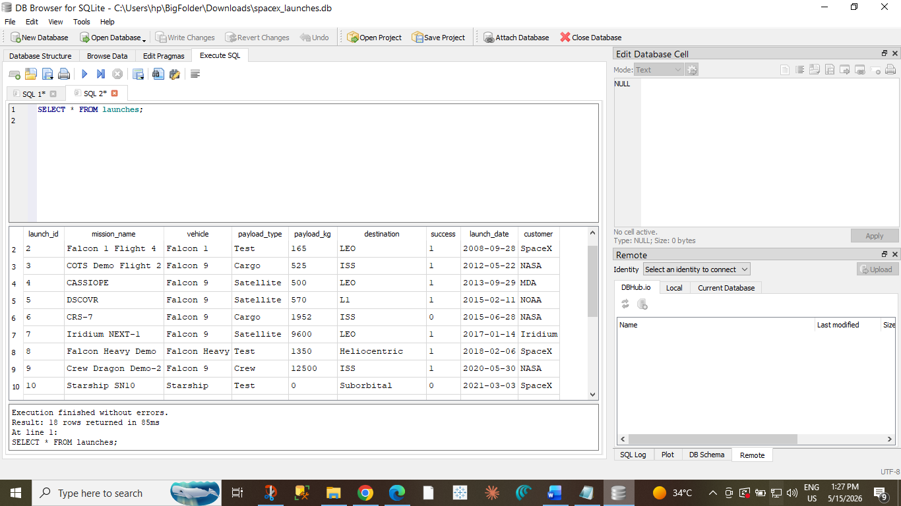
To increase font size edit-> preference
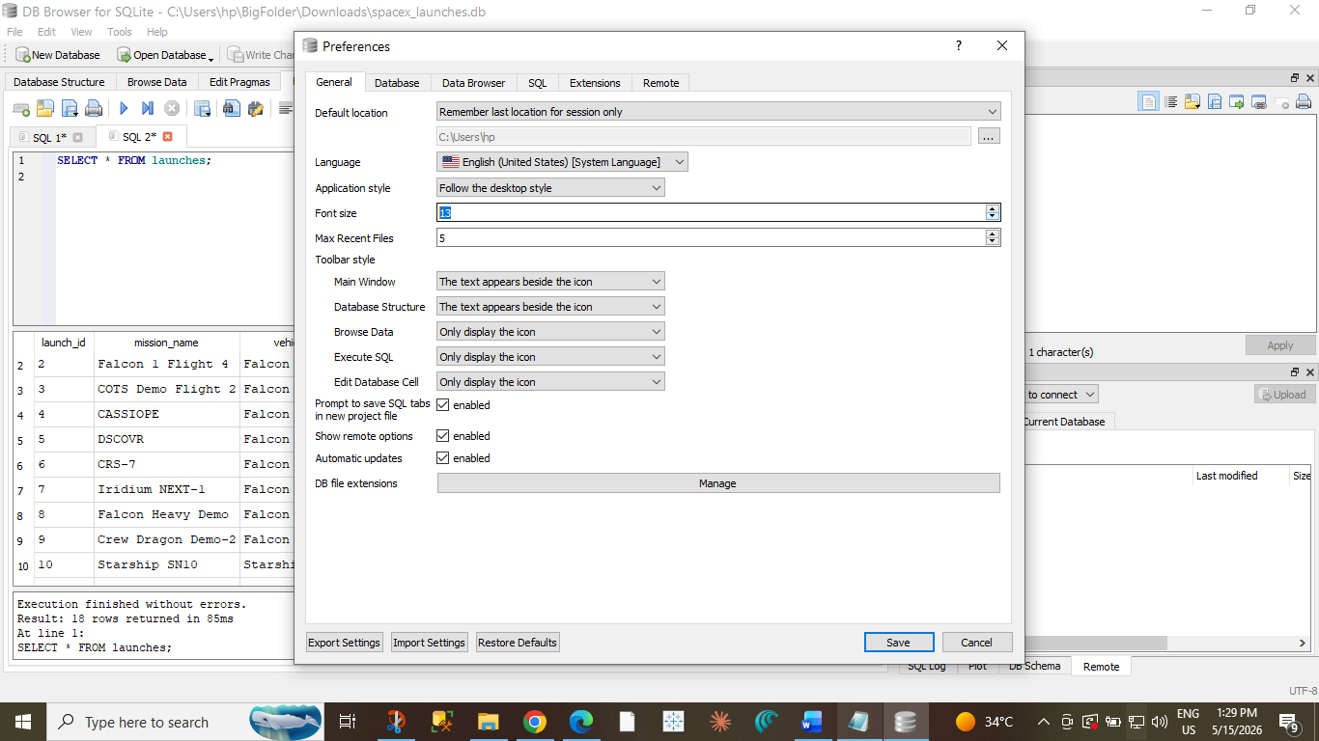

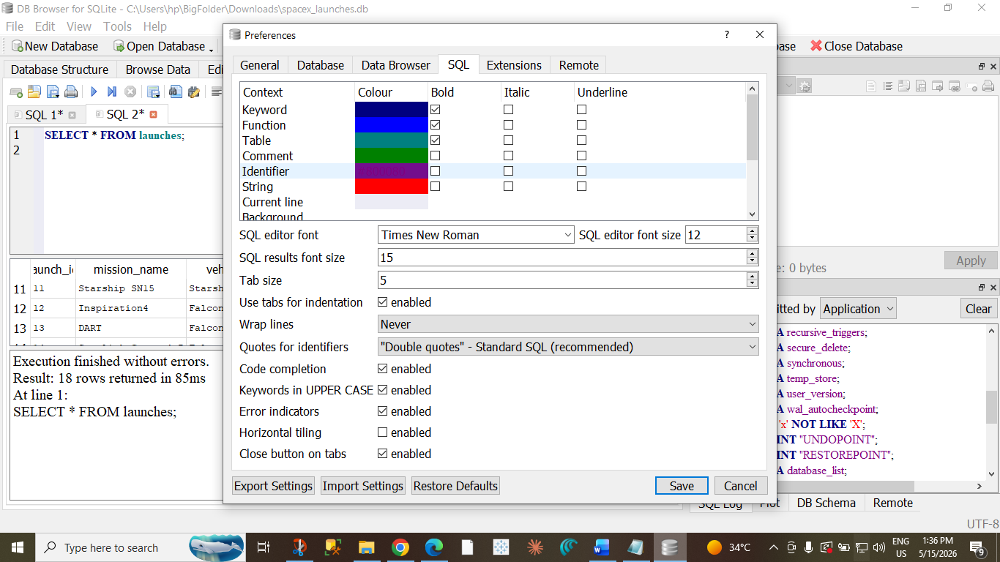
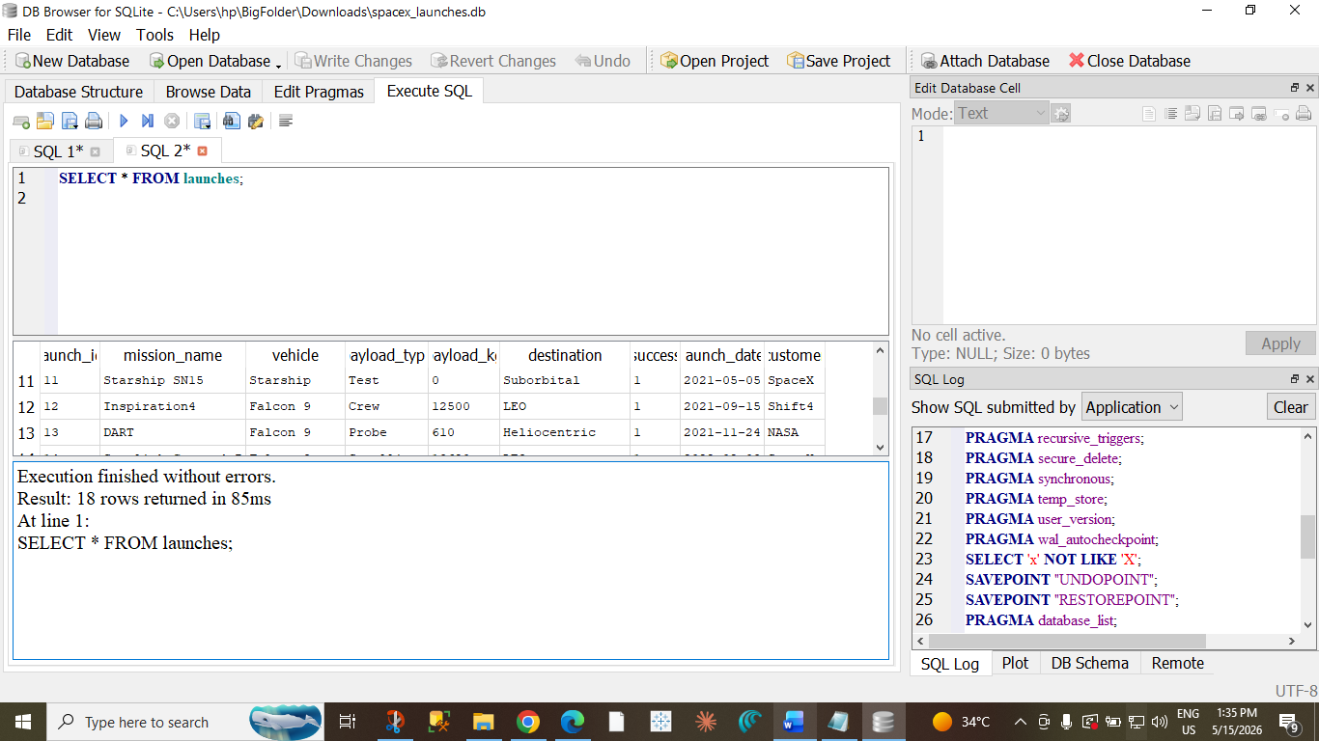

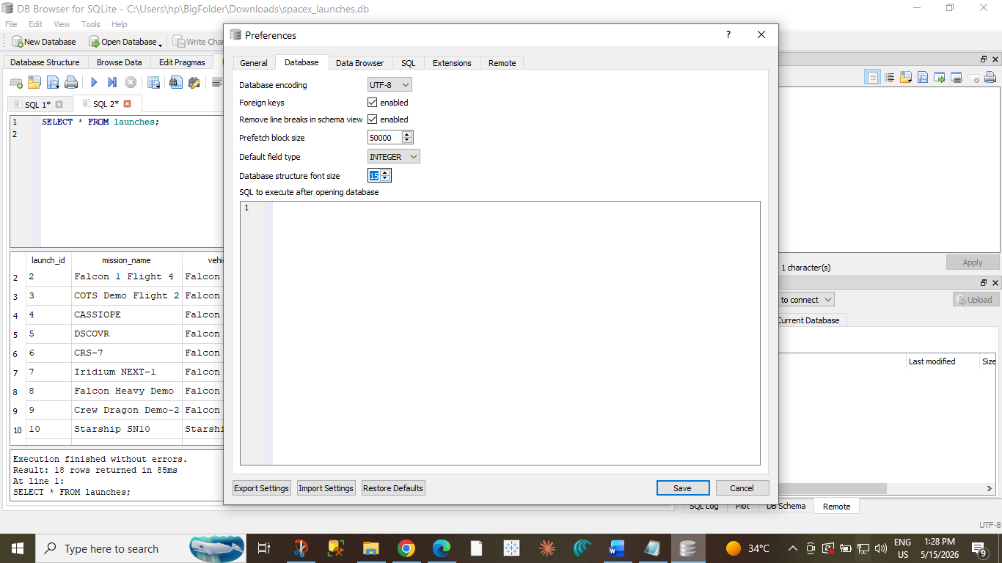
SQL evaluation pipelines
before creating a proper test suite, you should first verify that your SQL queries actually run correctly on the SQLite database.
Your workflow should be:
- Open SQLite database
- Run SQL query manually
- Verify output
- Add query into test suite

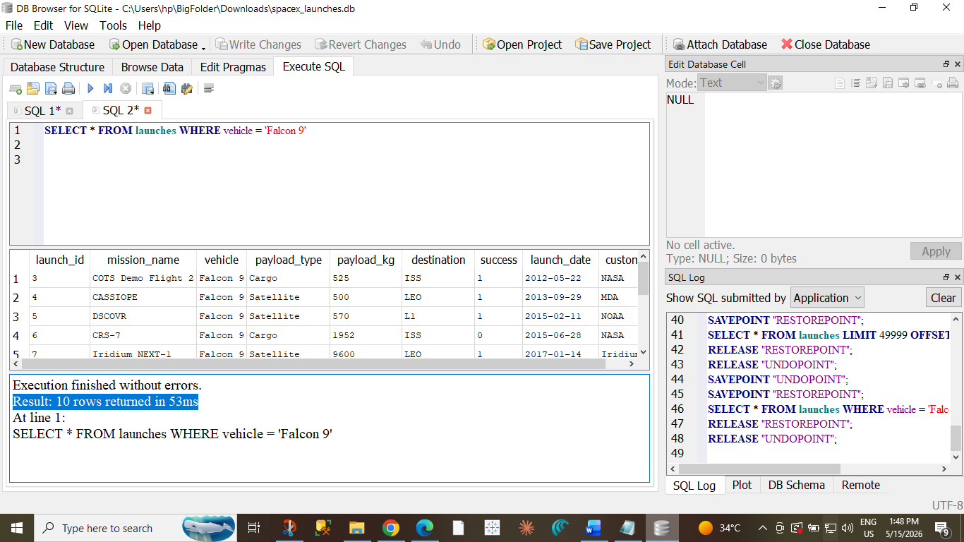

In Queries-
Where Show is written in Query-> do not count rows, See the name only
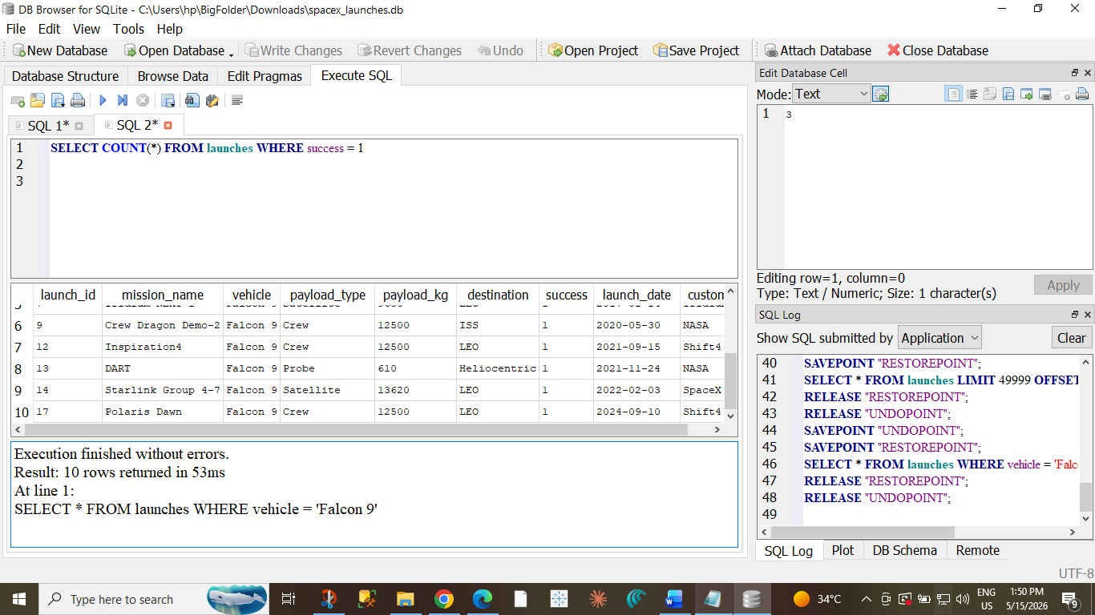
SQL evaluation categories done
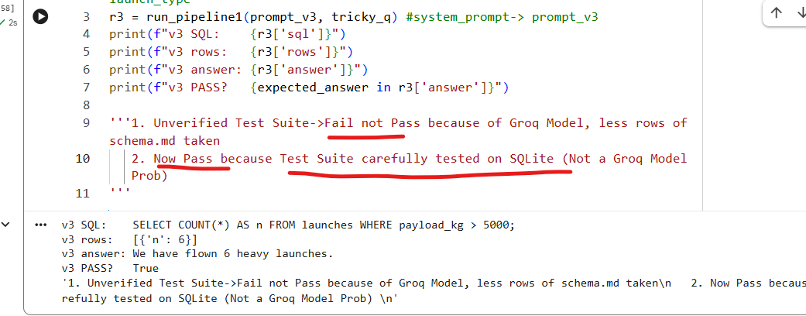
Taken break and re-run all code, again error
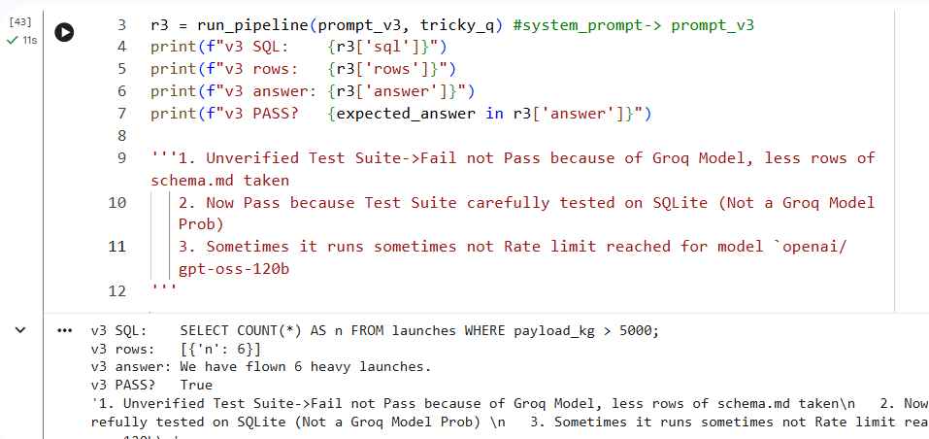
# A compact pass-rate summary
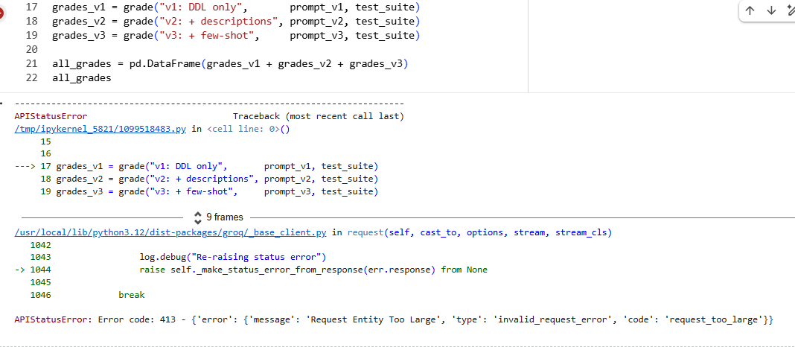
contains:
- long schema
- long instructions
- many examples
AND you're looping over many test cases.
So request size explodes.
Now checking Token Management
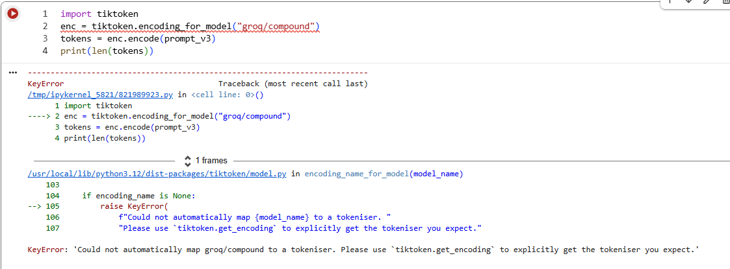
Groq Model, unable to run test_suite token usage so high
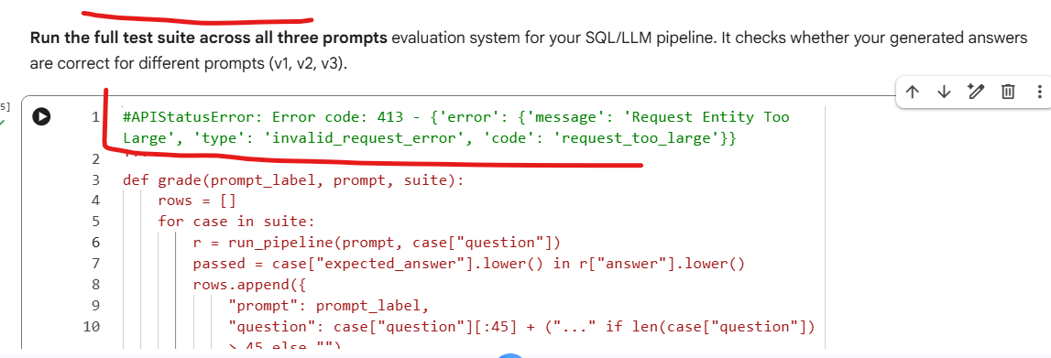
AI engineering concept:
- per-request tokens
vs
- cumulative experiment tokens
TPM (Tokens Per Minute) rate limit, not a coding error.
RateLimitError: Error code: 429 - {'error': {'message': 'Rate limit reached for model `openai/gpt-oss-120b` in organization `org_01k4hvz6z8fzpa7crfbv74azja` service tier `on_demand` on tokens per minute (TPM): Limit 8000, Used 4890, Requested 6556. Please try again in 25.845s. Need more tokens? Upgrade to Dev Tier today at https://console.groq.com/settings/billing', 'type': 'compound', 'code': 'rate_limit_exceeded'}}
You are sending too many requests too quickly.
Error meaning:
Limit: 8000 TPM
Used: 4890
Requested: 6556
So:
4890 + 6556 > 8000
Hence Groq blocks the request temporarily.
Best Solution: Run Separately
Instead of:
grades_v1 = grade(...)
grades_v2 = grade(...)
grades_v3 = grade(...)
run one at a time.

grades_v1 = grade(
"v1: DDL only",
prompt_v1,
evaluation_suite
)
pd.DataFrame(grades_v1)
Wait 30–40 seconds.
Then:
grades_v2 = grade(
"v2: + descriptions",
prompt_v2,
evaluation_suite
)
pd.DataFrame(grades_v2)
Then later v3.
Better: Add Delay Between Requests
Inside loop: import time and: time.sleep(5)
Example:
for case in suite:
r = run_pipeline(prompt, case["question"])
time.sleep(5)
This is common in production systems.
Small testing | 2–3 sec

Hitting rate limits | 5–10 sec

Large evaluations | 10+ sec

RateLimitError: Error code: 429 - {'error': {'message': 'Rate limit reached for model `openai/gpt-oss-120b` in organization `org_01k4hvz6z8fzpa7crfbv74azja` service tier `on_demand` on tokens per minute (TPM): Limit 8000, Used 3183, Requested 6538. Please try again in 12.9075s. Need more tokens? Upgrade to Dev Tier today at https://console.groq.com/settings/billing', 'type': 'compound', 'code': 'rate_limit_exceeded'}}

Reduce Evaluation Batch
5 seconds is not enough for TPM reset.
Prompt Compression techniques needed
Why Your Current Code Did Not Crash token usage 0 0 0
Because you used safe fallback:
r.get("usage", default)
So instead of error:
- it silently inserted zeros.
groq/compound dynamically routes requests across models. So context window may vary.
groq/compound in Groq is a routing/meta model.
It does NOT represent one fixed model.
Instead, Groq automatically chooses/reroutes your request to an underlying model depending on:
- prompt size
- task type
- speed
- reasoning needs
- availability/load
So yes:
model_name="groq/compound"
means:
"Groq decides the best backend model automatically."
Context window question
Because it routes dynamically:
There is NO single fixed context window for groq/compound
The effective limit depends on which backend model gets selected.
So practical context window is often:
~128k tokens
instead of sending huge schema every time:
- shorten schema
- remove unnecessary columns
- reduce examples
- reduce system prompt size

